Completing your  
IAS Online Performance Report

Contents

1. Accessing you IAS Online Performance Report 3

2. Entering Your Access Code 4

3. Entering your Password 5

4. Resetting Your Password 7

5. Saving and Navigation of the IAS Online Performance Report 10

6. The IAS Online Performance Report Welcome Screen 11

7. Step 1 of 5 – Your Progress and Performance against the Project 12

8. Step 2 of 5 – Performance Measures 13

9. Further Information on IAS KPIs that require Surveys, Feedback Forms or Questionnaires 15

10. Step 3 of 5 – Additional Documentation and Location Data 17

11. Step 4 of 5 – Project Contact Information 18

12. Step 5 of 5 – Declaration 19

13. Successful Confirmation Page 20

## Accessing your IAS Online Performance Report

When you are required to perform your online performance report, your Organisation will receive an email similar to the one below. This email is important, as it contains the weblink to the online performance report and an **Access Code** (underlined in red in the screenshot below) that you will need to access your report for the first time.

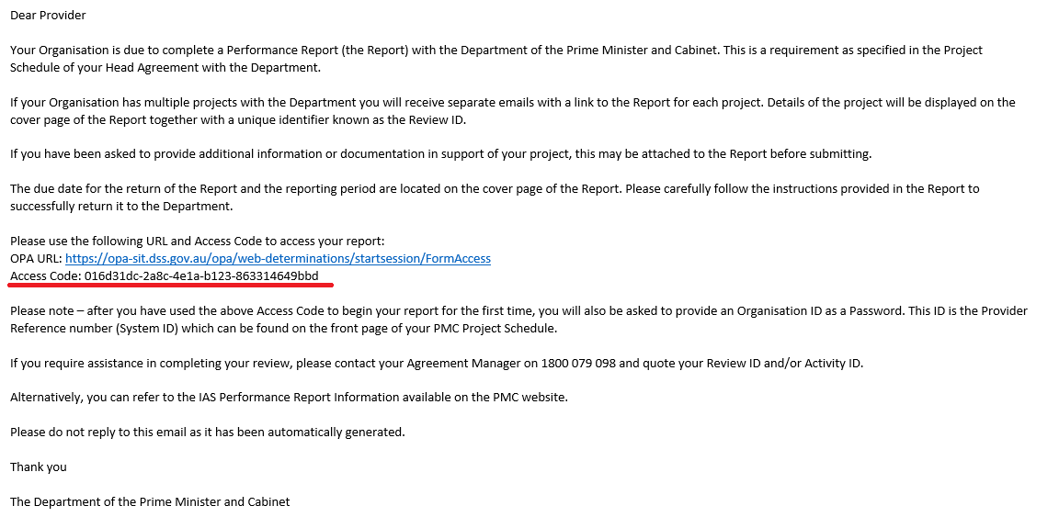

## Entering Your Access Code

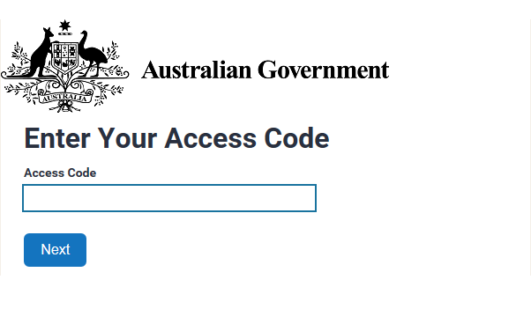When you access your Online Performance Report for the first time, you will be asked to enter your Access Code. Remember, your Access Code is contained in the email text you will receive from the Department. Please see the screenshot below for an example of the access code screen.

## Entering your Password

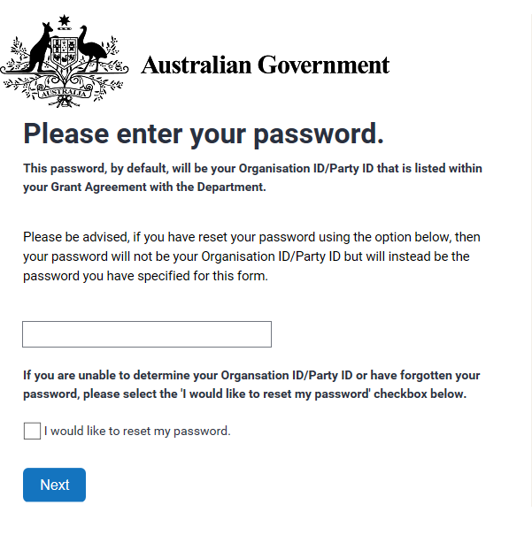After you have used the Access Code to begin your report for the first time, you will also be asked to provide your Organisation ID/Party ID as your password. This Organisation ID/Party ID is listed on the front page of your PMC Project Schedule, and is referred to on the Project Schedule as your **Provider reference number (System ID)**. Please see screenshots below and over page for further information.

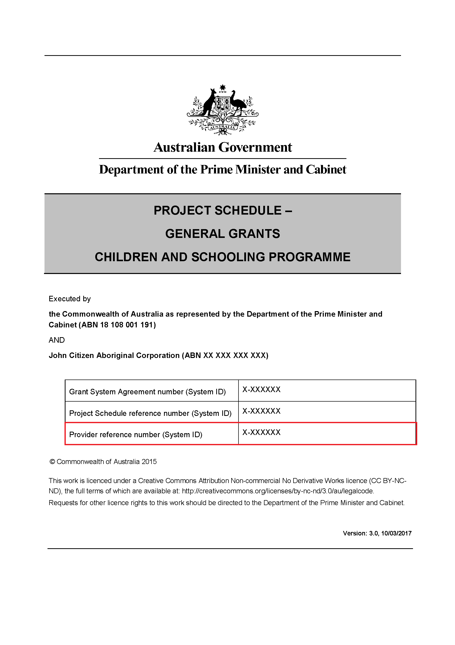**Please note** – if you cannot find your **Provider reference number (System ID)** or do not have a copy of your Project Schedule, you can contact your Agreement Manager for further assistance.

## Resetting Your Password

You can reset your password by ticking the box in the “I would like to reset my password” option.



If you wish to change your password, you will be asked to verify your email. This must be the same email that your access code was emailed to.

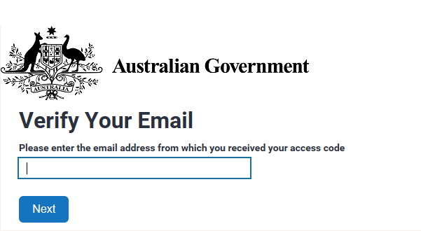

An email will be sent to you with a reset token. You will need to verify this token. You can cut and paste the reset token into the required field (see screen shot below).

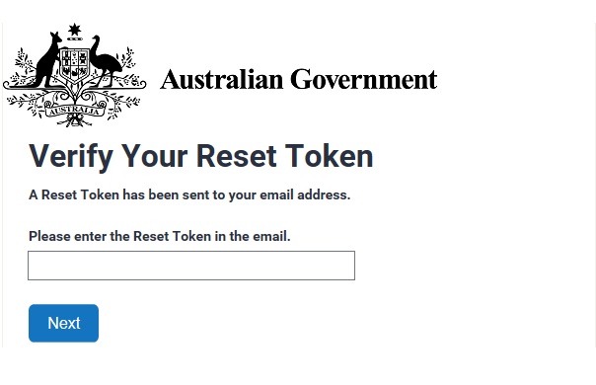

When changing your password you will need to ensure it meets the security requirements set out in the screenshot below.

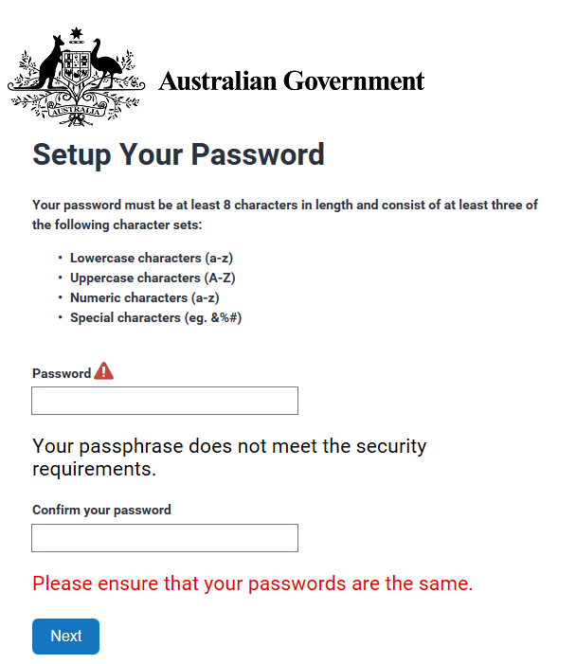

## Saving and Navigation of the IAS Online Performance Report

Your online performance report will be ‘auto saved’ as you progress through the screens, each time you select the H:\Current Work\How to Guide - IAS\Next button.PNG button.

**Please note -** if you choose to ‘**Exit’** your online performance report before you have completed the section (or screen), you may risk losing any unsaved work. Therefore, it is recommended that you complete each screen and press the H:\Current Work\How to Guide - IAS\Next button.PNG button, before selecting the “Exit” option.

If you need to make any changes to any of the information you have submitted (once it has been saved), you can click the  button. You can then perform any necessary changes, before selecting the H:\Current Work\How to Guide - IAS\Next button.PNG button once again to save your changes.

## The IAS Online Performance Report Welcome Screen

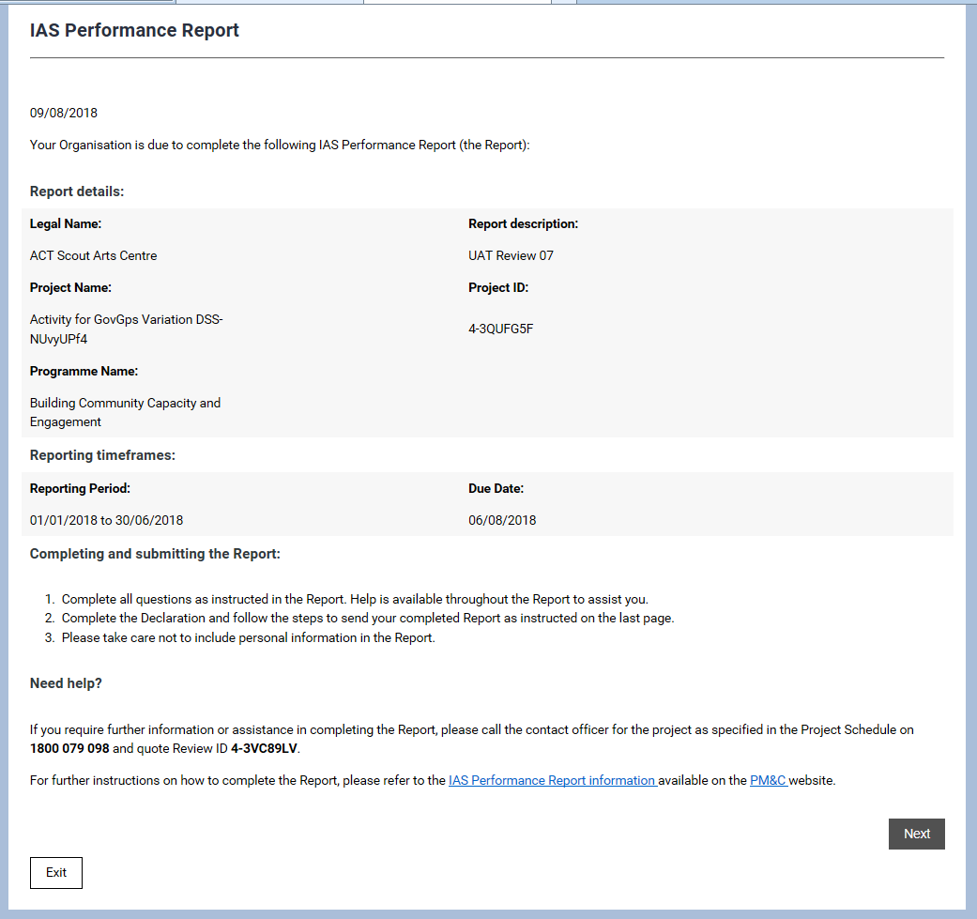When you first enter the IAS Online Performance Report, you will be presented with a Welcome Screen (see below), which will list the details of your project and instructions on how to complete and submit your IAS Online Performance Report. You will also find instructions on where to go if you require any help of further assistance in completing your IAS Online Performance Report.

## Step 1 of 5 – Your Progress and Performance against the Project

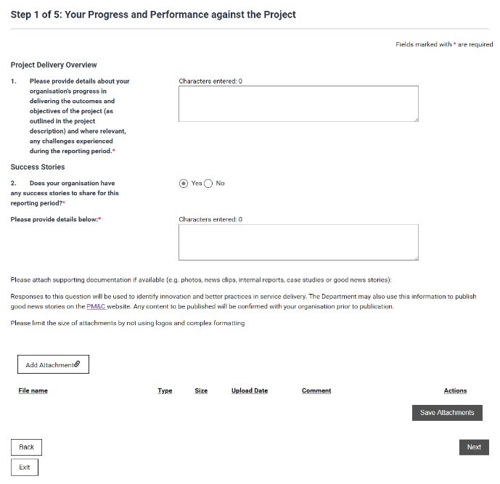In this step, you are required to provide details about the progress your Organisation has made towards achieving the agreed outcomes and objectives of the project.

It is also important to share any success stories that your organisation may have. These could be used as good news stories to highlight the success of your project. Any content to be published will be confirmed with your organisation prior to publication.

Please note that the limit to provide information is 2,000 character or approximately 300 words. If you have any supporting documentation, you can upload it by clicking the  button.

When you have completed this step, click the H:\Current Work\How to Guide - IAS\Next button.PNG button to save your changes and move on.

## Step 2 of 5 – Performance Measures

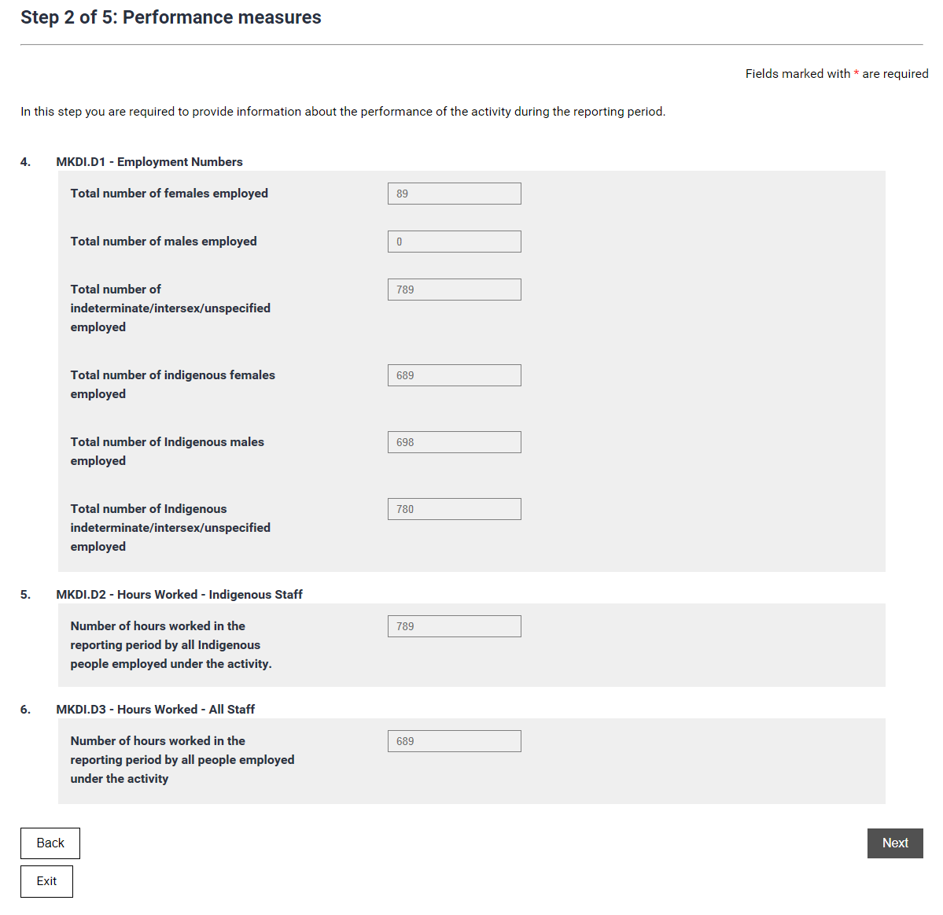In this step you are required to provide information against the Key Performance Indicators (KPIs) and Key Data Items (KDIs) listed in your Project Schedule.

You will first be required to answer questions against the mandatory Indigenous employment indicator MKPI.M1 (and associated MKDIs), and input the number of Indigenous and non-Indigenous staff that have been employed to implement your project.

You will also be required to provide information on the hours worked by Indigenous and non-Indigenous staff employed to implement your project.

You will then be asked to input information against any other KPIs or KDIs that appear in your Project Schedule.

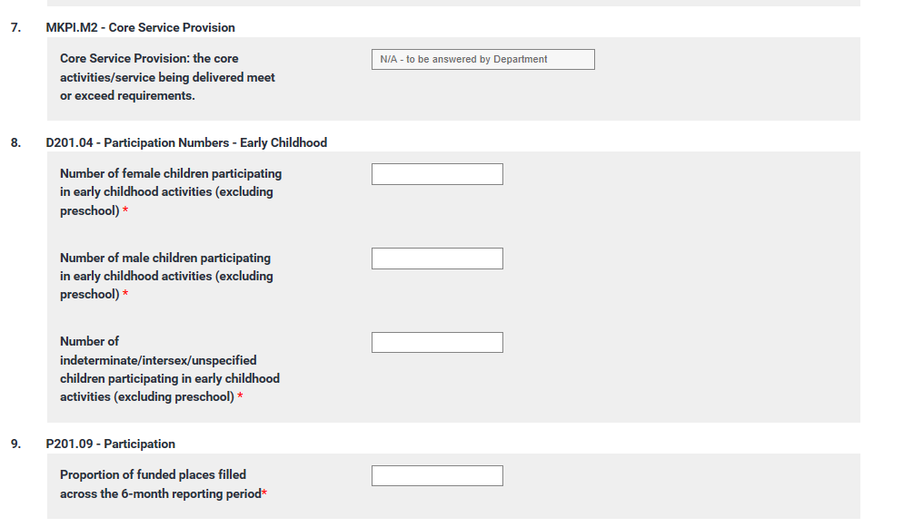**Please note –**the question **MKPI.M2 – Core Service Provision** has been‘greyed out’ in the IAS Online Performance Report, and you will not be required to provide any information in the corresponding answer box. This KPI will be answered by your IAS Agreement Manager.

When you have completed inputting all the required information for your project’s performance indicators, click the H:\Current Work\How to Guide - IAS\Next button.PNG button to save your changes.

## Further Information on IAS KPIs that require Surveys, Feedback Forms or Questionnaires

As you may be aware, a small number of the new IAS KPIs require a Survey, Client Feedback Form or Questionnaire as part of their reporting requirements.

With the exception of Program 2.2 Children and Schooling Activities, you will not be required to answer against these Survey/Client Feedback/Questionnaire KPIs for the July – December 2018 performance reporting cycle.

As such, the first time you complete this form, these questions will be ‘greyed out’, and you will not be required to answer them (please see screenshot below).

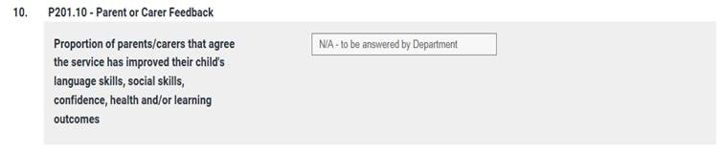

**However, please note -** the Department will expect you to answer against these KPIs for subsequent reporting periods (for example from the January to June 2019 reporting cycle).

For a full list of the Survey, Client Feedback Forms or Questionnaires KPIs that are required to be answered in the July – December 2018 performance reporting cycle, please refer to Table 1 (over page).

**Table 1 - Survey, Client Feedback Forms or Questionnaires KPIs that are not required to be answered in the January – July 2018 performance reporting cycle**

| **KPI Code** | **KPI Description** |
| --- | --- |
| P201.10 | Parent / carer feedback – 80 per cent of parents or carers whose children attend the service agree the service has improved their child’s language skills, social skills, confidence, health and/or learning outcomes |
| P202.04 | Parent / carer / training recipient confidence – 80 per cent of parents, carers or training recipients receiving services feel confident in their ability to provide a safe, nurturing and educational environment for their children |
| P203.01 | Community satisfaction – 80 per cent of clients agree that services were delivered by the right people, at the right time, in the right place and using the right language |
| P205.03 | Service quality – 80 per cent of participants receiving the services are satisfied they were useful and well-delivered |
| P205.04 | Participant job confidence – 80 per cent of participants agree they feel more adequately prepared to perform their job as a result of the services received |
| P208.03 | Parent / carer feedback – x* per cent of serviced parents or carers agree the service was useful and beneficial |
| P210.06 | Successful pathways to further education – x* per cent of participating students who are due to graduate Year 10 or Year 12 and exit secondary school in that year, intend to enrol in tertiary education within the next 6 months. |
| P213.04 | Successful pathway to further education – x* per cent of pre-tertiary people receiving any services say they intend to enrol in tertiary education with the next 6 months |
| P214.04 | Client satisfaction with services received – 90 per cent of tertiary students receiving services are satisfied that the services provided met their immediate needs and were well-delivered |
| P214.05 | Clients have fewer practical barriers to study – No more than 20 per cent of tertiary students receiving services report practical barriers to tertiary attendance |

## Step 3 of 5 – Additional Documentation and Location Data

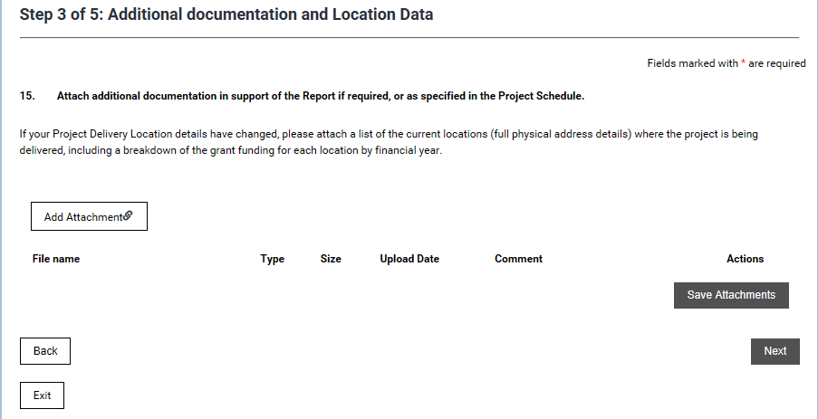In this step you can upload additional documentation for your Project (if required), as well as to update the address details of the current locations where the Project is being delivered.

To upload attachment click the  button and select the file you wish to upload.

Once you have uploaded all attachments click the H:\Current Work\How to Guide - IAS\Save attachments button.PNG button.

When you have completed this step, click the H:\Current Work\How to Guide - IAS\Next button.PNG button to save your changes.

## Step 4 of 5 – Project Contact Information

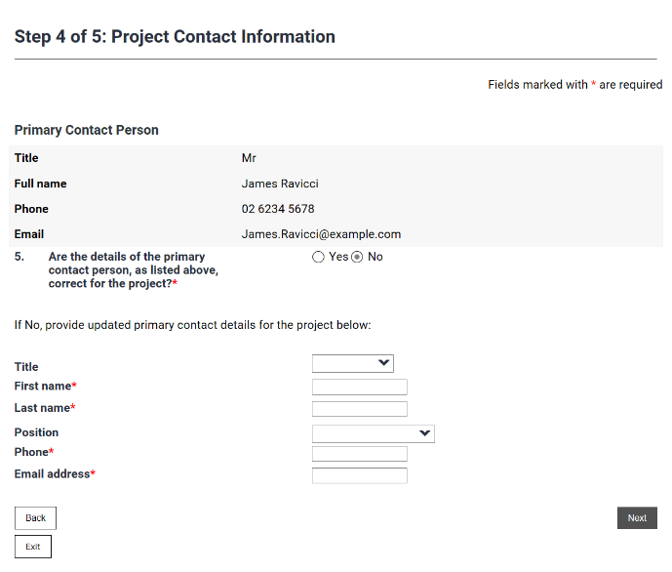In this step you are required to confirm the Primary Contact Person for the project.

If this information is correct click the  button.

If this information is incorrect click the  button. If you click this option you will need to provide the details of the Primary Contact Person for the project.

When entering in your phone number you will need to ensure it contains 10 digits including your area code (if using a land line) and nine digits if using a mobile number. Do not include any spaces.

Please also ensure that you are using a valid email address.

When you have completed this step, click the H:\Current Work\How to Guide - IAS\Next button.PNG button to save your changes.

## Step 5 of 5 – Declaration

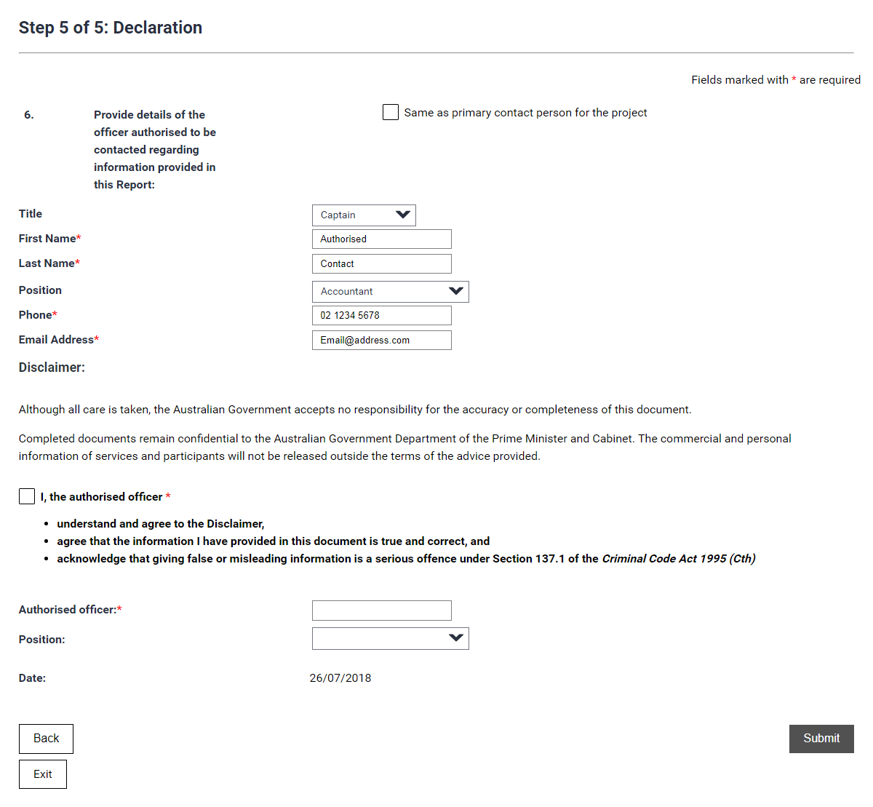In this step, you need to provide the details of the officer authorised to be contacted regarding information in this report.

If this is the same as the Primary Contact Person then check this box 

If not you will need to complete the details of the officer authorised to be contacted regarding the information in this report.

Do not forget to check this box once you have read and understood the terms listed below it.

Complete the name and position of the authorised officer and please take care to ensure all information is correct.

Once you are satisfied that you have included everything and all the information is correct click the  button.

## Successful Confirmation Page

Once you have clicked the  button you will be greeted with the following screen. If you do not receive an email within 24 hours, please contact your Agreement Manager.

