National Strategy for Food Security in Remote First Nations Communities

This is a short form of the draft discussion paper: National Strategy for Food Security in Remote First Nations Communities.

The discussion paper is meant to start conversations with Aboriginal and Torres Strait Islander people in remote areas, as well as with governments and businesses involved in remote food supply. The goal is to help create a National Strategy for Food Security in these communities.

Through consultations, we want to test the information included in the draft discussion paper, hear new ideas, and learn about different ways to put the strategy into action. The final strategy will be decided after talking with communities.

The full, referenced version of the discussion paper can be found [here](https://www.niaa.gov.au/sites/default/files/documents/2024-05/food-security-discussion-paper-29-5-2024.pdf).

### Acknowledgements

Strategy Partners acknowledge the Traditional Owners and Custodians of Country throughout Australia and recognise their continuing connection to land, waters, and community. We pay our respects to the people, the cultures, and the Elders past, present and emerging.

Strategy Partners extend our deep respect and thanks to the Aboriginal and Torres Strait Islander people working to improve food security in their communities. Whether by sharing knowledge with children or providing input to a national strategy, the impact is significant and has spanned many years.

We respectfully use the terms Aboriginal and Torres Strait Islander people, First Nations and Aboriginal in this document in acknowledgement that groups prefer to be referred to differently, and to recognise the different cultural groupings between Aboriginal and Torres Strait Islander people.

# Introduction

* **Food security** is when people can **access** the food they need to live **full, healthy lives**.

## What does food security look like?

* Fresh, healthy food is available on-Country and in stores
* Communities and families understand why healthy nutrition is important
* Healthy food is affordable
* Healthy food is always available
* Everyone can get to a store or have food delivered
* Cultural knowledge of on-Country foods is passed onto future generations
* Community making decisions about food systems for themselves
* Food systems are strong and flexible
* Clean and safe spaces to cook healthy meals
* Healthy bodies and minds

## What can stop communities from being food secure?

Structural issues and inequality mean not everyone can access good food. This can be because:

* Foods available might not be healthy
* Traditional foods might not be available
* Healthy foods might cost too much
* Healthy foods might not be affordable if there is a lack of employment opportunities
* Healthy foods might not be affordable if incomes are low
* Food deliveries might be unreliable
* Electricity and safe drinking water might not be available
* Homes may be overcrowded
* There may not be access to clean, safe places to store and prepare food

## The plan to solve this

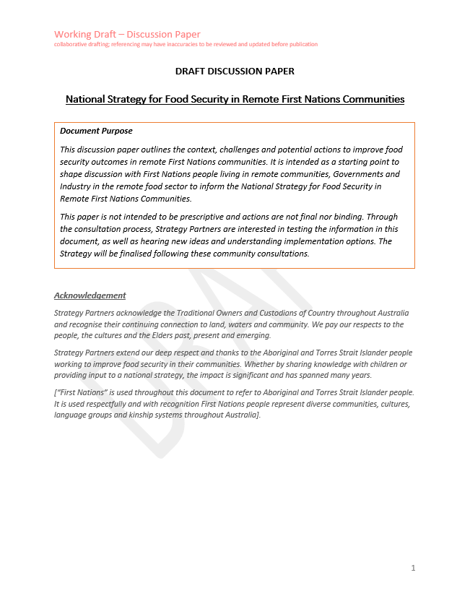There is not a simple solution to this challenge.

The National Strategy for Food Security in Remote First Nations Communities contains ideas about actions that community, government and industry can take.

## What is in the plan to solve food security?

**Where did this come from:** Communities have done a lot of work in this area and have been asking for changes for many years. The government is now listening and making changes.The National Indigenous Australians Agency (NIAA) is working with State and Territory governments and Aboriginal and Torres Strait Islander Health Peaks to design the Strategy.

The principles that guide the Strategy:

* All actions in the final Strategy will help improve Aboriginal and Torres Strait Islander peoples’ health and wellbeing
* First Nations people shape all levels and parts of the strategy
* Actions build on the strengths of community
* Systems must work together
* Aboriginal and Torres Strait Islander people, government and industry all work together to make it successful
* There are ways of measuring if the Strategy is working
* It is flexible enough to work in different situations

## The ideas in the Strategy are grouped in these 8 areas:

* **Country –** Community are the experts and teachers in culture; and local and traditional foods are valued and available.
* **Health** **–** Everyone has the food needed to live healthy and active lives. Health services help people to eat the right foods for them, including people with health problems, children and old people.
* **Housing** **–** Everyone lives in homes where food can be safely stored and cooked.
* **Families & Communities –** Everyone has access to places and equipment to make and eat healthy food.
* **Stores** **–** Fresh and healthy food is affordable and available in stores.
* **Getting Food into Communities –** Food and cooking and cleaning equipment can get to all communities at all times. Systems work together to cut the cost of getting food to remote communities.
* **Jobs, Partnerships & Affordability –** People have enough money to afford healthy foods. Remote communities have stable jobs and income support reflects the cost of living.
* **The Way Government Works –** Governments and Aboriginal and Torres Strait Islander people and communities work together to make decisions. The decisions help Aboriginal and Torres Strait Islander people live long and healthy lives.

## What we want to know

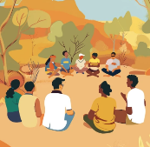We are asking remote community members across Australia to give us feedback on the plan.

* **What do you think about these ideas?**
* **What is already happening in your community?**

# Country

Community are experts and teachers in culture; and local foods are valued and available.

***Goal:*** *First Nations people are supported to increase participation in local food sourcing, production, distribution, and knowledge sharing (Closing the Gap Outcomes 15, 16).*

### What we hope will happen

* First Nations people look after land and waters to keep Country healthy and strong. This will also make sure wild foods are protected from climate change and will be available now and in the future.
* Foods are grown, hunted and harvested in ways that are good for the environment. This includes traditional foods and other foods grown locally.
* Different generations share food and nutrition knowledge on their land. This also includes trading food and creating businesses with other communities.

### Steps we could take

* Work with communities to make easy-to-understand information and training about how to get, grow, make and sell traditional and local foods.
* Make Land and Sea Management Programs bigger to identify, protect, and take care of traditional food sources for future generations.
* Work with communities to find ways to make and grow food locally. For example: help First Nations traditional food businesses get started with loans and support; help with market gardens and other food industries like farming and fish farming.
* Work with communities to set-up good, long-lasting ways to make and prepare food locally. Community, government and businesses work together to set these up, including buildings and equipment needed.
* Work with communities to safely sell and share food made, grown or collected locally.
* Make ways for Elders and knowledge holders to teach future generations and keep traditional food knowledge in community.

# Health

Everyone has the food needed to live healthy and active lives. Health services help people to eat the right foods for them, including people with health problems, children and old people.

***Goal:*** *Aboriginal and Torres Strait Islander peoples living in remote communities have equitable access to the nutrition needed for healthy lives (Closing the Gap Outcomes 1, 2, 4, 14).*

### What we hope will happen

* People in remote areas get the support and resources they need to be empowered and learn about healthy eating and staying healthy at all stages of life.
* People in remote communities get enough support and resources they need to prevent and manage health issues like diabetes, obesity, kidney issues.
* Community lead and control how health care for health issues is planned and given.

### Steps we could take

* Make plans to hire and keep local, Aboriginal Health Workers in remote areas. Support them to develop their careers.
  + Work with Training Organisations and universities to help more people to work in nutrition (healthy food).
  + Work with Community Development programs and local job services to attract and support people in remote areas to get jobs in health and food sectors.
  + Value and include First Nations views and traditional knowledge in food supply, health and nutrition training to work in remote areas.
* Promote and teach healthy eating and life skills like cooking and budgeting areas across community.
* Make sure remote health services have enough resources to give proper support to pregnant women, parents and young children.
* Make sure services work together so people get the right food for their health needs.​ Help community to make and run nutrition projects that promote healthy food choices in remote areas.

# Housing

Everyone lives in homes where food can be safely stored and cooked.

***Goal:*** *Remote Housing is sufficient for remote community residents to meet their food security needs (Closing the Gap Outcome 9).*

### What we hope will happen

* Remote housing investment and programs make sure houses are built, fixed, and updated to meet people’s food and health needs.
* Remote houses have the right equipment to store food, cook food and keep kitchens clean and safe.
* It is very important that remote houses can always get affordable electricity and safe water.

### Steps we could take

* Gather information with communities to make remote housing policies. The policies should include solutions for food storage and meal preparation.
  + Work with other government departments to make sure housing supports people to be food secure. This will let us see if food can be stored and made safely, water is safe for drinking and cooking, electricity supply is stable in remote houses and rent is affordable. Support agencies responsible for food use in remote homes and what they do. Support Aboriginal and Torres Strait Islander Community Controlled Organisations to work together to improve service delivery and coordination in housing and maintenance.
  + Support communities to design proper food storage and cooking facilities with housing providers.
* Train local First Nations people to work in housing maintenance in their local area.
* Make sure all houses in remote communities have electricity connected that is affordable, safe and works.
* Make sure all houses in remote communities have water that is always connected, affordable and safe for drinking, cooking and washing.

# Families and Communities

Everyone has access to places and equipment to make and eat healthy food.

***Goal:*** *Aboriginal and Torres Strait Islander families and communities have infrastructure, resources, and skills to safely and reliably store, prepare and consume nutritious food.*

### What we hope will happen

* Enough money for community projects like transport, cooking areas, and storage. Help people in the community to work together with owners of places like shops and services which serve food.
* Make sure food services in remote areas provide the right food for people to be healthy including old people and little children.
* Make sure people who need help can get good food easily.

### Steps we could take

* Provide money for community projects that will help community food security. The money could support projects like sustainable electricity, places to store food, transport, local food production, and ongoing maintenance.
* Make sure foods served by community programs, like aged care, are healthy and right for people.
  + Check service provider food-storage, preparation, and cooking facilities. Make sure they have proper places to store and cook food.
  + Help community care services work with local food growers.
  + Make sure First Nations children and young people can get good, healthy meals.
* Make sure emergency plans include how food will get to remote communities. In emergencies, people who need help can get healthy food easily and safely.
  + Help communities set up and run food banks and other projects for people who need help. Make sure people who need help know how to access these services.
* Help people learn more about budgeting, cooking, and keeping food safe to eat.

# Stores

Fresh and healthy food is affordable and available in stores.

***Goal:*** *Remote stores provide quality, affordable nutritious foods and other essentials in store environments that encourage healthy purchases.*

### What we hope will happen

* Make guidelines for remote stores. Check how they are doing and help them get better. Make sure these guidelines are used everywhere to help people get enough food.
* Make sure remote stores have good buildings, storage, power, and are ready for emergencies. This will make sure they always have food and other important things.
* Help remote stores to stay open and sell cheap, healthy food. Make sure the community is involved and in control.
* Give proper help that is easy to use for First Nations people to run their stores, manage them, and train local workers.

### Steps we could take

* Work with remote stores and First Nations health groups to make a national set of guidelines (Industry Code) for remote stores. Compare stores with each other and give help to stores to meet the rules.
  + The guidelines will give minimum food security standards and best ways to meet remote community food needs. Stores will be checked regularly and compared to other stores. Store owners, managers, and Boards will be told their results.
  + The stores will have help to get better, including encouraging people to buy healthy food.
* Put money into community stores to help them sell more healthy food, promote healthy food, and make healthy food cheaper.
* Help First Nations people be more involved in running and working in remote community stores.
  + Reward First Nations stores that support food security. They could support food security through jobs, promoting healthy foods, making healthy foods cheaper. Make sure stores have strong Boards.
* Work with Governments and communities to make sure food security is included in planning for emergencies. Emergencies can include bad weather and other events that make it hard to get food into communities.Review options for short‑term food help during emergencies.
  + Make a national plan for remote stores to get support and provide food and groceries even when there are problems. Problems could include emergencies, issues with trucks getting to communities, roads being cut off.
* Give support to stores that are losing money but are important for food and groceries. This could include helping communities to run stores.
* Collect information about which home products are stocked and sold in remote stores. Help stores sell more fridges and other kitchen items, cooking, and cleaning products.
* Help remote residents get to food stores by setting up transport help and food delivery services, especially for communities without a local store.
* Make and use a national system to monitor and compare prices in all remote community stores.
* Price Watch will check whether workto reduce prices is working, focus is where it’s needed, and give pricing information to help communities make decisions.

# Getting Food into Communities (Supply Chains)

Food and cooking and cleaning equipment can get to all communities at all times. Systems work together to cut the cost of getting food to remote communities.

***Goal:*** *Supply chains are improved to provide more direct, cost-efficient and resilient supply runs to remote communities.*

### What we hope will happen

* Remote supply chains work well, help reduce prices, and can change easily. They work better with remote First Nations people and can handle problems.
* Improve roads so they work in all weathers. Improve transport routes so trucks have fewer stops and trips are shorter.
* Buy and store more food in remote areas and deliver it on time.
* Make emergency plans with First Nations people to keep remote supply chains working during bad weather or other problems like pandemics.

### Steps we could take

* Share the results of the 2023-2024 supply chain study with remote communities. Work with First Nations people, communities, and experts to improve supply chain. Changes should make supply chains stronger and prices lower.
* Make a long-term plan with governments to make roads, air, and sea transport better. This will help improve food security in remote First Nations communities.
  + Plan to build food storage and distribution centres closer to remote communities. This would help make prices cheaper, avoid supply problems and help local producers get food to local communities.
* Help remote community stores work with local food producers, wholesalers, and other remote stores. By working together, they could lower costs and improve the quality and variety of food.
  + Ask food and grocery makers, wholesalers, distributors, and producers to give lower prices on important items. The items should be agreed with remote First Nations communities.
  + Find ways to help remote stores access more wholesalers. Working with more wholesalers would make supply chains stronger, increase variety, and encourage competition.
  + Help remote stores buy together to lower prices and improve the quality and variety of food.
  + Make sure food is transported in ways that keeps it fresher for longer.
  + Help stores talk better with customers about how the cost of food is decided, including how rebates are used.
* Make sure food security and getting food to communities is included in emergency planning.
  + Make plans for emergencies with remote community residents, organisations, service providers, and emergency response groups.

# Jobs, Partnerships & Affordability (Healthy Economies)

People have enough money to afford healthy foods. Remote communities have stable jobs and income support reflects the cost of living.

***Goal:*** *Aboriginal people in remote communities have the same economic opportunities for food security as non-remote communities (Closing the Gap Outcome 8).*

### What we hope will happen

* Make more training and job programs in remote areas to help with food, money, and health.
* Make sure the extra cost of food and groceries in remote areas is included in social security and tax rules. Help is available for those who need it.
* Support communities to join industry partnerships. These partnerships make lasting improvements for First Nations people in the remote food sector.

### Steps we could take

* Make sure the Remote Area Allowance is high enough to make sure people can afford the food they need.
* Make sure social support packages include help for people to afford food they need. Examples include home care or disability support.
* The Australian Government could create a National Sugar Tax.This would make food with lots of sugar in it a bit more expensive. The money could be used to improve community food security, give healthy food subsidies, invest in health, and provide access to drinkable water.
* Start a flexible training and job program in remote areas to improve food security and nutrition. Jobs could include making food, distributing food, farming, kitchen repair, and other maintenance work.
* Help Training Organisations give training that is needed in local communities. Help providers work together so more people can get training.
* Work with communities to find ways to help increase First Nations communities to start and run food businesses.

# The Way Government Works (Policies, Partnerships and Governance)

Governments and Aboriginal and Torres Strait Islander people and communities work together to make decisions. The decisions help Aboriginal and Torres Strait Islander people live long and healthy lives.

The National Agreement on Closing the Gap aims for Aboriginal and Torres Strait Islander people and governments to work together to overcome inequality and achieve equal life outcomes for all Australians. It includes four Priority Reforms to change how governments work with Aboriginal and Torres Strait Islander people. It also has 19 national targets across 17 areas that affect life outcomes for Aboriginal and Torres Strait Islander people.

***Goal:*** *Initiatives are considered holistically in ways that support First Nations people living in remote communities to attain healthy lives and outcomes.*

### What we hope will happen

* Make sure information about food security is collected and shared with Aboriginal and Torres Strait Islander communities to help with local decision-making.
* Make sure work on the Food Security Strategy links with Closing the Gap Priority Reforms and Targets.
* Include First Nations leaders in decision-making about food security problems.
* Make sure the Strategy links to and informs other government policies and programs without repeating them.

### Steps we could take

* Create a national group to oversee remote food security, with community‑controlled peak organisations as equal partners. This group will support working together and make plans to improve remote food security.
  + Think about creating a First Nations Food Security Peak Body or Closing the Gap Policy Partnership.
* Change Government processes to make sure policies and programs for remote food security are made and designed with First Nations people.
* Create and support regional food security working groups and community-based food security workforces with health providers, education, training, and service providers to make sure Closing the Gap Priority Reforms and Targets are met.
* Make sure the rules for food security partnerships work toward Closing the Gap Priority Reforms and Targets.
* Check which information Commonwealth and State and Territory Governments use to measure food security in remote communities.
  + Find ways to improve this information so it tells the whole story about remote food security.
* Make a plan with community to work out how well this plan is working to improve food security. Make sure that communities are asked how they think it is working and what they think is important when deciding about how well it is working.
* Collect information on nutrition and food security and report it in a way that Aboriginal communities can use the data to make food security better.
* Make sure governments collect and share information in ways that are good for community.

## Questions

We are asking remote community members across Australia to give us feedback on the plan. We want to know:

* What do you think about what is included?
* Is anything missing?
* Do you have ideas about actions that can be taken?
* How can we put the Plan into action?
* Do you have examples of what you are doing in your community?