Remote Australia Employment Service

Draft Grant Opportunity Guidelines consultation

Between 27 March 2025 and 21 April 2025, the National Indigenous Australians Agency (NIAA) published the draft Remote Australia Employment Service (RAES) Grant Opportunity Guidelines (GOGs) for public consultation.

# Delivering on the Australian Government’s commitment

The Government is changing the way it delivers remote employment programs and services by replacing the Community Development Program (CDP) in two stages.

1. ​The first stage is the new [Remote Jobs and Economic Development](https://www.niaa.gov.au/our-work/employment-and-economic-development/remote-jobs/employers) (RJED) program, creating 3,000 new jobs over 3 years until 2027.
2. The second stage is the design and delivery of the [Remote Australia Employment Service](https://www.niaa.gov.au/our-work/employment-and-economic-development/remote-jobs/employment-services) (RAES), which will start on 1 November 2025 and support job seekers to build their skills and address barriers to employment.

The design of RJED and RAES builds on the success of job trials and reflects feedback from consultation.

CDP services will continue to support remote job seekers until 31 October 2025. This will ensure a smooth transition for job seekers and providers before the RAES starts.

# Overview

**​**To prepare for the RAES the NIAA published the draft RAES GOGs for public consultation between 27 March 2025 and 21 April 2025.

The draft GOGs built on information already shared in previous consultations. They set out proposed elements of the new service such as the provider payment model, eligibility criteria, assessment criteria and the grant selection process.

# Consultation questions

Survey and submission questions were directed at sections of the GOGs to give everyone the opportunity to provide feedback to inform the final GOGs. The opportunity to provide feedback was promoted on the NIAA website, through social media channels and communication newsletters. A [factsheet](https://www.niaa.gov.au/resource-centre/remote-australia-employment-service-draft-grant-opportunity-guidelines-consultation) was also published to help people understand what we were seeking feedback on in the draft GOGs, the grants process and next steps. A full list of the consultation questions is available at **Appendix A.**

# What we did with your feedback

We received 8 surveys and 14 written submissions from key stakeholders, including peak bodies, providers and land councils.

Overall, the feedback on the new employment service’s design was positive. Stakeholders felt the draft GOGs broadly aligned with their aspirations and appreciated the emphasis on elements in the GOGs, particularly the following:

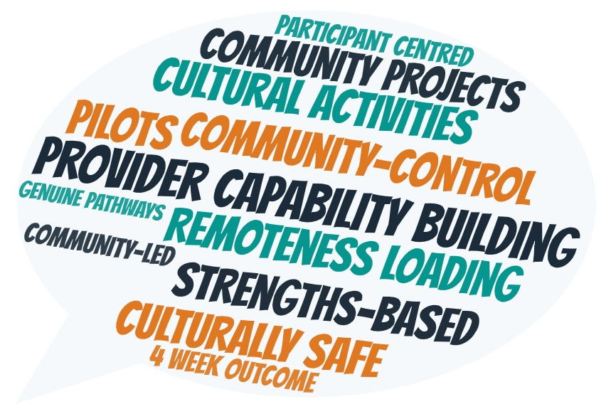

In response to your feedback, we have implemented the following changes to the GOGs:

1. Extend the grant period from 22 months to 32 months.
2. Adjust the timing of the first payment milestones for the Employment Placement Support payments to be paid at 4-weeks of continuous employment.
3. Add an additional payment milestone for the Employment Placement Support payments at 52 weeks of continuous employment.
4. Split the Employment Outcome Fee payments and the 52-week milestone Employment Placement Support payment with 60% to go to employers of RAES participants and 40% to RAES providers.
5. Preference First Nations Organisations.

We also received a lot of valuable feedback that went into the operational detail that will be taken into consideration for operational guidance.

| **We heard you wanted** | **How we have addressed your feedback** |
| --- | --- |
| More clarity on the **Provider Payment Model,** such as how the remoteness loading would work. | * Clarified the individual components of the Provider Payment Model at section 3.1 for RAES service delivery including case management, community projects, establishment funding and Right Fit For Risk accreditation. * We have reworded detail on the Provider Payment Model in Sections 3, 5.3 and 10.6 for readability and flow. * Detailed information on the Remoteness Loading Methodology has been added at Appendix 4. |
| More clarity and consistency of the **Employment Outcome Fee** - payment milestones, split between provider and employer, with a need to consider incentive and acknowledgement for employers. | * Clarified the split between employers and providers and outlined the milestone payments for Employment Outcome Fees in sections 3.1and 11.6 in the GOGs. * Adjusted the first milestone payment to 4 weeks of continuous employment and included a 52 week of continuous employment milestone payment for Employment Placement Support at sections 3.1 and 11.6. |
| More clarity around the **Reassessment Fee structure** and suggestion of incorporating into Service Fee. | * Provided further detail at section 11.6 on the Reassessment Fee payment and that it is paid on actual payable caseload on the completion of relevant RAES assessment tool training and Job Seeker Classification Instrument reassessment, once per participant and not for any subsequent reassessments. * The Reassessment Fee has been retained as a separate payment as it is linked to the completion of relevant assessments and training (refer to section 11.6). |
| Further detail about the **Provider Performance Framework** (KPIs, milestones, reporting etc), including what action will be taken to address providers not meeting their obligations. | * Clarified throughout the GOGs that the draft Grant Agreement will include high level details on the performance framework. * We intend to consult on specific measures and indicators of the performance framework after the grant round closes. Further information will be provided closer to consultation. * Detailed information on the final performance framework will be contained in the operational guidance. |
| Clear guidance on **Community Projects** (including funding allocation) with an emphasis on co-design and flexibility for cultural and economic variations. | * Clarified at section 2.1 and 5.1 that Community Projects are a mandatory activity for providers and voluntary, but encouraged, for participants. * Added information at section 2.1 about the requirement for providers to develop Community Projects Work Plans * Clarified at section 3.1 payment amounts for Community Projects. * Clarified throughout GOGs that further detail on timing and requirements will be included in the draft grant agreement to be made available during the grant round. * Detailed operational guidance with information on Community Projects will be provided to successful applicants. |
| Clear details around the **Participation Options** such as cultural programs and health and well-being initiatives. | * Added information throughout the GOGs and specifically at section 5.3 about Participation Options and how these are a mandatory part of RAES delivery. * Detailed operational guidance with information on Participation Options will be provided to successful applicants. |
| **Eligible Expenditure** to be broadened to include wrap around and post-placement support. | * Additional items added as example eligible expenditure items in Section 5.3 in the GOGs. This will help to ensure applicants will have a clearer understanding of what they can expect to deliver under the RAES. |
| The GOGs to include preferencing for Indigenous organisations. | * GOGs have been modified to include preferencing for Indigenous Organisations for funding where there are two similarly ranked applications, aligning with Closing the Gap Priority Reform Two (refer to section 7). |
| Greater transparency of weighting against selection criteria. | * Noted all selection criteria will have equal weighting (refer to section 6). |
| Longer contract lengths for providers. | * Funding period has been extended by 12 months, with providers now required to deliver the **RAES** between 1 November 2025 and 30 June 2028 (refer to section 3.1). |

# Previous consultations

To develop the best approach to replacing the CDP, we undertook targeted consultations in remote communities in two phases.

Consultation included a diverse range of stakeholders at a national, jurisdictional and community level. We wanted to hear from individuals, job seekers, CDP participants, former participants, community leaders, service providers, employers and Government or non-government organisations on ways a new program and service can best help those in remote communities.

## First phase of community consultations – 2023

Between February and June 2023, we conducted ‘listen and learn’ consultations with remote communities.  
A report on what we heard is available on the [NIAA website.](https://www.niaa.gov.au/resource-centre/replacing-community-development-program-consultation-report)

## Second phase of community consultations – 2024

Between mid-April and mid-July 2024, we conducted a second phase of community consultations to hear how the new RJED program could be designed and delivered. Whilst the key focus of the consultation was about the RJED program, it was also an opportunity to hear from people and record their feedback on how a new employment service could be designed and delivered. A report on what we heard during phase 2 is available on the [NIAA website.](https://www.niaa.gov.au/news-and-media/what-we-heard-communities-about-design-new-remote-jobs-program)

# Next Steps

Grants opened on 30 June 2025 to interested organisations who can deliver employment services in [RAES regions](https://www.niaa.gov.au/resource-centre/remote-australia-employment-service-raes-regions) (currently known as CDP regions).

The [GrantConnect](https://www.grants.gov.au/Go/Show?GoUuid=a2cee833-5414-4bfc-8d7b-1460d16b2373&keyword=GO7748) website will have supporting documents with the RAES GOGs other supporting documents and submit your application.

An approximate timeline for assessment of RAES grants is below:

* July 2025 – Grant round closes
* August 2025– Assessment of applications
* September 2025– Successful organisations expected to be notified
* October 2025 – Contracts expected to be executed

If you have questions about the RAES GOGs, or need grant writing support a helpdesk is available while grants are open.

You can call the RAES Helpdesk on 1800 939 500 or email [RAESHelpdesk@niaa.gov.au](mailto:RAESHelpdesk@niaa.gov.au)

Operating hours are between 9am-5pm AEST Monday to Friday, with some exceptions.

The NIAA is running two online information sessions to go through the Grant Opportunity Guidelines and application process, with the opportunity to ask questions.

Sessions times are:

Thursday 3 July 1:30pm - 2:30pm Canberra local time (AEST)

Wednesday 9 July 2pm - 3pm Canberra local time (AEST)

To find out more visit [www.niaa.gov.au/remote-services](http://www.niaa.gov.au/remote-services)

**Appendix A**

# Consultation questions

**Section 2: About the new Remote Australia Employment Service program**

* Do the objectives and direct benefits capture your aspirations for RAES?

**Section 3.1:  Grants Available**

* Is the Provider Payment Model (PPM) described in section 3.1 of the draft GOGs structured to support long-term employment outcomes?
* Are the payment milestones reasonable and achievable for providers working in remote employment?
* What modifications would you suggest in improving the way the Provider Payment Model is described in the draft GOGs?
* How frequently should the remoteness loading be re-calculated? Refer to table 10.1.

**Section 5.1: Eligible Grant Activities and 5.3 Eligible Expenditure**

* Are the expenditure guidelines clear and practical for grant recipients for remote Australia?
* Do the examples of eligible expenditure in section 5.3 (Eligible Expenditure) cover the key components of high-quality case management and employment outcomes?
* Is the explanation of Participation Options adequate and relevant to improving engagement of participants and pre-employment support for participants?
* Community Projects have been an integral part of previous programs, how can the process detailed in section 5.1 (Eligible Grant Activities) be improved?

**Section 6: Assessment criteria and Supporting Documentation**

* Does the assessment criteria enable the NIAA to appropriately assess an organisation’s ability to deliver employment services to meet the local needs of remote communities?
* Is there any other supporting documentation that could be requested as part of an application to assist with the assessment of applications?

**Section 12: How we monitor your grant activity High-Level Performance Framework**

* Is the performance framework in section 12 of the draft GOGs clear?
* How frequently should the NIAA provide advice on the performance of providers?

**Other**

* Is there any other feedback you would like to provide?

**Any other comments**

* Are there any other aspects of the draft guidelines that you would like to provide feedback on?

**Please note**: Feedback on ICT was out of scope as the RAES will initially use the existing IT system and ICT functionality to support transition from the CDP. Feedback on boundaries was also out of scope at this stage.