Budget 2026-27
  - Investment to build on progress in Closing the Gap

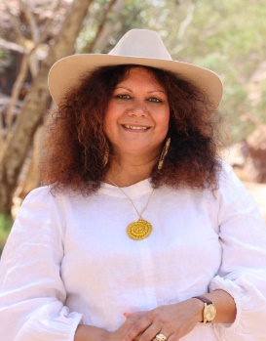
Minister’s Statement
The Albanese Labor Government is continuing to deliver on its Closing the Gap commitments through the 2026-27 Budget.
We are committed to the principles of
‘no-one held back’ and ‘no-one left behind’. We are delivering a range of actions to improve outcomes for First Nations people across the country.
In February this year, the Prime Minister released the Commonwealth’s Closing the Gap 2025 Annual Report and 2026 Implementation Plan. It outlined what the Commonwealth delivered in 2025 and our priorities for 2026.
This Budget invests $1.2 billion over 5 years from 2025-26 in initiatives to improve outcomes for First Nations people. It delivers the investment announced in our Closing the Gap Plan, as well as new investments to support First Nations partners and service providers to deliver community-led solutions.
We’re building on what is working for First Nations people and focusing investment in key areas that will make a real difference. This includes employment and economic development, food security, family safety, housing, and health.
These investments build on major commitments already underway, including a 10-year, $4 billion joint investment to halve overcrowding in remote Northern Territory communities, $600 million in dedicated First Nations housing funding through Round 3 of the Housing Australia Future Fund, expanded Indigenous Ranger and Junior Ranger programs, and targeted investments in education, justice reinvestment, health, water and digital connectivity.
We’re working with First Nations partners and backing community-led solutions to ensure policies and programs are developed in genuine partnership.
All governments have committed to the National Agreement on Closing the Gap. We will continue working with all Australian governments and the Coalition of Aboriginal and Torres Strait Islander Peak Organisations, through the Joint Council on Closing the Gap, to deliver on this commitment.
We will also continue working with the states and territories to make progress on the Closing the Gap targets where they hold the levers for change.
We are supporting communities to come together, to care for one another, celebrate culture and create opportunities for the next generation. This is what Closing the Gap is all about.

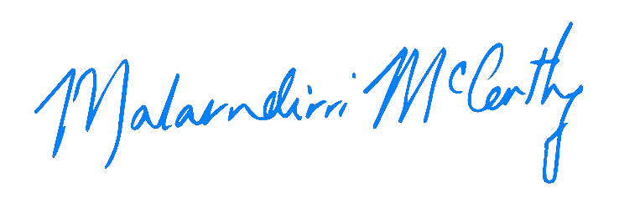
Senator the Hon Malarndirri McCarthy
Minister for Indigenous Australians

Jobs and economic empowerment
We know economic empowerment is crucial to improving outcomes for First Nations people and communities. In February 2026, we announced the expansion of Remote Jobs and Economic Development (RJED) program with an additional $299.0 million investment to double new jobs from 3,000 to 6,000 by 2030.
This builds on the Government’s previous investment of $724.7 million from the 2024-25 Budget and part of our commitment to replace the Community Development Program.
The RJED program gives people the dignity of work in jobs that support community priorities, with decent wages and conditions, including superannuation and annual leave. The RJED program, alongside the Remote Australia Employment Service (RAES) which launched in November 2025, is helping to improve employment outcomes in remote areas.
Eligible employers can apply for funding through grant rounds to pay for wages and equipment so they can create new jobs and hire local people. Employers are encouraged to work closely with communities to identify local priorities and job opportunities.
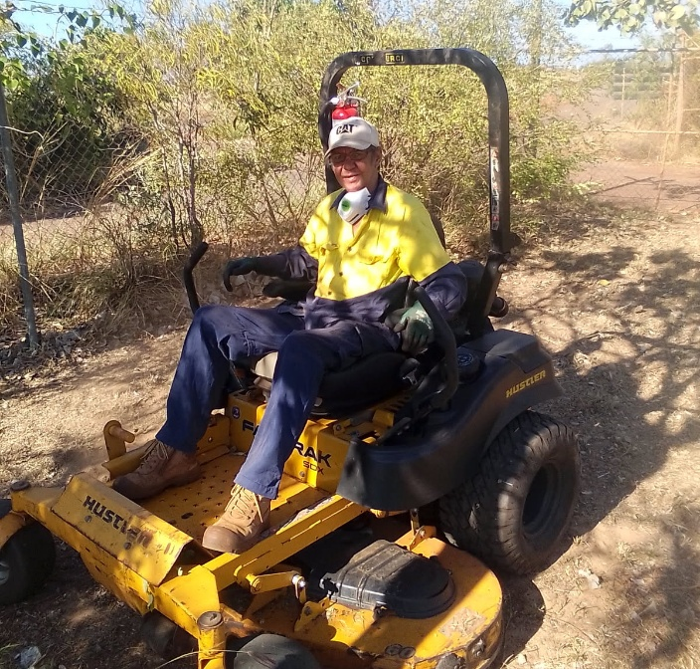
Phillip Carter, Groundskeeper at Ardyaloon Incorporated
Across remote Australia, people employed under RJED are supporting essential services, contributing to local enterprises and gaining new skills that help build stronger communities.
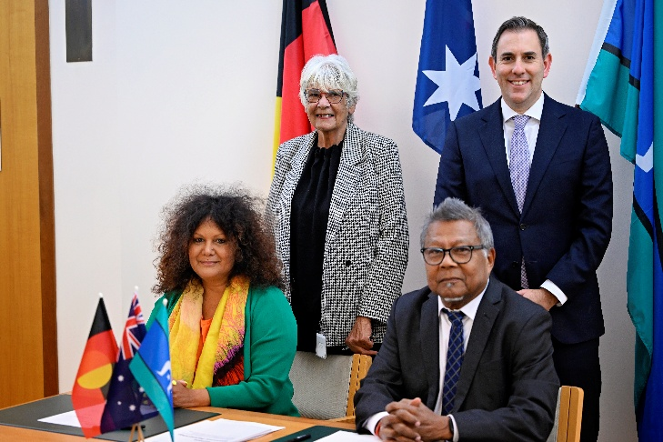 First Nations Economic Partnership signed on 29 September 2025 by Senator the Hon Malarndirri McCarthy; Ms Pat Turner AM, former Lead Convener Coalition of Peaks; Professor Peter Yu AM, Chair First Nations Economic Empowerment Alliance; and Treasurer, the Hon Dr Jim Chalmers MP
We’ve worked with the Prescribed Bodies Corporate (PBC) Steering Group and the First Nations Economic Partnership to finalise the design of a new PBC support program utilising the $75.0 million in new funding announced at the 2025 Garma Festival. The new support program will strengthen PBC operational capacity and assist Native Title holders to work with the private sector to build wealth.
As managers of 46% of Australia’s land mass subject to Native Title rights and interests, PBCs are essential in generating economic opportunities for First Nations communities, particularly in rural and remote areas.
The new PBC program will support PBCs to capitalise on emerging opportunities with Government and industry.

Food security
The Albanese Government is delivering more cost of living support for remote First Nations communities by expanding access to the Low-Cost Essentials Subsidy Scheme.
On 12 February 2026, we announced an additional investment of $27.4 million to enable all 225 remote stores across Australia to apply to join the Scheme.
Under the Scheme, the cost of 30 essential items has been reduced, so they are comparable to prices in urban areas. Remote consumers are seeing savings of up to 50%.
Food items that have been made cheaper include canned fruit, tinned vegetables, rice and pasta, along with everyday items including nappies, soap and toilet paper.
This additional investment means more Aboriginal and Torres Strait Islander people living in remote communities will have access to cheaper groceries. As of 6 May 2026, 118 stores have signed up to the Scheme.
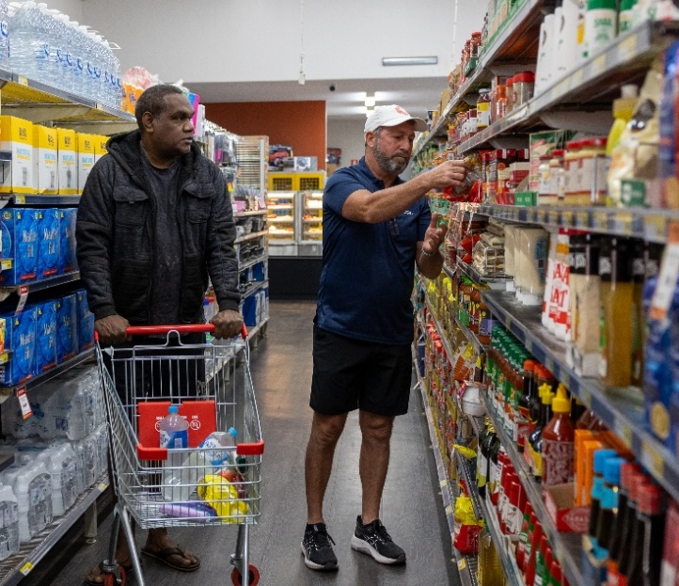
Local residents food shopping in Yuendumu, NT
We also announced the expansion of the Stores Efficiency and Resilience Package, committing $32.7 million to support an additional 75 remote stores with infrastructure uplifts. This investment will help to keep food fresh and enable increased supplies in remote communities when seasonal weather events make deliveries difficult.
By addressing the higher cost of essential goods in remote areas, the initiatives support improved food security and contributes to better health and wellbeing for individuals and families.
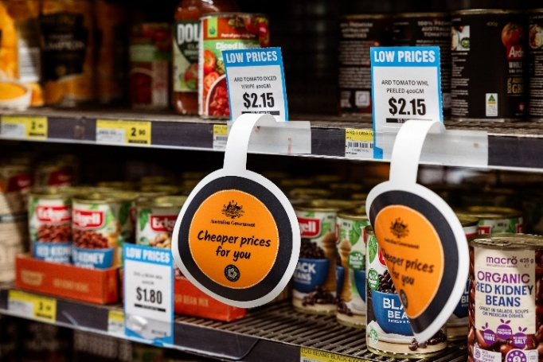 Cheaper prices are easing the cost of living and improving food security in remote communities, Lockhart River
Women, children and family safety
First Nations women and the community sector have called for strong action against family, domestic and sexual violence. The Government is delivering on this.
On 10 February 2026, we launched Australia’s first standalone plan that strives for a future where Aboriginal and Torres Strait Islander women and children live free from violence: Our Ways – Strong Ways – Our Voices: National Aboriginal and Torres Strait Islander Plan to End Family, Domestic and Sexual Violence 2026 – 2036 (Our Ways).
Our Ways recognises that lasting change must be driven by First Nations communities. It is backed by a $218.3 million investment for immediate actions, including $167.6 million for a national network of up to 40 Aboriginal Community Controlled Organisations to deliver community led specialist family, domestic and sexual violence services. We are also extending the Leaving Violence Program Regional Trials. This program provides $5,000 (indexed annually) in financial support, including up to $1,500 in cash and the remaining funds in goods and services, ensuring culturally safe and accessible supports to Aboriginal and Torres Strait Islander women in regional and remote communities.
On 25 March 2026, the Albanese Government and the Coalition of Peaks launched a new Aboriginal and Torres Strait Islander Peak Body for family, domestic and sexual violence – Our Ways Strong Together. The new peak body will play an invaluable role in shaping government policies and programs. It contributes to Target 13 of the National Agreement on Closing the Gap, to reduce family violence and abuse against First Nations women and children by at least 50% by 2031.
We’re also providing $12.1 million in 2026-27 to the Attorney-General’s Department, National Indigenous Australians Agency, Australian Federal Police, Australian Communications and Media Authority, Australian Institute of Criminology, and the Treasury. This is to continue initiatives to prevent, disrupt and combat child sexual abuse, and maintain support services for victims and survivors of child sexual abuse.
The Government is also progressing with establishing permanent, statutory arrangements for the National Commission for Aboriginal and Torres Strait Islander Children and Young People, with $42.8 million over five years from 2025-26 (and $9.3 million per year ongoing). The permanent establishment of the Commission will support better outcomes for the safety and wellbeing of First Nations children and young people.
We are also investing in critical initiatives to prevent and support First Nations people experiencing violence. We are investing $4.5 million in 2026-27 to continue delivery of culturally safe crisis accommodation services for Aboriginal and Torres Strait Islander people. We will also provide $1.5 million in 2026-27 to continue community-led services, programs and campaigns to prevent violence against Aboriginal and Torres Strait Islander women and children.
Health and wellbeing
We are investing in better health outcomes for First Nations people. Access to culturally safe, high-quality health care close to home makes a real difference for First Nations people and families, particularly in regional and remote areas.
In February 2026, we announced funding to support First Nations health services including:
- Reforming the health and hospital system to better meet the needs of First Nations people as part of a historic hospital funding agreement. The renewed National Health Reform Agreement will include $248.7 million in dedicated funding for new, co-designed programs to improve First Nations health outcomes, with $200 million matched by the states and territories.
- Investing a further $144.1 million over 2 years to continue to improve health infrastructure across Aboriginal Community Controlled Health Services (ACCHS), building on the over 100 projects already delivered or underway.
- Investing $18.9 million over 4 years (and $5.1 million per year ongoing) in 13YARN to extend hours and establish a text message service so more First Nations people can access culturally safe, crisis counselling.
- Supporting the successful Birthing on Country program across Australia with a $44.4 million investment over 4 years to provide culturally safe maternal care to 1,100 mothers and their babies annually.
- Boosting the First Nations Health Worker Traineeship program with an additional $2.7 million over 3 years.
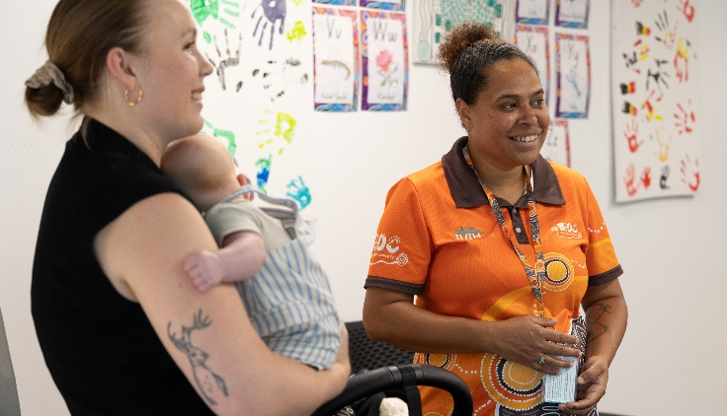
Birthing in Our Community (BiOC), South Queensland
We continue to support better renal services in remote areas, with a $53 million investment over 4 years to complete construction of dialysis units and associated workforce accommodation, and to provide operational funding to 30 June 2030. The units are located in communities where access to dialysis has historically required relocation to regional or metropolitan centres. The community-based dialysis approach supports social and emotional wellbeing, maintains family and cultural connections, and strengthens social cohesion by supporting people to remain on Country and continue their roles with community.
Additionally, we’re providing $3.2 million over 4 years from 2026-27 (and $0.4 million per year ongoing) to exempt Stolen Generations Redress Scheme payments from inclusion in residential aged care asset testing.
We will provide $1.2 million in 2026-27 to the Indigenous Marathon Foundation to continue the Indigenous Marathon Project which supports young First Nations people to train and participate in marathon events.
We’re supporting the commissioning of 2 First Nations youth mental health services in remote locations directly through the National Aboriginal Community Controlled Health Organisation. This ensures they are community designed and led. These services will replace 2 remote headspace services funded through the Government’s 2025 election commitment More Free Mental Health Services.
This Budget will also provide $1.1 million to the Cape and Torres Health Commissioning Ltd to continue to provide access to culturally appropriate health care services for First Nations peoples in Far North Queensland.
Housing and infrastructure
We’re supporting First Nations organisations and service providers to continue delivering critical services to First Nations people across Australia. This includes Aboriginal Hostels Ltd (AHL) with an investment of $48.3 million to continue to deliver critical short term accommodation services.
AHL has delivered culturally appropriate accommodation for over 50 years, supporting First Nations people from regional, remote and very remote communities to access health care, maternal services, education and employment when away from home. This funding ensures that First Nations people can continue to access vital accommodation support provided by AHL.
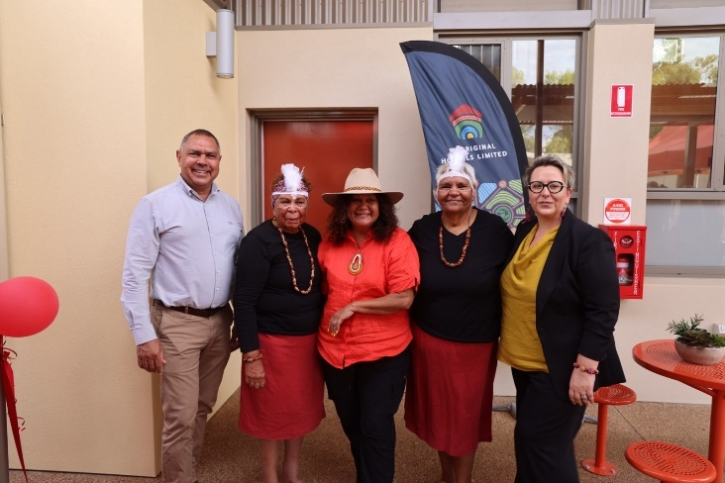
AHL Expansion at Apmere Mwerre Visitors Park, November 2025
We will also provide $6.3 million over 3 years for a national First Nations housing peak body to represent the Aboriginal and Torres Strait Islander housing sector and support better housing outcomes for First Nations people and communities.
We are continuing to deliver our commitment for the $200 million Housing Australia Future Fund Acute Housing measure for the repairs, maintenance and improvements of housing in remote Indigenous communities. This Budget releases the remaining $100 million through this measure to support jurisdictions to continue projects that improve housing quality for First Nations Australians in remote communities.
This builds on our major long-term housing commitments already underway, including $600 million in dedicated First Nations housing funding through Round 3 of the Housing Australia Future Fund.
Additionally, we have announced a $2 billion package for local governments and state utility providers to expedite the delivery of enabling infrastructure across a range of communities Australia wide. This includes $500 million set aside for regional communities. The initiative will be available in states and territories that commit to further planning, zoning and productivity reforms.
Education and learning pathways
We continue to support First Nations students to achieve their full learning potential.
This Budget will provide $23.8 million to extend the Indigenous Boarding Provider grants program in 2027 to provide tailored support to First Nations students completing schooling away from home. The Indigenous Boarding Provider grants provide critical engagement supports for students who have to live away from home to access secondary school and attend boarding providers that mainly support First Nations boarders. The extension will enable continued support for around 2,500 remote and very remote First Nations boarding students in 2027.
We will provide $55.5 million to extend funding for the Clontarf Foundation for 2 further calendar years (2027 and 2028). The funding will enable the Clontarf Foundation to continue delivering its academy program, providing school engagement and wrap around support to up to 12,500 First Nations boys and young men at more than 160 academies.
We’re also providing $30.0 million to continue support for the Australian Indigenous Education Foundation to provide secondary school scholarships for high-achieving First Nations students for the 2027 and 2028 school years.

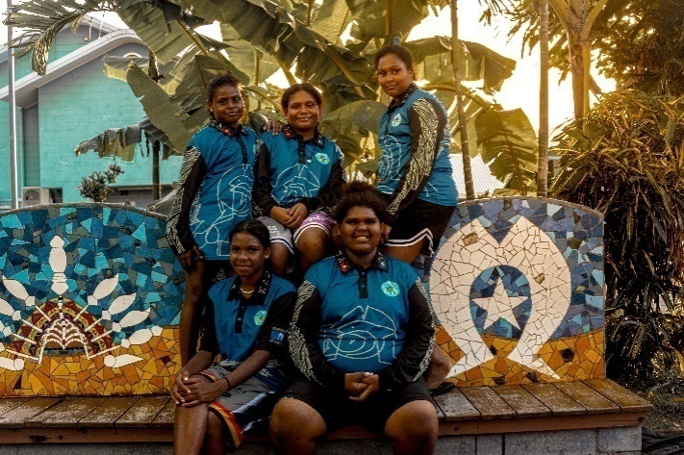
Torres Strait Kaziw Meta boarders at their boarding facility
We will continue to support First Languages Australia with a $2.2 million investment to extend its existing program in the 2027 school year. This funding will support First Languages Australia to continue working with teachers and educators supporting Indigenous language journeys and embed knowledge of local cultures to First Nations primary school students.
A further $1.5 million will be invested in 2026-27 to extend the Making Up Lost Time in Literacy (MultiLit) program in the 2027 school year. MultiLit delivers evidence-based phonics programs using verified tools to support primary school students who are behind their peers to catch up in reading and early literacy.
Supporting First Nations organisations and community-led solutions
Closing the gap requires partnership with
First Nations organisations, who have the knowledge and trust of their communities.
We will provide $4.5 million in 2026-27 to extend funding for the Coalition of Peaks Secretariat to support implementation and delivery arrangements for the National Agreement on Closing the Gap. The Coalition of Peaks Secretariat supports its member organisations to negotiate on issues in a coordinated and effective manner, and to work with all levels of governments to design, lead and deliver initiatives to achieve Closing the Gap outcomes.
We’re providing $2.5 million in 2026-27 to support Children’s Ground to continue to deliver health and wellbeing services to children and families in Central Australia and West Arnhem. This will enable the ongoing delivery of services in 2026-27 while a sustainable long-term funding solution is considered by Government.
We will also continue to support First Nations people to own, access and manage water in Australia with a $6.8 million investment in 2026-27. This funding will support continuing arrangements and maintain momentum on water reform led by First Nations people. This includes progressing co-design of a Charitable Trust model to enable First Nations ownership of water entitlements. It will also continue to support the role of the Committee on Aboriginal and Torres Strait Islander Water Interests in national water reform. It will also support delivery of the Closing the Gap Inland Waters Target through partnership with the National Native Title Council.
First Nations electoral participation
We will provide $36.6 million over 4 years, with $7.9 million per year ongoing, to extend the Indigenous Electoral Participation Program (IEPP).
The IEPP seeks to strengthen Indigenous electoral participation, particularly in remote and very remote First Nations communities through community-led engagement and communication approaches. The IEPP is implemented by the Australian Electoral Commission through a partnership model of community engagement.
The IEPP will continue to support community-led partnership approaches to implement long-term, meaningful and sustainable initiatives co-designed with First Nations communities.

Celebrating histories, culture and heritage
The 2026-27 Budget progresses our commitment to deliver Ngurra: The National Aboriginal and Torres Strait Islander Precinct (Ngurra) at Acton Peninsula, Australian Capital Territory (ACT).
Ngurra is a nationally significant initiative which will create a world-class cultural precinct to celebrate the rich heritage of Aboriginal and Torres Strait Islander people, comprising two elements:
- The National Indigenous Knowledge and Cultural Centre, which will empower and support First Nations people to tell their own stories and celebrate the 65,000-year history of this nation.
- The National Resting Place, which will house and care for repatriated ancestral remains and associated cultural material with limited provenance on their journey back to Country.
The establishment of Ngurra will affirm our commitment to recognising the central place of Aboriginal and Torres Strait Islander history, culture and heritage in Australia’s national story. Ngurra will provide all Australians and visitors to Australia with opportunities to engage in transformative experiences across the living stories of First Nations peoples.
The National Resting Place will realise a long-held aspiration of First Nations communities by providing a respectful and culturally appropriate facility for unprovenanced ancestral remains repatriated to Australia.
We will also continue supporting the protection of Australia’s cultural and First Nations heritage sites, by empowering local communities and First Nations people to assess and identify priorities for the protection of heritage, with a further $2.2 million investment in 2026-27.

