PBC Support Framework

Introduction
This document provides guidance to Prescribed Bodies Corporate (PBCs) and Native Title Representative Bodies and Service Providers (NTRB/SP) on how PBC operational funding and support (also known as PBC Basic Support) will be provided to PBCs. It explains the types of support provided, how funding can be used, and the responsibilities of both NTRB/SPs and PBCs.
This guidance was developed in response to recommendations from PBCs and NTRB/SPs for more information about what services PBCs can access through their NTRB/SP.
There are 14 NTRB/SPs that provide support to PBCs across Australia. Each NTRB/SP represents a number of PBCs within what is called a Registered Aboriginal and Torres Strait Islander Body (RATSIB) area. They are:
- Cape York Land Council
- Carpentaria Land Council Aboriginal Corporation
- Central Desert Native Title Services
- Central Land Council
- First Nations Legal and Representative Services
- Gur A Baradharaw Kod Torres Strait Sea and Land Council
- Kimberley Land Council
- Native Title Services Goldfields.

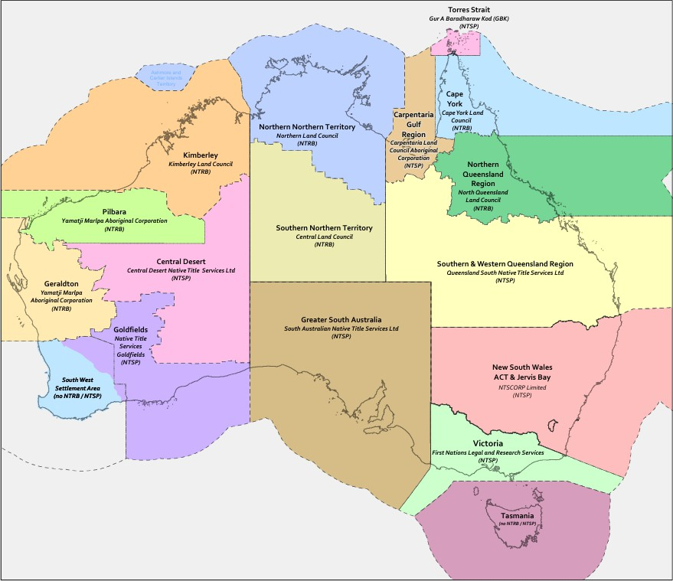
A map prepared by the National Native Title Tribunal showing Representative Aboriginal/Torres Strait Islander Body Areas as at 1 April 2026.

Operational funding for PBCs
The Australian Government provides funding to NTRB/SPs to support PBCs to run their corporations and to meet their corporate, governance and legal obligations. This funding is called PBC operational funding.
PBC Operational funding supports PBCs to meet basic operational costs so they can fulfil their Native Title engagement, consultation, reporting and compliance obligations arising from Commonwealth legislation including but not limited to: the Native Title Act 1993, the Corporations (Aboriginal and Torres Strait Islander) Act 2006, and the Native Title (Prescribed Bodies Corporate) Regulations 1999.
NTRB/SPs are responsible for reporting to NIAA how PBC operational funding is being used and must ensure expenditure aligns with NIAA funding agreement terms and conditions and financial and performance reporting requirements.

The role of NTRB/SPs
NTRB/SPs use PBC operational funding to deliver a range of services that support PBCs. The type and level of support a PBC receives depends on its needs, available funding, and the NTRB/SP’s service approach.
For many PBCs, operational funding will go towards activities that support them to meet their corporate and compliance obligations. PBCs that can demonstrate their capacity to deliver core activities and meet their legal and other obligations can work with their NTRB/SP to negotiate additional services that target other areas of need.
Attachment A provides examples of activities that can be delivered through operational funding, noting it will not be possible to provide all of these services to all PBCs. Activities that NTRB/SPs should prioritise are listed under the First Priority heading.
NTRB/SPs and PBCs can also work together to use operational funding in ways that help Native Title holders to unlock economic opportunities. This can include supporting PBCs to engage with and respond to industry opportunities, and to identify their own economic opportunities, pursue grants or other program and service delivery arrangements.

Service Catalogues
NTRB/SPs must work with PBCs to develop a service catalogue outlining the types of support and services that PBCs can access in their region. The service catalogue should clearly explain:
- What support services are available to PBCs to help them meet their core legal, operational, and other Native Title obligations
- Other types of support offered and available
- Agreed service standards and decision-making protocols
- Funding allocation processes, and
- Models of support available to PBCs.
Once finalised, NTRB/SPs should publish and distribute service catalogues so PBCs and their members can be aware of the support available to them.

How NTRB/SPs can deliver PBC support
NTRB/SPs deliver operational support to PBCs in ways that consider what kind of support is best for each PBC.
NTRB/SPs are independent of the NIAA and can make decisions and set their own priorities in performing their functions under the Native Title Act 1993, including how they deliver PBC operational funding to PBCs. The support NTRB/SPs provide to each PBC may vary depending on the circumstances and capacity of the PBC, associated costs and other regional and placed-based matters.
The different service delivery models NTRB/SPs can use are outlined in the table below.
Some NTRB/SPs may use a mix of delivery models to provide funding and support to PBCs in their region, while others may use only one or two of the delivery models.
Regardless of which model of support an NTRB/SP uses, they should be able to explain to PBCs which model is being used, and why.
PBCs can receive operational support from their NTRB/SP in four main ways:
Reimbursement of Costs or Invoicing  - The NTRB/SP holds and manages operational funding on behalf of the PBC.  - The NTRB/SP reimburses the PBC for eligible expenses or pays invoices directly.  The PBC is informed of the amount of funding available and the activities in scope. They then arrange services and submit invoices for payment. | PBC Support Unit  - Some NTRB/SPs may have a dedicated Support Unit that provide direct, tailored assistance to PBCs.  - NTRB/SP staff may work exclusively with one PBC or support multiple PBCs.  - Support Unit staff help the PBC meet corporate requirements, such as arranging Directors’ meetings, organising AGMs, and preparing required reports.
Support offered on an ad hoc basis  - Support is provided when requested by the PBC.  - The NTRB/SP may also identify additional needs and offer extra support beyond what was requested.  - This allows funds to be targeted to specific or unexpected needs. | NTRB/SP pays funding through to the PBC  - The full amount of operational funding is provided directly to the PBC to manage.  - The PBC must use the funds according to an agreed budget or the terms set out in a service agreement with the NTRB/SP.  - The PBC is required to report back to the NTRB/SP on how the funds were spent, as outlined in the service agreement.

PBCs are encouraged to talk with their NTRB/SP to confirm which support options are available to them, who their contact person is, and how funding and reporting will work. PBCs that would like to transition to a support or funding delivery model that better meets their needs are encouraged to discuss their options directly with their NTRB/SP.

Service Agreements
Each NTRB/SP must work with the PBCs within its region to enter into formal service agreements for PBC Support. These agreements will outline to PBCs the types of services being delivered, and how PBCs will receive this support. NTRB/SPs are encouraged to consider the different capacity levels of individual PBCs when entering into these agreements (for example, in some cases, short form agreements like an exchange of letters may be appropriate). Whatever agreements are in place, at a minimum they are encouraged to cover:
- the services being provided to the PBC and how they will be delivered
- the roles and responsibilities of NTRB/SPs and PBCs
- how disputes will be managed including response timeframes, review processes and escalation pathways
- annual reports including details of how funding has supported the PBC to increase its capacity
NTRB/SPs are encouraged to make the agreement available to the PBC’s directors, members, or Common Law
holders on request, to demonstrate transparency of service delivery.

Attachment A – Activities that may be delivered through operational support funding

First Priority

Organisational and Governance Support
- Delivery of General and Annual General meetings including logistical and secretariat support, meeting room hire, travel for PBC members and/or Native Title holders, audio and video-conferencing facilities, and any other reasonable costs associated with meeting delivery (not including sitting fees)
- Statutory reporting requirements
- Facilitating and processing membership applications
- Complaints management and dispute resolution services (including maintaining a complaints register)
- Communications (e.g. meeting notifications, website, social media, newsletter)
- Director and staff training (covering governance, decision making, financial reporting etc)
- Rulebook amendments
- Culturally appropriate decision making
- Support with Native Title processes (e.g. managing access to Country and engaging with proponents)

Second Priority

Operational Support
- Office expenses (including rent, utilities, equipment)
- Vehicle expenses (including fuel, registration and insurance)
- Human Resource (HR) services including for payroll, workplace health and safety, data management, policies and procedures, audit and other HR systems
- Executive support including engaging staff such as an administrative assistant or operations manager
- General insurance requirements, including public liability
- Corporate compliance matters

Financial support
- Record keeping and financial statement preparation
- Establishing financial policies and procedures
- Financial Planning, management and advice including for PBC finances and any externally held funds (e.g. trust funds)
- Accounting and Financial advice to assist with budgeting, payments accounting or other financial matters.

Legal support
- Legal advice to assist in responding to Future Acts and other Native Title applications and post-determination matters

Capital expenses
- Small equipment purchases to support PBC core operational requirements (including office equipment and IT)

Business and economic support
- Support to establish fee for service arrangements
- Strategic Planning and reporting to support a PBC to understand opportunities and risks, and work with members and Native Title holders to outline the goals and aspirations of the PBC
- Grant application assistance to secure funding from other Commonwealth and/or State and Territory programs
- Member education (e.g. to promote understanding of native title; support collective decision-making)

