06 June 2018

Dear stakeholders,

Aboriginal Land Commissioner’s Detriment Review – Update and Procedure

In November 2017, the Aboriginal Land Commissioner (Commissioner) commenced his review into the status of detriment issues associated with 16 land claims recommended for grant but not yet finalised. The Terms of Reference for the Detriment Review (Review) were issued by the Minister for Indigenous Affairs (Minister) on 6 July 2017 and can be accessed at: https://www.pmc.gov.au/resource-centre/indigenous-affairs/terms-reference-review-detriment-aboriginal-land-claims-recommended-grant-not-yet-finalised

On 13 April 2018, the Minister granted the Commissioner an extension of time
until 31 December 2018 for completion of the Review.

The Commissioner has now written to those stakeholders who participated in the land claim inquires and to new stakeholders who may have an interest in the Review. A schedule of those who were contacted is enclosed at Annexure 1.

The Commissioner also published notices in four Northern Territory newspapers inviting submissions from any persons and entities who might have a potential interest in the Review and who were not identified when the invitations to participate were sent out.

These notices were published in the following newspapers on the following dates:
  - NT News on 19 May 2018
  - Centralian Advocate on 18 May 2018
  - Katherine Times on 23 May 2018
  - Tennant & District Times on 18 May 2018

A copy of the newspaper notice is enclosed at Annexure 2.

The 16 land claims subject to the Review have been addressed in 6 groupings. These land claim groupings reflect the groupings in the land claim reports as well as geographical factors. The Commissioner has staggered his requests for submissions in respect of each land claim grouping, so as to assist those stakeholders intending to provide detriment submissions on multiple land claims and to assist the Northern Land Council (NLC), who have been asked to respond to the claims of detriment concerning each land claim.

The land claim groupings are as follows:

Grouping 1: Garrwa (Wearyan and Robinson Rivers Beds and Banks) Land Claim No. 178; McArthur River Land Claim No. 184 and Manangoora Land Claim No. 185.
Grouping 2: Lower Daly Land Claim No. 68
Grouping 3: Maria Island & Limmen Bight River Land Claim No. 71; Maria Island Region Land Claim No. 198 and Lorella Region Land Claim No. 199
Grouping 4: Seven Emu Region Land Claim No. 186 and part of Wollogorang Area II Land Claim No. 187
Grouping 5: Lower Roper River Land Claim No. 70 and the Upper Roper River Land Claims comprising: Mataranka Area (NT Portion 916) Land Claim No. 129; Western Roper River (Bed and Banks) Land Claim No. 141; Roper Valley Area Land Claim No. 164 and Elsey Region Land Claim No. 245
Grouping 6: Finniss River Land Claim No. 39 and Mataranka Land Claim No. 69

The final date for the provision of detriment submissions from potential stakeholders who were contacted directly has elapsed for groupings 1 to 5.

Submissions received in relation to these groupings have been provided to the NLC and circulated amongst other stakeholders participating in the Review for the relevant grouping. A schedule of
those who have provided detriment submissions in respect of these five groupings are enclosed at Annexure 3.

The NLC is yet to respond to the detriment submissions provided to them. In formulating their responses, they are holding on-country consultations with claimants and traditional Aboriginal owners. Their current deadline to respond to detriment submissions in respect of all six groupings
is 31 August 2018.

In addition to detriment submissions, the Office of the Aboriginal Land Commissioner has received the following submissions in relation to matters of legal principle and procedural issues:
- NLC’s submission on legal principles in respect of detriment interests acquired post land claim dated 25 May 2018;
- Northern Territory Government’s (NTG) submission on legal principles in respect of detriment interests acquired post land claim dated 17 May 2018;
- NTG’s letter to the Commissioner in respect of considering section 50(3)(c) and section 50(3)(b) of the Land Rights Act in his report and recommendations to the Minister dated 22 January 2018; and
- NLC’s letter to the Commissioner’s Associate in regards to the matter of contacting and consulting with Aboriginal ranger groups on the question of detriment
dated 18 December 2017.

The Commissioner has also sent the following letters concerning general matters in respect of the Review. These have been sent, as necessary, to stakeholders who have confirmed an interest in an area or areas recommended for grant:

- Letter of the Commissioner in respect of extension requests for detriment submissions;
- Memorandum of the Commissioner – Claims of detriment by stakeholders to be supported by particulars and documentary material with the annexed Schedule;
- Letter of the Commissioner considering section 50(3)(c) and section 50(3)(b) of the Land Rights Act in the Review (sent to those stakeholders who confirmed an interest in Groupings 1 and 2).

If there is anything further that you believe the Commissioner should have regard to, please contact me by email at Elena.Zola@network.pmc.gov.au or by mail addressed to the Office of the Aboriginal Land Commissioner, 4th Floor, 39-41 Woods Street, DARWIN, NT 0800 or GPO BOX 9322, DARWIN NT 0801.

This letter has been sent to all persons and entities that have, to date, made any submissions to the Commissioner for the purposes of his Review. It can also be accessed on the Aboriginal Land Commissioner’s website, at: https://www.pmc.gov.au/indigenous-affairs/land/aboriginal-land-commissioner

Yours sincerely,
Elena Zola
Associate to Aboriginal Land Commissioner Mansfield

ANNEXURE 1

Schedule of persons and entities that were sent invitations to participate per grouping

Grouping 1: Garrwa (Wearyan and Robinson Rivers Beds and Banks) Land Claim No. 178; McArthur River Land Claim No. 184 and Manangoora Land Claim No. 185

Australian Border Force
Australian Communications and Media Authority
Australian Fisheries Management Authority
Commonwealth Department of Agriculture
Australian Institute of Marine Science
Australian Maritime Safety Authority
Bureau of Meteorology
Commonwealth Scientific and Industrial Research Organisation
Commonwealth Department of Defence
Director of National Parks, Commonwealth Department of Environment
Commonwealth Department of Finance
Geoscience Australia
Commonwealth Department of Infrastructure
Solicitor for the Northern Territory, Northern Territory Government
Northern Territory Seafood Council
Amateur Fishermen’s Association of the Northern Territory
Northern Territory Cattlemen’s Association
Northern Territory Guided Fishing Industry Association
Association of Mining and Exploration Companies
Minerals Council of the Northern Territory
Roper Gulf Council
The Australian Petroleum Production & Exploration Association
Borroloola Hotel Motel
Borroloola Houseboats
Savannah Way Motel Borroloola
McArthur River Caravan Park
McArthur River Charters
NT Coastal Fishing Charters
Savannah Way Motel
Carpentaria Shipping Services, P&O Maritime
Britmar (Aust) Pty Ltd
Glencore/Mount Isa Mines Ltd
Greenback Station
Spring Creek Station
Manangoora Station
Seven Emu Station
McArthur River Station
King Ash Bay Fuels
King Ash Bay Fishing Club
Lianthwirriyarra Rangers
Mabunjii Association
Waanyi Garawa and Garawa Rangers
Waralungku Arts
Sandfire Resources NL
Molyhil Mining Pty Ltd

Grouping 2: Lower Daly Land Claim No. 68

Australian Border Force
Australian Communications and Media Authority
Australian Fisheries Management Authority
Commonwealth Department of Agriculture
Australian Institute of Marine Science
Australian Maritime Safety Authority
Bureau of Meteorology
Commonwealth Scientific and Industrial Research Organisation
Commonwealth Department of Defence
Director of National Parks, Commonwealth Department of Environment
Commonwealth Department of Finance
Geoscience Australia
Commonwealth Department of Infrastructure
Solicitor for the Northern Territory, Northern Territory Government
Northern Territory Seafood Council
Amateur Fishermen’s Association of the Northern Territory
Northern Territory Cattlemen’s Association
Northern Territory Guided Fishing Industry Association
Association of Mining and Exploration Companies
Minerals Council of the Northern Territory
Roper Gulf Regional Council
The Australian Petroleum Production & Exploration Association
Daly River Barra Resort
Fishabout
Mousie’s Barra
Litchfield Station

Grouping 3: Maria Island & Limmen Bight River Land Claim No. 71; Maria Island Region Land Claim No. 198 and Lorella Region Land Claim No. 199

Australian Border Force
Australian Communications and Media Authority
Australian Fisheries Management Authority
Commonwealth Department of Agriculture
Australian Institute of Marine Science
Australian Maritime Safety Authority
Bureau of Meteorology
Commonwealth Scientific and Industrial Research Organisation
Commonwealth Department of Defence
Director of National Parks, Commonwealth Department of Environment
Commonwealth Department of Finance
Geoscience Australia
Commonwealth Department of Infrastructure
Solicitor for the Northern Territory, Northern Territory Government
Northern Territory Seafood Council
Amateur Fishermen’s Association of the Northern Territory
Northern Territory Cattlemen’s Association
Northern Territory Guided Fishing Industry Association
Association of Mining and Exploration Companies
Minerals Council of the Northern Territory
Roper Gulf Regional Council
The Australian Petroleum Production & Exploration Association
Sandfire Resources NL
Britmar (Aust)
Limmen Bight Fishing Camp
Maximus No. 82 (Lorella Springs Station)

Grouping 4: Seven Emu Region Land Claim No. 186 and part of Wollogorang Area II Land Claim No. 187

Australian Border Force
Australian Communications and Media Authority
Australian Fisheries Management Authority
Commonwealth Department of Agriculture
Australian Institute of Marine Science
Australian Maritime Safety Authority
Bureau of Meteorology
Commonwealth Scientific and Industrial Research Organisation
Commonwealth Department of Defence
Director of National Parks, Commonwealth Department of Environment
Commonwealth Department of Finance
Geoscience Australia
Commonwealth Department of Infrastructure
Solicitor for the Northern Territory, Northern Territory Government
Northern Territory Seafood Council
Amateur Fishermen’s Association of the Northern Territory
Northern Territory Cattlemen’s Association
Northern Territory Guided Fishing Industry Association
Association of Mining and Exploration Companies
Minerals Council of the Northern Territory
Roper Gulf Regional Council
The Australian Petroleum Production & Exploration Association
Armour Energy Ltd
Australian Wildlife Conservancy (Pungalina-Seven Emu Wildlife Sanctuary)
McArthur River Charters
Australian Sportfishing Charters
J & A Fishing Charters
NT Coastal Fishing Charters
Mr Darryl Everett
Seven Emu Station
Greenback Station
Manangoora Station
Pardoo Beef Company Pty Ltd (Wollogorang Station)
Mr Peter Anderson

Grouping 5: Lower Roper River Land Claim No. 70 and the Upper Roper River Land Claims comprising: Mataranka Area (NT Portion 916) Land Claim No. 129; Western Roper River (Bed and Banks) Land Claim No. 141; Roper Valley Area Land Claim No. 164 and Elsey Region Land Claim No. 245

Australian Border Force
Australian Communications and Media Authority
Australian Fisheries Management Authority
Commonwealth Department of Agriculture
Australian Institute of Marine Science
Australian Maritime Safety Authority
Bureau of Meteorology
Commonwealth Scientific and Industrial Research Organisation
Commonwealth Department of Defence
Director of National Parks, Commonwealth Department of Environment
Commonwealth Department of Finance
Geoscience Australia
Commonwealth Department of Infrastructure
Solicitor for the Northern Territory, Northern Territory Government
Northern Territory Seafood Council
Amateur Fishermen’s Association of the Northern Territory
Northern Territory Cattlemen’s Association
Northern Territory Guided Fishing Industry Association
Association of Mining and Exploration Companies
Minerals Council of the Northern Territory
Roper Gulf Regional Council
The Australian Petroleum Production & Exploration Association
Mr Paul Reed
Roper Bar Store
Northern Territory Iron Ore Pty Ltd
Kaylan Resources Pty Ltd
Australian Mining and Exploration Title Services
Australian Ilmenite Resources Pty Ltd
Macmines Austasia Pty Ltd
Big River Station
MS Contracting (Flying Fox Station)
Mr Simon Hoar (Goondooloo and Moroak Stations)
DK Grazing (Lonesome Dove Station)
Red Metal Ltd
Sandfire Resources NL

Grouping 6: Finniss River Land Claim No. 39 and Mataranka Land Claim No. 69

Australian Border Force
Australian Communications and Media Authority
Australian Fisheries Management Authority
Commonwealth Department of Agriculture
Australian Institute of Marine Science
Australian Maritime Safety Authority
Bureau of Meteorology
Commonwealth Scientific and Industrial Research Organisation
Commonwealth Department of Defence
Director of National Parks, Commonwealth Department of Environment
Commonwealth Department of Finance
Geoscience Australia
Commonwealth Department of Infrastructure
Solicitor for the Northern Territory, Northern Territory Government
Northern Territory Cattlemen’s Association
Association of Mining and Exploration Companies
Minerals Council of the Northern Territory
Roper Gulf Regional Council
Coomalie Community Government Council
Rio Tinto Exploration Ltd
Rio Tinto Services Ltd
Ward Keller
Northern Australia and Major Projects Division, Department of Industry, Innovation and Science
Namul-Namul Aboriginal Corporation
Mount McMinn Station
DK Grazing (Lonesome Dove Station)
Mr Simon Hoar (Goondooloo and Moroak Stations)
Big River Station
MS Contracting (Flying Fox Station)

Further entities that were provided letters indirectly in respect of Grouping 6:
Northern Territory Iron Ore Pty Ltd
Northern Territory Resources Pty Ltd
Australian Mining and Exploration Title Services
Doe Run Company

ANNEXURE 2

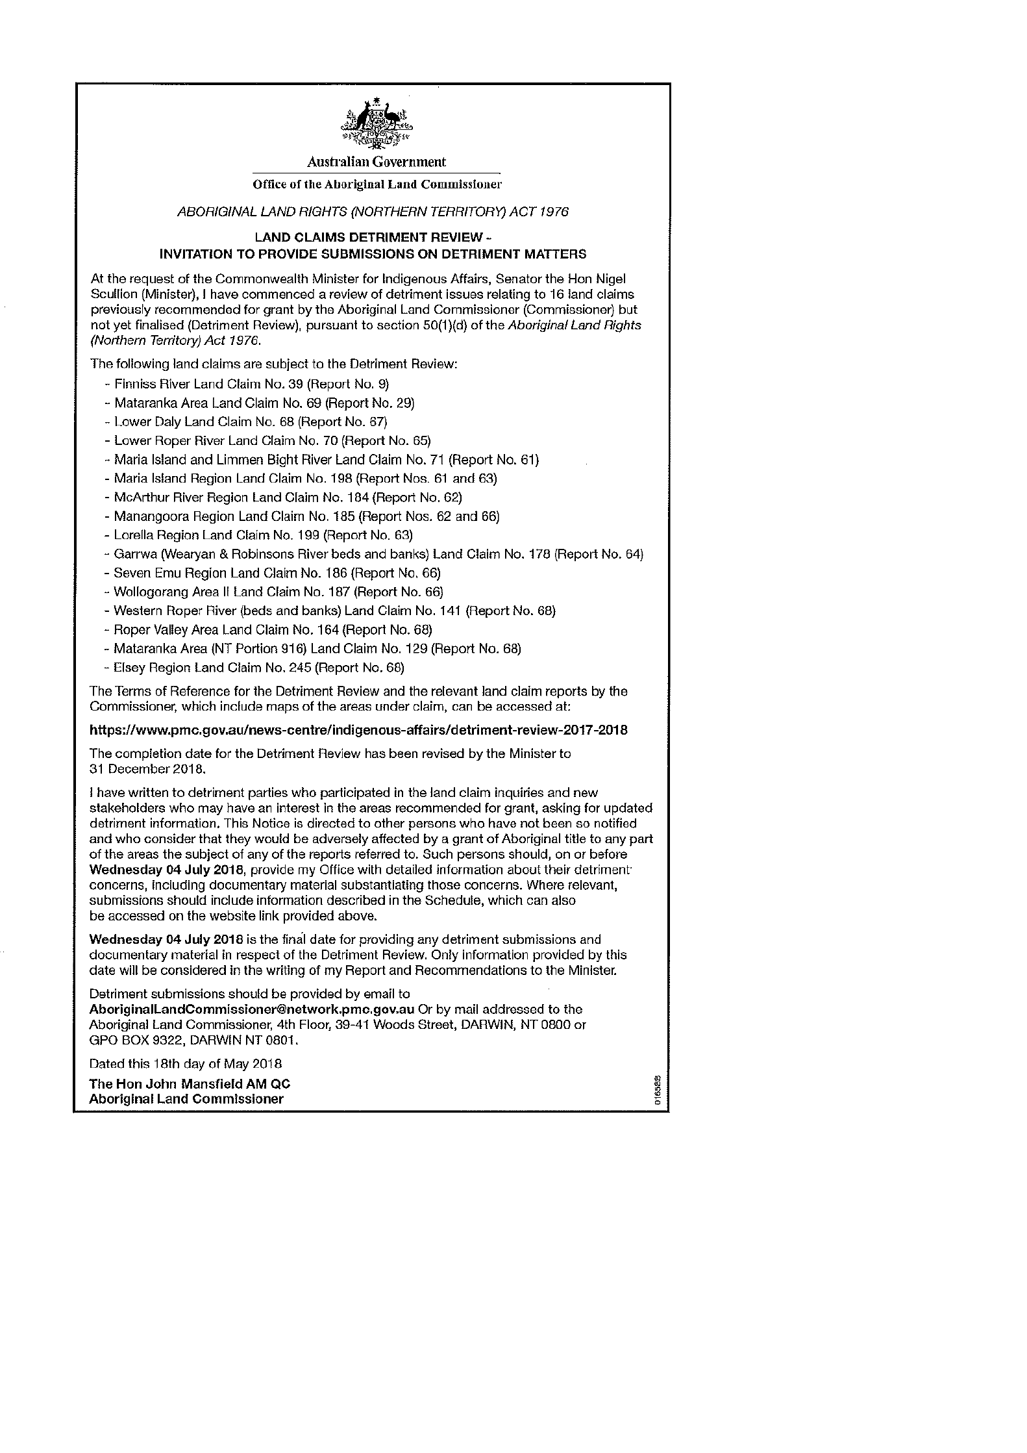
Newspaper notice published in the NT News, Centralian Advocate, Katherine Times and Tennant & District Times between the dates of 18 May 2018 to 23 May 2018.

ANNEXURE 3

Schedule of persons and entities that have provided detriment submissions to date in respect of groupings 1 to 5

Grouping 1: Garrwa (Wearyan and Robinson Rivers Beds and Banks) Land Claim No. 178; McArthur River Land Claim No. 184 and Manangoora Land Claim No. 185

Solicitor of the Northern Territory, Northern Territory Government
Northern Territory Seafood Council
Amateur Fishermen’s Association of the Northern Territory
Northern Territory Cattlemen’s Association
NT Coastal Fishing Charters together with King Ash Bay Lodge
Carpentaria Shipping Services, P&O Maritime
Britmar (Aust) Pty Ltd
Glencore/Mount Isa Mines Ltd
Mr Frank Shadforth, Seven Emu Station
King Ash Bay Fishing Club
King Ash Bay Service Station & Supermarket (as part of King Ash Bay Fishing Club’s submission)
Alice Springs Outback Anglers (as part of King Ash Bay Fishing Club’s submissions)
Tennant Creek Fishing Club (as part of King Ash Bay Fishing Club’s submissions)
Mabunjii Association (as part of Northern Territory Seafood Council’s submissions)
Armour Energy Ltd
Gulf Mini Mart Borroloola

Grouping 2: Lower Daly Land Claim No. 68

Amateur Fishermen’s Association of the Northern Territory
Daly River Barra Resort
Mousie’s Barra
Litchfield Station
Solicitor for the Northern Territory, Northern Territory Government
Northern Territory Cattlemen’s Association

Grouping 3: Maria Island & Limmen Bight River Land Claim No. 71; Maria Island Region Land Claim No. 198 and Lorella Region Land Claim No. 199

Solicitor for the Northern Territory, Northern Territory Government
Northern Territory Cattlemen’s Association
Amateur Fishermen’s Association of the Northern Territory
Limmen Bight Fishing Camp
Maximus No. 82 (Lorella Springs Station)
Four Wheel Drive Australia Inc. (as part of Maximus No. 82’s submissions)
Tourism Top End Inc. (as part of Maximus No. 82’s submissions)
Northern Territory Seafood Council
Northern Territory Iron Ore Pty Ltd
Britmar (Aust) Pty Ltd
Grouping 4: Seven Emu Region Land Claim No. 186 and part of Wollogorang Area II Land Claim 187
Pardoo Beef Company Pty Ltd (Wollogorang Station)
Mr Frank Shadforth, Seven Emu Station
Armour Energy Ltd
Northern Territory Seafood Council
Amateur Fishermen’s Association of the Northern Territory
Solicitor for the Northern Territory, Northern Territory Government
Northern Territory Cattlemen’s Association

Grouping 5: Lower Roper River Land Claim No. 70 and the Upper Roper River Land Claims comprising: Mataranka Area (NT Portion 916) Land Claim No. 129; Western Roper River (Bed and Banks) Land Claim No. 141; Roper Valley Area Land Claim No. 164 and Elsey Region Land Claim No. 245

Northern Territory Cattlemen’s Association
MS Contracting (Flying Fox Station)
Moroak Pastoral Company Pty Ltd (Goondooloo and Moroak Stations)
DK Pastoral Company Pty Ltd (Lonesome Dove Station)
Northern Territory Seafood Council
Amateur Fishermen’s Association of the Northern Territory
Northern Territory Iron Ore Pty Ltd

To receive Friday 15 June 2018:
Solicitor for the Northern Territory, Northern Territory Government
Roper Bar Store

Schedule of persons and entities that have provided an intention to participate in respect of Grouping 6 to date:

Grouping 6: Finniss River Land Claim No. 39 and Mataranka Land Claim No. 69

Northern Territory Iron Ore Pty Ltd
Northern Territory Resources Ptd Ltd
Doe Run Company
Northern Australia and Major Projects Division, Department of Industry, Innovation and Science
Northern Territory Cattlemen’s Association
DK Pastoral Company Pty Ltd (Lonesome Dove Station)
MS Contracting (Flying Fox Station)
Solicitor for the Northern Territory, Northern Territory Government

