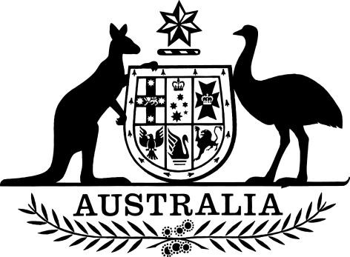

Freedom of Information Act 1982 (Cth) (Chief Executive Officer) Delegation 2022

I, Jody Broun, Chief Executive Officer of the National Indigenous Australians Agency (the Agency), being the principal officer of the Agency, REVOKE all previous delegations and exercise my power under section 23(1) of the Freedom of Information Act 1982 (the FOI Act) to approve the following arrangements:
- Each officer holding, or for the time performing the duties of, a position specified below, is authorised to make decisions under the FOI Act in respect of a request made to the Agency:
  - all positions classified as positions in the Senior Executive Service in the Agency.
- The officer holding, or for the time performing the duties of, a positions specified below is authorised to make decisions under the FOI Act in respect of a request made to the Agency, except for decisions on whether or not to grant access to documents:
  - Principal Lawyer, Legal Services Branch; and
  - FOI Coordinator, Legal Services Branch.
- Where an FOI applicant requests an internal review of a decision, the review decision is to be made by a more senior officer than the officer who made the decision under review.

This Instrument commences upon signature.

Signed this ……… day of 2022

Jody Broun
Chief Executive Officer, National Indigenous Australians Agency

Freedom of Information Act 1982 (Cth) (Chief Executive Officer) Delegation 2022

