National Roadmap
for Indigenous
Skills, Jobs and
Wealth Creation

The National Roadmap for Indigenous Skills, Jobs and Wealth Creation
  - FACT SHEET

What is the National Roadmap?
The National Roadmap for Indigenous Skills, Jobs and Wealth Creation is a collaborative effort to enable enhanced economic opportunities and outcomes for Aboriginal and Torres Strait Islander peoples. It provides a long term commitment to support strengthened pathways to economic development and enable Indigenous Australians to gain the skills and confidence needed to pursue the careers and businesses they want.

Who is involved?
The National Roadmap is a collaborative effort between governments, business and industry, the non-government sector and Indigenous Australians. The involvement and leadership of all sectors will be required to effect meaningful change in partnership with Indigenous Australians.
The National Roadmap will support industry leaders to demonstrate leadership through specific actions that enable enhanced pathways for Aboriginal and Torres Strait Islander people into their companies and sectors, and support opportunities for career advancement. Government, industry and Indigenous businesses, communities and leaders will work in partnership to achieve desired outcomes. It will also enhance opportunities for Indigenous Australians to set up and grow a business.

Why do we need a National Roadmap?
The Indigenous economic sector holds significant potential as a key contributor to the Australian economy. As a comparatively younger and faster growing population, Indigenous Australians will form an important part of Australia’s future labour supply, particularly for regional economies.
The National Roadmap recognises there are still significant challenges that exist for Indigenous Australians seeking to enter the job market, progress their careers and start and expand businesses. The National Roadmap seeks to address these barriers by driving Government and industry investment to connect Indigenous Australians with pathways to training and employment, further business support and broader economic opportunities.
The National Roadmap complements the National Agreement on Closing the Gap.

What will it achieve?
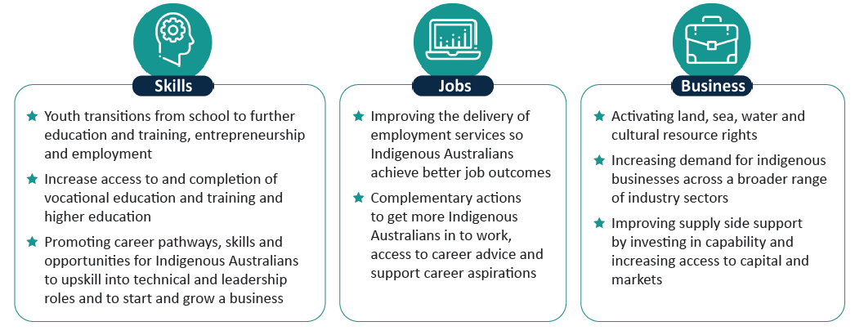
The National Roadmap has three key domains, each underpinned by a series of policy pillars designed to drive enhanced economic opportunities and pathways to enable sustainable change across industry and government.
When will it be implemented?
The National Roadmap will be implemented through a National Roadmap Action Plan which will outline actions and areas for focus. The National Indigenous Australians Agency is working closely with Indigenous Australians, industry, businesses and state and territory governments to identify tangible actions and commitments for the National Roadmap Action Plan.
Updates on the progress of the National Roadmap will be made publically available on the National Indigenous Australians Agency website.
For all other enquires please contact NationalRoadmap@niaa.gov.au.

