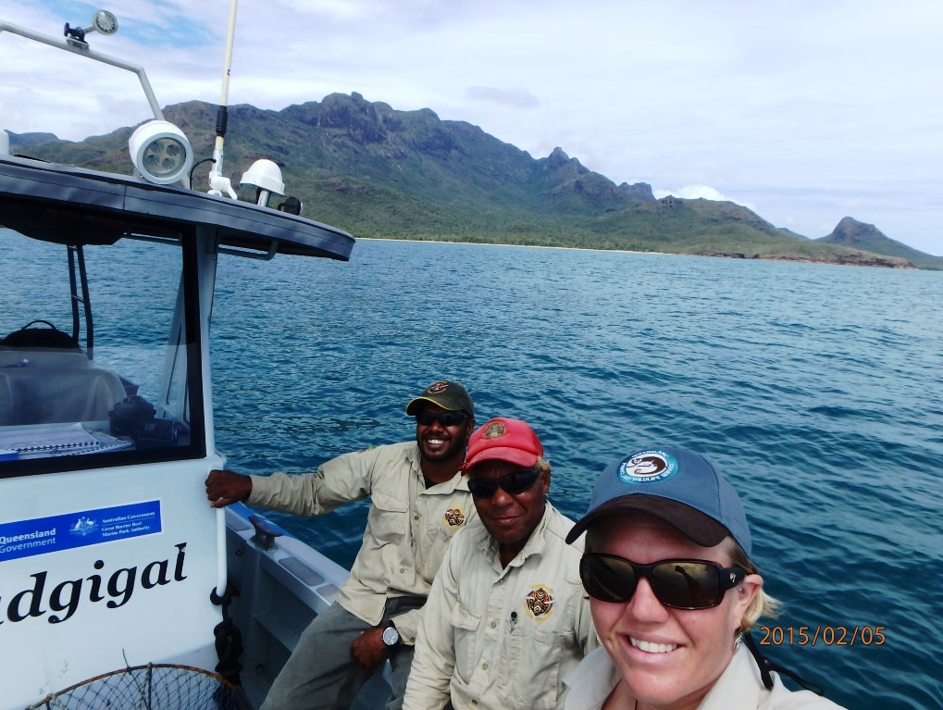

© Girringun Aboriginal Corporation

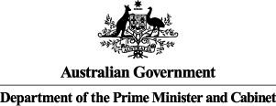
Girringun Indigenous Protected Area (IPA)
Social Return on Investment Analysis
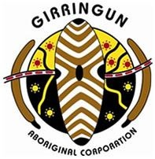
“All the Rangers have had a tough background in one way or another. We said to them, whoever you are come and work with us… Just having a job helps. It is something to do…Something meaningful. That's the best medicine.”
Phil Rist, traditional owner and Executive Officer, GAC

Insights
- The Girringun IPA and associated Indigenous ranger programme has provided an opportunity for Indigenous people from eight traditional owner groups in Northern Queensland to actively manage their diverse land and sea country, and re-engage with culture and language through country
- Critical to the success of the Girringun IPA and associated Indigenous ranger programme is its co-management model, whereby Girringun Aboriginal Corporation (GAC) partners with Local, State and Federal Governments as well as numerous NGO and Research partners to achieve shared outcomes for country
- The IPA’s management team offers a culturally assured process to its partners - whereby the appropriate people are consulted about activities undertaken on country – and plays a leading role in the region as advisors, trainers and channels of support for other organisations.
- The IPA and associated Indigenous ranger programmes have demonstrated successes across a broad range of outcome areas, effectively overcoming barriers to addressing Indigenous disadvantage and engaging Indigenous Australians in meaningful employment to achieve large scale conservation outcomes, thus aligning the interests of Indigenous Australians and the broader community

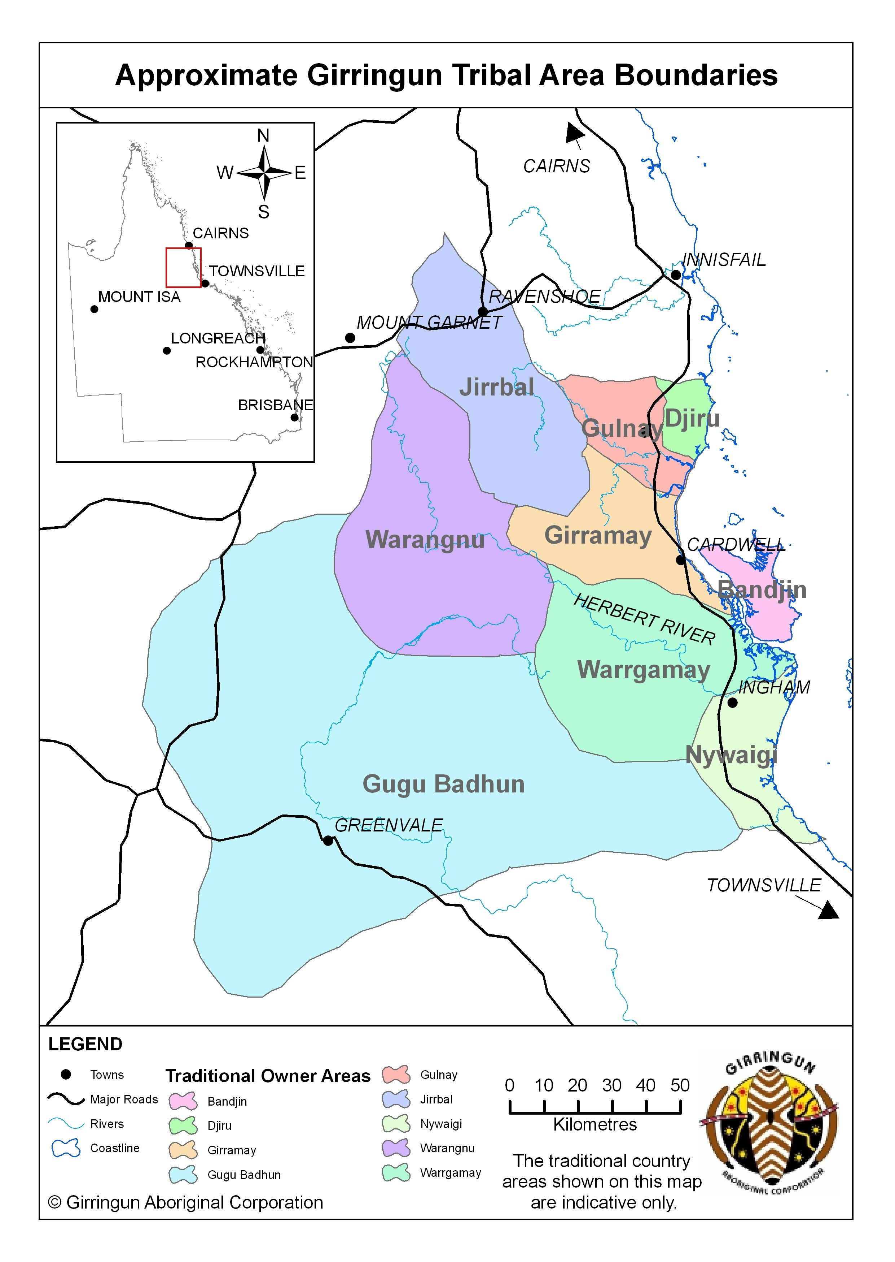
About the Girringun IPA
The Girringun IPA is located in Northern Queensland and was declared in June 2013. It consists of 1.26 million ha of land and sea country comprising Aboriginal-held land, private landholdings, national parks, conservation parks, fish habitat areas, marine protected areas and world heritage areas including the Great Barrier Reef World Heritage Area and Wet Tropics of Queensland World Heritage Area.
The land within the IPA belongs to eight traditional owner groups - Bandjin, Djiru, Girramay, Gugu Badhun, Gulnay, Nywaigi, Warrgamay and Warungnu traditional owners.
The IPA aims to prioritise outcomes that Indigenous people seek for country alongside the interests of the broader Australian community, which are protected through marine and terrestrial protected areas. The IPA’s plan of management for country identifies works that traditional owners have prioritised through the consultation process including threatened species management, cultural site maintenance and research, monitoring and data collection. The transfer of cultural knowledge and language to young people, and the education of the broader community within the IPA about Indigenous culture, are also high priorities.
Impact of the Girringun IPA
In the six year period covered by this SROI analysis, the Girringun IPA has generated substantial social, economic, cultural and environmental outcomes for Rangers, Community members, Government and other stakeholders. The achievement of these outcomes is strongly influenced by the time Rangers and Community members spend living and working on country.
The most significant outcomes for Rangers relate to better caring for country, increased pride and sense of self, and better health and wellbeing. The most important outcomes for Community are leveraging the IPA for additional funding and economic opportunities, and better cultural asset management.
Government is also a significant beneficiary of the IPA, experiencing a range of outcomes including more skilled Indigenous people and greater respect for Traditional Ecological Knowledge (TEK). Indigenous corporations, NGO partners and Research partners have also benefited from deeper relationships with traditional owners and being better able to meet their core objectives.
Financial proxies have been used to approximate the value of these outcomes. The social, economic, cultural and environmental value associated with the outcomes was estimated to be $30.9m for FY10-15. During this period, $13.9m was invested in the Girringun IPA and associated Indigenous ranger programme, with most (96%) coming from Government.
Value of social, economic, cultural and environmental outcomes created by stakeholder group, FY10-15
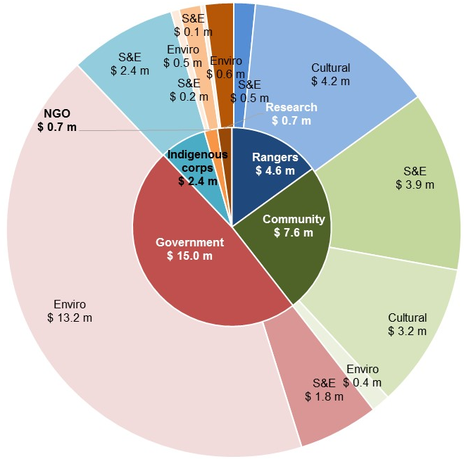
Key:
S&E: Social and Economic Outcomes
Cultural: Cultural Outcomes
Enviro: Environmental Outcomes
Social Return on Investment
The Girringun IPA delivered an SROI ratio of 2.2:1 based on the investment in operations between FY10-15.
That is, for every $1 invested, approximately $2.2 of social, economic, cultural and environmental value has been created for stakeholders.

In the spotlight: Penny Ivey, Girringun Ranger
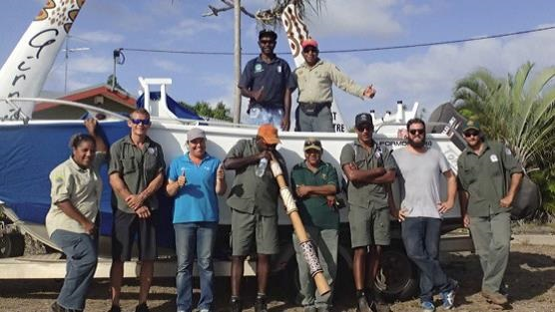
Penny Ivey is a Girramay woman who has worked as a Girringun Ranger for five years. Prior to becoming a Ranger, Penny was fruit picking. She became a Ranger because she wanted to learn more from the Elders.
While with Girringun, Penny has undertaken training in mapping, dolphin and dugong surveys, operating a front loader and bobcat, and using GPS tracking devices. She is now one of the more experienced Rangers at Girringun and has assumed responsibility for teaching others.
© Girringun Aboriginal Corporation

Over time, Penny has transformed from a shy person into a more confident one. Penny attributes this to mixing with other Rangers during trips, conferences and Ranger exchanges where she was representing Girringun. She has career ambitions to one day become a supervisor or work for National Parks.
“I was once a quiet girl - that changed when we went away and met with others.”

About this project

The Department of the Prime Minister & Cabinet (PM&C) commissioned Social Ventures Australia (SVA) Consulting to understand, measure or estimate and value the changes resulting from the investment in the Girringun IPA and associated Indigenous ranger programme. This analysis is part of a broader project that considers five IPAs across Australia including Birriliburu and Matuwa Kurrara Kurrara in Western Australia (together forming one analysis), Minyumai in New South Wales and Warddeken in the Northern Territory. The SROI methodology was used to complete each of these analyses.
This analysis involved 45 consultations with stakeholders of the IPA, including 15 Community members (overlapping with representatives from two Indigenous corporations), five Rangers, seven representatives of Local, Queensland and Australian Governments, five NGO partners and five Research partners.

In the spotlight: Jessica Hoey, Director – Indigenous Partners, Great Barrier Reef Marine Park Authority (GBRMPA)
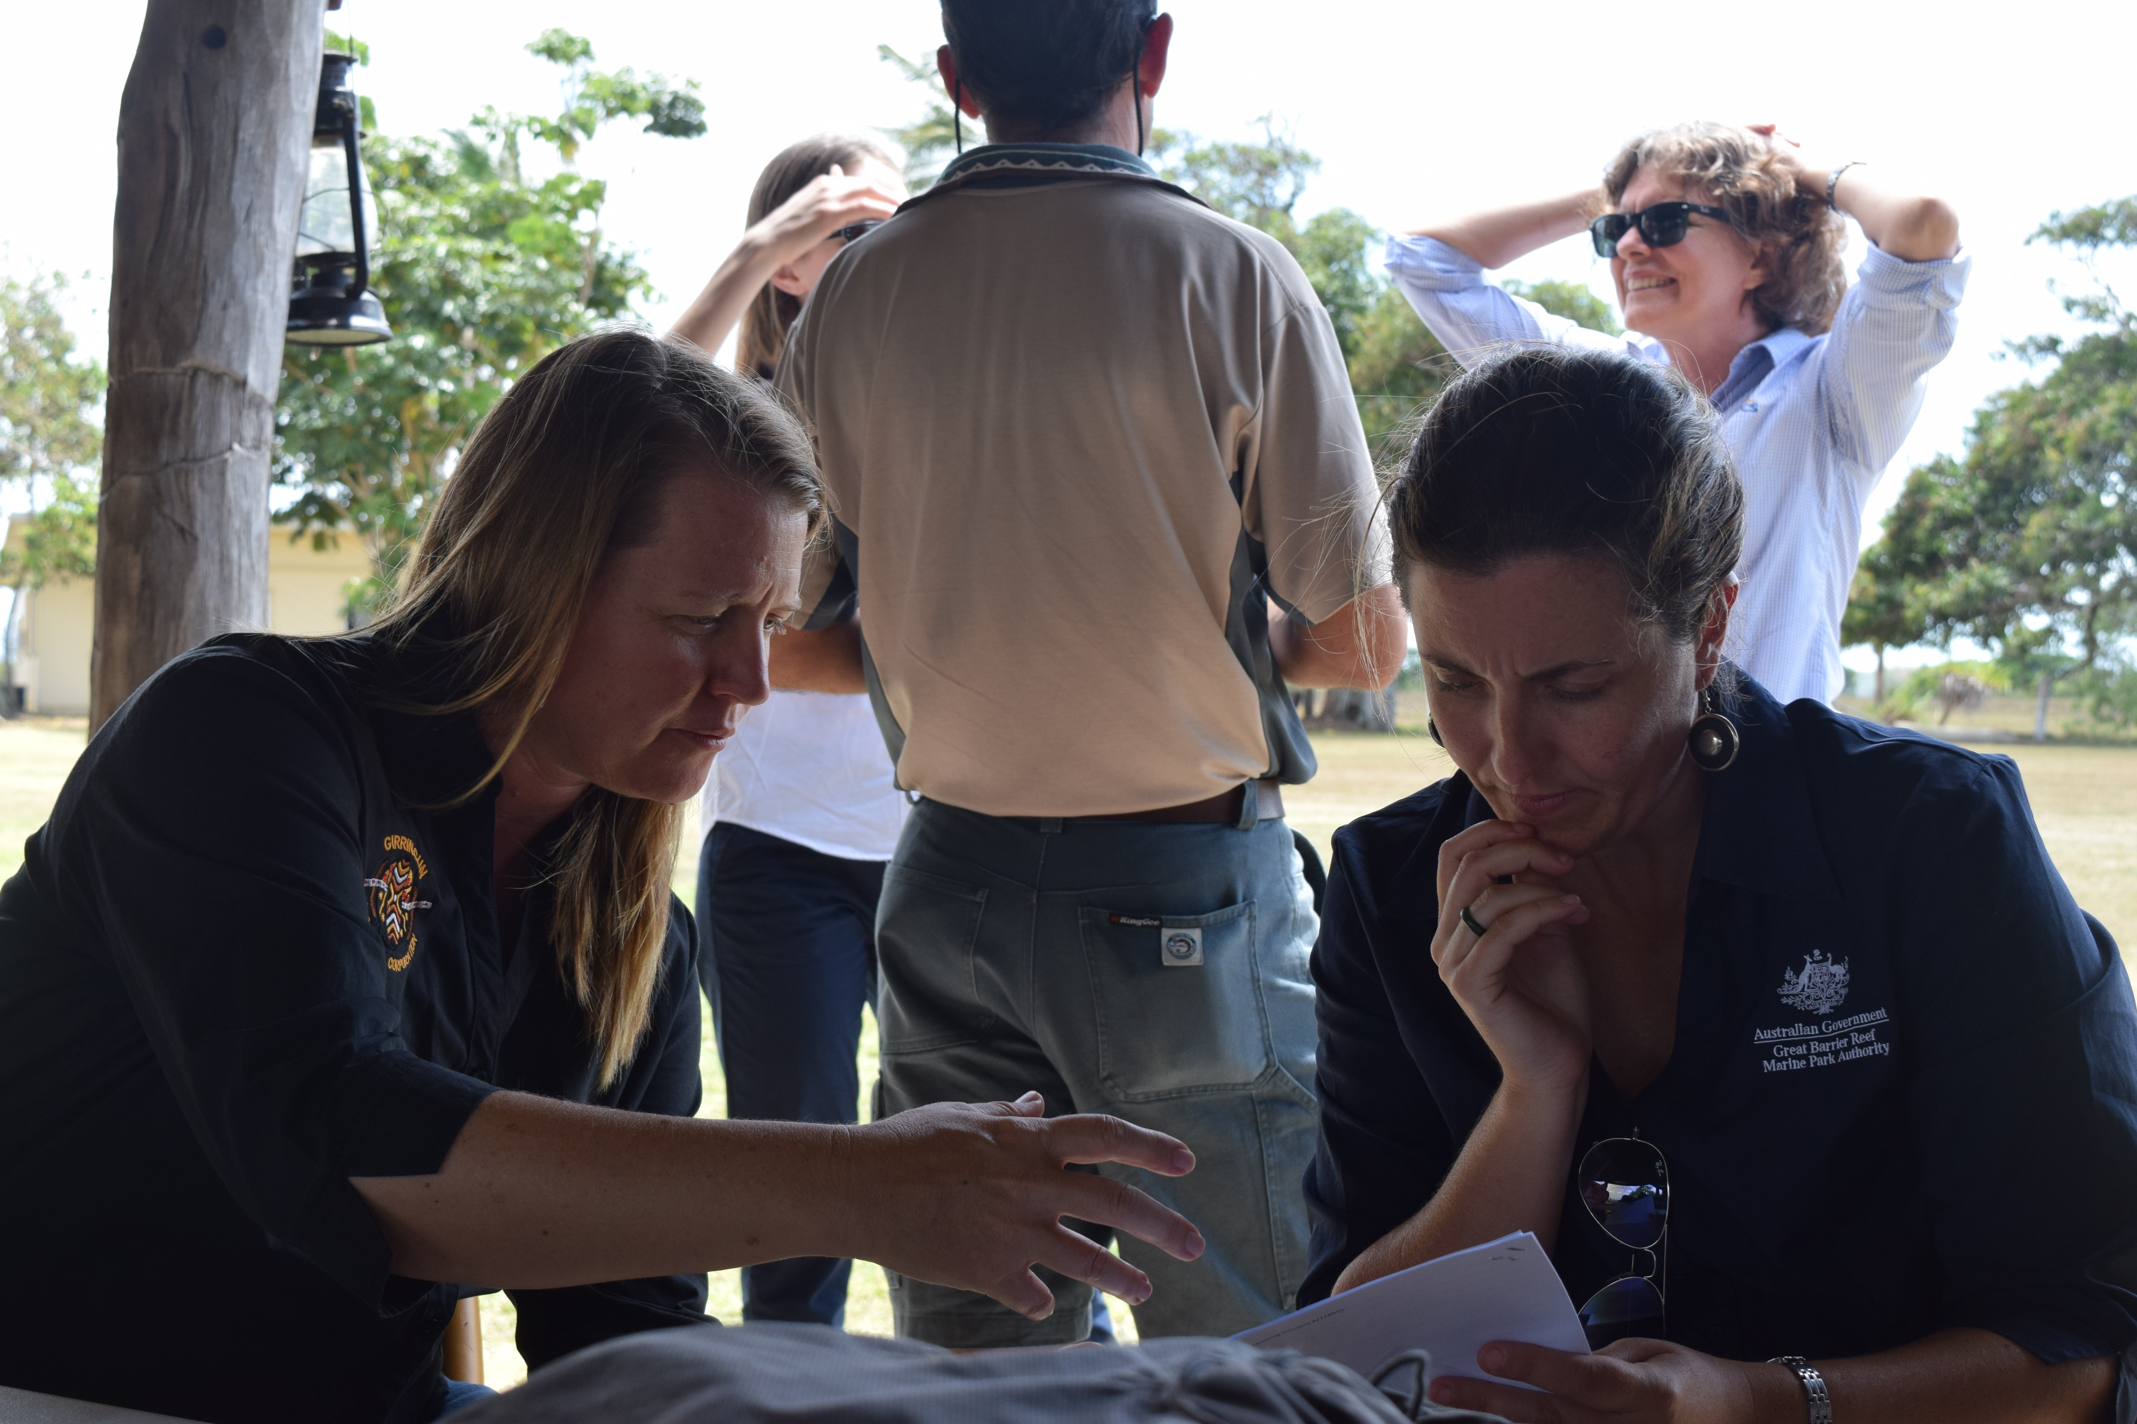
The Girringun IPA and GBMRPA work closely together since part of the Girringun IPA’s sea country falls within the Great Barrier Reef World Heritage Area.
When the Great Barrier Reef was at risk of an ‘in danger’ listing by the United Nations Educational, Scientific and Cultural Organization (UNESCO) World Heritage Committee (WHC), the Girringun IPA led stakeholder engagement with local Indigenous communities on the Government’s behalf. This information, along with numerous references to the Girringun IPA, was used in a submission which resulted in the WHC deciding against declaring the Reef ‘in danger’.
© Girringun Aboriginal Corporation

“Girringun played a role in the positive partnership between Great Barrier Reef region traditional owners and the Australian Government, which was internationally recognised in the government’s response to World Heritage Committee concerns about the Reef.”

For more information about the Girringun IPA, or for a copy of the full report, contact:

Karman Lippitt

Girringun Indigenous Protected Area Coordinator

T: 07 4066 8300

E: ipa@girringun.com.au

For more information on the IPA programme, contact:

T: 02 6228 6481 or 02 6228 6717

E: IndigenousEnvironment@pmc.gov.au

The Jirrbal people support declaration of the IPA in principle.

