Efficient system costs of Remote Indigenous housing
Input into the Review of the National Partnership Agreement on Remote Indigenous Housing
4 July 2017

This page is intentionally blank.
© Nous Group
Contents
Executive summary 4
1 Opportunities to reduce costs in remote Indigenous housing needs robust evidence 6
1.1 While high costs are widely accepted, this report seeks to provide much-needed in-depth analysis 6
1.2 There are systems limitations to in depth data analytics 8
2 Remote Indigenous housing operates with a significant revenue-cost shortfall 10
2.1 As much as three-quarters (or more) of ongoing costs are capital maintenance and recurrent maintenance 10
2.2 Other costs comprise employee expenses, bad debts and utility costs 11
2.3 Costs of specific maintenance activities are significantly higher under NPARIH than public housing 12
2.4 On average, 84 per cent of the costs of delivery are not covered by rental income 13
2.5 The revenue-cost shortfall is largely driven by much higher ongoing costs rather than a lower rental income when compared to public housing 15
3 The key drivers of cost are remoteness and emergency maintenance activities 16
3.1 Maintenance costs are highly variable within NPARIH 16
3.2 Jurisdictions have a strong sense of which costs are controllable and uncontrollable 17
3.3 The relationships between remoteness and costs are complex 19
3.4 Emergency maintenance can drive costs up to 20 times higher 25
4 Jurisdiction experience indicates targeted cost savings are possible, but there are ultimately irreducible costs 27
4.1 Cost savings may flow from changes to PTM approaches, both broad and targeted 27
4.2 There are other factors which could deliver cost reductions that aren’t directly related to the approach to PTM 30
4.3 Analysis of revenue-raising and cost-reducing scenarios show that there are significant irreducible costs 32
5 There is need for improved data collection, and improved optimisation of jobs, and greater sharing of experience, evidence and expertise 34
5.1 Data collection could be significantly improved to better document PTM activities, and associated outcomes and costs 34
5.2 Investment in systems to improve work package optimisation could yield significant returns 36
5.3 The jurisdictions sharing experience, evidence and expertise will catalyse improvements in PTM approaches in remote Indigenous housing 38
Appendix A Excerpt from cost template 39
Appendix B Remoteness classifications 40
Appendix C Data definitions and assumptions 46
Appendix D Alternative Text…………………………………………………………………………………………………..47

Executive summary
It is undisputed that the cost of maintaining houses in remote Indigenous communities is high. What is less clear is the magnitude of the shortfall between rent collected from remote Indigenous tenancies and the costs required to maintain the housing stock. There is also a gap in understanding the key drivers of remote housing costs and the extent to which improved property and tenancy management (PTM) approaches can reduce these costs. Understanding the cost drivers and revenue-cost shortfall is critical to developing informed policy.
As part of the Review of the National Partnership Agreement on Remote Indigenous Housing (NPARIH), Nous Group was commissioned to provide a quantitative analysis of the distribution of costs of repairs and maintenance and the revenue-cost shortfall of remote Indigenous housing. Data was provided by four jurisdictions receiving Commonwealth funding under NPARIH (Queensland, South Australia, Western Australia and Northern Territory). This data was analysed and supplemented by qualitative data and benchmarking from a literature review.
Housing provision in remote Indigenous communities faces a significant and unavoidable revenue-cost shortfall. On average, 84 per cent of the costs of ongoing property maintenance of housing stock are not covered by rental income. This shortfall is consistent across all participating jurisdictions, with rent collected only covering between 11 and 21 per cent of total costs. While this data is based on a limited sample of communities, and largely from 2017-18 budget projections, it gives a good indication of the quantum of the government subsidy required for the ongoing management of remote Indigenous housing. This shortfall in remote Indigenous housing is significantly higher than in mainstream public housing, where in the case of one jurisdiction, rental income collected covers approximately 90 per cent of ongoing costs.
The difference in shortfall between public housing and remote Indigenous housing is driven mostly by a much higher cost of housing provision in remote Indigenous communities. Higher costs account for 80 per cent of the difference in shortfall between public housing and remote Indigenous housing, with lower rental collections accounting for only 20 per cent of the difference. This indicates that greater gains can be made from focusing upon achieving cost efficiencies in property and tenancy management than from increasing rental revenues.
The key drivers of the high cost of housing provision in remote Indigenous communities are the level of remoteness and the significantly higher cost of emergency repair activities. Based on a limited sample of data, maintenance costs in very remote communities are more variable than in remote communities, and are between 1.3 and 5.1 times higher in the majority of cases. The effects of remoteness are especially pronounced for emergency repairs, due to the higher travel costs per job. On average, emergency repairs cost 8.5 times more in very remote communities than in remote communities. Typically, the costs of emergency repair activities are 75 per cent higher than planned activities, while responsive activities are 50 per cent more costly than planned. Shifting the balance of maintenance from emergency or responsive to planned maintenance will reduce costs considerably, as it allows for transport costs to be spread over a greater number of jobs.
Existing experience across jurisdictions indicates targeted cost savings are possible, but there are ultimately irreducible costs. Cost savings can be realised by bundling jobs to reduce travel costs, procuring local labour for maintenance and tenancy management and up-skilling local tradespeople to perform non-specialised tasks. Initial build decisions and choice of durable, standardised fittings have been shown to reduce lifecycle costs.

With a concerted approach to cost reduction (and to a lesser extent rental income improvements), benchmarking analysis places optimistic revenue to cost ratios at 21 to 33 per cent. In other words, the smallest revenue-cost shortfall of all of the NPARIH communities in the data sample was 67 per cent, as opposed to the NPARIH-wide value of 84 per cent. This finding implies that there are lessons of better practice that can be learned about PTM from the communities that have the smallest shortfalls. While this report does not include investigation of the specific practices of high performing communities, this is an area recommended for future in-depth investigation. However, these figures also indicate that unlike in the context of mainstream urban social housing, the ongoing management of remote Indigenous housing stock is far from being independently financially viable. There is a clear need for ongoing government subsidy for the ongoing management of remote housing stock.
While targeted data collection as part of this review has enabled an in-depth analysis of the costs of remote indigenous housing, there is a need for improved data collection on maintenance activities, costs and housing outcomes. Sharing of expertise between jurisdictions, along with a concerted approach to data collection and investment in systems to improve work package optimisation, could yield significant reductions to the overall revenue –cost shortfall.

Opportunities to reduce costs in remote Indigenous housing needs robust evidence

While high costs are widely accepted, this report seeks to provide much-needed in-depth analysis
The premise that delivering remote Indigenous housing entails high costs is not disputed. However, a review of the academic and grey literature shows that there is limited evidence available. In particular, there is limited evidence on:
- The shortfall between rental revenue and delivery costs
- The statistical description of costs and costs drivers
- Quantitative analysis of the impact of various measures to reduce costs.
As part of the Review of the National Partnership Agreement on Remote Indigenous Housing (NPARIH), Nous Group was commissioned to provide in-depth quantitative evidence on property and tenancy management (PTM) costs.
Nous’ analysis focused on the ongoing costs of PTM in remote Indigenous housing, which included identifying the major cost drivers, comparisons to mainstream public housing, and identifying any realised or potential gains from changes to PTM approaches. This work does not include analysis of construction costs. It only incidentally examined connections between initial construction cost and ongoing repair and maintenance costs.
For the purposes of this analysis, Nous undertook a targeted approach to data collection and analysis, to maximise consistency of data definitions across jurisdictions, ensure a realistic data request and timeframe was provided, and enable a thorough analysis of the significant costs and their drivers. Our methodology comprised four components.

1. Literature review
In preparation for analysis of jurisdictional data, Nous undertook a review of relevant literature on the topic of public housing provision, particularly in regional and remote areas and Indigenous communities.
The key research reports and resources that were relevant were:
- Habibis et al, Reviewing changes to housing management on remote Indigenous communities, AHURI, 2016
- T Sowerbutts & B Mansell, Cost Benefit Analysis for Housing Management, 2012
- J Fien & E Charlesworth, ‘Why isn’t it solved?’ Factors affecting improvements in housing outcomes in remote Indigenous communities in Australia, Habitat International, 36, 2012
- J Fien, E Charlesworth, G Lee, D Baker, T Grice & D Morris, Life on the edge: housing experiences in three remote Australian indigenous settlements, Habitat International 35(2):343–9, 2011
- 2011 review conducted by Rider Levett Bucknall of construction methods and whole of life costs for a Typical 3 Bedroom House delivered under the Strategic Indigenous Housing and Infrastructure Program – NT Alliance.
- J Standen, Closing the Gap: 10 Years of Housing for Health in NSW, NSW Health, 2010
- P Pholeros, T Lea, S Rainow, T Sowerbutts, P Torzillo, Improving the state of health hardware in Australian Indigenous housing: building more houses is not the only answer, International Journal of Circumpolar Health, 72, 2013
- P Pholeros & P Phibbs, Constructing and maintaining houses, Resource sheet no.13 produced for Closing the Gap Clearing House, Australian Institute of Health and Welfare, 2012
- T McPeake & P Pholeros, Fixing houses for better health in remote communities, National Housing Conference, 2005
- Construction Cost Guide, Rawlinsons Publishing, 2016

2. Engagement with states and territories
Nous engaged all jurisdictions in preliminary discussions, in order to understand the volume and breadth of data available, gauge a realistic data request and timeline, and focus on the data points of most significance to the review.
In order to delve into the most significant drivers of cost in remote Indigenous housing, all four jurisdictions currently within the NPARIH agreement (Queensland, South Australia, Western Australia and Northern Territory) participated in a workshop in Adelaide on 19 January 2017. The workshop served to draw out shared knowledge and various points of expertise, understand the key drivers of the cost of housing provision (and their respective levels of controllability) and gain agreement on a realistic data request and timeframe.

3. Cost data template
Following the workshop, in conjunction with follow up calls with jurisdictions, Nous developed a data request template to be filled by each jurisdiction, covering:
- Remoteness classifications: Jurisdictions were asked to provide a sample of communities against four indicative levels of remoteness – Regional Indigenous (non-NPARIH), Remote, Very Remote and Island – to allow analysis of the effects of remoteness on cost. Jurisdictions were also asked to provide data points against mainstream public housing.
- The revenue – cost shortfall: Jurisdictions were asked to provide high level annual cost and rent budgets, for each of the remoteness classifications as well as comparator data for mainstream public housing, to gain an understanding of the overall revenue-cost shortfall. Costs were further broken down into seven categories – see Table 1 .
- Distribution of costs: Jurisdictions were asked to complete a detailed template on the breakdown of costs for each of seven repair and maintenance activities, by remoteness classification. Where possible, cost data was broken down into materials, labour, and travel/ mobilisation costs. To understand the effects of scale and job packaging on per-unit cost, the template also included allowance for data for three levels of job packaging:
  - Planned maintenance bundle (40 orders). This includes proactive, non-urgent repair and maintenance activities which can be bundled with other jobs
  - Responsive maintenance bundle (15 orders). This includes non-urgent repair and maintenance activities which can be bundled with other jobs.
  - Emergency maintenance activity (1 order). This includes urgent repair and maintenance activities which cannot be bundled with other jobs.
To understand remoteness effects, jurisdictions were also asked to provide data by remoteness classification, where possible. An indicative excerpt from the data template is provided in Appendix A.
- PTM approach change: As part of the workshop with all jurisdictions, a number of previously achieved and planned cost savings resulting from a change to Property and Tenancy Management were identified. The data template provided the opportunity for jurisdictions to provide detail on the cost savings achieved (or planned) and a description of the cost factor affected. The template provided pre-filled prompts based on workshop discussions, and also options to add any further opportunities for cost reduction.

4. Analysis and presentation
Upon receipt of the data from the respective jurisdictions, Nous undertook an analysis, guided by previous discussions with jurisdictions, literature review and the scope of the overarching NPARIH review. Data analysis focussed on:
- The net cost of delivery of remote Indigenous housing (including comparison with mainstream public housing)
- Impact of location on cost, including distribution of various costs by remoteness
- Impact of job bundling on cost, including distribution of various costs by job package
- Impact of Property and Tenancy Management Approaches on cost
- Potential for reduction in the net cost of housing provision
The significant findings of the analysis are provided in the subsequent sections of this report.
The presentation of findings is largely jurisdiction agnostic and anonymous, given that the focus is on system wide analysis and not for assessing jurisdictional performance or for making inter-jurisdictional comparisons. The data and analysis is therefore presented in a way which de-identifies jurisdictions.
Given the small sample of data available, there are inherent limitations to the depth of analysis, and findings must be interpreted with caution. For example, variability within the small set of data available can be high, yielding a high margin for error and making it challenging to identify a mean that is representative of all communities. Throughout the report, we have flagged the limitations to the findings where necessary.

There are systems limitations to in-depth data analytics
The nature of the differing approaches to data management and analysis taken across jurisdictions provides challenges to consistent and in-depth data analysis.
The challenges in extracting and analysing cost patterns and trends stem from:
- The absence of a consistent set of data definitions
- A wide variety of systems being used, including a high reliance on manual systems
- Data being distributed across different delivery agencies
- Cost data not being tied to activity data
- Cost data not being tied to the assets and asset conditions
- Insufficient ongoing measurement of outcomes.
These various challenges has meant that the data that could be collated from the jurisdictions was generally only partially complete, was not always comparable, and may not be sufficiently consistent to support meaningful inter-jurisdictional comparisons.
It should also be noted that this analysis does not include a comparison against the PTM cost figures reported by jurisdictions to the Department of Prime Minister and Cabinet (PMC). Discrepancies between the data collated by Nous and the data collated by PMC are likely due to differences in definition between data points, and the growth in housing stock over different time periods (figures provided are for 2017/18 budgets, whereas most recent PMC data is 2015/16 reported figures).
Jurisdictions were asked to provide high level annual cost budgets and rental revenues for each of the remoteness classifications as well as comparator data for mainstream public housing. However, the data received was at times incomplete, owing to some of the systems limitations outlined above, and also due to the lack of common data definitions.
For example, costs breakdowns were requested in seven broad categories, as outlined in the Table 1 below. While most jurisdictions have investigated the costs differences between remote Indigenous housing and other public housing – including Indigenous housing in regional areas, and mainstream social housing in metropolitan areas – not all jurisdictions were able to provide breakdowns across all cost categories.
It should also be noted that deprecation costs were not included in this analysis. Consultation with jurisdictions found variance in definitions, data collection and treatment of depreciation costs. The capital maintenance cost category includes estimation of projected costs for major upgrades, with costs spread over a number of years.
Table 1: Cost category definitions provided to jurisdictions
Category | Inclusions/ exclusions
Recurrent maintenance | Includes programmed, responsive and vacancy maintenance
Capital maintenance | Refers to expenditure such as: kitchen and wet area upgrades; major external building fabric upgrades; major disabled modifications; DV security; and vacancy upgrades. May be an estimated figure. (In one jurisdiction - this is calculated as $50k per remote house over 10 years. i.e. $5k per year)
Employee related payments | Does not include employees that are currently funded entirely by the respective jurisdiction government
Bad Debts | Not defined
Water | Not defined
Insurance | Not defined
Other expenses | Includes council rates, motor vehicles, travel costs, business service fees, general administration, client-related costs (brokerage), occupancy costs, office and ICT equipment

Remote Indigenous housing operates with a significant revenue-cost shortfall

As much as three-quarters (or more) of ongoing costs are capital maintenance and recurrent maintenance
The costs of remote Indigenous housing are driven by the costs of capital maintenance and recurrent maintenance. Maintenance accounts for 73 to 87 per cent of total ongoing cost. Total cost comprises:
- Capital maintenance ranges from 25 to 62 per cent of total cost
- Recurrent maintenance ranges from 14 to 49 per cent
- Other expenses – including employee related payments, bad debts, water, insurance, and any other expenses – comprise 13 to 27 per cent.
A high level breakdown of total ongoing costs is provided for each jurisdiction in Figure 1 below.
Figure 1: High level annual cost breakdown by jurisdiction (2017/18 budget)
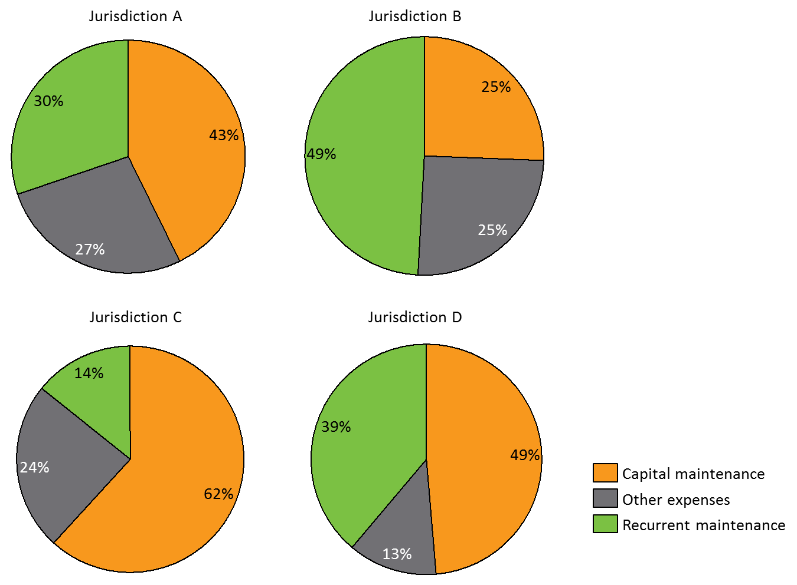
View the text version for Figure 1.
Within total ongoing maintenance costs, the ratio between capital maintenance and recurrent maintenance varies widely ranging from 19:81 to 66:34.
This difference is likely to be driven at least in part by definitional differences. As defined in the data template provided to jurisdictions, capital maintenance refers to expenditure such as: kitchen and wet area upgrades; major external building fabric upgrades; major disabled modifications; DV security; and vacancy upgrades. (In one jurisdiction - this is calculated as $50k per remote house over 10 years, which we have included as a $5k annual cost). As capital maintenance is an estimated figure, there is likely considerable difference in estimation methods across jurisdictions.
Variation could also be driven by the age of capital stock and the extent to which capital refurbishments are required. Those jurisdictions with an older asset base, or a capital stock that has been subject to more extensive decline, would be faced with the need for more capital maintenance.

Other costs comprise employee expenses, bad debts and utility costs
Non-maintenance expenses – comprising employee related payments, bad debts, water, insurance, and any other expenses – comprise 13 to 27 per cent of total cost (as shown in Figure 1).The breakdown of non-maintenance expenses is provided in Figure 2 below.
There is insufficient consistent data available to draw meaningful conclusions about the differences in ‘other costs’ associated with the delivery of remote Indigenous housing. There do not appear to be detailed breakdowns on tenancy management costs available on a consistent basis across jurisdictions. This presents an opportunity to move towards reporting against a common set of categories with agreed definitions.
Where more detailed data is available (from one jurisdiction), insurance costs appear to account for 15 per cent of non-maintenance expenses, while bad debts range from 8 per cent to 12 per cent. There is a high range of variability in employee-related expenses, making up 30 per cent to 73 per cent of total non-maintenance expenses.
Figure 2: Detailed annual cost breakdown (excl. capital and recurrent maintenance), 2017/18 budget,,
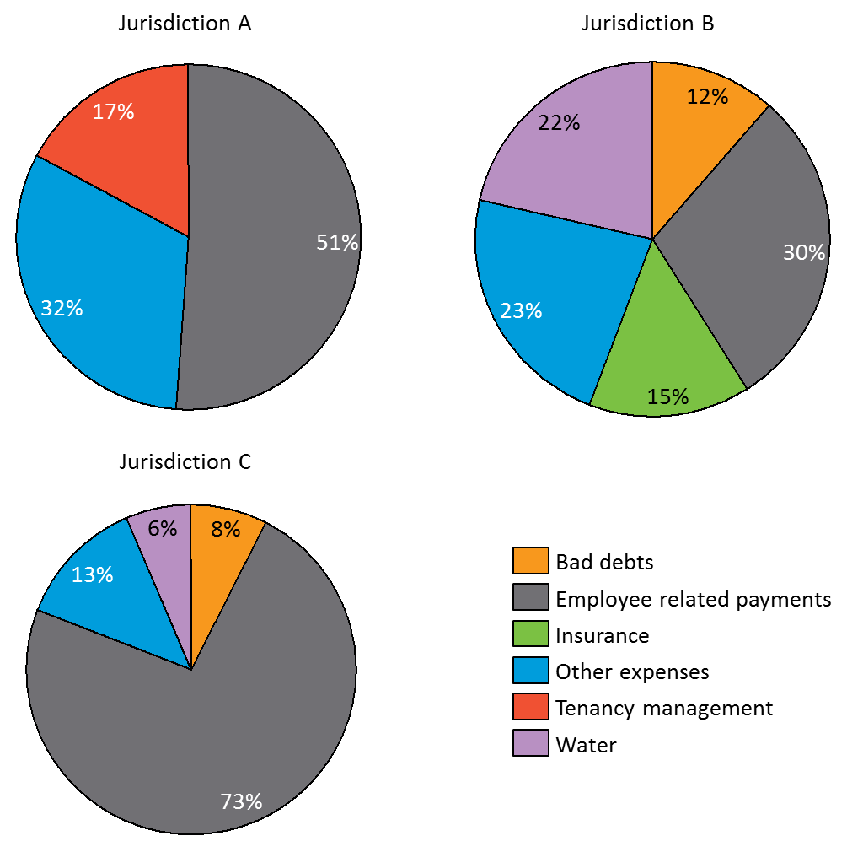
View the text version for Figure 2.

Costs of specific maintenance activities are significantly higher under NPARIH than public housing
As part of this analysis, jurisdictions provided an indicative distribution of costs for six repair and maintenance activities, across different communities and works packages.
The variability in cost is apparent in the distribution of costs across the six repair and maintenance activities, which jurisdictions were able to supply data on. These were:
- Replace smoke detector(s)
- Replace solid core door(s)
- Replace external lock set(s)
- Replace stove(s)
- Replace internal tap(s) – top half
- Pump out septic tank(s)
Analysis of data available on the costs of individual maintenance items shows that the costs under NPARIH communities are, for the most part, far higher than that of housing in regional Indigenous communities and other public housing. This is evident in Figure 3, displaying per-unit cost comparisons for selected repair and maintenance items with mainstream public housing and regional Indigenous housing, indexed to the cost of equivalent activity in mainstream public housing.
More than half of maintenance and repair activities in remote Indigenous housing cost between 1.4 and 4.5 times the cost of the equivalent activity in mainstream public housing. At the extreme, costs of specific maintenance and repair items can be up to 47 times higher in remote Indigenous communities. (The drivers of the above cost disparities are explored in detail in Sections 3 and 4 below.)
Figure 3: Cost of repair and maintenance activities in Indigenous communities (indexed to cost of equivalent activities in mainstream public housing)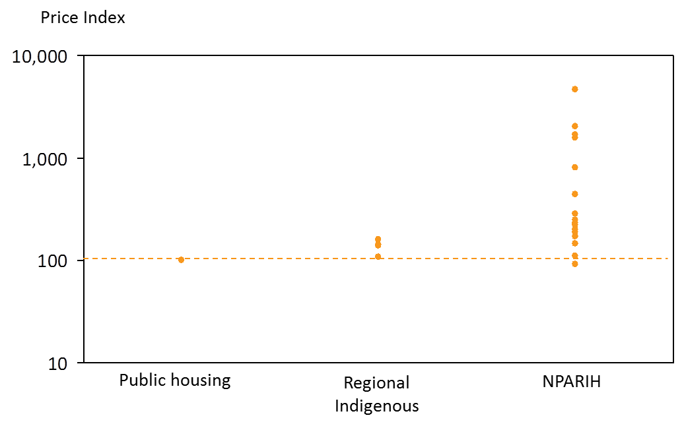
View the text version for Figure 3.

On average, 84 per cent of the costs of delivery are not covered by rental income
As discussed elsewhere in this review, the jurisdictions apply a variety of rental income regimes across Australia. As a general rule, these various approaches to rent setting and collection are based on some notion of ability to pay, rather than willingness to pay or any notion of market rents.
As the data from the jurisdictions in the following figure shows, in most cases, public housing results in much smaller cost shortfalls in comparison to remote Indigenous housing.
- Based on a limited sample of communities, the data shows that annual rental income for remote Indigenous housing covers 16 per cent of costs, on average, excluding depreciation. Across jurisdictions, rental income collection ranges between 11 and 21 per cent of costs.
- This is in stark contrast to public housing in metropolitan areas where almost 90 per cent of costs can be covered by rental income.

Figure 4: Rental income as a proportion of annual ongoing cost, by jurisdiction (2017/18 budget)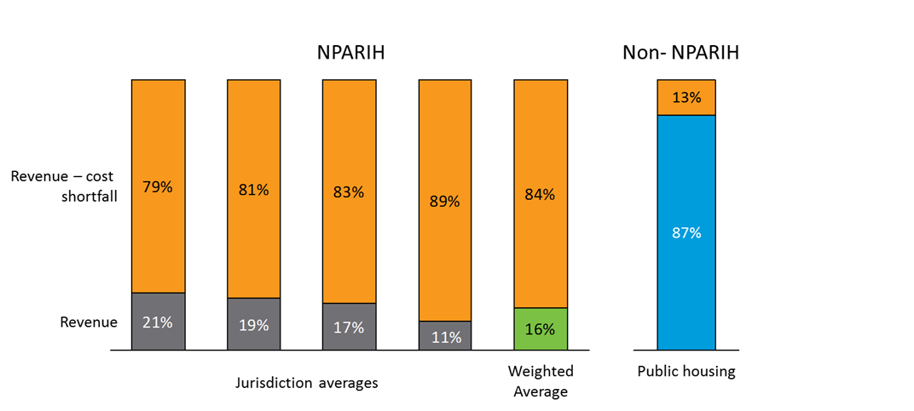
View the text version for Figure 4.
This analysis is undertaken at a high level, noting the small number of data points, variability in the data from the trend, and inherent challenges of dealing with a small sample size. Further detailed analysis of the differences of housing costs across communities is included in Section 3.
Figure 5 shows that there are particular types of communities or levels of remoteness driving either a higher or lower ratio of costs to rental returns. Even when taking the varying sizes of remote Indigenous communities into account, the data shows a broadly linear relationship between costs and revenue such that:
- There are some outliers where the proportion of costs not covered by rental income is much lower than 84%
- There are no communities where the proportion of costs not covered is much higher that 84%
This analysis is undertaken at a high level, noting the small number of data points, variability in the data from the trend, and inherent challenges of dealing with a small sample size. Further detailed analysis of the differences of housing costs across communities is included in Section 3.
Figure 5 : Distribution of annual costs and rental income for various public housing settings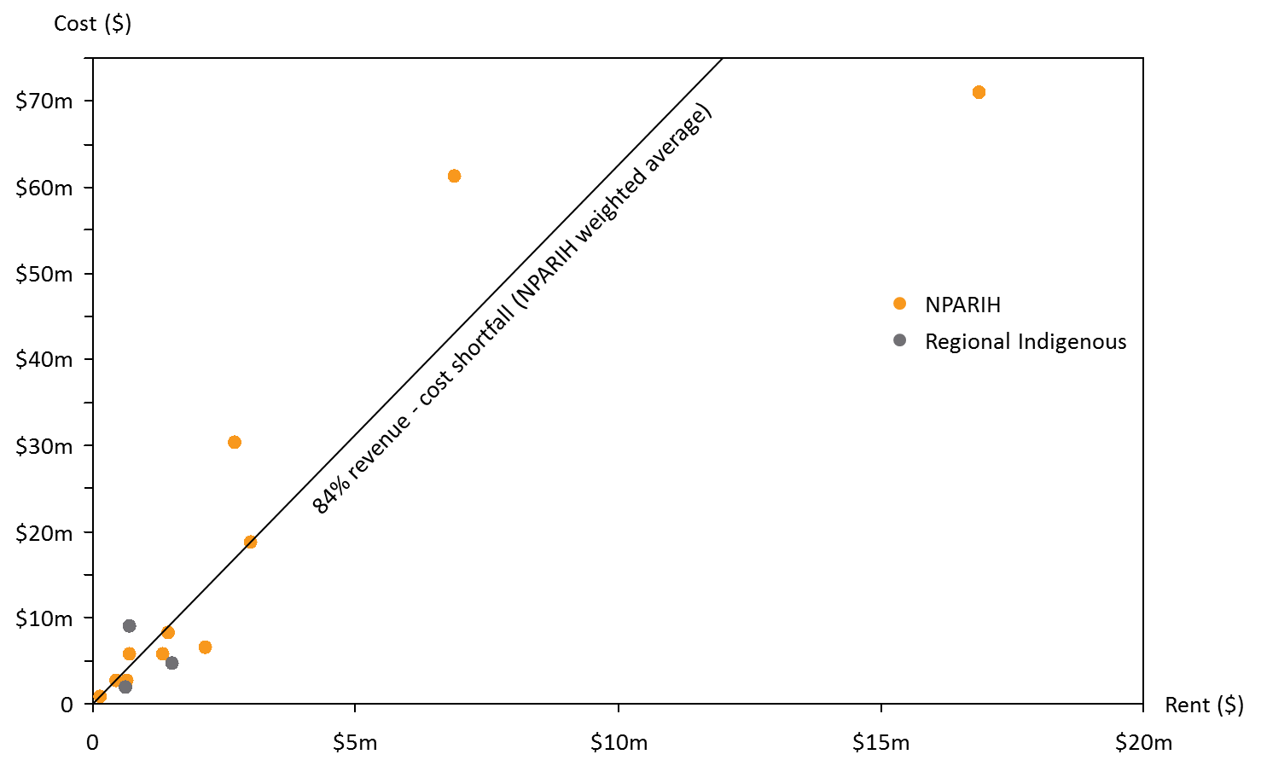
View the text version for Figure 5.

The revenue-cost shortfall is largely driven by much higher ongoing costs rather than a lower rental income when compared to public housing
The revenue-cost shortfall per dwelling in remote Indigenous housing is estimated to be 16 times the shortfall in mainstream public housing. This difference between mainstream public housing and remote Indigenous housing is mostly attributable to a significantly higher relative cost, and to a lesser extent, lower relative rental income. As shown in Figure 6, approximately 80 per cent of the difference in cost shortfall is accounted for by a relatively higher cost in remote Indigenous housing, while the relatively lower rental income in remote Indigenous housing accounts for 20 per cent of the difference.
Recurrent maintenance and capital maintenance are the major drivers of this difference in cost, with recurrent maintenance costs estimated to be 3 times higher in remote Indigenous housing than mainstream public housing, and capital maintenance costs estimated to be 15 times higher in one jurisdiction.

Figure 6: Revenue-cost shortfall (per dwelling) – breakdown of difference in shortfall between public housing and NPARIH
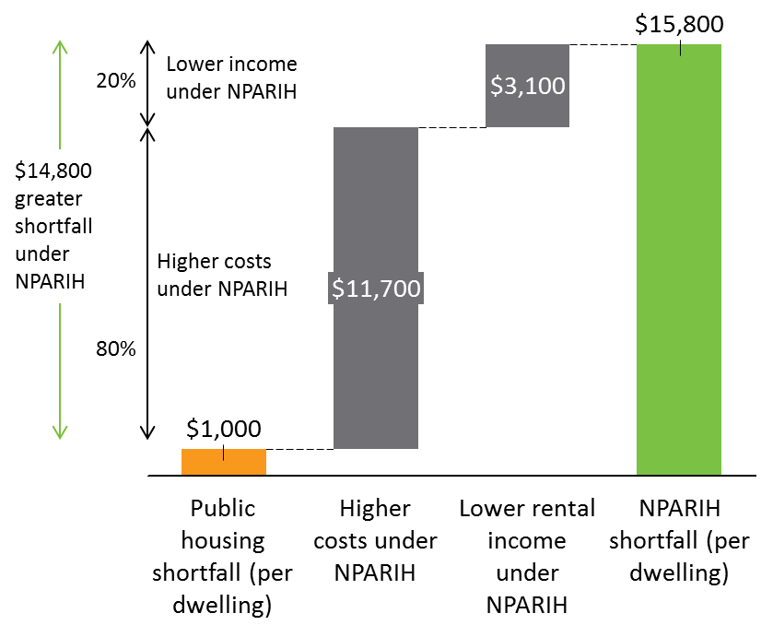
View the text version for Figure 6.

The key drivers of cost are remoteness and emergency maintenance activities

Maintenance costs are highly variable within NPARIH
In addition to being significantly higher than mainstream public housing, the cost of repair and maintenance activities is also highly variable within NPARIH. This is evident in Figure 7, with a high level of variability across all six maintenance and repair activities, plotted on an exponential scale.
On comparable data points (specifically for stove replacements), the cost of specific repair and maintenance activities identified in this analysis lies within a similar range of those estimated by AHURI.
The major drivers of this variability and the extent of their controllability are explored in detail in the sections that follow.
Figure 7: Cost distribution of selected maintenance and repair items in NPARIH communities
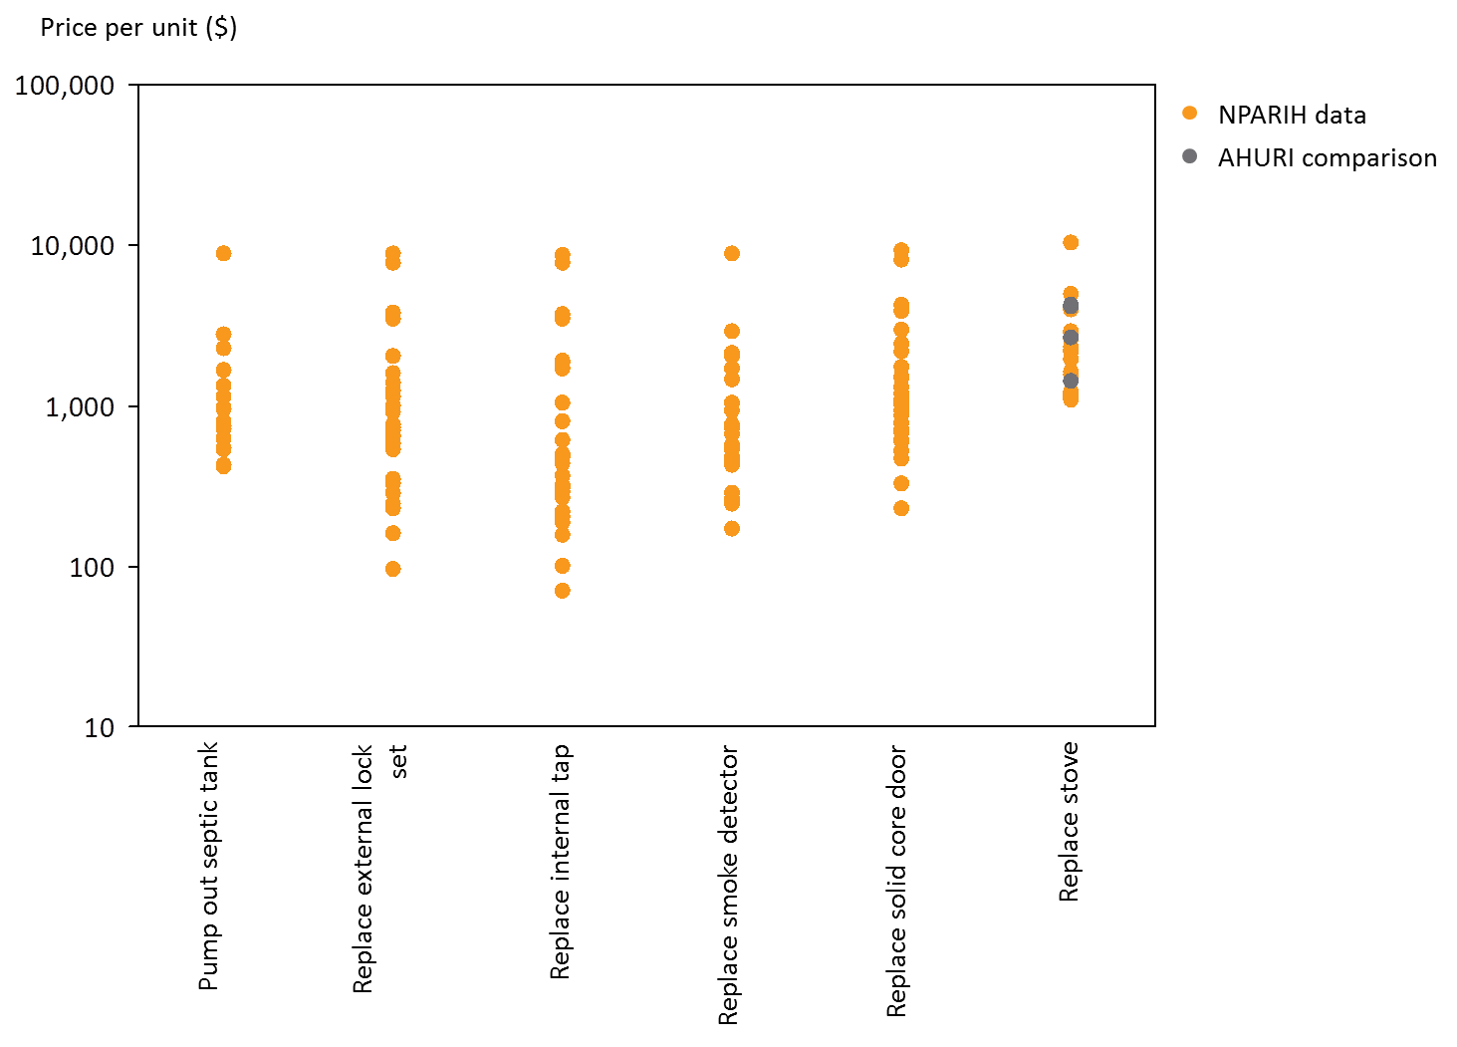
View the text version for Figure 7.

Jurisdictions have a strong sense of which costs are controllable and uncontrollable
The high cost of delivery of remote Indigenous housing is driven by a number of factors, varying in their relative size and significance and ranging from directly controllable to entirely uncontrollable.
For the purpose of this analysis, the various drivers of cost have been approached using a framework of classification under three levels of ‘controllability’:
- Entirely uncontrollable exogenous factors
- Factors directly controllable under the chosen Property and Tenancy Management Approach
- Other factors, over which jurisdictions and service providers have some level of control, but are not directly under the influence of the chosen PTM approach.
The key cost drivers identified by jurisdictions under each of the three levels of ‘controllability’ are provided in Table 2 below. The various drivers were identified and explored in the workshop with all jurisdictions in January 2017. Each of these classifications is explored in turn in the sections below.

Table 2: 'Level of control' framework for NPARIH cost drivers
Classification | Drivers
Uncontrollable factors | - Location characteristics, including:  - Extreme weather conditions, leading to increased maintenance costs and accelerated deterioration of properties  - Remoteness, including long distances from services and increased travel time for maintenance and repair activities.  - Community size, including the availability and level of service from local providers and the level market competition  - Cultural factors, including:  - Home maintenance practices  - Overcrowding and transient populations  - Culturally sensitive locations limiting construction and maintenance activities  - Infrastructure, including:  - Quality of plumbing, drainage and other infrastructure  - Water quality (and its effect on housing assets)  - Land tenure associated with native title and traditional land ownership issues  - Procurement model
Factors controllable under PTM approach | - Frequency of maintenance  - Proactive vs reactive maintenance decisions  - Refurbishment vs replacement decisions
Other factors (some level of control) | - Build decisions (design and materials)  - Standard of service  - Tenant behaviour  - Transport decisions  - Contract scale  - Local/indigenous participation requirement

As shown in Table 2, there are factors directly under the control of jurisdictions’ PTM approaches which affect annual repair and maintenance costs in remote Indigenous communities. In particular, the way in which repair and maintenance jobs are planned and bundled, was identified by jurisdictions as a major driver of cost. Repair and maintenance items can be largely considered as being either reactive or proactive.
Proactive repairs and maintenance includes all planned activities. This typically includes annual repair maintenance activities which reduce the risk of damage or improper function of specific items. For the purpose of this analysis, jurisdictions provided an estimate per unit repair cost of selected repair activities for a planned maintenance bundle of 40 jobs.
Reactive repairs and maintenance includes any repair and maintenance works undertaken following damage or improper function, usually identified by a tenant. For the purpose of this analysis, jurisdictions provided an estimated per-unit cost of selected repair and maintenance activities for:
- Responsive maintenance bundle (15 jobs). This includes non-urgent repair and maintenance activities which can be bundled with other jobs.
- Emergency maintenance activity (1 job). This includes urgent repair and maintenance activities which cannot be delayed for bundling with other jobs, due to safety or functionality.

The relationships between remoteness and costs are complex

There are no simple ways to describe the extent of remoteness of a regional Indigenous community
The most significant uncontrollable driver of cost in NPARIH is broadly agreed to be the level of remoteness. This is supported by widespread experience within jurisdictions, and borne out in the data collected on maintenance and repair activity costs as detailed later in Section 3.
In order to fully investigate the effects of remoteness on PTM cost, data collected from jurisdictions included an analysis of the level of remoteness of NPARIH communities. Jurisdictions were asked to provide a sample of communities against four indicative levels of remoteness – Regional Indigenous (non-NPARIH), Remote, Very Remote and Island. These classifications were included to further provide a more nuanced analysis of the different levels of remoteness than the standard ABS ‘Remoteness Structure’ utilised under the Australian Statistical Geography Standard. Jurisdictions were also asked to provide data points against mainstream public housing for comparative purposes.
Loose guidelines for remoteness classification are provided below. Detailed lists of communities by remoteness level are included in Appendix B.
Analysis of the impact of remoteness on cost in this section is based on the classification of communities provided by jurisdictions against the above categories.

Table 3: Remoteness classification guidelines provided to jurisdictions
 | Remoteness category | Guideline | Example community
NPARIH | Remote | > 2 hours travel from regional town. | Yalata (220 km from Ceduna)  Woorabinda (40km to next town, 170km from closest regional city)  Bayulu (271km from Derby)
 | Very Remote | > 6 hours travel from regional town. | Piplyatjara (814 km from Coober Pedy)  Aurukun (206km to next town, 817km to closest regional city)  Mulan (608km from Kunanurra)
 | Island | Offshore communities. Travel requires barge/plane/helicopter. | Kalumburu (565km from Kununurra)  Palm Island
Comparison (non-NPARIH) | Regional Indigenous | Non-NPARIH Indigenous housing outside of major cities. | Davenport (5 km from Port Augusta)  Cherbourg (6km to next town, 171km to closest regional city)  Kardaloo (123km from Geraldton)
 | Public | Mainstream public housing (may include both Indigenous and non-Indigenous). | Metropolitan

The impacts of remoteness are recognised in industry cost standards
Remote Indigenous housing provision, by its nature, faces a number of uncontrollable factors over and above those faced in mainstream public housing. These cost drivers can be considered ‘facts of life’, which must be dealt with and managed by remote Indigenous housing providers, but cannot be directly reduced by any activity under NPARIH.
Along with NPARIH experience, expert literature supports the view that costs increase significantly with remoteness.
As shown in Table 4, costs of construction in regional and remote towns are found to be up to double the levels of costs in metropolitan areas.
Table 4: Selection of Rawlinsons construction cost indices
State/ index base | Location | Cost index
QLD  Base = Brisbane | Brisbane | 100
 | Kingaroy | 105
 | Normanton | 160
 | Bamaga | 170
 | Weipa | 180
 | Lockhart River | 180
 | Torres Strait Island | 180-200
 | Mornington Island | 200
WA  Base = Perth | Perth | 100
 | Broome | 150
 | Derby | 155
 | Kununnurra | 160
NT and SA  Base = Adelaide | Adelaide (SA) | 100
 | Port Augusta (SA) | 115
 | Port Lincoln (SA) | 118
 | Ceduna (SA) | 130
 | Coober Pedy (SA) | 140
 | Oodnadatta (SA) | 150
 | Darwin (NT) | 123
 | Alice Springs (NT) | 117
 | Katherine (NT) | 139
 | Tennant Creek (NT) | 164
 | Yulara (NT) | 175
 | Milikapiti (NT) | 191

Fien & Charlewsorth (2012), identify the key reasons for high costs of providing and managing housing in remote areas of Australia as being:
- Increased cost of materials due to distance from sources of building materials and a lack of competition
- High costs of transporting materials to remote building sites
- Shortage of trades people and high costs of external labour
- Lack of competition in tender processes
- Poor economies of scale in purchasing
- Higher labour costs from having only a 6-7 month construction season due to climate issues in some parts of Australia
- Greater costs of infrastructure – costs that must be divided across a relatively low number of residents compared with urban and provincial centres

Remoteness affects cost for all maintenance activities
When looking at individual maintenance and repair items, there is a clear link between remoteness and per-unit cost. Figure 8 displays the cost of various repair and maintenance activities in very remote and island communities, indexed to the cost of the equivalent activity in remote communities. As evident in the chart, 80 per cent of maintenance activities are more costly in very remote communities than remote communities, while 71 per cent of activities are more costly in island communities than the equivalent activity in remote communities.
The majority (57 per cent) of repair and maintenance activities in very remote communities cost between 1.3 and 5.1 times the equivalent activity in a remote community. Fifty-nine per cent of activities in island communities also lie in this range.
The cost difference between remote communities and very remote and island communities is not confined to any subset of particular activities. The figure below displays no clear difference in remoteness effect for one or more particular activity.
Figure 8: Cost of maintenance activities by remoteness classification, indexed to cost in remote communities, grouped by maintenance and repair activity, (exponential scale)
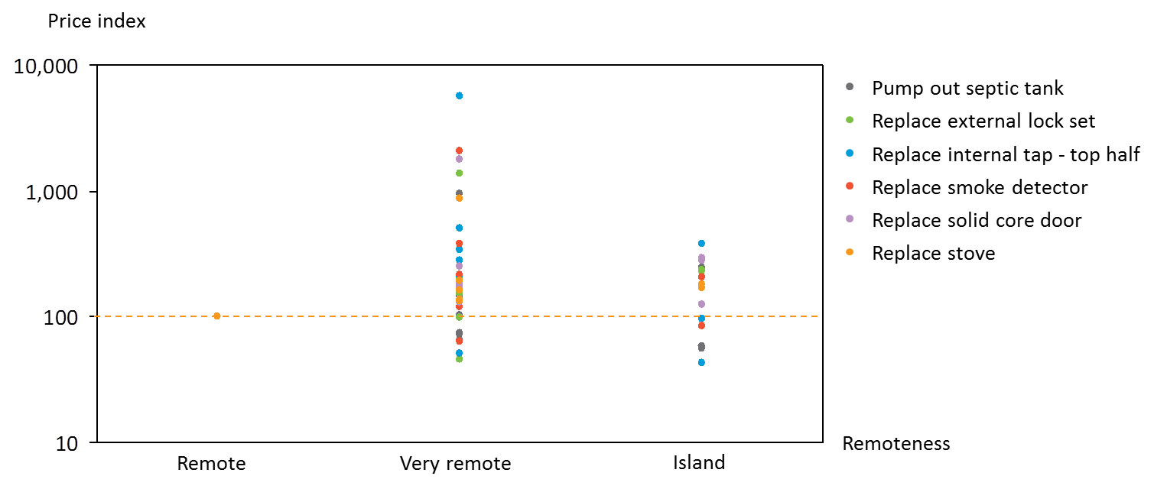
View the text version of Figure 8.
Very remote and island communities also experience a greater variability in maintenance and repair costs than remote communities. This is shown in Figure 9, which displays the middle 50 per cent (interquartile range) of cost items for maintenance and repair activities for each of the three levels of remoteness. While the first quartile values sit at similar levels for all three remoteness classifications, the third quartile values are significantly higher in very remote and island communities, than in remote communities.

Figure 9: Distribution of all maintenance and repair costs per-unit, by remoteness classification
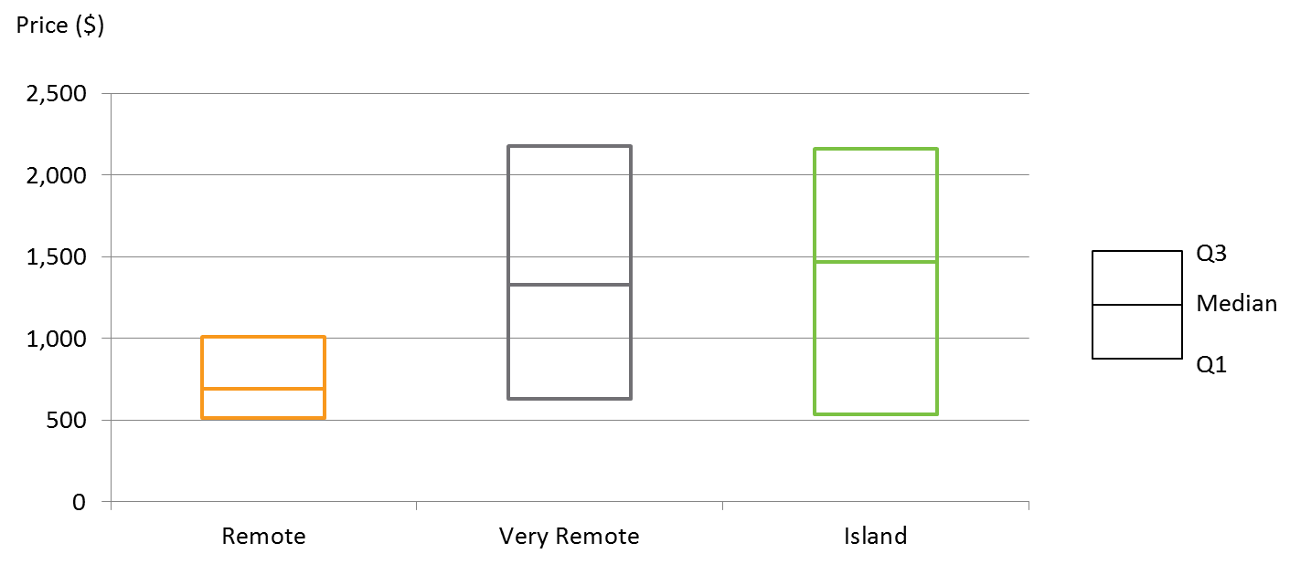
View the text version for Figure 9.

Analysis of individual repair items shows a relatively consistent slope with costs rising to 2 to 3 times in island communities
While very remote or island settings do not automatically result in higher overall recurrent maintenance costs, analysis of discrete maintenance and repair activities shows a distinct effect of remoteness.
Figure 10 and Figure 11 below show a clear increase in mean repair and maintenance costs by remoteness.
Costs of replacing a smoke detector (in a responsive maintenance bundle), are shown in Figure 10. In this example, a positive linear trend in mean repair cost is evident. Analysis suggests a $435 increase in mean repair cost as remoteness increases (going from remote, to very remote, to island locations). The mean cost in island communities is approximately three times the mean in remote communities. Minimum and maximum per-unit repair cost also increase with remoteness.
Figure 10: Distribution of per-unit costs of replacing a smoke detector (responsive maintenance)
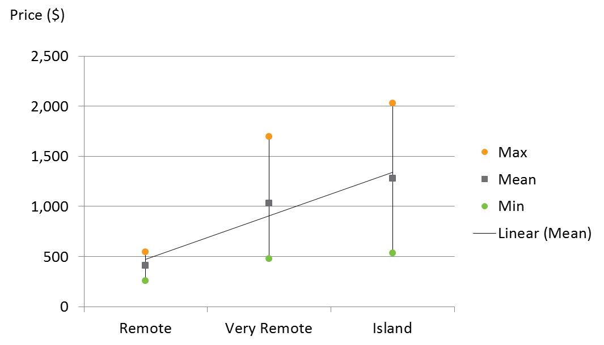
View the text version for Figure 10.
Costs of replacing a stove (in a responsive maintenance bundle), are shown in Figure 11. As in Figure 10, a positive linear trend in mean repair cost is evident. Analysis suggests a $770 increase in mean repair cost as remoteness increases. The mean cost in island communities is approximately double the mean cost in remote communities. Once again, minimum and maximum per-unit repair cost also increase with remoteness.
Figure 11: Distribution of per-unit costs of replacing a stove (responsive maintenance)
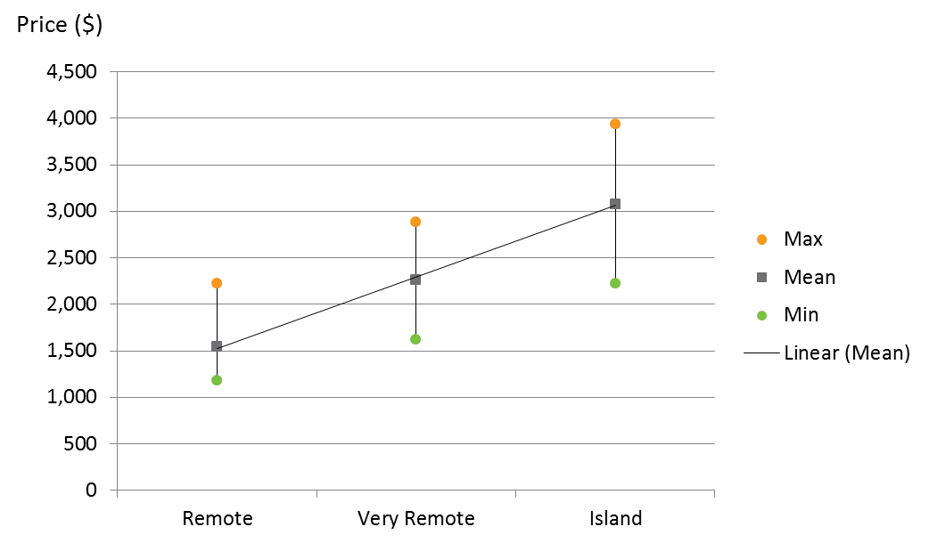
View the text version for Figure 11.
While the above analysis is conducted on a small set of data, available quantitative and qualitative evidence indicates that the effects of remoteness are significant and largely unavoidable.

Emergency maintenance can drive costs up to 20 times higher

Emergency maintenance costs are on average 75 per cent higher than planned maintenance costs
Analysis of works packaging indicates that the median cost of emergency maintenance and repair activities is 75 per cent higher than planned activities, while responsive activities are 50 per cent more costly than planned.
At the extremes, some maintenance and repair activities are up to 20 times higher in an emergency situation than in a planned maintenance package.
Figure 12: Distribution of per-unit cost by work package (indexed to planned bundle, exponential scale)
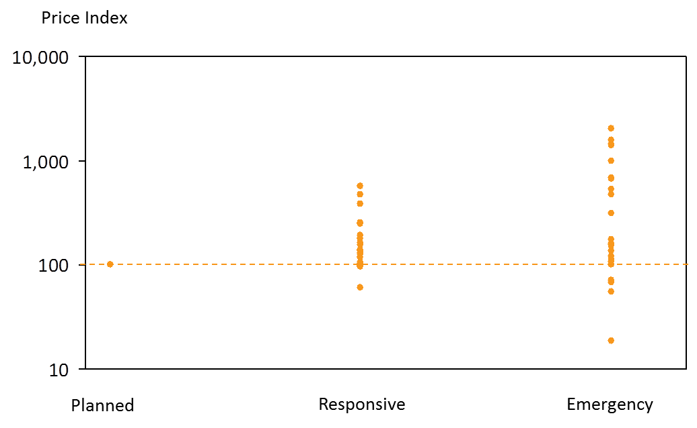
View the text version for Figure 12.

Emergency maintenance costs are also significantly more variable than planned and responsive activities. The coefficient of variation (a measure of relative variability from the average) of per-unit costs is 77 per cent for planned maintenance, 88 per cent for responsive maintenance and 142 per cent for emergency repairs.

The effects of remoteness are 7 times greater for emergency repairs than for planned maintenance
The impact of job bundling is most significantly borne out in very remote communities. As shown in Figure 13, the greatest effects of remoteness are found in emergency repair activities. On average, emergency repairs cost 8.5 times the equivalent activity in very remote communities. This is in contrast to planned maintenance activities, which in very remote communities cost on average 1.3 times their equivalent in remote communities.
Figure 13: Very remote: remote cost ratio - distribution of maintenance cost in very remote communities relative to equivalent activity in remote communities (index base = per-unit cost in remote communities)
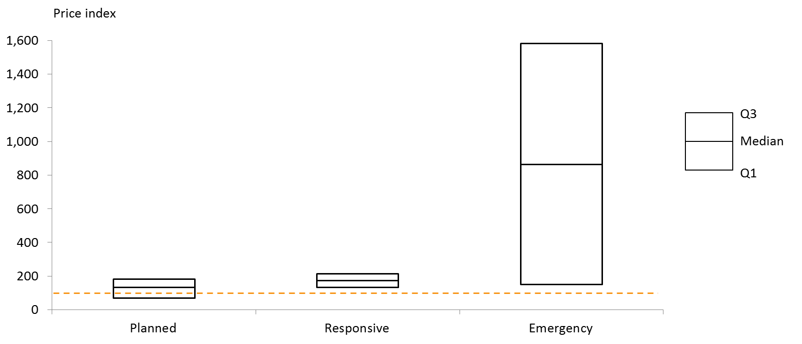
View the text version for Figure 13.

Travel costs account for up to 96 per cent of emergency repair costs
The disparity in emergency costs across the different levels of remoteness can be attributed to the inability to share travel costs across multiple jobs. As shown in Figure 14, travel costs can account for up to 96 per cent of per-unit costs for emergency repairs, compared with 11 per cent to 37 per cent for planned maintenance activities.
Figure 14: Breakdown of per unit-maintenance costs in very remote communities
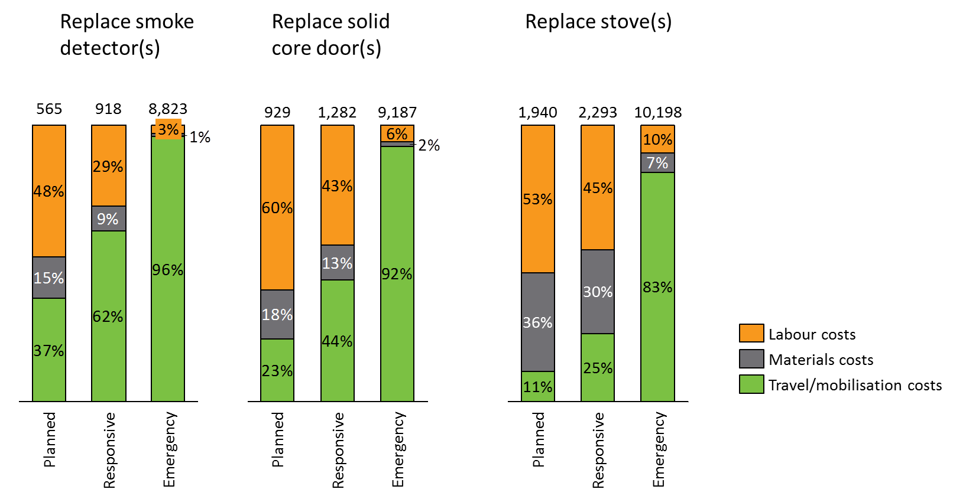
View the text version for Figure 14.

Jurisdiction experience indicates targeted cost savings are possible, but there are ultimately irreducible costs

Cost savings may flow from changes to PTM approaches, both broad and targeted
Consultation with jurisdictions indicates macro level changes are more difficult to implement and less certain to generate cost savings than discrete, targeted improvements. Changes to the overall approach to Property and Tenancy Management are typically made as an incremental business as usual process. As such, these are more difficult to implement via a distinct change in approach, with benefits measurement equally difficult.
Examples of macro level changes, as identified by jurisdictions, include:
- Strategic approach to the procurement of maintenance, through the consolidation of contracts for all state government maintenance works
- Upskilling general sub-trade handypersons to perform non-specialised activities. Findings by Habibis et al. in a 2016 review of property and tenancy management on remote Indigenous communities suggest this should be coupled with increased inspections of finished work, including photographs or videos by handypersons for review by a centralised maintenance team
Other factors in improving repairs and maintenance costs, as identified by Habibis et al., include:
- Providing better information to tenants on realistic repair and maintenance expectations, and explanation for delays (due bundling of jobs etc.)
- Standardisation of components and fittings. This allows stockpiling of commonly required items and enables maintenance to be undertaken in situations where communities are inaccessible by road (due to weather or accessibility).

Case Study A: Procurement of maintenance
One jurisdiction has achieved savings in maintenance costs through issuing a consolidated contract for all state government maintenance works, not just NPARIH housing.
The region has a very small number of properties spread across vast distances that receive a full maintenance and tenancy management service. The scale and remoteness limits local employment opportunity and impacts on value for money, given the low level of competition.
A number of other state government departments (14 in total) maintain facilities or staff housing in the region, including schools, police stations, early childhood centres and clinics, with similar issues related to scale and remoteness. It was observed that up to three air conditioning services were present in one community servicing three different arrangements.
The government has consolidated all facility and employee housing repairs and maintenance management in the region to generate scale, strengthen local job opportunity and promote value for money. A consolidated contract has been tendered for all state government maintenance works. The new pricing will see a significant reduction in costs associated with the delivery of maintenance services and increased capacity to recruit local employees and apprentices due to the length of the contract and the volume of works now available.
The contractor will work with schools and the regional trade training centre to generate skill development and vocational opportunities. Small business enterprises are also possible, starting with air conditioning pad making. This will save shipment of pads and provide opportunity for local people to make the pads on site, required for servicing and replacement.
There are some clear benefits to this arrangement:
- better utilisation of funds and resources allocated across state agencies towards region
- increased employment and apprenticeship opportunities
- opportunities for small business enterprises
- more efficient and timely servicing.

Experience across the participating jurisdictions has also identified specific targeted examples of reducing costs. Targeted changes, of which there are many examples, show direct benefits but are not clearly catalogued.
These provide a starting point to generate a shared evidence base of good practice and cost-effective measures, for the benefit of all jurisdictions.
Savings achieved include:
- Change in the design and materials used for bathroom refurbishments and new builds
- Change in batteries used in smoke alarms
Two such case studies are provided below.
Case Study B: Smoke Alarm product alternative
The cost to one jurisdiction of replacing the current hardwired smoke alarms in the 2015/2016 financial year was almost $950,000. Over 75% of this cost was attributed to the cost of travel required for ad-hoc replacements. Over a ten year period, this equates to a cost of $9.5 million which is not sustainable. Having a number of defective / damaged Smoke Alarms in remote Aboriginal properties also creates considerable risk to tenants, properties and the housing authority.
A number of contributing factors were identified:
- Tenant damage - Smoke alarms being broken by the tenants is a common problem in remote Aboriginal communities. When the power runs out (see ‘power outages’ below), the smoke alarms default to a rechargeable battery power supply and the smoke alarm emits a constant warning sound. To stop the noise, the tenants often break them by knocking them off the ceiling with a broom or similar object.
- Power outages - caused by the supply dropping out, community generators not working or being turned off / turned on and pre-paid electricity plans not being topped up.
- Faulty wiring - Across all properties smoke alarms sometimes fail due to faulty wiring though this appears to occur more regularly in remote Aboriginal communities.
- Vandalism - Damage due to random acts of vandalism or even to stop a genuine warning sound.
- Poor placement - Too close to cookers / bathrooms causing excessive warning sounds to be emitted.
- Low tenant awareness - Tenants are not generally aware of ways to reset smoke alarms or of their liability in relation to damages they may cause.
The jurisdiction has initiated a project to introduce 10-year lithium battery powered smoke alarms that are not reliant on the mains power supply in order to function. This is expected to deliver:
- An estimated 50% reduction in smoke alarm replacement maintenance costs; and
- A reduction in risk to both tenants and properties.
CASE STUDY C: Washer product alternative
The existing rubber tap washer used in all properties in one jurisdiction is prone to leakage and being over-tightened by tenants. In areas of poor or very hard water quality this causes excessive damage to the tap seat and other tap components. This has resulted in approximately $400,000 in the 2015/16 financial year in washer replacement costs.
The jurisdiction has become aware of an alternative product, the Aqualoc ‘Monster Washer’ that is designed to eliminate leaking and over-tightening.
This project has been initiated with a goal to reduce the cost of replacing washers in remote Aboriginal communities. To achieve this goal the project objectives are to:
- Instigate a pilot project to evaluate the Monster Washer product to ascertain if it will increase washer lifecycles in remote Aboriginal communities; and
- Introduce Monster Washers into other properties if data suggests it will prove more cost-effective.
The benefits analysis of the pilot project has estimated savings on washer replacement maintenance costs in the region of 76%.

There are other factors which could deliver cost reductions that aren’t directly related to the approach to PTM
Develop a detailed understanding of the various costs over the last 4 years
Brought 2 agency procurement contract together
15-30% saving over next 12 months unit cost price reduction
Planned – before $ 33 k, after $11k
Emergency 0 before $8.5k, after $3.4k
Expected savings
Length of time – of contract
-1.5 + 3+3 years
May result in difficulty in varying contract
Replace v newbuild – SA should be doing more replacements but budget restraints prevent

Beyond the entirely uncontrollable factors and directly controllable factors identified in earlier sections of this chapter, there is a set of cost drivers which represent a middle ground between the two extremes. These are factors over which jurisdictions and service providers have some level of control, but which are not directly under the influence of the chosen PTM approach. These factors have been identified through discussions with subject matter experts within the jurisdictions and include:
- Build decisions (design and materials). While not directly within scope of this chapter of work, it is widely accepted that construction decisions play a significant role in the ongoing costs of property and tenancy management in remote Indigenous communities. A 2011 review of remote Indigenous housing construction by Rider Levett Bucknall found that any savings generated by a cheaper initial capital cost can be out-stripped by a higher on-going recurrent cost. Whilst there is an initial premium incurred for a more robust solution, there are fewer replacements required over a 30 year period. The review found that over a 30 year life cycle study, the initial capital cost represents about one third of the total life cycle cost. A 2005 study by Health Habitat also found that 26 per cent of maintenance costs are incurred as a result of faulty construction. Expert literature indicates that construction methods and materials should take particular consideration of the local environment, and Indigenous communities should be involved in planning and implementing construction programs.
- Standard of service. Similar to build decisions, jurisdictions face choices in the standard to which repairs and maintenance activities (as well as refurbishments) are carried out and the subsequent effect on ongoing repair and maintenance costs.
- Tenant behaviour. The behaviour of tenants is considered by jurisdictions to play a large role in ongoing costs. To an extent, tenant behaviour is able to be affected by tenant engagement and education. Anecdotally, better informed and educated tenants are less likely to inadvertently cause damage to property and more likely to be able to perform routine repair activities of their own accord, reducing ongoing costs of housing provision. In saying this, McPeake & Pholeros (2005) found that rough treatment and resident damage accounts for only 8 per cent of repair and maintenance needs in Indigenous houses. However, education on the correct use of cleaning products and other routine housekeeping issues is believed to reduce cleaning costs for tenants, improving the likelihood of rent collection. Good tenant engagement also increases the likelihood of damage being reported proactively, and being fixed before the consequences are greater. A specific (unquantified) example is provided in Case Study D below.
- Transport decisions. Transport decisions are closely linked with uncontrollable remoteness factors discussed earlier in this report, including seasonality of access in some areas. While transport destinations are uncontrollable, transport decisions remain to some extent within the control of jurisdictions. In particular, these include mode of transport, timing of transport and potential transport sharing with other government agencies and other service providers. Beyond the analysis of works packaging costs detailed earlier in this report, Nous’ analysis does not include a detailed analysis of the costs of various transport decisions.
- Local Indigenous employment. Expert advice indicates that local communities should be consulted on design, construction and maintenance plans and should be involved in their implementation, utilising local labour. Findings by AHURI also recommend increasing local involvement in repairs and maintenance. “The use of local handypersons can help improve repairs and maintenance outcomes as well as provide some local employment and upskilling”. Findings also suggest that local Indigenous involvement could assist tradespeople with job bundling, act as guides and interpreters and help with simple labouring tasks. A specific example is provided in Case Study E below, as demonstrated by Pholeros and Phibbs (2012).
- Changes to rent setting or rent collection policies. Rent setting policy is a revenue-increasing rather than cost-minimising approach. While our analysis has shown that the most high impact area of focus is in cost reduction, small gains are possible through increasing the amount of rent set and the amount collected. Commonwealth data indicates that there is a large variation between each jurisdiction in the amount of rent charged as well as the amount of rent collected. Increasing some of the lower value rents and applying lessons on rent collection policy from the jurisdictions which collect greater proportion of rents has the potential to increase the revenues achieved from remote Indigenous housing.
Case Study D: Tenant education
One jurisdiction achieved improvements in maintenance requirements through a tenant education program. This involved a locally based and employed tenancy educator working with families and in school settings.
The program focused on how to live in a house and included cooking education and information on appropriate cleaning products.
Following the implementation of the tenant education, the jurisdiction found an increase in rental revenue and a reduction in reactive repairs and maintenance (unquantified at this stage).
Case Study E: Highlighting the need for local Indigenous involvement: the case of Chris the plumber (adapted from Pholeros & Phibbs, 2012)
A plumber arrives with his apprentice in an Indigenous Community, having driven 250km from a regional town. He faces problems identifying the correct houses to perform repairs. He also has trouble communicating with local residents. When he finally finds someone home, he decides to replace their toilet rather than replace their damaged washer in order to pay for the trip (and his apprentice’s wages). It is unlikely he will return unless work elsewhere is very short.
If he had the support of a local Indigenous team, who could have bundled up a larger number of maintenance jobs for him, his trip would have been more profitable and productive. The local team could have assessed houses, assembled work lists, acted as guides and interpreters and helped him by doing simple labouring tasks (allowing the plumber to leave his apprentice in their home town to work on other jobs). The local team could also have earned a wage and helped the plumber to complete more work in their community during his trip.

Analysis of revenue-raising and cost-reducing scenarios show that there are significant irreducible costs
While the preceding section identifies a number of ways this shortfall can be reduced, and further areas for exploration, it is expected that the shortfall will continue to be significant, even under a range of improvement scenarios.
A number of potential shortfall improvement scenarios are outlined below. These are based on consistent achievement of existing best result benchmarks. Figure 15 and Figure 16 below show the cost shortfall under optimistic scenarios.
Figure 15 displays an improvement in rental income: cost ratio to 21 per cent (the benchmark highest current figure for any jurisdiction), while Figure 16 shows an improvement to a 33 per cent ratio (the benchmark highest current figure for any level of remoteness within NPARIH). Both figures show a current state cost of $100m for illustrative purposes only.
In other words, this analysis shows that the smallest revenue-cost shortfall of all of the NPARIH communities in our sample was 67 per cent (compared to the NPARIH-wide value of 84 per cent). This implies that there are lessons of better practice that can be learned about PTM from the communities that have the smallest shortfalls that could be applied more broadly. While this report does not include investigation of the specific practices of high performing communities (due to limitations in data availability) this is an area recommended for future in-depth investigation. However, it also indicates that unlike in the context of mainstream urban social housing, the ongoing management of remote Indigenous housing stock is far from being independently financially viable through rental collections. There is a clear need for ongoing government subsidy if remote housing stock is to be maintained.
As identified earlier in this chapter, the cost shortfall under NPARIH is largely driven by the extreme costs of housing provision in remote areas (rather than a significant rental income shortfall). As such, analysis of potential improvement scenarios focuses largely on reduction in ongoing costs, rather than improvements in rental income.

The below figures display ratio improvements firstly through a reduction in cost only (holding rental income constant), and secondly though a reduction in cost and an improvement in rental income. Scenarios involving improvements in both cost and rental income have been projected according to the proportions outlined earlier in this report, such that 80 per cent of the improvement in shortfall is accounted for by a reduction in cost, while 20 per cent of the improvement is due to an increase in rental income.
Figure 15: Cost shortfall under optimistic scenarios (21% rental income: cost ratio)
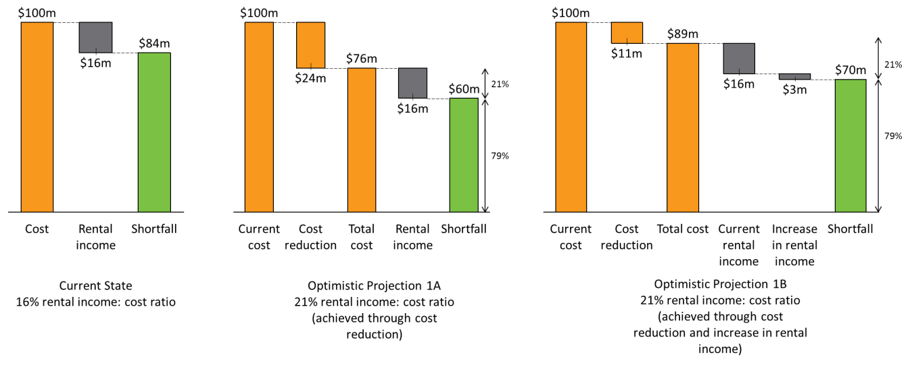
View the text version for Figure 15.

Figure 16: Cost shortfall under optimistic scenarios (33% rental income: cost ratio)
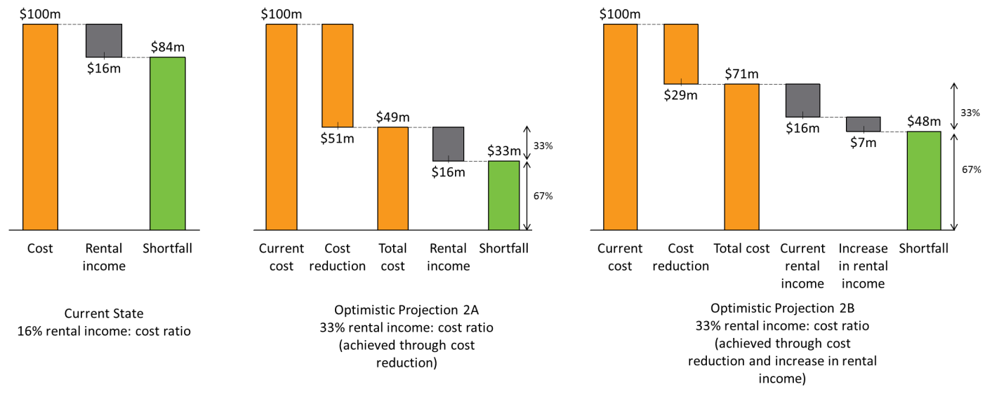
View the text version for Figure 16.
It should be noted that this scenario analysis focuses on benchmark ratios rather than shortfall figures in absolute terms. This means that shortfall projections in the figures above are higher under scenarios involving improvements in both cost and income than those involving cost improvements only. This is a result of the proportional nature of the calculations, and not included to suggest that increases in the amount of rental income collected have a detrimental effect on shortfall. Rather, it should be concluded that while cost improvements have the greatest effect on reducing shortfall, benchmark scenarios are more realistically achieved through a combination of improvements in both cost and rental income, improving proportionally towards figures attained in mainstream urban social housing.
Scenarios involving improvements in rent collection would require a 19% (Figure 15) and 44% (Figure 16) increase in rent collection respectively (net of collection costs). This appears to be attainable, as rent collected per house per week has more than doubled on average across jurisdictions since 2010/11. For example, a 19% increase in the value of rent collected could be achieved by improving the rate of rent collection across all jurisdictions from 78% of rent charged to the current best case of 93%.
It should also be noted that the above rental income: cost benchmarks (21 per cent and 33 per cent respectively) show best practice under the current state (for jurisdiction level or community level data, respectively). The best case benchmark demonstrated in Figure 16 is unlikely to be attained in the short term. This figure is based on consistent achievement of the current best case scenario of any level of remoteness included in this analysis across all jurisdictions and would thus require a widespread reduction in costs associated with remoteness via the optimisation methods outlined earlier in this section and in section 5.
This is not to say that 33 per cent is the most efficient ratio that can be achieved in the long term. Through improvements to property and tenancy management, this figure could improve. However, given how great the shortfall is, it is unlikely that a totally self-sufficient system will be achieved.

There is need for improved data collection, improved optimisation of jobs, and greater sharing of experience, evidence and expertise

Data collection could be significantly improved to better document PTM activities, and associated outcomes and costs
The challenges in collecting consistent, comprehensive and detailed data to perform this analysis highlight a broader challenge in the management of remote Indigenous housing. There is inconsistent data measurement, recording and reporting between jurisdictions, and an apparent lack of oversight from program administrators of data critical to informed decision-making on the costs of housing delivery and performance of the program.
Further opportunities to share expertise and increase identification of opportunities for improvement could involve a concerted push for greater collection of data on housing quality and maintenance cost. One such example for jurisdictions to draw upon is the Housing for Health licenced methodology. The approach used is a survey-fix program. It involves integrating service delivery with a detailed survey of housing condition, to enable accurate assessment of housing quality and to target maintenance towards the most critical issues for housing functionality. There is no survey without service, and no service without survey. From the information recorded by the survey teams, the job cost data can be integrated with data points on housing quality (before and after specific repair and maintenance activities), to gain an understanding of the ‘bang for buck’ provided by maintenance activities, with respect to housing condition.
Figure 17 below displays the improvement in critical healthy living practices (an indicator of housing quality) across two surveys, with repair and maintenance works undertaken in the intervening period. The magnitude of the improvement between both surveys is stark. Not shown is the link that can be drawn between this data and financial records, to understand how much money is typically required to bring a house up to an acceptable standard of living conditions. For the 7,543 houses that received Housing for Health program across Australia from 1999-2012, the average cost per house was $7,500, as shown in Figure 17.
Figure 17: Housing for Health projects showing proportion of houses passing health hardware assessment in 7,543 houses serviced between 1999-2012 at Survey–Fix 1 before any fix work and 6,732 houses at Survey–Fix 2 after fix works; average cost per house $7,500.
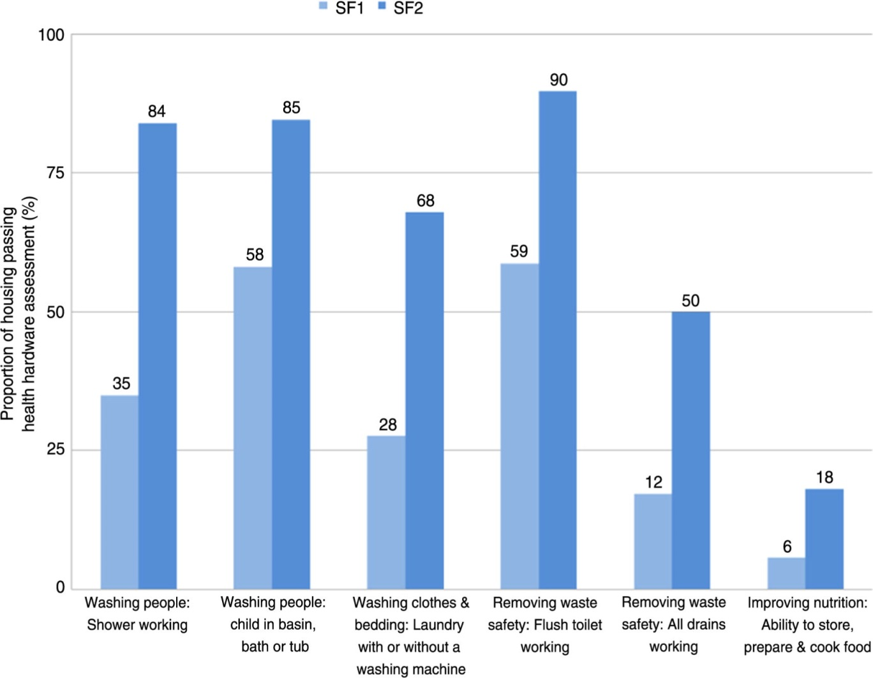
View the text version of Figure 17.
As identified in Section 4.2, expert literature also finds initial construction and design decisions impact ongoing maintenance costs. Data collection and analysis should also account for construction and design, to allow jurisdictions to gain a further detailed understanding of their effects on ongoing PTM costs.

Investment in systems to improve work package optimisation could yield significant returns
While reducing emergency repair trips is a natural starting point for reducing costs in remote Indigenous housing, there is an opportunity to investigate further savings through a concerted approach to works package optimisation.
This opportunity is consistent with recommendations in expert literature. Pholeros and Phipps (2012) found that where possible, maintenance programs should be based on periodic or cyclical (proactive) maintenance supplemented with local, ongoing testing of houses, rather than ‘responsive’ maintenance following tenant-identified issues. Proactive cyclical maintenance should also be undertaken “that is focused on ensuring housing is in good condition before major seasonal changes such as the onset of the wet season or summer and winter seasons.”
As shown in Figure 18, specialised tradesman can perform a number of jobs, ranging widely in cost, within the same trip to a particular community. Analysis of planned and responsive maintenance activities should be conducted to optimise costs based on prioritisation decisions, minimising per-unit travel costs where possible, and maximising the number of jobs performed on a particular trip. This may also include visiting several communities within one repair and maintenance trip, and sourcing tradespeople from the most cost-effective locations.
Figure 18: Distribution of job prices for plumbing services
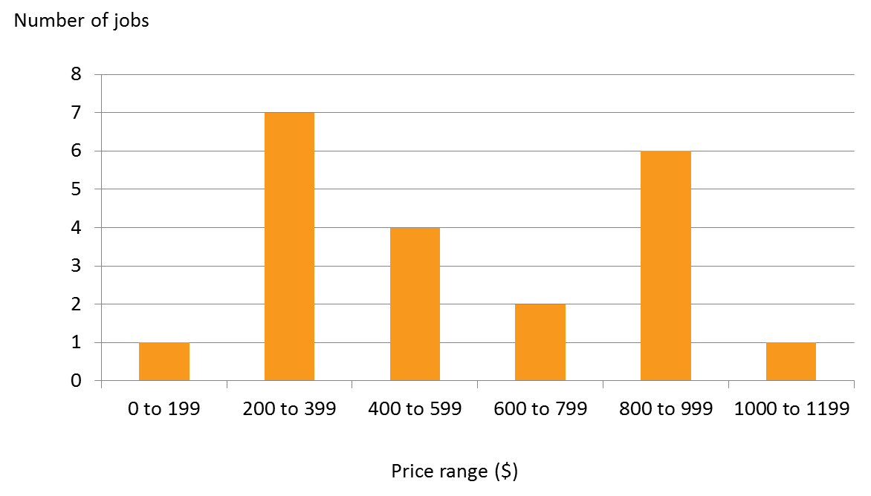
View the text version of Figure 18.
At a discrete maintenance and repair activity level, reduction in emergency activities can result in significant savings. If forty separate emergency repair activities were to be avoided by a planned maintenance bundle of 40 jobs, this would result in an average reduction in cost of between$135,000 and $215,000. This is shown in Table 5 below.
Table 5: Potential cost savings in very remote communities from avoiding 40 emergency maintenance activities
Maintenance activity | Cost saving per planned bundle
Replace external lock set(s) | $ 183,065
Replace internal tap(s) - top half | $ 137,495
Replace smoke detector(s) | $ 214,980
Pump out septic tank(s) | $ 187,507

Further projections of savings as a result of avoiding emergency repairs (via planned maintenance) are demonstrated in Figure 19 below.
Figure 19: Reduction in cost achieved by avoidance of emergency maintenance activities in very remote communities
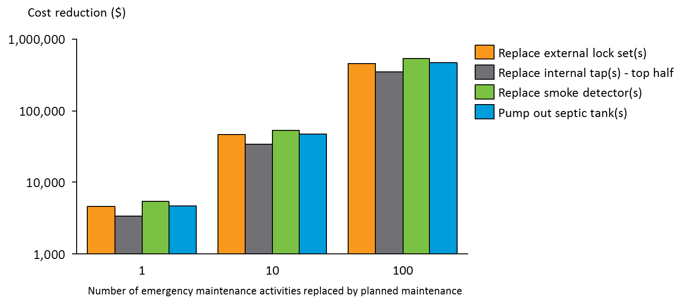
View the text version of Figure 19.

The jurisdictions sharing experience, evidence and expertise will catalyse improvements in PTM approaches in remote Indigenous housing
There is a high degree of professionalism and mutual respect between the four participating jurisdictions, and substantial goodwill towards our process to undertake this analysis of the financial costs of PTM. This was evidenced by openness to meeting with Nous to discuss the issues at a broad level, strong engagement at the workshop with jurisdictions in Adelaide, and the completion of the cost template.
It is clear that there is a wealth of expertise held across jurisdictions, and an opportunity to share experiences on delivering remote Indigenous housing for mutual benefit. This includes clear opportunities for:
- Documenting and learning from shared challenges
- Benchmarking the costs and delivery of outcomes in PTM for remote Indigenous housing
- The development and dissemination of good practices, including quantification of the most significant drivers of cost reduction.
At the workshop with jurisdictions in Adelaide, State and Territory representatives acknowledged the opportunity to share experiences, evidence and expertise, and made a commitment to do so in the coming year.

- Excerpt from cost template

 |  | Remote |  |  | Very Remote etc.
Maintenance activity | Cost categories | Planned (40 orders) | Responsive (15 orders) | Emergency (1 order) | Planned (40 orders) | Responsive (15 orders) | Emergency (1 order)
Replace smoke detector(s) | Materials costs | $ xx | $ xx | $ xx | $ xx | $ xx | $ xx
 | Labour costs | $ xx | $ xx | $ xx | $ xx | $ xx | $ xx
 | Travel/mobilisation costs | $ xx | $ xx | $ xx | $ xx | $ xx | $ xx
TOTAL |  | $ xx | $ xx | $ xx | $ xx | $ xx | $ xx
- Remoteness classifications
 | Remoteness | Guidelines | Jurisdiction | Communities
NPARIH | Remote | > 2 hours travel from regional town. | SA | Dunjiba  Yalata  Koonibba  Umoona
 |  |  | WA | Burawa (260km from Derby)  Bungardi (264km from Derby)  Bayulu (271km from Derby)  Gilaroong (271km from Derby)  Lamboo Gunian (378km from Kununurra)  Joy Springs (279km from Derby)  Moongardie (390km from Derby)  Lundja (358km from Kununurra)  Mardiwah Loop (358km from Kununurra)  Nicholson Block (358km from Kununurra)  Kurnangki (256km from Derby)  Mindi Rardi (256km from Derby)  Junjuwa (256km from Derby)  Parukupan (256km from Derby)  Darlngunaya (256km from Derby)  Ngurtuwarta (266km from Derby)  Muludja (288km from Derby)  Yakanarra (384km from Derby)  Beagle Bay (100km from Broome)  Bobieding (100km from Broome)  Yungngora (237km from Derby)  Koorabye (247km from Derby)  Yulga Jinna (397km from Newman)  Djugerari (368km from Derby)  Yandeyarra (130km from Port Hedland)  Warralong (182km from Port Hedland)  Jigalong (165km from Newman)  Djarindjin (200km from Broome)  Lombadina (200km from Broome)  Ardyaloon (220km from Broome)  Cosmo Newberry (439km from Kalgoorlie)  Wongatha Wonganarra (359km from Kalgoorlie)  Bondini (538km from Kalgoorlie)  Mount Margaret (340km from Kalgoorlie)  Ngalingkadji (324km from Derby)  Ngumpan (347km from Derby)  Pullout Springs (430km from Derby)  Yiyili (430km from Derby)  Ganinyi (434km from Derby)  Wangkatjungka (363km from Derby)  Mandangala (130km from Kununurra)  Kupartiya (382km from Derby)  Warmun (198km from Kununurra)  Bidyadanga (190km from Broome)  Bindi Bindi (306km from Karratha)
 |  |  | QLD | Woorabinda (40 km to next town, 170km to Rockhampton - closest regional city)  Wujal Wujal (70 km to next town, 340km to Cairns - closest regional city)  Hope Vale (72 km to next town, 392km to Cairns - closest regional city)
 |  |  | NT | Acacia Larrakia  Belyuen
 | Very Remote | > 6 hours travel from regional town. | SA | APY Lands
 |  |  | WA | Kadjina (285km from Derby)  Mindibungu (531km from Kununurra)  Ringer Soak (524km from Kununurra)  Mulan (608km from Kununurra)  Wirrimanu (637km from Kununurra)  Imintji (220km from Derby)  Burringurrah (393km from Tom Price)  Kupungarri (300km from Derby)  Pia Wadjari (324km from Geraldton)  Ngallagunda (307km from Kununurra)  Warburton (904km from Kalgoorlie)  Jameson (1029km from Kalgoorlie)  Tjirrkarli (906km from Kalgoorlie)  Wanarn (1066km from Kalgoorlie)  Blackstone (1101km from Kalgoorlie)  Warakurna (1135km from Kalgoorlie)  Patjarr (1128km from Kalgoorlie)  Wingellina (1174km from Kalgoorlie)  Tjukurla (1297km from Kalgoorlie)  Mulga Queen (487km from Kalgoorlie)
 |  |  | QLD | Aurukun (206 km to next town, 817km to Cairns - closest regional city)  Doomadgee (98 km to next town, 614km to Mt Isa - closest regional city)  Napranum (12 km to next town, 801km to Cairns - closest regional city)  Mapoon (78 km to next town, 887km to Cairns - closest regional city)  Coen (53km to next town, 551km to Cairns - closest regional city)  Kowanyama (360 km to next town, 607km to Cairns - closest regional city)  Lockhart River (72 km to next town, 778km to Cairns - closest regional city)  Pormpuraaw (503 km to next town, 750km to Cairns - closest regional city)  Bamaga (394 km to next town, 998km to Cairns - closest regional city)  New Mapoon (398 km to next town, 1002km to Cairns - closest regional city)  Umagico (390 km to next town, 995km to Cairns - closest regional city)  Injinoo (380 km to next town, 984km to Cairns - closest regional city)
 |  |  | NT | "Gunbalanya  Maningrida  Ali Curung  Alpurrurulam  Ampilatwatja  Canteen Creek  Imangara  Tara  Tennant Creek CLAs  Wutunugurra  Amanbidji  Barunga  Beswick  Binjari  Bulla  Bulman  Daguragu  Eva Valley (Manyallaluk)  Jilkminggan  Kalkarindji  Kybrook Farm  Minyerri  Nauiyu  Nganmarriyanga (Palumpa)  Ngukurr  Numbumar  Peppimenarti  Pigeon Hole  Rittarangu  Robinson River  Wadeye  Weemol  Yarralin  Alice Springs Town Camps  Amoonguna  Areyonga  Atitjere  Engawala  Finke  Haasts Bluff  Imanpa  Kaltukatjara  Kintore  Lajamanu  Mount Liebig  Mutitjulu  Ntaria (Hermannsburg)  Nturiya  Nyirripi  Papunya  Pmara Jutunta  Santa Teresa  Titjikala  Wallace Rockhole  Willowra  Wilora  Yuelamu  Yuendumu  Gapuwiyak  Gunyangara  Milingimbi  Ramingining  Yirrkala
 | Island | Offshore communities. Travel requires barge/plane/helicopter. | WA | Kalumburu (565km from Kununurra)  Tjuntjuntjara (654km from Kalgoorlie)  Kiwirrkurra (1112km from Port Hedland)
 |  |  | QLD | Palm Island  Boigu  Duaun  Erub  Hammond  Iama  Kubin  Mabuiag  Masig  Poruma  Saibai  St Pauls  Ugar  Warraber  Badu  Mornington Island  Mer  Seisa
 |  |  | NT | Milikapiti  Minjilang  Pirlangimpi  Warruwi  Wurrumiyanga (Nguiu)  Angurugu  Galiwin'ku  Milyakburra  Umbakumba
Non-NPARIH | Regional Indigenous | Non-NPARIH Indigenous housing outside of major cities. | SA | Pt Pearce  Raukkan  Davenport  Gerard
 |  |  | WA | Kandiwal (300km from Kununurra)  Emu Creek (8km from Kununurra)  Karnparrmi (280km from Derby)  Four Mile (20km from Kununurra)  Cockatoo Springs (25km from Kununurra)  Molly Springs (25km from Kununurra)  Jinparinya (30km from Port Hedland)  Punju Njamal (30km from Port Hedland)  Wuggubun (40km from Kununurra)  Marta Marta (60km from Port Hedland)  Budulah (0km from Derby)  Nillir Irbanjin (2km from Broome)  Ninga Mia Village (5km from Kalgoorlie)  Jimbilum (8km from Kununurra)  Bell Springs (10km from Kununurra)  Mud Springs (10km from Kununurra)  Munthanmar (10km from Kununurra)  Hollow Springs (12km from Kununurra)  Yirralalem (18km from Kununurra)  Galburang (20km from Kununurra)  Biridu (275km from Derby)  Innawonga (50km from Tom Price)  Mirtunkarra (206km from Port Hedland)  Galamunda (242km from Derby)  Woodgamia (200km from Carnarvon)  Dodnun (345km from Derby)  Tirralintji (400km from Derby)  Yulumbu (457km from Kununurra)  Kanpa (827km from Kalgoorlie)  Nambi Village (237km from Kalgoorlie)  Parnpajinya (0km from Newman)  Bedunburru (60km from Derby)  Galeru Gorge (366km from Derby)  Mimbi (355km from Derby)  Bawoorrooga (341km from Derby)  Jimbalakudunj (148km from Derby)  Kardaloo (123km from Geraldton)  Jundaru (198km from Karratha)
 |  |  | QLD | Cherbourg (6 km to next town, 171km to Coolum - closest regional city)  Yarrabah (40 km to next town, 52km to Cairns - closest regional city)

- Data definitions and assumptions
Nous acknowledges the limitations of this analysis, due to the constrained and estimated nature of the dataset involved. Further definitions and assumptions are provided below.
- Data provided for three jurisdictions is budgeted figures for 2017/18. Data for one jurisdiction is actual 2015/16 figures.
- Estimation methods for works packaging and travel costs may differ between jurisdictions
- Public housing comparison figures are based on data from one jurisdiction only
- Data on the distribution of maintenance and repair activities across remoteness classifications is available for three jurisdictions only. Some jurisdictions were not able to provide data points for all levels of remoteness, all works packages, or all maintenance and repair activities.

- Alternative Text
Figure 1: gives a breakdown of capital maintenance, other expenses and recurrent maintenance by jurisdiction.
Go back to Figure 1.
Figure 2: shows a detailed annual cost breakdown for three jurisdictions, of bad debts, employee related expenses, insurance, other expenses, tenancy management and water costs.
Go back to Figure 2.
Figure 3: shows cost of repair and maintenance activities in Indigenous communities indexed to cost of equivalent activities in mainstream public housing.
Go back to Figure 3.
Figure 4: shows rental income as a proportion of annual cost, by jurisdiction.
Go back to Figure 4.
Figure 5: shows distribution of annual costs and rental income for various public housing settings. NPARIH costs are significantly higher than regional Indigenous housing.
Go back to Figure 5.
Figure 6: shows the difference in shortfall between public housing and NPARIH, with NPARIH being higher.
Go back to Figure 6.
Figure 7: shows the cost distribution in selected maintenance and repair items ranging from pumping a septic tank to replacing a stove, with costs ranging from below $100 to above $10,000.
Go back to Figure 7.
Figure 8: shows the cost of maintenance activities by remoteness classification, indexed to the cost in remote communities. The other two classifications include very remote and island, and maintenance activities includes anything from replacing a stove to pumping a septic tank.
Go back to Figure 8.
Figure 9: shows the distribution of all maintenance and repair costs per-unit in remote, very remote, and island settings with median prices approximately $750, $1,400, and $1,500 respectively.
Go back to Figure 9.
Figure 10: shows the per-unit cost of replacing a smoke detector in remote, very remote, and island communities, detailing the minimum, mean, and maximum cost.
Go back to Figure 10.
Figure 11: shows the per-unit cost of replacing a stove in remote, very remote, and island communities, detailing the minimum, mean, and maximum cost.
Go back to Figure 11.
Figure 12: details the differences in costs for planned, responsive and emergency maintenance.
Go back to Figure 12.
Figure 13: shows the distribution of costs when comparing planned, responsive and emergency maintenance activities.
Go back to Figure 13.
Figure 14: shows that as the situation moves from planned maintenance to emergency maintenance, the most significant cost becomes travel/mobilisation costs instead of labour costs.
Go back to Figure 14.
Figure 15: details the cost shortfall in different scenarios, this one on the assumption that rental income will account for 21% of the costs.
Go back to Figure 15.
Figure 16: details the cost shortfall in different scenarios, this one on the assumption that rental income will account for 33% of the costs.
Go back to Figure 16.
Figure 17: shows the percentage of houses passing health hardware assessment before any fix-work and after fix-work.
Go back to Figure 17.
Figure 18: shows that attending to more than one job per visit can result in cost efficiencies.
Go back to Figure 18.
Figure 19: shows the correlation between cost reduction and planned maintenance. As you move further away from emergency maintenance to planned maintenance, the costs are reduced.
Go back to Figure 19.

Data for one of the jurisdictions is taken from a sample of communities
Data for one of the jurisdictions is actual 2015/16 figures rather than 2017/18 budget as it was the most up to date data available
Data not available for one jurisdiction
Data for one jurisdiction is actual 2015/16 figures
Data for one jurisdiction is taken from a sample of communities
Note that public housing data is from one jurisdiction only
As defined above, these costs are the ongoing costs of capital and recurrent maintenance and other ongoing maintenance. They do not reflect depreciation or the cost of initial construction.
Based on data collected from one jurisdictions as part of this analysis
Based on data from one jurisdiction only
Habibis et al, AHURI , 2016
Rawlinsons Construction Cost Guide, 2016
J Fien & E Charlesworth, ‘Why isn’t it solved?’ Factors affecting improvements in housing outcomes in remote Indigenous communities in Australia, Habitat International, 36, 2012
This represents data for one jurisdiction only
Habibis et al, Reviewing changes to housing management on remote Indigenous communities, AHURI, 2016
2011 review conducted by Rider Levett Bucknall of construction methods and whole of life costs for typical houses delivered under the Strategic Indigenous Housing and Infrastructure Program – NT Alliance.
T McPeake & P Pholeros, Fixing houses for better health in remote communities, National Housing Conference, 2005
FAHCSIA (Department of Families, Housing, Community Services ad Indigenous Affairs), National Indigenous housing guide, 2008, as quoted in P Pholeros & P Phibbs, Constructing and maintaining houses, Resource sheet no.13 produced for Closing the Gap Clearing House, Australian Institue of Health and Welfare, 2012
P Pholeros & P Phibbs, Constructing and maintaining houses, Resource sheet no.13 produced for Closing the Gap Clearing House, Australian Institute of Health and Welfare, 2012
Habibis et al, Reviewing changes to housing management on remote Indigenous communities, AHURI, 2016
Current state cost shortfall displayed does not represent actual shortfall figure. $100 used for illustrative purposes only.
Commonwealth administrative data
Based on Commonwealth administrative data, 2014/15
P Pholeros, T Lea, S Rainow, T Sowerbutts, P Torzillo, Improving the state of health hardware in Australian Indigenous housing: building more houses is not the only answer, International journal of circumpolar health, 72, 2013
P Pholeros & P Phibbs, Constructing and maintaining houses, Resource sheet no.13 produced for Closing the Gap Clearing House, Australian Instituye of Health and Welfare, 2012
Health Habitat data, from one community in far-west New South Wales

