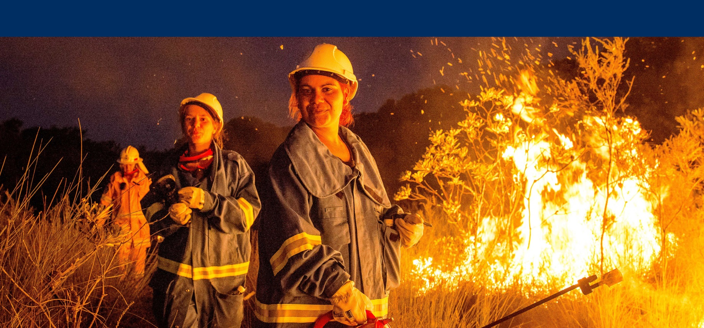



Department of the   
Prime Minister & Cabinet

Consolidated report on Indigenous Protected Areas   
following Social Return on Investment analyses

#### February 2016

# About Social Ventures Australia

Social Ventures Australia (SVA) works with innovative partners to invest in social change. We help to create better outcomes for disadvantaged Australians by bringing the best of business to the for-purpose sector, and by working with partners to strategically invest capital and expertise. SVA Impact Investing introduces new capital and innovative financial models to help solve entrenched problems. SVA Consulting partners with non-profits, philanthropists, corporations and governments to strengthen their capabilities and capacity to address pressing social problems.

# List of Abbreviations

CDEP Community Development Employment Projects

DoE Department of the Environment

IAS Indigenous Advancement Strategy

IPA Indigenous Protected Area

IUCN International Union for Conservation of Nature

MKK Matuwa Kurrara Kurrara

NGO Non-Government Organisation

NRS National Reserve System

NSW New South Wales

NT Northern Territory

PM&C Department of the Prime Minister & Cabinet

Qld Queensland

SROI Social Return on Investment

SVA Social Ventures Australia

TEK Traditional Ecological Knowledge

WA Western Australia

WALFA West Arnhem Land Fire Abatement

WoC Working on Country

Table of Contents

About Social Ventures Australia 1

List of Abbreviations 2

Executive Summary 4

Insights 4

1 Introduction 7

1.1 Project objectives 7

1.2 Purpose, structure and audience of this report 7

1.3 Indigenous land and sea management 7

1.4 Methodology 10

2 Summary of findings from the SROI analyses 12

2.1 Overview 12

2.2 Investment and corresponding activities 12

2.3 The nature of change 14

2.4 Value created 16

2.5 Social Return on Investment 20

3 Drivers of Value 21

4 Alignment with Indigenous Advancement Strategy 27

5 Conclusion 30

A1.1 Executive Summary – Warddeken IPA SROI analysis 32

A1.2 Executive Summary – Girringun IPA SROI analysis 35

A1.3 Executive Summary – Birriliburu & Matuwa Kurrara Kurrara IPAs SROI analysis 38

A1.4 Executive Summary – Minyumai IPA SROI analysis 41

A2.1 Theory of change – Issues, Stakeholders, Activities and Inputs (Investment) 44

A2.2 Theory of change – Ranger and Community member outcomes 45

A2.3 Theory of change – Government outcomes 46

A2.4 Theory of change – Other Stakeholder outcomes 47

A3 Total adjusted value ($) by outcome and by IPA analysis, over period of investment 48

A4 Total adjusted value ($) by outcome as aligned with Indigenous Advancement Strategy 50

# Executive Summary

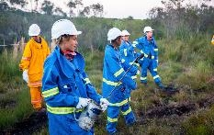

Insights

* The Indigenous Protected Area (IPA) and associated Indigenous ranger programmes have demonstrated success across a broad range of outcome areas, effectively overcoming barriers to addressing Indigenous disadvantage andengaging Indigenous Australians on country in meaningful employment to achieve large scale conservation outcomes, thus aligning the interests of Indigenous Australians and the broader community
* By facilitating reconnection with country, culture and language, the IPA and WoC programmes have achieved exceptional levels of engagement amongst Indigenous Australians, driving the achievement of positive social, economic, cultural and environmental outcomes, delivering a mutual benefit for all key stakeholders
* Of the 35 outcomes valued in these analyses, 28 are closely aligned with the Department of Prime Minister & Cabinet (PM&C)’s Strategic Priorities, accounting for 91% of the adjusted value
* While IPAs provide a programme structure with intrinsic value, increased investment in ranger activities on country will accelerate the rate of social return
* Together, the IPA and WoC programmes have begun to catalyse the development of an Indigenous land and sea based economy, empowering Indigenous landowners to manage their country in accordance with their priorities.

**Participating Indigenous Protected Areas**

This report consolidates four separate analyses, which considered five IPAs across Australia, specifically:

1. Warddeken in the Northern Territory (NT);
2. Girringun in Queensland (Qld);
3. Birriliburu and Matuwa Kurrara Kurrara (MKK) in Western Australia (WA) (together forming one analysis); and
4. Minyumai in New South Wales (NSW).

**Impact of the Indigenous Protected Areas**

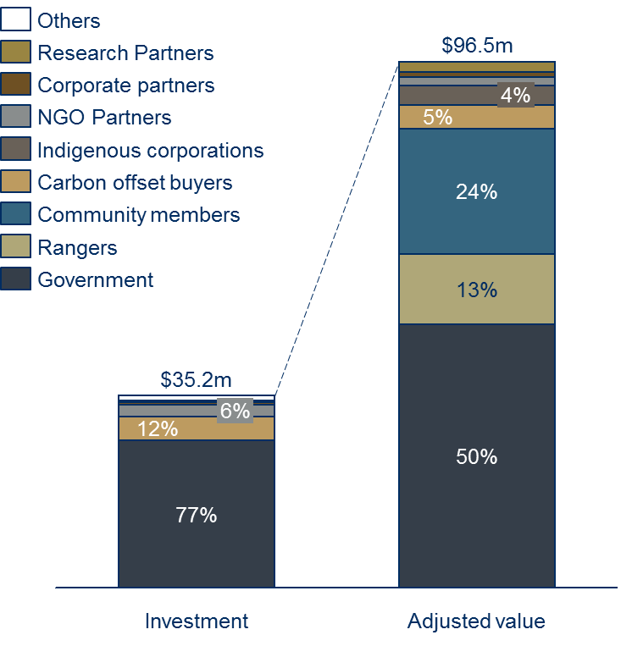The analyses explored the nature and value of changes resulting from investment in the participating IPAs and associated Indigenous ranger programmes across Australia, using the Social Return on Investment (SROI) methodology. The analyses concluded that, between the 2009-15 financial years, an investment of $35.2m from Government and a range of third parties has generated social, economic, cultural and environmental outcomes with an adjusted value of $96.5m.

These outcomes are dependent on the engagement of traditional owners on country; the more time Rangers spend working on country, the greater the value created. Primary beneficiaries are Indigenous Community members – particularly those who are working as Rangers – and Government.

**In the spotlight: Terrah Guymala, Senior Ranger, Warddeken IPA**

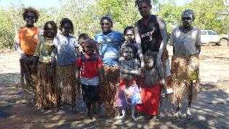Terrah Guymala has lived for most of his life at Manmoyi Outstation Community. As a young boy, life could sometimes be difficult as food was scarce in the wet season. After spending some time in jail as a young man, he decided to make a positive change in his life and started a band with some of his brothers. Today, Terrah is a Senior Ranger, Company Director and Lead Singer of Nabarlek band.

Terrah is passionate about supporting Nawarddeken to return to country, where they can have a healthy body and healthy mind, and transfer knowledge to younger generations.

*“Before we returned here, it was empty country; our old people would call it ‘orphaned country'. The country was damaged by uncontrolled fires and there were buffalo everywhere. The land management and the IPA helps us fix this. We pass on the knowledge to the children so that they know their language, and about the plants and animals.”*

**Drivers of value**

*Individual circumstances:*

1. History, location and landscape are all contributing factors when understanding the extent of change that is likely to occur in each IPA

*Value creation:*

1. The creation of value for a range of stakeholders is directly tied to investment in meaningful employment opportunities for Rangers on country
2. The nature and extent of active land management is a significant determinant of IPA value creation
3. IPAs are a catalyst for deep and long-term partnerships with Government, Corporate, Non-Government Organisation (NGO) and Research Partners

*Return on investment:*

1. Long-term investment promotes significant, sustained change
2. Increased investment through Working on Country (WoC) and other sources will generate higher (rather than diminishing) rates of return
3. Investment in training to build management capacity and technical land and sea management skills drives sustainable value creation

**Alignment with the Department of Prime Minister & Cabinet’s Strategic Priorities**

Material outcomes identified in the analyses have been mapped to PM&C’s five Strategic Priorities, indicating that 28 of 35 material outcomes directly align.

|  |  |  |  |
| --- | --- | --- | --- |
| PM&C Strategic Priorities | Number of aligned outcomes | Adjusted $ value of aligned outcomes | Proportion of adjusted value[1] |
| **Jobs, Land & Economy** | **9** | **60,884,801** | **63.1%** |
| **Children & Schooling** | **1** | **478,125** | **0.5%** |
| **Safety & Wellbeing** | **5** | **6,074,926** | **6.3%** |
| **Culture & Capability** | **10** | **17,528,823** | **18.2%** |
| **Remote Australia** | **3** | **3,211,842** | **3.3%** |

**About this project**

PM&C commissioned SVA Consulting to understand, measure or estimate and value the changes resulting from the investment in five IPAs across Australia. The SROI methodology was used to complete each of these analyses, which were informed by interviews with 143 stakeholders as well as desktop research canvassing relevant qualitative and quantitative data.

This report synthesises findings from across the analyses, exploring the relevant drivers of value and alignment of programme outcomes with PM&C's Strategic Priorities.

# 1 Introduction

## 1.1 Project objectives

Since 1997, the Australian Government has supported Indigenous communities to voluntarily establish IPAs on Indigenous owned or jointly managed land and sea country. There has long been an understanding within Indigenous communities, within Government and amongst other IPA stakeholders, of the breadth of positive changes generated through the IPA programme. To date, however, PM&C has primarily collected information in relation to activities undertaken on IPAs, with mainly an environmental focus.

PM&C commissioned SVA Consulting to conduct four SROI analyses to understand, measure or estimate, and value the changes resulting from the investment in five IPAs across Australia, specifically:

* Warddeken in NT;
* Girringun in Qld;
* Birriliburu and MKK in WA (together forming one analysis); and
* Minyumai in NSW.

There were two objectives in conducting these analyses:

1. To test and validate PM&C’s understanding of the broad environmental, cultural, social and economic outcomes generated by IPAs; and
2. To supplement the existing body of information by assigning a financial value to those outcomes, helping PM&C to better understand the relative benefits of the IPA programme for Indigenous communities, Government and other stakeholders.

## 1.2 Purpose, structure and audience of this report

The purpose of this report is to synthesise findings from the four SROI analyses and draw conclusions in relation to the value created by IPAs.

The report is structured as follows:

* Section 1 (this section) introduces the analyses
* Section 2 summarises the findings from each IPA’s SROI analysis
* Section 3 explores the underlying drivers of value created by IPAs
* Section 4 considers the alignment between outcomes generated by IPAs and the Australian Government’s Indigenous Advancement Strategy (IAS).

## Indigenous land and sea management

Prior to colonisation, Australia was inhabited by more than 500 different Indigenous nations. For over 50,000 years, these nations built up knowledge of how to care for country and effectively manage its resources. The people cared for country and, in turn, country supported the health of the people. Today, there is increasing recognition of the role that Indigenous Australians have historically played – and should continue to play – in the management of country.

**Connection to Country**

The term *‘country’* is imbued with far greater meaning for Indigenous Australians than simply a reference to land. Country encompasses land, water, sky and all life and geologic forms therein, which are inextricably linked. *Country* speaks to a peoples’ spiritual connection with that land, articulated through the country’s dreaming, which has been passed down through generations. The opportunity to access and manage land is critical in maintaining connection to country.

Since 1997 and 2007 respectively, the IPA and WoC programmes have served as a mechanism for the Australian Government to formally engage Indigenous Australians in the conservation of land and sea, facilitating the integration of Traditional Ecological Knowledge (TEK) into contemporary land management practices. The success of these programmes has precipitated a range of cultural, social and economic outcomes, in addition to targeted environmental outcomes. That success has been documented in several independent reports and evaluations since 2006.[2]

**The Indigenous Protected Area programme**

The IPA programme supports Indigenous landowners to use land and sea management as a framework for achieving employment and conservation outcomes.[3] An IPA is formed when traditional owners voluntarily enter into an agreement with the Australian Government to manage their land or sea country for conservation with government support.

**History and Evolution of IPAs**

The IPA concept was co-developed by representatives of Indigenous people and the Australian Government in the mid-1990s, in response to a commitment by the Australian Government to establish a comprehensive and adequate protected area system representative of the full range of ecosystems in Australia in the context of the 1994 International Union for Conservation of Nature (IUCN) guidelines for establishing protected areas (Smyth & Sutherland, 1996).

These initiatives coincided with growing interest from Indigenous people across Australia to re-engage in the management of their traditional estates, including large areas returned to them through land claim processes of the 1970s and 80s, as well as areas included in government national parks.

It was apparent that a comprehensive system of protected areas representative of all Australian bioregions could only be achieved with the inclusion of some Indigenous-owned lands, whose owners were unlikely to voluntarily return their lands to government ownership and management… Consultations with Indigenous groups across Australia determined that some Indigenous landholders were interested in voluntarily dedicating and managing their land as protected areas as part of the National Reserve System (NRS), in return for government funds and other assistance required for the planning and ongoing management of their land.

The first IPA was voluntarily dedicated by Adnyamathanha people in 1998 at Nantawarrina in South Australia, the first occasion in Australia that any form of protected area had been established with the consent of Indigenous landowners.

Extract from Dermot Smyth, *Indigenous Protected Areas and ICCAs: Commonalities, Contrasts and Confusions*, Parks, Vol 21.2 November 2015

The Convention on Biological Diversity sets a target of 17% of terrestrial and inland water areas being subject to effective area-based conservation measures by 2020. Currently, at a national level, over 17% of terrestrial land is included in the NRS. All 89 Australian bioregions are represented in the NRS, however a number of bioregions are less than 10% protected. The Australian Government, in collaboration with the states and territories, is seeking to achieve this target through the NRS for each of Australia’s 89 bioregions.[4]

An IPA project begins with a consultation period during which traditional owners determine the size of land they wish to dedicate, the level of protection they wish to apply to the land and their management priorities, all of which is agreed and articulated in a plan of management.

The plan of management is based on community consensus. Using a combination of traditional knowledge and contemporary conservation management practices, the plan identifies an IUCN category to ensure that management is undertaken in line with international standards. Over 90% of dedicated IPAs have identified IUCN Categories V and VI, emphasising:

* the value of interaction between people and nature over time (IUCN Category V); and
* the sustainable use of natural resources to deliver social and economic benefits for local Indigenous communities (IUCN Category VI).[5]

Government provides funding for the consultation phase. On approval of the management plan by Government, the project can proceed to dedication. Once dedicated, IPAs form part of the NRS. As at November 2015, there were 72 dedicated IPAs across almost 65 million hectares accounting for more than 43% of the total area of the NRS.[6]

The IPA programme is managed by the Environment Branch of the Indigenous Employment and Recognition Division within the Indigenous Affairs Group of PM&C. Funding is provided through the National Heritage Trust under the National Landcare Programme administered by the Department of the Environment, with $73.08 million allocated for the five year period between the 2014 and 2018 financial years (inclusive).[7]

In the 2015 financial year, the IPA programme delivered:

* $1.76m to 12 IPA consultation projects, an average of $146,000 per project; and
* $12.86m to 67 declared IPA projects to support on-going management, an average of $186,000 per project.[8]

**The Working on Country programme**

The WoC programme began in 2007 to create real job opportunities for Indigenous people as part of the reforms to the Community Development Employment Projects (CDEP).[9] The WoC programme supports Indigenous peoples’ aspirations to care for country and seeks to build on Indigenous people’s traditional knowledge and obligations with respect to land, sea and culture.[10] Through the WoC programme, nationally accredited training and career pathways for Indigenous people in land and sea management are provided in partnership with others.[11] The WoC programme complements the IPA programme, funding groups of rangers to care for country in accordance with agreed plans of management.

The WoC programme received a funding commitment of $335 million for the five year period between the 2014 and 2018 financial years (inclusive).[12] As at November 2015, there were 108 Australian Government funded Indigenous ranger groups in Australia, employing over 1,600 Indigenous Rangers across 775 full-time equivalent contracted positions.[13]

An IPA can exist without an associated Indigenous ranger programme funded through WoC or other mechanisms. Where this is the case, the IPA typically uses a proportion of funding for a very limited number of part time ranger positions or provides limited casual work opportunities for rangers. Similarly, the existence of an IPA is not a prerequisite to the receipt of WoC funding.

While there is not perfect geographical alignment between the two, in the 2015 financial year there were WoC funded ranger groups working on approximately 50 IPA projects. Across those projects:

* $10.41m of IPA funding was received, an average of $208,000 per project; and
* $42.79m of WoC funding was received, an average of $856,000 per project.[14]

In 34 such cases, WoC funded ranger groups were managed by the same organisation as the IPA contract. Several IPAs are supported by multiple ranger groups.

The 32 IPAs without any WoC funding received a total of $4.21m in the 2015 financial year, an average of $131,000 each.

## 1.4 Methodology

**Social Return on Investment**

SROI is an internationally recognised methodology used to understand, measure and value the impact of a programme or organisation. It is a form of cost-benefit analysis that examines the social, economic, cultural and environmental outcomes created and the costs of creating them using relevant financial proxies to estimate relative values.

The SROI methodology was used to complete the four underlying analyses of IPA projects and associated Indigenous ranger programmes. Using this methodology, we sought to understand, measure or estimate and value the impact of the relevant IPAs.

Further detail in relation to the principles of SROI can be found in the individual reports, which present findings with respect to each of the IPAs considered. Methodological attachments to each of those reports detail the approach that was taken in conducting those analyses.

Each of the five IPAs involved in this project were invited to participate. Five very different IPAs were deliberately selected in order to provide points of distinction for comparison. Key variations between the IPAs are set out in the table below.

|  | Warddeken | Girringun | Birriliburu / MKK | Minyumai |
| --- | --- | --- | --- | --- |
| **State** | Northern Territory | Queensland | Western Australia | New South Wales |
| **Remoteness** | Very remote | Regional | Very remote | Regional |
| **Size** | 1.4 million hectares | 1.3 million hectares | 7.2 million hectares | 2,164 hectares |
| **Country** | Stone and gorge country on the western Arnhem Land plateau, adjoining Kakadu National Park | Terrestrial, marine and coastal areas; southern wet tropics and northern dry tropics | Desert landscape; sand dunes, sandstone mountain ranges, salt lakes & claypans | Paperbark groves, scribbly gum, swamp mahogany and bloodwood forests |
| **WoC funding** | Yes | Yes | No | No |
| **Total income FY15[15]** | $4.0m | $2.5m | $1.1m | $0.2m |
| **Declaration** | September 2009 | June 2013 | April 2013 (Birriliburu)  July 2015 (MKK) | May 2011 |

*Table 1.1 – Characteristics of IPAs considered in the SROI analyses*

The activities undertaken on country have differed across the IPAs, as have the nature and extent of partnerships established across the private, non-profit and government sectors.

Each SROI analysis was heavily informed by stakeholder consultation as well as desktop research canvassing relevant qualitative and quantitative data. Across the four analyses, 143 stakeholders were directly engaged. This report synthesises findings from those four analyses. The views expressed in this report have been informed by each of those 143 interviews, our desktop analysis and further data specifically requested from PM&C.

# 2 Summary of findings from the SROI analyses

## 2.1 Overview

This section seeks to explain the consolidated findings of the SROI analyses, as well as the process required to arrive at those findings. It includes a discussion of the following elements:

* Investment in the IPAs and corresponding land and sea management activities
* The nature of change occurring on account of the IPAs and associated Indigenous ranger programmes
* Value creation, which includes a discussion of how we have measured and valued change and the amount of value created by stakeholder group, by category and over time
* The resultant social return on investment for each analysis.

## 2.2 Investment and corresponding activities

**Investment**

In each analysis, the value of all inputs required to achieve the outcomes was described, measured and valued. Inputs include financial (cash) investments over the relevant investment period. No in-kind (non-cash) investments were found to be material.

Across all analyses, Government (particularly through IPA and WoC funding) was the largest funder of the IPAs and associated Indigenous ranger programmes. Government’s investment in the IPAs and associated Indigenous ranger programmes varied from an average of 61% (Warddeken) to 96% (Girringun) of total investment over the relevant period.

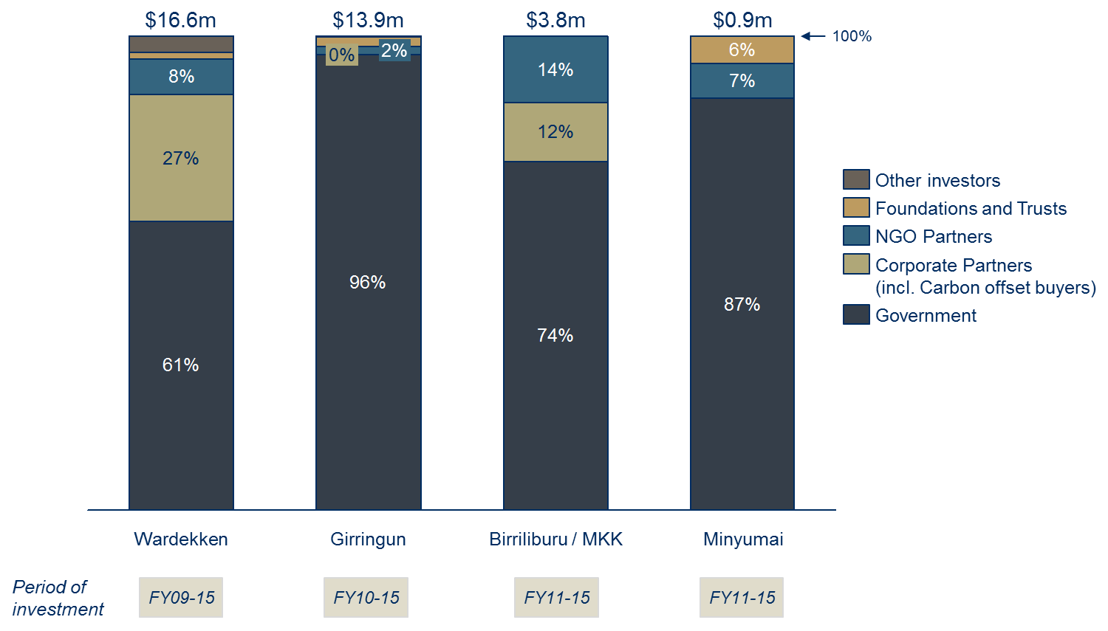

*Figure 2.1 – Proportion of total income received over the relevant period of investment, by funding source, by IPA*

The next most significant sources of investment were Corporate and Environmental NGO partners. Corporate investment was greatest in the case of Warddeken, where significant investment was received from Carbon offset buyers (27%), while environmental NGOs such as Rangelands NRM and Bush Heritage Australia (BHA) provided 14% of the income received at Birriliburu and MKK. Other investments were received from:

* Foundations and Trusts;
* Research partners;
* Land Councils; and
* Local businesses.

Investment from the latter three groups was included in the analysis as an input, but no material benefits were realised by those stakeholders.

Between the 2011 and 2015 financial years (inclusive) – the period for which all four IPAs were analysed[16] – total investment grew annually by 15%. This was driven by an 11% increase in Government funding and substantial growth in Corporate partner investment, primarily in the 2015 financial year.

By the 2015 financial year, 65% of the total investment across the IPAs and associated Indigenous ranger programmes came from Government while the remainder came from other sources.

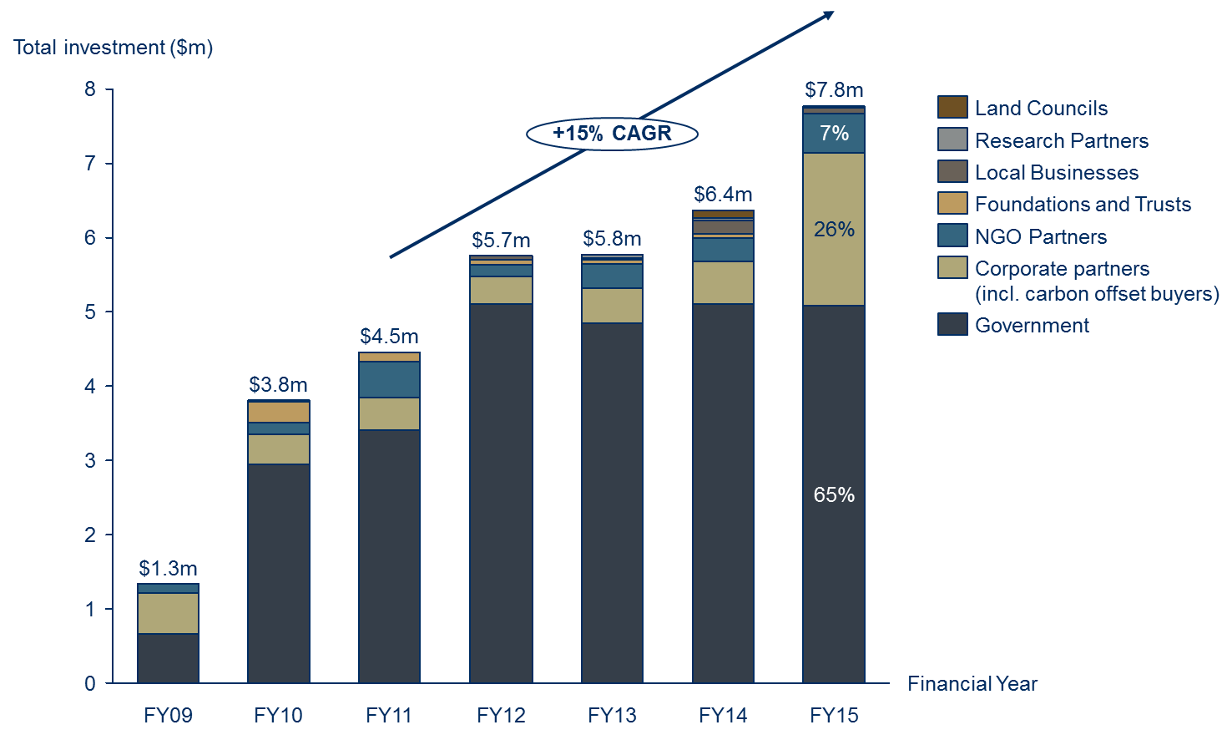

*Figure 2.2 – Consolidated investment into the IPAs and associated Indigenous ranger programmes over the period of investment, by source, year on year, FY09-15 (note: CAGR refers to the Compound Annual Growth Rate)*

**Activities**

The land and sea management activities to which this investment was applied were generally consistent across the IPAs and associated Indigenous ranger programmes. Common activities included burning country, managing feral animals, protecting threatened species and managing tourist visitation.

There were, however, some subtle differences in land and sea management activities undertaken on the IPAs. For instance:

* Approximately one third of activity carried out on the Warddeken IPA was related to fire management, the most of the IPAs considered. The risk posed by late season wildfires on the Warddeken IPA is greater than for the other IPAs.
* Since the Girringun IPA incorporates freshwater and saltwater sea country, extensive sea management activities were undertaken on that IPA with partners including Queensland Marine Park Rangers.
* On the Birriliburu, MKK and Minyumai IPAs, little weed management was undertaken and on the Minyumai IPA, little feral animal management was undertaken.

These differences are explained by the varying characteristics of the country encompassed by the IPAs and the different priorities of traditional owners. Those priorities are articulated in the respective plans of management, which provide the blueprint for ranger activities undertaken on the IPAs.

Further detail in relation to these activities is set out in Appendix A2.1 as part of the IPA programme ‘theory of change’ (introduced in section 2.3 below).

## 2.3 The nature of change

Across the four analyses, the IPAs and associated Indigenous ranger programmes have generated significant social, economic, cultural and environmental outcomes for Rangers, Community members, Government and other stakeholders.

We use a theory of change to understand the nature of, and the relation between, changes created by the IPAs and associated Indigenous ranger programmes. A consolidated theory of change, which describes the change occurring across all four of the IPAs analysed, is set out in Appendix A2.[17]

The theory of change consists of four pages, which articulates:

1. **Issues** that the IPAs and associated Indigenous ranger programmes seek to address, the **stakeholders** involved, the **activities** that take place and **inputs** (investments) into the programmes
2. **Outputs** (i.e. the immediate consequences of activities), **outcomes** and **impact** for Community members and Rangers
3. Outputs, outcomes and impact for Government
4. Outputs, outcomes and impact for other stakeholders.

Outcomes should be read from left to right and are expressed as either short, medium or long term outcomes (i.e. the relative period of time before they are likely to occur). There are three types of outcomes represented:

* Material (i.e. relevant and significant) outcomes, which have been measured or estimated and valued as part of the SROI analyses;
* Intermediate outcomes, which have been achieved during the investment period but are not measured as part of the SROI analysis because their value is subsumed by later, related outcomes that carry a higher value; and
* Other outcomes, which have not yet been achieved and are therefore aspirational.

The theory of change includes clusters of closely related outcomes which together represent identifiable ‘threads’ of change over time. These related outcomes have been intentionally grouped together where possible. It is worth considering an example of one cluster of outputs and outcomes which represent such a thread of change across the Community member, Ranger and Government stakeholder groups.

Figure 2.3, below, sets out a number of outcomes directly related to the employment of Rangers on country:

* **Immediate**: The immediate consequence of the IPAs and associated Indigenous ranger programmes is the availability of job opportunities (for prospective Rangers) and an increase in the number of Indigenous adults in meaningful employment (from Government’s perspective).
* **Short to medium term**: Rangers receive income, gain skills and training and increase in confidence, young people in community have more role models, while Government receives more income tax and pays less income support.
* **Long term**: In time, it is hoped that the long term impact of these employment opportunities will be improved land management career prospects for Rangers through the development of an Indigenous land-based economy and in turn, stronger Indigenous communities.

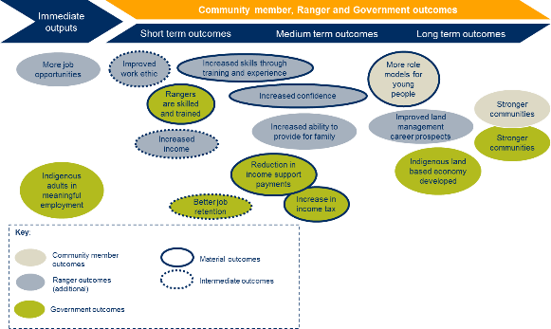

*Figure 2.3 – Community member, Ranger and Government outcomes regarding employment of Rangers*

**In the spotlight: Penny Ivey, Ranger, Girringun IPA**

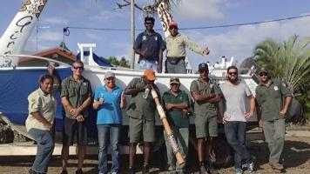Penny Ivey is a Girramay woman who has worked as a Girringun Ranger for five years. Prior to becoming a Ranger, Penny was fruit picking. She became a Ranger because she wanted to learn more from the Elders.

While with Girringun, Penny has undertaken training in mapping, dolphin and dugong surveys, operating a front loader and bobcat, and using GPS tracking devices. She is now one of the more experienced Rangers at Girringun and has assumed responsibility for teaching others.

Over time, Penny has transformed from a shy person into a more confident one. Penny attributes this to mixing with other Rangers during trips, conferences and Ranger exchanges where she was representing Girringun. She has career ambitions to one day become a supervisor or work for National Parks.

*“I was once a quiet girl - that changed when we went away and met with others.”*

The theory of change emphasises the interrelationship between social, economic, cultural and environmental outcomes. This is aligned with how stakeholders perceived the changes they experienced through the programmes. The key points to draw out of the representations in Appendix A2 are:

* The outcomes generated by the programmes are widespread across the social, economic, cultural and environmental domains;
* In all analyses, the programmes have pushed well beyond outputs to generate extensive short and medium term outcomes, and in some cases long term outcomes;
* Many of the outcomes for different stakeholders are interrelated or are shared across stakeholder groups;[18] and
* In all cases, stakeholders are striving for two interrelated impacts: healthier people and healthier country.

There were no material negative outcomes associated with the IPAs and associated Indigenous ranger programmes.

## 2.4 Value created

**Measuring and valuing change**

Once the nature of change occurring through the IPAs and associated Indigenous ranger programmes is understood, there are two further phases of a SROI analysis: to measure and value that change.

In each case, the measures are estimates inferred through stakeholder consultation and other quantitative data. Wherever possible we have estimated the extent to which outcomes have occurred through the use of quantitative data previously collected by IPA managers or by other sources. The measures have also been deeply informed by stakeholder consultation.

Once the extent of change has been measured or estimated, financial proxies are used to value all material outcomes. This is particularly important in SROI as it relates to the principle of valuing what matters. This means that there is a need to value outcomes even if they do not carry a commonly understood market value.

There are a number of techniques used to identify financial proxies and value outcomes. Importantly, within an SROI, the financial proxy reflects the value that the stakeholder experiencing the change places on the outcome. This could be obtained directly through stakeholder consultation, or indirectly through research. The financial proxies approximate the value of the outcome from the stakeholder’s point of view.

Two commonly used approaches, often used in tandem, are the revealed and stated preference techniques. Financial proxies are inferred through the revealed preference technique from the value of related market prices. For instance, when Rita Cutter – a Ranger on the Birriliburu and MKK IPAs – described an increase in her confidence resulting from working on country, she explained that she was now far more comfortable speaking to visitors about herself and her country. An appropriate financial proxy in that case might therefore be the cost of a public speaking course.

*“I didn't used to think whitefellas wanted to listen to me."*

Rita Cutter, Ranger

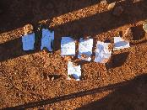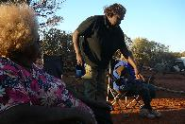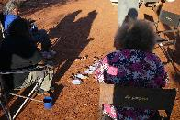Stakeholders were further asked to identify the relative importance of outcomes – their stated preference – to ensure that the financial proxies used were in line with the relative value placed on those outcomes by stakeholders.

*Figure 2.4 – Birriliburu and MKK Rangers – Lina Long, Caroline Long and Rita Cutter (left to right in third image) – debate the relative importance of Ranger and Community member outcomes identified through stakeholder consultation on country*

A more detailed explanation of various techniques used to value outcomes is included in the individual SROI Reports and their Methodological Attachments.

Finally, valuation filters are appliedto different financial proxies to ensure that the analysis is not over‑claiming. An explanation of each SROI filter assumption category – Deadweight, Attribution, Displacement, Duration and Drop-off – is set out in the body of each SROI report and the Methodological Attachments to those reports.

The value created for a stakeholder group on account of each material outcome is therefore calculated with reference to:

* the indicator (how much changed has occurred);
* the financial proxy (how valuable is that change);
* the valuation filters (how much of that change has occurred as a result of the IPA and associated Indigenous ranger programme).

A full list of outcomes deemed to be material for the purpose of these analyses, based on extensive stakeholder consultation, appears in Appendix A3, along with their relative, associated values.

**Value by stakeholder group**

Across the four analyses, the greatest value is created for Government, and for Community members – particularly those employed as Rangers.

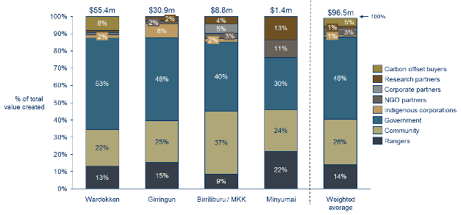

*Figure 2.5 – Total % value created by stakeholder group for each IPA analysis and as a weighted average across the analyses. Raw values are set out in the table appearing at Appendix A3.*

*Rangers and Community members*

* Without Rangers working on country, none of the outcomes measured in this analysis would be achieved.
* Community member engagement with country is a substantial contributor to value created through the IPAs and associated Indigenous ranger programmes, particularly where cultural activities precipitate the transfer of knowledge in relation to country, culture and language.
* The most significant outcomes for Rangers and Community members relate to strengthening connection to country and the opportunity to leverage the IPA for additional funding and economic opportunities.
* Total combined value created for Rangers and Community members varies from 35% (Warddeken) to 46% (Minyumai and Birriliburu / MKK) of the total value created.

*Government*

As the principal investor, Government is understandably a significant beneficiary of the IPAs and associated Indigenous ranger programmes. In each of the four analyses, the value generated by the IPAs and associated Indigenous ranger programmes for Government is greater than its investment.

* As a result of the IPAs and associated Indigenous ranger programmes:
  + More Indigenous people are working as Rangers and being trained for other local jobs in their communities;
  + As a result of more Indigenous people working, there is a reduction in income support payments and increase in income tax;
  + Rangers and Community members report that there is less violence, resulting in safer communities;
  + There is greater understanding of, and respect for, TEK in the broader community; and
  + Government engagement with Indigenous communities has improved and innovative models of partnership are being promoted within both State and Federal Governments.
* The most valuable outcome for Government across all analyses was low cost land management due to Rangers working on country. This outcome subsumes numerous, specific environmental outcomes including:
  + More burning using cultural practices;
  + Less dangerous fires;
  + Less noxious weeds;
  + Less feral animals; and
  + Better threatened species management.
* The proportion of total value created for Government varied from 30% (Minyumai) to 53% (Warddeken) of the total value created.
* On average, across the four analyses, half of the total value created accrued to Government.

*Other stakeholders*

Other stakeholders experienced material outcomes as a result of the IPAs and associated Indigenous ranger programmes, including:

* Indigenous corporations;
* NGO partners;
* Corporate partners (Birriliburu, MKK and Warddeken only);
* Research partners; and
* Carbon offset buyers (Warddeken only).

Cumulative value created for other stakeholders ranges from 12% (Warddeken) to 24% (Minyumai) of total value created. The value created depends on the number and extent of these relationships with external partners.

**Value across outcome categories**

When all stakeholders are considered, environmental outcomes account for the greatest value.[19] In the case of Warddeken, environmental outcomes accounted for as much as 50% of the total value created.

When considering Community member and Ranger outcomes across the four analyses, most value accrues to either cultural outcomes (61% of total value in Girringun) or social and economic outcomes (59% of total value for Birriliburu and MKK).[20] This emphasises the potential for Indigenous land and sea management programs to precipitate change beyond anticipated environmental outcomes.

Further detail in relation to the proportion of value created by category, for each stakeholder group, is set out in the individual SROI Report summaries in Appendix A1.

**Value over time**

In all analyses, the outcomes last for the period of investment only. Throughout stakeholder consultation, there was a consensus amongst interviewees that there would be no continuous change without ongoing investment in the IPAs and associated Indigenous ranger programmes. The predominant reason for this was that the IPAs and associated Indigenous ranger programmes facilitate access to country, the foundation upon which almost all outcomes are achieved.

## 2.5 Social Return on Investment

An SROI ratio is generated by comparing the total adjusted value of the outcomes experienced by stakeholders to the investment required to create that value. The SROI ratios achieved in each analysis were as follows:

|  | Warddeken | Girringun | Birriliburu / MKK | Minyumai |
| --- | --- | --- | --- | --- |
| **Investment ($)** | 16,557,998 | 13,940,476 | 3,814,365 | 933,291 |
| **Value created ($)** | 55,422,986 | 30,882,480 | 8,798,502 | 1,372,388 |
| **SROI ratio** | **3.4:1** | **2.2:1** | **2.3:1** | **1.5:1** |

*Table 2.1 – SROI ratios for each IPA and associated Indigenous ranger programme.*

When interpreting the SROI ratio, one should consider the following:

* The values for the outcomes created are estimates and provide an indication of the value that was generated through the IPAs and associated Indigenous ranger programmes;
* The SROI ratio represents a comparison of the unique value created in each instance, based on the Social Value principles, with the investment required during a defined period.
* A comparison of SROI ratios should only be conducted with a clear understanding of each organisation’s mission, strategy, theory of change, geographic location and stage of development. A judgement about investment decisions can only be made when using comparable data.

Specific drivers of value are considered below in section 3.

**Limitations of SROI**

While the breadth and depth of the consultation process provides a compelling picture of the impact of the IPA programme, it is important to consider the limitations of the SROI analyses.

The key limitations concern the lack of accurate data available to measure outcomes, particularly for Rangers and Community members, and the involvement of other organisations in achieving the identified outcomes. To help overcome these limitations and inform assumptions, SVA Consulting drew on the rich information provided through the stakeholder engagement process as well as existing research, and made conservative assumptions where necessary.

Improvement in on-going measurement and evaluation will help to overcome these limitations over time.

# 3 Drivers of Value

There was a high degree of consistency in the outcomes and associated value created across the four IPAs, which reflects a common understanding of the nature of change occurring across the IPAs. However, there were sufficient differences to draw important conclusions in relation to the relevant drivers of value. Those conclusions are set out below and organised with reference to individual circumstances, investment and value creation.

**Key messages**

*Individual circumstances:*

1. History, location and landscape are all contributing factors when understanding the extent of change that is likely to occur in each IPA

*Value creation:*

1. The creation of value for a range of stakeholders is directly tied to investment in meaningful employment opportunities for Rangers on country
2. The nature and extent of active land management is a significant determinant of IPA value creation
3. IPAs are a catalyst for deep and long-term partnerships with Government, Corporate, NGO and Research Partners

*Return on investment:*

1. Long-term investment promotes significant, sustained change
2. Increased investment through WoC and other sources will generate higher (rather than diminishing) rates of return
3. Investment in training to build management capacity and technical land and sea management skills drives sustainable value creation

**Individual circumstances**

1. ***History, location and landscape are all contributing factors when understanding the extent of change that is likely to occur in each IPA***

Not all of the outcomes identified in the theory of change will be relevant to each IPA. The most significant example of this is in relation to carbon abatement.

The value created for carbon offset buyers is only relevant to the Warddeken IPA. This is due to the pre-existing West Arnhem Land Fire Abatement (WALFA) project involving traditional owners, the NT Government, the Northern Land Council, Tropical Savannas CRC and ConocoPhillips[21], which recognises the significant carbon abatement achieved through fire management work on the Warddeken IPA. Other IPAs are constrained in realising this outcome by the rainfall zones in which their country lies and the approval of methodologies which recognise that sufficient levels of carbon are offset by burning country.

Other material outcomes that are not relevant across all IPAs on account of specific circumstances include:

* The Community member outcome of Rangers and their families living on country, which is not relevant in the case of the Birriliburu, MKK and Minyumai IPAs, where it is currently impractical to live on country.
* All Corporate partner outcomes, which are not relevant in the case of the Girringun and Minyumai IPAs, where Corporate partnerships have not yet been developed.
* The Community member outcome of less violence and associated Government outcome of less offending by Rangers, which are not relevant in the case of the Birriliburu, MKK and Minyumai IPAs:
  + For Birriliburu and MKK, where the absence of WoC funding limits Ranger employment opportunities, the outcome was not deemed material, primarily because of the limited amount of time that Rangers spend working on country before returning to Wiluna, where violence and offending is more likely to occur.
  + For Minyumai, violence and offending were not raised as material issues during stakeholder consultations.

**Value creation**

1. ***The creation of value for a range of stakeholders is directly tied to investment in meaningful employment opportunities for Rangers on country***

Rangers working on country is the foundation upon which almost all outcomes are based. The value created by an IPA is, therefore, largely proportional to the size of investment in ranger employment opportunities:

* When Rangers work on country, they experience personal benefits including increased skills and confidence, and better health and wellbeing.
* Community members benefit directly from ranger activities with the reassurance that country is being cared for and the transfer and preservation of cultural knowledge that occurs while Rangers are working on country. As a result, all of the outcomes experienced by Community members are directly related to Rangers’ activities.
* Similarly, all Government outcomes are linked to Ranger work on country because of its flow-on effects, including skilled Rangers, greater respect for TEK and more cost-effective land management.

While there is intrinsic value in an IPA, particularly as a catalyst for partnership opportunities, funding for Ranger positions through WoC or other mechanisms has the potential to generate increased rates of social return on investment.

1. ***The nature and extent of active land management is a significant determinant of IPA value creation***

The amount of land managed is an important driver of value, impacting upon the Community member outcomes of less noxious weeds and less feral animals and the Government outcome of low cost land management. The combined value of these outcomes amounts to 52% of the total value created by the IPAs and is affected by both land tenure and land management activities.

The value of outcomes related to the amount of land managed varies from $3,000 for the 200 hectares of land actively managed within the Minyumai IPA, to approximately $27 million for the 1.3 million hectares of land actively managed within the Warddeken IPA. While the Birriliburu IPA is the largest of the IPAs considered, at 6.6 million hectares, the absence of WoC funding limits the Martu Rangers to active management of three discrete work zones within the Birriliburu IPA.

1. ***IPAs are a catalyst for deep and long-term partnerships with Government, Corporate, NGO and Research Partners***

The quantity and depth of partnerships with Government, Corporate, NGO and Research partners are key contributors to the amount of value generated by an IPA and are responsible for up to 38% of the total value created by the IPAs considered.

Through their engagement with the IPAs, partner organisations build deeper relationships in community and are better able to meet their core objectives, while Rangers and Community members benefit from additional funding and economic opportunities.

* As an IPA on multi-tenured land, the Girringun IPA operates through a co-management model and works in collaboration with over a dozen Government, NGO and research partners. The management team of the IPA also supports Indigenous Corporations, including five Prescribed Bodies Corporate (PBCs) representing traditional owners within the Girringun IPA, to create a vision for their communities and engage with external partners.
* The Warddeken IPA has established deep relationships with four NGO partners, one Corporate partner and five Research partners, creating almost $6 million in value for those partners and approximately $5 million in value through increased funding and economic opportunities for Community members.
* Managers of the Birriliburu and MKK IPAs have had great success in leveraging the IPAs to secure additional partnerships. However, when compared to Warddeken, many of these partnerships are relatively new and in the absence of the opportunity to explore carbon abatement, the associated value of partnership outcomes during the investment period is much lower. That value is expected to increase in the 2016 financial year, following an increase in investment from BHA.

Successful partnerships are based on recognition of shared values and mutual benefits. Those IPAs generating the greatest value from partnerships also invest significant time and resources into building and maintaining those partnerships. Without sufficient resources to invest in IPA coordination and management, it is very difficult for groups to leverage IPAs to their full potential.

**Return on investment**

1. ***Long-term investment promotes significant, sustained change***

Some IPAs have progressed further on a particular path within the theory of change and have achieved more advanced outcomes than other IPAs. This is most likely to be on account of either additional time since project inception or resources (or both).

All four IPAs have enabled Government to establish new partnerships, and develop and promote new partnership models. However, increased local and international credibility for Government – a longer term outcome – is most evident in the case of the Girringun IPA. As a key partner of the Great Barrier Reef Marine Park Authority (GBRMPA), Girringun coordinated Indigenous consultation and supported the Authority’s ultimately successful submission to the United Nations Educational, Scientific and Cultural Organization (UNESCO) World Heritage Committee to ensure the Great Barrier Reef did not receive an ‘in danger’ listing. Government may achieve similar increased local and international credibility through other IPAs over time as the IPAs are exposed to further collaboration and partnership opportunities and develop deeper relationships with Government departments and agencies.

Another material outcome, which is yet to be realised across all of the IPAs is the Community member outcome of increased respect for women. This outcome did not present as material through stakeholder consultation on the Warddeken IPA. However, that may well change after a proposed women’s ranger group is established.

A number of critical, long-term outcomes have not yet been achieved by any of the IPAs considered, including, for example:

* Stronger communities
* Increased capacity for self-determination
* Development of an Indigenous land based economy.

It is unlikely that these and other important outcomes will be realised without sustained investment from the range of funding partners canvassed in these analyses.

1. ***Increased investment through WoC and other sources will generate higher (rather than diminishing) rates of return***

The SROI ratios reflect the relationship between the value created by an IPA and the size of investment. Those IPAs with WoC funding have received far greater investment than those without WoC funding. The rates of social return generated by IPAs with WoC funding were higher, on average, than the rates of social return generated by IPAs without WoC funding.

|  | Warddeken | Girringun | With WoC | BB / MKK | Minyumai | No WoC |
| --- | --- | --- | --- | --- | --- | --- |
| **Investment ($)** | $16.6m | $13.9m | $30.5m | $3.8m | $0.9m | $4.8m |
| **Value created ($)** | $55.4m | $30.9m | $86.3m | $8.8m | $1.3m | $10.2m |
| **SROI ratio** | **3.4:1** | **2.2:1** | **2.8:1** | **2.3:1** | **1.5:1** | **2.1:1** |

*Table 3.1 – Investment, adjusted value created and SROI ratios for each IPA and associated Indigenous ranger programme, referencing those with WoC funding and those without.*

While the sample size is small, the analyses suggest that increased investment through WoC and other sources will generate higher (rather than diminishing) rates of return. This can be explained by the fact that, IPAs without WoC funding were not able to achieve several of the outcomes deemed material in the case of IPAs with WoC funding. For instance:

* The Community member outcomes of increased respect from the non-Indigenous community, better cultural asset management, less noxious weeds and less feral animals have not yet been achieved in the case of the Minyumai IPA. This reflects the limited scale of the Minyumai operation, with an investment of only $930,000 over five years.
* The Government outcomes of increased income tax and reduced income support payments have not yet been achieved in the case of the Birriliburu and MKK IPAs. This is because Rangers have not worked sufficient hours to move beyond the tax-free threshold, or to disqualify them from income support. In the 2015 financial year, 39 casual Indigenous Rangers shared 2.6 full time equivalent Ranger positions on the Birriliburu IPA.

In discussions with Ranger groups involved in the SROI analyses and managers of several other WoC and IPA funded projects, a consensus emerged that there is likely to be a ‘threshold’, beyond which investment in an IPA and associated Indigenous ranger activities will increase in efficiency. That threshold will differ on account of individual circumstances – e.g. location, landscape, personnel (see above) – but several basic rules of thumb are as follows:

* **IPA Management**: In the 2015 financial year, 67 declared IPA projects[22] across the country received an average of $186,000 to support on-going management. In reality, this funding is sufficient only to employ one full time manager and cover administration and reporting requirements. At this level of funding, there is little scope for land and sea management activities in accordance with an agreed plan of management for country. Furthermore, if IPA management is undertaken by non-Indigenous staff, there may be little funding available to employ local Indigenous land owners.
* **Land and sea management activities**: A bare bones ranger group is likely to require in the vicinity of $500,000 a year. This funding provides for:
  + A Ranger Coordinator
  + Five full time equivalent ranger positions
  + Overheads including for the operation of 1-2 vehicles
  + Training for Rangers
  + Other costs, including communications, administration, reporting and traditional owner meetings.

The 50 IPAs with WoC funding received an average of $856,000 through that programme in the 2015 financial year.

* **Start-up capital**: Some groups may also require start-up capital to invest in infrastructure (e.g. ranger station, accommodation or storage facility), vehicles, equipment and training. This may increase the amount of funding required in the first 1-3 years.
* **Investment period**: While the initial investment will likely be required exclusively from Government, it is reasonable to expect that, once established, an IPA Manager would be in a position to leverage additional funds from other sources (e.g. environmental NGOs, Corporate partners, Research partners, Foundations and Trusts, fee for service commercial activities). In a recent report commissioned by Pew Charitable Trusts, Synergies Economic Consulting suggest a 3 year ‘start-up’ and ‘capacity building’ period, before ‘outreach’ and ‘maturity’, during which time collaboration and potential to capitalise on other revenue sources will take hold. It is reasonable to anticipate that the proportion of an organisation’s funding derived from Government might decline from years 3-5 onwards as other funding partners come to the table.

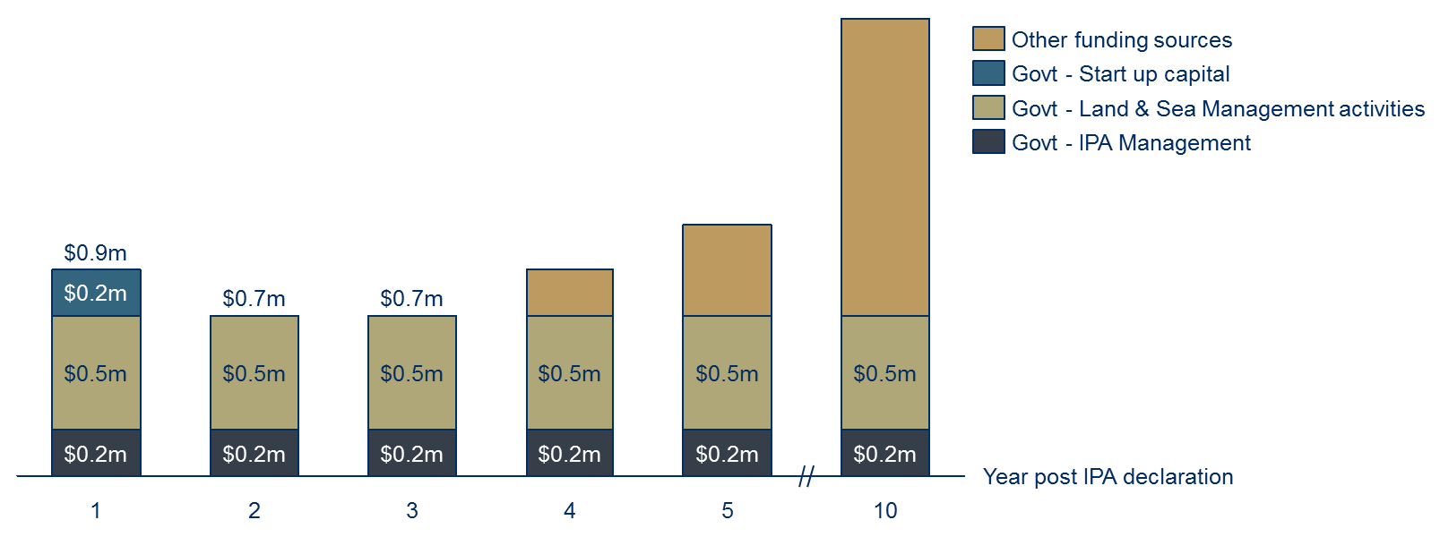

*Figure 3.1 – Indicative profile of base funding requirement for IPA Management & single Ranger team post declaration*

1. ***Investment in training to build management capacity and technical land and sea management skills drives sustainable value creation***

In order to ensure that Government funding effectively seeds further investment from other sources, sufficient up-front investment in management capacity is critical. The management of grants and reporting and the coordination of Rangers requires a significant investment of time and resources, particularly given the widespread reliance on a casual labour force. A further investment is then required to leverage the IPA to its full potential, through brokerage of new partnerships, which might lead in turn to more Ranger work. Additional management capacity is likely to be the distinguishing factor between the Minyumai and Birriliburu / MKK IPAs, the latter having generated a range of valuable Corporate, NGO, Government and Research partnerships.

Furthermore, unless Rangers receive appropriate training to build their technical land and sea management skills, the return associated with positive Ranger outcomes is likely to plateau. The capacity of Ranger groups to supplement Government funding by capitalising on commercial land management opportunities will be limited unless groups become increasingly professionalised and prepared to compete with other market participants.

# 4 Alignment with Indigenous Advancement Strategy

A stated objective of this project was to improve PM&C’s understanding of the breadth of social, economic, cultural and environmental outcomes achieved through the IPA programme. In particular, PM&C was interested to understand the extent to which those outcomes aligned with its Strategic Priorities, which underpin the IAS.[23]

Material outcomes identified in the analyses have been mapped to PM&C’s five Strategic Priorities, indicating strong alignment:

* Of the 35 material outcomes valued in the analyses, 28 directly support the achievement of PM&C’s Strategic Priorities
* The adjusted value of outcomes aligned with PM&C’s Strategic Priorities accounts for 91% of the total adjusted value, consolidated across the analyses
* Greatest alignment – unsurprisingly – was with the Jobs, Land & Economy programme, to which 9 outcomes were closely aligned, comprising 63% of total adjusted value
* Ten outcomes (18% of total adjusted value) aligned with the Culture and Capability programme
* Five outcomes (6% of total adjusted value) aligned with the Safety and Wellbeing programme.

Table 4.1 below summarises the adjusted value of outcomes with reference to the PM&C Strategic Priorities. A full list of outcomes mapped to the Strategic Priorities – by consolidated, adjusted value – appears at Appendix A4.

The **Jobs, Land & Economy** programme aims to get Indigenous adults into work, foster Indigenous business and assist Indigenous people to generate economic and social benefits from effective use of their land. Nine of the identified outcomes closely align with these objectives. For instance:

* Rangers are working in circumstances where they weren’t previously, and in the process they are being trained and are developing skills. Job retention amongst rangers has consistently been measured at over 80%.[24] In the case of the Birriliburu and MKK IPAs, there is direct line of sight from work on the IPAs to land management and rehabilitation work at the Jundee mine site.
* The IPAs enable traditional owners to leverage their land for additional funding & economic opportunities. The IPA programme creates a structure through which corporate and NGO partners can engage with traditional owners, leading to economic and social benefits for community members. Wardekken’s sale of $4.4m worth of carbon offsets presents as a compelling example. These commercial opportunities provide a platform upon which Indigenous businesses may be built.

The **Culture and Capability** programme aims to support Indigenous people to maintain their culture, participate equally in the economic and social life of the nation and ensure that Indigenous organisations are capable of delivering quality services to their clients. Ten of the identified outcomes closely align with these objectives. For instance:

* IPAs and associated Indigenous ranger programmes provide Indigenous land owners with the opportunity to reconnect with country, culture and language. These programmes also empower Indigenous land owners to manage their country in accordance with their priorities, concurrently pursuing conservation outcomes for country and social, economic and cultural benefits for their people. Through land and fire management work, Bandjalang traditional owners on the Minyumai IPA have seen the restoration of native plants and animals that were thought to have been lost. Their return serves as a powerful reminder of the resilience of the Bandjalang people and enables them to better understand themselves, their culture, and their place in the world.
* Culture is reinforced not just among Indigenous land owners, but also within the broader community, as Government and other partner organisations have developed a greater appreciation and respect for TEK.
* In many cases, IPAs have provided PBCs with a point of focus beyond management of native title rights, strengthening their governance and management capacity. Through this support for local Indigenous governance and decision-making, IPAs are critical to the agenda of community empowerment and self-determination amongst Australia’s Indigenous nations.

**In the spotlight: Warddeken IPA’s achievement of outcomes aligned with the Safety and Wellbeing programme**

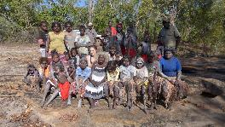The Warddeken IPA has worked closely with the NT Department of Correctional Services in relation to three offenders who have returned to country to serve their parole and have gained employment as Rangers with Warddeken. Once on country, these Rangers are supported and mentored by Senior Rangers and Elders in the community, who are in regular contact with their Probation and Parole Officer or Case Manager.

The Department sees employment as a significant factor which reduces reoffending, as a job provides routine, pride, and interaction with others. Being on country also helps offenders re-connect with their identity and culture.

Anthony Jones from the Department observes:  *“If Warddeken was not there, these men would be more susceptible to reoffending. It is a vicious cycle in the communities; resources are so limited and there are the temptations that come with living in the bigger communities, such as the pressure from family and friends.”*

The **Remote Australia Strategies** programme aims to ensure strategic investments in local, flexible solutions based on community and Government priorities. The focus of this programme is less about the achievement of specific outcomes, but rather, it is concerned with Government’s capacity to engage with remote Indigenous communities and in doing so, achieve its broader agenda in areas where Indigenous disadvantage is most prevalent.

The SROI analysis includes the Government outcome of ‘improved engagement with communities’, which is achieved through the IPA consultation period prior to declaration, community-driven annual planning and ongoing communication with traditional owners. This form of engagement has improved Government’s standing within community and offers a model of partnership that can be leveraged by Government to increase the potential success of other initiatives.

Through the creation of Ranger jobs in remote communities and the facilitation of valuable partnerships with the private and non-profit sectors, IPAs are supporting a development agenda across remote Australia. Together, the IPA and WoC programmes have begun to catalyse the development of an Indigenous land and sea based economy. A distinguishing feature of the IPA and WoC programmes, which underpins their success to date, is the high level of engagement achieved amongst Indigenous Australians. This provides a platform from which PM&C might continue to pursue long term objectives of community development and empowerment.

| PM&C Strategic Priorities  *Improving the lives of Indigenous Australians* | Adjusted $ value of aligned outcomes | Proportion of total adjusted value |
| --- | --- | --- |
| **Jobs, Land & Economy**  *Getting adults into work, fostering Indigenous business and assisting Indigenous people to generate economic and social benefits from effective use of their land.* | **60,884,801** | **63.1%** |
| **Children & Schooling**  *Getting children to school, improving education outcomes and supporting families to give children a good start in life. Improving access to further education.* | **478,125** | **0.5%** |
| **Safety & Wellbeing**  *Ensuring the ordinary law of the land applies in Indigenous communities, and that Indigenous people enjoy similar levels of physical, emotional and social wellbeing enjoyed by other Australians.* | **6,074,926** | **6.3%** |
| **Culture & Capability**  *Supporting Indigenous people to maintain their culture, participate equally in the economic and social life of the nation and ensuring that Indigenous organisations are capable of delivering quality services to their clients.* | **17,528,823** | **18.2%** |
| **Remote Australia Strategies**  *Ensuring strategic investments in local, flexible solutions based on community and Government priorities. Support for remote housing strategies focussed on achieving results in Government priority areas.* | **3,211,842** | **3.3%** |
| Outcomes not directly aligned with PM&C Strategic Priorities | **8,297,841** | **8.6%** |
| **Total** | **96,476,357** | **100%** |

*Table 4.1 – Adjusted value (total & proportion) of outcomes identified in SROI analyses which align with PM&C Strategic Priorities.*

# 5 Conclusion

This report has considered the nature and value of changes resulting from the investment in five IPAs and associated Indigenous ranger programmes across Australia, using the SROI methodology. The analyses have concluded that, over the period between the 2009 and 2015 financial years, an investment of $35.2m from Government and a range of third party investors has generated social, economic, cultural and environmental outcomes with an adjusted value of $96.5m.

The analyses support the prevailing view – promoted in a range of previous evaluations and reports in the public domain[25] – that the IPA and WoC programmes have succeeded across a broad range of outcome areas, effectively overcoming barriers to addressing Indigenous disadvantage and engaging Indigenous Australians in meaningful employment to achieve large scale conservation outcomes. Underpinning that success is the alignment of Indigenous Australian and broader community interests and priorities.

The IPA programme supports Indigenous Australian nations in their pursuit of self-determination, facilitating reconnection with country, culture and language. The desire to access and care for country runs deep within Indigenous Australians across the country. Time spent on country enables the transfer of traditional knowledge from the old people to young people, ensuring that country remains healthy and safe for generations to come. Concurrently, Federal and State Governments value the creation of sustainable employment for Indigenous Australians and the achievement of conservation outcomes at scale.

Successful engagement of Indigenous Australians has driven the achievement of positive social, economic, cultural and environmental outcomes, delivering a mutual benefit for all key stakeholders. The primary beneficiaries of the IPAs considered in these analyses were Indigenous Community members – particularly those who are working as Rangers – and Government. There is strong alignment between the outcomes identified in the analyses and the Strategic Priorities pursued by PM&C under the IAS. Of the 35 material outcomes valued in the analyses, 28 appear to directly support the achievement of PM&C’s Strategic Priorities, accounting for 91% of the total adjusted value across the analyses.

The four SROI analyses canvassed in this report indicate that increased investment in projects will continue to drive high rates of social return. In particular, value is generated through:

* The creation of Ranger employment opportunities on country, complemented by training to develop an increasingly skilled Indigenous land management workforce;
* The provision of sufficient resources to actively manage land at scale; and
* Investment in management capacity to effectively coordinate Ranger work and leverage IPAs for mutually beneficial, cross sector partnerships.

Together, the IPA and WoC programmes have begun to catalyse the development of an Indigenous land and sea based economy, empowering Indigenous landowners to manage their country in accordance with their priorities, and delivering social, economic and cultural benefits for their people.Appendices

1. Executive Summaries of SROI Analyses for each IPA:

A1.1 Warddeken

A1.2 Girringun

A1.3 Birriliburu and MKK

A1.4 Minyumai

1. Consolidated ‘Theory of Change’ for the IPAs and associated Indigenous ranger programmes

A2.1 Issues, Stakeholders, Activities and Inputs (Investment)

A2.2 Community member and Ranger outcomes

A2.3 Government outcomes

A2.4 Other Stakeholder outcomes

1. Total adjusted value ($) by outcome and by IPA analysis, over period of investment
2. Total adjusted value ($) by outcome as aligned with Indigenous Advancement Strategy

## A1.1 Executive Summary – Warddeken IPA SROI analysis

**About the Warddeken IPA**

**At a glance**

Traditional Owners: Nawarddeken

State/Territory: Northern Territory

Declaration: September 2009

Size: 1,394,951 hectares

IUCN Category: VI

IPA funding (FY15): $0.34m

WoC funding (FY15): $1.31m

Total income (FY15): $4.04m

Permanent rangers (FY15): 22

Casual rangers (FY15): 109

The Warddeken IPA consists of approximately 1.4 million ha of stone and gorge country in West Arnhem Land, NT and was declared in September 2009. The land belongs to Nawarddeken, who are traditional owners from at least 30 clan groups of the Bininj Kunwok language group. The land within the IPA is of high biodiversity significance and contains very important cultural, rock art and archaeological sites.

The main activities conducted on the IPA include extensive fire management, feral animal and weed control, and monitoring threatened species, which support Nawarddeken to take ownership of the natural and heritage management of their country. Culturally-focused activities are a strong focus, providing an opportunity for Rangers and Community members to return to places of cultural and historical significance, and transfer knowledge to younger generations.

The IPA has been leveraged for numerous economic opportunities, the most significant of which is carbon offset sales to buyers including the IPA’s corporate partner ConocoPhillips. The IPA has also played a pivotal role in the development of Indigenous corporations in Arnhem Land, which has resulted in significant financial benefits to a wide range of communities through the carbon market.

**Impact of the Warddeken IPA**

Insights

* The Warddeken IPA and associated Indigenous ranger programmes has had a transformative effect on Nawarddeken, to whom the land belongs, enabling them to stay living on country and manage their land while connecting with culture and ancestors
* Significant value is derived from the IPA’s fire management work conducted by Rangers on country using traditional and contemporary practices, which has generated substantial revenue for Nawarddeken as a result of carbon offset sales facilitated through innovative partnerships including the WALFA project
* The IPA has developed deep, longstanding relationships with NGO and Research partners including Bush Heritage Australia, The Nature Conservancy and The Pew Charitable Trusts which has enabled them to successfully pursue shared conservation management outcomes
* The Indigenous Protected Areas (IPA) and associated Indigenous ranger programmes have demonstrated successes across a broad range of outcome areas, effectively overcoming barriers to addressing Indigenous disadvantage and engaging Indigenous Australians in meaningful employment to achieve large scale conservation outcomes, thus aligning the interests of Indigenous Australians and the broader community

This SROI analysis demonstrates that the Warddeken IPA has generated significant social, economic, cultural and environmental outcomes for Nawarddeken Rangers, Community members, Government and other stakeholders. The achievement of these outcomes is strongly influenced by the time Rangers and Community members spend living and working on country, and the remoteness of the IPA location.

*“We are much happier. We feel better. We like being back on country where our ancestors are.”*

Dean Yibarbuk, Expert Consultant and Senior traditional owner

For Rangers, the most significant outcomes relate to better caring for country, and increased pride and sense of self. The most important outcomes for Community members include Rangers and their families living on country, and more burning using cultural practices. The NT and Australian Governments benefit through more Indigenous people working, and safer communities. Indigenous corporations, Corporate, NGO and Research partners, and carbon offset buyers have also benefited from deeper relationships with community and being better able to meet their core objectives.

Financial proxies have been used to approximate the value of these outcomes. The social, economic, cultural and environmental value associated with the outcomes was estimated to be $55.4m for FY09-15.

During this period, $16.6m was invested in the programmes, with most (62%) coming from Government and Carbon offset buyers (25%).

**Value of social, economic, cultural and environmental outcomes created by stakeholder group, FY09-15**

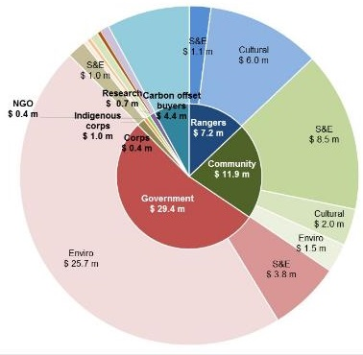

**Key:**

S&E: Social and Economic Outcomes

Cultural: Cultural Outcomes

Enviro: Environmental Outcomes

**Social Return on Investment**

The Warddeken delivered an SROI ratio of 3.4:1 based on the investment in operations between FY09-15.

That is, for every $1 invested, approximately $3.4 of social, economic, cultural and environmental value has been created for stakeholders.

**About this project**

PM&C commissioned SVA Consulting to understand, measure or estimate and value the changes resulting from the investment in in the Warddeken IPA and associated Indigenous ranger programme

The Warddeken analysis involved 43 consultations with stakeholders of the IPA, including 19 Community members, 12 Rangers, four representatives of the NT and Australian Governments, two Indigenous corporations, three NGO partners, one Corporate partner (overlapping with one Carbon offset buyer), and one Research partner.

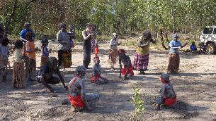 **In the spotlight: Ray Nadjamerrek, Ranger**

Ray is a grandson of Bardayal 'Lofty' Nadjamerrek AO, who led the movement of Nawarddeken back to the Stone Country, alongside his wife Mary Kolkkiwarra Nadjamerrek. Ray has lived in the bush all his life and came to Kabulwarnamyo as a teenager when the community was established.

Ray now lives in Kabulwarnamyo with his wife Eliza and their son Richard so he can raise his son on his traditional land and be near his grandmother. He also looks after some of his nieces and nephews on country, because he believes they will have a better life there than in a nearby growth community. Ray believes that if he was not living on country, he would be unemployed, sitting around and drinking.

*“If I wasn't here, I wouldn't have another job - I would probably be in town unemployed, sitting and drinking, waiting for the Club [pub in Gunbalanya] to open, fighting, doing nothing. That's what people do in Gunbalanya.”*

## A1.2 Executive Summary – Girringun IPA SROI analysis

**About the Girringun IPA**



**At a glance**

Traditional Owners: Eight groups

State/Territory: Queensland

Declaration: June 2013

Size: 1.26 million hectares

IUCN Category: II, III, IV and VI

IPA funding (FY15): $0.89m

WoC funding (FY15): $1.24m

Total income (FY15): $2.45m

Permanent rangers (FY15): 14

Casual rangers (FY15): Nil

The Girringun IPA is located in Northern Qld and was declared in June 2013. It consists of 1.26 million ha of land and sea country comprising Aboriginal-held land, private landholdings, national parks, conservation parks, fish habitat areas, marine protected areas and world heritage areas including the Great Barrier Reef World Heritage Area and Wet Tropics of Queensland World Heritage Area.

The land within the IPA belongs to eight traditional owner groups - Bandjin, Djiru, Girramay, Gugu Badhun, Gulnay, Nywaigi, Warrgamay and Warungnu traditional owners.[26]

The IPA aims to prioritise outcomes that Indigenous people seek for country alongside the interests of the broader Australian community, which are protected through marine and terrestrial protected areas. The IPA’s plan of management for country identifies works that traditional owners have prioritised through the consultation process including threatened species management, cultural site maintenance and research, monitoring and data collection. The transfer of cultural knowledge and language to young people, and the education of the broader community within the IPA about Indigenous culture, are also high priorities.

**Impact of the Girringun IPA**

Insights

* The Girringun IPA and associated Indigenous ranger programme has provided an opportunity for Indigenous people from eight traditional owner groups in Northern Qld to actively manage their diverse land and sea country, and re-engage with culture and language through country
* Critical to the success of the Girringun IPA and associated Indigenous ranger programme is its co-management model, whereby Girringun Aboriginal Corporation (GAC) partners with Local, State and Federal Governments as well as numerous NGO and Research partners to achieve shared outcomes for country
* The IPA’s management team offers a culturally assured process to its partners - whereby the appropriate people are consulted about activities undertaken on country – and plays a leading role in the region as advisors, trainers and channels of support for other organisations.
* The Indigenous Protected Areas (IPA) and associated Indigenous ranger programmes have demonstrated successes across a broad range of outcome areas, effectively overcoming barriers to addressing Indigenous disadvantage and engaging Indigenous Australians in meaningful employment to achieve large scale conservation outcomes, thus aligning the interests of Indigenous Australians and the broader community

In the six year period covered by this SROI analysis, the Girringun IPA has generated substantial social, economic, cultural and environmental outcomes for Rangers, Community members, Government and other stakeholders. The achievement of these outcomes is strongly influenced by the time Rangers and Community members spend living and working on country.

The most significant outcomes for Rangers relate to better caring for country, increased pride and sense of self, and better health and wellbeing. The most important outcomes for Community are leveraging the IPA for additional funding and economic opportunities, and better cultural asset management.

*“All the Rangers have had a tough background in one way or another. We said to them, whoever you are come and work with us… Just having a job helps. It is something to do…Something meaningful. That's the best medicine.”*

Phil Rist, traditional owner and Executive Officer, GAC

Government is also a significant beneficiary of the IPA, experiencing a range of outcomes including more skilled Indigenous people and greater respect for TEK. Indigenous corporations, NGO partners and Research partners have also benefited from deeper relationships with traditional owners and being better able to meet their core objectives.

Financial proxies have been used to approximate the value of these outcomes. The social, economic, cultural and environmental value associated with the outcomes was estimated to be $30.9m for FY10-15. During this period, $13.9m was invested in the Girringun IPA and associated Indigenous ranger programme, with most (96%) coming from Government.

**Value of social, economic, cultural and environmental outcomes created by stakeholder group, FY10-15**

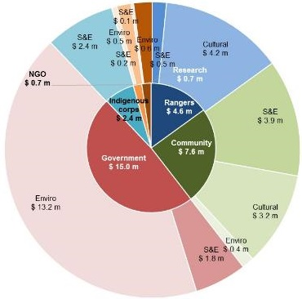

**Key:**

S&E: Social and Economic Outcomes

Cultural: Cultural Outcomes

Enviro: Environmental Outcomes

**Social Return on Investment**

The Girringun IPA delivered an SROI ratio of 2.2:1 based on the investment in operations between FY10-15.

That is, for every $1 invested, approximately $2.2 of social, economic, cultural and environmental value has been created for stakeholders.

*S&E: Social and Economic Outcomes*

*Cultural: Cultural Outcomes*

*Enviro: Environmental Outcomes*

**About this project**

PM&C commissioned SVA Consulting to understand, measure or estimate and value the changes resulting from the investment in the Girringun IPA and associated Indigenous ranger programme.

The Girringun analysis involved 45 consultations with stakeholders of the IPA, including 15 Community members (overlapping with representatives from two Indigenous corporations), five Rangers, seven representatives of Local, Qld and Australian Governments, five NGO partners and five Research partners.

|  |
| --- |
| **In the spotlight: Jessica Hoey, Director – Indigenous Partners, Great Barrier Reef Marine Park Authority (GBRMPA)**  Working with parnters from the Great Barrier Reef Marine Park Authority.The Girringun IPA and GBMRPA work closely together since part of the Girringun IPA’s sea country falls within the Great Barrier Reef World Heritage Area.  When the Great Barrier Reef was at risk of an ‘in danger’ listing by the UNESCO World Heritage Committee, the Girringun IPA led stakeholder engagement with local Indigenous communities on the Government’s behalf. This information, along with numerous references to the Girringun IPA, was used in a submission which resulted in the WHC deciding against declaring the Reef ‘in danger’.  *“The positive partnership between traditional owners of the Great Barrier Reef region and the Australian Government was recognised internationally as part of the government’s response to World Heritage Committee concerns about the Reef. Girringun played a role in this and helped shape the actions of the Reef 2050 report.”* |

## A1.3 Executive Summary – Birriliburu & Matuwa Kurrara Kurrara IPAs SROI analysis

**About the Birriliburu & Matuwa Kurrara Kurrara IPAs**

**At a glance**

Traditional Owners: Martu

State/Territory: Western Australia

Declaration: April 2013 (BB); July 2015 (MKK)

Size: 6.6m ha (BB); 0.6m ha (MKK)

IUCN Category: III & VI (BB); III, IV & V (MKK)

IPA funding consolidated (FY15): $0.5m

WoC funding consolidated (FY15): Nil

Total income consolidated (FY15): $1.1m

Permanent rangers (FY15): Nil

Casual rangers (FY15): 55

The Birriliburu and MKK IPAs are located in central WA, north east of Wiluna. The land belongs to the Martu people, who were among the last of Australia’s Indigenous people to make contact with Europeans. Many living Martu recall their experience of first contact, occurring as late as the 1960’s. Whilst Martu culture and connection to country remains strong, many Martu live in towns on the edge of the desert, rather than on their country.

The Birriliburu IPA consists of 6.6 million ha and was declared in April 2013. The MKK IPA, declared in July 2015, covers 596,754 ha south of Birriliburu and consists of two former pastoral properties, Lorna Glen (Matuwa) and Earaheedy (Kurrara Kurrara).

The IPAs’ plans of management for country identify works that Martu have prioritised through the consultation process. Those works include burning country, managing feral animals, protecting threatened species and managing tourist visitation to important Martu sights. The IPAs do not receive funds through the Australian Government’s WoC programme. Instead, revenue generated through Government, NGO and Corporate partnerships contributes to limited Ranger employment opportunities.

**Impact of the Birriliburu & Matuwa Kurrara Kurrara IPAs**

Insights

* The Birriliburu & Matuwa Kurrara Kurrara (MKK) IPAs have provided an opportunity for Martu people to reconnect with and actively manage their traditional country, whilst supporting improved local governance and decision-making
* The two IPAs have delivered critical programme structures with which to attract third party investment, through a joint management arrangement with the WA Government, fee-for-service environmental service contracts with mining companies and project specific funding from environmental NGOs
* Increased and diversified investment from a range of funding sources would meet the high demand for Ranger jobs and could deliver a more expansive programme of works, which would, in turn, increase the social, economic and cultural outcomes for Martu Rangers and Community Members
* The IPA programme has demonstrated successes across a broad range of outcome areas, effectively overcoming barriers to addressing Indigenous disadvantage and engaging Indigenous Australians in meaningful employment to achieve large scale conservation outcomes, thus aligning the interests of Indigenous Australians and the broader community

This SROI analysis demonstrates that the Birriliburu and MKK IPAs have generated significant social, economic, cultural and environmental outcomes for Martu Rangers, Community members, Government and other stakeholders. The achievement of these outcomes is strongly dependent on the engagement of Martu on country; the more time Martu spend working on country, the greater the value created by the Birriliburu and MKK IPAs.

*“We want jobs and money for Martu; people to look after country.”*

‘What Martu want for country’, Birriliburu IPA, Plan for Country, 2012

The three most significant outcomes for Rangers and Community members relate to better caring for country, preserving culture and language and leveraging the IPAs for additional funding and economic opportunities. The Birriliburu IPA is characterised by a strong custodial responsibility to look after country and provides for the transfer of traditional knowledge between generations. The MKK IPA provides for the development of Rangers’ natural resource management and work readiness skills through a joint management arrangement with the WA Department of Parks and Wildlife (DPaW).

The WA and Australian Governments have experienced a range of outcomes, including more skilled Indigenous people and improved engagement with community. Corporate, NGO and Research partners have also benefited from deeper relationships with community and being better able to meet their core objectives.

Financial proxies have been used to approximate the value of these outcomes. The social, economic, cultural and environmental value associated with the outcomes was estimated to be $8.8m for FY11-15.

During this period, $3.8m was invested in the programmes, with most (74%) coming from Government and the remainder from NGO and Corporate partners.

**Value of social, economic, cultural and environmental outcomes created by stakeholder group, FY11-15**

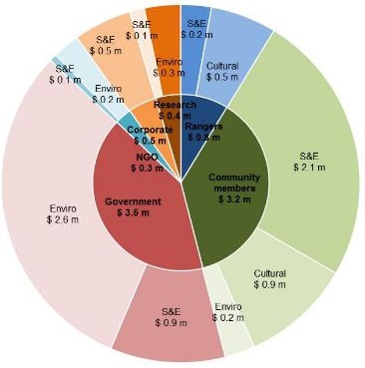

**Key:**

S&E: Social and Economic Outcomes

Cultural: Cultural Outcomes

Enviro: Environmental Outcomes

**Social Return on Investment**

The Birriliburu & MKK IPAs delivered an SROI ratio of 2.3:1 based on the investment in operations between FY11-15.

That is, for every $1 invested, approximately $2.3 of social, economic, cultural and environmental value has been created for stakeholders.

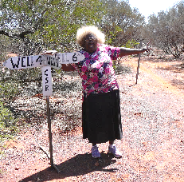

In the spotlight: Lena Long, Ranger

Lena Long was born at Well 7 on the Canning Stock Route. Lena tells of how her mother gave birth, then spent the following day on horseback, carrying Lena into the pastoral station at which she worked. Lena is pictured here at Well 5, pointing up the road to her birthplace.

Lena has been one of the most consistent Ranger employees. She has enjoyed reconnecting with country and passing on her knowledge to younger generations. She sees a huge opportunity to effect greater change with increased investment in the IPAs.

At a meeting with representatives of DPaW, Lena explained how Martu and the Department staff can continue to strengthen their working relationship and learn from each other.

"We want to work with the scientists. Even if it's just one or two Martu. Learning from the scientists. And we can teach them Martu names and looking for tracks."

DPaW Regional Manager, Ian Kealley, agrees.

*"I don't think our staff could ever read the country and track a cat cross country the way Martu can."*

**About this project**

PM&C commissioned SVA Consulting to understand, measure or estimate and value the changes resulting from the investment in the Birriliburu & MKK IPAs using the SROI methodology.

The Birriliburu and MKK analysis involved 34 consultations with stakeholders of the two IPAs, including nine Community members, seven Rangers (overlapping with representatives from two Indigenous corporations), six representatives of local, WA and Australian Government, four NGO partners, two Corporate partners and two Research partners.

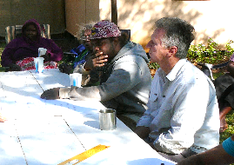

In the spotlight: Zareth Long, Ranger

Zareth started working on country because he liked hearing stories from “the old fellas”. He has since found that Ranger work helps him to get away from the stress of living in town, to live a healthier lifestyle and better manage his alcohol consumption.

Zareth is one of several young Rangers who are working and learning together and growing in confidence. He is pictured (second from right) preparing to Chair a meeting with representatives from DPaW at the Lorna Glen research station on the MKK IPA.

Zareth hopes to pass on his knowledge to his wife (who is Noongar, from Perth) and his five year old son.

*“I want to teach my son about town stuff and about Martu stuff. I want to teach my wife about Martu stuff. We can’t teach Martu stuff unless we’re out on country.”*

## A1.4 Executive Summary – Minyumai IPA SROI analysis

**About the Minyumai IPA**

**At a glance**

Traditional Owners: Bandjalang

State/Territory: NSW

Declaration: May 2011

Size: 2,164 hectares

IUCN Category: IV and VI

IPA funding (FY15): $0.16m

WoC funding (FY15): Nil

Total income (FY15): $0.22m

Permanent rangers (FY15): 3

Casual rangers (FY15): 16

Minyumai is a 2,164 hectare freehold property of largely uncleared native forest, woodland and wetland habitats on the far north coast of NSW. The land was handed back to the traditional owners of the land, the Bandjalang clan, on 16 April 1999 by the ILC and is managed by the Minyumai Land Holding Aboriginal Corporation (MLHAC). The Minyumai IPA was declared in August 2011.

Over the last five years an estimated 24 Bandjalang have been employed as Rangers. They protect and conserve Minyumai’s threatened plants and animals and their habitats through weed, feral animal and fire management work.

**Impact of the Minyumai IPA**

Insights

* The Minyumai IPA has provided an opportunity for the Bandjalang clan to re-engage with culture and language through country
* Through land and fire management work, Bandjalang have seen the restoration of native plants and animals that were thought to have been lost. Their return serves as a powerful reminder of the resilience of the Bandjalang people and enables them to better understand themselves, their culture, and their place in the world
* The IPA programme has demonstrated successes across a broad range of outcome areas, effectively overcoming barriers to addressing Indigenous disadvantage and engaging Indigenous Australians in meaningful employment to achieve large scale conservation outcomes, thus aligning the interests of Indigenous Australians and the broader community
* Other key factors for success are the presence of a passionate and committed community with a strong cultural connection to the land and the collaborative partnership developed with the Firesticks Project

Over the last five years, the Minyumai IPA has produced a wide range of social, economic, cultural and environmental outcomes.

The most significant outcomes for Rangers and Community members relate to better caring for country and strengthening their connection to country. The ability to leverage the IPA for additional funding and economic opportunites, most notably, the Firesticks Project, has also been critical.

*“Being on the land is like meditating to me. Everything drops away and you leave it at the gate.”*

Simone Barker, Director, Minyumai Land Holding Aboriginal Corporation

Government has experienced a range of outcomes, including more skilled Indigneous people and improved engagement with community. NGO and Research partners have benefitted as well from deeper relationships with community and being better able to meet their core objectives.

Financial proxies have been used to approximate the value of these outcomes. The social, economic, cultural and environmental value associated with the outcomes was estimated to be $1.4m for the five financial years between 2011 and 2015 inclusive.

During this period, $0.9m was invested in the programs, with most (~90%) coming from Government and the remainder from NGO partners and Foundations and Trusts.

**Value of social, economic, cultural and environmental outcomes created by stakeholder, FY11-15**

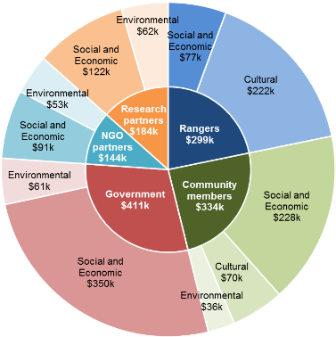

The Minyumai IPA delivered an SROI ratio of 1.5:1 based on the investment and operations of FY11-15.

That is, for every $1 invested, approximately $1.5 of social, economic, cultural and environmental value has been created for stakeholders.

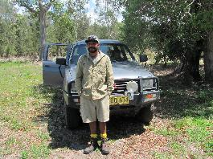

In the spotlight: Daniel Gomes, Senior Ranger

*“When we burned this area, I didn’t think the native plants would come back but they did. I couldn’t believe it... When I see these changes, I feel proud.”*

Daniel grew up hearing his grandfather, the late elder Lawrence Wilson, tell stories of the native plants and animals that used to inhabit Minyumai. He worried they would never return.

He has been working on country for the last 15 years, often in his spare time and most recently as a Senior Ranger, and is starting to see his land and fire management work pay off. The return of the native plants isn’t just ecological to him. It is intimately connected with his sense of self, locating him in his culture and ancestry, and serves as a powerful symbol and reminder of the resilience of the Bandjalang people.

**About this project**

PM&C commissioned SVA Consulting to understand, measure or estimate and value the changes resulting from the investment in the Minyumai IPAs using the SROI methodology.

The analysis involved 19 consultations with stakeholders of the Minyumai IPA including five Rangers, six Community members, two Government, two Land councils, two NGO partners, one Corporate partner and one Research partner.

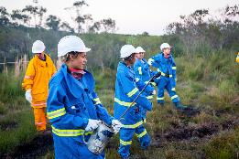

In the spotlight: Kesha Wilson, Belinda Gomes, and Lily Wilson, Casual Rangers

*“We just want to do more; learn more.”*

Prior to working on country, Kesha, Belinda, and Lily weren’t sure if they would like working in the bush. Now they love it and have been involved in burns with high commercial value such as a hazard reduction burn at Coffs Harbour Airport. They want to do more work but are limited by the amount of funding available.

Nevertheless they continue to brainstorm where else they can apply their skills. Community members describe their relentless enthusiasm as inspirational.

## A2.1 Theory of change – Issues, Stakeholders, Activities and Inputs (Investment)

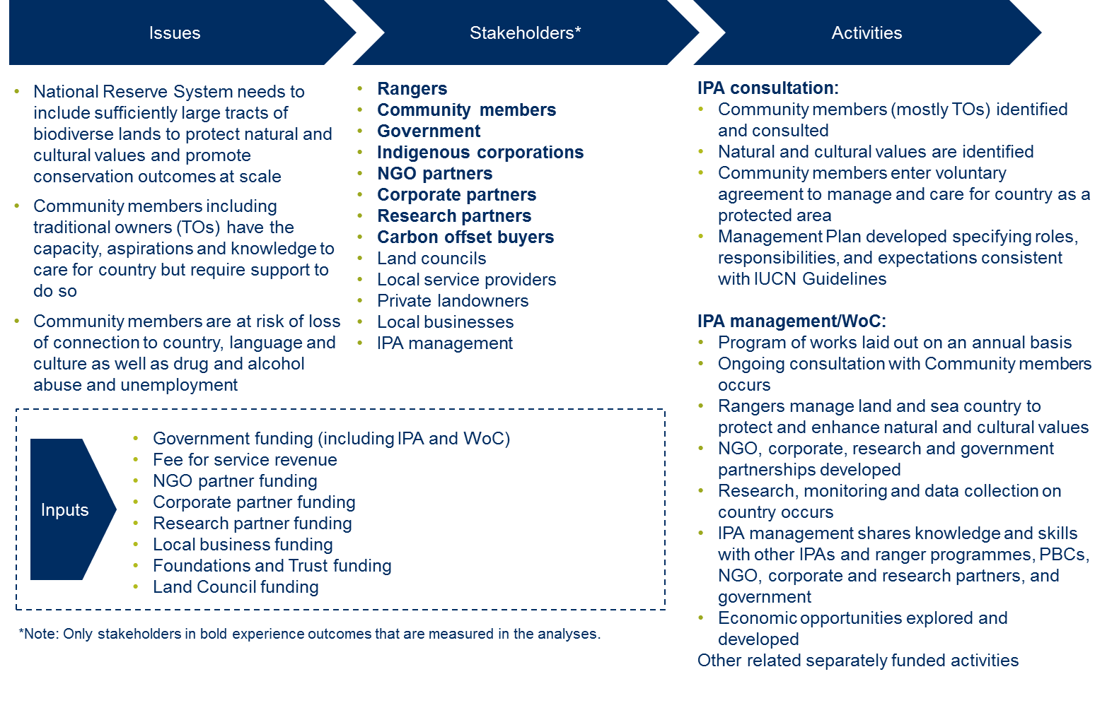

## A2.2 Theory of change – Ranger and Community member outcomes

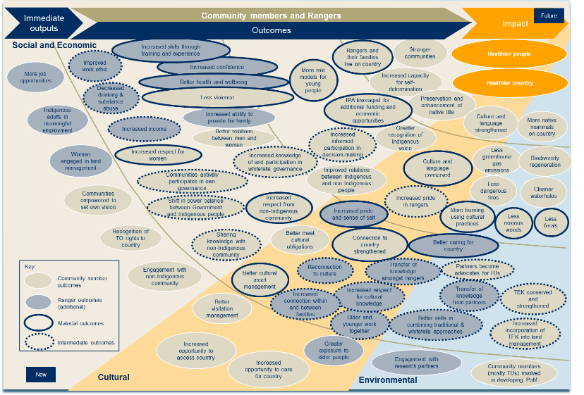

## A2.3 Theory of change – Government outcomes

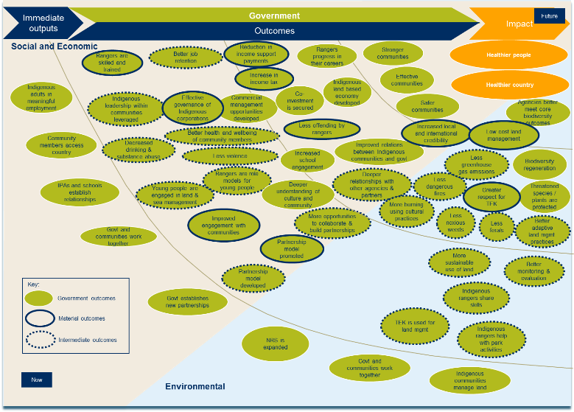

## A2.4 Theory of change – Other Stakeholder outcomes

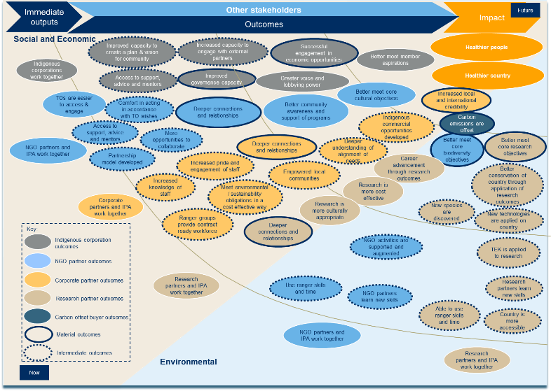

## A3 Total adjusted value ($) by outcome and by IPA analysis, over period of investment

Outcomes and attributed IPA investments.

Table continued

## A4 Total adjusted value ($) by outcome as aligned with Indigenous Advancement Strategy

PM&C priorities and attributed SROI outcomes and values.

1. Totals 91.4%, as 7 of the 35 material outcomes were not deemed to be closely aligned with PM&C’s Strategic Priorities
2. See e.g. Gilligan, 2006; Smyth, 2011; The Allen Consulting Group, 2011; Urbis, 2012; Social Ventures Australia, 2014
3. PM&C Working on Country and Indigenous Protected Areas programmes 2013-14 annual report, p4.
4. <https://www.environment.gov.au/land/nrs/about-nrs/requirements>
5. <https://www.dpmc.gov.au/sites/default/files/publications/IPA_FS_2015_1.pdf>; <https://www.iucn.org/about/work/programmes/gpap_home/gpap_quality/gpap_pacategories/>
6. <https://www.dpmc.gov.au/indigenous-affairs/about/jobs-land-and-economy-programme/indigenous-environment-branch/indigenous-protected-areas-ipas>
7. <https://www.dpmc.gov.au/indigenous-affairs/about/jobs-land-and-economy-programme/indigenous-environment-branch/funding-indigenous-land-and-sea-management-projects>
8. Data provided by PM&C
9. <http://www.dpmc.gov.au/indigenous-affairs/about/jobs-land-and-economy-programme/indigenous-environment-branch/indigenous-rangers-working-country>; PM&C Working on Country and Indigenous Protected Areas programmes 2013-14 annual report, p5.
10. <http://www.dpmc.gov.au/indigenous-affairs/about/jobs-land-and-economy-programme/indigenous-environment-branch/indigenous-rangers-working-country>
11. PM&C Working on Country and Indigenous Protected Areas programmes 2013-14 annual report, p5.
12. Ibid.
13. <http://www.dpmc.gov.au/indigenous-affairs/about/jobs-land-and-economy-programme/indigenous-environment-branch/indigenous-rangers-working-country>
14. Data provided by PM&C
15. Income is the total amount received from all sources, not just from Government.
16. The relevant period of investment for Wardekken commenced in FY09 and for Girringun in FY10, while for Birriliburu, MKK and Minyumai, the relevant period commenced in FY11.
17. Each IPA and associated Indigenous ranger programme will have a slightly different theory of change, depending on the context. Those individual theories of change are accessible in the individual SROI reports relating to each IPA.
18. For example, Rangers acquiring new skills manifests as an outcome for Rangers (“Increased skills through training and experience”) and Government (“Rangers are skilled and trained”); in addition, numerous environmental outcomes are shared across Community members and Government (such as “More burning using cultural practices”).
19. The other two categories being ‘cultural’ and ‘social and economic’
20. When reviewing this information, it must be kept in mind that many cultural outcomes (such as ‘better caring for country’ and ‘connection to country strengthened’) can be viewed simultaneously as environmental outcomes and that a high value has been attributed to environmental outcomes realised by Government.
21. NAILSMA, <http://www.nailsma.org.au/walfa-west-arnhem-land-fire-abatement-project>.
22. 69 IPAs were in existence in the 2015 financial year but 67 of these were funded
23. Department of the Prime Minister and Cabinet, Corporate Plan, 2015-19, Improving the lives of Indigenous Australians
24. Commonwealth of Australia (2013), Working on Country: Reporting back to you, 2009-2012
25. See e.g. Gilligan, 2006; Smyth, 2011; The Allen Consulting Group, 2011; Urbis, 2012; Social Ventures Australia, 2014
26. The Jirrbal people support declaration of the IPA in principle.