Department of the Prime Minister & Cabinet
Social Return on Investment analysis of the Warddeken Indigenous Protected Area and associated Indigenous ranger programme

FULL REPORT

February 2016

About Social Ventures Australia
Social Ventures Australia (SVA) works with innovative partners to invest in social change. We help to create better outcomes for disadvantaged Australians by bringing the best of business to the for purpose sector, and by working with partners to strategically invest capital and expertise. SVA Impact Investing introduces new capital and innovative financial models to help solve entrenched problems. SVA Consulting partners with non-profits, philanthropists, corporations and governments to strengthen their capabilities and capacity to address pressing social problems.

List of Abbreviations
ALFA Arnhem Land Fire Abatement
CDEP Community Development Employment Projects
DoE Department of the Environment
IAS Indigenous Advancement Strategy
IPA Indigenous Protected Area
IUCN International Union for Conservation of Nature
NERP National Environmental Research Programme
NGO Non-Government Organisation
NRS National Reserve System
NT Northern Territory
PM&C Department of the Prime Minister & Cabinet
SROI Social Return on Investment
SVA Social Ventures Australia
TEK Traditional Ecological Knowledge
WALFA West Arnhem Land Fire Abatement
WLML Warddeken Land Management Limited
WoC Working on Country

Table of Contents
About Social Ventures Australia 1
List of Abbreviations 2
Executive Summary 4
1 Introduction 8
1.1 Project objective 8
1.2 Project scope 8
1.3 Report structure 9
2 Context 10
2.1 Indigenous Protected Areas 10
2.2 Working on Country programme 11
2.3 About the Warddeken IPA and associated Indigenous ranger programme 12
2.4 Investment (inputs) 14
3 Methodology for this project 16
3.1 Understanding change 16
3.2 Measuring change 18
3.3 Valuing change 19
3.4 SROI ratio 20
4 Impact of the Warddeken IPA and associated Indigenous ranger programme 21
4.1 Understanding the change 21
4.2 Stakeholder outcomes 27
4.3 Measuring the change 41
4.4 Valuing the change 46
4.5 Calculating the SROI 49
5 Conclusion 56
6 Appendices 59

Executive Summary
Insights
- The Indigenous Protected Areas (IPA) and associated Indigenous ranger programmes have demonstrated successes across a broad range of outcome areas, effectively overcoming barriers to addressing Indigenous disadvantage and engaging Indigenous Australians in meaningful employment to achieve large scale conservation outcomes, thus aligning the interests of Indigenous Australians and the broader community
- The Warddeken IPA and associated Indigenous ranger programme has had a transformative effect on Nawarddeken, to whom the land belongs, enabling them to stay living on country and manage their land while connecting with culture and ancestors
- Significant value is derived from the IPA’s fire management work conducted by Rangers on country using traditional and contemporary practices, which has generated substantial revenue for Nawarddeken as a result of carbon offset sales facilitated through innovative partnerships including the West Arnhem Land Fire Abatement (WALFA) project
- The IPA has developed deep, longstanding relationships with NGO and Research partners including Bush Heritage Australia, The Nature Conservancy and The Pew Charitable Trusts which has enabled them to successfully pursue shared conservation management outcomes.
About the Warddeken IPA and associated Indigenous ranger programme
The Warddeken IPA consists of approximately 1.4 million ha of stone and gorge country in West Arnhem Land, Northern Territory (NT) and was declared in September 2009. The land belongs to Nawarddeken, who are traditional owners from at least 30 clan groups of the Bininj Kunwok language group. The land within the IPA is of high biodiversity significance and contains very important cultural, rock art and archaeological sites.
The main activities conducted on the IPA include extensive fire management, feral animal and weed control, and monitoring threatened species, which support Nawarddeken to take ownership of the natural and heritage management of their country. Culturally-focused activities are a strong focus, providing an opportunity for Rangers and Community members to return to places of cultural and historical significance, and transfer knowledge to younger generations.
The IPA has been leveraged for numerous economic opportunities, the most significant of which is carbon offset sales to buyers including the IPA’s corporate partner ConocoPhillips. The IPA has also played a pivotal role in the development of Indigenous corporations in Arnhem Land, which has resulted in significant financial benefits to a wide range of communities through the carbon market. During the seven year period of investment covered by this analysis, 253 Indigenous people, mostly traditional owners, worked on the IPA.
Impact of the Warddeken IPA and associated Indigenous ranger programme
“Here we have healthy country and culture, and everyone has a healthy body and healthy mind.”
Terrah Guymala, Senior Ranger
This SROI analysis demonstrates that the Warddeken IPA has generated significant social, economic, cultural and environmental outcomes for Nawarddeken Rangers, Community members, Government and other stakeholders. The achievement of these outcomes is strongly influenced by the time Rangers and Community members spend living and working on country, and the remoteness of the IPA location.
For Rangers, the most significant outcomes relate to better caring for country, and increased pride and sense of self. The most important outcomes for Community members include Rangers and their families living on country, and more burning using cultural practices. The NT and Australian Government benefit through more Indigenous people working, and safer communities. Indigenous corporations, Corporate, NGO and Research partners, and carbon offset buyers have also benefited from deeper relationships with community and being better able to meet their core objectives.
Financial proxies have been used to approximate the value of these outcomes. The social, economic, cultural and environmental value associated with the outcomes was estimated to be $55.4m for FY09-15.
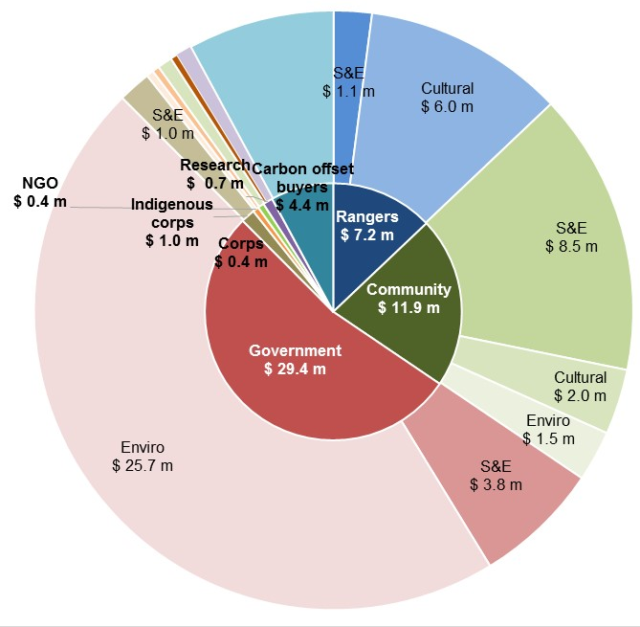
S&E: Social and Economic Outcomes
Cultural: Cultural Outcomes
Enviro: Environmental Outcomes
Social Return on Investment
The Warddeken delivered an SROI ratio of 3.4:1 based on the investment in operations between FY09-15.
That is, for every $1 invested, approximately $3.4 of social, economic, cultural and environmental value has been created for stakeholders.
Figure E.1 – Value of social, economic, cultural and environmental outcomes created by stakeholder group, FY09-15
During this period, $16.6m was invested in the programmes, with most (62%) coming from Government and Carbon offset buyers (25%).

Stakeholder | Total
Government  Includes WoC funding (68%) and IPA funding (25%) | $10,120,191
Carbon offset buyers  Includes revenue from carbon offset sales from ConocoPhillips (FY09-15) and other buyers (FY15 only) | $4,383,662
NGO Partners  Includes funding from Bush Heritage Australia (80%) and The Nature Conservancy (15%) | $1,295,095
Local Businesses | $347,000
Foundations and Trusts | $217,686
Land Councils  Includes funding from Northern Land Council (100%) | $100,000
Research Partners  Includes grant income from Charles Darwin University (100%) | $94,364
Total | $16,557,998
Table E.1 – Investment FY09-15
In the spotlight: Ray Nadjamerrek, Ranger
Ray is a grandson of Bardayal 'Lofty' Nadjamerrek AO, who led the movement of Nawarddeken back to the Stone Country, alongside his wife Mary Kolkkiwarra Nadjamerrek. Ray has lived in the bush all his life and came to Kabulwarnamyo as a teenager when the community was established.
Ray now lives in Kabulwarnamyo with his wife Eliza and their young son Richard so he can raise his son on his traditional land and be near his grandmother. He also looks after some of his nieces and nephews on country, because he believes they will have a better life there than in a nearby growth community.
Ray believes that if he was not living on country, he would be unemployed, sitting around and drinking.
“If I wasn't here, I wouldn't have another job - I would probably be in town unemployed, sitting and drinking, waiting for the Club [pub in Gunbalanya] to open, fighting, doing nothing. That's what people do in Gunbalanya.”
About this project
The Department of the Prime Minister & Cabinet (PM&C) commissioned SVA Consulting to understand, measure or estimate and value the changes resulting from the investment in the Warddeken IPA and associated Indigenous ranger programme. This analysis is part of a broader project that considers five IPAs across Australia, also including Birriliburu and Matuwa Kurrara Kurrara in Western Australia (together forming one analysis), Girringun in Queensland, Minyumai in New South Wales. The Social Return on Investment (SROI) methodology was used to complete each of these analyses.
The Warddeken analysis involved 43 consultations with stakeholders of the IPA, including 19 Community members, 12 Rangers, four representatives of the NT and Australian Governments, two Indigenous corporations, three NGO partners, one Corporate partner (overlapping with one Carbon offset buyer), and one Research partner.
“Warddeken falls on top of the most important biodiversity hotspot in the Northern Territory and the IPA allows us to protect it in the most cost effective way.”
Alaric Fisher, Manager, Biodiversity Unit, Flora and Fauna Division of the Department of Land Resource Management, NT Government
Recommendations
Recommendations derived from this analysis have been provided to the WLML management team.
Consolidated Report
A corresponding report has also been developed by SVA Consulting titled, Consolidated report on Indigenous Protected Areas following Social Return on Investment analyses, which includes key insights from this analysis alongside the analyses of three other IPAs. That report is available on the PM&C website.

1 Introduction

1.1 Project objective
PM&C commissioned SVA Consulting to understand, measure or estimate and value the changes resulting from the investment in the Warddeken IPA in the NT and associated Indigenous ranger programme. This analysis is part of a project that analyses five IPAs across Australia including Birriliburu and Matuwa Kurrara Kurrara in Western Australia (together forming one analysis), Girringun in Queensland and Minyumai in New South Wales. The SROI methodology was used to complete this analysis. The analysis will enable PM&C to understand the social, economic, cultural and environmental outcomes created by the Warddeken IPA and associated Indigenous ranger programme for stakeholders and to inform the future policy direction of the IPA programme.
Social Return on Investment
SROI is an internationally recognised methodology used to understand, measure or estimate and value the impact of a programme or organisation. It is a form of cost-benefit analysis that examines the social, economic, cultural and environmental outcomes created and the costs of creating them. The Social Value principles are defined in the methodological attachment to this report.

1.2 Project scope
The scope of the current analysis represents a SROI of the Warddeken IPA and associated Indigenous ranger programme for a seven year period between July 2008 and June 2015. This period is the time from the beginning of the consultation period to establish the IPA to the end of the 2015 financial year.
There are two forms of SROI analysis outlined in the SROI Guide, a forecast SROI and an evaluative SROI. A forecast SROI makes a prediction about what will happen and is informed by stakeholder consultation and other research. An evaluative SROI looks back to assess the value created as a result of an investment. This analysis is most similar to an evaluative SROI, in that it forms a judgment on the value created by the Warddeken IPA and associated Indigenous ranger programme over time. However, due to the limited data available for comparison, this analysis has been less rigorous than an evaluative SROI. This SROI looks back in time and takes account of the available evidence from past performance and, where appropriate, from project social values. In line with Social Value principles, it is informed by stakeholder consultation.
The analysis involved 43 consultations with stakeholders of the Warddeken IPA and associated Indigenous ranger programme including 19 Community members, 12 Rangers, four representatives of the NT and Australian Governments, two Indigenous corporations, three NGO partners, one Corporate partner, one Research partner and one Carbon offset buyer. A review of Warddeken Land Management Limited (WLML) financial and payroll data was also undertaken. The methodology for this analysis and interview guides are set out in the Methodological Attachment to this report.

1.3 Report structure
The structure of the report is set out below.
- Section 1 (this section) introduces the analysis
- Section 2 provides the context of the Warddeken IPA and associated Indigenous ranger programme
- Section 3 includes information about the methodology for this project
- Section 4 describes the impact of the Warddeken IPA and associated Indigenous ranger programme
- Section 5 synthesises the findings and draws insights from the analysis
- Section 6 contains details of the Appendices

2 Context

2.1 Indigenous Protected Areas
An IPA is an area of Indigenous owned or managed land or sea country that is formed when traditional owners voluntarily enter into an agreement with the Australian Government to manage their land for conservation with government support. The IPA programme was developed in the mid 1990’s and supports Indigenous landowners to use land and sea management as a framework for employment and natural and cultural heritage conservation outcomes.
Goals of the IPA programme
- Support Indigenous land owners to develop, declare and manage Indigenous Protected Areas on their lands as part of Australia's National Reserve System
- Support Indigenous interests to develop cooperative management arrangements with Government agencies managing protected areas
- Support the integration of Indigenous ecological and cultural knowledge with contemporary protected area management practices.
There are five key steps involved in establishing and maintaining an IPA:
- Community and stakeholder consultation
- Developing a Plan of Management
- IPA Declaration
- Implementing the Plan of Management
- Monitoring, evaluation, reporting and improvement.
An IPA can be declared after a consultation period has occurred and a Plan of Management has been developed. During the consultation period, Indigenous communities are supported by the Australian Government to consult with their communities and other stakeholders about whether an IPA is suitable for them. A Plan of Management is then developed which sets out how country, its cultural values and threats to these values will be managed.
Once recognised by the Australian Government, IPAs form part of the NRS that seeks to protect Australia’s biodiversity for the benefit of all Australians in line with international guidelines. As at November 2015, there were 72 dedicated IPAs across almost 65 million hectares accounting for more than 43% of the total area of the NRS.
The IPA programme is managed by the Environment Branch of the Indigenous Employment and Recognition Division within the Indigenous Affairs Group of the Department of the Prime Minister and Cabinet. Funding is provided through the Natural Heritage Trust under the National Landcare Programme which is administered by DoE, with $73.08 million allocated from 2013-14 through to 2017-18.
There are four key features of an IPA:
- An open-ended consultation period in which Indigenous traditional owners can decide whether to proceed to IPA declaration or not, depending on their intentions for managing their country
- Commitments made by Indigenous communities outlined in a Management Plan to manage their land and sea within the IPA are voluntary, rather than by statutory agreement with the Australian Government
- Partnerships with various Government agencies, NGOs, corporates, research institutions and others are often formed to support capacity building and undertake joint activities within the IPA
- IPAs can occur over sea country as well as on multi-tenure land including national park, local government reserves, private land and native title returned lands, under co-management arrangements

2.2 Working on Country programme
Caring for country is a phrase used by Indigenous Australians to describe their deep spiritual and cultural connection to country and their responsibilities for looking after it. These cultural obligations can sit alongside paid work looking after country as part of the WoC programme.
The WoC programme is now part of the PM&C IAS. It began in 2007 to create real jobs for Indigenous people as part of the reforms to the Community Development Employment Projects (CDEP). The WoC programme supports Indigenous peoples’ aspirations to care for country and seeks to build on Indigenous peoples’ traditional knowledge and obligations with respect to land, sea and culture. Through the WoC programme, nationally accredited training and career pathways for Indigenous people in land and sea management are provided in partnership with others. The WoC programme also helps Government meet its environmental responsibilities and complements the IPA programme.
As at November 2015, there were 108 Indigenous Ranger groups in Australia and 775 full-time equivalent Indigenous Rangers. The WoC programme received funding of $335 million over five years. In the NT, a further commitment of $12.7 million from 2013-16 through Stronger Futures created an additional 53 new jobs.
An IPA can exist without an associated Indigenous ranger programme funded through WoC or another mechanism. Similarly, the existence of an IPA is not a prerequisite to the receipt of WoC funding.

2.3 About the Warddeken IPA and associated Indigenous ranger programme
The Warddeken IPA consists of 1,394,951 hectares of stone and gorge country in West Arnhem Land, NT. The land within the IPA belongs to Nawarddeken who are traditional owners from at least 30 clan groups of the Bininj Kunwok language group. The boundaries of the IPA are based on Aboriginal cadastral information and detailed knowledge of clan estates.
Historical context of Warddeken
Before the IPA was declared, Nawarddeken had lived on the plateau for thousands of years until the 1950s when they walked off the land and moved to communities such as Gunbalanya (Oenpelli) and Maningrida in search of work. In the early 1990s, led by Elders including Warddeken’s visionary leader and distinguished artist Bardayal 'Lofty' Nadjamerrek AO (Lofty), some Nawarddeken decided to repopulate the plateau. Outstations that had previously been populated were re-established and a new outstation called Kabulwarnamyo was established. An early Ranger programme, Manwurrk Rangers, was established in the early 2000s.
In May 2007, senior representatives of ten of the land owning clans within the Warddeken IPA met with the Manuwurrk rangers, Warddeken’s then CEO Peter Cooke and consultant Dan Gillespie to start management planning for the IPA. Following this, ten consultation meetings were held in 2007 with landowners to discuss the draft management plan and subsequent meetings with clan members and the Northern Land Council were held.
Following this, WLML was established in 2007 to facilitate the delivery of land management services across the country within the IPA. WLML is not a traditional owner group that represents or makes decisions for country; decisions remain with landowning groups. The board of WLML consists of 12 positions – three people from each of the clans North, South, East and West of the IPA who guide the strategic direction of the IPA and associated Indigenous ranger programme on behalf of traditional owners.
The Warddeken IPA was declared in September 2009 and is managed under the IUCN Category VI as a protected area with sustainable use of natural resources. The area within the IPA is a critical part of the Arnhem Land Plateau as it includes large areas of Arnhem Plateau sandstone heath, substantial habitat for endemic and highly restricted species, sandstone rainforest thickets and sections of significant floristic diversity. The IPA also contains very significant cultural, rock art and archaeological sites.
Working on the IPA
Today, Indigenous Rangers look after country within the Warddeken IPA through positions funded by the Australian Government’s WoC programme. During the period of investment covered by this analysis, 253 Indigenous people, mostly traditional owners, worked on the Warddeken IPA.
There are four key features of the Warddeken IPA and Ranger programme:
- The IPA is situated in remote West Arnhem Land and includes five outstations which are dry communities (i.e. no alcohol is permitted)
- The IPA has been leveraged for numerous economic opportunities, the most significant of which is the WALFA project which enables the sale of carbon offsets by Warddeken as a result of sustainable fire management conducted by Rangers using traditional methods. Over the seven year period, this has generated income for Warddeken’s traditional owners of approximately $4.4 million, representing a significant co-benefit
- A charitable trust, the Karrkad-Kanjdji Trust, has been established to increase resources for the Warddeken Rangers and Djelk Rangers, a neighbouring Indigenous Ranger group, to undertake natural and cultural resource management work
- In 2015, the Warddeken IPA established a school called Nawarddeken Academy on the largest outstation within the IPA, Kabulwarnamyo, which teaches primary school aged children of Rangers and their families.
Table 2.1 and Figures 2.1 and 2.2 below describe the key activities and participants of the Warddeken IPA and the Ranger programme.
Activities | Description | Participants and key details (FY09-15)
Ranger work (Working on Country) | Provides employment and training for older and younger Nawarddeken as Rangers fulfilling standard Ranger responsibilities to manage the environment (e.g. fire management, feral animal and weed control, monitoring threatened species), but also to support Nawarddeken to take ownership of the natural and heritage management of their country. While there is no specific female Ranger programme, female Rangers work on country particularly on monitoring and evaluation activities. | - 253 people employed as WoC Rangers (approximately 53% men and 47% women)  - Two Ranger teams operating across five outstations  - 175,029 Ranger hours worked  - $3.9m in salaries paid (gross)
Culturally-focused activities linked to work undertaken on the IPA | Provides an opportunity for Rangers and Community members to return to places of cultural and historical significance, having a profound effect on the individuals and facilitating important capture and transfer of knowledge to the younger generation and more broadly to the community. | - Approximately four major organised cultural experiences per year involving 25 Rangers, 6 Cultural Experts and 50 Community members  - Numerous other ad-hoc cultural activities
Economic activities | Carbon offset sales through WALFA as a result of fire management work using traditional knowledge carried out by Rangers on country which results in less greenhouse gas emissions. | - Fire management work by Rangers results in thousands of tonnes of carbon abated per year
Table 2.1 – Summary of investment
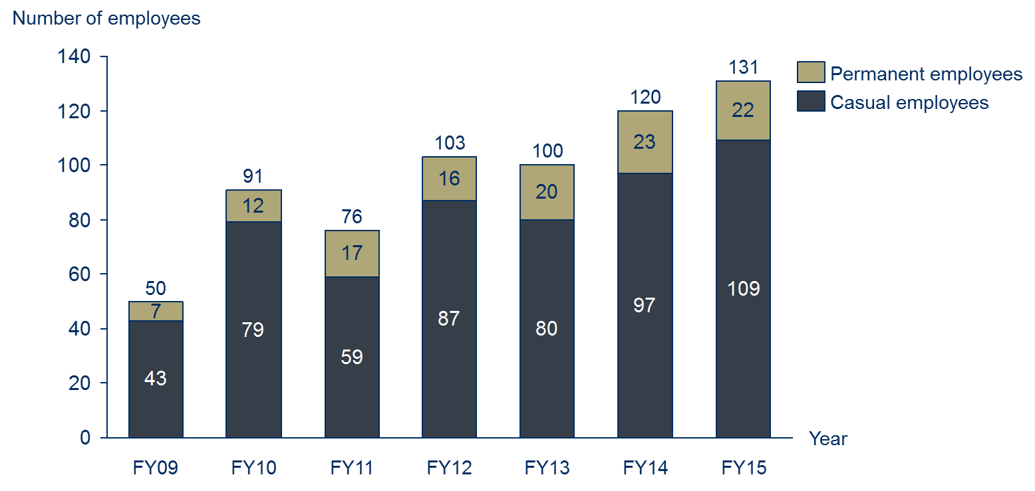
Figure 2.1 – Number of Warddeken Indigenous Rangers (referred to as Rangers throughout this report), FY09-15
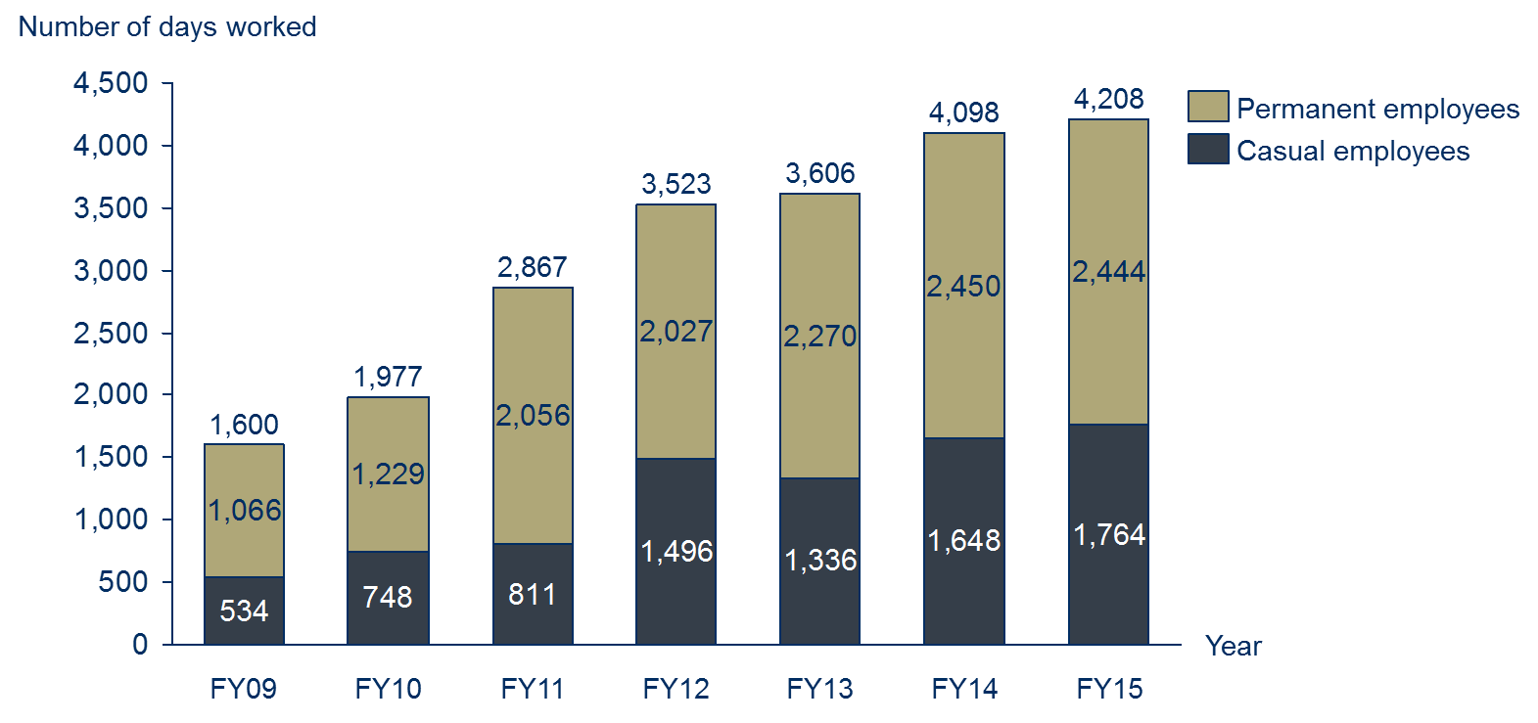
Figure 2.2 – Number of days worked by Warddeken Indigenous Rangers, FY09-15

2.4 Investment (inputs)
The investment included in an SROI analysis is a valuation of all the inputs required to achieve the outcomes that will be described, measured or estimated and valued. For the purpose of this SROI analysis, the investment includes the value of financial (cash) investment over the seven year period between FY09 and FY15. No in-kind (non-cash) investments were found to be material. Total investment over the seven years was approximately $16.6 million.
Investment Summary
Table 2.2 and Figure 2.3 include a summary of the investment for the Warddeken IPA and associated Indigenous ranger programme.
Stakeholder | Total | Notes
Government | $10,120,191 | Includes WoC funding (68%) and IPA funding (25%)
Carbon offset buyers | $4,383,662 | Includes revenue from carbon offset sales from ConocoPhillips (FY09-15) and other buyers (FY15 only).
NGO Partners | $1,295,095 | Includes funding from Bush Heritage Australia (80%) and The Nature Conservancy (15%)
Local Businesses | $347,000
Foundations and Trusts | $217,686
Land Councils | $100,000 | Includes funding from Northern Land Council (100%)
Research Partners | $94,364 | Includes grant income from Charles Darwin University (100%)
Total | $16,557,998
Table 2.2 – Investment by stakeholder group, FY09-FY15
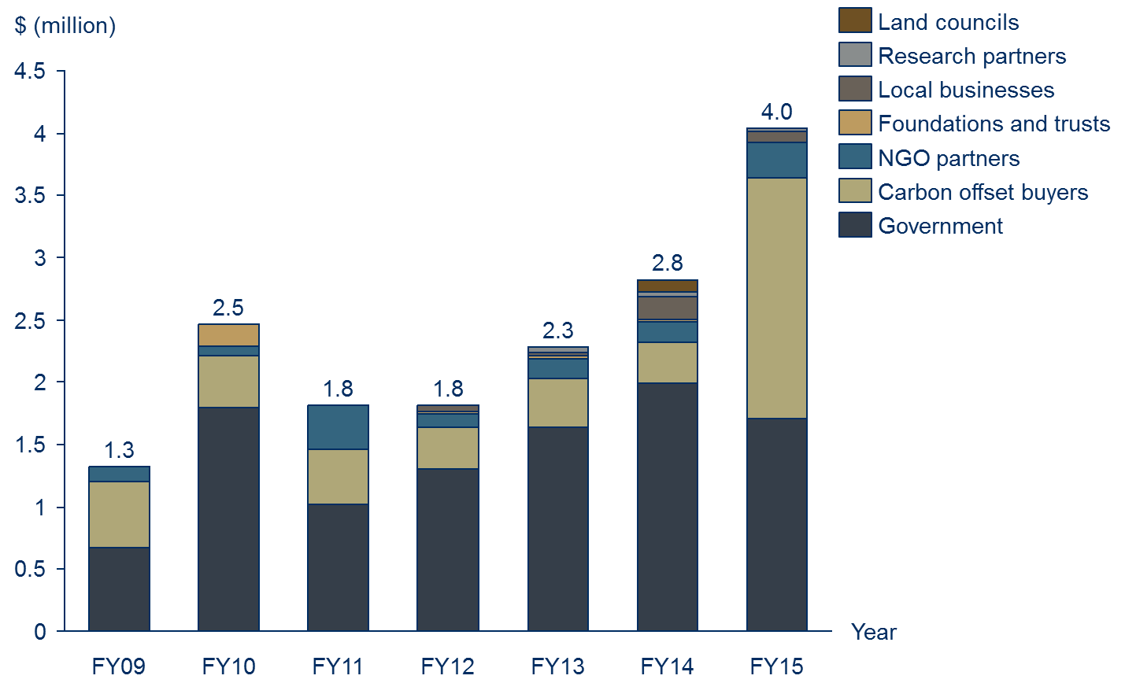
Figure 2.3 - Investment by stakeholder group, FY09-15

3 Methodology for this project

3.1 Understanding change
An SROI analysis requires that the key changes are described, measured or estimated and valued. It requires a balance between developing a hypothesis that can be tested on the one hand, and hearing the stories which emerge from stakeholder consultation on the other. SVA facilitated a theory of change workshop with PM&C to develop the theory of change for the IPA programme overall in order to define the key changes. The information from the workshop informed the focus of the research approach to ensure relevant data was collected from all key stakeholders.
About theory of change
A theory of change tells the story of change that takes place as a result of the activities of the organisation or programme. It specifies:
- The issue that the organisation or programme is seeking to address
- The key participants in the activities of the organisation or the programme
- The activities that organisation or programmes deliver
- The inputs required to generate the outcomes
- The outcomes of activities that occur through the organisation or programme, for various stakeholders
- The overall impact of these outcomes.

h
The theory of change developed during the workshop was subsequently refined to incorporate findings from the research and stakeholder consultations and tailored to ensure it adequately reflected the situation within the Warddeken IPA.
Defining stakeholder groups
Stakeholders are defined as people or organisations that experience change, whether positive or negative, or those who want to see change, as a result of the activity. For stakeholders to be included in an SROI, they must be considered material to the analysis. Materiality is a concept that is borrowed from accounting, whereby information is classified as material if it has the potential to affect the readers’ or stakeholders’ decisions about the programme or activity. According to the SROI Guide, a piece of information is material if leaving it out of the SROI would misrepresent the organisation’s activities.
A preliminary list of stakeholders was developed by the management team of WLML, which was used as a basis for stakeholder consultation. Stakeholder consultations were later completed to test the materiality of changes experienced by those stakeholders.
Based on this analysis, it was determined that there were eight material stakeholder groups that experience outcomes as a result of the Warddeken IPA and associated Indigenous ranger programme:
- Rangers
- Community members, including Indigenous traditional owners
- Government, including the Australian and NT Governments
- Indigenous corporation partners
- NGO partners
- Corporate partners
- Research partners
- Carbon offset buyers.
Stakeholder consultations
Stakeholders were consulted to identify and understand the relative importance of changes (or outcomes); consider how to prove and measure or estimate change; and consider how to value the outcomes. The consultation approach completed for this analysis involved a two-phased approach:
- Phase 1: SVA and PM&C completed in-person consultations, predominately with Indigenous stakeholders, while on country within the Warddeken IPA and surrounding areas in mid-September 2015
- Phase 2: SVA and PM&C completed phone consultations, predominately with non-Indigenous stakeholders, after returning from country in late September 2015. These consultations involved additional stakeholders identified by the management team of WLML and Indigenous stakeholders on country during phase 1. These stakeholders were consulted to determine whether the Warddeken IPA and associated Indigenous ranger programme had generated material changes for them, and to define the nature of those changes.
An outline of completed stakeholder consultations is included in Table 3.1 below.
Stakeholder group | Participation in consultations | Estimated total number of stakeholders
Rangers | 12 | 253
Community members | 19 | ~1200
Government | 4 | N/A
Indigenous corporation partners | 2 | 11
Non-Government Organisation (NGO) partners | 3 | 3
Corporate partners | 1 | 1
Research partners | 1 | 2
Carbon offset buyers | 1 | 5
Total | 43 engaged through consultation | ~1475
Table 3.1 – Summary of stakeholder consultations
The management team of WLML were involved in the verification of results at three main points:
- Stakeholder consultations – through feedback on the theory of change;
- The measurement and valuation phase – through feedback on the measurement or estimation approach and the calculation of the value of outcomes; and
- The reporting phase – through feedback on the draft report.
Research and analysis
To complement the stakeholder consultations, desktop research and analysis was completed using WLML data as well as secondary research relating to land management and previous evaluations of aspects of the IPA and WoC programmes. Key data sources used to supplement the stakeholder consultations are outlined in the Table 3.2 below.
Data source | Use in the SROI analysis
Dermot Smyth, Indigenous Protected Areas and ICCAs: Commonalities, Contrasts and Confusions, 2015 | Background information
Dermot Smyth, Caring for Country: An Indigenous Propitious Niche in 21st Century Australia, 2014 | To inform Ranger and Community member outcomes
PM&C, Working on Country and Indigenous Protected Areas programmes, 2013-14 | To inform section 2 of this report
Urbis, Assessment of the social outcomes of the Working on Country program, 2012 | Background information
The Allen Consulting Group, Assessment of the economic and employment outcomes of the Working on Country program, 2011 | Background information
Garnett and Sithole, Healthy Country, Healthy People: Sustainable Northern Landscapes and the Nexus with Indigenous Health, 2007 | To inform Ranger and Community member outcomes
Putnis, Josif and Woodward, Healthy Country, Healthy People: Supporting Indigenous Engagement in the Sustainable Management of Northern Territory Land and Seas, 2007 | To inform Ranger and Community member outcomes
WLML, Annual Reports, 2009-10 to 2012-13 | To inform section 2 of this report
Table 3.2 – Data sources used to supplement consultation

3.2 Measuring change
The stakeholder outcomes included in the SROI represent the most significant consequences that are experienced by stakeholders as a result of the Warddeken IPA and associated Indigenous ranger programme up to July 2015. The measures are estimates inferred through stakeholder consultation and quantitative data. Wherever possible we have estimated the extent to which the outcomes have occurred through the use of quantitative data previously collected by the IPA or by other sources. The measures have also been deeply informed by stakeholder consultation. Throughout the data collection process, attention was paid to all possible consequences that arise as a result of the Warddeken IPA and associated Indigenous ranger programme: intended and unintended; positive and negative.
Defining the material outcomes for stakeholder groups is complex. When defining the material outcomes for each stakeholder group, an SROI practitioner must ensure that each outcome is unique or it would be considered double counting. This is difficult as the outcomes for each stakeholder group are necessarily related because they describe all of the changes experienced by the stakeholder. Outcomes also happen at different times throughout the period being analysed with different levels of intensity.
These various factors were considered when identifying appropriate measures or estimates and indicators for a particular outcome or set of outcomes created through the Warddeken IPA and Ranger programme.

3.3 Valuing change
Financial proxies
Financial proxies are used to value an outcome. This is particularly important in SROI as it relates to the principle of valuing what matters. This means that there is a need to value outcomes even if there isn’t an existing market value.
There are a number of techniques used to identify financial proxies and value outcomes. Importantly, within an SROI, the financial proxy reflects the value that the stakeholder experiencing the change places on the outcome. This could be obtained directly through stakeholder consultation, or indirectly through research. The financial proxies approximate the value of the outcome from the stakeholder’s point of view. Techniques for valuing outcomes are included in the Methodological Attachment to this report.
SROI (Valuation) filters
To present an accurate view of the value created through the Warddeken IPA and associated Indigenous ranger programme, SROI (Valuation) filters have been applied to different financial proxies. This is in accordance with the Social Value principle to not over-claim. Different techniques were used to identify the most appropriate filter for each of the outcomes, including SROI filter assumption categories, also included in the Methodological Attachment to this report.
Consideration of the different SROI filters for this analysis is as follows:
- Deadweight: Deadweight is an estimation of the value that would have been created if the activities from the programme did not happen. To estimate deadweight for the current analysis, stakeholder consultations and desktop research were completed to understand the context and nature of outcomes
- Attribution: Attribution estimates how much change was as a result of other stakeholders or activities, which were not included in the investment. An understanding of the contribution of others to each outcome was determined through stakeholder consultations and research
- Displacement: Displacement is an assessment of how much of the activity displaced other outcomes. Stakeholder consultations and desktop research were completed to identify if any of the outcomes displaced other activities
- Duration and drop-off: Duration refers to how long an outcome lasts for. The duration and drop- off are linked to whether the stakeholder is likely to benefit from the activities over a defined period.
Valuing the outcomes
The total adjusted value is the value calculated for each outcome, which takes into account the following components:
- Quantity: the number of stakeholders who will experience an outcome
- Financial proxy: value of the outcome
- SROI filters: accounting for whether the outcome would have happened anyway (deadweight), who else will contribute to the change (attribution), whether the outcome will displace other activities or outcomes (displacement), how long the outcome will last for (duration) and how it changes over time (drop off).

3.4 SROI ratio
The SROI ratio is a comparison of the value of the benefits to the value of investment. It is expressed in numerical terms e.g. 3:1, which means that for every dollar invested, $3 of value is returned.
It is important that the SROI calculations are tested by understanding how the judgements made throughout the analysis affect the final result. The judgements that are most likely to influence the SROI ratio were identified, and a sensitivity analysis was conducted to see how sensitive the ratio was to changes in these judgements. To decide which judgements to test, two key questions were considered:
Considerations for interpreting the ratio
- The SROI ratio represents the additional value created, based on the Social Value principles. This is the unique value that is created by a programme or organisation for a specific period
- SROI ratios should not be compared between organisations without having a clear understanding of each organisation’s mission, strategy, theory of change, geographic location and stage of development. A judgement about investment decisions can only be made when using comparable data
- How much evidence is there to justify our judgement? The less evidence available, the more important it is to test
- How much does it affect the final result? The greater the impact, the more important it is to test.

4 Impact of the Warddeken IPA and associated Indigenous ranger programme

4.1 Understanding the change
Theory of change
A theory of change was initially drafted for the Warddeken IPA and associated Indigenous ranger programme via a workshop completed with 12 PM&C staff. The theory of change developed during the workshop was extensively tested and subsequently refined to incorporate evidence collected through stakeholder consultations and specific feedback from stakeholders. At least one stakeholder from each stakeholder group provided feedback during the testing of the theory of change. The refined theory of change is included in Figure 4.1.
The theory of change tells the story of change for the Warddeken IPA and associated Indigenous ranger programme. It consists of four pages:
- Issues, Stakeholders, Activities and Inputs
- Outputs, outcomes and impact for Community members and Rangers
- Outputs, outcomes and impact for Government
- Outputs, outcomes and impact for other stakeholders – Indigenous corporation partners, NGO partners, Corporate partners, Research partners and Carbon offset buyers
The first page outlines the issue that the Warddeken IPA and the associated Indigenous ranger programme seek to address, the stakeholders involved, the activities that take place and the inputs (investments) into the programme. Only those stakeholders that appear in bold experience outcomes that are measured or estimated in the analysis.
The next three pages consist of outputs (i.e. the immediate consequences of activities), outcomes and impact for stakeholders identified in bold. The outcomes represented on these pages should be interpreted from left to right, and consist of short, medium and long term outcomes. There are three types of outcomes represented:
- Material outcomes
- Intermediate outcomes
- Other outcomes
Material outcomes are outcomes that have been measured or estimated and valued as part of the SROI analysis. These outcomes are considered “material” because they are relevant and significant changes that stakeholders experienced due to the Warddeken IPA and associated Indigenous ranger programme during the period of investment being analysed. Decisions around materiality were informed by stakeholder consultation.
Intermediate outcomes are outcomes that have been achieved as a result of the Warddeken IPA and associated Indigenous ranger programme, however their value is subsumed by later outcomes that carry a higher value. For this reason, intermediate outcomes are not measured or valued in the analysis as it would be considered double counting.
Other outcomes are those outcomes that have not yet been achieved, and are aspirational outcomes based on the logic of what should occur given other outcomes have been achieved.
The theory of change emphasises the interrelationship between social, economic, cultural and environmental outcomes. This is aligned with how stakeholders perceived the change they experienced through the programme. The key points to draw out of this representation are:
- The outcomes generated by the Warddeken IPA and associated Indigenous ranger programme are widespread across the social, economic, cultural and economic domains
- Over the last seven years, the Warddeken IPA and associated Indigenous ranger programme has pushed well beyond outputs to generate extensive short and medium term outcomes, and some long term outcomes
- Many of the outcomes for different stakeholders are interrelated. For example, less violence in community manifests as an outcome for Community Members (“Less violence”) and Government (“Less offending by Rangers”); in addition, numerous environmental outcomes are shared across Community members and Government (such as “More burning using cultural practices”)
- In all cases, stakeholders are striving for two interrelated impacts: healthier people and healthier country.
Potential negative or unintended outcomes were tested throughout stakeholder consultation, for example, less ability for Indigenous corporations to pursue their own goals; negative effects from physically demanding Ranger work on health. On balance, it was determined that there were no material negative outcomes associated with the Warddeken IPA and associated Indigenous ranger programme. Ongoing, significant challenges are evident, particularly for Community members and Rangers (such as alcohol overuse) however the Warddeken IPA and associated Indigenous ranger programme was not seen as contributing negatively to these issues.

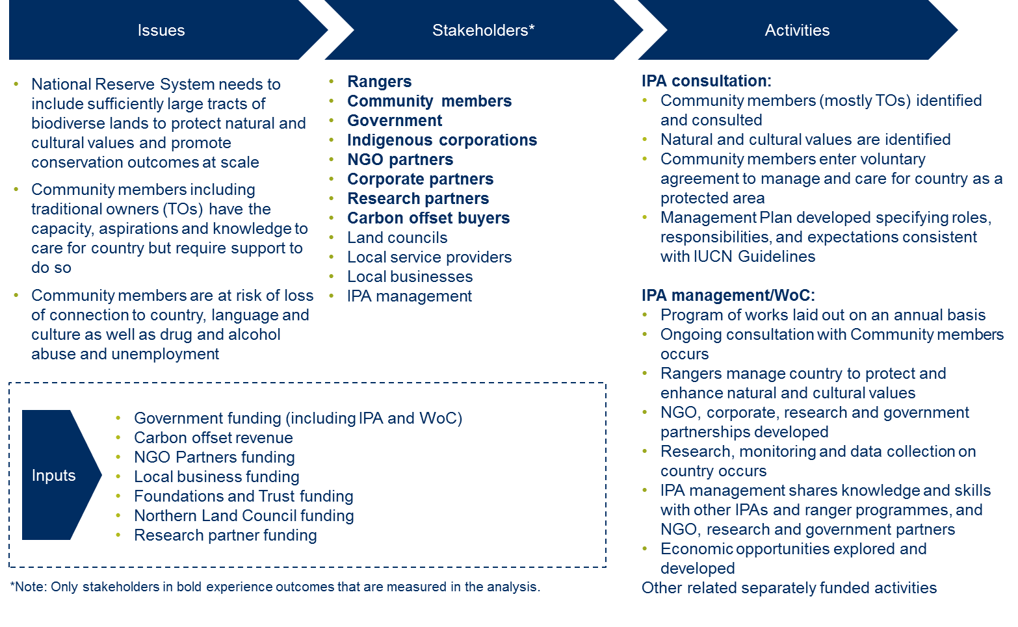
Figure 4.1a –Theory of change for the Warddeken IPA and associated Indigenous ranger programme – Issues, Stakeholders, Activities and Inputs (Investment)
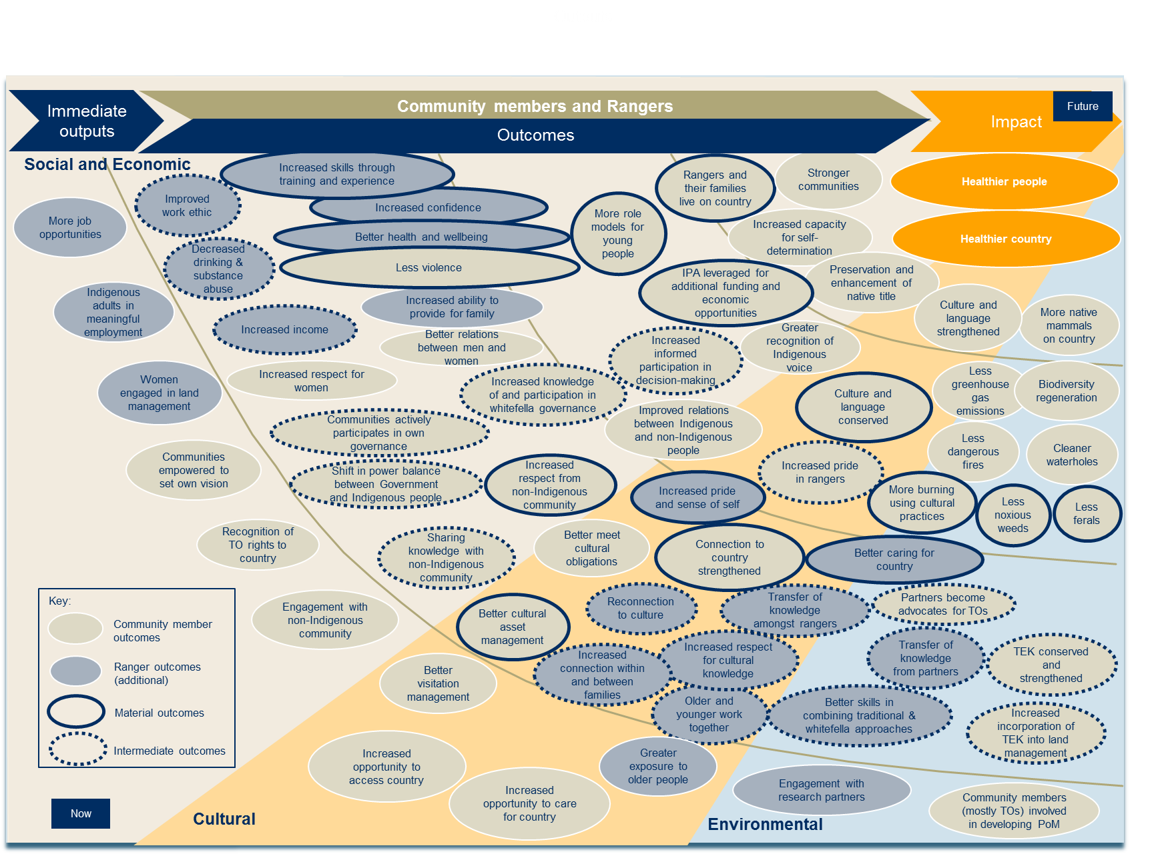
Figure 4.1b –Theory of change for the Warddeken IPA and associated Indigenous ranger programme – Community member and Ranger outcomes
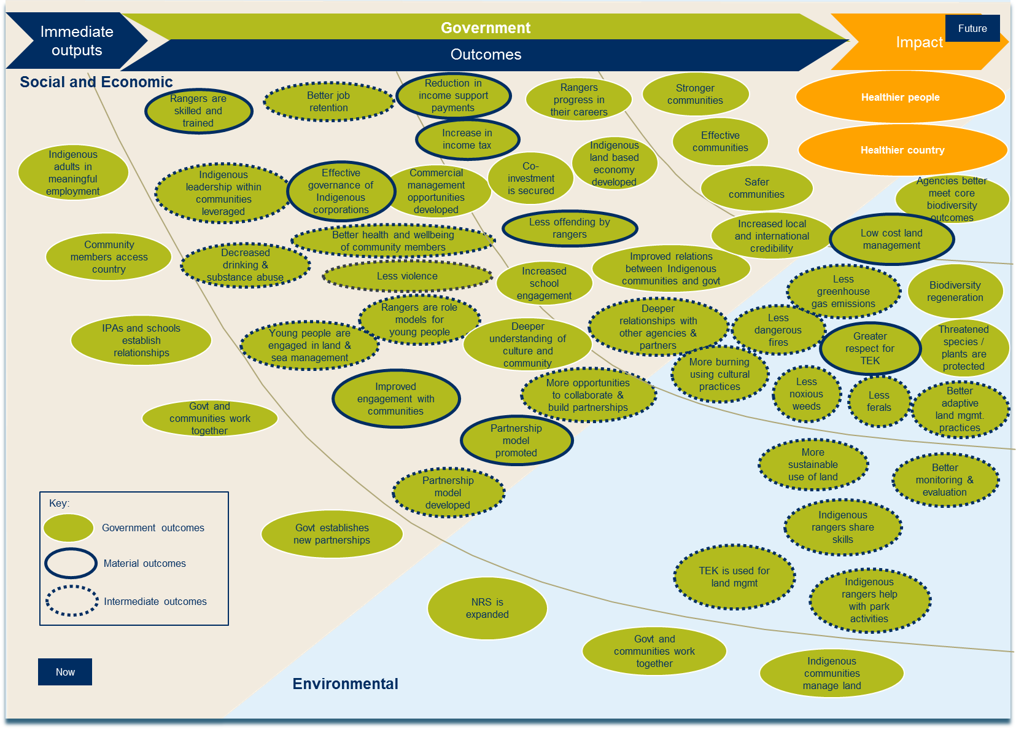
Figure 4.1c –Theory of change for the Warddeken IPA and associated Indigenous ranger programme – Government outcomes
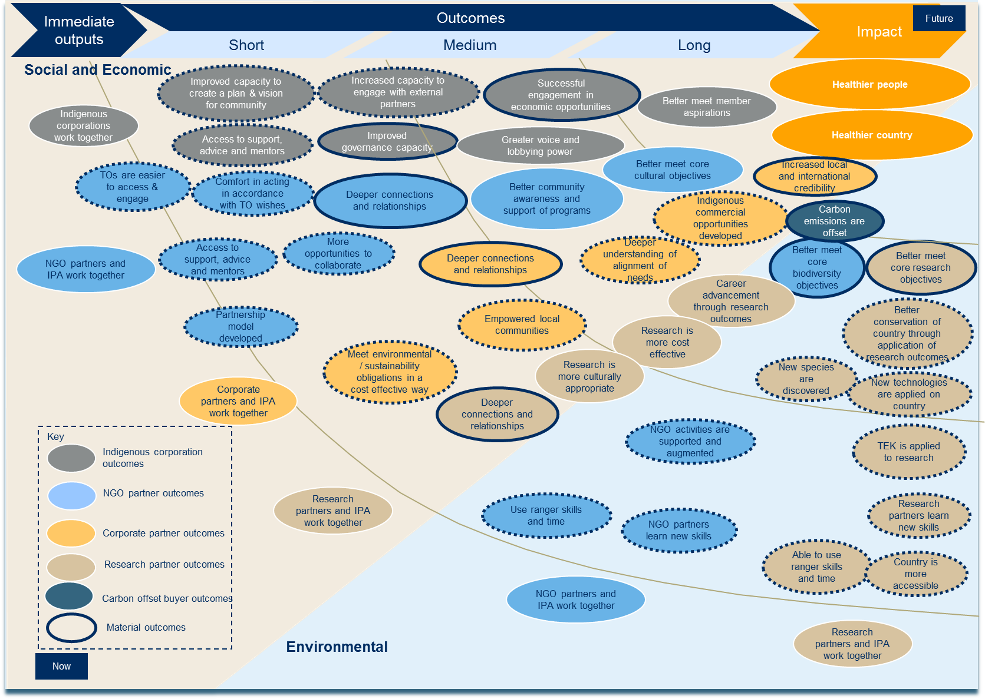
Figure 4.1d –Theory of change for the Warddeken IPA and associated Indigenous ranger programme – Indigenous corporation, NGO partner, Corporate partner, Research partner & Carbon offset buyer outcomes

4.2 Stakeholder outcomes
The stakeholder outcomes are represented in the theory of change outlined in section 4.1. This section describes the outcomes experienced by each of the following stakeholders, in more detail:
- Rangers
- Community members, including Indigenous traditional owners
- Government, including the Australian and NT Governments
- Indigenous corporation partners
- Non-Government Organisation (NGO) partners
- Corporate partners
- Research partners
- Carbon offset buyers.
The outcomes described below are included in the SROI analysis and represent incremental changes for stakeholders that occur as a result of the Warddeken IPA and associated Indigenous ranger programme.
- Rangers
Rangers include all those people who work on country within the Warddeken IPA, whether on a casual or permanent basis. During the period of investment covered by this analysis 253 Indigenous people, mostly traditional owners, worked on the Warddeken IPA. The average tenure of Rangers within the investment period was 2.7 years. The average number of hours worked by Rangers during the investment period was 692 hours, equivalent to 86 full (i.e. eight-hour) days over seven years.
Rangers working on country is the foundation upon which all outcomes are based. Because Rangers work on country, they experience personal benefits including increased skills and confidence, and better health and wellbeing. A significant part of the reason why Community members living on the outstations within the Warddeken IPA have thrived is because of Ranger work on country. As a result, all of the outcomes experienced by Community members are directly related to Ranger activities. Similarly, all Government outcomes are linked to Ranger work on country because of its flow-on effects including skilled Rangers, greater respect for TEK and lower cost land management.
It is likely that a Ranger working on country fits within two stakeholder groups: Rangers and Community Members, which reflects both their job and their role within community. Outcomes achieved by Rangers, captured in Table 4.1 below, are additional to those that are achieved by Community Members.
A summary of the inputs (investment in the programme), outputs (summary of activity) and outcomes (changes) that are experienced by Rangers is included in Table 4.1 below.
Inputs | Outputs | Material outcomes
Nil | - More job opportunities  - Indigenous adults in meaningful employment  - Women engaged in land management  - Greater exposure to older people  - Engagement with research partners | 1.1 Increased skills through training and experience  1.2 Increased confidence  1.3 Better health and wellbeing  1.4 Increased pride and sense of self  1.5 Better caring for country
Table 4.1 – Inputs, Outputs and Outcomes for Rangers
Within Ranger outcomes, there are two threads of outputs and outcomes: social and economic, and cultural.
Social and economic outcomes
The material outcomes that have been generated for Rangers in the social and economic thread are:
- 1.1 Increased skills through training and experience
- 1.2 Increased confidence
- 1.3 Better health and wellbeing
One of the most immediate changes for Rangers working on country is the increase in their technical skills. Technical skills encompass Traditional Ecological Knowledge (TEK) and Western scientific knowledge, which together form a ‘two-toolbox approach’. This is the preferred method among Rangers to undertake land management on country. TEK is gained through learning from older people in the community, mostly Senior Rangers and Expert Consultants. Western scientific knowledge is learnt through undertaking TAFE courses in subjects such as conservation and land management, chemical application (for weed management) and fire management. Most Rangers undertake work across a variety of activities and therefore receive training in relation to fire management, flora and fauna surveys and feral animal and weed management.
Social and economic outcomes for Rangers
This analysis estimates the value of better health and wellbeing as a result of working on country. This outcome is calculated at an average value of $3,438 per Ranger per year. The total adjusted value associated with this outcome over seven years is $0.3 million. See sections 4.3 to 4.5 for more information about the adjusted value of each outcome.

“We train our young people using the two-toolbox approach – the balanda [whitefella] way and the bininj [Indigenous] way.”
Terrah Guymala, Senior Ranger
An outcome occurring for Rangers slightly later than ‘increased skills through training and experience’ is increased confidence. Achievement of this outcome is directly related to time spent on country learning new skills, spending time with the older people and connecting to culture and landscape. Some Rangers compared their lives before and after working with Warddeken to demonstrate how they had grown and developed over time into a more self-assured person.
Better health and wellbeing is a change that almost all Rangers who were interviewed mentioned as an outcome of working on country. Achievement of this outcome is far broader than physical and mental benefits, and is inextricability linked to their relationship with land, culture and spirituality. Rangers referred to the clean air, healthy lifestyle, exercise, purchase of healthy food through the Wages Trust system and, most importantly, connection to the land as elements of this outcome. Rangers compared this with what they would be doing if they were not working on country – sitting around, drinking, fighting or experiencing violence. In contrast, their experiences on country led to this outcome and ultimately, a deep sense of happiness and contentment.
“Here we have healthy country and culture, and everyone has a healthy body and healthy mind.”
Terrah Guymala, Senior Ranger

Cultural outcomes
The material outcomes that have been generated for Rangers in the cultural thread are:
- 1.4 Increased pride and sense of self
- 1.5 Better caring for country
Increased pride and sense of self is a short to medium term outcome that results from increased connection within and between families, and connection (or reconnection) to culture. Rangers described this outcome as linked to the development of their cultural identity, which made them understand themselves, their culture and their place in the world better. For those who transfer knowledge onto the younger generations, pride comes from helping others to connect with their culture and carrying on the work of Lofty, who established the outstation at Kabulwarnamyo and was Warddeken’s leader and patron.
“I decided that I wanted to get away from the town, the violence and the humbug so I came to live here. I pass on knowledge to the kids and am doing building work here. It feels good to know I am here, on the land my father came back to.”
Keith Nadjamerrek, Senior Ranger
Better caring for country is closely linked with the outcome ‘increased pride and sense of self’. It is a short to medium term outcome that results from older and younger people working together, increased respect for cultural knowledge and the transfer of knowledge among Rangers.
Better caring for country is a direct result of Ranger work on country. For approximately fifty years prior to re-population of the plateau, hardly any Nawarddeken lived on country which resulted in damage by wildfires, feral animals and weeds. The return of Nawarddeken people to live and work on country had a transformative effect on the health of country. This process has been accelerated by the establishment of the IPA and associated Indigenous ranger programme because it has enabled more resources – including Ranger time, equipment and revenue from other economic opportunities – to be allocated to caring for country.
Cultural outcomes for Community members
This analysis measures a cultural outcome related to Rangers’ ability to better care for country. This outcome is calculated at an average value of $37,242 per event per year. The total adjusted value associated with this outcome over six years is $3.1 million. See sections 4.3 to 4.5 for more information about the adjusted value of each outcome.
The transfer of knowledge is an essential element of this outcome. Older people are actively involved in better caring for country by sharing TEK with younger generations. The older people are flown over country within the Warddeken IPA to ensure that pre-season burning, feral animal management and weed management are carried out in accordance with their wishes for country. At the same time, they are passing on their knowledge of the landscape, trees and animals to both bininj (Indigenous) and balanda (non-Indigenous) people so that country is better looked after. Over time, many of the older people have passed away. The new generation of Elders are investing heavily in young Rangers and are passionate about ensuring that country is better cared for now and forever by Nawarddeken people.

- Community members
Community members represent Indigenous people, mostly Nawarddeken, who are involved with the Warddeken IPA and associated Indigenous ranger programme. Community members may either live on country at one of the five outstations within the Warddeken IPA or live nearby at one of the growth towns such as Gunbalanya or Maningrida. There are two ways in which someone falls within this stakeholder group:
- The country within the Warddeken IPA is their father’s country, mother’s country, mother’s mother’s country, or mother’s mother’s mother’s country
- They are married to or are a relative of someone connected with the Warddeken IPA as outlined in 1.
This classification was informed by stakeholder consultations and tested with the WLML management team and Community members.
A summary of the inputs (investment in the programme), outputs (summary of activity) and outcomes (changes) that are experienced by Community members is included in Table 4.2 below.
Inputs | Outputs | Material outcomes
Nil | - Communities empowered to set own vision  - Recognition of TO rights on country  - Engagement with non-Indigenous community  - Better visitation management  - Increased opportunity to access country  - Increased opportunity to care for country  - Community members (mostly traditional owners) involved in developing Plan of Management for Warddeken IPA | 2.1 More role models for young people  2.2 Rangers and their families live on country  2.3 Less violence  2.4 IPA leveraged for additional funding and economic opportunities  2.6 Increased respect from non-Indigenous community  2.7 Better cultural asset management  2.8 Connection to country strengthened  2.9 Culture and language conserved  2.10 More burning using cultural practices  2.11 Less noxious weeds  2.12 Less ferals
Table 4.2 – Inputs, Outputs and Outcomes for Community members
Social and economic outcomes
The material outcomes that have been generated for Community members in the social and economic thread are:
- 2.1 More role models for young people
- 2.2 Rangers and their families live on country
- 2.3 Less violence
- 2.4 IPA leveraged for additional funding and economic opportunities
- 2.6 Increased respect from non-Indigenous community
As a direct result of Rangers working on country, Community members benefit because role models are created for young people to look up to. Community members emphasised the dearth of role models prior to Warddeken’s Ranger programme – most community members were unemployed and many experienced problems with drinking and substance abuse, violence and boredom. There were no resources to look after country and so young people could not observe and learn from the older people about fulfilling their cultural obligations. Since the IPA declaration and commencement of the Ranger programme, young people have been able to see Rangers applying their skills to caring for country, living in a dry community and, in some cases, avoiding violent behaviour. For community members, wearing the badge and uniform of the Warddeken Rangers is a powerful symbol of a strong and resilient community member that the young people look up to.
“If I wasn't here, I wouldn't have another job - I would probably be in town unemployed, sitting and drinking, waiting for the Club [pub in Gunbalanya] to open, fighting, doing nothing. That's what people do in Gunbalanya.”
Ray Nadjamerrek, Ranger
“We have healthier country. We are now role models for the kids. We teach them about the landscape.”
Berribob Watson, Ranger and Senior Cultural Advisor
During stakeholder consultations, a number of older Community members spoke of the great importance to them of family returning to country to live in the traditional way. Older people who fought hard to return to country would like to see more family members living where they belong and their ancestors are from. The very remote location of Kabulwarnamyo, Manmoyi and the other outstations within the Warddeken IPA necessitate living on country for those Rangers and their families that work regularly. In this way, the Ranger programme has facilitated achievement of this outcome for Community members.
“[The IPA] has had a big impact - we are glad that we can live here. It has also been good for my nieces and nephews - I took three of my nieces and nephews away from Gunbalanya and brought them here so that they can live with us on country.”
Ray Nadjamerrek, Ranger

Related to the outcome above of ‘more role models for young people’, as a result of the Warddeken IPA and Ranger programme there is less violence in communities. There are two types of violence covered by this outcome:
- Violence committed by Community members who were convicted of offences and served parole on country
- Family and domestic violence committed by Community members outside of the Warddeken IPA.
The first type of violence related to specific individuals who had been convicted of an offence and were suitable to serve some or all of their parole on country. These Community members are able to work with Warddeken in paid employment which provides them with routine, a sense of pride and interaction with others. Senior Rangers mentor these Community members throughout their time on country. According to the NT Department of Correctional Services, employment of this nature is the single biggest factor that prevents someone from reoffending.
The second type of violence is family and domestic violence occurring in community. This type of violence is often strongly linked with alcohol and substance abuse. As a result of living in dry communities, Community members experience less violence.
“[The offender's lives] are just enriched from the word go. They are much more likely to comply with the conditions of their suspended sentence. It is very different in Gunbalanya where there is road access, and even though it is an alcohol restricted area grog is regularly brought in from outside sources.”
Anthony Jones, Department of Correctional Services, NT Government

Community members experience a direct and significant benefit from the IPA in the form of additional funding and economic opportunities, the largest of which is income from carbon offset sales through the WALFA project. WALFA, which began in 2008, is the first Savanna Fire Management project which uses TEK together with Western scientific knowledge and research to control savanna wildfires in West Arnhem and subsequently reduce carbon emissions. The reduction in carbon emissions is then ‘sold’ by the traditional owners in the form of carbon offsets to buyers including ConocoPhillips. Because the work carried out by Rangers on the IPA enables fire to be managed effectively and in a way that creates carbon offsets, the IPA is directly leveraged to create this additional revenue.
Economic outcomes for Community members
Warddeken’s extensive and highly successful fire management work using traditional burning methods has been covered in numerous resources including Murphy et al’s 2015 book Carbon Accounting and Savanna Fire Management. This analysis measures an economic outcome related to Warddeken’s ability to leverage the IPA to generate additional funding and economic opportunities, such as revenue through the sale of carbon offsets that occurred as a result of the success of the fire management. This outcome is calculated at an average value of $398,232 per opportunity per year. The total adjusted value associated with this outcome over seven years is $5.4 million. See sections 4.3 to 4.5 for more information about the adjusted value of each outcome.

The last material outcome in the social and economic thread to be estimated is increased respect from the non-Indigenous community. Non-Indigenous community members that experience increased respect are mostly people living outside of the IPA who have some contact with the Warddeken IPA, such as local business owners AAA Charters. In large part, the increased respect is derived from seeing Rangers wearing the Warddeken uniform and in paid employment through which they are able to support their families.
Cultural outcomes
The material outcomes that have been generated for Community members in the cultural thread are:
- 2.7 Better cultural asset management
- 2.8 Connection to country strengthened
- 2.9 Culture and language conserved
These three outcomes are closely linked to each other, and to the Ranger outcomes related to caring for country. Better cultural asset management results from access to country, fire and feral animal management. The IPA facilitates better access to country for Community members to live on and look after country. The very remote location of the IPA means that, without the resources embedded within the IPA and Ranger programme, Community members would not as easily go onto country and look after cultural sites. Rangers undertake preventative fire management on fuel surrounding cultural sites including rock art sites to ensure fires do not damage them, and cull feral animals such as buffalos to reduce the damage they cause to rock art.
As a result of Rangers carrying out this and other land management work, Community members experience strengthened connection to country primarily through living on country. In the Warddeken IPA, the necessity of Rangers living on country to undertake regular work has created stronger communities on at least two of the outstations within the IPA. Family members of Rangers are able to live on country while being supported through Ranger incomes, to supplement Centrelink payments. Community members not living on country are still able to experience stronger connection to country through visiting country more regularly and passing on their knowledge.
Environmental outcomes
The material outcomes that have been generated for Community members in the environmental thread are:
- 2.10 More burning using cultural practices
- 2.11 Less noxious weeds
- 2.12 Less ferals
Better caring for country by Rangers leads to these three outcomes for Community members.
More burning using cultural practices refers to increased early season burning to address the critical problem of wildfires late in the dry season. Approximately one third of the activity on the Warddeken IPA is related to fire management. This is carried out using the knowledge and expertise of traditional owners, with the resources of the IPA and Rangers. This outcome leads to greater variation in vegetation growth, less dangerous late season fires and, ultimately, less greenhouse gas emissions.
Less noxious weeds and less ferals lead to cleaner waterholes and biodiversity regeneration. It is Warddeken’s aspiration that, through initiatives such as a feral cat project that was funded through the National Environmental Research Programme (NERP), there will ultimately be more native mammals on country. Warddeken country is mostly free from weeds excluding areas such as the Mikginj Valley where mimosa is present. Feral animals, mostly buffalo, are a bigger problem and are controlled largely through aerial culling. This work ultimately leads to healthier country and healthier Nawarddeken.
- Government
In this analysis the Government stakeholder group includes:
- Australian Government including PM&C, DoE and Kakadu National Park (Kakadu)
- NT Government including the Flora and Fauna Division of the Department of Land Resource Management and the Department of Correctional Services.
Impact for Government is both broad and deep, and stems from a variety of activities including Rangers working on country taking care of the land, Government working more closely with communities and Government establishing new partnerships.
Social and economic outcomes for Government
An intended outcome for Government under the IAS is adults in jobs. This analysis estimates a material outcome for Government ‘Rangers are skilled and trained” which leads to the achievement of this outcome. This outcome is calculated at a value of $9,000 per Ranger per year. The total value associated with this outcome is $2.9 million. See sections 4.3 to 4.5 for more information about the adjusted value of each outcome.
As the IPA abuts Kakadu, the two Ranger groups work closely together on joint feral animal and weed control activities. The Warddeken IPA and associated Indigenous ranger programme also lends support to Kakadu where needed including in relation to fire management activities.
Importantly, there is strong alignment between the impact envisaged and created by the Warddeken IPA and various outcomes targeted through PM&C’s Indigenous Advancement Strategy, including:
- Fostering Indigenous business, and assisting Indigenous people to generate economic and social benefits from their land
- Increased levels of community safety and wellbeing, and less alcohol and substance misuse and associated harm
- Supporting Indigenous Australians to maintain their culture and language
- Indigenous participation in society and organisational capacity
- Improved engagement in remote Australia and progress in remote employment, education and community safety outcomes.
A summary of the inputs (investment in the programme), outputs (summary of activity) and outcomes (changes) that are experienced by Government is included in Table 4.3 below.
Inputs | Outputs | Material outcomes
$10.1 million | - Indigenous adults in meaningful employment  - Community members access country  - IPAs and schools establish relationships  - Government and communities work together  - Government establishes new partnerships  - NRS is expanded  - Indigenous communities manage land | 3.1 Rangers are skilled and trained  3.2 Reduction in income support payments  3.3 Increase in income tax  3.4 Effective governance of Indigenous corporations  3.5 Less offending by Rangers  3.6 Improved engagement with communities  3.7 Partnership model promoted  3.8 Greater respect for TEK  3.9 Low cost land management
Table 4.3 – Inputs, Outputs and Outcomes for Government
Social and economic outcomes
The material outcomes generated for Government in the social and economic thread are:
- 3.1 Rangers are skilled and trained
- 3.2 Reduction in income support payments
- 3.3 Increase in income tax
- 3.4 Effective governance of Indigenous corporations
- 3.5 Less offending by Rangers
- 3.6 Improved engagement with communities
- 3.7 Partnership model promoted
An immediate, direct consequence of Indigenous adults in meaningful employment as Rangers is that they are skilled and trained. Government benefits from a more skilled Ranger workforce as it improves job retention. Warddeken Rangers may remain as Indigenous Rangers or they may eventually move into other roles.
There are two flow-on effects of more Indigenous adults in jobs which is a reduction in income support payments and an increase in income tax. These outcomes are based on the assumption, tested during stakeholder consultations, that the vast majority of Warddeken Rangers were on income support prior to being Rangers. This situation is exacerbated by the remoteness of the Warddeken IPA where alternative employment is extremely limited. Since Warddeken employed 253 Rangers during the seven year period, many of whom are casuals, the quantum of these outcomes is fairly modest – an average of $212 in income support savings per Ranger, per year and an average increase of $1,851 in tax revenue per Ranger, per year.
Government also experiences benefit in the form of effective governance of Indigenous corporations. The Warddeken IPA has supported 11 other Indigenous corporations with a broad range of activities, the most significant of which is building the capacity of Indigenous communities to profit from fire management work by assisting with the establishment of ALFA (NT) Limited (ALFA), the conduit between Carbon offset buyers and Indigenous communities. This situation is advantageous for Government as the capacity of Indigenous corporations and Indigenous communities is increased, the work carried out by Indigenous corporations is more effective and Government’s dealings with Indigenous corporations are easier.
As we noted in Community member outcomes, as a result of the Warddeken IPA there is less violence in communities. The logic underpinning this assertion is that Rangers who spend time on country and experience outcomes including pride and sense of self are less likely to be violent. The corollary of this for Government is that there is less offending by Rangers. This was referred to during stakeholder consultation with the NT Department of Correctional Services and is a direct consequence of decreased drinking and substance abuse on the dry outstations within the IPA.
“If Warddeken was not there, these men would be more susceptible to reoffending. It is a vicious cycle in the communities; resources are so limited and there are the temptations that come with living in the bigger communities, such as the pressure from family and friends.”
Anthony Jones, Department of Correctional Services, NT Government
The final two social and economic outcomes for Government deal more directly with Government’s role in the Warddeken IPA. Improved engagement with communities is a short-term outcome experienced by Government as a result of Government and communities working closely together. Representatives from PM&C noted that the IPA programme in particular is perceived favourably by many Indigenous communities and has resulted in the Indigenous people becoming involved and owning a Government funded programme in ways not always observed. The stakeholder consultations for this analysis demonstrated that this experience is mirrored in the Warddeken IPA.
Over time, one of the outcomes from the cooperation with the Warddeken IPA is expected to be a deepening understanding within Government of culture and community, improved relations between Indigenous communities and Government, and ultimately, increased local and international credibility of Government programmes.
The Government has established a variety of new partnerships through the Warddeken IPA. The Flora and Fauna Division of the NT Government developed a partnership with Warddeken at about the time the IPA was established, and has had strong involvement over the past five years through funding of an embedded ecologist / scientist position working with the Warddeken and Djelk IPAs. The NT Government also partnered with Warddeken and ConocoPhillips to build the initial partnership which still continues in a different form today. The Warddeken IPA has facilitated the promotion of the latter public / private partnership model, which may lead to more opportunities to collaborate and deepen relationships with partners (including other agencies).
Environmental outcomes
The material outcomes that have been generated for Government in the environmental thread are:
- 3.8 Greater respect for TEK
- 3.9 Low cost land management
“The fire management work they do is much more cost effective than the work we do here at Kakadu, which is based on preserving tourist sites. The fire management work they do also benefits us - because the fires don't spread across the border of the IPA into Kakadu.”
Fred Hunter, WLML Chairman and Park Ranger, Kakadu National Park
Land management is procured at a low cost and encompasses numerous environmental outcomes including:
- More burning using cultural practices
- Less dangerous fires
- Less greenhouse gas emissions
- Less noxious weeds
- Less ferals
- Better adaptive land management practices.
The value associated with these intermediate outcomes is accounted for through the estimation of outcome 3.9 “Low cost land management”.
Land management through the Warddeken IPA also facilitates the use of TEK in land management which has numerous flow on effects for Government including sharing of skills by Indigenous Rangers, more sustainable use of land and better monitoring and evaluation. Greater respect for TEK from within Government is also a benefit which accrues when Government agencies gain a deeper appreciation of the critical role played by TEK in land management.
- Indigenous corporations
This stakeholder group consists of Indigenous corporations that are involved with land management, engage with Government and develop economic and other opportunities to improve the wellbeing of their people, for whom native title has been determined.
A summary of the inputs (investment in the programme), outputs (summary of activity) and outcomes (changes) that are experienced by Indigenous corporations is included in Table 4.4 below.
Inputs | Outputs | Material outcomes
Nil | - Indigenous corporations work together | 4.1 Improved governance capacity  4.2 Successful engagement in economic opportunities
Table 4.4 – Inputs, Outputs and Outcomes for Indigenous corporations
Social and economic outcomes
The material outcomes that have been generated for Indigenous corporations in the social and economic thread are:
- 4.1 Improved governance capacity
- 4.2 Successful engagement in economic opportunities
The Warddeken IPA and associated Indigenous ranger programme has played a pivotal role in the development of Indigenous corporations in Arnhem Land. The most prominent examples of this are the work WLML undertook which culminated in the establishment of ALFA (NT) Limited and Mimal Land Management Aboriginal Corporation. ALFA (NT) Limited was established in 2014 and acts as an intermediary between Indigenous communities and the carbon market. Of the five partners represented by ALFA, WLML has the highest capacity and as a result has provided significant support and guidance to the other partners.
The establishment of these Indigenous corporations has enabled a very significant financial benefit to be available to a wide range of other communities. It is anticipated that Mimal Rangers will receive approximately $1 million annually in revenue through ALFA (NT) Limited as a result of the sale of carbon credits in the near future. Without the support of WLML in establishing these companies, this revenue would not be available.
The Warddeken IPA, with other groups, applied for the Indigenous Carbon Farming Fund through PM&C. With Federal Government funding and $400k in additional funding, Warddeken led an extensive range of activities conducted by six separate ranger groups (including the Warddeken rangers) which resulted in the sale of $8.6 million worth of Australian carbon credit units. Much of the work done by these ranger groups was conducted under the auspices of WLML as these groups did not have the capacity to manage these contracts.
WLML has also acted as a conduit between philanthropic funders and other ranger groups. For example, The Nature Conservancy (TNC) has provided grants to Mimal Rangers and Yugul Mangi rangers which has been managed by WLML as they did not have the capacity to do this themselves. This is an in-kind contribution to these rangers, as no management fee is derived from this work. In the case of the Yugul Mangi rangers, WLML assistance has led them to use the TNC grant on their country in a strategic way for fire management work from which they will derive revenue under a ten year contract.
- Non-Government Organisation partners
NGO partners of Warddeken include Bush Heritage Australia (BHA), TNC and The Pew Charitable Trusts (Pew).
A summary of the inputs (investment in the programme), outputs (summary of activity) and outcomes (changes) that are experienced by NGO partners is included in Table 4.5 below.
Inputs | Outputs | Material outcomes
$1.3 million | - NGO partners and IPAs work together | 5.1 Deeper connections and relationships  5.2 Better meet core biodiversity objectives
Table 4.5 – Inputs, Outputs and Outcomes for NGO partners
Social and economic outcomes
NGO partners experience deeper connections and relationships as a result of working with Warddeken. These relationships build up slowly over time, and are linked to a number of earlier outcomes for NGO partners (not measured in this analysis) including:
- Traditional owners are easier to access and engage
- Comfort in acting in accordance with traditional owner wishes
- Access to support, advice and mentors
- Partnership model developed
- More opportunities to collaborate.
BHA and Warddeken began working together in 2007 during the IPA consultation phase. Since that time, the relationship between them has grown to include support from BHA with governance, development of a legal framework, an endowment fund, (the Karrkad-Kanjdji Trust) and funding for management staff and on-ground conservation work. Warddeken’s relationship with TNC is also longstanding. It began when TNC assisted Nawarddeken during the consultation period to establish the IPA through funding, scientific expertise and strategic advice. Pew has worked closely with Warddeken and the Djelk Rangers in an effort to improve land management practices across the two IPAs and secure long term funding for environmental management on country. The relationship has, among other things, led Pew to ask Warddeken to share its knowledge and learnings with a delegation of Canadian First Nations.

In each case, these relationships are mutually beneficial and WLML is frequently called upon to share their ideas, come up with solutions and connect NGO partners with other organisations where needed.
Environmental outcomes
As a result of working with the Warddeken IPA and associated Indigenous ranger programme, NGO partners experience a significant, long term outcome related to better meeting their core biodiversity objectives The biodiversity objectives of Warddeken’s partners relate broadly to three interrelated themes:
Environmental outcomes for NGO partners
Environmental outcomes that occur as a result of land management undertaken on IPAs have been discussed in numerous reports including PM&C’s Working on Country and Indigenous Protected Areas programmes 2013-14 annual report. This analysis considers the value associated with this work for stakeholders other than Community members and Government, such as NGO partners. An outcome for NGO partners related to better meeting their core biodiversity objectives has been calculated at a value of $70,306 per NGO partner per year. The total adjusted value associated with the outcome over seven years is approximately $211k. See sections 4.3 to 4.5 for more information about the adjusted value of each outcome.
- Protect ecologically important land and sea, including different habitats of plants and animals
- Addressing threats to conservation
- Protect threatened species, and create the right conditions for native species to thrive
The approach taken to achieving these biodiversity objectives by NGO partners involves:
- Working in partnership and collaboration
- Using proven scientific methods
- Being pragmatic and results-focused
NGO partners strongly believe that their deep partnerships with Warddeken have assisted them to achieve these objectives.
- Corporate partners
Warddeken’s principle corporate partner is multinational energy company ConocoPhillips. The relationship began in 2006 when Darwin LNG (a joint venture of which one of the partners is ConocoPhillips) had a licensing requirement to offset 100,000 tonnes of carbon a year. ConocoPhillips considered savannah burning methodology and made a decision to invest in the WALFA project, of which Warddeken is a member. This partnership has enabled ConocoPhillips to purchase carbon offsets and experience a range of co-benefits. The benefit accrued by ConocoPhillips through the purchase of carbon offsets is captured through Stakeholder 8, Carbon offset buyers.
A summary of the inputs (investment in the programme), outputs (summary of activity) and outcomes (changes) that are experienced by Corporate partners is included in Table 4.6 below.
Inputs | Outputs | Material outcomes
Nil | - Corporate partners and IPA work together | 6.1 Deeper connections and relationships  6.2 Increased local and international credibility
Table 4.6 – Inputs, Outputs and Outcomes for Corporate partners
Social and economic
The material outcomes that have been generated for Corporate partners in the social and economic thread are:
- 6.1 Deeper connections and relationships
- 6.2 Increased local and international credibility
What began as a vehicle for fulfilling a licensing requirement eventually morphed into a strong and deep relationship between all parties involved in WALFA, including ConocoPhillips and Warddeken. Stakeholder consultations clearly indicated ConocoPhillips valued its relationship with Warddeken far beyond the tangible benefit of offsetting carbon including for the effects the IPA was having in protecting cultural practice and providing jobs.
“WALFA is so much more than just a compliance issue. The success and pride in this project has ensured that ConocoPhillips has continued to be involved."
Patrick Hastwell, External Relations Adviser, ConocoPhillips
A significant, long-term benefit accruing to ConocoPhillips is increased local and international credibility resulting from the empowerment of local communities, a deeper understanding of alignment of corporate and community needs and, ultimately, Indigenous commercial opportunities (primarily WALFA) being developed. WALFA is recognised in Australia and overseas as a leading, innovative initiative that uses the ‘two tool-box approach’ of combining Indigenous tradition and Western scientific knowledge. WALFA has won awards including the 2007 Eureka Prize and the 2011 Banksia Award – Indigenous Caring for Country. As the primary corporate partner involved in the project, ConocoPhillips has significantly benefited from WALFA’s success in terms of brand, reputation and credibility.
“WALFA and our involvement in it has had a profound impact on our Australian Business Unit – we are proud to support a programme that has become a leader in sustainable community development investment.”
Patrick Hastwell, External Relations Adviser, ConocoPhillips
- Research partners
Warddeken’s Research partners include: Jeremy Russell-Smith and the Darwin Centre for Bushfire Research at Charles Darwin University; Jon Altman, Emeritus Professor of the Australian National University; and Rick and Elizabeth Tudor. All Research partners have had strong, long-term relationships with the Warddeken IPA and associated Indigenous ranger programme.
A summary of the inputs (investment in the programme), outputs (summary of activity) and outcomes (changes) that are experienced by Research partners is included in Table 4.7 below.
Inputs | Outputs | Material outcomes
$94,364 | - Research partners and IPA work together | 7.1 Deeper connections and relationships  7.2 Better meet core research objectives
Table 4.7 – Inputs, Outputs and Outcomes for Research partners
Social and economic outcomes
As a result of Research partners working with the Warddeken IPA, deeper connections and relationships have formed over many years. On all sides, significant time, money and effort has been invested. The partnerships have been successful because Research partners unequivocally recognised that traditional owners had final control and the work was fundamentally rooted in traditional structures and support systems. This outcome eventually leads to later outcomes including “research is more culturally appropriate and cost effective”, and “researchers’ careers are advanced through research outcomes”.
“It was inspirational. This was certainly breaking totally new ground about how blackfellas and whitefellas could join together and get things done.”
Jeremy Russell-Smith, Darwin Centre for Bushfire Research, Charles Darwin University
Environmental outcomes
Involvement with the Warddeken IPA and associated Indigenous ranger programme has also had a substantial impact on the work of its Research partners. Jeremy Russell-Smith, for example, worked extensively with Warddeken traditional owners on developing the savanna burning methodology as well as online resources such as North Australian Fire Information which have contributed significantly to research in this field.
“[Lofty] made it clear that we balanda [non-Indigenous] could learn a lot from them about how to properly engage with country into the future. That is what has really happened with this savanna burning. It has transformed the way fire management business is done in Northern Australia.”
Jeremy Russell-Smith, Darwin Centre for Bushfire Research, Charles Darwin University
- Carbon offset buyers
Carbon offset buyers includes ConocoPhillips, identified as a Corporate partner in this analysis, as well as other buyers of carbon offsets from WLML through WALFA. Prior to 2015, ConocoPhillips was the sole purchaser of carbon offsets from WLML. In 2015 other purchasers were involved, a trend which is expected to continue in the future.
A summary of the inputs (investment in the programme), outputs (summary of activity) and outcomes (changes) that are experienced by Carbon offset buyers is included in Table 4.8 below.
Inputs | Outputs | Material outcomes
$4.4 million | - Increased opportunity to care for country (Community member output)  - Government establishes new partnerships (Government output)  - Corporate partners and IPA work together (Corporate partner output) | 8.1 Carbon emissions are offset
Table 4.8 – Inputs, Outputs and Outcomes for Carbon offset buyers

4.3 Measuring the change
Modelling indicators of change
At the commencement of this project, there had been some data collected on the activities and outputs of the Warddeken IPA and associated Indigenous ranger programme, with particular reference to environmental outcomes. However, there had been little data collected over time to indicate the changes experienced by stakeholders and the quantities of stakeholders experiencing those changes. Having identified the material changes experienced by stakeholder groups, we worked with WLML management and used payroll data to calculate (for the investment period):
- Number of people falling within each stakeholder group
- Number of funding and economic opportunities available since the IPA declaration
- Number of cultural sites that have been better managed since the IPA declaration
- Number of organised cultural experiences
- Average number of days carrying out burns using cultural practices in a year
- Number of hectares with improved weed management
- Number of hectares with less ferals
- Number of Indigenous corporations that the IPA supports
- Number of hectares within the IPA where land management is low cost
- Average number of economic opportunities for Indigenous corporations that the IPA supports
- Number of NGO partners, Corporate partners and Research partners of the IPA
- Percentage of value created by carbon offsets for Carbon offset buyers
- Degree of Government, NGO partner, Corporate partner and Research partner outcomes achieved as a result of the IPA and associated Indigenous ranger programme (on a scale of Low to Very High)
As the groups of Rangers and Community Members were large, and their experiences varied, it was not possible to count individuals for whom outcomes had, or had not occurred. Instead we used basic threshold assumptions around the level of engagement required to experience the material outcomes.
The thresholds used with respect to Ranger and Community member outcomes are included in Table 4.9 below.
Outcome | Indicator | Quantity
Rangers
1.1 Increased skills through training and experience | # of Rangers who have worked on country for between 3 and 12 weeks in a year (measured in Ranger-years) | 202
1.2 Increased confidence | # of Rangers who have worked on country for more than 12 weeks in a year (measured in Ranger-years) | 117
1.3 Better health and wellbeing | # of Rangers who have worked on country for more than 12 weeks in a year (measured in Ranger-years) | 117
1.4 Increased pride and sense of self | # of Rangers who have worked on country for more than 12 weeks in a year (measured in Ranger-years) | 117
1.5 Better caring for country | # of Rangers who have worked on country for more than 12 weeks in a year (measured in Ranger-years) | 117
Community members
2.1 More role models for young people | # of Rangers who have worked on country for more than 12 weeks in a year (measured in Ranger-years) | 117
2.2 Rangers and their families live on country | # of Rangers and their families living on country | 96
2.3 Less violence | Inferred # of community members not exposed to violence | 41
2.4 IPA leveraged for additional funding and economic opportunities | # of funding and economic opportunities available since the IPA declaration | 18
2.6 Increased respect from non-Indigenous community | Inferred # of non-Indigenous community members that have increased respect for Indigenous community members | 234
2.7 Better cultural asset management | # of cultural sites that have been better managed since the IPA declaration | 1,000
2.8 Connection to country strengthened | # of community members who engage with country (in addition to Rangers) | 468
2.9 Culture and language conserved | # of organised cultural experiences | 4
2.10 More burning using cultural practices | Average # of days carrying out burns using cultural practices in a year | 140
2.11 Less noxious weeds | # of hectares of weed management carried out in a year | 20,924
2.12 Less ferals | # of hectares with feral animals actively managed | 784,660
Table 4.9 – Outcomes, Indicators and Proxies for Ranger and Community member outcomes
Box 4.1 – Modelling indicators of change – Rangers and Community members
An outline of the measurement approach to a sample of indicators for Rangers and Community members is included below, and corresponds to the indicators outlined in Table 4.9.
- Number of Rangers who have worked on country for between 3 and 12 weeks in a year
The number of Rangers who have worked on country for between 3 and 12 weeks in a year is measured in Ranger-years, based on WLML’s payroll data. For example, if a Ranger worked 4 weeks a year over the seven year investment period, he or she will be counted once for each year worked.
Indicator | FY09 | FY10 | FY11 | FY12 | FY13 | FY14 | FY15 | Total
Number of Rangers who have worked on country for between 3 and 12 weeks in a year | 11 | 15 | 18 | 39 | 31 | 43 | 45 | 202

- Number of Rangers who have worked on country for more than 12 weeks in a year
An identical process to number one above has been used for modelling the number of Rangers who have worked on country for more than 12 weeks in a year. WLML’s payroll data was used to model this indicator.
Indicator | FY09 | FY10 | FY11 | FY12 | FY13 | FY14 | FY15 | Total
Number of Rangers who have worked on country for more than 12 weeks in a year | 7 | 12 | 17 | 16 | 20 | 23 | 22 | 117

- Number of Community members who engage with country
For this indicator, the number of Rangers who have worked on country for more than 12 weeks in a year was used as a reference point. The assumption underpinning this indicator was tested with WLML during the project.
Indicator logic steps | Number
Number of Rangers who have worked on country for more than 12 weeks in a year | 117
Assumed number of Community members who engage with country for every Ranger who works on country for more than 12 weeks in a year | 4
Total number of Community members who engage with country | 468

The indicators for Government are formed using four main sources:
- With reference to the number of Rangers who have achieved certain outcomes (such as Rangers who have increased their skills through Ranger work)
- With reference to the number of Indigenous corporate partners Warddeken has
- With reference to an inferred level of an outcome achieved by Government (on a scale of Low to Very High)
- With reference to the number of hectares actively managed by the IPA.
The thresholds used with respect to Government outcomes are included in Table 4.10 below.
Outcome | Indicator | Quantity
Government
3.1 Rangers are skilled and trained | # of Rangers who have increased skills through Ranger work | 319
3.2 Reduction in income support payments | # of Rangers not eligible for income support in a year | 314
3.3 Increase in income tax | # of Rangers that earn above the tax-free threshold | 110
3.4 Effective governance of Indigenous corporations | # of Indigenous corporation partner employees who engage with IPA | 15
3.5 Less offending by Rangers | # of Rangers who do not offend | 41
3.6 Improved engagement with communities | Inferred degree of engagement with communities as a result of IPA | 5
3.7 Partnership model promoted | Inferred promotion of partnership model | 5
3.8 Greater respect for TEK | Inferred increase in respect from TEK as result of the IPA | 5
3.9 Low cost land management | # of hectares in the IPA actively managed | 1,394,951
3.10 Rangers are skilled and trained | # of Rangers who have increased skills through Ranger work | 319
3.11 Reduction in income support payments | # of Rangers not eligible for income support in a year | 314
Table 4.10 – Outcomes, Indicators and Proxies for Government outcomes
Box 4.2 – Modelling indicators of change – Government
An outline of the estimation approach to a sample of indicators for Government is included below, and corresponds to the indicators outlined in Table 4.10.
- Number of Rangers who have increased skills through Ranger work
The number of Rangers who have increased skills through Ranger work is estimated by combining two Ranger indicators: Rangers who have worked on country for between 3 and 12 weeks in a year, and Rangers who have worked on country for more than 12 weeks in a year. The rationale behind this modelling is that all Rangers who have worked on country for more than 3 weeks a year have gained skills.
Indicator | FY09 | FY10 | FY11 | FY12 | FY13 | FY14 | FY15 | Total
Number of Rangers who have increased skills through Ranger work | 18 | 27 | 35 | 55 | 51 | 66 | 67 | 319

- Number of Rangers not eligible for income support in a year
This indicator was modelled with reference to the number of Rangers with a reduced Newstart Allowance, based on WLML’s payroll data and the Income test amounts for the Newstart Allowance available through the Department of Human Services. This indicator assumes all Rangers were on the Newstart Allowance when not working with Warddeken, which was tested during stakeholder consultation.
Indicator | FY09 | FY10 | FY11 | FY12 | FY13 | FY14 | FY15 | Total
Number of Rangers not eligible for income support in a year | 17 | 25 | 33 | 52 | 51 | 68 | 68 | 314

- Number of Rangers that earn above the tax-free threshold
This indicator was modelled with reference to the number of Rangers earning above the tax-free threshold of $18,200 (FY13-15) or $6,000 (FY09-FY12).
Indicator | FY09 | FY10 | FY11 | FY12 | FY13 | FY14 | FY15 | Total
Number of Rangers that earn above the tax-free threshold | 12 | 16 | 23 | 27 | 29 | 11 | 12 | 110

The full set of indicators for each material outcome is set out in the Methodological Attachment to this report.
In our recommendations to the WLML management team, improvements to the measurement and evaluation of the Warddeken IPA and associated Indigenous ranger programme have been suggested to enable more robust analyses in the future.

4.4 Valuing the change
Financial proxies
SROI seeks to value the things that matter. Financial proxies approximate the value of an outcome from the stakeholders’ point of view. In determining appropriate financial proxies, we were initially informed by:
- Interviews with stakeholders
- Discussions with WLML management.
Before applying a financial proxy, we first needed to understand the relative importance of the outcomes. Once this was ascertained, we could find an appropriate financial proxy, most often using the revealed preference technique. This technique looks at the market price of a similar service, programme or activity that could have achieve a similar outcome for the stakeholder. Other techniques used include potential resource reallocation from changes in demand for service and cash transactions.
Table 4.11 shows the value of the financial proxies for each Government outcome, and the description and rationale for selecting the proxy.
Outcome | Financial proxy (description) | Financial proxy value (per annum) | Financial proxy rationale
Government
3.1 Rangers are skilled and trained | Value placed on achieving work readiness (per person per year) | $9,000.00 | Direct savings to Government as a consequence of skilled IPA Rangers trained on the job and no longer requiring training through a pre-employment program
3.2 Reduction in income support payments | Average income support savings (per person per year) | $214.51 | Direct savings to Government as a consequence of permanent Rangers earning over the threshold for receipt of Newstart and other allowances
3.3 Increase in income tax | Average increase in tax revenue (per person per year) | $1,877.64 | Increased revenue for Government as a result of increased taxable income
3.4 Effective governance of Indigenous corporations | Value of governance programme | $9,065.00 | The improved governance is similar to that which might be achieved through undergoing a governance education program
3.5 Less offending by Rangers | Costs to Government related to a domestic violence offence | $2,225.72 | Reduced incarceration, police, and prevention programmes frees up resources
3.6 Improved engagement with communities | Annual salary of a Community Relations Coordinator for this IPA (and others) | $36,083.00 | Government stakeholders observed that they are more welcome at, and are able to better engage with, communities through the IPA. No on-costs were included.
3.7 Partnership model promoted | Annual salary of a Strategic Partnerships Manager for this IPA (and others) | $49,255.50 | The IPA/WoC programmes have been promoted internally and externally in recognition of their success. No on-costs were included.
3.8 Greater respect for TEK | Average annual cost of Environmental Scientist salary | $68,625.00 | An alternative for achieving a similar depth of connections and relationships is hiring an environmental scientist. No on-costs were included.
3.9 Low cost land management | Difference in cost between land management on IPAs and national parks | $18.20 | Direct savings to Government as a consequence of voluntary commitment of IPA land
Table 4.11 – Financial proxies used in the SROI analysis
A detailed description of the valuation of each of the outcomes, including the calculations and the source of the financial proxy, is included in the Methodological Attachment to this report.
SROI (Valuation) filters
To present an accurate view of the unique value created through the Warddeken IPA and associated Indigenous ranger programme, SROI filters are applied to the financial proxies. This is in accordance with the Social Value principle of not over-claiming. The SROI filters applied to Government outcome 3.1 - ‘Rangers are skilled and trained’ - are included in Table 4.12 below. No displacement was found.
Filter | Assumption | Rationale
Deadweight | 0% | No deadweight has been accounted for in the calculations. It is unlikely that the Rangers would be able to obtain skills or training without the ability to work on country provided by the IPA/WoC programmes or subsequent opportunities that have been catalysed by the IPA/WoC programme.
Attribution | 0% | No attribution has been accounted for in the calculations. No other programs, initiatives or organisations contribute to achievement of this outcome in a material way.
Duration | 1 | This outcome lasts for the duration of the investment (seven years). Since all calculations have been made with reference to the seven year investment period, the duration is therefore one.
Drop-off | 0% | This outcome is assumed to be maintained for the duration of the investment period only. Since the outcome does not last beyond the period of investment, no drop-off is recorded.
Table 4.12 – SROI filters for Outcome 3.1 ‘Rangers are skilled and trained’

4.5 Calculating the SROI
Once the SROI filters have been applied to each outcome (where applicable), the outcome’s total adjusted value can be determined.
Valuing the outcomes created by the Wardddeken IPA and associated Indigenous ranger programme
The total adjusted value is the value created for each outcome, which takes into account the following components:
- Quantity
- Financial proxy
- SROI filters: deadweight; attribution; displacement; duration and drop-off.
The application of the SROI filters results in an adjusted value for each financial proxy identified for the analysis. This adjusted value represents the value of the outcome that can be solely attributed to the investment described in this analysis. A worked example of the adjusted value for the outcome the Government outcome 3.1 ‘Rangers are skilled and trained’ is set out in Figure 4.1 below.

Quantity
Number of Rangers who have increased skills through Ranger work (calculated as by combining two Ranger indicators: Rangers who have worked on country for between 3 and 12 weeks in a year, and Rangers who have worked on country for more than 12 weeks in a year
Deadweight
It is unlikely that the Rangers would be able to obtain skills or training without the ability to work on country provided by the IPA/WoC programmes or subsequent opportunities that have been catalysed by the IPA/WoC programme.
Adjusted
value

319 x $9,000 x (1 - 0%) x (1 - 0%) = $2,871,000

Attribution
No one else contributed to the outcome
Financial proxy
Revealed preference – Value placed on achieving work readiness (per person per year) based on a per person commitment made by the Australian Government to deliver Vocational, Training & Employment Centres

Figure 4.1 – Worked example for adjusted value of Outcome 3.1
Table 4.13 is a summary of the total adjusted value for all of the outcomes experienced by each stakeholder group.
Outcome | Total value for outcome | Value per stakeholder
Rangers
1.1 Increased skills through training and experience | $469,271 | $7,159,039  (13%)
1.2 Increased confidence | $366,795
1.3 Better health and wellbeing | $301,685
1.4 Increased pride and sense of self | $1,663,974
1.5 Better caring for country | $4,357,314
Community members
2.1 More role models for young people | $263,250 | $11,941,992  (22%)
2.2 Rangers and their families live on country | $2,160,000
2.3 Less violence | $605,089
2.4 IPA leveraged for additional funding and economic opportunities | $5,376,130
2.6 Increased respect from non-Indigenous community | $63,180
2.7 Better cultural asset management | $252,000
2.8 Connection to country strengthened | $1,209,195
2.9 Culture and language conserved | $493,252
2.10 More burning using cultural practices | $1,260,000
2.11 Less noxious weeds | $73,382
2.12 Less ferals | $186,514
Government
3.1 Rangers are skilled and trained | $2,871,000 | $29,414,691  (53%)
3.2 Reduction in income support payments | $67,357
3.3 Increase in income tax | $206,541
3.4 Effective governance of Indigenous corporations | $101,981
3.5 Less offending by Rangers | $68,441
3.6 Improved engagement with communities | $189,436
3.7 Partnership model promoted | $258,591
3.8 Greater respect for TEK | $270,211
3.9 Low cost land management | $25,381,133
Indigenous corporations
4.1 Improved governance capacity | $135,975 | $979,725  (2%)
4.2 Successful engagement in economic opportunities | $843,750
NGO partners
5.1 Deeper connections and relationships | $213,413 | $424,330  (1%)
5.2 Better meet core biodiversity objectives | $210,917
Corporate partners
6.1 Deeper connections and relationships | $213,413 | $438,413  (1%)
6.2 Increased local and international credibility | $225,000
Research partners
7.1 Deeper connections and relationships | $213,413 | $681,135  (1%)
7.2 Better meet core research objectives | $467,723
Carbon offset buyers
8.1 Carbon emissions are offset | $4,383,662 | $4,383,662  (8%)
Table 4.13 – Total adjusted value of outcomes
Return on investment
The SROI ratio is generated by comparing the total value of the adjusted outcomes experienced by stakeholders to the investment required to create the value.
The Warddeken IPA has delivered an SROI ratio of 3.4:1 based on the investment across seven years between July 2008 and June 2015.
That is, for every $1 invested, approximately $3.4 of social, economic, cultural and environmental value has been created for stakeholders.

That is for every $1 invested, approximately $[ ] of social value is created.

SROI Ratio
3.4:1
Present value of benefits
$55.4 mil
Present value of investment
$16.6 mil
=

Figure 4.1 – SROI ratio for the Warddeken IPA and associated Indigenous ranger programme
There are a number of issues that need to be considered when interpreting the SROI ratio. These include:
- The values for the outcomes created are estimates and provide an indication of the value that was generated through the Warddeken IPA and associated Indigenous ranger programme
- The SROI ratio represents the additional value created, based on Social Value principles. This is the unique value that is created by the Warddeken IPA and associated Indigenous ranger programme attributable to the investment for this specific period
- SROI ratios should not be compared between organisations without having a clear understanding of each organisation’s mission, strategy, theory of change, geographic location and stage of development. A judgement about investment decisions can only be made when using comparable data.
Note on discount rates
To calculate the present value, costs and benefits incurred or generated in different time periods need to be aggregated. In many cases, for costs and benefits to be comparable, a process called discounting is required to reflect a preference for present consumption, expected inflation and future uncertainty.
In the case of this analysis, no discounting is required. All investments were treated as cash at the time it was received, and there was no need to adjust its value to present dollars. Benefits also required no discounting as there are no outcomes expected to last beyond the duration of the investment.
Testing assumptions
A series of sensitivity analyses was completed to identify the impact of changes to key assumptions. The outcomes for the sensitivity analyses completed for this SROI are included in Table 4.14 below. These show that the return on investment is very sensitive to key assumptions.
Outcome | Variable | Baseline judgement | Low case | High case
1.3 Better health and wellbeing | Financial proxy: Average cost of engaging in stress-reducing activities | $3,438 | 50% of baseline | $7,995  Note: Average health expenditure per Aboriginal/Torres Strait Islander person in 2010-2011.  Source: AIHW, Expenditure on health for Aboriginal and Torres Strait Islander people 2010-11 (2013). Available at: http://www.aihw.gov.au/publication-detail/?id=60129542787 (accessed 5 Dec 2015)
2.3 Less violence | Indicator assumption: # of community members not exposed to violence per Ranger | 4 | 50% of baseline | 150% of baseline
2.4 IPA leveraged for additional funding and economic opportunities | Attribution | 0% | 0% | 25%
2.7 Better cultural asset management | Financial proxy assumption: Breakdown between diffuse and targeted management | 90% diffuse and  10% targeted management | 95% diffuse and  5% targeted management | 85% diffuse and  15% targeted management
2.10 More burning using cultural practices | Financial proxy: Cost of hiring a contractor to carry out a burn (per day) | $6,000 * remoteness multiplier where appropriate | 50% of baseline | 150% of baseline
2.11 Less noxious weeds | Financial proxy: Cost per hectare of weed management | $4 | 50% of baseline | 150% of baseline
2.12 Less ferals | Financial proxy: Cost per hectare of feral animal control | $0.24 | 50% of baseline | 150% of baseline
3.5 Less offending by Rangers | Indicator assumption: # of community members not exposed to violence per Ranger | 4 | 50% of baseline | 150% of baseline
3.9 Low cost land management | Financial proxy: Difference in cost between land management on IPAs and national parks | $18.20 | $6.17  Note: WA and lowest state estimate in Gilligan (2006) evaluation. Adjusted for inflation. | $49.38  Note: VIC/NSW and highest estimate in Gilligan (2006) evaluation. Adjusted for inflation.
5.2 Better meet core biodiversity objectives | Financial proxy: Estimated value of activities carried out by the IPA that assist with core biodiversity objectives | $210,917 | 50% of baseline | 150% of baseline
6.2 Increased local and international credibility | Financial proxy assumption: % attributable to corporate | 30% | 50% of baseline | 150% of baseline
7.2 Better meet core biodiversity objectives | Financial proxy: Estimated value of activities carried out by the IPA that assist with meeting core research objectives | $467,723 | 50% of baseline | 150% of baseline
SROI ratio |  | 3.4:1 | 2.1:1 | 6.1:1
Table 4.14 – Sensitivity analyses
In the high and low scenarios tested in this sensitivity analysis, the SROI ratio remains in the range of 2.1:1 to 6.1:1 indicating that – even with the most conservative of assumptions – the social value created by the Warddeken IPA and associated Indigenous ranger programme is likely to be in excess of the investment.
In the future, it will be important for Warddeken to collect data related to the most sensitive variables over time to ensure that estimates are robust and that the programmes are creating the estimated level of social return on investment. In particular, data needs to be collected on
- Number of Community members involved with the IPA, other than Rangers
- Number of Community members not exposed to violence as a result of the IPA and associated Indigenous ranger programme.

5 Conclusion
An outline of key findings and insights collected through the SROI analysis is included below.
Creation of value
This analysis demonstrates that Warddeken IPA and associated Indigenous ranger programme has generated significant social, economic, cultural and environmental outcomes for Rangers, Community members, Government and other stakeholders with an interest in Warddeken. The achievement of these outcomes is strongly dependent on the engagement of Nawarddeken on-country. For the Rangers, Community Member and Government outcomes in particular, the more time Nawarddeken spend on country, the greater the value created by the Warddeken IPA and associated Indigenous ranger programme.
“We are much happier. We feel better. We like being back on country where our ancestors are.”
Dean Yibarbuk, Expert Consultant and Senior traditional owner
Value by stakeholder group
Rangers and Community members are the primary beneficiaries of the Warddeken IPA and associated Indigenous ranger programme. As a result, a significant amount of value (34% of total value created over seven years) accrues to these stakeholder groups consisting of:
- Almost $12 million in value for Community members (22% of total value)
- Over $7 million in additional value for Rangers (13% of total value).
The accumulation of significant value to these stakeholder groups is logical when their dedication to living on, working on and connecting with country is taken into account. Without Community members and Rangers living and working on country, none of the outcomes measured or estimated in this analysis would be achieved.
The most significant outcomes for Rangers relate to better caring for country, increased pride and sense of self, and increased skills through training and experience. These outcomes amount to 91% of value for Rangers ($6.5 million of value across seven years). The most significant outcomes for Community members relate to leveraging the IPA for additional funding and economic opportunities, Rangers and their families living on country and more burning using cultural practices. These outcomes amount to approximately 74% of value created for Community members ($8.8 million of value across seven years).
Government is also a significant beneficiary of the Warddeken IPA and associated Indigenous ranger programme, experiencing 53% of total value created through Warddeken amounting to $29.4 million. The most significant driver of value for Government is the low cost management of land through the IPA, compared with the rest of the NRS, amounting to 86% of value created for Government ($25.4 million across seven years).
Other stakeholders experience benefit from their involvement with the IPA. Carbon offset buyers, principally ConocoPhillips, experience 7% of total value created due to their carbon emissions being offset ($4.4 million across seven years). Indigenous Corporation, NGO, Corporate and Research partners together experience 4% of the value created ($2.3 million over seven years).
Value by outcome type
For Rangers and Community members, the split between the value attributed to social and economic, cultural and environmental outcomes is:
- Social and economic outcomes – 50% of value for Rangers and Community members
- Cultural outcomes – 42% of value for Rangers and Community members
- Environmental outcomes – 8% of value for Rangers and Community members.
When reviewing this information, it must be kept in mind that many cultural outcomes (such as ‘better caring for country’ and ‘connection to country strengthened’) can be viewed simultaneously as environmental outcomes and that a high value has been attributed to environmental outcomes realised by Government.
Across all stakeholder groups, the split between the value attributed to social and economic outcomes, cultural and environmental outcomes is:
- Social and economic outcomes – 35% of total value
- Cultural outcomes – 14% of total value
- Environmental outcomes – 50% of total value.
Differences in the total value of outcomes when Rangers and Community members are considered separately, to when all stakeholders are considered together, has two key drivers:
- There are no cultural outcomes other than for Rangers and Community members, which diminishes the proportional value to this type of outcome when all stakeholders are included
- The low cost of land management for Government, which comes within Environmental outcomes, is a significant driver of value overall.
Value over time
During the analysis, the creation of value over time was tested with stakeholders. Initially it was thought that some value would accrue to stakeholders after the period of investment, with a drop-off in that value over time. However, consultation revealed a strong belief that there would be no continuous change without ongoing investment in the Warddeken IPA and associated Indigenous ranger programme. The overwhelming reason for this is that the Warddeken IPA and associated Indigenous ranger programme facilitates access to country – without these programmes, Community members would be much less likely to live on country and Rangers would not be able to work on country. Although outcomes such as increased skills, connection to country and better health and wellbeing have occurred, these would not continue to be achieved without ongoing investment.
Reasons for success
To understand the reasons for success of the Warddeken IPA and associated Indigenous ranger programme, one first needs to understand the crucial ingredient which explains the success of both the IPA and WoC programmes nationwide. That is, the alignment of Indigenous Australian and broader community interests.
- The IPA programme supports Indigenous Australian nations in their pursuit of self-determination, facilitating reconnection with country, culture and language. The desire to access and care for country runs deep within Indigenous Australians across the country. Time spent on country enables the transfer of traditional knowledge from the old people to young people, ensuring that country remains healthy and safe for generations to come.
- Concurrently, Federal and State Governments value the creation of sustainable employment for Indigenous Australians and the achievement of conservation outcomes at scale.
Extraordinary engagement of Indigenous Australians in these programmes has generated a range of positive social, economic, cultural and environmental outcomes, delivering a mutual benefit for all key stakeholders.
In the case of Warddeken IPA and associated Indigenous ranger programme, the traditional owners are Nawarddeken, whose connection to country, culture and language remains strong. Their engagement with the Warddeken IPA and associated Indigenous ranger programme reflects that strength. In particular Senior Rangers and Cultural Experts, who in recent years have taken on responsibilities for knowledge transfer as the older people have passed, are dedicated individuals who are creating significant value for Rangers, Community members and others. They are motivated by the significant legacy left by Lofty and have managed to inspire younger generations to feel the same.
Nawarddeken, with support from the WLML management team led by CEOs Peter Cooke and Shaun Ansell, and IPA co-ordinator Georgia Vallance, have managed to successfully leverage the IPA for additional funding and economic opportunities. The most significant of these, the WALFA project, generated almost 50% of Warddeken’s revenue for FY15 and represents an important step on the journey towards self-determination for Nawarddeken people. The Warddeken IPA and associated Indigenous ranger programme has plans to grow its influence and impact on the community, and is well placed to do so.
“We are happy with the IPA… we are happy that they are caring for our country. It is our vision for all the homelands and outstations to be full and growing with people and with employment. The IPA is beginning to achieve this.”
Lois Nadjamerrek, Senior traditional owner

Recommendations
Recommendations derived from this analysis have been provided to the WLML management team.
Consolidated Report
A corresponding report has also been developed by SVA Consulting titled, Consolidated report on Indigenous Protected Areas following Social Return on Investment analyses, which includes key insights from this analysis alongside the analyses of three other IPAs. That report is available on the PM&C website.

6 Appendices
All appendices have been published separately in a Methodological Attachment to this report. Those appendices, referenced throughout this report, are as follows:
- Social Value principles
- Project methodology
- Interview guides
- List of interviewees
- Stakeholder groups
- Measurement
- Valuation techniques
- Financial proxies
- SROI filter assumptions
- SROI filters
The Methodological Attachment is available upon request from the WLML management team. To obtain a copy, please contact:
Georgia Vallance
Warddeken IPA Coordinator
E: operations@warddeken.org.au

End of Report

Social Value UK, The SROI Guide, 2012: http://socialvalueuk.org/what-is-sroi/the-sroi-guide
Three NGO partners – Bush Heritage Australia, The Nature Conservancy and Pew Charitable Trusts – were consulted indirectly as part of broader consultations for this project
Consultation with ConocoPhillips is listed under Corporate partner and Carbon offset buyer
PM&C, Working on Country and Indigenous Protected Areas programmes 2013-14 annual report, 2015: http://www.dpmc.gov.au/pmc-indigenous-affairs/publication/reporting-back-2013-14-working-country-and-indigenous-protected-areas-programmes
PM&C, Indigenous Protected Areas – IPAs: https://www.dpmc.gov.au/indigenous-affairs/about/jobs-land-and-economy-programme/indigenous-environment-branch/indigenous-protected-areas-ipas
Ibid.
DoE, Indigenous Protected Areas: https://www.environment.gov.au/land/indigenous-protected-areas.
PM&C, Indigenous Rangers – Working on Country: http://www.dpmc.gov.au/indigenous-affairs/about/jobs-land-and-economy-programme/indigenous-environment-branch/indigenous-Rangers-working-country; PM&C, Working on Country and Indigenous Protected Areas programmes 2013-14 annual report, 2015
PM&C, Indigenous Rangers – Working on Country: http://www.dpmc.gov.au/indigenous-affairs/about/jobs-land-and-economy-programme/indigenous-environment-branch/indigenous-Rangers-working-country
PM&C Working on Country and Indigenous Protected Areas programmes 2013-14 annual report, 2015
PM&C, Indigenous Rangers – Working on Country: http://www.dpmc.gov.au/indigenous-affairs/about/jobs-land-and-economy-programme/indigenous-environment-branch/indigenous-Rangers-working-country
PM&C Working on Country and Indigenous Protected Areas programmes 2013-14 annual report, 2015
Bawinanga Aboriginal Corporation, Djelk Indigenous Protected Area - Central Northern Arnhem Land Management Plan 2009, 2009. See reference: http://www.karrkad-kandji.org.au/index.php/ipa-s/threatened-species/
Warddeken Land Management Plan 2009 – 2013
Ibid
Ibid
Ibid
Social Value UK, The SROI Guide, 2012: http://socialvalueuk.org/what-is-sroi/the-sroi-guide
Ibid
A detailed outline of the basis for including and excluding stakeholders is included in the Methodological Attachment to this SROI report
This is an estimate provided by WLML.
ConocoPhillips is counted as a Corporate Partner and Carbon offset buyer
Expert Consultants are usually older Community members who transfer their knowledge to the younger generations
The Wages Trust system has been set up by WLML to enable employees to hold back part of their wage in a trust to be used by themselves or family members for transport, food and other costs
This approach to defining connection to country is consistent with the beliefs of the Nawarddeken people
The numbering of outcomes is consistent across the four SROI analyses. Only the outcomes for the Warddeken IPA have been identified here, which explains why numbering is not always sequential. This is the approach taken for Community members and for subsequent stakeholder groups
Interview with Anthony Jones, Department of Corrective Services, NT Government
Ibid
See Laslett et al, The hidden harm: Alcohol’s impact on children and families, 2015: http://www.fare.org.au/wp-content/uploads/research/01-ALCOHOLS-IMPACT-ON-CHILDREN-AND-FAMILIES-web.pdf; Australian Institute of Family Studies, Issues for the safety and wellbeing of children in families with multiple and complex problems, 2010: https://aifs.gov.au/cfca/publications/issues-safety-and-wellbeing-children-families/co-occurrence-parental-mental-health
NAILSMA, WALFA – West Arnhem Land Fire Abatement Project: http://nailsma.org.au/walfa-west-arnhem-land-fire-abatement-project
Stakeholder consultations indicated that Community members not working as Rangers were most likely on Centrelink payments
Stakeholder consultation
The Indigenous mainstream employment rate (i.e. excluding Community Development Employment Program, which has been phased out since 2008) in remote and very remote areas combined was 35% in 2012-13. See PM&C, Aboriginal and Torres Strait Islander Health Performance Framework 2014 Report, 2.07 Employment: https://www.dpmc.gov.au/sites/default/files/publications/indigenous/Health-Performance-Framework-2014/tier-2-determinants-health/207-employment.html
Arnhem Land Fire Abatement.
Interview with Alaric Fisher, Manager, Biodiversity Unit, Flora and Fauna Division of the Department of Land Resource Management, NT Government
Bush Heritage Australia: http://www.bushheritage.org.au/what_we_do/aboriginal-partnerships/warddeken
The Nature Conservancy, Australia: Arnhem Land: Indigenous Australians Protect the Past: http://www.nature.org/ourinitiatives/regions/australia/explore/arnhem-land-indigenous-australians-preserve-the-past.xml
The Pew Charitable Trusts, Outback Australia: West Arnhem Land: http://www.pewtrusts.org/en/projects/outback-australia/where-we-work/west-arnhem-land
Sydney Morning Herald, Ancient wisdom sends message across the world, 2013: http://www.smh.com.au/national/ancient-wisdom-sends-message-across-the-world-20130602-2njqs.html
Interview with Patrick Hastwell, External Relations Adviser, ConocoPhillips.
ConocoPhillips, Sustainable Development: WALFA: http://www.conocophillips.com.au/sustainable-development/Pages/WALFA.aspx
Interview with Jeremy Russell-Smith, Darwin Centre for Bushfire Research at Charles Darwin University.
For each outcome, a judgement of Low (L = 0.25), Medium (M = 0.5), High (H = 0.75) or Very High (VH = 1.0) has been made, informed by stakeholder consultation, for the state of the outcome as at the end of FY15. This value was then multiplied by seven (the number of years since consultation) to obtain the resulting quantity of change for the outcome.
Financial proxies do not differ between units based on size and apply average rates where relevant.

