decorativedecorative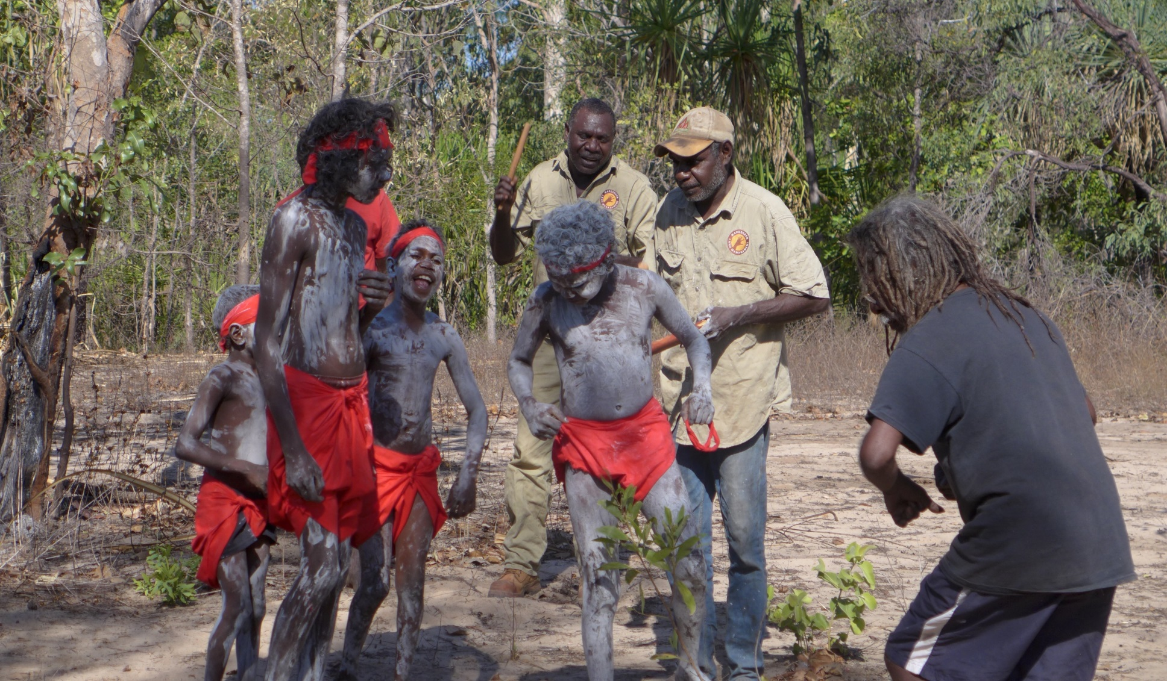

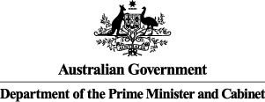**Warddeken Indigenous Protected Areas (IPA)**

***Social Return on Investment Analysis***

Insights

* The Warddeken IPA and associated Indigenous ranger programme has had a transformative effect on Nawarddeken, to whom the land belongs, enabling them to stay living on country and manage their land while connecting with culture and ancestors
* Significant value is derived from the IPA’s fire management work conducted by Rangers on country using traditional and contemporary practices, which has generated substantial revenue for Nawarddeken as a result of carbon offset sales facilitated through innovative partnerships including the West Arnhem Land Fire Abatement (WALFA) project
* The IPA has developed deep, longstanding relationships with NGO and Research partners including Bush Heritage Australia, The Nature Conservancy and The Pew Charitable Trusts which has enabled them to successfully pursue shared conservation management outcomes
* The IPA and associated Indigenous ranger programmes have demonstrated successes across a broad range of outcome areas, effectively overcoming barriers to addressing Indigenous disadvantage and engaging Indigenous Australians in meaningful employment to achieve large scale conservation outcomes, thus aligning the interests of Indigenous Australians and the broader community

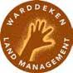

*“We are much happier. We feel better. We like being back on country where our ancestors are.”*

Dean Yibarbuk, Expert Consultant and Senior traditional owner

decorative**About the Warddeken IPA**

The Warddeken IPA consists of approximately 1.4 million ha of stone and gorge country in West Arnhem Land, Northern Territory (NT) and was declared in September 2009. The land belongs to Nawarddeken, who are traditional owners from at least 30 clan groups of the Bininj Kunwok language group. The land within the IPA is of high biodiversity significance and contains very important cultural, rock art and archaeological sites.

The main activities conducted on the IPA include extensive fire management, feral animal and weed control, and monitoring threatened species, which support Nawarddeken to take ownership of the natural and heritage management of their country. Culturally-focused activities are a strong focus, providing an opportunity for Rangers and Community members to return to places of cultural and historical significance, and transfer knowledge to younger generations.

The IPA has been leveraged for numerous economic opportunities, the most significant of which is carbon offset sales to buyers including the IPA’s corporate partner ConocoPhillips. The IPA has also played a pivotal role in the development of Indigenous corporations in Arnhem Land, which has resulted in significant financial benefits to a wide range of communities through the carbon market.During the seven year period of investment covered by this analysis, 253 Indigenous people, mostly traditional owners, worked on the IPA.

**Impact of the Warddeken IPA**

This SROI analysis demonstrates that the Warddeken IPA has generated significant social, economic, cultural and environmental outcomes for Nawarddeken Rangers, Community members, Government and other stakeholders. The achievement of these outcomes is strongly influenced by the time Rangers and Community members spend living and working on country, and the remoteness of the IPA location.

For Rangers, the most significant outcomes relate to better caring for country, and increased pride and sense of self. The most important outcomes for Community members include Rangers and their families living on country, and more burning using cultural practices. The NT and Australian Governments benefit through more Indigenous people working, and safer communities. Indigenous corporations, Corporate, NGO and Research partners, and carbon offset buyers have also benefited from deeper relationships with community and being better able to meet their core objectives.

Financial proxies have been used to approximate the value of these outcomes. The social, economic, cultural and environmental value associated with the outcomes was estimated to be $55.4m for FY09-15.

During this period, $16.6m was invested in the programmes, with most (62%) coming from Government and Carbon offset buyers (25%).

**Value of social, economic, cultural and environmental outcomes created by stakeholder group, FY09-15**

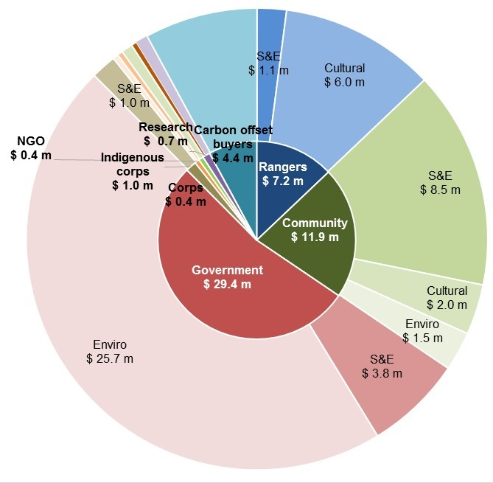

**Key:**

S&E: Social and Economic Outcomes

Cultural: Cultural Outcomes

Enviro: Environmental Outcomes

**Social Return on Investment**

The Warddeken delivered an SROI ratio of 3.4:1 based on the investment in operations between FY09-15.

That is, for every $1 invested, approximately $3.4 of social, economic, cultural and environmental value has been created for stakeholders.

|  |
| --- |
| decorativeIndigenous kids on Warddeken IPA**In the spotlight: Terrah Guymala, Senior Ranger**  Terrah Guymala has lived for most of his life at Manmoyi Outstation Community. After spending some time in jail as a young man, he decided to make a positive change in his life and started a band with some of his brothers. Today, Terrah is a Senior Ranger, Company Director and Lead Singer of Nabarlek band.  Terrah is passionate about supporting Nawarddeken to return to country, where they can have a healthy body and healthy mind, and transfer knowledge to younger generations.  *“Before we returned here, it was empty country; our old people would call it ‘orphaned country'. The country was damaged by uncontrolled fires and there were buffalo everywhere. The land management and the IPA help us fix this…”* |

**About this project**

The Department of the Prime Minister & Cabinet (PM&C) commissioned Social Ventures Australia (SVA) Consulting to understand, measure or estimate and value the changes resulting from the investment in the Warddeken IPA and associated Indigenous ranger programme. This analysis is part of a broader project that considers five IPAs across Australia, also including Birriliburu and Matuwa Kurrara Kurrara in Western Australia (together forming one analysis), Girringun in Queensland, Minyumai in New South Wales. The Social Return on Investment (SROI) methodology was used to complete each of these analyses.

The Warddeken analysis involved 43 consultations with stakeholders of the IPA, including 19 Community members, 12 Rangers, four representatives of the NT and Australian Governments, two Indigenous corporations, three NGO partners, one Corporate partner (overlapping with one Carbon offset buyer), and one Research partner.

|  |
| --- |
| Kids learning ceremony**In the spotlight: Ray Nadjamerrek, Ranger**  Ray is a grandson of Bardayal 'Lofty' Nadjamerrek AO, who led the movement of Nawarddeken back to the Stone Country, alongside his wife Mary Kolkkiwarra Nadjamerrek. Ray has lived in the bush all his life and came to Kabulwarnamyo as a teenager when the community was established.  Ray now lives in Kabulwarnamyo with his wife Eliza and their son Richard so he can raise his son on his traditional land and be near his grandmother. He also looks after some of his nieces and nephews on country, because he believes they will have a better life there than in a nearby growth community. Ray believes that if he was not living on country, he would be unemployed, sitting around and drinking.  *“If I wasn't here, I wouldn't have another job - I would probably be in town unemployed, sitting and drinking, waiting for the Club [pub in Gunbalanya] to open, fighting, doing nothing. That's what people do in Gunbalanya.”* |

decorative

For more information about the Warddeken, or for a copy of the full report, contact:

Georgia Vallance

Warddeken IPA Coordinator

E: [operations@warddeken.org.au](mailto:operations@warddeken.org.au)

For more information on the IPA programme, contact:

T: 02 6228 6481 or 02 6228 6717

E: [IndigenousEnvironment@pmc.gov.au](mailto:IndigenousEnvironment@pmc.gov.au)