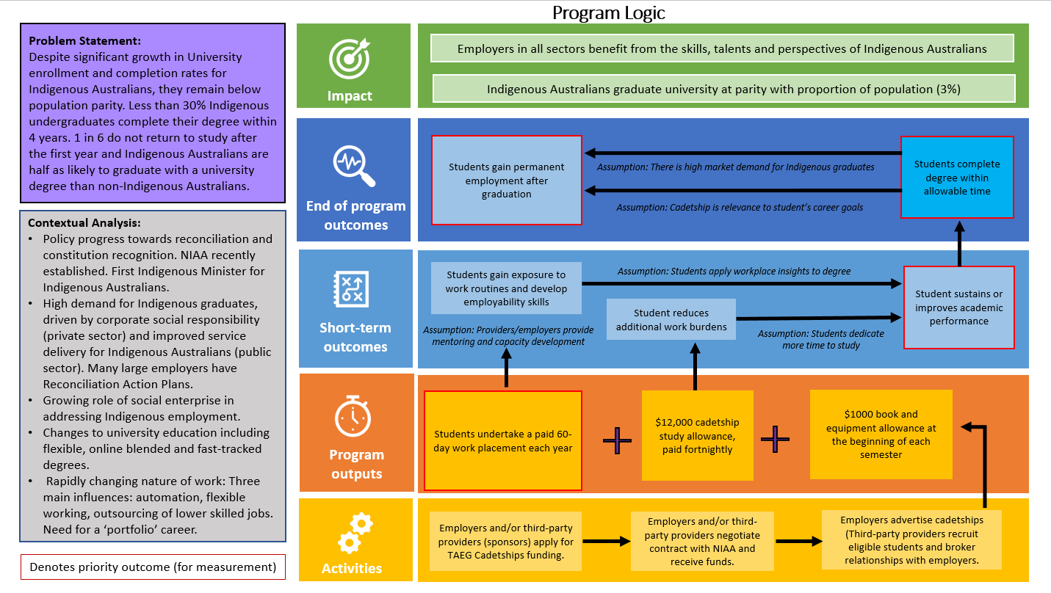

Program Logic

Problem Statement:
Despite significant growth in University enrollment and completion rates for Indigenous Australians, they remain below population parity. Less than 30% Indigenous undergraduates complete their degree within 4 years. 1 in 6 do not return to study after the first year and Indigenous Australians are half as likely to graduate with a university degree than non-Indigenous Australians.

Contextual Analysis:
- Policy progress towards reconciliation and constitution recognition. NIAA recently established. First Indigenous Minister for Indigenous Australians.
- High demand for Indigenous graduates, driven by corporate social responsibility (private sector) and improved service delivery for Indigenous Australians (public sector). Many large employers have Reconciliation Action Plans.
- Growing role of social enterprise in addressing Indigenous employment.
- Changes to university education including flexible, online blended and fast-tracked degrees.
- Rapidly changing nature of work: Three main influences: automation, flexible working, outsourcing of lower skilled jobs. Need for a ‘portfolio’ career.

Impact
1st Line - Employers in all sectors benefit from the skills, talents and perspectives of Indigenous Australians
2nd Line - Indigenous Australians graduate university at parity with proportion of population (3%)

End of program outcomes
Students gain permanent employment after graduation *
- Assumption: there is a high market demand for indigenous graduates
- Assumption: Cadetship is relevance to student’s career goals
Students complete degree within allowable time *

Short term outcomes
Students gain exposure to work routines and develop employability skills
- Assumption: Providers/employers provide mentoring and capacity development
- Assumption: Students apply workplace insights to degree
Student reduces additional work burdens
- Assumption: Students dedicate more time to study
Student sustains or improves academic performance *

Program outputs
Students undertake a paid 60-day work placement each year *
Plus
$12,000 cadetship study allowance paid fortnightly
Plus
$1,000 book and equipment allowance at the beginning of each semester

Activities
Employers and/or third party providers (sponsors) apply for TAEG Cadetships funding
Employers and/or third party providers negotiate contract with NIAA and receive funds.
Employers advertise cadetships (Third-party providers recruit eligible students and broker relations with employers.

* Denotes priority outcome (for measurement)

