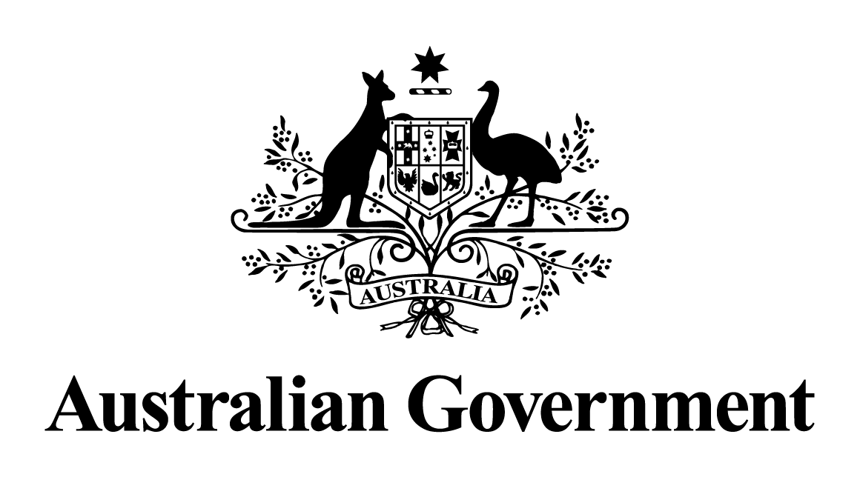

Australian Government response to the
Finance and Public Administration Legislation Committee report:

Budget Estimates 2022–23
March 2023
Recommendation Key
Support | Government supports the recommendation/action in full.
Support in principle | Government supports the recommendation in principle, and commits to an alternative action or exploring options, including in consultation with states and territories.
Support in part | Government supports part of the recommendation.
Note | Government notes the recommendation, but does not agree to additional related activity at this time.

Recommendation 1
3.51 The committee recommends that the Central Land Council and the Northern
Land Council provide regular training and support to senior staff and Board
members to enable them to better meet their responsibilities to the Senate and
its committees through understanding Senate procedures, and that senior
officials of both the Central Land Council and Northern Land Council
undertake training organised by the Senate Procedure Office at the earliest
opportunity.

Response:
The Government supports this recommendation. Senior staff from the Northern Land Council and the Central Land Council (the Land Councils) have undertaken training provided by the Senate Procedure Office. It is the intention of the Land Councils to incorporate this in their training programs for senior staff to ensure that they continue to be supported in meeting their related responsibilities.

