To
OFFICIAL
OFFICIAL
Summary report
CATSI Act review survey
This report details the findings from the survey available on the National Indigenous Australians Agency website for phase one of the CATSI Act review.
Contents
Summary report 4
Executive summary 4
Background 5
Survey method 6
Survey results 7
Survey commentary 7
The purpose of the CATSI Act 8
Governance requirements 9
Transparency and accountability of officers of the corporation 10
Greater support for native title corporations 11
Bringing the CATSI Act up to date 12
Winding up and insolvency of corporations 12
Other areas and comments 12
Conclusion 13
Appendix A 14
Appendix B 15

Summary report

Corporations (Aboriginal and Torres Strait Islander) Act 2006 (CATSI Act) review survey

Executive summary
- As phase one of the CATSI Act review, the National Indigenous Australian’s Agency (NIAA) sought input from respondents in relation to those aspects of the CATSI Act that should be considered as part of the review. The survey was available on the NIAA’s website from 11 December 2019 to 14 February 2020.
- Sixty-eight responses were received for phase one of the consultation, including:
  - sixty responses to the NIAA’s online survey; and
  - eight submissions received mostly through the CATSI Act review inbox (CATSIActReview@niaa.gov.au).
- Governance was identified as the area that was important to most online survey respondents, closely followed by the purpose of the CATSI Act.
- This report summarises the main issues identified by respondents according to themes.
- Responses to the online survey and the separate submissions will be used to inform a draft report that will be published on the NIAA’s website as part of phase two of the CATSI Act review. Consultation will be undertaken in relation to the draft report.

Background
- The CATSI Act establishes a framework for the incorporation, regulation and support of Indigenous corporations. The CATSI Act also provides for the Registrar of Aboriginal and Torres Strait Islander Corporations (the Registrar) and the Office of the Registrar of Indigenous Corporations (ORIC). As Aboriginal and Torres Strait Islander corporations play a crucial role in delivering services and supporting economic development in Indigenous communities, it is important that they receive the necessary support to thrive.
- At the time of publishing this report there were more than 3,300 Aboriginal and Torres Strait Islander corporations incorporated under the CATSI Act.
- On 11 December 2019, the Minister for Indigenous Australians, the Hon Ken Wyatt announced a comprehensive review of the CATSI Act to be led by the NIAA. The review will build on the 2017 Technical Review and will consider:
- The effectiveness of the CATSI Act as a special measure under the Racial Discrimination Act 1975.
- Whether the CATSI Act can better support economic and community development opportunities for Aboriginal and Torres Strait Islander people.
- Other aspects of the CATSI Act that are working effectively and areas that could be improved.
- The review will include extensive consultation with a broad range of stakeholders and is expected to benefit Aboriginal and Torres Strait Islander corporations.
- There will be several phases of consultation during the review and this report details the findings of phase one: an online survey made available on the NIAA’s website; and separate submissions received mostly through the CATSI Act review inbox (CATSIActReview@niaa.gov.au). The findings of the survey will be used to inform the later phases of consultation.

Survey method
- An online survey was made available on the NIAA’s website from 11 December 2019 to 14 February 2020. The survey was seeking feedback on aspects of the CATSI Act that should be considered in the review. The survey was promoted on Indigenous.gov.au, Facebook, Twitter, Instagram, LinkedIn, ORIC’s website and the NIAA’s website.
- Survey respondents were asked to indicate from a list provided, those areas of the CATSI Act that were important to them. There were targeted questions under each listed area to prompt responses and free text fields were available for each listed area in order for survey respondents to provide more detailed information for the review to consider. The listed areas were based on analysis of existing material, including previous stakeholder feedback and reviews. The listed areas were:
- The purpose of the CATSI Act
- Governance requirements
- Transparency and accountability of officers of the corporation
- Greater support for native title corporations
- Bringing the CATSI Act up to date
- Winding up and insolvency of corporations.
- Survey respondents were also asked (with accompanying free text fields):
- Are there any other areas (apart from those listed above) that the Review should consider?
- Do you have any other comments in relation to the Review?
- The online survey is reproduced at Appendix B.

Survey results
- Sixty-eight responses were received in total, with 60 received via the online survey and a further eight submissions received via email. Governance was identified as the area that was important to most online survey respondents, closely followed by the purpose of the CATSI Act. Figure 1 illustrates the number of responses that indicated the relevant area was important.

Figure 1. Respondents who marked ‘this is important to me’ in the online survey

Survey commentary
- Themes from the free text comments are discussed below under the relevant heading. However, a few themes were applicable or relevant to more than one heading/area. These were:
- Increased support for corporations, especially for remote organisations.
- Implementation of streamlined and simplified processes.
- Consistency between the CATSI Act and other legislative instruments and regulatory frameworks.
- Ensuring that Aboriginal and Torres Strait Islander tradition and cultural practice is appropriately accommodated by the CATSI Act.

The purpose of the CATSI Act
- The purpose of the CATSI Act is to establish a framework for the incorporation, regulation and support of Indigenous corporations. As a special measure under the Racial Discrimination Act 1975, the objects of the CATSI Act should be periodically reviewed.
- Fifty-five online survey respondents indicated that the purpose of the CATSI Act was important to them.

Registrar powers
- The CATSI Act provides for the Registrar of Aboriginal and Torres Strait Islander Corporations (the Registrar) and ORIC. The Act also sets out the functions and powers of the Registrar. A number of respondents indicated that this was an important area of review. In particular, comments indicated:
- That the Registrar’s powers should be reviewed, and potentially expanded, to allow the Registrar to intervene in minor issues before serious problems emerge. For example, the Registrar should be able to intervene in membership disputes and have authority to appoint an arbitrator.
- A desire for the Registrar to undertake more prosecutions and to analyse the circumstances of those prosecutions to identify ways to better support corporations.

The continuing need for the CATSI Act
- Most of the comments indicated strong support for the continuing need for the CATSI Act, particularly those that recommended strengthening and expanding the Registrar’s powers. Although in the minority, some respondents queried whether the rationale for the CATSI Act still existed.

The CATSI Act as special measure under the Racial Discrimination Act 1975
- As a special measure under the Racial Discrimination Act 1975, the ongoing objects of the CATSI Act should be subject to periodic and comprehensive review. Included in the scope of this review is considering the effectiveness of the CATSI Act as a special measure. Comments from respondents expressed:
- Support for the CATSI Act as a special measure, although some respondents questioned whether certain aspects of the Act were discriminatory and suggested that any changes need to meet the special measure criteria.
- The role of special administration should be reviewed to ensure it is appropriate and advances the needs of Indigenous corporations.
- A desire for a less interventionist measure than special administration.

Governance requirements
- The CATSI Act outlines governance standards to suit the needs of Indigenous corporations.
- Fifty-seven of the 60 online survey respondents indicated that governance was important to them, and as such, it was the most important area to respondents overall.
- Many submissions stressed the importance of making governance processes streamlined, incorporating traditional practices into the governance practice of corporations, and making the CATSI Act consistent with other comparative legislative instruments such as the Corporations Act 2001, the Australian Securities and Investment Commission Act 2001, and the Australian Charities and Not-for-profits Commission Act 2012. General comments also noted the need for transparency and accountability of governance arrangements, however, one respondent noted that this should not come at the expense of entrepreneurship.

Membership
- Corporations are controlled by members who elect directors to run the corporation on their behalf. New members are accepted into the corporation by the directors. Respondents suggested that the privacy and access provisions to membership registers be reviewed.

Directors
- Directors are responsible for making strategic and operational decisions about the corporation. The role and duties of directors under the CATSI Act was a key point for a number of respondents in the survey. Feedback suggested:
- A need to streamline and simplify the appointment, management and removal of directors.
- Training for directors should be strengthened.
- Respondents suggested that director requirements should change by:
- Introducing a replaceable rule that restricts the number of immediate family members who can be directors at one time.
- Limiting the structure of directors to one community member representative with the remaining positions to be specialists or experts in a relevant field such as accounting and law.
- Introducing requirements for corporations to establish committees such as an audit and risk committee.

Meetings and reporting
- All corporations are required to hold an annual general meeting within five months of the end of their financial year unless the Registrar has approved an extension or exemption. Corporations are also required to prepare reports within six months of the end of their financial year, unless granted an extension or exemption from the Registrar. The format and level of reporting is determined by the size of the corporation. Submissions recommended:
- Removing the requirement for corporations to hold their first general meeting within three months of incorporation.
- Adding safeguards to conducting an annual general meeting to ensure an independent process, for example, engaging an independent person to count votes.
- Only requiring annual general meetings every three years, as opposed to annually. This would also extend the terms of appointment for directors to three years, providing greater continuity.
- In relation to reporting, submissions indicated that:
- Some respondents were wary of changing the reporting requirements for smaller corporations.
- The need for audited reports should be reviewed. Audited reports provide a level of rigour and accountability but compliance with the requirement needs to be balanced with the costs.

Corporations’ rules
- Under the CATSI Act, corporations have internal governance rules. That is, rules that guide how each corporation should be run based on principles of good governance. The CATSI Act allows Aboriginal and Torres Strait Islander people to create rules that best suit their specific needs. These rules form the corporation’s rule book. The majority of responses recommended that rule books should be simplified and made easier to understand. There was also an indication that ORIC should require all rule books to be updated and for those of native title corporations to be compliant with both the CATSI Act and the Native Title Act 1993 (Native Title Act).

Transparency and accountability of officers of the corporation
- Directors, Chief Executive Officers (CEOs) and other officers play a crucial role in the management of a corporation. As such, it is important that they comply with their legal duties and act responsibly.
- Fifty of the 60 online survey respondents marked this item as being important to them.

Transparency
- A number of respondents indicated that transparency was a key concern for them and as such, should be prioritised. In particular, submissions addressed the following issues:
- Transparency should be mandated, rather than an optional inclusion in the corporation’s rule book.
- Some respondents suggested that the remuneration information of senior executives and board members should be reported to members. However, other responses indicated that this was not appropriate.
- Financial reports on all payments made to directors should be provided to members, including sitting fees, loans and cultural heritage management payments.
- The CATSI Act should hold senior executives and board members accountable for the transparent use of funds.
- Corporations should have transparent human resources and employment processes to ensure fairness.

Related third party transactions
- A related third party is a party with a close relationship to the corporation. A number of responses emphasised the importance of transparency and accountability in relation to related third party transactions. Submissions indicated that:
- Expenses should be clearly defined in relation to third party transactions.
- Maintaining a related party disclosure regime aligned with the Corporations Act 2001 was preferable.
- Transparency and reporting should be easy, cost-effective and not time-consuming.
- Finally, some respondents favoured no changes to the current approval and reporting process for third party transactions.

Other
- There were a range of miscellaneous issues that were also raised in relation to the transparency and accountability of officers of corporations, including:
- Whether there should be additional remedies available to the courts where transgressions have occurred, for example, compulsory training for board members.
- Corporations should specify in their rules traditional customs and practices, which could form the basis of a safe harbour for directors and officers.
- Providing an additional defence, based on the business judgment rule, for directors complying with traditional customs and practices.
- A need to ensure that directors have the requisite financial, engagement, literacy and numeracy skills to advance a corporation.

Greater support for native title corporations
- Prescribed Bodies Corporate (PBCs) are established following a determination of native title by the Federal Court. PBCs are responsible for managing native title on behalf of the traditional owners and they are required to register under the CATSI Act.
- Forty-five of the 60 online survey respondents indicated that this area was important to them.
- Some respondents noted that while it was not personally important to them, it was an important area for native title corporations and common law holders. Most submissions indicated that greater support was needed for native title bodies and their members. The need to balance transparency and accountability with accessibility and flexibility was also identified as important.

Reporting about native title monies held in trust
- Often native title monies are held in trust by another entity, rather than the PBC itself. Overall, submissions indicated that greater support and transparency around native title monies held in trust was important. Multiple submissions suggested that the CATSI Act should have provisions requiring that the receipt and expenditure of relevant native title monies be reported to members and common law holders.

Consistency between the CATSI Act and the Native Title Act
- A number of respondents indicated frustration at the lack of consistency between these related statutes. In particular submissions noted:
- That the Registrar and ORIC had no role in relation to common law holders that were not members of the PBC.
- That regulatory bodies should be better informed about the interplay between the different legislative instruments.

Regulatory frameworks
- It was noted that PBCs are an integral part of the native title system, and that they require a responsive regulatory framework that enables them to discharge statutory responsibilities and meet the needs of local communities. Respondents advocated for regulatory frameworks that are supportive and sustainable, particularly for PBCs.
- Respondents also noted the overlap between the roles of National Native Title Tribunal, the Federal Court and ORIC, and queried whether there should instead be a separate legislated body with oversight responsibility of PBCs.

Bringing the CATSI Act up to date
- The CATSI Act was introduced in 2007 and has been operating for approximately 13 years. As such, it is important to ensure the Act is contemporary and fit-for-purpose in the current environment.
- Forty-eight of the 60 online survey respondents indicated that bringing the CATSI Act up to date was important to them. The submissions received suggested:
- The CATSI Act must stay up-to-date with emerging technologies. However, the majority of these suggestions related to policy changes, rather than statutory changes, for example the use of SMS updates and reminders, and accommodating improved technology.
- There should be a greater focus on supporting the pursuit of economic development opportunities.

Winding up and insolvency of corporations
- A corporation registered under the CATSI Act is insolvent if it is unable to pay its debts. The CATSI Act has provisions for dealing with insolvent corporations and provides for the winding up of a corporation if needed.
- Forty-one of the 60 online survey respondents indicated that this area was important to them, although this area received fewer comments. Submissions indicated a preference for:
- Improved provisions for investigating insolvency when organisations do not lodge financial reports.
- Streamlined winding up processes.
- Consideration of timelines that apply to the provision of insolvency notices.
- Stronger penalties for directors who allow corporations to trade under insolvent conditions.

Other areas and comments
- Most of the additional comments related to one of the six areas above have been included in this report under the relevant heading. However, a couple of responses in this section reflected other themes including suggestions that:
- The Registrar’s research function be broadened to enable ORIC to release de-identified data. This would allow stakeholders to use the data for their own research and reduce the administrative burden on ORIC staff.
- The CATSI Act review should consider appropriate dispute resolution mechanisms, including low cost options that are more culturally appropriate.

Conclusion
- While the focus of the 68 responses received by the NIAA was varied, there was an underlying theme that any subsequent amendments to the Act must advance the needs and interests of Aboriginal and Torres Strait Islander people. Another recurring view among respondents was that the review must take into account the traditions and circumstances of individual Aboriginal and Torres Strait Islander groups.
- Thank you to everyone who provided his or her time to contribute to phase one of the review. Further information on the CATSI Act review and details on how to stay involved in the consultation process can be found at niaa.gov.au/indigenous-affairs/economic-development/review-catsi-act. You can also send an email to CATSIActReview@niaa.gov.au.

Appendix A
Issues raised in survey or submission commentary that were not directly relevant to the review of the CATSI Act will be referred to the responsible entity.
Issue | Referral to NIAA | Referral to ORIC
Funding of the Registrar and ORIC | X
Funding of corporations registered under the CATSI Act | X | X
Capacity of ORIC to support the Act (including staff, structure, policy and procedures) |  | X
Support and resources to help corporations comply with the CATSI Act | X | X
Investigation of complaints and/or non-compliance | X | X
Improvements to the consultation process during the review (including clear and ample timeframes, meaningful engagement with Indigenous communities and ranging locations) | X
Capacity building for officers of the corporation (including ORIC governance training for directors) |  | X
Review of rule books (including bilingual options, accompanying hand books and compliance) |  | X
Indigeneity requirements (including consideration of an Indigeneity register) |  | X
Updates to ORIC’s systems and processes |  | X

Appendix B
Phase one online survey available on the NIAA’s website from 11 December 2019 to 14 February 2020.

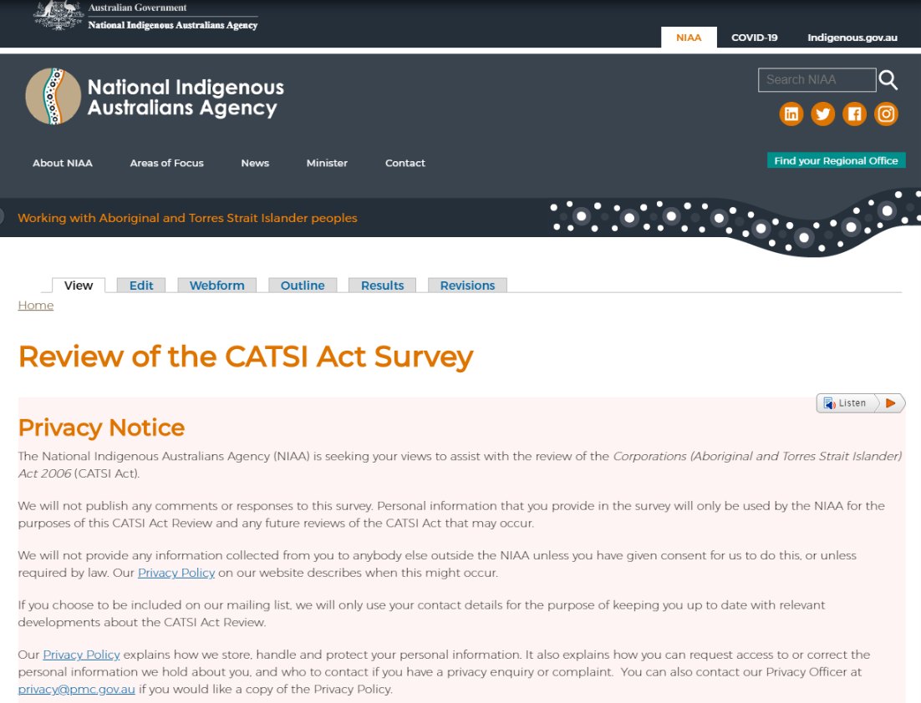
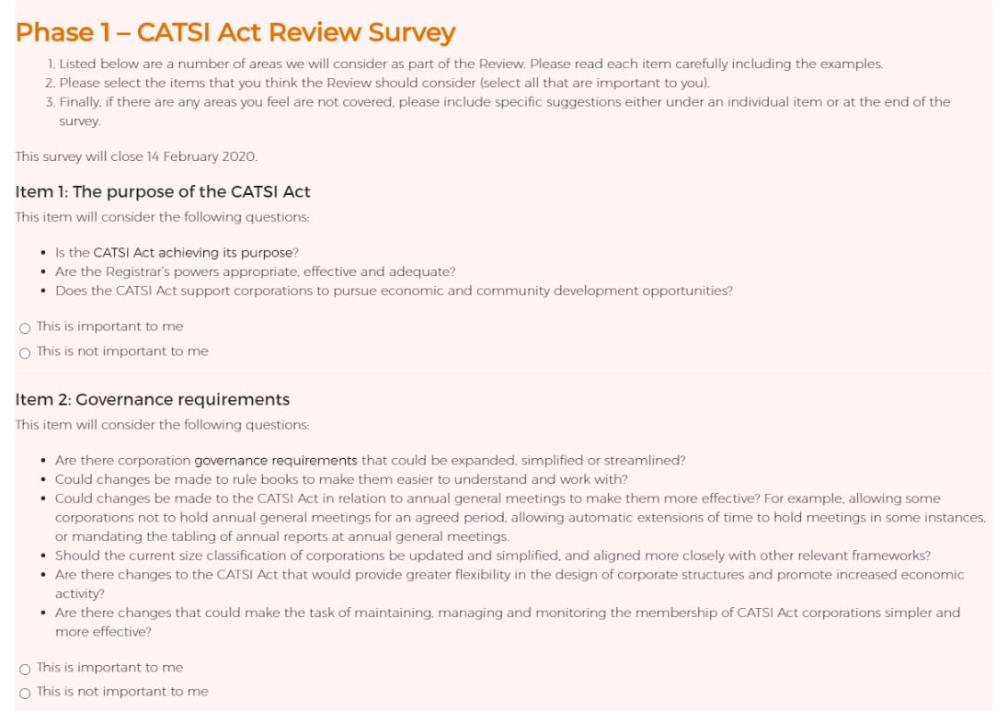
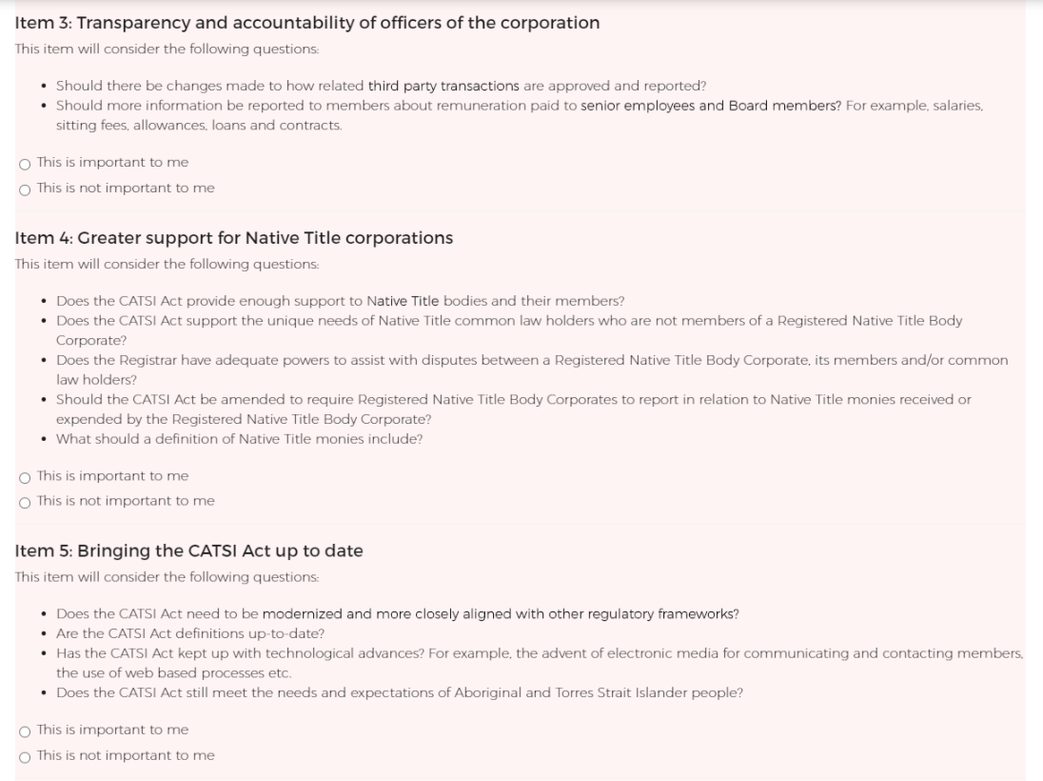
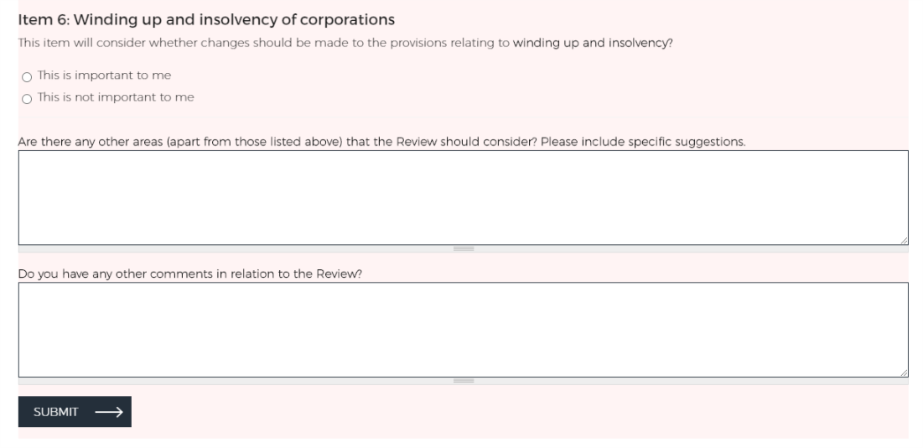

The term ‘online survey’ will be used throughout this report when the data has been drawn from the online survey responses alone, and not the additional eight submissions. Throughout this report, all qualitative data (free text comments) will be drawn from all 68 submissions, however all quantitative data (respondents who marked ‘this item is important to me’) will be drawn from the 60 online survey responses alone.
Issues raised in commentary that were not directly relevant to the review of the CATSI Act are included in Appendix A and will be referred to the responsible entity.
DLA Piper, Technical Review of the Corporations (Aboriginal and Torres Strait Islander) Act 2006 [Internet], ORIC, 2017, available from <https://www.oric.gov.au/catsi-review> [accessed 19 March 2020].
A safe harbour provision in a statute specifies that particular conduct will not be deemed a violation of a given rule. An example of a safe harbour provision can be found under section 588GA of the Corporations Act 2001, which protects directors from being personally liable for debts if they have taken courses of action likely to lead to a better outcome for the company.
The business judgment rule is a defence that directors can rely on if they acted: in good faith; for a proper purpose; on an informed basis; without a significant personal interest in the subject matter; and on the belief that their actions were in the best interests of the company.

