Changes to Mutual Obligations Requirements for Community Development Program (CDP)
- The Australian Government will introduce a new remote jobs program in 2023, replacing the CDP. Please refer to Changes to the Community Development Program fact sheet for more information about the consultation, co-design and pilot process.
- While this process is underway, the Government has made changes to Mutual Obligation Requirements for all CDP job seekers. From 12 May 2021, all CDP job seekers will still be required to meet their Mutual Obligation Requirements, but there will be some changes. Job seekers will be able to volunteer to participate in activities, but a range of requirements will continue to be compulsory, such as attending appointments with service providers or looking for work. These requirements are listed below.
- CDP job seekers will continue to be supported by their providers to find employment and work with communities.

Changes to Mutual Obligation Requirements
As part of the transition from the CDP to a new remote jobs program, Mutual Obligation Requirements for all CDP job seekers will change to make activities voluntary, allowing job seekers to focus on job opportunities as the economy recovers from COVID-19 pandemic.
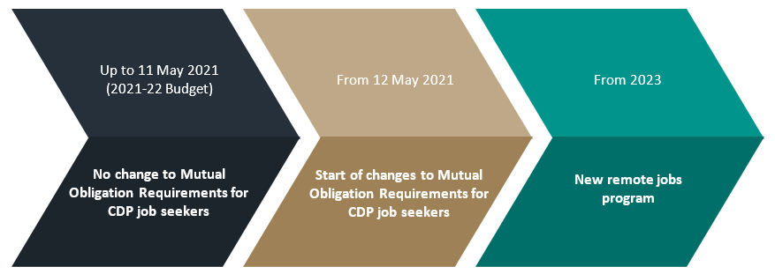
Key changes to Mutual Obligation Requirements
Under the new arrangements, all CDP job seekers can volunteer to take part in activities but will still be required to meet their Mutual Obligation Requirements by:
- agreeing to a job plan
- attending regular appointments and job interviews
- meeting job search requirements (dependent on strength of local labour market)
- accepting suitable paid work when it is offered.
- not to voluntarily leave suitable employment
Why is the Government changing Mutual Obligation Requirements?
The Government has heard what communities and stakeholders have said about the CDP, and calls from remote communities for changes to the program. As part of the lead up to the full roll out of a new remote jobs program in 2023, the Government is changing Mutual Obligation Requirements for CDP job seekers to make activities voluntary. The new program will be co-designed with Indigenous Australians and key stakeholder to better fit the changing job market and meet the unique needs of job seekers in remote communities. It will also align with the implementation of the New Employment Services Model (NESM) being rolled out in the latter half of 2022.

More information
- www.niaa.gov.au/indigenous-affairs/employment/cdp

