Changes to the Community Development Program (CDP)
- The Australian Government will introduce a new remote jobs program in 2023, replacing the CDP.
- As a first step, the National Indigenous Australians Agency (NIAA) will pilot a new remote jobs program in a number of locations from late 2021 following a co-design process.
- Program features will be co-designed with Indigenous Australians and key stakeholders in the coming months, with more information to be announced about these processes.
- While this process is underway, the Government has made changes to Mutual Obligation Requirements for all CDP job seekers. All CDP job seekers will still be required to meet their Mutual Obligation Requirements, but there will be some changes. From 12 May 2021, job seekers will be able to participate in activities on voluntary basis, but will continue to have some compulsory requirements, such as attending appointments with service providers or looking for work. Please refer to the fact sheet - Changes to Mutual Obligations Requirements for CDP for further information.
- CDP job seekers will continue to be supported by their providers to find employment and work with communities.

New remote jobs program pilot
The NIAA will commence piloting a new remote jobs program in a number of locations by the end of 2021, following a co-design process.
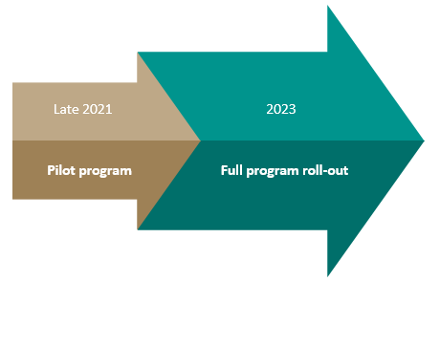
The pilot sites will be announced over the coming months and will reflect remote Australia’s regional and economic diversity.
Through a co-design process, the pilots will trial new ways of engaging job seekers and building skills that respond to the unique circumstances job seekers experience in remote Australia.
The design of the new remote jobs program model will better tailor the support job seekers need to find and secure work as the economy recovers.

Community consultation
Local communities, State and Territory governments, business and Government service providers will be consulted during the design of the new remote jobs program.
The Government wants to hear views from across Australia about how the new program can best support communities in remote Australia. More information will be available soon.

Why is the Government changing CDP?
The Government has heard what communities and stakeholders have said about the CDP. The new remote jobs program will be designed to better fit the changing job market and meet the unique needs of job seekers in remote communities. Program features will be co-designed with Indigenous Australians in consultation with CDP Providers and key stakeholders.

More information
- www.niaa.gov.au/indigenous-affairs/employment/cdp

