

Closing the Gap
Prime Minister’s Report 2014

Introduction 2
Overview of the Government’s agenda for Indigenous Affairs 3
Analysis of the need for a new direction 4
Progress in meeting the Government’s commitments 5
Update on current Closing the Gap targets 5
Closing the Gap targets 6
Focus on schooling 9
Focus on jobs 10
Focus on safer communities 10
Constitutional recognition 11
About the artwork 12

Introduction
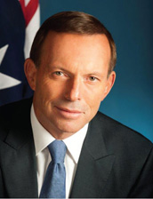

Absolute commitment to Indigenous Affairs

This is the sixth Closing the Gap Report.

While progress has been made in some objectives, it is clear that we are still failing in too many.

In acknowledging our successes and failures, the Government will not be taking credit or casting blame.

Closing the Gap has always been a bipartisan goal and, as such, our successes and failures are always shared.

Our challenge is to turn good intentions into better outcomes.

For the gap to close we must get kids to school, adults to work and the ordinary law of the land observed.

Everything flows from meeting these three objectives.

This is the living reflection of Noel Pearson’s prophetic call for the “right to take responsibility”. We should want nothing less for Aboriginal and Torres Strait Islander people than we want for every Australian – the hope that his or her life is at least as good as the lives of his or her parents and that the lives of his or her children will be better than the life he or she has led.

The style of this report is different from previous Closing the Gap reports. The Government is shifting the focus of this yearly report from what the Government is doing, to how our people are living.

Future Closing the Gap reports will provide more data that better answer the questions we have about what is happening to Indigenous people across our country. We will work with state and territory governments to deliver better insight into the key determinants of education, employment and community safety.

The Australian Government is determined to deliver a demonstrable improvement in the lives of Indigenous people across our country.
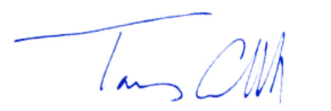

The Hon Tony Abbott MP
Prime Minister of Australia

Overview of the Government’s agenda for Indigenous Affairs

Indigenous Affairs: a long-term commitment

A new engagement with Aboriginal and Torres Strait Islander people should be one of the hallmarks of this Government.

As this report highlights, no one should be under any illusion about the difficulty of swiftly overcoming two centuries of comparative failure. Nevertheless, it would be complacent, even neglectful, to not redress, from day one, the most intractable difficulty our country has ever faced.

One of the first acts of the new Government was to bring the administration of more than 150 Indigenous programmes and services, from eight different government departments, into the Department of the Prime Minister and Cabinet.

The Department, the Minister for Indigenous Affairs, Senator the Hon Nigel Scullion and the Parliamentary Secretary to the Prime Minister, the Hon Alan Tudge MP, are working with the Prime Minister to ensure that the changes result in improved performance across government.

For too long, there has been overlap and inconsistency in the administration of Commonwealth-funded Indigenous services. Placing all Indigenous programmes in the Department of the Prime Minister and Cabinet is an opportunity to overhaul the system, to make it simpler and less burdensome, and to ensure that the right resources supported by the right capabilities go to those who need them most.

Improving governance is an essential element of strengthening the work that is already being done in communities across Australia.

The Prime Minister’s Indigenous Advisory Council, chaired by Mr Warren Mundine, is informing the Government’s policy work. The Council is focusing on practical changes to improve people’s lives.

Later this year, the Prime Minister will take senior officials to a remote Indigenous community for a week. This annual commitment to help in an Indigenous community reflects the Prime Minister’s belief that national leaders make better decisions when grounded in the real life of our country.

Preserving Indigenous culture and building reconciliation means doing more to ensure that children go to school, adults go to work and the ordinary rule of law operates throughout our country.

Getting children to school

Getting children to school is the Australian Government’s number one priority in Indigenous Affairs. Poor attendance means that Indigenous children find it hard to perform at school.

We must break the cycle of non-attendance to ensure today’s kids are educated and equipped to become future leaders in their communities.

From Term 1 this year, we introduced a plan to get Indigenous children back to school in 40 remote communities in the Northern Territory, South Australia, New South Wales, Queensland and Western Australia.

Getting adults to work

Our next priority is getting people into real jobs. Too often, employment and training programmes provide ‘training for training’s sake’ without delivering the practical skills people need to get real jobs.

The Government has commissioned a review of employment and training programmes led by Mr Andrew Forrest. This review will provide recommendations to make Indigenous training and employment services better targeted and administered to connect unemployed Indigenous people with real and sustainable jobs.

Safer Indigenous communities

All Australians have a right to live in a community where they can be safe.

The Government wants Indigenous Australians to live in communities where crime rates are low and people can go about the ordinary business of making a living and raising a family.

We will continue to support tough alcohol regulations across the country so all community members, particularly women, children and the elderly, can live peacefully and safely in their own homes.

Through the Council of Australian Governments (COAG), the Government will work with state and territory governments to establish a permanent police presence in some additional remote Indigenous communities.

Analysis of the need for a new direction

In too many areas, people’s lives are not improving or not improving fast enough.

The COAG Reform Council recently concluded there had been no improvement in Indigenous school attendance over five years. While there are some isolated examples of success, such as Cape York Welfare Reform, existing strategies are having no overall impact on school attendance.

The record of progress against other targets has also been disappointing. There has been no progress on the employment target and while Indigenous life expectancy has improved, the pace of change is far too slow to close the gap by 2031.

While the COAG targets have provided a useful focus, there has been a proliferation of National Partnership Agreements, frameworks and strategies. Some of these National Partnerships – such as the Remote Service Delivery National Partnership – have very complicated and detailed reporting requirements that have diverted attention from actually delivering better outcomes. There is too much focus on whether bureaucratic processes have been completed and not enough focus on delivering better services and outcomes.

We should not equate spending money with getting results. Spending more money on Indigenous Australians is not a sign of success and is not something that should be celebrated for its own sake.

There is also a need to engage Indigenous people more in solving their own problems. We have to stop pretending that a government policy or programme on its own can overcome Indigenous disadvantage. No matter how well coordinated or organised they are, government programmes alone will never close the gap. We also need to more honestly assess the impact of policies and programmes and, where success is not being achieved, be prepared to change tack and try new things.
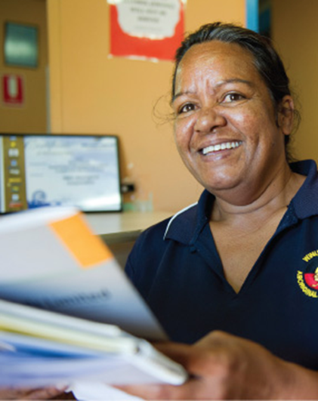

Progress in meeting the Government’s commitments

The Australian Government is honouring its key election commitments in Indigenous Affairs. Actions undertaken include:

Moving the administration of more than 150 Indigenous programmes and services, from eight different government departments, into the Department of the Prime Minister and Cabinet.

Establishing the Prime Minister’s Indigenous Advisory Council.

Implementing the $28.4 million Remote School Attendance Strategy.

Commissioning a review of Indigenous employment and training programmes.

Providing up to $45 million to fast-track the implementation of a demand-driven Vocational Training and Employment Centres training model.

Providing $5 million to support the design of the Empowered Communities initiative.

Working to build support for a successful referendum to recognise the first Australians in our Constitution.

Update on current Closing the Gap targets

Progress against the targets

Key findings:

While there has been a small improvement in Indigenous life expectancy, progress will need to accelerate considerably if the gap is to be closed by 2031.

The target to halve the gap in child mortality within a decade is on track to be met.

In 2012, 88 per cent of Indigenous children in remote areas were enrolled in a pre-school programme. Data for 2013, to show whether the 95 per cent benchmark for this target has been met, will be available later this year.

New data on whether enrolled children are actually attending school should also be available later this year.

Progress against the target to halve the gap in reading, writing and numeracy within a decade has been disappointing. Only two out of eight areas have shown a significant improvement since 2008.

The target to halve the gap for Indigenous people aged 20–24 in Year 12 or equivalent attainment rates by 2020 is on track to be met.

No progress has been made against the target to halve the employment gap within a decade.

Closing the Gap targets

Target

Close the life expectancy gap within a generation (by 2031)

Life expectancy is affected by a range of factors such as education, employment, housing, exposure to violence and poverty which in turn impact on health risk behaviours and the physiological impact of stress.

In 2010–12, Indigenous life expectancy was estimated to be 69.1 years for males and 73.7 years for females. The gap in life expectancy between Indigenous and non-Indigenous people was 10.6 years for males and 9.5 years for females. Over the last five years, there has been a small reduction in the gap of 0.8 years for males and 0.1 years for females. The current rate of progress will have to gather considerable pace from now on if the target is to be met by 2031.

Life expectancy for Indigenous males living in outer regional, remote and very remote areas was estimated to be 0.7 years lower than for those living in major cities and inner regional areas (67.3 years compared with 68.0 years) and 0.8 years lower for females (72.3 compared with 73.1 years).

Target

Halving the gap in mortality rates for Indigenous children under five within a decade
(by 2018)

There have been significant improvements in Indigenous child mortality in recent years. During the period 1998 – 2012, the Indigenous child mortality rate declined by 32 per cent, outpacing the decline in non-Indigenous child mortality. This has led to a significant (37 per cent) narrowing of the gap in child mortality between non-Indigenous and Indigenous children over this period. Changes in Indigenous child mortality since the 2008 baseline are currently within the range required to meet the target by 2018.

Target

Ensuring all Indigenous four-year-olds in remote communities have access to early childhood education within five years (by 2013)

The benchmark for the achievement of this target is 95 per cent enrolment for Indigenous four-year-old children in remote communities by 2013.

The new National Early Childhood Education and Care Collection is used to assess progress. These data show that in August 2012, 88 per cent of Indigenous children in remote areas were enrolled in a pre-school programme in the year before full-time schooling. While this is lower than the estimate for 2011 of 91 per cent, this apparent fall represents improvements in data quality (such as the removal of duplicate records).

Data on pre-school enrolment in remote areas for 2013 will be available in March 2014. Revised population data will be available in April 2014.

Target

Halve the gap for Indigenous children in reading, writing and numeracy within a decade (by 2018)

This target is measured using outcomes of the annual National Assessment Program — Literacy and Numeracy (NAPLAN). The gap is measured as the difference between the proportion of Indigenous and non-Indigenous students at or above the National Minimum Standards (NMS) in reading and numeracy at Years 3, 5, 7 and 9.

Between 2008 and 2013, the proportion of Indigenous students at or above the NMS in reading and numeracy has shown a statistically significant improvement in only two out of eight instances – Years 3 and 5 Reading.

The improvement in Year 5 Reading from 2008 – 2013 reflects a very large improvement in 2013 which should be treated with some caution.³ This very large increase of 18.6 percentage points in one year is out of step with the pattern observed in previous years. It will be important to confirm this large improvement when NAPLAN data for 2014 becomes available.

Another way to assess progress is to compare actual results against agreed trajectories. In 2013, results in four of the eight areas were consistent with or above the required trajectory points at the national level: Years 3, 5, and 9 Reading and Year 5 Numeracy. In the other four areas, 2013 results were below the required trajectory points.

NAPLAN results for Indigenous students vary sharply by remoteness area. As an example, in 2013, 81 per cent of all Indigenous students in metropolitan areas met or exceeded the NMS for Year 9 Reading compared to only 31 per cent of Indigenous students in very remote areas. As results for non-Indigenous students vary considerably less by remoteness area, the ‘gap’ is much wider in very remote areas than it is in metropolitan areas.

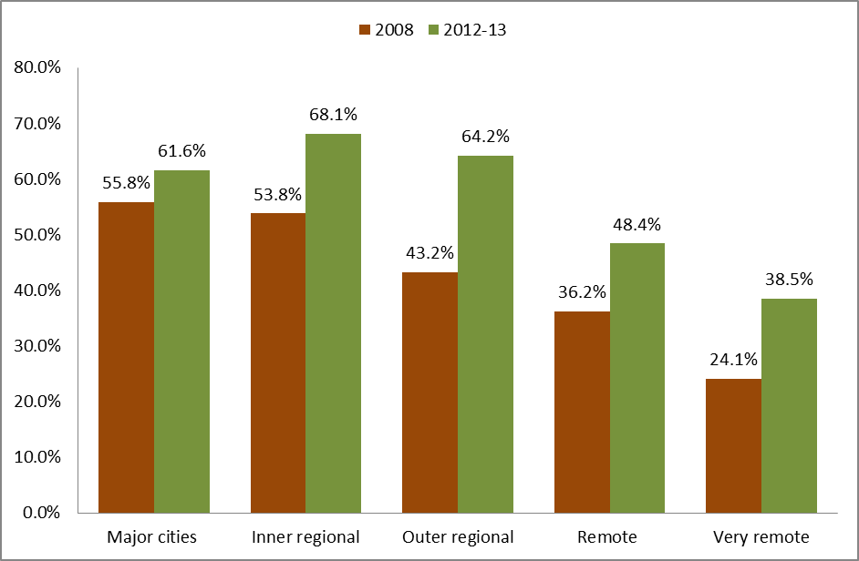

Target

Halve the gap in employment outcomes between Indigenous and non-Indigenous Australians within a decade (by 2018)

In late 2013, employment data from the Australian Aboriginal and Torres Strait Islander Health Survey (AATSIHS) became available. This data suggested that the proportion of Indigenous people aged
15–64 who are employed fell from 53.8 per cent in 2008 to 47.8 per cent in 2012–13. As the proportion of non-Indigenous people who are employed rose from 75 per cent to 75.6 per cent, this means that the employment gap widened.

Some care is required in assessing progress on this target as the Australian Bureau of Statistics (ABS) counts participants in Community Development Employment Projects (CDEP) as being employed. The policy goal is to increase mainstream (non-CDEP) employment not the number of CDEP participants – CDEP is not intended to be a substitute for mainstream employment.

There has been a large fall in the number of CDEP participants from 2008 to 2012–13, which accounts for more than 60 per cent of the decline in the Indigenous employment rate over this period. The Indigenous mainstream (non-CDEP) employment rate also fell from 48.2 per cent in 2008 to 45.9 per cent in 2012–13. However, this fall was not statistically significant.

The mainstream employment gap widened from 2008 to 2012–13 but this change was not statistically significant. However, on the data presented, it is clear that no progress has been made against the target to halve the gap in employment outcomes within a decade (by 2018).

Mainstream (non-CDEP) Indigenous employment rates vary sharply by remoteness area. Only 30.2 per cent of Indigenous adults aged 15–64 in very remote areas were employed in a mainstream job in 2012–13 compared to 51.4 per cent in inner regional areas.

Focus on schooling

The Australian Government’s highest priority in Indigenous Affairs is getting children to school.

A good education provides a passport to more opportunities and a better life. It is a key pathway to prosperity and wellbeing for all Australians.

Education is also the fundamental building block to establishing strong, sustainable communities.

Within the first 100 days of Government, the Prime Minister sought and received agreement from Premiers and Chief Ministers to have a stronger focus on school attendance, including improved reporting, support and compliance measures.

The Government has already acted to increase school attendance. Actions include:

Rolling out the $28.4 million Remote School Attendance Strategy to 40 communities in the Northern Territory, Western Australia, Queensland, New South Wales and South Australia.

Committing to expand the Improving School Enrolment and Attendance through Welfare Reform Measure (SEAM) from 15 to 23 communities over the next two years.

Continuing the $22 million committed in the 2013–14 Budget to expand scholarship opportunities for Indigenous students.

Working with the states and territories to ensure school-by-school attendance data is available and published on a regular basis.

In addition, the Government is committed to supporting remote primary schools to implement evidence-based teaching methods to improve English literacy.

Initiatives to improve ear health and hearing are giving Indigenous children a better start to their education. Being able to hear properly makes learning easier, helps engagement and supports literacy and numeracy development.

The Care for Kids’ Ears initiative is providing community-level communications and activities to improve understanding of the causes, prevention and treatment of ear disease.

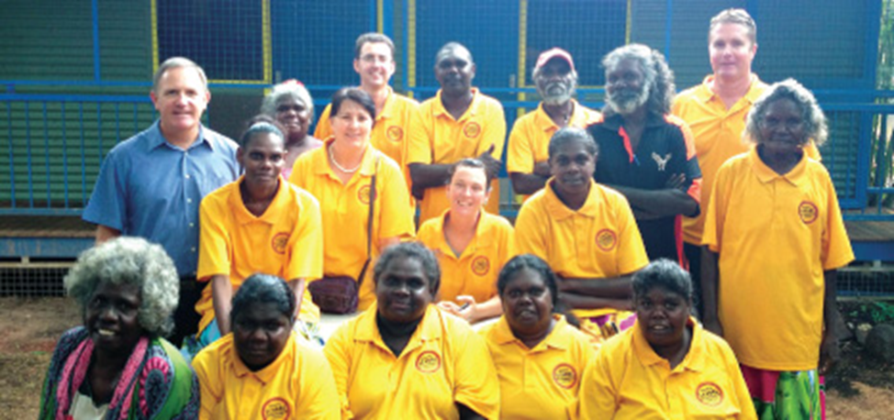

Focus on jobs

Ensuring Indigenous adults are working is critical if Indigenous adults and their families are to enjoy better economic opportunities.

Too often, employment and training programmes provide ‘training for training’s sake’ without providing the practical skills people need to get jobs.

This is one of the reasons why the Government has commissioned a review of Indigenous training and employment programmes, led by Mr Andrew Forrest. This review will provide recommendations to ensure Indigenous training and employment services are more effectively linked to employment outcomes.

We will ensure Job Services Australia (JSA) is focused on delivering better outcomes for Indigenous jobseekers and making sure training is targeted at sustainable jobs. JSA will have a stronger emphasis on working with employers to ensure jobseekers have the skills demanded by employers, work experience is job-focused and post-placement support is provided to deliver sustainable jobs.

We are also investing up to $45 million to deliver demand-driven Vocational Training and Employment Centres, along the lines developed by GenerationOne, to train up to 5,000 Indigenous Australians for guaranteed jobs.

On 29 November 2013, the Government announced immediate changes to the Remote Jobs and Communities Programme (RJCP). These changes will ensure that people in remote communities are engaged in training that leads to real jobs, or are participating in activities that benefit their communities.

Focus on safer communities

All Australians have a right to live in a community where the ordinary law of the land is observed.

This applies to Indigenous communities just as much as it does to the general community.

Improving community safety is one of the Australian Government’s key priorities in Indigenous Affairs.

We will continue to support the efforts of Indigenous communities to combat alcohol-fuelled violence through tough alcohol regulations so all community members, particularly women, children and the elderly, can live peacefully and safely.

The Australian Government has committed $5 million to support the Empowered Communities initiative that aims to strengthen local leadership and governance and build strong, healthy, prosperous and safe communities. The Government is working with the Jawun Indigenous Corporate Partnerships as part of this process. A taskforce that includes Indigenous leaders, governments and representatives of the business community has been established to lead the design work.

Through COAG, governments have agreed to work together to make larger Indigenous communities safer. This includes establishing a permanent police presence in some additional communities.

In 2014, the Government will further address the issue of petrol sniffing in the Top End by expanding the rollout of low aromatic fuel across Northern Australia.

Constitutional recognition

The Australian Government wants a successful referendum to recognise the first Australians in our Constitution and will put forward a draft amendment in late 2014.

A successful referendum would be a unifying moment for our nation – as in 1967 when more than 90 per cent of Australian voters approved a referendum in support of Indigenous Australians, and in 2008 when the National Apology was made to Australia’s Indigenous people.

Recognising the first Australians in our Constitution would acknowledge our shared history and the value we place on Australia’s Aboriginal and Torres Strait Islander heritage.

In December 2013, we established a Joint Select Committee on Constitutional Recognition of Aboriginal and Torres Strait Islander Peoples which will work to build a secure, strong multi-partisan parliamentary consensus around the timing, content and wording of referendum proposals.

The Government continues to support Reconciliation Australia’s Recognise campaign to build public awareness and community support for recognising the first Australians in our Constitution.

About the artwork

This artwork design was created to symbolise the Australian Government’s commitment to creating a better future for Indigenous Australians.

The design depicts an empowered individual who represents the improving wellbeing of Indigenous communities, through increased education, work, community safety and constitutional recognition.

An array of dotted rings encourage the empowered individual. These rings represent the Government’s coordinated agenda to achieve these outcomes that will ultimately culminate in higher standards of living for all Indigenous Australians.

This original artwork design was created by Marcus Lee. Marcus Lee Design is a creative design agency accredited by Supply Nation



The target of 95 per cent, rather than 100 per cent, enrolment reflects the fact that early childhood education is not compulsory.
Prior to 2011, measurement of this target also used the NAPLAN Writing test. In 2011, the Writing test for all year levels was altered from an assessment of Narrative Writing to Persuasive Writing. This change in the Writing test has created a break in the data series over time. Writing results from 2011 onwards cannot be directly compared to the Writing results from previous years, and so have been excluded.
The proportion of Indigenous students at or above NMS in Year 5 Reading rose from 64.7 per cent in 2012 to 83.3 per cent in 2013.
  © Commonwealth of Australia 2014 ISBN 978-1-922098-28-3 (Hardcopy) ISBN 978-1-922098-29-0 (PDF) ISBN 978-1-922098-30-6 (RTF) Ownership of intellectual property rights in this publication Unless otherwise noted, copyright (and any other intellectual property rights, if any) in this publication is owned by the Commonwealth of Australia (referred to below as the Commonwealth). Creative Commons licence With the exception of the Coat of Arms, this publication is licensed under a Creative Commons Attribution 3.0 Australia Licence.  Creative Commons Attribution 3.0 Australia Licence is a standard form license agreement that allows you to copy, distribute, transmit and adapt this publication provided that you attribute the work. A summary of the licence terms is available from. http://creativecommons.org/licenses/by/3.0/au/deed.en. The full licence terms are available from http://creativecommons.org/licenses/by/3.0/au/legalcode. The Commonwealth’s preference is that you attribute this publication (and any material sourced from it) using the following wording: Source: Licensed from the Commonwealth of Australia under a Creative Commons Attribution 3.0 Australia Licence. The Commonwealth of Australia does not necessarily endorse the content of this publication. Use of the Coat of Arms The terms under which the Coat of Arms can be used are set out on the Department of the Prime Minister and Cabinet website (see http://dpmc.gov.au/guidelines/). Please be aware that this report may contain the images of Aboriginal and Torres Strait Islander people who have passed away.

