Procedures for determining breaches of the APS Code of Conduct and the imposition of sanctions

I, Raymond James Griggs AO, CSC, Chief Executive Officer, National Indigenous Australians Agency (the Agency}, have established these procedures in accordance with section 15(3} of the Public
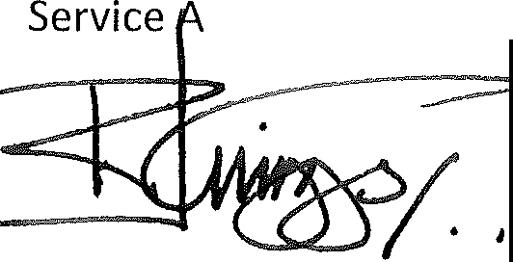
ct 1999 (The Act}.

Ray Griggs, AO, CSC Chief Executive Officer
National Indigenous Australians Agency 1 July 2019

Application
  - These Procedures must be complied with in determining:

a} whether an employee of the agency, or former employee of the agency, has breached the APS Code of Conduct in s 13 of the Act ('the Code of Conduct'}.
b} the sanction/s, if any, that should be imposed on an APS employee in accordance with section 15(1}, where a breach of the Code of Conduct has been determined.

Note: These Procedures apply in relation to a suspected breach of the Code of Conduct by an APS employee, a former APS employee or the actions of an employee prior to commencing with the agency, in respect of which a determination is to be made. Not all suspected breaches of the Code of Conduct may need to be dealt with by way of a determination. In particular circumstances, another way of dealing with a suspected breach of the Code may be more appropriate.

Availability of procedures

  - These procedures are made publicly available on the Agency's website in accordance with subsection 15(7) of the Act.

Information to be given to the APS employee, or former APS employee before a determination is made
  - A determination may not be made in relation to a suspected breach of the Code of Conduct by an APS employee, or former APS employee, unless reasonable steps have been taken to:
a} inform the person of:

515(3) - Procedures for determining suspected breaches of the APS Code of Conduct

    - the details of the suspected breach (including any subsequent variation of those details); and
    - the sanctions that may be imposed on the APS employee under subsection 15(1) of the Act
b) give the person a reasonable opportunity to make a statement in relation to the suspected breach.

Information to be given to the employee before sanction is imposed
  - If a determination is made that an APS employee has breached the Code of Conduct, a sanction may not be imposed on the APS employee unless reasonable steps have been taken to:
- inform the APS employee of:

  - the details of the determination of breach of the Code of Conduct; and

  - the sanction or sanctions that are under consideration in accordance with subsection 15(1) of the Act; and
  - the factors that are under consideration in determining any sanction to be imposed; and
- give the APS employee reasonable opportunity to make a statement in relation to the sanction/sunder consideration.

Person making determination to be independent and unbiased
  - The agency will take reasonable steps to ensure that:

- the person who determines whether an APS employee, or former APS employee, has breached the Code of Conduct is, and appears to be, independent and unbiased; and
- the person who determines any sanction to be imposed is, and appears to be, independent and unbiased.

Determination process to be informal
  - The process for determining whether an APS employee, or former APS employee, has breached the Code of Conduct must be carried out with as little formality and as much expedition as a proper consideration of the matter allows.

Record of determination and sanction
  - If a determination is made in relation to a suspected breach of the Code of Conduct by an APS employee, or former APS employee, a written record must be made of:
- the suspected breach; and

- the determination; and

- any sanctions imposed as a result of the determination that the APS employee breached the Code of Conduct; and

- any statement of reasons provided to the employee.

Note: The Archives Act 1983 and the Privacy Act 1988 apply to a record made under this clause.

Procedure when an employee seeks to move to another Agency during an investigation
  - This clause applies if:

- an APS employee in the Agency is suspected of having breached the Code of Conduct; and
- reasonable steps have been taken to formally advise the APS employee of the suspected breach in accordance with clause 3.1; and
- a decision is made to promote an APS employee and the matter to which the suspected breach relates has not yet been resolved before the employee moves to take up the promotion; or
- a decision has been made, apart from these procedures, that would result in the movement of the employee under section 26 of the Act to another Agency.
  - Unless the original Agency Head and the new Agency Head agree otherwise, the movement (including on promotion) does not take effect until the matter is resolved.
  - For this clause, the matter is taken to be resolved when:

- a determination is made as to whether the APS employee has breached the Code of Conduct; or
- it is decided that such a determination is not necessary.

