More than radio – a community asset

Social Return on Investment (SROI) analyses of Indigenous Broadcasting Services

Gadigal Information Services (GIS)

Insights
- GIS’s Indigenous broadcasting service and associated media activities are forecast to generate significant social, economic and cultural outcomes for a broad range of stakeholders including employees and volunteers, community and the Australian Government.
- GIS is much more than radio – it provides an essential service that strengthens community. GIS is supporting the community to build a collective identity through a vibrant music scene, positive stories about Indigenous people and coverage of topical, relevant issues. Its activities not only serve community communication needs but also strengthens their connectivity and resilience and are highly valued by stakeholders.
- GIS activities provide an opportunity to strengthen the culture of the Indigenous community. They do this by playing a major role in ensuring there is a vibrant Indigenous music scene in Australia and through facilitating the appropriate recording, sharing and protecting of culture. GIS also enables non-Indigenous people to learn more about, and pay respect to, Indigenous cultures and to stand in solidarity with Indigenous people in a positive and respectful way.
- The outcomes achieved by GIS are aligned with Government priorities. GIS is also able to generate value not only by achieving the outcomes above, but also by effectively communicating public interest messages.
- GIS has leveraged Government funding to generate its own revenue and stimulates operations beyond broadcasting, which then enables it to achieve the impact valued by community.

“When I moved to Sydney five years ago, Koori radio helped me connect into the community”
-Koori radio listener, Sydney

About GIS

Redfern is a community of 13,200 people, 2% of whom identify as Indigenous.

Land of the Gadigal people, it is now home to Aboriginal and Torres Strait peoples from across the country and a large non-Indigenous community. Redfern has been the heart of Aboriginal urban activism since the 1960s.

GIS at a glance
Broadcasting range: 9000 km²
Total income (FY17): $1,176,000
IAS funding (FY17): $450,000
Estimated audience size: 213,000
Indigenous staff (FY17): 9 employees, _ and 35 regular volunteers

GIS was established in 1993 to provide a positive voice for the Indigenous community in Sydney in response to negative stereotypes portrayed by mainstream media. It was inspired by the impact of Radio Redfern, which had given the local community a voice during the 1980s. GIS honours by name the traditional Gadigal custodians of the land in and around the Sydney CBD. It also represents Aboriginal and Torres Strait Islander communities of all nations, as well as other First Nations communities, including many Pacific Islands peoples.
GIS produces and broadcasts radio programs, music, runs community outreach programs like the ‘Young, Black and Deadly’ workshops and hosts big community events like the Yabun festival in Sydney, which attracts around 35,000 Indigenous and non-Indigenous people.

Impact of GIS
In the three year period covered by this SROI analysis, GIS is projected to generate substantial outcomes across four key areas: providing a communication medium, strengthening community, strengthening culture, and facilitating meaningful employment and participation. These outcomes will be generated for listeners and community members (Indigenous and non-Indigenous), employees and volunteers, Indigenous musicians and artists and the Government.
GIS’ activities generate the greatest value to listeners and community members by strengthening their community and cultures. Community is strengthened by being informed about issues that matter to them, by being able to tune in and hear positive stories and music about Indigenous people and by having a platform to celebrate Indigenous culture. Non-Indigenous minority communities experience value in having an increased sense of belonging. GIS also plays an important role in reconciliation of the Indigenous and non-Indigenous communities through broadcasts and events like the Yabun festival. The Government benefits from having a trusted medium through which to effectively communicate public messages and through GIS’ support for cultural maintenance and expression.
For employees and volunteers, value is generated through GIS supporting people into meaningful employment through training and creating work and volunteer opportunities aligned with the interests of individuals. Indigenous musicians and artists also experience value in being supported into the music industry.
Financial proxies have been used to approximate the value of these outcomes. The social, economic and cultural value associated with the outcomes is forecast to be $10.6m for FY18-20. During this period, $3.6m is forecast to be invested in GIS Media, with 39 percent of that income received from the Department of the Prime Minister Cabinet (PM&C) through the Indigenous Advancement Strategy.
Forecast value of GIS outcomes generated by stakeholder group, FY18-20
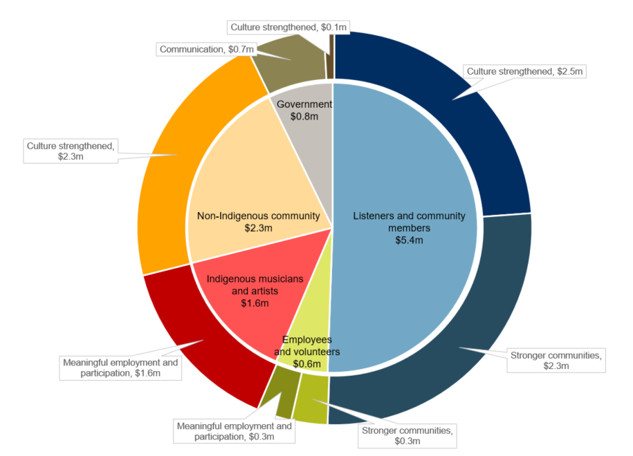
GIS is forecast to deliver an SROI ratio of 2.9:1 from July 2017 to June 2020.
That is, for every $1 invested, approximately $2.90 of social, economic and cultural value will be created for stakeholders.

About this project

PM&C commissioned Social Ventures Australia Consulting to understand, estimate and value the changes expected to be achieved through the investment in GIS’s activities from FY18-20. This analysis is part of a broader project that considers three Indigenous Broadcasting Services across Australia including PAW Media and Communications in the Northern Territory and Umeewarra Media in South Australia. The SROI methodology was used to complete each of these analyses.
This analysis involved 20 consultations with stakeholders of GIS (this included employees, volunteers, listeners and community members) and community service organisations. Interviews were conducted from June through to August 2017.
The broader project involved 79 stakeholder consultations and an Indigenous broadcasting sector survey. Further detail in relation to the methodology applied and the findings of the analysis are set out in the full report, More than radio – a community asset: Social Return on Investment analyses of Indigenous Broadcasting Services, and corresponding methodological attachment. and corresponding methodological attachment.

For more information about GIS, or for a copy of the full report, contact:

Jodie Choolburra, Interim CEO
Gadigal Information Services

T: (02) 9384 4000

E: ceo@gadigal.org.au

For more information on the Government’s funding of Indigenous Broadcasting Services, contact:

Culture and Capability Programme

T: 02 6271 6000 (request to speak with the Broadcasting, Interpreting and Telecommunications team)

E: CultureandCapabilityProgramme@pmc.gov.au

