More than radio – a community asset: Social Return on Investment analyses of Indigenous Broadcasting Services

November 2017

Report funded by the Department of the Prime Minister & Cabinet

Acknowledgements
In preparing this report, Social Ventures Australia (SVA) had the privilege of engaging with the people of Port Augusta, Yuendumu, Laramba and Sydney. The communities welcomed us and trusted us to share their stories and experiences. We acknowledge the Traditional Owners and Custodians of these lands, and all land and sea across this country. We honour and pay our respects to their Elders, past and present.
The report also greatly benefited from the engagement of stakeholders from across the Indigenous broadcasting and media sector. We would like to acknowledge those who participated in interviews and the survey, particularly the Indigenous Remote Communications Association (IRCA), the peak body for Indigenous broadcasting, media and communications. For more information about IRCA, please see: https://www.irca.net.au IRCA webpage

About Social Ventures Australia
SVA is a social purpose organisation that works with partners to improve the lives of people in need. SVA’s services are designed to scale social impact, helping business, government and philanthropists to be more effective funders and social purpose organisations to be more effective at delivering services. For more information about SVA, please see: www.socialventures.com.au Social Ventures webpage

Professional disclosure statement
SVA has prepared this report in good faith on the basis of our research and information available to us at the date of publication. Information has been obtained from sources that we believe to be reliable and up to date. No responsibility will be accepted for any error of fact or opinion based on such reliance. This report was prepared by SVA for the use and benefit of our client for the purpose for which it was provided. SVA does not accept any liability if this report is used for an alternate purpose from which it was intended, nor to any third party in respect of this report.

List of Abbreviations
ABC Australian Broadcasting Corporation
ABS Australian Bureau of Statistics
ACMA Australian Communications and Media Association
APRA Australian Performing Right Association
APY Lands Anangu Pitjantjatjara Yankunytjatjara Lands
BRACS Broadcasting for Remote Aboriginal Communities Scheme
Broadcasting Australian Government Indigenous Broadcasting and Media Priorities
Priorities
CAAMA Central Australian Aboriginal Media Association
CBF Community Broadcasting Foundation
GIS Gadigal Information Services
IAS Indigenous Advancement Strategy
IBS Indigenous Broadcasting Service (including RIBS, RIMOs and other radio
broadcasters)
ICTV Indigenous Community Television
ICRS Indigenous Community Radio Station
IRCA Indigenous Remote Communications Association
NAIDOC National Aborigines and Islanders Day Observance Committee
NITV National Indigenous Television
NSW New South Wales
NT Northern Territory
PAW Pintubi Anmatjere Warlpiri Media and Communications
PM&C Department of the Prime Minister & Cabinet
RIBS Remote Indigenous Broadcasting Services
RIMOs Remote Indigenous Media Organisations
SA South Australia
SBS Special Broadcasting Service
SROI Social Return on Investment
SVA Social Ventures Australia
Umeewarra Umeewarra Media
UNDRIP United Nations Declaration on the Rights of Indigenous Peoples
UNESCO United Nations Educational, Scientific and Cultural Organisation

Table of Contents
Acknowledgements 1
About Social Ventures Australia 1
List of Abbreviations 2
Executive Summary 4
1 Introduction 7
1.1 Project objectives and intended audience 7
1.2 Structure of this report 7
1.3 Methodology 8
2 Indigenous Broadcasting and Media Sector 11
2.1 History and context of the sector 11
2.2 PAW 16
2.3 Umeewarra 18
2.4 GIS 20
3 Investment 21
3.1 Sector overview 21
3.2 PAW 24
3.3 Umeewarra 25
3.4 GIS 26
4 The Impact 27
4.1 Sector overview 27
4.2 PAW 36
4.3 Umeewarra 41
4.4 GIS 46
5 The Value of Impact 51
5.1 Method for estimating the extent and value of impact 51
5.2 Applying the method 53
6 Social Return on Investment 55
6.1 Sector overview 55
6.2 PAW 57
6.3 Umeewarra 60
6.4 GIS 62
7 Insights 64
8 Conclusion 76
Appendix 1 – PAW Logic Model 77
Appendix 2 – Umeewarra Logic Model 79
Appendix 3 – GIS Logic Model 81
Appendix 4 – Alignment of IBSs outcomes with Government priorities 83

Executive Summary
There are over 120 Australian Government funded Indigenous Broadcasting Services (IBSs) operating in Australia, with further unfunded IBS transmission sites. They vary in size from very small remote services to large community radio broadcasting services, and together, they reach an estimated audience of at least 100,000 Indigenous listeners who listen regularly. The most substantial investment in Indigenous broadcasting is provided by the Culture and Capability Programme under the Indigenous Advancement Strategy (IAS) which is administered by the Department of the Prime and Minister and Cabinet (PM&C).
The purpose of this project was to forecast the return on investment over three years of a very remote, regional and urban IBS by understanding, estimating and valuing their impact on stakeholders. The analysis was verified through broader sector consultation to inform the Australian Government about the breadth and depth of impact likely to occur as a result of their continued investment in IBSs.
The Social Return on Investment (SROI) methodology was used to guide the process. SROI is a stakeholder informed process which seeks to tell the story of change and the value of that change from each stakeholder’s perspective. This project involved targeted sector wide consultation and research and a thorough analysis of three IBSs:
- PAW Media and Communications (PAW):
  - located in the very remote Tanami region of the Northern
Territory (NT); and
1
3
2
  - a Remote Indigenous Media Organisation (RIMO) operating a network of 14 Remote Indigenous Broadcasting Services (RIBS);
- Umeewarra Media (Umeewarra):
  - located in regional Port Augusta, South Australia (SA); and
  - an Indigenous Community Radio Service (ICRS); and
- Gadigal Information Services (GIS):
  - located in urban Sydney, New South Wales (NSW); and
  - the ICRS.
This report communicates the story of change and demonstrates the estimated value the three IBSs achieve. This is done using logic models, estimates of how much change will occur, valuations of forecast outcomes and an investment analysis of each of the three IBSs. The report has been developed in close consultation with communities and tested and validated by feedback from PM&C, the IBSs, sector leaders and data analysis.
The report describes how the activities of IBSs are achieving valuable outcomes for stakeholders. All three IBSs analysed are achieving outcomes in the following four interrelated areas:
- Communication;
- Stronger communities;
- Culture strengthened; and
- Meaningful employment and participation.
Within each of the outcome areas, IBSs are achieving various foundational outcomes (e.g. Indigenous people are brought together through events), which lead to community members experiencing more aspirational outcomes (e.g. Indigenous people feel an increased sense of identity and belonging).

Investments in each of the three IBSs analysed are forecast to achieve significant returns with an average across the three broadcasters of $2.87 of social, cultural and economic value for every dollar invested. The SROI ratio is calculated using the total value created by the three IBSs and the total investment in those three IBSs as shown in the table below:
 | Total input
Total Present Value of three IBSs (PV) | $25,791,249
Investment in three IBSs (including investment of volunteer hours) | $8,986,984
Net Present Value (PV minus the investment) | $16,804,265
SROI ratio | 2.87

Our analysis provides a useful foundation for monitoring the future impact of IBSs. It identifies outcomes and a theory of how impact is achieved. It also includes indicators and proxies that could inform appropriate measures. Those outcomes and measures constitute a theory, which should first be tested more broadly with the sector.
We have identified six key insights from the analyses, explored in detail in section 7 of this report.
Key insights
- IBSs provide much more than radio – they are community assets that contribute to strengthening culture, community development and the local economy

IBSs effectively execute their core business of broadcasting Indigenous information, news, interviews, music, community events and stories to large audiences. They also achieve a wide range of valuable outcomes that go much further than simply delivering a radio service.
IBSs core funding enables them to help keep culture alive by creating culturally rich environments and by recording, preserving and broadcasting culture in an appropriate way. IBSs also play a crucial role increasing community cohesion, building community resilience and supporting people into meaningful employment. This is consistent with how international community development literature conceives of community broadcasters – as services which contribute to community and economic development.
- The outcomes achieved by IBSs appear consistent but the activities they undertake are varied

All three IBSs analysed are delivering outcomes consistent with the four themes of communication, strengthening culture, stronger communities and increased employment and participation. But their approach to achieving those outcomes vary dramatically; from a Claymation video studio in Yuendumu to puppets delivering public safety messages in Port Augusta and a programme supporting young musicians to develop their careers in Sydney.
- The activities IBSs undertake are tailored to the specific needs of the community which helps build trust amongst the community

IBSs must have the trust and support of the community in order to operate effectively. Without that trust and support, IBSs would not have such significant and engaged listener bases. Community members also may not feel comfortable sharing content with them, which would reduce the amount of relevant content they had to broadcast. IBSs need the trust of the community in order to undertake the activities the Government funds them to deliver.
Community needs vary greatly and IBSs understand and respond to those community needs, which in turn builds the necessary community trust. Examples of activities that have built that trust include managing a cultural archive of national significance, facilitating job skills training and CV writing support and running Indigenous festivals for 35,000 Indigenous and non-Indigenous people to celebrate culture.
IBSs further build trust through a close connection to the community. All three IBSs analysed are controlled and largely staffed by local Indigenous people, they have welcoming physical premises and cultivate an active network of connections to members of the community.
- IBSs are achieving a range of social returns on investment, heavily informed by their context, and value flows to a variety of stakeholder groups
Across all analyses, the stakeholder group experiencing the greatest share of value are listeners and community members. Other stakeholders experiencing significant value from IBSs include employees, volunteers, Indigenous musicians, artists and the Australian Government. Value was split relatively evenly across outcome themes, which reinforces the interrelationship of outcomes.
All three IBSs are achieving substantial value. Different ratios are influenced by the size of an IBS’s listener base, the level of investment the IBS receives, the relatively high costs of servicing a remote area and the investment a RIMO must make to service multiple RIBS.
- IBSs are contributing towards more of the Government’s priorities than is currently realised
The Australian Government’s Indigenous Broadcasting and Media Priorities are being achieved by IBSs and nearly all of those priorities can be mapped to material outcomes identified in this analysis.
IBSs are contributing to more of the Australian Government’s IAS objectives than is currently realised. IBSs contribute to all of the objectives under the Culture and Capability programme – including culture, community development and reconciliation – as well as priorities under other programme streams through employment, support for education and wellbeing outcomes and investment in remote Australia.
- IBSs can leverage government funds to generate additional revenue – and greater impact – but only if they have sufficient resourcing available

The IBSs we surveyed receive approximately 75 per cent of their funding through PM&C and an additional 8 per cent from other government sources (at the state and federal level). IBSs have demonstrated their capacity to generate their own revenue but there is a minimum resourcing threshold that must be maintained to enable IBSs and their staff to diversify their activities and funding. For example, IBSs cannot spend time writing grant applications and training new staff unless they have sufficient resourcing, nor can they produce videos that generate revenue without video production facilities.

1 Introduction

1.1 Project objectives and intended audience
Since 1987, the Australian Government (referred to interchangeably as Government throughout this report) has provided support to Indigenous Australians to operate IBSs. The importance of IBSs has long been understood by Indigenous communities and Government alike. However, to date, Government has collected information on the type and frequency of activities undertaken by these services with an employment and communication focus, rather than capturing the full scope of their impact in Indigenous communities.
PM&C commissioned SVA Consulting to conduct three SROI forecast analyses to understand, estimate and value the social, cultural and economic impact likely to result from the investment in three IBSs across Australia, as well as undertake a broader sector consultation to test and validate those findings. The three broadcasters analysed were:
- PAW in the Tanami region of the NT;
- Umeewarra in Port Augusta, SA; and
- GIS in Sydney, NSW.
There were three objectives in conducting these analyses:
- Estimate the SROI likely to be generated by each of the three identified IBSs over the next three years;
- Contextualise these analyses with reference to the Indigenous broadcasting sector; and
- Consider what we can learn from the analyses, including key insights and the alignment of impact with PM&C’s targeted outcomes.
The intended audience of this report is primarily Government and the Indigenous broadcasting sector.

1.2 Structure of this report
The report is structured as follows:
- Section 1 (this section) introduces the report;
- Section 2 sets out the history and context of the Indigenous broadcasting and media sector and the three IBSs analysed;
- Section 3 describes the investments in the sector and in each organisation analysed;
- Section 4 explains the impact being achieved in the sector and by each IBS analysed;
- Section 5 estimates and values the change created for each IBS analysed;
- Section 6 sets out the SROI achieved by each IBS analysed;
- Section 7 sets out the key lessons from the analyses and considers the alignment between IBSs’ impact and the Government’s Indigenous Broadcasting and Media Priorities (Broadcasting Priorities) and the IAS; and
- Section 8 offers concluding remarks.
Complimentary to this report is a separate Methodological Attachment, and a standalone summary of the SROI analysis conducted for each of the three IBSs analysed.

1.3 Methodology
Social Return on Investment
SROI is an internationally recognised methodology used to understand, estimate and value the impact of a programme or organisation. It is a form of cost-benefit analysis that examines the social, economic, cultural and environmental outcomes created and the costs of creating them using relevant financial proxies to estimate relative values.
The objective of the project was to understand, estimate, and value the social, cultural and economic impact likely to result from the investment in three IBSs across Australia. We used the SROI methodology as it uniquely suits this purpose.
The SROI methodology is grounded in the principles of Social Value, which can be found in the Methodological Attachment of this report.
The SROI methodology relies on stakeholder consultation to inform our understanding of the impact experienced by stakeholders. We use indicators to establish the quantity and extent of impact on stakeholder experience and financial proxies to value that impact. The Methodological Attachment provides a full explanation of the assumptions that we have used to arrive at the estimate of social return generated by IBSs.
A further objective of this project was for the analysis of the three IBSs to provide insight into the breadth of service types and activities delivered by IBSs across the country. While acknowledging that the three IBSs cannot be representative of every IBS, the IBSs selected were deliberately different in terms of type of service and geographic location.
Key variations between the IBSs are set out in the table below. For a more detailed description of the differences between the three primary means of delivering Indigenous broadcasting, see section 2.1 below.
 | PAW | Umeewarra | GIS
IBS type | RIMO, operating a network of Remote IBS’s | ICRS | ICRS
State | NT | SA | NSW
Remoteness | Very remote | Regional | Urban
Broadcasting range | 450,000 km² | 150 km² | 9000 km²
Cultural groups in the community | Predominantly Pintubi, Anmatjere and Warlpiri peoples. Also Kaytetye, Gurindji, Eastern Arrente, Warumungu and Luritja. | At least 30 distinct Aboriginal language groups | Diverse Aboriginal and Torres Strait Islander language groups and non-Indigenous Australian cultural groups
Estimated audience size | 6,000 | 15,000 | 213,000
Total financial income FY17 | $1,081,000 | $382,000 | $1,176,000
PM&C funding FY17 | $864,000  (80% of total income) | $323,000  (85% of total income) | $450,000  (38% of total income)
Table 1.1 – Characteristics of IBSs considered in the forecast SROI analyses
Each SROI analysis was heavily informed by stakeholder consultation as well as desktop research canvassing relevant qualitative and quantitative data. Across the three analyses, 79 stakeholders were directly engaged.
We also chose to verify our findings from the analyses with sector engagement in the form of further interviews and a survey. Eight key stakeholders were interviewed from across the Indigenous broadcasting and media sector, and all IBSs were invited to participate in a survey to test and validate the findings of the three SROI analyses and reduce the likelihood of sampling errors.
This report synthesises findings from those three analyses and the broader sector consultation. The views expressed in this report have been informed by each of those stakeholder interviews, our desktop analysis, a sector survey conducted by SVA and further data specifically requested from PM&C.
1.4 Scope
The analyses in this report forecast the impact likely to be achieved by the three IBSs over the next three financial years, 2017-18 to 2019-20. To inform the forecast, we have looked back at the investments, activities and impact of the IBSs over the three years of 2014-15 to 2016-17.
For the purposes of the analyses, we have included all investments in, and activities undertaken by, the three IBSs. That includes investment other than that provided by PM&C and activities other than those funded by PM&C. This was in acknowledgement that PM&C’s funding enables IBSs to undertake a range of activities that are complementary and inseparable from broadcasting, a point established through this report.
It was determined that investment and activities over the 2017-18 to 2019-20 financial years are likely to be sufficiently similar to the previous 2014-15 to 2016-17 financial years for those previous years to be a reasonable predictor of future impact. The broadcasters’ annual funding from PM&C for 2017-18 to 2019-20 will be similar, if not the same, as for the period analysed and the permissible activities under the agreement have not altered. Future non-government sources of funding, where applicable, are more difficult to predict, though trends suggest it will be similar to previous years.
As noted in the methodology, to contextualise the analyses we conducted interviews with organisations from across the Indigenous broadcasting and media sector, including Indigenous television stations, to understand their interaction with radio broadcasters. As their activities are distinctly different (albeit complimentary) to the activities of IBSs, television stations and news distribution services were deemed out of the scope of the sector overview in this report. Television audiences were also out of scope of stakeholder consultations, though may experience benefit from, for example, the broadcast of PAW’s video productions.

2 Indigenous Broadcasting and Media Sector

2.1 History and context of the sector
The Indigenous broadcasting and media sector has a long and proud history of celebrating Aboriginal and Torres Strait Islander culture, sharing positive stories and connecting communities. It has earned a reputation for innovation and adaptability, operating across some of the most remote country in Australia as well as serving diverse urban populations. Further, it provides technical training and employment opportunities and contributes to the development of the Indigenous music and film industry, now recognised on the world stage.
The sector has grown from humble beginnings. In 1972, the first Indigenous-produced community radio programs went to air on 5UV in Adelaide and at 4K1G FM at Mount Stuart (south of Townsville) – 50 years after the first radio broadcast in Australia. By 1980, the first Aboriginal owned and controlled community radio station was formed, the Central Australian Aboriginal Media Association (CAAMA) in Alice Springs. Today, there are more than 120 IBSs in operation across the country with an estimated audience of 100,000 regular listeners and three Indigenous television stations with an audience reach up to two million people. Indigenous content is also broadcast through community radio stations.
Establishment of the Broadcasting for Remote Aboriginal Communities Scheme (BRACS)
In the 1980s the number of Indigenous broadcasters grew dramatically when the Australian Government first provided funding for Indigenous broadcasting. In 1985, with the launch of Australia’s first domestic satellite, AUSSAT, many Indigenous communities gained access to radio and video broadcasts for the first time. This was perceived both as an opportunity for Indigenous communities and a threat to their already diminished languages and cultures. Responding to this threat - and in acknowledgement of the lack of broadcasting options available in remote communities - the Government established BRACS in 1987. BRACS gave Indigenous people access to, and control of, their own media at a community level, including the ability to produce radio and video programs and broadcast this content locally. The scheme provided for 80 FM radio and UHV television transmitters to be set up in communities across the country.
The Indigenous broadcasting sector has grown to encompass three primary means of delivering broadcasting content around Australia.
RIBS:
- Are broadcasting services licensed by the Australian Communications and Media Association (ACMA) to provide a broadcasting service in a community designated by the Australian Bureau of Statistics (ABS) as a remote Indigenous community. The licensee is a not-for-profit organisation or local government entity;
- Are licenced for broadcast to a single community and may produce its own content as well as take content from other sources. A RIBS has a radio studio and transmission facility;
- Generally hold a five-year Community Broadcasting Licence as an outcome of their establishment under BRACS. RIBS established in the early 2000s generally hold a one-year Temporary Community Broadcasting Licence;
- Generally broadcast local content for only a few hours each day; and
- Are generally affiliated with and supported by a larger RIMO.
A RIMO is one of the eight remote Indigenous organisations allocated through the BRACS Revitalisation Programme to take responsibility for coordinating service provision to and taking live content from RIBS in a designated geographic area. RIMOs:
- Provide training, technical support and production services to their allocated RIBS;
- Aggregate content from individual RIBS;
- Produce and syndicate content themselves and retransmit the content as a regional radio service into their RIBS communities and a range of other communities; and
- Are not-for-profit Indigenous organisations, with an Indigenous board.
An ICRS:
- Is an ACMA licensed independent Indigenous radio broadcasting service in a remote, regional or urban community representing an Indigenous community of interest;
- Is not a RIBS established through the BRACS funding programme;
- Does not have operational responsibility for other ACMA licenced Indigenous radio services in its region;
- May feed its content to other radio services or take feeds from other radio services as part of its programming;
- Generally provides at least eight hours of programming each day; and
- Is managed by an Indigenous not-for-profit organisation with an Indigenous board.
Previous studies of Community Broadcasting
in Australia and overseas

Studies within Australia and overseas have helped develop a good understanding about community broadcasting audience preferences, and highlighted potential areas of impact.

Key findings from the literature include that community radio:
- Is a vital communications channel for remote areas not easily reached through other mediums
- Shows potential for improving social and economic outcomes (such as education, health and employment)
- Can be effective in delivering public interest messages, when messaging is tailored to the local audience
- Face barriers to sustainability, and that sustainability can be considered to comprise of three interdependent elements: (1) Social sustainability: when stations are responsive to audiences and engage actively in communities, (2) Institutional sustainability: when stations have good governance and management, and (3) Financial sustainability. The first two are preconditions for the third.

The importance of Indigenous Broadcasting and Media
Indigenous owned and operated media provides much more than music and news for its audiences. It provides Indigenous Australians with a voice and with ownership of their identity.
The United Nations Declaration on the Rights of Indigenous Peoples (UNDRIP) Article 16.1 established this voice as a right:
Indigenous peoples have the right to establish their own media in their own languages and to have access to all forms of non-Indigenous media without discrimination.
This report seeks to articulate, amongst other things, why this voice is important to Indigenous Australians. One common theme when considering the importance of Indigenous media is the negative focus of the mainstream media when reporting on Indigenous issues. A 2010 survey of non-Indigenous and Indigenous Australians found only 16 per cent of respondents believed the media presents a balanced view of Indigenous Australia.
This has consequences for the Indigenous community’s self-perception and the public’s perception of Indigenous Australians. The Royal Commission into Aboriginal Deaths in Custody Report recognised the impact this could have on people and recommended the ongoing funding of Indigenous media to ensure Indigenous Australians continued to have their own voice heard. The Review of Australian Government Investment in the Indigenous Broadcasting and Media Sector also highlighted the important role that the sector plays in providing positive representations of Indigenous Australians, enhancing self-esteem, identity, social inclusion and pride within community. The Review concluded that the sector could play an important role in Closing the Gap on Indigenous disadvantage.
Film and Television
Indigenous Australian film on the world stage*
Warwick Thornton, a Kaytetye man and celebrated Indigenous Australian director, began his media career as a DJ on CAAMA radio in Alice Springs. His debut feature film, Samson and Delilah, won the Caméra d’Or at the 2009 Cannes Film Festival.
Indigenous communities experimented with video production through the early 1980s, but from 1988 the content began to reach a wider audience. Through the 1980s, some remote communities adapted the technology available to them to begin locally broadcasting ‘pirate’ television, including in Yuendumu (NT) and Ernabella (SA). The first official Indigenous television station, Imparja, launched in Alice Springs in 1988. Its early broadcasts reached about 60,000 people, and today reach over 500,000 through its affiliation with Channel 9.
Imparja has since been joined by Indigenous Community Television (ICTV), who launched in 2001 and broadcasts to Indigenous communities across the country, and National Indigenous Television (NITV) which launched in 2007. NITV now reaches an average audience of over 2 million Australians per month and about 150,000 regular Indigenous Australian viewers. Indigenous television stations provide a vital platform for the broadcast of Indigenous produced content, some of which is produced by RIBS and RIMOs.
While Indigenous television stations are a critical part of the Indigenous broadcasting and media sector, this report will focus on those broadcasting radio; that is, RIBS and RIMOs and other ICRSs funded by the Australian Government.
Australian Government funding
The Australian Government has provided funding to support the Indigenous broadcasting sector through a number of programmes since 1987. The stability of that funding has supported the sector to achieve its current size and place in Indigenous communities. Today that support is provided predominantly through the Culture and Capability Programme of the IAS, administered by PM&C.
Around $63 million of grant funding has been committed from 2017-18 to 2019 - 20 to support IBSs. Around two-thirds of this funding will go to remote and very remote broadcasting services. Funding is provided for operational costs, employment positions, training, infrastructure, equipment and capital projects, radio news for broadcast on Indigenous and local community radio stations and support for peak body activities. Funding does not cover content, that is, the research and production of radio programs.
Funding supports 43 organisations and over 120 licensed IBSs. These include:
While Australian Government funding supports a variety of organisations across the IBS sector, the analyses in this report focus on those broadcasting radio
- 92 RIBS;
- 7 RIMOs;
- 27 ICRSs;
- 1 News service; and
- ICTV broadcasting services to remote Australia.
This funding also supports IRCA in its role as the national peak body for the Indigenous broadcasting, media and communications sector.
An additional $1.1 million in grants are available for Indigenous programming each year through the Community Broadcasting Foundation (CBF), an independent agency funded through the Commonwealth Department of Communications and the Arts. These grants support the production of Indigenous programmes broadcast on non-Indigenous community stations, in-language programming on Indigenous licensed stations, special content projects (such as documentaries and language series) and equipment upgrades.
Australian Government priorities for Indigenous broadcasting
Through the Culture and Capability Programme, PM&C funding for IBSs has the overarching objectives of:
- Supporting the expression, engagement and conservation of Indigenous culture;
- Increasing Indigenous Australians’ participation in the social and economic life of Australia through healing and strengthening the capability, governance and leadership of Indigenous Australians, organisations and communities; and
- Promoting broader understanding and acceptance of the unique place of Indigenous cultures in Australian society.

In addition, PM&C has identified five priority outcomes for Indigenous broadcasting and media for the 2017-2020 financial years:
- Use of new technology to improve content and audience reach, and reduce costs
- Systematic monitoring and response to community communication needs
- Contribution to cultural expression and maintenance
- Contribution to community economic and social development.
- Cooperative engagement on communication of community and government priorities.
Activities of IBSs
IBSs undertake a wide range of activities, identified in table 2.1 below, not all of which attract government funding.
Activities | Description
Radio production and broadcasting | Production and airing of local content to communities across the country, as well as re-broadcasting material from other IBSs across Australia. Content includes music, news and current affairs, documentaries and oral histories, emergency information transmission, community messages, and sponsored messages for local service providers and government. 1,344 hours of content was broadcast by RIBS and RIMOs per week in 2014.
Training, mentoring and employment | Supporting people into meaningful employment through training, offering flexible working arrangements and creating work opportunities that are aligned with the interests of individuals. In 2017, IBSs employed around 430 people, 350 of whom are Indigenous Australians (83%).  Training and employment is provided in broadcasting, video and music production and associated technical skills. In 2014, 11,940 training hours were provided by RIBS and RIMOs to Indigenous workers.
News gathering | Gathering, researching, and broadcasting news content. The National Indigenous Radio Service is the primary distributor of news content. Some RIMOs also gather news.
Video production | Production of video material, shared through a range of mediums including for broadcast on NITV, ICTV, Special Broadcasting Service (SBS) and Australian Broadcasting Corporation (ABC). A selection of RIBS and RIMOs produce video.
Music production | Production of Indigenous music in their own recording spaces, and distribution of this music through various means. A selection of RIBS and RIMOs perform this role for their communities.
Archiving | Preservation, digitisation, maintenance and research of culturally significant material for their communities. A selection of RIBS and RIMOs produce music.
Cultural protocols management | Management of visiting journalists, film crews, protection of cultural IP.  A selection of RIBS and RIMOs perform this role for their communities.
Community events | Running community events including concerts, sports events, outdoor broadcasts and movie screenings. A selection of RIBS and RIMOs perform this role for their communities.
Technical services | Provided by RIMOs to RIBS, including technical support and infrastructure upgrades, and retransmitting ABC radio services at RIBS sites. About 4,685 hours of technical services were provided in 2014 by RIMOs to RIBS.
Community services | Ad hoc provision of services to meet the needs of local communities. May include being a touch-point or information point for local community services or for getting in touch with Indigenous people in the community. A selection of RIBS and RIMOs perform this role for their communities. For example, about 60 per cent of IBSs surveyed for this report identified that they ‘help people find jobs’.
Maintaining access for people in remote locations | Maintaining broadcasting infrastructure including retransmission sites in remote locations. Maintaining access also involves operating RIMOs and providing training, technical support and production services to RIBS.
Table 2.1 – Summary of activities undertaken by Indigenous Broadcasting Services

2.2 PAW

Remote: Yuendumu is an Indigenous community of 2100 people, 300 kilometres North West of Alice Springs on the edge of the Tanami desert. It is on Warlpiri and Anmatjere lands, also home to the Pintubi peoples.
The community maintains strong cultural practices, and many of its residents speak English as a second or third language.

Warlpiri Media Association, known as PAW Media (abbreviated to PAW in this report), is based in Yuendumu, and is a core part of the community and the wider Tanami region of NT. PAW produces radio, video and music, runs community events, and maintains the Warlpiri Media Archive of culturally significant photos and video.

PAW is a RIMO and operates a network of 14 RIBS. It is the only RIMO assessed in this report. PAW produces content in English, Pintubi, Anmatjere and Warlpiri. It maintains transmitters and studios in the 14 communities in its network, spread across 450,000 square kilometres, and can produce radio from 10 of these locations. PAW incurs the expense associated with maintaining a network of services in very remote locations, including the cost of relocating and housing staff, business interruption due to road closures and other environmental conditions and higher costs of goods and services in remote locations (e.g. fuel, power, and internet). PAW also makes approximately two trips per year to each of the 14 transmission sites, ranging from 40km to 592kms from its base at Yuendumu, as well as incurring leasing costs, security, power and water expenses for each site.
PAW has its roots in producing video. Early video production was through the Warlpiri Literature Centre, renamed the Warlpiri Media Association in 1983. An American anthropologist, Dr Eric Michaels, is credited with encouraging the productions and supported Kumanjayi Japanangka Granites and Francis Jupurrurla Kelly in developing a distinctively Warlpiri approach to video. PAW is famous for its nationally broadcasted documentary – Bush Mechanics – a light-hearted Aboriginal take on fixing cars in the bush.
Residents of Yuendumu were vocal in their concerns about the pending launch of AUSSAT in the 1980s. They feared that mainstream media and radio would dilute language and culture as younger generations were introduced to western TV and advertising – and wanted to ‘fight fire with fire’ through their own cultural productions. Warlpiri Media Association gained a radio transmitter with the establishment of BRACS in 1987. PAW also became a shareholder in Imparja at its launch in 1988, together with CAAMA, on account of its leading role developing Aboriginal media in Central Australia.
Key features
Table 2.2 describes the key activities undertaken by PAW.
Activities | Description
Maintaining access for people in remote locations | PAW operates a network of 14 RIBS, which ensures the approximately 6,000 people in remote communities outside Yuendumu have access to broadcast content. PAW performs the role of a RIMO, including providing training, technical support and production services to the RIBS
Radio production and broadcasting | PAW’s broadcasters produce and air local content in Pintubi, Anmatjere, Warlpiri and English, from studios across their network. They hold outside broadcasts at community events. They broadcast community messages and are sponsored to produce and broadcast content for local service providers and government.  PAW broadcasts to approximately 5,000 listeners across the network with around 200 community members attending each outside broadcast event.
Training, mentoring and employment | PAW supports people into meaningful employment through training, offering flexible working arrangements and creating work opportunities that are aligned with the interests of individuals. PAW employs 13 Indigenous employees, which includes radio broadcasters, video directors and editors, sound engineers and an archivist.
Video production | PAW is commissioned by NITV, ABC and other film producers to produce film and video. This includes video commissions from commercial clients requesting infomercials and advertising.
Music production | PAW helps foster a vibrant music scene through mentorship and access to resources including rehearsing and recording space. PAW provides opportunities for musicians to perform at community concerts, play their songs on air and be featured on a CD which PAW produces.
Archive | PAW manages an archive of national significance which contains 25 years' worth of video footage and photographs chronicling life and culture of Warlpiri people. There are approximately 3,500 Warlpiri people. People access the archive approximately 10 times per week to remember family members, cultural ceremonies and past events and to assist with evidence for land claims. The archive is also frequently utilised by researchers. The archive is also a resource for many universities, school and visiting academics (historians, anthropologists and linguists) in assisting with research in Warlpiri language and culture.
Cultural protocols management | PAW manages adherence to cultural protocols by visiting journalists and film crews. It protects cultural intellectual property.
Community events | PAW runs community events including concerts and sports events and movie screenings which attract an average crowd of 1,500 people from Yuendumu and surrounding communities. A significant portion of the population attends these events and people travel for a weekend to attend and stay with family. The events are seen by community members as a chance to see people and celebrate together.
Technical services | PAW’s broadcasting, video and music production activities are enabled by technicians who repair equipment and ensure the network’s ongoing functioning.
Table 2.2 – Summary of activities undertaken by PAW

2.3 Umeewarra

Regional: Port Augusta is a community of 6,500 people, 19% of whom identify as Aboriginal*
Traditionally a meeting place for Aboriginal people, it is still home to over 35 language groups, including a great number from the Anangu Pitjantjatjara Yankunytjatjara (APY) lands.

Umeewarra Aboriginal Media Association, or Umeewarra Radio 89.1 FM, is based in Port Augusta, SA and was established in 1987. Umeewarra produces radio and community education campaigns and provides a range of community services.
Ultimately, Umeewarra aims to “promote the important role Aboriginal people play in this region… discuss the issues they face in today's society... [and] promote true reconciliation through sharing cultural information and breaking down the barriers.”
Umeewarra was established when Michael Turner, then a member the Aboriginal Community Affairs Panel, asked John Macumba, one of the co-founders of CAAMA, to research the feasibility of setting up an Aboriginal Media Association in Port Augusta. In August 1988, a broadcasting workshop was co-ordinated and Harry Dare, Raymond Weetra and George Reid were the first to go to air. In 1989, Umeewarra began producing a 15-minute program for the ABC. In 1991, the ABC gave Umeewarra some surplus equipment and enabled the setting up of two studios. On 23 February 1993, Umeewarra was granted a license to broadcast across the eastern side of the Flinders Ranges as well as the Aboriginal communities in Davenport, Whyalla and Port Pirie.
Understanding Umeewarra requires an understanding of Port Augusta itself. Port Augusta has a large Aboriginal population. Local leaders estimate that the population is significantly higher (around 7,500) than ABS census results indicate (2,513) and that the number fluctuates throughout the year with people from APY lands travelling to spend time in Port Augusta.
The Aboriginal and non-Aboriginal people of Port Augusta have endured a fractious relationship over the years. Port Augusta returned a majority ‘No’ vote during the 1967 Referendum on Aboriginal inclusion. Umeewarra also shares a name with Umeewarra Mission, established by the Brethren church in the 1930s and operated until 1995. It was home to many Aboriginal children who were forcibly removed from their families under policies which led to the ‘Stolen Generation’. Today, Aboriginal people come to Umeewarra to help locate their loved ones from the Mission days. Media is now one of only two Aboriginal community controlled organisations in Port Augusta, down from at least 10 in the 1980s. It is considered home for many of the Aboriginal community of Port Augusta.
Key features
Table 2.3 describes the key activities undertaken by Umeewarra Media.
Activities | Description
Radio production and broadcasting | Umeewarra’s broadcasters produce and air local content in English and in local Aboriginal languages and broadcast it across Port Augusta, Whyalla, Port Pirie, Hawker and Quorn. They broadcast community messages and are sponsored to produce and broadcast content for local service providers and government. Umeewarra broadcasts to approximately 4,500 listeners.
Training, mentoring and employment | Umeewarra provides some employment opportunities and a number of training opportunities in the form of internships. Umeewarra has three employees and 25 volunteers.  Umeewarra offers job readiness and awareness for the community by advertising locally available jobs on air and helping community members polish their CVs and prepare for interviews. Umeewarra also provides free educational classes to the community in technology and social media. Umeewarra supports approximately 305 people in obtaining employment each year.
Community Services | Umeewarra provides a range of community services including offering a meeting place for events, being a touchpoint for information and referrals for Port Augusta’s Aboriginal community, providing mediation support (as trusted members and leaders within the community), offering cultural competency advice to local service providers, and preparing eulogy cards for the community.
Community events | Umeewarra run community events including through National Aborigines and Islanders Day Observance Committee (NAIDOC) week. Umeewarra has a presence at most large public events in Port Augusta with its broadcast van.
Table 2.3 – Summary of activities undertaken by Umeewarra

2.4 GIS

Urban: Redfern, a suburb in Sydney, is a community of 13,200 people, 2% of whom identify as Indigenous.
Land of the Gadigal people, it is now home to Aboriginal and Torres Strait peoples from across the country. Redfern has been the heart of Aboriginal urban activism since the 1960s.

GIS was established in 1993 to provide a positive voice for the Indigenous community in Sydney in response to negative stereotypes portrayed by mainstream media. It was inspired by the impact of Radio Redfern, which had given the local community a voice during the 1980s.

GIS honours by name the traditional Gadigal custodians of the land in and around the Sydney CBD but also represents Aboriginal and Torres Strait Islander communities of all nations, as well as other First Nations communities, including many Pacific Islands peoples.
GIS has continued to grow in its footprint, activities and ambition. In May 2001, GIS qualified for a 50KW full time broadcasting license under the name of ‘Koori Radio’, after running several test transmissions under the same name. They moved to new premises with other Aboriginal organisations in Sydney’s inner west. From here, GIS extended its community outreach programme, leading to the establishment of the Young, Black & Deadly workshops in performance and later in radio broadcasting and associated areas such as DJ’ing. They have since established the successful and renowned Yabun festival, now held annually in Victoria Park on 26 January, which attracted 28,000 people in 2016. Yabun celebrates Aboriginal people, culture, music, politics, and spirit, and honours those who have fought to maintain it. In 2008, GIS moved back to Redfern, to its current home on the site of the original National Black Theatre.
Key features
Table 2.4 describes the key activities undertaken by GIS.
Activities | Description
Radio broadcasting | GIS broadcasters produce and air local content to metropolitan Sydney. They broadcast community messages and are sponsored to produce and broadcast content for local service providers and government, and run outside broadcasts for events. GIS broadcasts to 41,000 regular Indigenous listeners and 167,000 regular non-Indigenous listeners.
Training, mentoring and employment | GIS provide some employment opportunities and a large number of training opportunities to volunteers. They also offer training in media, performance and creative arts to the general public through their Young Black and Deadly and other talent development programmes. GIS has nine employees and 45 radio volunteers. Six staff members and 35 regular volunteers are Indigenous.
Music production | GIS support the Indigenous music scene through access to rehearsing and recording space, providing opportunities for musicians to perform at concerts such as Yabun, playing their songs on air and by distributing their music. GIS supports approximately 200 artists per year.
Archive | GIS archives all broadcast content and holds one of the largest resources of Indigenous music in the country with every album having been digitised.
Community events | GIS runs community events including the Yabun festival held in Sydney and Klub Koori concerts held in venues across Sydney and occasionally in regional NSW centres. Approximately 15,000 Indigenous people attend the Yabun festival, and 20,000 non-Indigenous people
Table 2.4 – Summary of activities undertaken by GIS

3 Investment

3.1 Sector overview
This section outlines investment trends across the Indigenous broadcasting sector and then provides a summary of the investment across the three organisations analysed.
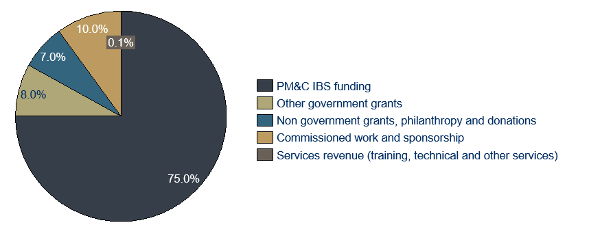
The Indigenous broadcasting sector attracts investment from a range of sources, but is predominantly funded by PM&C. This core funding enables some IBSs in the sector to leverage funding from other sources. On average, IBSs surveyed through this project identified that 75 per cent of their total income in the last financial year was received from PM&C.
Figure 3.1 – Average proportion of total income received, by funding source, for surveyed IBSs
Funding from PM&C: As noted in section 2 of this report, funding from PM&C is provided to cover the operational and employment expenses of the sector, furthering the Australian Government’s Broadcasting Priorities and the IAS Culture and Capability programme priorities. This has been the dominant source of funding for the sector since funding commenced in 1987. Australian Government funding for the Indigenous broadcasting sector has not increased in real terms since 2006-07.
Grant funding from other government sources: As noted in section 2 of this report, the Federal Department of Communications and the Arts provides around $1.1 million per annum to the CBF specifically to provide grants to support the Indigenous broadcasting sector. These include grants for producing special content (content is not covered by PM&C’s funding). State and territory governments and their agencies also provide grants on an ad hoc basis. This includes for the production of community communications campaigns and to support the production of cultural media, particularly film.
Non-government grants, philanthropy and donations: Some IBSs in the sector also attract grants, including from local Indigenous community foundations and trusts and in rare cases, through donations and philanthropy. The remoteness of many of these providers, however, makes it difficult to attract philanthropic funding.
Sponsorship revenue: Though community broadcasters are not allowed to broadcast advertisements, they can broadcast public interest messages that promote community services or community events and receive revenue for it. Again, the remoteness of many providers means sponsorship generating opportunities are limited due to the limited pool of businesses and services in these communities.
Commissioned work and production fees: Some IBSs, particularly RIMOs, are commissioned to produce film and video, including for the ABC, NITV, and Imparja. This work can range in value from a few thousand to tens of thousands of dollars.
Volunteer hours: While IBSs are funded to provide employment opportunities, in many cases, employees are supported by volunteer staff. This is a common feature of the community broadcasting sector in Australia, which was supported by about 24,600 volunteers in 2015/16. Nine of the 13 IBSs who responded to the survey for this report (70 per cent) had volunteer staff.
Artists work: Musicians and video producers contribute their material for broadcast. In most cases, due to remote radio playlists not being available to the Australian Performing Rights Association (APRA), musicians do not receive royalties when their work is played on air by IBSs, and where they do, the royalties are not economically significant.
Overview of investment across three analyses
In each analysis, the dollar value of all inputs required to achieve impact is calculated. Inputs are primarily financial (cash) investments over the relevant period, including grant funding and self-generated revenue. The value of volunteer hours is also considered as an investment. The investment across the three analyses is illustrated in Figure 3.1.2 below.
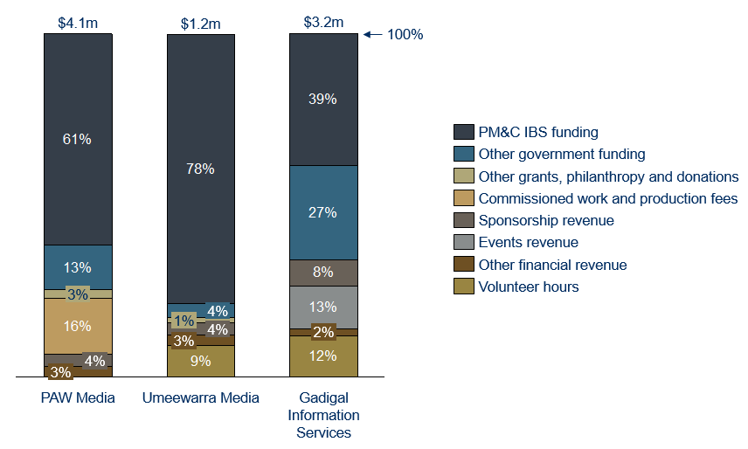

Figure 3.1.2 – Proportion of total investment from FY15-FY17, by source
Across all analyses, government departments and agencies were the largest source of funding for IBSs and their associated activities. PM&C was the largest source of government funding. Its grant funding accounted for between 39 per cent (GIS) and 78 per cent (Umeewarra) of total investment in the organisations over the relevant period.
The sources and proportion of self-generated revenue varied between the three providers and were highly dependent on each providers’ context:
- Video production is a significant asset for PAW and generated 16 per cent of its investment for the period. This function required capital investments to establish which was partly funded by government through previous grants. The other IBSs analysed do not have video production facilities.
- GIS attracted 13 per cent of its investment through revenue from public events. High attendance at these events is largely due to GIS being in Sydney, which gives GIS access to large audiences.
- All three providers attracted between four to nine per cent of their revenue from sponsorship. GIS attracted the most, at nine per cent, which was again in large part due to it having access to a larger audience and range of community services willing to pay to reach those audiences.
- Both Umeewarra and GIS benefitted from significant non-financial investments over the period, in the form of volunteer hours.
Further commentary on IBSs capacity to leverage PM&C’s investment to generate revenue is provided in section 7.

3.2 PAW
From financial years 2014-15 to 2016-17, 78 per cent of PAW’s revenue came from government sources. Most was PM&C’s Indigenous broadcasting grant funding (61 per cent), with an additional portion from non-recurring government grants (13 per cent) and from government commissioned video productions (5 per cent). Government grants included funding towards the digitisation of PAW’s Media Archive ($200,000 over this three-year period). Sixteen per cent of PAW’s revenue over this period was for the production of film and videos, including for NITV and Screen Australia.
PAW experienced a 33 per cent drop in its annual revenue over the period, driven by fluctuations in the commissioning of video productions and one-off government grants.
Investment Summary
Table 3.3 summaries the investment in PAW between the 2014-15 and 2016-17 financial years, inclusive.
Stakeholder | Total  [FY2015-2017] | Proportion of total | Comment
PM&C Indigenous broadcasting Funding | $2,567,484 | 61% | Includes funding in FY15 from a separate Australian Government programme to support Indigenous employment at PAW, rolled into the PM&C IBS grant in subsequent years.
Commissioned work and production fees | $684,194 | 16% | 5% of this work was commissioned by government bodies.
Other Government funding (non-commissioned work) | $544,890 | 13%
Sponsorship revenue | $155,428 | 4%
Other revenue | $120,037 | 3%
Other grants, philanthropy, and donations | $105,131 | 3%
Total | $4,177,164 | 100%
Table 3.2 – Summary of investment in PAW

3.3 Umeewarra
From financial years 2014-15 to 2016-17, Umeewarra attracted over 90 per cent of its revenue from government sources, with the remaining revenue drawn from sponsorship, facilities hire and donations.
PM&C’s IBS grant funding accounted for 78 per cent of Umeewarra’s total revenue, with a further four per cent provided by the CBF. Sponsorship revenue and facilities hire each accounted for four per cent of revenue.
We have valued the non-financial investment of volunteer hours, which results in nine per cent of the total investment in Umeewarra over the period. Voluntary hours were worked both by employed staff (as overtime) and volunteers.
Investment Summary
Table 3.3 summarises the investment in Umeewarra between the 2014-15 and 2016 -17 financial years, inclusive.
Stakeholder | Total  [FY2015-2017] | Proportion of total | Comment
Financial investments
PM&C Indigenous broadcasting funding | $913,358 | 78%
Other Government funding | $49,410 | 4% | CBF grant
Sponsorship revenue | $40,925 | 4%
Other revenue | $37,395 | 3% | For the hiring of Umeewarra’s meeting room.
Other grants, philanthropy, and donations | $17,461 | 1%
Commissioned work and production fees | - | 0%
Non-financial investments
Estimated value of staff voluntary hours | $108,000 | 9% | Voluntary hours were calculated using Umeewarra’s average hourly rate of $30, over a total of 1,200 hours. Umeewarra’s average wage was used rather than the Australian minimum wage, as voluntary hours were often worked by Umeewarra’s paid staff.
Total | $1,058,549 | 100%
Table 3.3 – Summary of investment in Umeewarra

3.4 GIS
GIS had the highest revenue of the three IBSs analysed and the most diversified revenue base. This was in large part due to their access to a significant audience. While 66 per cent of revenue was provided by government (39 per cent from PM&C), GIS attracted significant sponsorship revenues nearing $300,000 over the period and generated events revenue over $500,000 in value. Volunteers made a significant non-financial investment over the period of $430,000, or 12 per cent of revenue. Volunteer involvement was predominantly for the Yabun festival event, which commonly involves around 100 volunteers.
Investment Summary
Table 3.4 summaries the investment in GIS between the 2014-15 and 2016-17 financial years, inclusive.
Stakeholder | Total  [FY2015-2017] | Proportion of total | Comment
Financials investments
PM&C Indigenous Broadcasting funding | $1,408,136 | 39%
Other Government funding | $990,677 | 27%
Events | $455,458 | 13%
Sponsorship revenue | $279,697 | 6%
Other revenue | $72,839 | 2% | Includes studio rental, equipment hire and membership fees
Other grants, philanthropy, and donations | $5,734 | 0.2% | Excludes $1.7 million for a capital grant in FY2015
Commissioned work and production fees | - | 0%
Non-Financial investments
Estimated value of staff voluntary hours | $430,740 | 12%
Total | $4,952,955 | 100%
Table 3.4 – Summary of investment in GIS

4 The Impact

4.1 Sector overview
While there are significant differences in the activities pursued by IBSs, they are all achieving valuable outcomes for stakeholders, and there is broad alignment on the outcomes they achieve.
We have used logic models to understand the impact created by IBSs. In this section, we have articulated our consolidated understanding of the Indigenous broadcasting sector’s impact, informed by the three analyses and our broader sector consultation. This speaks only to the impact of IBSs who broadcast radio. It excludes the impact of television or the National Indigenous News service which generates news, despite these services being complementary to IBSs activities.
We have also developed unique logic models for each of the three IBSs, to account for their specific contexts. There is guidance in this section on how to interpret the logic models and commentary about their contents, particularly the outcomes, which ultimately describe the impact of IBSs.
Contents of the logic models
The logic models provide the foundation for an understanding of the impact of IBSs, so it is helpful to reflect on each element of the logic model. The logic models each consist of two pages, which articulate:
- On the first page:
  - Issues that the Indigenous broadcasting sector activities seek to address;
  - The strategic response of broadcasters to the issue;
  - The stakeholders involved;
  - The activities that take place; and
  - The inputs (investments) into their activities;
- On the second page:
  - Outcomes and, by consequence, the impact for stakeholders.
Section 2 of this report detailed the history and context of the Indigenous broadcasting sector and in doing so, describes the issues, the stakeholders and the activities.
Section 3 of this report set out the inputs (investments) into the Indigenous broadcasting sector.
This section 4 of the report uses the logic model to introduce a detailed exploration of the outcomes and impact of IBSs. It considers initially the outcomes that were consistent across the three organisations analysed before turning to outcomes that are specific to each organisation.
Interpreting the logic models
The logic models are informed by what has occurred over the past three years. We have used this as a basis to forecast the outcomes which are likely to be achieved by continued investment in the sector for the next three years. If investment and activities change, the outcomes, and the extent of the impact, are also likely to change.
It is important to note that as the services have been operating for some time (in many cases for 30 years), the outcomes are an expression of the continual and accumulative impact being achieved by these services, rather than an isolated ‘change’ that is expected to occur in the next three years. Often logic models represent a program where the participants enter and exit at specific points and during that time they experience change. Rather than creating change for individuals, IBSs maintain, and in some cases, strengthen an existing positive state for individuals and communities.
Key points to consider when interpreting the second page of the logic models are as follows:
- The extent of the change varies between stakeholders;
- Many of the outcomes for different stakeholders are interrelated;
- Achievement of outcomes in the communications outcome theme is necessary to achieve outcomes in the other outcome themes;
- The outcomes towards the bottom left of each logic model are foundational outcomes which must be in place before stakeholders can experience outcomes towards the top right of the logic model;
- The outcomes towards the top right of the logic model represent the desired state for all stakeholders. As a consequence of the broadcasters’ activities, many stakeholders are experiencing - and will continue to experience – those outcomes, but not necessarily all stakeholders; and
- Our hypothesis is that a greater number of stakeholders experience the foundational outcomes than the aspirational outcomes
The points above, and the outcomes contained in the logic model constitute the theory of how IBSs are achieving impact. The theory has been established through analysis of information collected through stakeholder consultation and consideration of international research. As it is a theory, the elements above, as well as the outcomes contained in the logic model, should be tested over time through further data collection, research and evaluation.
Figure 4.1.1 below explains how to read the second page of the Logic Model, which speaks to outcomes and impact.
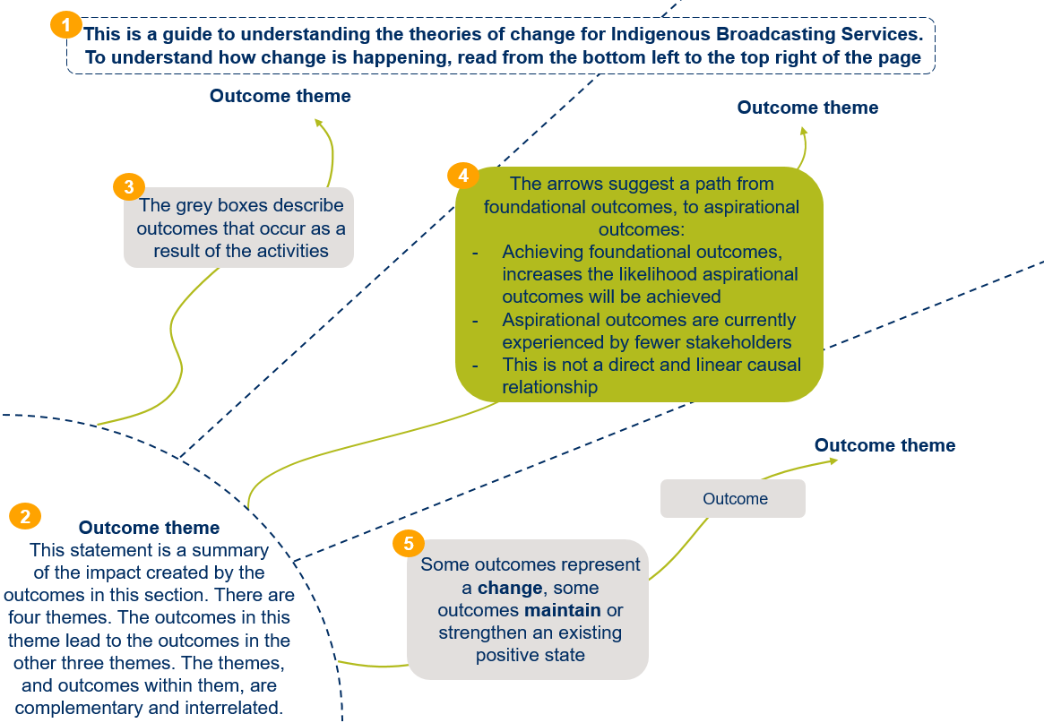 Figure 4.1.1 – How to read the logic model
The Indigenous broadcasting sector logic model
The two-page logic model articulating the impact of the Indigenous broadcating sector is set out below at Figures 4.1.2 and 4.1.3.

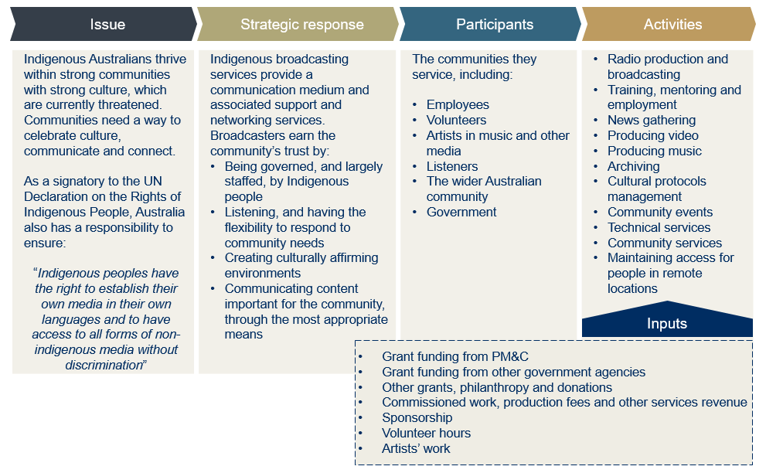 Figure 4.1.2 – Logic model for Indigenous broadcasting services, page 1
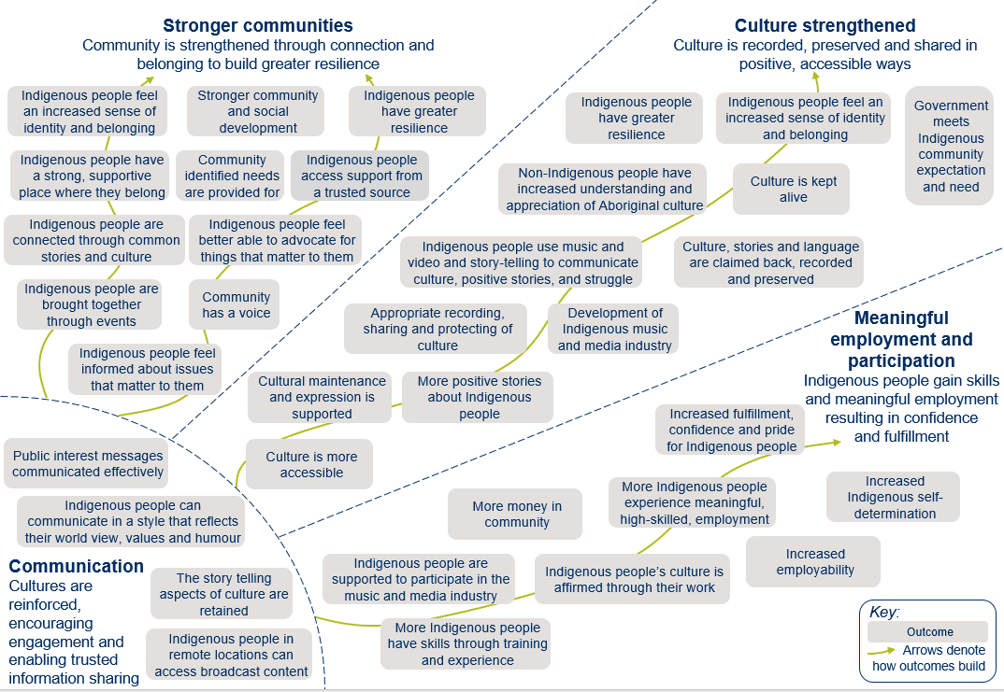 Figure 4.1.3 –Logic model for Indigenous broadcasting services, page 2 - Outcomes
Strategic response
Before describing the outcomes in detail below, it is worth summarising the key factors that enable IBSs to achieve impact to inform an understanding of how outcomes are generated. In summary, the critical enablers are:
- IBSs are governed and largely staffed by Indigenous people;
- IBSs core PM&C funding enables them to leverage the infrastructure and human resources available in the community in which they operate;
- IBSs invest heavily in gaining and maintaining the trust of the community; and
- IBSs respond well to the specific and wide-ranging needs of their communities.
Section 7of this report describes the key insights from the analysis and explores in detail these enablers and how IBSs achieve outcomes.
Outcome theme: Communication
The most elemental function of Indigenous broadcasting is as a communications medium. Across the country, Indigenous Australians and, to a lesser extent, the broader Australian community, are accessing IBSs content through radio, video, and other creative mediums including animation and puppetry. These mediums enable communication in a familiar style that is respectful of Indigenous cultures, and the sharing of information through a trusted medium.
Outcomes:
- Indigenous people can communicate in a style that reflects their world view, values and humour; and
- Story telling aspects of culture are retained.
We heard from listeners that they valued being able to ‘switch on’ the radio to tap into their culture and hear from people who affirm their cultural identity. But Indigenous Australians tune in to their local station for a broad range of reasons, identified in Figure 4.1.4 below. 39 per cent of listeners tune in to hear from Indigenous personalities and 40 per cent tune in to hear from their community members. That cultural identity is affirmed in subtle ways, by local personalities who speak from a perspective and with a sense of humour that listeners can associate with. Broadcasters share stories on radio, and through film and other mediums, and this retains the story telling aspects of indigenous culture.
Listeners value that IBSs communicate in a manner that is accessible for them, including in their language. About 28 per cent tuned in to hear people speaking in their language. This is particularly significant for Indigenous Australians who are not fluent in English. In 2011, 17 per cent of Indigenous Australians who spoke an Indigenous Australian language at home reported not speaking English well. Radio and film are also natural mediums to share stories, central to celebrating and passing on Indigenous cultures.
We've always talked to each other. This (radio) has just taken the smoke signals out of it.
It's a modern version of it"
Community member and radio listener in Yuendumu
XXX

Figure 4.1.4 –Reasons for Listening to Indigenous Radio Stations, nationally. Source: McNair Australian Indigenous Communications and Media Survey, March 2017
Outcomes:
- Indigenous people feel informed about issues that matter to them; and
- Public interest messages are communicated effectively.
Listeners tune in to be informed about issues that matter to them, be that for news or public health and safety messages. About 48 per cent of listeners tuned in because of the "Indigenous focus in the news and current affairs programming", and 61 per cent “to hear about my own people and my community”. Community messages are often shared over the radio and IBSs are commissioned to produce radio clips and songs about public safety issues. This has been found to be highly effective, benefiting communities and the Australian Government alike. Between 2009-2013 the Australian Government funded IBSs to deliver information to their Indigenous communities about the importance of ear health. The initiative was found to lead to improved health outcomes.
“There was a reported increase in delivery of ear health screening, particularly to hard-to-reach groups, and direct improvements were noted in children’s health and wellbeing”
Finding from the Evaluation of the National Indigenous Ear Health Campaign
XXX
By providing an effective, trusted and accessible communications medium, IBSs are able to achieve further outcomes which contribute to strengthening communities, strengthening culture and meaningful employment and participation.
Outcome theme: Stronger communities
IBS’s activities are contributing to building stronger, more connected and resilient communities and helping individuals feel they belong within them. The services are central and trusted members of their communities. This trust enables the organisations’ activities to have the greatest impact possible.

Outcome:
- Indigenous people are brought together through events
Through community concerts, events and outside broadcasts, IBSs help communities connect to one another. Indigenous stations conduct an average of 20 outside broadcasts each per year, double the average of 10 outside broadcasts by non-Indigenous community stations across the country. These include broadcasts from local nursing homes, so elderly Indigenous community members feel engaged in the community, and from community concerts, local schools and NAIDOC events. In remote areas, these events bring people together across vast distances, and provide opportunities to celebrate culture.
Outcomes:

IBSs are integral, active and trusted members of their local Indigenous communities.
This puts them in a unique position to be able to identify and respond well to communities’ needs, which contributes to the strengthening of these communities.
- Community has a voice; and
- Indigenous people feel better able to advocate for things that matter to them.
We heard consistently that IBSs provide a voice for their communities. They are uniquely placed to hear and share communities’ strengths, priorities and concerns. In providing news and information to a community, they are also providing the community with the information they need to hear. We heard that communities valued knowing the information had been ‘filtered’ and that communities trusted they were hearing the information they needed to better advocate for things that matter to them.
Outcomes:
- Community identified needs are provided for; and
- Indigenous people have a strong supportive place where they belong
Indigenous broadcasters are embedded in their communities and have longstanding relationships within them. They behave as though they are community members and use their operational funding to produce tailored content and activities to respond to their communities’ needs. Their ability to do this is a big part of what the communities’ value in these broadcasters.
Stations are meeting the needs of the community in diverse ways. Pilbara and Kimberley Aboriginal Media and Ngaanyatjarra Media in Western Australia, Pitjantjatjara Yankunytjatjara Media in SA, CAAMA and PAW in NT have established media archives to preserve culturally significant items. Other IBSs have branched out into different communication mediums so they best reach their audiences, including podcasts and puppets. In some communities, IBSs serve as an information touch-point, referring community members to different services – a natural extension of their broadcasting of community and public interest messages.
“By keeping people informed on a range of community information, good music and positive stories, we raise the overall level of self-esteem within the community and play a major role in keeping people on track. It has been said that ‘our community is much quieter when the radio is operating’.”
-Remote Indigenous Media Organisation, survey response
”
XXX
Outcome theme: Culture strengthened
IBSs are celebrating and strengthening Indigenous culture through their activities, to the benefit of Indigenous listeners, their communities and the Australian public at large. Ultimately, this leads to Indigenous people and communities having an increased sense of identity and belonging and greater resilience. When IBSs were asked to identify the most important thing that they contributed to the community, the majority selected ‘strengthening language and culture’.
Outcomes:
- More positive stories about Indigenous people; and
48% of Indigenous listeners to IBSs tuned in to hear positive stories, and 36% because it makes them feel proud
- People feel pride hearing language and culture.
This can be as simple as the pride people feel in listening to Indigenous stories and music on the radio and in sharing in the celebration of positive stories of Indigenous success. People can simply ‘switch on’ the radio to access culturally affirming content. This improves access to culture and enables listeners to see their culture in a positive light.
Outcome:
- Indigenous people use music and video to communicate culture, positive stories and struggle.
Cultural expression through music and visual means is an important part of Indigenous Australian culture and the Indigenous broadcasting sector enables and cultivates this expression to the benefit of communities. Music and video can play a therapeutic role for audiences. When a person or group of people identify their own feelings or experiences in music or video, the person or group is often better able to deal with that experience themselves. Listeners value this content; 52 per cent of listeners to Indigenous radio prefer Indigenous music content above all other music styles. In the absence of Indigenous broadcasting, this material would be harder to access, as commercial broadcasters are not required to broadcast Indigenous content. A recent study found the Indigenous music scene “struggles to assert itself through accepted mainstream media outlets”.
Outcome:
- Culture, stories and language are claimed back, recorded and preserved.
IBSs, through their broadcasts, archiving and film production, are also keeping culture alive and preserving it for future generations. This material ultimately benefits Indigenous and non-Indigenous Australians alike. Stations broadcast large portions of their content in language, highly valued by listeners, and capture and share stories.
The Songlines on Screen series, funded through Screen Australia, has provided an opportunity to capture and share the histories of Indigenous songlines through the production of short films, an opportunity grasped by many RIMOs across the country. Numerous RIMOs also collect and preserve media of cultural significance. This benefits both the Indigenous communities whose stories are being maintained and the Australian community, who will have the opportunity to engage with this material for generations to come. The value of these archives has been recognised by the Australian Government, who have declared some collections to be of national significance.
Outcome:
- Non-Indigenous people have increased understanding and appreciation of Indigenous culture.
Non-Indigenous people increase their knowledge and appreciation of Indigenous culture through accessing the content broadcasters produce, attending the events they run and by turning to broadcasters for guidance on cultural matters. A significant number of non-Indigenous people tune in to IBSs, particularly in urban areas. In a 2017 survey of GIS’s audience of 265,000 people, 82 per cent were non-Indigenous. Video content produced by RIMOs is also attracting a broader audience, particularly content that is broadcast by ICTV, NITV, ABC and SBS. Community events held by IBSs, such as the Yabun festival, increase exposure to Indigenous culture. We also heard through consultations that IBSs are regularly contacted by individuals and organisations for advice on cultural protocols. IBS operational funding not only enables radio station operations, but also the existence of an advisory body.
Outcome theme: Meaningful employment and participation
The Indigenous broadcasting sector provides meaningful employment, training and participation opportunities for Indigenous Australians.
Outcome:
- More Indigenous people experience meaningful high skilled employment.

IBSs employ around 430 people, 350 of whom are Indigenous Australians (83%).*
Broadcasters offer flexible working arrangements in culturally safe environments. They create work opportunities that are aligned with the interests of individuals, and there is pride associated with working for these organisations.
Many of the providers are located in rural and remote areas where there are limited opportunities for work, particularly for work that is culturally aligned. We heard through consultations that some employees had reduced their use of alcohol and other substances as a result of their employment with the broadcasters, which they found more meaningful than alternatives such as ‘work for the dole’. We also heard that while some employees develop their skills and move to other media organisations in urban and regional settings, many value the opportunity to stay and work on country in their communities. Employees are also positive role models in their communities and inspire others to contemplate media careers.
Outcomes:
- Indigenous people are supported to participate in the media industry; and
- More Indigenous people have skills through training and experience.

70% of IBSs surveyed for this report stated that, in addition to providing employment and training, they “helped people find jobs”
In addition to jobs, the Indigenous broadcasting sector provides opportunities to volunteer and receive training and mentorship, which can lead to jobs in the industry. A 2014 census of IBSs estimated 11,940 training hours had been provided in that year by RIBS and RIMOs to Indigenous people. Indigenous musicians and film producers benefit from mentorship and the facilities available to them through IBSs. Where available, IBSs offer studio space and professional film and video equipment, and programs to develop the skills of artists. Some stations also run programs to increase the digital literacy of their communities.
Outcomes for the Australian Government
While value predominantly flows to Indigenous people, Indigenous communities and the Australian public, many of the outcomes described above also benefit the Australian Government. Section 7 of this report maps the alignment between outcomes generated by IBSs and the Australian Government’s priorities under the IAS and its Broadcasting Priorities. However, four additional outcomes have material benefit for the Australian Government in the analyses and are outlined below.
Outcome:
- Public interest messages communicated effectively.
The Australian Government benefits from IBSs providing a means to communicate public interest messages to Indigenous communities. Community messages are shared over the radio multiple times a week. These messages are provided to the IBSs for broadcast from local service providers and community members, and occasionally by different levels of government. It is critical to note that IBSs are not, however, obligated to deliver government messages. IBSs also broadcast emergency messages in times of crisis, such as when there is flooding in remote communities. Messages are often translated into local languages and spoken by local broadcasters, who are known and trusted by the community. Specific examples are referenced in the below. If the Australian Government had to replicate this communication channel themselves, the cost of translators, remoteness and time for production would be significant.
Community messages are often translated into local languages and spoken by local broadcasters, who are known and trusted by their community
Outcome:
- Cultural maintenance and expression is supported; and
- Government meets Indigenous community expectations and need.
Supporting cultural expression and maintenance is an identified priority of the Broadcasting Priorities. Beyond satisfying this priority, Government benefits from Indigenous Australians having a strong cultural identity and being able to express that identity. A growing body of evidence suggests that people with strong cultural identity experience better life outcomes and those people are less likely to access Government funded services. Community concern around limited avenues for communication and cultural expression was a key reason Government decided to establish funding for IBSs (as identified in section 2.2). Government funding of Indigenous broadcasting and media also supports Indigenous peoples to express their right to establish their own media, a right established in the UNDRIP, of which the Australia Government is a signatory.
Outcome:
- Stronger community and social development.
Government also benefits from the significant work being achieved by IBSs in strengthening community cohesion and contributing to community and social development. IBSs are helping Indigenous people better connect to one another, have a place where they feel they belong, have a stronger sense of identity and are ‘filling the gaps’ in the communities in which they serve. As a consequence, individuals are strengthened personally, they have a stronger support-network and as a collective, those individuals can form stronger, more resilient communities. It would be difficult for a non-Indigenous organisation that is not embedded in the community to achieve the same impact. In the absence of that community cohesion, Government would need to invest significantly in activities to establish and maintain community cohesion.

4.2 PAW
PAW is capturing and preserving precious culture, and strengthening community connections. PAW serves the remote and isolated communities of Yuendumu and surrounding areas where Pintubi, Anmatjere and Warlpiri languages are widely spoken and where most people have a strong connection to culture.
PAW is an innovative hub that sensitively combines traditional knowledge, culture, language and protocols with modern technology. Community members feel pride in having their culture recorded, shared and protected in an appropriate way through the archive which PAW maintains, through music and stories that are broadcast on air and through other creative media such as Claymation videos. Radio broadcasts and community concerts help community members feel informed about things that are going on, and connected to one another.
The unique logic model for PAW is presented in Appendix 2. It highlights that many of the outcomes achieved by PAW are similar to those achieved by other broadcasters, as represented in the sector logic model, and presents a number of outcomes distinct to PAW. The story behind these outcomes is presented below, by outcome theme.
Outcome theme: Communication
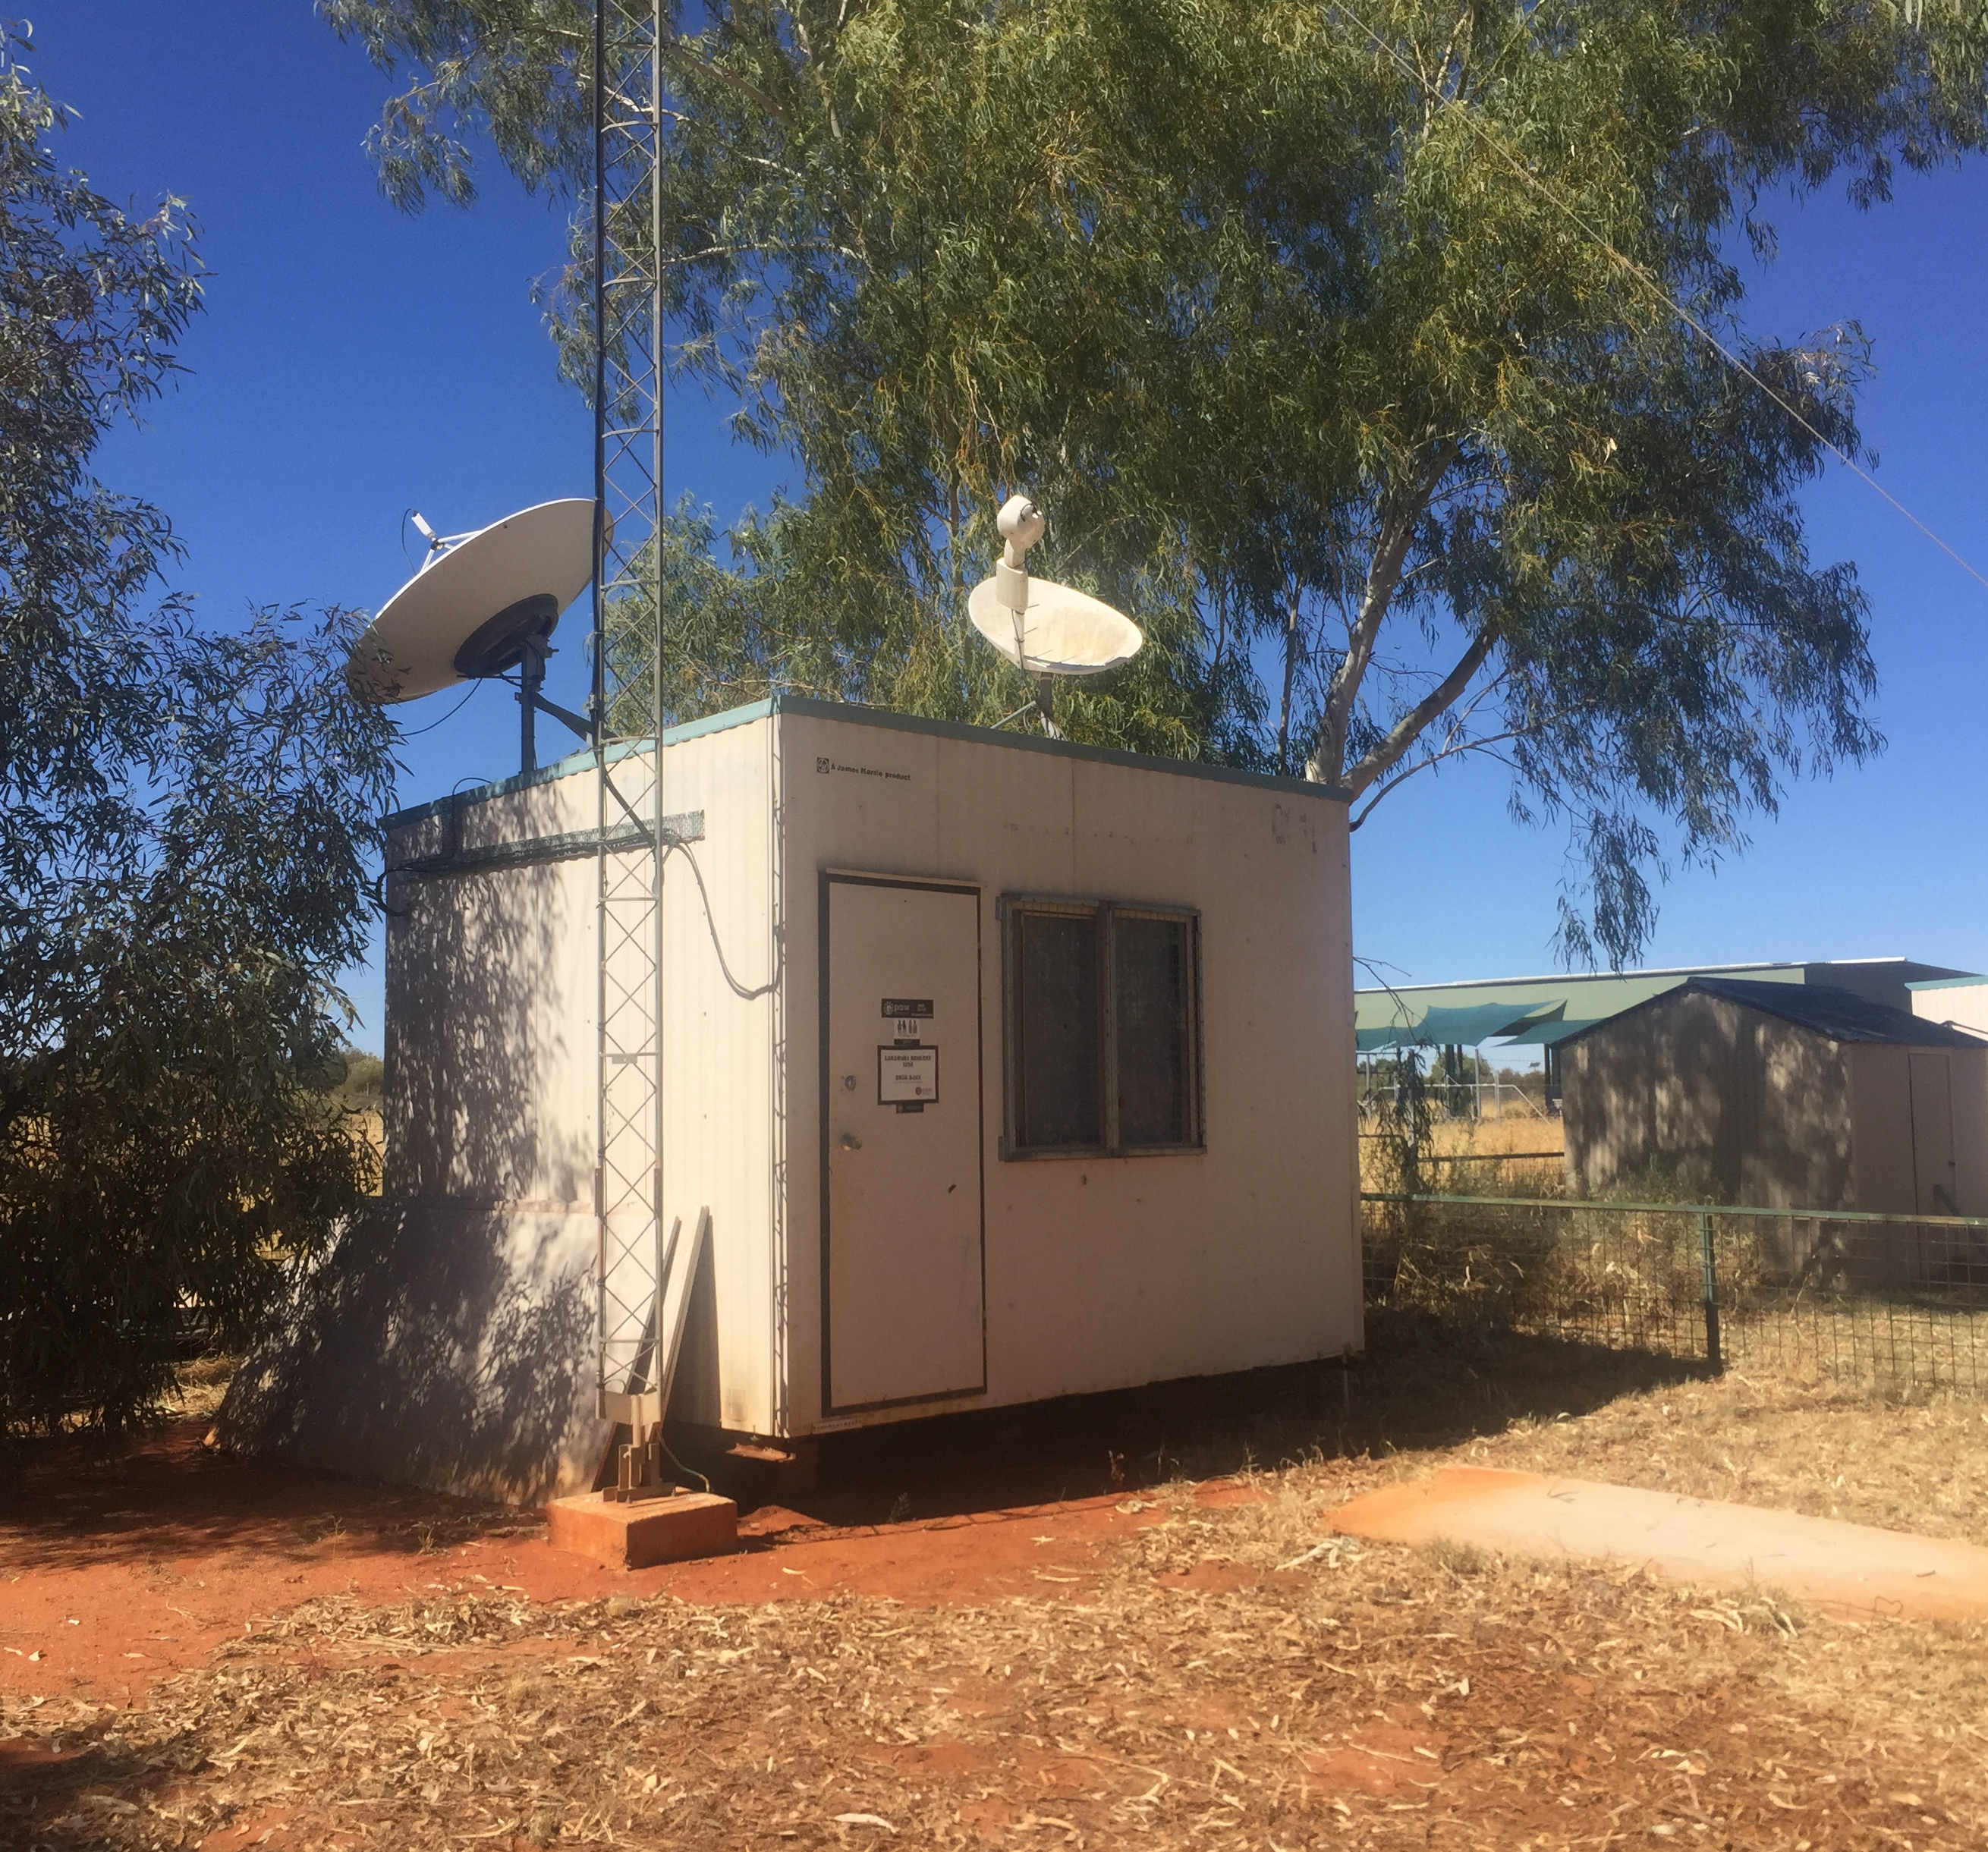
PAW operates a RIMO and services a network of RIBS. This means it provides access to broadcast content for approximately 6,000 people in remote communities in and around Yuendumu. PAW provides a means to communicate with community in a culturally appropriate way. As a result, PAW is able to achieve many of the other outcomes it achieves in other outcome themes. In addition, public interest messages are communicated effectively, and government meets the community’s broadcasting expectations.
Outcome:
- Public interest messages communicated effectively.
Because PAW is a trusted member of the community, they are in a good position to communicate public health and safety messages, which benefits listeners, the community as a whole and the Australian Government. Community members and community service providers pass messages on to PAW who broadcast them over the radio multiple times every week. PAW has also been commissioned to produce radio spots with original music about public safety issues like asbestos near the airport, which are then broadcast on radio, and advertising video infomercials incorporating Claymation about water preservation and violence.
A PAW RIBS broadcasting unit, in Laramba
The number of people who experience this value is not limited to listeners. There was a sense that a critical number of people who get information from radio then share that information with other community members, so that a majority of the community is informed about the important things that are happening. The local health centre reported that when announcements are made relating to the health centre, attendance rates significantly improved. In this way, PAW also helps Government achieve its objective of having co-operative engagement on communication of community and government priorities.
Outcome theme: Stronger communities
PAW’s activities help forge stronger communities across PAW’s network, by connecting people and fostering a sense of belonging to community.
Outcome:
- Indigenous people feel informed about issues that matter to them.
We spoke to many community members who said they like to know what is going on inside and outside of Yuendumu and that PAW provides that information in a way that is tailored to them, and that they trust. PAW collects community announcements from service providers and community members most days, ensuring the broadcast content is relevant and localised. A recent survey reported 48 per cent of listeners tune in "to hear about my own people and my community" and 62 per cent listen because of the "Indigenous focus in the news and current affairs programming". PAW broadcasts in local languages which is important, as only 18 per cent of those in Yuendumu and surrounding communities speak English at home. People spoke about the importance of knowing what Kardiya (non-Indigenous people) are doing. They trust PAW for this information above all others – PAW is the primary source of news for 47 per cent of those surveyed in Yuendumu.
This outcome is supported by the outcome of Indigenous people in remote locations having access to broadcast content. As a consequence of PAW maintaining a network of RIBS, thousands of people in isolated, remote locations have access to relevant content.
“It’s important we can hear what’s happening outside of here – the current news – in our way.
To shine a light on it.”
-Radio listener, Yuendumu
XXX
Outcome:
- Communities brought together through entertainment.
PAW runs community events that bring people together across vast distances. PAW hosts approximately four concerts or sports events (average attendance 1,500) and approximately 16 outdoor broadcasts or movie screenings per year (average attendance 200). For communities separated by vast distances, and with limited mobile and internet connectivity, these events are significant opportunities to connect and celebrate. People will travel for a weekend to attend and stay with family.
PAW is also a source of pride for people in the communities it serves. We heard from community members that as a successful Aboriginal owned and operated organisation, PAW gave them great pride. Further, we heard that the broadcast of PAW’s content in national media such as NITV and ICTV, gave the community pride and made them feel strong, knowing their cultures are being shared widely. While important, the feeling of pride and strength was expressed by a small number of people, so we have not valued these outcomes as material.
Outcome theme: Culture strengthened
PAW’s activities ensure cultures are recorded, preserved and shared in positive, accessible ways. Outcomes in this theme were seen as most valuable by community members we spoke to. They also benefit the Australian community and Government.
Outcomes:
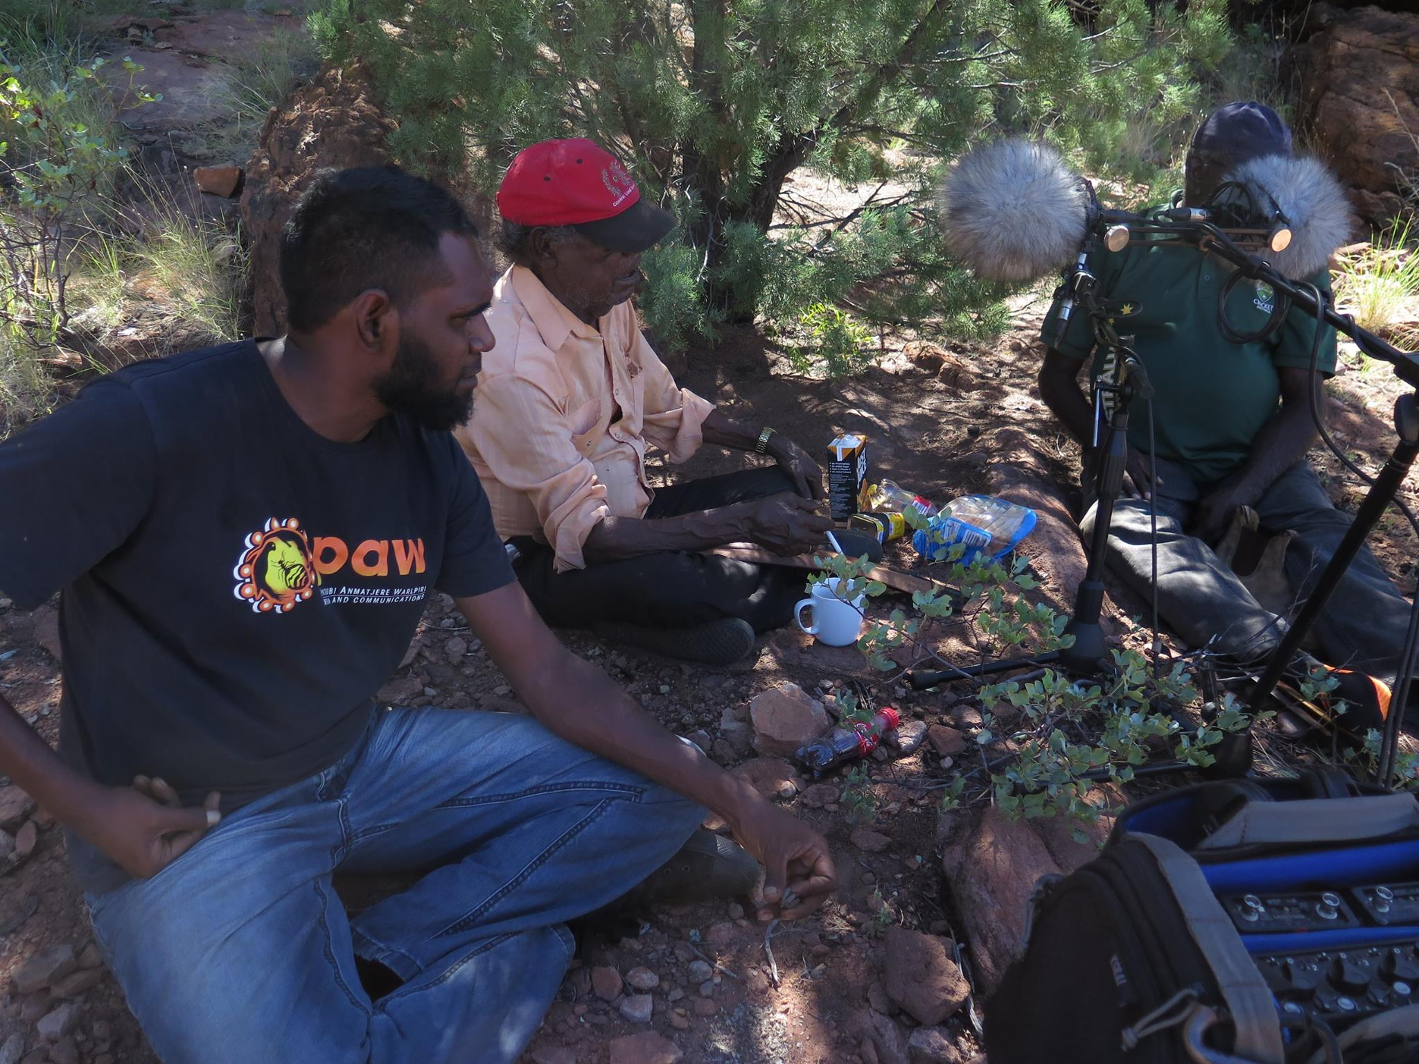
- Appropriate recording, sharing and protecting of culture;
- An extensive archive of Warlpiri items is preserved for future generations; and
- National broadcasters have more Indigenous content to broadcast.
PAW manages an archive of national significance which contains 25 years' worth of video footage and photographs chronicling the life and culture of Warlpiri people and, to a lesser extent, Pintubi and Anmatjere people. Community members highly value this asset and access it regularly. People described the importance of culture and "sacred" knowledge being preserved and stored in one place, on Warlpiri land. Researchers also access the archive to research Warlpiri culture. To better comprehend the scale and relevance of the archive:
Recording oral history on country, in Yuendumu*
- In 2009, there were an estimated 4,000 - 5,000 individual production items stored in the archive; that number is now at least 5,500;
- Approximately 10 people per week seek access to the archive to look at photographs of family members or to remember past events;
- Approximately 20 people per year consult the archive for information to support a land rights claim; and
- There are approximately 3,000 - 3,500 Warlpiri people who benefit from the preservation of Warlpiri culture.
Community members trust PAW to deal appropriately with video and photographic material that belongs to them and respect cultural protocols. For example, PAW respects that certain footage of men’s business should not be viewed by women, and vice versa. Having such a significant archive stored in Yuendumu by a trusted community controlled organisation, gives people comfort that their culture is being protected and appropriately shared.
Community members valued that the archive helped them claim culture back. Certain cultural practices have been regenerated by referring to video footage. Some equated this with the significance associated with acquiring land rights. They also described how Warlpiri cultural items had been repatriated from galleries, even from overseas.
In addition to protecting historical records, PAW generates significant new content to contribute to the archive and for broadcast by national broadcasters such as NITV and the ABC:
- PAW obtains funding to produce innovative videos capturing Jukurrpa (dreaming) in accessible ways;
- PAW has overlayed drone footage with claymation animals travelling across the country to illustrate significant Songlines, narrated by an elder; and
- PAW also captures daily life content, including sports events or celebrations.
“I get to tell stories about the early days… I put my grandfather’s song line on the map.”
- Film producer, Yuendumu

The broader Australian community also benefits from the preservation, study and promotion of history and culture. The PAW archive has been determined to be an archive of national significance, containing material of potential research value for a range of disciplines including anthropology, linguistics, sociology, media studies, history and political science. Cultural anthropologist, Kate Waters, concluded the archives are the only major collection of Warlpiri material held nationally or internationally. As a collection of Indigenous Australian media, there are few, if any, collections that match the depth of this collection in terms of the time period covered and the wide range of community activities that are represented.
Outcome:
- Indigenous people use music and video to communicate culture, positive stories and struggles
PAW also enables people in and around Yuendumu to communicate culture and struggles through music by supporting the development of musical talent and facilitating the production and sharing of music. Both musicians and listeners experience value from the common stories being shared. One community leader described the pride he feels when he hears young people singing in language.
This outcome is also supported by the outcome of Indigenous people in remote locations having access to broadcast content. As a consequence of PAW maintaining a network of RIBS, thousands of people in isolated, remote locations, can use music to communicate culture, positive stories and struggles.
"It gives me goose bumps. It is so great to see these young people doing what they are good at, especially singing in language. It’s so important because it talks about feelings, it talks about country. They are singing what's in them, so when they sing about country, they are talking about their Jukurrpa (dreaming), and all their places and that is so great. We don't hear much in English about that. They sing it because they feel it, [they think]: ‘I want to sing about this place, I want to sing about how I feel, even if I'm feeling happy or feeling sad’. They sing it because they're feeling it. This is their home.”
-Radio listener, Yuendumu
Outcome theme: Meaningful employment and participation
PAW provides employment and opportunities to participate in purposeful activities through the development of musical and media talent, which benefits both community members and Government.
Outcome:
- More Indigenous people experience meaningful, high-skilled, employment.
PAW supports people into meaningful employment by training, offering flexible working arrangements and creating work opportunities that are aligned with the interests of individuals. PAW is a culturally safe environment. There is pride associated with working for PAW; a well-regarded, community controlled, organisation. People experience fulfilment regardless of the number of hours they work per week. Indigenous employees at PAW are proud of the content and programs they produce and have a certain standing in the community. They also develop their skills on the job – in language, literacy and numeracy and in audio-visual and digital literacy skills, in what is a highly technical industry. Technical skills development will also be extended to the community, with plans in place to hold digital literacy classes.
Outcomes:
- Decreased drinking and substance abuse; and
- Decreased welfare dependence.
A smaller number of employees expressed more significant benefits of employment. Employees stated that by working with PAW in Yuendumu, they could avoid going to work in Alice Springs which they said has associated alcohol and drug challenges. They also expressed that they valued the financial independence that came with having a job, and that without the job, they would be relying on welfare.
Outcome:
- Increased skills through mentoring in a professional studio.
PAW fosters the significant musical talent of the community of Yuendumu and local communities. Musicians are mostly self-taught and are assisted by PAW through mentorship and access to resources including a rehearsing and recording space. PAW fosters a vibrant music scene by providing opportunities for musicians to perform at community concerts, play their songs on air and be featured on a CD which PAW produces.
Outcome:
- Increased fulfilment, confidence and pride.
There is pride associated with being a musician or artist. Involvement in the music and media industries represents an opportunity to pursue a positive pathway for musicians and artists, many of whom are young men. One young man had recently moved to the area and so was not yet aware of the services offered by PAW. He was clearly proud as he used his phone to play us some of the music he had recorded using free online tools. He said he was saving up to pay the $500 needed to record his music in a studio in Alice Springs. He was excited to learn that he could use the studio in Yuendumu for free and to then be invited by PAW to have a go at broadcasting.

4.3 Umeewarra
Umeewarra operates in Port Augusta and broadcasts to a large Indigenous population (~4,700) on a small annual budget (~$380,000 per annum). Port Augusta is home to a community of more than 30 language groups, it has a history of racism and in recent years it has seen a significant reduction in Aboriginal community controlled organisations. Despite having limited resources, Umeewarra acts as the heart of the community and is a safe place where Aboriginal people feel they belong, and where culture is kept alive.
Umeewarra has earned the trust of the community by being responsive to its specific needs over many years. Through that trust, Umeewarra effectively disseminates relevant information and supports the achievement of education outcomes, grief support, access to social services, increased participation in decision making and ultimately community resilience.
The unique logic model for Umeewarra is presented in Appendix 3. It highlights that many of the outcomes achieved by Umeewarra are similar to those achieved by other IBSs, as represented in the sector logic model, and presents a number of outcomes distinct to Umeewarra. The story behind these outcomes is presented below, by outcome theme. Note that only the most material outcomes are described.
Outcome theme: Communication
By providing a communication platform, Umeewarra connects with the community of Port Augusta and surrounds in a culturally appropriate way, and listeners feel informed about issues that matter to them.
Outcome:
Getting ready to go to air at Umeewarra Radio*
- Increased awareness of public health and safety messaging.
Umeewarra radio is an effective vehicle for delivering public health and safety messaging and as a consequence, there are higher rates of engagement by Indigenous people in non-Indigenous social services. More than 100 community messages are shared over the radio every month. Umeewarra has recently been commissioned to deliver a Trachoma campaign for the SA Government's Health Department.
Outcome theme: Stronger Communities
Umeewarra’s activities help forge a stronger Aboriginal community in Port Augusta and surrounds, provides a safe place where people belong, supports people through grief and enables people to better advocate for things that matter to them.
Outcome:
- Aboriginal people have a strong, safe place where they belong; and
- Non-Aboriginal service providers can offer more appropriate services.
Umeewarra creates a space where people feel they belong, both on air, and at their studios. Umeewarra was described by many community members as "home", because it is a welcoming and supportive space that is made available to community. Umeewarra is located in a building that was previously the Aboriginal community centre and before that, the workers club. The community has for a long time seen the place as somewhere they can meet, be welcomed, feel safe and access support. Umeewarra is highly responsive to the specific needs of the community (for example, providing an information service and supporting people through grief). Numerous people expressed serious concern around how the community would function without Umeewarra and predicted that if Umeewarra was shut down, it would be like ripping the heart, or the soul, out of the community. This fear was likely a response to the declining number of Aboriginal community controlled organisations in Port Augusta. In the 1980's, Port Augusta had at least 10 such organisations, but after years of funding challenges, there are now only two.
“It (radio) is a huge part of people's day - it connects them. Especially people who aren't mobile. You have conversations over the table after listening to the radio"
-Aboriginal community member and listener, Port Augusta
“People don’t just see it as a radio station. It’s like the heart of the community – like a home for people… It gives people a sense of belonging.”
- Non-Aboriginal community member and listener, Port Augusta

Umeewarra provides a culturally safe place for community meetings and the community benefits from the positive outcomes that flow from those meetings. Umeewarra has a meeting room available for hire which is booked an average of 10 days per month by key organisations in the community. By providing a culturally safe environment, Umeewarra facilitates the participation of Aboriginal community members in important conversations. Service providers told us this is the only space in which they can hold community meetings because no other organisation is trusted by the community.
In some cases, Umeewarra initiates meetings itself, which have led to better collaboration between service providers. Due to Umeewarra's awareness of the local services ecosystem, it identified that organisations delivering services to victims of domestic and family violence were not working together. Umeewarra convened a meeting between approximately 20 providers. Community members, government, and service providers all benefit from these meetings leading to better service delivery and collaboration between service providers. Umeewarra staff also act as mediators when disagreements arise between families and between the Aboriginal community and the non-Aboriginal community.
Outcome:
- Aboriginal people access support from a trusted source.
Community members also use Umeewarra as an information and connection service because Umeewarra is so well integrated with the community. Approximately 60 people drop in to Umeewarra every month for assistance on a wide range of things including seeking information on where to get financial assistance for hardship, how to enrol to vote or complete the census, mediation services, native title assistance, assistance filling in forms or assistance with court issues. In meeting this demand, Umeewarra connects people to services in Port Augusta, which improves access to services. Significantly, Umeewarra is the organisation that members of the Stolen Generation trust when seeking assistance in finding lost family members, as Umeewarra is so well connected to the community, and there is nowhere else to go.
Outcome:
- Aboriginal people are supported through grief.
Umeewarra also supports the community through grief. This work is done outside of normal working hours, on volunteer time, as Umeewarra’s staff are the friends and family of the community. When someone in the community passes away, family members go to Umeewarra to tell the story of the person's life and have it recorded in a eulogy card. Umeewarra collates stories and photographs of the deceased and prepares eulogy cards for the funeral. Cultural practices mean people are limited in how much they can speak about a person who has passed away and so eulogy cards are a special way of remembering a person. Umeewarra produces eulogy cards on average five times per month and supports approximately two thirds of Aboriginal funerals in Port Augusta.
Outcome:
- Aboriginal people feel informed about issues that matter to them.
Listeners told us they value having a news source they trust. People feel like the news has been filtered such that it is relevant and accessible to them. In addition to national and local news items, Umeewarra announces community relevant information such as funeral announcements, local events and job opportunities. Umeewarra is also a trusted, accessible medium through which public safety and emergency messages are effectively communicated. Umeewarra makes approximately 100 community announcements per month. The number of people who experience this value is not limited to listeners. A critical number of people getting their news from radio then share news with other community members so that a majority of the community is informed about the important things that are happening.
“The information we’re getting has already been filtered. It’s the
information we need to know about”
- Davenport community leader and radio listener
- Source

Outcome:
- Aboriginal people feel better able to advocate for things that matter to them.
By informing the community about what matters, Umeewarra also helps the community to better advocate for things that matter to them. People feel comfortable knowing that if there is an issue that will affect the rights of Aboriginal people, Umeewarra radio will arm them with the information they need to have an informed view. One community leader reported learning about the proposed cashless welfare card through Umeewarra and being able to then have an informed conversation with the Port Augusta Mayor on the subject.
Umeewarra also facilitates the community's advocacy efforts in a meaningful and constructive way. When Clinton Pryor passed through Port Augusta as part of his Walk for Justice from Perth to Canberra, in order to bring Indigenous and non-Indigenous Australians together, Umeewarra facilitated the peaceful closing of the Port Augusta Bridge so that supporters could walk with Clinton.
Outcome theme: Culture Strengthened
Umeewarra’s activities ensure Aboriginal people have more opportunity to access culture and help develop the cultural understanding of the non-Aboriginal community.
Outcome:
- Aboriginal people use music and story-telling to communicate culture, positive stories and the true story.
Umeewarra facilitates the sharing of stories and culture through music and interviews with Aboriginal people. People explained that they value being able to switch on the radio and access their culture and their community. People value being able to share positive stories about people with whom they identify, particularly as the mainstream media largely portrays a negative view of Aboriginal people. Umeewarra celebrates positive, real stories about successful Aboriginal people. People explained that hearing other community members share their stories helped them relate better to that person, be proud of that person or appreciate that they are not the only one experiencing a particular challenge or injustice.
It validates your own stories… It makes you know you’re not alone and that makes you feel empowered.”
-Traditional Owner and radio listener, Port Augusta

Outcome:
- Aboriginal people have more opportunities to access culture.
In addition to the outcome of people using music and story-telling to communicate culture, Umeewarra provides opportunities for community members to come together and participate in events that celebrate culture. For example, Umeewarra is involved in a full week of NAIDOC events every year, which it broadcasts live on-location. During the week, Umeewarra facilitates traditional cookouts, dancing, games for kids, bush tucker tastings, art activities, walks and discussions in line with the theme at the time. The 2017 theme was Our Languages Matter, so Umeewarra ran tours where eight different language groups taught participants some words in language.
Outcome:
- Non-Aboriginal people have increased understanding and appreciation of Aboriginal cultures.
The Aboriginal community in Port Augusta benefits from non-Aboriginal people having an increased understanding and appreciation of Aboriginal cultures, resulting in reduced racism. Umeewarra supports an increased understanding and appreciation of culture by sharing knowledge, as outlined above, and by having a presence at most large community events.
Umeewarra takes its van to community events which helps make Aboriginal people feel welcome at those events and helps non-Aboriginal people to develop positive associations with Aboriginal culture. Umeewarra also educates mainstream service providers and interested people by displaying educational poster boards and by facilitating discussion about Aboriginal history and issues that matter to Aboriginal people.
Umeewarra radio is an accessible way for non-Aboriginal people to learn more about the Aboriginal community and hear positive stories about Aboriginal people. Umeewarra radio is regularly played in the Port Augusta main street and in stores. This is particularly important given the history of racial tension in Port Augusta, which has been highlighted in section 2.3.
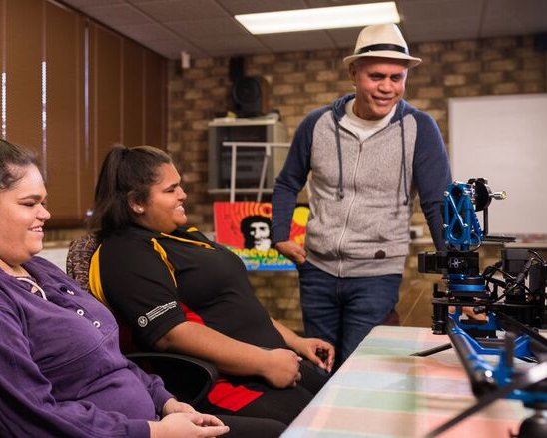
Outcome theme: Meaningful employment and participation
Umeewarra provides a small number of employment opportunities, numerous training opportunities and plays a strong role in facilitating employment of the Aboriginal population of Port Augusta.
Outcome:
- Meaningful, high-skilled training and employment in the media industry; and
- More Aboriginal people engaged in training and job application processes in Port Augusta.
Umeewarra currently provides direct employment opportunities for five people and a number of training opportunities in the form of internships. The opportunities are significant. While there are other employment opportunities in Port Augusta, very few are so culturally-aligned, in part due to the scarcity of Aboriginal community controlled organisations. After consultations, we estimate that four of the five employees would have left Port Augusta if they could not work at Umeewarra. We have included in this number non-Aboriginal employees, who are instrumental in Umeewarra achieving its outcomes. One non-Aboriginal employee said that it was very difficult finding a job before securing the role at Umeewarra.
Volunteer training session in media skills,
at Umeewarra
Umeewarra also assists people into employment with other organisations. Assistance includes advertising job opportunities on the radio, helping people to prepare resumes and job applications, receiving resumes and job applications and forwarding them to employees and providing a safe space in which job readiness training providers run their training sessions and employees hold interviews. Approximately 80 per cent of all the Aboriginal people employed in Port Augusta (310 per year) are assisted in the employment process in some way by Umeewarra. Approximately 25 people per month visit Umeewarra for employment-related support from Umeewarra staff or volunteers. Others visit Umeewarra to attend interviews or training sessions with potential employers or external employment support providers.
Outcome:
- Staff, board members and young people develop skills.
Umeewarra also offers opportunities for people to develop their skills in other areas. These include leadership skills (by sitting on the board); workplace skills (through work experience), media skills; technology skills; cultural skills in the workplace (through volunteering and work experience). Because people feel more comfortable in the Umeewarra environment, it is conducive to trying new things and learning. In addition, while the technology involved in radio is technical, the basics can be taught relatively quickly. This means young people can "have a go", and get on radio, which we heard results in increased pride in being an Aboriginal person, and increased confidence.
“I remember my first show. It was really hard for me to talk, I was mumbling.
I started to get better at public speaking”
-Young radio broadcaster

4.4 GIS
GIS is supporting the healing journey of the Indigenous community. GIS has 256,000 monthly listeners, 46,000 of whom are Indigenous. It is a geographically and culturally diverse community with many Indigenous community members and listeners having been disconnected from culture. Despite the fractured state of the community, GIS facilitates connection to culture. GIS is supporting the community to build a collective identity through a vibrant music scene, positive stories about Indigenous people, and coverage of topical, relevant issues.
In aid of the healing journey, GIS is making significant progress towards reconciliation. On 26 January – a day that has proved increasingly divisive in the Australian community – GIS brings together 15,000 Indigenous and 20,000 non-Indigenous Australians to celebrate Indigenous culture at the Yabun Festival.
The unique logic model for GIS is presented in Appendix 4. It highlights that many of the outcomes achieved by GIS are similar to those achieved by other IBSs, as represented in the sector logic model and presents a number of outcomes distinct to GIS. The story behind these outcomes is presented below, by outcome theme.
Outcome theme: Communication
GIS effectively communicates to a very large listener base in a culturally appropriate way. As a result, GIS is able to achieve many of the other outcomes it achieves in other outcome themes. In addition, public interest messages are communicated effectively, and government meets the needs and expectations of community.
Outcome theme: Stronger Communities
By providing information, music and opportunities to celebrate, GIS helps connect people and build greater community identity, belonging and resilience. People can feel part of a supportive community of people and services which facilitates the healing journey.
Outcome:
- People feel informed about issues that matter to them.
GIS produces content that is curated and relevant to its community. Listeners told us that the content available on Koori radio is not available anywhere else. It is valuable to listeners because they trust they are being made aware of any big issues that might affect them or their community. Listeners also value that the content does not include negative stereotypes about Indigenous people and it tells the true story, not the rhetoric that listeners say they hear in mainstream media. Community members value being able to connect through different mediums, such as the Koori Radio facebook page, where the community engage around important events, such as Clinton Pryor visiting Redfern in August 2017.
“Where else do our children get truth? Where they’re not being fed the rhetoric…
It’s not negative – it gives them reassurance that anything is possible”
- Founder of GIS

Outcome
- Indigenous people can come together to celebrate being Indigenous.
GIS provides opportunities for Indigenous people to come together as a community. It holds the largest one day celebration of Indigenous culture in Australia, the Yabun festival, and holds other events through its Klub Koori program. GIS events are well attended due to the trust the community has in GIS. GIS was invited to host the 50th anniversary of the 1967 referendum because GIS has the skills and capacity to run important events and is able to attract community leaders.
“The 50th Anniversary dinner was just so great. Everyone was there and it was so positive. We don’t get many opportunities to celebrate what our parents and grandparents have achieved.”
- Community member and listener

There is huge value in holding events at which being Indigenous is celebrated as a positive, to counter the negative rhetoric and racism that people face each day. GIS staff and regular volunteers are visible in the community, including at entertainment events or important meetings. This physical presence encourages Indigenous people to feel welcome at events. GIS promotes Indigenous community events such as art exhibitions, events at Redfern Community Centre and film screenings.
Outcome:
- The community has a voice.
GIS provides a medium for advocates in the Indigenous community. The Black Chat program plays an important role challenging and questioning politicians and community leaders. This is especially important for the Sydney Indigenous community as it unites them around common issues. The community is made up of Indigenous people from many nations, many of whom have been disconnected from culture through the stolen generation and dispossession. While culturally diverse, political issues are common across Indigenous groups and so it is important for the community to have a trusted advocate through which they can feel represented and informed.
Outcome:
- Indigenous people access support from a trusted source.
GIS is situated in the heart of Redfern. Redfern is a meeting place; it is home to numerous Indigenous services and has a long history of being a central point for the Indigenous community of NSW. GIS supports and cultivates that community. It has strong relationships with other Indigenous service providers in Redfern and works collaboratively with them to achieve outcomes for individuals. GIS is sufficiently connected to the community that community members expect GIS staff to know what is happening and who they could be referred to for more help. GIS staff are regularly asked for assistance by community members. GIS facilitates community cohesion. In addition to the services that operate in Redfern, GIS has developed a network of community members to whom people can be referred for opportunities or support on a wide range of things.
"Gadigal is a safe space - anyone can come in and participate in programs. There can be lots of intergenerational conflict in other organisations but this is neutral.”
- Koori radio presenter

Outcome theme: Culture Strengthened
GIS plays an important role in supporting a healing journey for the Indigenous people of Sydney. GIS helps people connect to traditional and contemporary culture in a safe and accessible way, many of whom have been disconnected from culture through dislocation or disadvantage. GIS also encourages reconciliation by providing opportunities for non-Indigenous people to learn about and celebrate Indigenous cultures.

Outcome:
- Appropriate recording, sharing and protecting of culture.
Despite the diversity of Indigenous culture represented in the GIS community, GIS offers a vehicle through which culture can be captured and shared and readily accessible whenever a community member chooses to engage with it. GIS has created a safe space where all language groups and families are welcome. The recording studio is impressive and has been specially designed to capture the sounds produced by Indigenous instruments. GIS has also earned the trust of the community so the community feels confident sharing stories with GIS, and stories that are shared there are more likely to be listened to. This content is culturally affirming.
One example of culture being captured is 99 stories. 99 stories, an initiative of GIS, City of Sydney and the Blacktown City Council, is engaging Sydney’s Aboriginal and Torres Strait Islander communities to record and document 99 stories of Aboriginal and Torres Strait Islander experience. The 99 Stories archive will provide a valuable and much needed resource for Indigenous communities, young people, educators and historians, helping to preserve the knowledge of elders for generations to come.
Outcome:
- Indigenous peoples use music to communicate culture, positive stories and struggles.
GIS plays a major role in ensuring there is a vibrant Indigenous music scene in Australia. GIS promotes artists through interviews, discussing them and playing their music on air and on their website. GIS supports the development of musical talent, and facilitates music production in its studio. GIS enables people in Sydney and around Australia to communicate culture, strength and struggles through music. Aboriginal cultures have always used music to communicate and the Indigenous music scene continues to play that role, communicating in a traditional way and also helping to develop contemporary use and interpretations of culture.
One community leader observed that music and humour is common across many Aboriginal and Torres Strait Islander cultures. Many of the values, behaviours, rhythms and patterns are the same and regardless of which culture a person identifies with, those elements provide familiarity.
“Music is the universal language. There are similar rhythms and patterns across cultures. And humour.”
- Community member and listener
Outcome:
- Non-Indigenous minority communities have an increased sense of belonging.
Disenfranchised individuals such as young urban disadvantaged people and people from minority communities such as minority cultural groups or the LGBTI community are drawn to GIS. This could be due to its capacity to build community amongst people from many different cultures. GIS staff described GIS' approach as embracing "our brown brothers and sisters". Others explained that embracing these other cultures added to the richness of the culture and the story that is being told.
Koori radio’s programming includes slots for non-Indigenous shows including Tangata Whenua, Bollywood Beats, Talking Africa, Puha and Pork Bones, Fijian show, Reggae show, Pacific Sounds, Listening in Colour, African Rhythms, Sheba caravan of worldbeats, Samoan Dreaming and Bollywood Border Crossing.
Outcome:
- Non-Indigenous people have increased understanding and appreciation of Indigenous culture.
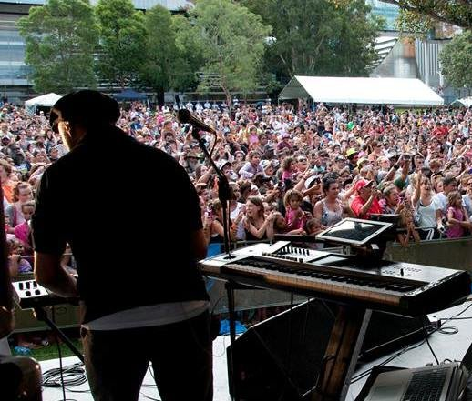
GIS’ events and radio programming enable non-Indigenous people to learn more about, and pay respect to, Indigenous cultures and to stand in solidarity with Indigenous people in a positive and respectful way. The Yabun festival welcomes people from all cultures and provides an opportunity for non-Indigenous Australians to experience the generosity with which Indigenous people are willing to teach, and share their culture despite generations of discrimination. The Yabun Festival continues in the tradition of Aboriginal ‘Survival Day’ gatherings. The event is held on 26 January to coincide with ‘Australia Day’ and so seeks to commemorate, bring attention to, and celebrate the survival of Australia’s Indigenous cultures in the face of European invasion.
Local Indigenous musicians playing to crowds at the Yabun festival, Sydney*
Non-Indigenous people are also able to learn about Indigenous culture by listening to Koori radio. While it might not be their primary reason for listening, when a person listens every month, their exposure to culture, values, positive stories and community would result in increased understanding and appreciation of Indigenous culture. We have not valued this change for non-Indigenous listeners as it is difficult to establish attribution to GIS, but we recognise that non-Indigenous listeners do experience value.
GIS also responds to requests from non-Indigenous members of the public relating to cultural issues. For example, businesses might ask about the correct wording to include in a plaque acknowledging country. GIS reported that these requests occur most days and in responding to these requests, GIS provides the wider community with a cultural sensitivity sounding board. Whilst important to acknowledge, we have not valued this outcome.
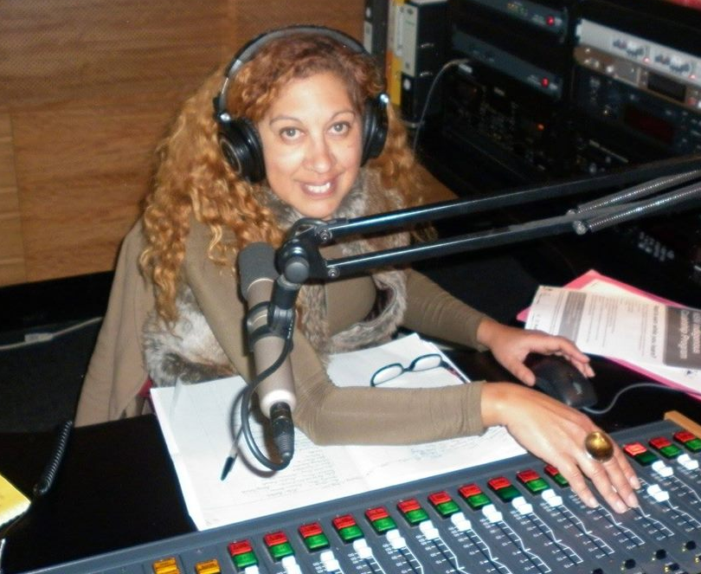
Outcome theme: Meaningful employment and participation
GIS provides employment and volunteer opportunities and significant support to approximately 200 artists per year. The support from GIS is fundamental to ensuring there is a vibrant music scene.

Outcome:
- More Indigenous people experience meaningful, high-skilled, employment and volunteer opportunities.
GIS supports people into meaningful employment by training, offering flexible working arrangements and creating work opportunities that are aligned with the interests of individuals. GIS is a culturally safe environment. GIS provides valuable training that enables employees to develop in their current role or to go on to roles in mainstream settings feeling more confident in their ability to "walk in both worlds" or in the case of non-Indigenous staff, to play a valuable role in an Indigenous organisation.
Broadcaster on air with Koori Radio
GIS employees feel pride and responsibility in their work as they are a vital part of the fabric of the community. Community members expect employees to be holders of information and to represent the interests of the community in the work that they do.
Outcome:
- More Indigenous people have skills through mentoring, training and experience.
GIS provides intensive support to emerging artists. The Young, Black and Deadly program provides comprehensive mentorship, training, exposure to a network of supportive artists, studio time, music production and marketing of the artist’s music. Participants are supported to write and produce music through recording workshops, and develop their brand. Participants perform to thousands of people at the Yabun festival.
Outcome:
- Indigenous people are supported to participate in the music industry.
GIS helps foster a vibrant, welcoming music scene where musicians are encouraged to participate. GIS supports any Aboriginal or Torres Strait Islander artist who requests support in a range of ways including by ensuring there is a safe place for musicians to come and record their music in a high-quality studio. Specific support is given to GIS music participants, Young, Black and Deadly participants and Klub Koori artists to help them succeed and have their talents recognised. Support might include referring them on to events, writing support letters, negotiating reduced rates for studio hire and offering general advice. GIS provides support to approximately 200 artists a year.
GIS raises the profile of Indigenous artists by playing their music on air, interviewing them on air and introducing them to other artists to foster a supportive community of artists. GIS supports artists to secure performing opportunities by first enabling them to perform at Yabun or Club Koori events and then recommending them to other festivals. Artists earn royalties when GIS plays their music on air. Every year, approximately five musicians go on to produce their own albums, perform at larger mainstream festivals like Splendour in the Grass, or achieve economic success in the music industry as a consequence of direct support from GIS.

5 The Value of Impact

5.1 Method for estimating the extent and value of impact
The sections above described how IBSs achieve outcomes and impact. The next phase of the SROI analysis is to estimate the extent and value of that impact.
Stakeholders
Estimating the extent of impact requires consideration of which stakeholder group is likely to experience each outcome and how many stakeholders are likely to experience those outcomes. McNair Ingenuity recently completed surveys of radio listeners which provided information as to the number of people who listen to radio and why they listen to radio. The IBSs hold records of staff and volunteer numbers as well as attendance numbers at events. This information, combined with stakeholder consultation, informed estimates of the number of stakeholders likely to experience each material outcome.
Some common stakeholder groups emerged for all IBSs: the listeners and participating community members, employees and Government. In addition, one or two of the IBSs achieved outcomes for Indigenous musicians and artists, the Australian community, other IBSs and employees of other organisations. Further information about stakeholders is included in the Methodological Attachment.
Material outcomes
The next step in estimating the extent and value of impact is to identify material outcomes. The logic models describe how the strategic response and the activities that an IBS undertakes lead to outcomes for stakeholders. Some outcomes are experienced by many stakeholders, and without the achievement of these outcomes, the IBS is unlikely to achieve impact. There are some outcomes that fewer stakeholders will experience, but which are still significant for those stakeholders. These factors are all taken into account to determine which outcomes are the most representative of the impact on stakeholders. Those outcomes are the material outcomes and they are the outcomes that are valued.
Many of the outcomes in the logic models are interrelated although there is not a direct and linear causal relationship between each outcome. Care was taken when defining and selecting material outcomes to select mutually exclusive and collectively exhaustive outcomes so that when the outcomes are valued, there is no double-counting. The same stakeholder will not be deemed to have experienced value from two outcomes where the second outcome actually represents a culmination of the first outcome.
Section 4 of this report explains that some outcomes in the logic models represent a change for the stakeholder but many represent a maintenance of the status quo. It also explains that outcomes towards the bottom left of the logic model are foundational outcomes. When the foundational outcomes are experienced by stakeholders, the IBSs’ activities are more likely to result in the more aspirational outcomes towards the top right of the logic model. Outcomes identified as material outcomes tended to be the more foundational outcomes, which are experienced by a larger number of stakeholders.
Material outcomes were selected from all four outcome themes. Some outcomes were common across all IBSs while others were specific to the particular experience of stakeholders in a community.
Indicators
Once the material outcomes experienced by each stakeholder group has been identified, the extent of each outcome must be estimated. This is done by determining an appropriate indicator of scale for each outcome then collecting data to establish the scale. This required a collection of data to inform the number of:
- People falling within each stakeholder group;
- People who listen to radio for music, news content or for information about their own community;
- Employees and volunteers and the hours they work;
- Attendees at events held by IBSs;
- Funding opportunities available to IBSs for sponsorship and commissioned work;
- Bands supported by IBSs including using recording studios;
- Cultural items preserved;
- Community members who seek advice from IBSs; and
- Funerals for which Umeewarra provides eulogy cards.
As the numbers of listeners were large, and their experiences varied, it was not possible to count individuals for whom outcomes had or had not occurred. Instead, basic threshold assumptions were used around the level of engagement required to experience the material outcomes. Two important thresholds used were:
- Listeners were only deemed to experience value if they listen to radio at least monthly; and
- Employees experienced value if they were working at least the number of hours they wished to work, even if that number did not constitute full-time work.
Valuation
Once the extent of change has been estimated, an assessment was required of how valuable each outcome is to each stakeholder group. A combination of different techniques was used to inform an estimate of value:
- Stakeholders described some outcomes as being most important to them, which suggests that relative to other outcomes, this outcome is most valuable to that stakeholder. This is called the relative importance assessment;
- Some stakeholders described how much they would pay to achieve the same, or a similar outcome. This is called a stated preference; and
- Some outcomes were assessed as being valuable after analysing other quantitative data and research about the relevant community that reveal the value of an outcome. This is called a revealed preference.
Financial proxies approximate the value of the outcome from the stakeholder’s point of view and can be used to value all material outcomes. Some outcomes have a commonly agreed valuation technique that may use cash transactions or resource reallocations to value the outcome. However, in this analysis, even if outcomes do not currently have a commonly understood market value, we valued the outcome. This is in line with the Social Value principle of Valuing What Matters.
Care was taken when selecting financial proxies to identify values that reflect the true value of the outcome. For example, often disadvantaged cohorts pay less for services either because those services are subsidised, or because they are paying for a sub-standard service, so the amount of money that cohort spends on services does not account for the full value of the service. Therefore, we need to look at other market values, such as those used by mainstream Australia, to approximate the value of the outcome.
“We’ve repatriated our culture. It’s so important, it’s like getting land rights back”
Community leader, Yuendumu
Finally, valuation filters are applied to the outcomes to ensure that the analysis is not over claiming. An explanation of each SROI filter assumption category – Deadweight, Attribution, Displacement, Duration and Drop-off – is described in the Methodological Attachment.
The value the IBS creates is calculated by estimating the forecast value of each material outcome and is set out in section 6.

5.2 Applying the method
The Methodological Attachment describes the material outcomes and the corresponding indicators, financial proxies, valuation filters and the relative, associated values for the three IBSs analysed.
Included below is a selection of examples from the Stronger Communities outcomes domain that demonstrate how the method set out above has been applied. The outcomes selected include an example from each IBS.
People feel more informed about issues that matter to them
In all three communities, community members described the importance of being able to access information that is relevant to them, from a trusted source. Stakeholder interviews, IBS records and the McNair survey were used to establish the number of Indigenous people who feel more informed about issues that matter to them as a consequence of Indigenous broadcasting. The McNair survey established the number of people who listen to radio regularly and the proportion of that group who listen to radio for news or for Indigenous or local focus in news content.
In Yuendumu, stakeholders explained that they wanted to know what was happening in the rest of Australia, but they wanted to hear it from people they know. The importance of being informed about issues that matter to them was highlighted when people explained that it is difficult for them to access the information anywhere else. Interviewees explained that mainstream media is not sufficiently localised, it contains negative stereotypes of Indigenous people and it is not in Indigenous languages. It was also established that listener’s need for information might be greater than for the average Australian due to feelings of being isolated, disempowered and disenfranchised. Many listeners cannot access other forms of media because their communities do not have mobile phone or internet coverage.
The financial proxy used to value being informed about issues that matter to you is an annual subscription to Koori mail. The Koori mail contains news that is relevant to Indigenous people and does not contain negative stereotypes.
Two additional financial proxies were used for PAW to account for the news content being particularly tailored to the needs of the community and accessible by listeners in remote locations. The proxy of the annual salary of a translator was used to reflect the value of content being broadcast in language. The proxy of the cost of a mobile phone contract with a data plan was used as a proxy for having access to content.
Aboriginal people access support from a trusted source
GIS and Umeewarra respond to a wide range of requests from community members for support and information. Understanding the scale of the outcome was a matter of estimating the number of times in a year request is sought of the IBS. Establishing an appropriate financial proxy for each location required consideration of the types of services offered. In Umeewarra, community members request support on important, sensitive and complex matters such as a request for assistance from a person with limited English language skills to resolve a dispute with a telephone company over a substantial and incorrect telephone bill. The type of support given by GIS is generally less sensitive and complex and might include referral advice which GIS staff are able to provide due to the collaborative relationship service providers in Redfern have, including GIS.
The nature of the outcome is the same for GIS and Umeewarra but the intensity of the support, and consequently the value of the service for each recipient, is greater in Umeewarra. The proxy used to account for this value was the non-subsidised cost of a doctor’s visit. The financial proxy used for Umeewarra was the cost of a long consultation at a doctor’s surgery in Port Augusta ($95). The financial proxy used for GIS was the cost of a short consultation at a doctor’s surgery in Redfern ($60).
Indigenous people can come together to celebrate being Indigenous
In Sydney, Indigenous community members described how the Yabun festival is their favourite day of the year and how Klub Koori events were not just about the music, they were also a place where attendees see people they know and feel welcome. This is despite living in a community where they are part of a minority cultural group and often experience racism and barriers to opportunities. People feel a sense of belonging and pride in being Indigenous by attending these events.
The communities in Yuendumu and surrounding areas are geographically isolated. Despite this, people travel to Yuendumu to attend sports weekends or concerts held by PAW. These events represent an important opportunity to have family all in one place around positive events. The events strengthen community cohesion and resilience.
Despite Yuendumu and Sydney being vastly different places, the value stakeholders experience from attending the respective events was deemed to be equivalent. The indicator used to measure the scale of the outcome is the number of people who attend events. The financial proxy used to account for this value is the cost of attending a footy match. Football offers entertainment, but also an opportunity to come together with family and friends, to feel part of a group and to experience pride in supporting your team. This financial proxy is relevant to the Indigenous community because footy is widely supported by the Indigenous community and the value has been determined by the entire Australian public, so is a fair reflection of the “market” value of the outcome.
Aboriginal people have a strong, safe place where they belong
Umeewarra provides a building where Indigenous people feel safe. As a consequence, Umeewarra is able to host important community meetings, training sessions and support services. To understand the significance of this outcome, stakeholder consultation was conducted. Community members articulated the importance of having the space by saying it was like a home. The indicator for the outcome was binary, either the space existed or it did not. In determining an appropriate financial proxy, there were two components of the outcome that needed to be valued:
- First, the financial proxy must account for the value of having a space available for use whenever it is needed. The financial proxy is the cost of renting a meeting room at the market rate in Port Augusta and applying that daily rate across the year; and
- Second, the financial proxy must recognise the importance of the space being welcoming and culturally affirming. The financial proxy used to account for that value is the cost of paying a traditional owner to perform a welcome to country. That cost was taken from the Sydney Metropolitan Local Aboriginal Land Council because in Sydney there is an established market for the service, so the price reflects an amount people are frequently willing to pay for the service.

6 Social Return on Investment

6.1 Sector overview
An SROI ratio is generated by comparing the total adjusted value of the outcomes experienced by stakeholders to the investment required to create that value.
In each of the three cases analysed, the investment is forecast to achieve significant returns with an average across the three broadcasters of $2.87 for every dollar invested.
Limitations of SROI
While the breadth and depth of the consultation process provides a compelling picture of the impact of the IBSs, it is important to consider the limitations of the SROI analyses. The limitations of this project included the following:
- The SROI ratio is one part of telling a story that is unique to the particular organisation and should be viewed in that context, taking into account the community, stakeholders, activities and outcomes that are also important parts of the story;
- Different broadcasters run different operations in response to the different communities they are servicing. While attempts were made to use comparable indicators and proxies, it was often not appropriate and so readers should be careful not to compare ratios; and
- Although listener numbers impact the SROI ratio, it was not practical to undertake extensive research into the number of people who listen to radio. We relied on recent research into listener numbers conducted by McNair Ingenuity for PAW and GIS. We also relied on ABS census data on Indigenous population numbers for all three locations. Port Augusta residents and leaders estimate that the population is significantly higher (around 7,500) than ABS census results indicate (2,513). For the purposes of this analysis, we conservatively used the ABSs population figure but we recognise that there are likely to be significantly more people experiencing value from Umeewarra.

When interpreting SROI ratios, the following should be considered:
- The SROI ratio represents a comparison of the unique value to be created in each instance, based on the Social Value principles, with the investment required during a defined period;
- The values for the outcomes created are estimates and provide an indication of the value that is forecast to be generated through the IBS and their associated activities; and
- A comparison of SROI ratios should only be conducted with a clear understanding of each organisation’s context. Relevant considerations include the organisation’s strategy, logic model, geographic location, investment profile and activities, stage of development and the history and demographics of people serviced by the organisation.
Throughout the analysis, conservative assumptions were used for the calculations. Given the number of outcomes that occur for different stakeholder groups for each IBS, there is not any one outcome that changes the SROI ratio significantly. Sensitivity analyses were tested for each IBS but the results were consistent: the investment in these three IBSs have positive social returns.
The SROI calculations for each of the three analyses is described in sections 6.2 through 6.4 below. A discussion of the insights drawn from these returns can be found in section 7.
The total forecast adjusted value is the value calculated for each outcome, which takes into account the quantity, the value of the financial proxy and the SROI filters. For this analysis, deadweight (what would have happened anyway) and attribution (who else contributed the change) were accounted for. No displacement (has the activity or outcome simply moved another outcome) was identified and the outcomes were all forecast to last for the investment period only, so there was extra duration or drop-off calculated for each outcome.
This adjusted value represents the value of the outcome that can be solely attributed to the investment described in this analysis. A worked example of the adjusted value for the outcome, “people use music and video to communicate culture, positive stories and struggles”, is set out in Figure 6.2 below, for the stakeholder group ‘Indigenous listeners and community members’ for PAW.
Deadweight
People are currently sharing music through USB sticks and so it is likely that people would find a way to access music without radio. However, it might be more difficult and there might not be as much relevant local music available
Quantity
Number of listeners who listen to music on PAW radio, or music that was produced with support from PAW
Adjusted
value
Financial proxy
Value of an annual Spotify subscription. PAW gives its listeners access to music they relate to. This is equivalent to a person paying to select their own music. People pay for Spotify subscriptions for that. privilege

Attribution
PAW broadcasts music, mentors musicians and provides recording facilities, but musicians themselves are responsible for much of the value
4,200 x $144 x (1 - 50%) x (1 - 50%) = $151,074

Figure 6.2 – Worked example for adjusted value of an outcome
Note on discount rates
To calculate the present value, costs and benefits incurred or generated in different time periods need to be aggregated. In many cases, for costs and benefits to be comparable, a process called discounting is required to reflect a preference for present consumption, expected inflation and future uncertainty.
In the case of this analysis, no discounting is required. All investments were treated as cash at the time it was received and there was no need to adjust its value to present dollars. Benefits also required no discounting as there are no outcomes expected to last beyond the duration of the investment.
Total valuing of outcomes across the three analyses
Table 6.1.2 and Figure 6.1.2 summarises the total value of outcomes by outcome theme and stakeholder group across all providers. This information is provided for each provider individually in sections 6.2 through 6.4 below, for each outcome.
Stakeholder group | Total Value | Outcome theme | Sub-Value
Listeners and participating community members | $13,946,429 | Culture strengthened | $5,425,258
 |  | Stronger communities | $8,505,705
 |  | Meaningful employment and participation | $15,465
Employees and volunteers | $2,961,363 | Meaningful employment and participation | $2,647,933
 |  | Stronger communities | $313,430
Indigenous musicians and artists | $1,731,527 | Meaningful employment and participation | $1,731,527
Non-Indigenous community | $2,386,988 | Culture strengthened | $2,386,988
Other broadcasters | $786,194 | Culture strengthened | $786,194
Government | $3,978,747 | Communication | $3,119,625
 |  | Culture strengthened | $230,058
 |  | Stronger communities | $629,064
Total | $25,791,249 |  | $25,791,249

Figure 6.1.1 – Total value of outcomes by stakeholder group and outcome theme across the three SROI analyses
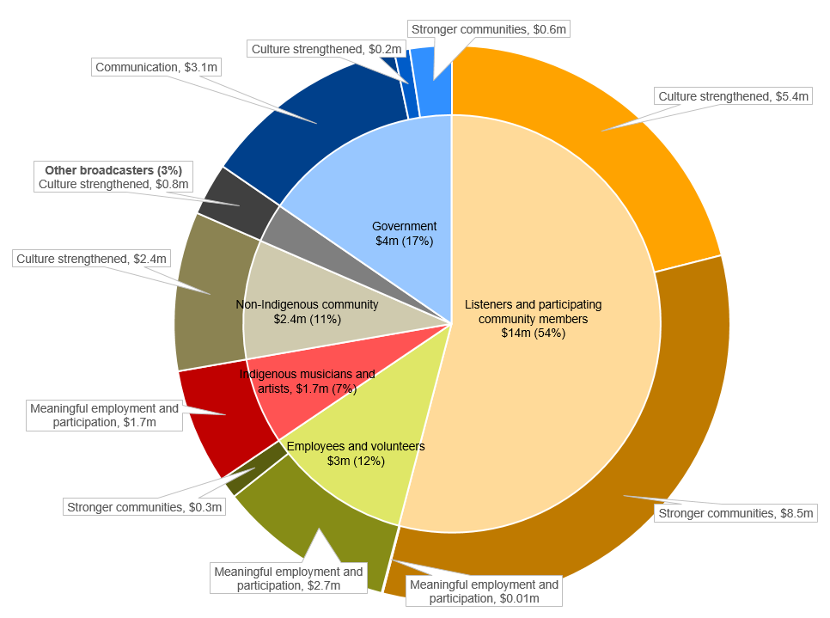
Figure 6.1.2 – Total value of outcomes across all three IBSs analysed, by stakeholder group and outcome theme

6.2 PAW
Valuing the outcomes created by PAW
Table 6.2 summarises the total value for all of the outcomes experienced by each stakeholder group. Figure 6.2 illustrates this information by stakeholder group and outcome theme.
Outcome | Total forecast value  (over 3 years) | Value per stakeholder  (over 3 years) | Per centage of total value
Indigenous listeners and participating community members
Appropriate recording, sharing and protecting of culture | $891,000 | $5,693,681 | 56%
People use music and video to communicate culture, positive stories and struggles | $622,462
Communities brought together through entertainment (sports, concerts and music) | $554,951
People feel informed about issues that matter to them | $3,471,562
Aboriginal people access support from a trusted source | $138,240
More Indigenous people have skills through training and experience | $15,465
Indigenous employees
More Indigenous people experience meaningful, high-skilled, employment | $1,100,141 | $1,380,941 | 14%
Decreased drinking and substance abuse | $255,528
Decreased welfare dependence | $25,272
Indigenous musicians and artists
Increased skills through mentoring in a recording studio | $136,800 | $172,800 | 2%
Increased fulfillment, confidence and pride | $36,000
Australian community
An extensive archive of Warlpiri items is preserved for future generations | $91,372 | $91,372 | 1%
Government
Public interest messages communicated effectively | $1,957,125 | $2,047,125 | 20%
More Indigenous people experience meaningful, high-skilled, employment | Value flows to community
Government meets Indigenous community expectation and need (as well as its UNDRIP obligations) | Value flows to community
Cultural maintenance and expression is supported | $90,000
Other broadcasters
National broadcasters have more Indigenous content to broadcast | $786,194 | $786,194 | 8%
Table 6.2 – Total value of outcomes as a result of PAW’s activities, by stakeholder group
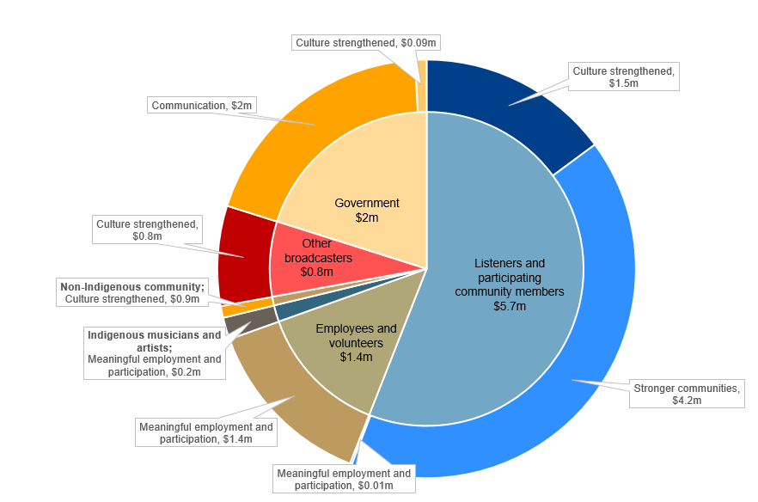
Figure 6.2 – Total value of outcomes as a result of PAW’s activities, by stakeholder group and outcome theme

Return on investment
The SROI ratio is generated by comparing the total value of the adjusted outcomes experienced by stakeholders to the investment required to create the value.
PAW is forecast to deliver an SROI ratio of 2.44:1 from July 2017 to June 2020.
That is, for every $1 invested, approximately $2.44 of social, economic and cultural value will be created for stakeholders.

SROI Ratio
2.44:1
Present value of benefits
$10,172,113
Present value of investment
$4,177,164
=

Figure 6.2 – SROI ratio for PAW

6.3 Umeewarra
Valuing the outcomes created by Umeewarra
Table 6.3 is a summary of the total value for all of the outcomes experienced by each stakeholder group. Figure 6.3 illustrates this information by stakeholder group and outcome theme.
Outcome | Total forecast value  (over 3 years) | Value per stakeholder  (over 3 years) | Per centage of total value
Listeners and community members
Aboriginal people have a strong, safe place where they belong | $377,460 | $2,900,992 | 58%
Aboriginal people access support from a trusted source | $205,200
Aboriginal people are supported through grief | $194,400
Aboriginal people feel informed about issues that matter to them | $603,708
People feel better able to advocate for things that matter to them | $131,688
Aboriginal people have more opportunities to access culture | $38,400
People use music and story-telling to communicate culture, positive stories and the true story | $865,014
Non-Aboriginal people have increased understanding and appreciation of Aboriginal cultures | $485,123
Umeewarra employees
Meaningful, high-skilled training and employment in media industry | $447,308 | $447,308 | 9%
Employees of other organisations
More Aboriginal people engaged in training and job application process in Port Augusta | $361,573 | $361,573 | 7%
Volunteers
Staff, board members and young people develop skills | $156,600 | $156,600 | 3%
Government
Increased awareness of public health and safety messaging | $487,500 | $1,166,622 | 23%
Non-Aboriginal service providers can offer more appropriate services | $50,058
Government meets Indigenous community expectation and need (as well as its UNDRIP obligations) | Value flows to community
Stronger community and social development | $629,064
Table 6.3 – Total value of outcomes as a result of Umeewarra’s activities, by stakeholder group

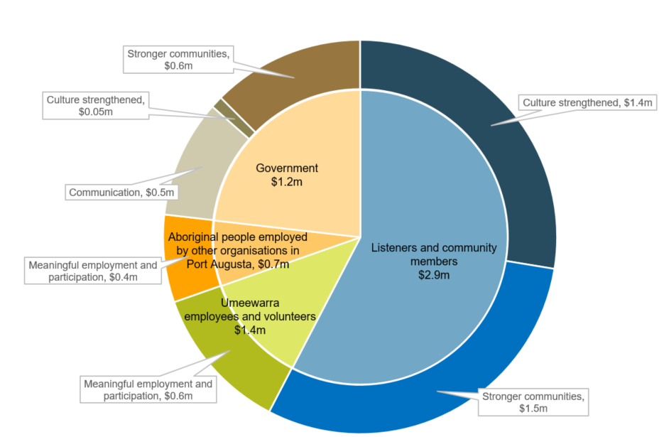
Figure 6.3 – Total value of outcomes as a result of Umeewarra’s activities, by stakeholder group and outcome theme

Return on investment
The SROI ratio is generated by comparing the total value of the adjusted outcomes experienced by stakeholders to the investment required to create the value.
SROI Ratio
4.3:1
Present value of benefits
$5,033,095
=
Present value of investment
$1,166,549

Figure 6.3 – SROI ratio for the Umeewarra
Umeewarra is forecast to deliver an SROI ratio of 4.3:1 from July 2017 to June 2020.
That is, for every $1 invested, approximately $4.30 of social, economic and cultural value will be created for stakeholders.

6.4 GIS
Valuing the outcomes created by GIS
Table 6.4 is a summary of the total value for all of the outcomes experienced by each stakeholder group. Figure 6.4 illustrates this information by stakeholder group and outcome theme.
Outcome | Total value for outcome | Value per stakeholder | Per centage of total value
Indigenous listeners and participating community members
Appropriate recording, sharing and protecting of culture | $388,800 | $5,351,756 | 51%
Indigenous people use music to communicate culture, positive stories and struggles | $2,134,460
Indigenous people can come together to celebrate being Indigenous | $1,524,096
People feel informed about issues that matter to them | $1,173,000
Aboriginal people access support from a trusted source | $131,400
Non-Indigenous listeners and participating community members
Non-Indigenous people have increased understanding and appreciation of Indigenous cultures | $652,320 | $652,320 | 6%
Non-Indigenous minority communities
Non-Indigenous minority communities have an increased sense of belonging | $1,643,296 | $1,643,296 | 16%
Indigenous employees
More Indigenous people experience meaningful, high-skilled, employment and volunteer opportunities | $313,430 | $313,430 | 3%
Volunteers
More Indigenous people experience meaningful, high-skilled, employment and volunteer opportunities | $301,511 | $301,511 | 3%
Indigenous musicians and artists
More Indigenous people have skills through mentoring, training and experience | $343,727 | $1,558,727 | 15%
Indigenous people are supported to participate in the music industry | $1,215,000
Government
Public interest messages communicated effectively | $675,000 | $765,000 | 7%
More Indigenous people experience meaningful, high-skilled, employment | Value flows to community
Government meets Indigenous community expectation and need (as well as its UNDRIP obligations) | Value flows to community
Cultural maintenance and expression is supported | $90,000
Table 6.4 – Total value of outcomes as a result of GIS’s activities, by stakeholder group
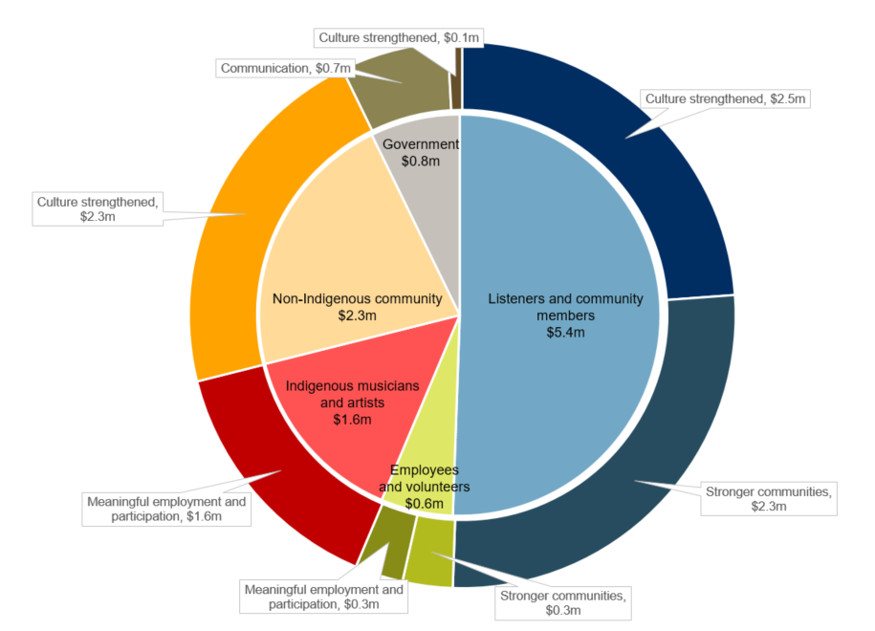

Figure 6.4 – Total value of outcomes as a result of Gadigal’s activities, by stakeholder group and outcome theme
Return on investment
The SROI ratio is generated by comparing the total value of the adjusted outcomes experienced by stakeholders to the investment required to create the value.
=
Present value of investment
$3,643,271
Present value of benefits
$10,586,040
SROI Ratio
2.9:1

Figure 6.4 – SROI ratio for the GIS
GIS is forecast to deliver an SROI ratio of 2.91:1 from July 2017 to June 2020.
That is, for every $1 invested, approximately $2.90 of social, economic and cultural value will be created for stakeholders.

7 Insights
IBSs provide a means to address the needs of communities. Indigenous people thrive within strong communities, with strong culture. This requires ongoing investment and maintenance. IBSs support this by providing a means to celebrate culture, communicate and connect. IBSs are also the expression of a fundamental human right for Indigenous peoples to have their own media and express themselves. This report, through the analysis of a remote, regional and urban broadcaster, has demonstrated the significant value generated for stakeholders as a result of IBSs’ activities.

This section elicits key insights drawn from the analyses and explores the alignment of stakeholder value with Government priorities. It explores the impact they are creating, but also how IBSs are achieving that impact, by unpacking their strategic response to the needs of community.
Key insights
- IBSs provide much more than radio – they are community assets that contribute to strengthening culture, community development and the local economy
- The outcomes achieved by IBSs appear consistent, but the activities they undertake are varied
- The activities IBSs undertake are tailored to the specific needs of the community which helps build trust amongst the community
- IBSs are achieving a range of social returns on investment, heavily informed by their context, and value flows to a variety of stakeholder groups
- IBSs are contributing towards more of the Government’s priorities than is currently realised
- IBSs can leverage government funds to generate additional revenue – and greater impact – but only if they have sufficient resourcing available

- IBSs provide much more than radio – they are community assets that contribute to strengthening culture, community development and the local economy

Indigenous owned and operated broadcasting services are effective at their elemental role of broadcasting, which includes the broadcast of Indigenous information, news, interviews, music, community events and stories to large audiences. But IBSs also achieve a wide range of valuable outcomes that go much further than listeners simply having access to information and music.
Strengthening culture
IBSs contribute to the ongoing maintenance and strengthening of one of the greatest assets of Indigenous peoples and of Australia – Indigenous culture. IBSs help keep culture alive by creating culturally rich environments and by recording, preserving and broadcasting traditional and contemporary songs and stories in an appropriate way.
In all IBSs’ environments, culture is strong – whether it be in the workplace where employees and volunteers learn and contribute, in the welcoming spaces they create for community members to drop in to, at the outside broadcasts and community events that they run, or even the virtual space that is created on air which community members can engage with whenever they choose. The positive, culturally affirming environments are achieved in subtle ways, including by having Indigenous staff and governance, by offering staff flexibility around cultural obligations, by exploring, sharing and celebrating Indigenous stories in an Indigenous way and by living and breathing Indigenous values. Indigenous people see the IBSs as places they feel comfortable sharing their stories, accessing information and getting support.
By creating culturally strong environments and recording and sharing traditional and contemporary culture in accessible ways, IBSs play a crucial role in supporting communities on a healing journey. Community members can feel pride and celebrate being Indigenous and have a strengthened sense of identity and belonging.
“I’m putting my grandfather’s songline on the map.”
- Indigenous video producer, referring to a video that he is producing involving claymation animals laid over drone footage of country, and narrated by an elder.
Community development
IBSs also play a crucial role increasing community cohesion and building community resilience. This is consistent with how community development literature conceives of community broadcasters – as services which contribute to community and economic development. IBSs hold community events that bring people together and often in spite of physical distance, cultural barriers and social pressures. IBSs are in a privileged position. They have permission from the community to develop relationships with community members from all families and language groups, with community organisations, government, social service providers, the arts and music community and political leaders. They have a mandate to solicit information from all of those stakeholders and they are trusted with that information and with music, language and culture. They also have a receptive audience. These factors make them well placed to facilitate connections, support community cohesion and to bring people together for the benefit of the Indigenous community.
IBSs support community responses to challenges. IBSs are embedded in the community and broadcast local news content every day. Consequently, they often have unique and comprehensive knowledge of community activities, services and challenges. They are also well placed to identify and action efficient responses. For example, one IBS described how they brought together around 20 organisations delivering services relating to domestic and family violence after identifying the need for better communication between those organisations.
“You can’t put a price on having an organisation that is respected by everyone. Without that assistance [if you were to take that organisation away], it could be the straw that breaks the camel’s back.”
- Community member
IBSs facilitate access to services. IBSs’ listener bases usually represent a majority of the local Indigenous community. Its listeners are receptive, and trust the content that the IBS broadcasts. IBSs are therefore an important vehicle for communicating public safety messages and connecting communities to government services, thereby increasing access to services. IBSs provide people with information that they need to make informed decisions.
“People come into the clinic and say, ‘I heard on the radio not to eat this or that’.”
- Community Health Clinic
IBSs support communities to develop a positive collective identity by broadcasting shared positive stories and music. They cultivate a physical and on-air community to which people can identify and belong and provide a vehicle through which Indigenous communities can access and leverage existing social capital to ensure community resilience.
IBSs are a rare asset for community and government alike and one that could not easily be recreated. Their value has often accrued over many years of being Indigenous community controlled and by building trust within communities. These services are embedded members of their communities.
Economic development

IBSs provide positive working environments for local people, where individuals can perform meaningful roles and develop skills and confidence. Employees describe an alignment between their values, their interests, their culture and their work. Employees are supported to discover roles that interest them, they are given training and mentoring and are often given sufficient flexibility to fulfil family and cultural obligations. IBSs also facilitate access to employment by creating volunteer, work experience and intern positions which have easier entry points, but also represent opportunities to develop skills and confidence.
“Now I am smiling on the inside, not just pretending to smile on the outside. It’s a fit.
I write music about the struggle, I talk to people on radio about their struggles. That’s what I’m good at, supporting people, so sometimes I don’t come to work because I have to support people [outside work].”
- Indigenous broadcaster
IBSs establish pathways to employment at other organisations. The skills employees and volunteers gain working with the IBS are transferable. Some IBSs also leverage their networks and general knowledge of opportunities in the community to facilitate community members obtaining training or employment with other organisations. For example, in Port Augusta approximately 80per cent of all Aboriginal people employed in a year have either heard the role advertised on radio, have received CV writing support or attended job skills training or interviews at Umeewarra.
IBSs support growth in a number of ways. They grow capacity in areas that employees or the community have expressed an interest in developing. For example, IBSs have developed video and Claymation studios, digital and physical archive facilities and they have built reputations for producing popular, professional community events. IBSs also facilitate growth in community governance with community members, leaders and politicians being able to have a voice through radio.
- The outcomes achieved by IBSs appear consistent, but the activities they undertake are varied
All three IBSs analysed are effectively delivering broadcasting services, and leveraging their role as a broadcaster to achieve outcomes in the following three domains:
- Stronger communities;
- Culture strengthened; and
- Meaningful employment and participation.
The theories of change at Appendix 1, 2 and 3 show that a majority of the outcomes achieved by IBSs within each of those domains are consistent across IBSs. Those common outcomes include things such as increased employability of Indigenous people, more positive stories about Indigenous people, people being brought together through events, public interest messages being communicated effectively and non-Indigenous people having increased understanding and appreciation of Indigenous culture.
Where the broadcasters differ is in how they go about delivering broadcasting and ancillary services in order to achieve those outcomes. Each IBS tailors its approach to the community they are operating in. For example, in Yuendumu, PAW runs a Claymation video studio, in Port Augusta, Umeewarra uses puppets to teach children about public safety issues and in Sydney, GIS runs the Young Black and Deadly program supporting young musicians to develop their careers.
Insight three explains how the different activities respond to the specific needs of the community.
- The activities IBSs undertake are tailored to the specific needs of the community which helps build trust amongst the community

Building trust through reciprocity
Because of the symbiotic, close relationship IBSs have with the community, the IBSs are able to learn what the community-identified gaps are. They work with the community to put into effect locally-designed, efficient solutions and as a consequence, deliver substantial value to the community.
IBSs must have the trust and support of the community in order to operate effectively. Without that trust and support, IBSs would not have such significant and engaged listener bases. Community members also may not feel comfortable sharing content with them, which would reduce the amount of relevant content IBSs have to broadcast. The IBSs are in a relationship of reciprocity where the community welcomes the IBS as a member of the community and supports the IBS to fulfil its basic function of delivering broadcasting services and the IBS responds to the community’s needs. All three IBSs we engaged have invested in building trust over many years by responding to community requests that they undertake a broader range of activities than simply “a voice behind a mic”. This approach is consistent with research by UNESCO, cited in section 2 of this report, which identified social responsiveness as critical for the sustainability of community radio stations.
The community needs that IBSs must respond to vary greatly. Relevant differences for broadcasting services generally include:
- the size of the population;
- the culture and interests of listeners; and
- the range of alternative news and media sources available to listeners.
Relevant differences specific to IBSs include:
Being a radio station makes IBSs uniquely placed to understand and respond to the needs of the community – because they’re a trusted communications channel. They know what’s happening in community and who to talk to get things done.
- the number of appropriate social services available to the community;
- the level of disadvantage and social cohesion;
- community history and politics;
- how connected people are to culture;
- languages spoken by the community;
- the remoteness of the community; and
- the quality of the broadcasting and technology infrastructure in the community.
“We pride ourselves on being connected with our community. We refer to them as our community for that reason, not an audience. We’re an extension of the community. They’ll pick up the phone or give us a shout if something doesn’t sit right with them.”
- Indigenous broadcaster
The ways IBSs respond to the specific needs are as wide-ranging as the communities they serve; from hosting a dinner in the Sydney town hall to celebrate 50 years since the 1967 Referendum, to writing eulogy cards and taking food and shelter to mourners at sorry camps. The table below highlights an example of how the three IBSs involved in this analysis respond to specific community needs:
Community | What does the community need? |  | How does the IBS respond?
Yuendumu | In Yuendumu, culture and language is strong. People are isolated but there are a number of services, a strong land council and community leaders supporting community needs. What the community needs is for culture to be protected and preserved. |  | PAW has taken on the role of cultural protocols management, it generates recordings of culture and it manages the largest archive of Warlpiri images and video content. The archive has been recognised as an archive of national significance.
Port Augusta | In Port Augusta, there is poor social cohesion between the Aboriginal and non-Aboriginal community. There are high levels of disadvantage, limited Aboriginal-owned community services and over 30 language groups. There is a mistrust of services and real or perceived discrimination against Aboriginal people. What the community needs from Umeewarra is a trusted organisation that can connect the Aboriginal community to key services and to employment opportunities. |  | Umeewarra provides a safe space for community members to meet.  Umeewarra provides employment support to 80per cent of the Aboriginal people who obtain employment in Port Augusta. Umeewarra advertises roles on radio, offers a CV-writing service, collects CVs and forwards them to employers, supports with interview preparation and works with an employment provider to run job skills training and interviews in Umeewarra’s meeting room.
Sydney | In Sydney, there is a large, culturally and geographically diverse Indigenous population. Many people are disconnected from culture, and many experience prejudice, judgment and barriers to achieving goals. What the community needs from GIS is an accessible way to connect to culture even if they did not grow up in culture; a way to better understand their Indigenous identity, and a sense of belonging in a place where they can feel proud to be Indigenous. |  | GIS runs a series of events including Klub Koori for younger people. It runs Yabun festival, the largest one-day celebration of Indigenous culture in Australia, held every year on 26 January. The Yabun festival is a positive event where participants can celebrate being Indigenous on a day that is otherwise a day of mourning. 15,000 Indigenous people attend Yabun festival, and 20,000 non-Indigenous, making it an important contributor to reconciliation.

These activities are not obvious broadcasting activities but IBSs perform them in order to secure and retain the community’s trust and support. Because of the symbiotic, close relationship IBSs have with the community, the IBSs are able to learn what the community-identified gaps are. They are then able to work with the community to put into effect locally-designed, efficient solutions and as a consequence, deliver substantial value to the community.
Building trust through connection
Another way IBSs build trust is through close connection to the community. All three IBSs are controlled and largely staffed by local Indigenous people and cultivate an active network of connections to members of the community.
IBSs operate an accessible “shop-front” out of offices and studios that are located in the heart of the community. GIS is located in Redfern, the “Black Capital” of Sydney, PAW is in the very centre of Yuendumu and Umeewarra is located in a building that has been known as a safe place for community members for many years, having previously been a community centre and before that a worker’s club. The offices are all culturally affirming environments that are neutral spaces for people from all language groups. This helps the IBS to connect to the community and makes them accessible for people who would rather receive or share information face to face.
When asked which factors were most important to ensuring the trust of the community, IBSs, on average, ranked ‘Being an Aboriginal community controlled organisation’ first. Some of the staff at the organisations analysed are leaders in their communities, which adds to their credibility and influence. It also enables the organisation to be responsive to community needs, as the organisations are comprised of community members. This factor is consistent with research by UNESCO, cited in Section 2 of this report, which identified strong community governance and staffing as critical for the sustainability of community radio.
IBSs are effective at connecting to the community using appropriate content and accessible communication mediums. Content is generated by broadcasters being embedded in the community, and community members feeling comfortable sharing content. Communities reported valuing the content because it is relevant, local and trusted, and often in their language. IBSs are using whichever medium will be most effective for their audience under the circumstances.
A survey of IBSs conducted for this report revealed 69% of respondents are streaming their radio stations online, 77% are using social media, and
38% are using podcasts.
However, 46% identified lack of access to affordable broadband as limiting their implementation of new technologies.
Practical limitations facing remote IBSs make the adoption of some technologies difficult, highlighting the importance of retaining radio and utilising a “shop-front”. According to a McNair survey, 48 per cent of Indigenous people in remote communities serviced by RIBS or RIMOS did not own or use a mobile phone at all (compared to 14 per cent in regional and metro areas), and 35 per cent did not use a desktop computer at all. PAW will soon begin sharing content within the community for free through a PAW-hosted WiFi network, alleviating internet access barriers faced by those living in the remote community of Yuendumu.

- IBSs are achieving a range of social returns on investment, heavily informed by their context, and value flows to different stakeholder groups

The social returns on investment generated by the IBSs analysed through this report range between 2.4:1 and 4.3:1, and generate significant returns for stakeholders across a range of outcomes. While caution should be exercised in any direct comparison of returns (due to the unique circumstances in which IBSs operate), some observations can be made about how value is flowing, the factors that contribute to that value, and the return on investment:
- Across all analyses, the stakeholder group experiencing the greatest share of value are listeners and community members. They experienced 54 per cent of the value, on average (see section 6 above). They experience this value through outcomes associated with the strengthening of culture, and of their communities. The value flowing to this stakeholder group is in part a reflection of the volume of individuals experiencing the benefit.
- Consequently, the size of an IBSs listener base is a key driver of value. The larger the audience, the bigger the total value created. Consequently, IBSs in remote areas, such as PAW, have a lower quantum of stakeholders experiencing outcomes and a smaller total value. However, the size of the population can challenge an IBS’s ability to have deeper engagement with the community, maintain an awareness of their needs and respond through the broadcast of relevant content thereby resulting in less value per listener. GIS responds to this challenge by producing a wide range of content covering issues relevant regardless of cultural background, such as political issues facing Indigenous people. PAW and Umeewarra, in smaller communities, can respond to emerging needs with targeted solutions, and are able to attract a higher per centage of their population as listeners.
- Employees, volunteers and Indigenous musicians and artists experience significant value (19 per cent of total). Despite being a relatively small stakeholder group in numbers (relative to the listener population, due to their close and meaningful engagement with IBSs , employees and volunteers (12 per cent), as well as Indigenous musicians and artists (7 per cent of value) experience significant value.
- The Australian Government experiences value from IBSs, generally in the form of expected savings. In these analyses, value generated for the Australian Government (17 per cent of total) was predominantly through IBSs providing Government with an effective means to communicate public interest messages to communities, including public health and safety messaging. While Government pays for this service, a study of a Government funded National Indigenous Ear Health Campaign broadcast on IBSs found the true value of this service was 2.5 times higher than the price paid. In absence of IBSs, Government would need to expend resources to achieve the same outcomes, particularly in a remote and regional settings which may otherwise be expensive to reach, and require language translation.
- Value is split relatively evenly across outcome themes, which reinforces the interrelationship of outcomes. Closer analysis of this split is unhelpful because the outcome themes and outcomes are mutually reinforcing. Achievement of outcomes in the communications outcome theme is necessary to achieve outcomes in the other outcome themes. IBSs must employ local community members in order to maintain the trust of the community, thereby securing a listener base who can experience value. Stronger communities and culture being strengthened are mutually reinforcing. A community cannot continue to grow if it loses culture and a strong, supportive, resilient community is better placed to celebrate culture and keep it alive.
- The relatively high costs of servicing a remote area, and servicing multiple RIBS, affect an IBSs return on investment. While a cost analysis was not within the scope of this report, it is well established that the costs of living, and of operating an organisation, in remote areas is higher than that in urban or regional areas. For example, for PAW to do business in a remote location, it incurs the expense of staff housing and relocation, environmental interruptions to business such as road closures and higher costs of fuel, power, internet and support services. Consequently, a relatively higher investment is required in remote areas to achieve the results seen in an urban environment (noting the limitations of audience reach). Further, it should be noted that PAW, as a RIMO, plays a distinctly different role from the other two IBSs analysed, in that it services 14 RIBS across a range of 450,000km², with the associated costs noted above with regards to remoteness.
- The level of investment, naturally, impacts upon the return on investment. Despite different levels of investment, however, all providers are achieving substantial impact.
- IBSs are contributing towards more of the Government’s priorities than is currently realised
A stated objective of this project was to improve PM&C’s understanding of the breadth of social, economic, and cultural outcomes achieved through their investment. In particular, PM&C was interested to understand the extent to which those outcomes aligned with the Government’s Indigenous Broadcasting Priorities and the Strategic Priorities which underpin the IAS.
Indigenous Broadcasting and Media Priorities
To ascertain alignment with the Government Broadcasting priorities – outcomes achieved by the three IBSs have been mapped to those Broadcasting Priorities. Those priorities are being achieved by IBSs and nearly all of those priorities map to material outcomes identified in the analyses of the three IBSs. However, that does not tell the full story of impact, as there are a number of additional outcomes not captured by the Broadcasting Priorities.
We note that we have not sought to align outcomes with the priority, ‘use of new technology to improve content and audience reach, and reduce costs’, as technology is the means through which broadcasters achieve their impact, rather than an outcome in itself. We have, however, included a discussion of broadcasters use of technology above. Further, as the outcomes are interrelated, some of the outcomes contribute to the achievement of multiple priorities, so the value could arguably be attributed elsewhere. We have not sought to split the value of outcomes between priorities.
Figure 7.2 below shows the approximate value experienced by stakeholders through achievement of outcomes aligned with the Broadcasting Priorities. A description of the priorities alignment with key outcomes is below, and a list of outcomes associated with each priority, for each organisation analysed, is at Appendix 1.

Figure 7.2: Approximate value experienced by stakeholders through achievement of outcomes aligned with Broadcasting Priorities
Systematic monitoring and response to community communication needs
About 12 per cent of the value stakeholders experience is aligned with this priority. IBS activities ensure the community has access to news and community relevant content. Listeners value the local focus of the news and that fact that the content has already been ‘filtered’ by the broadcasters means listeners get to hear about the issues that matter. IBSs also help to address the community's need to communicate and connect. Community concern around limited avenues for communication and cultural expression was a key reason Government began to fund IBSs (see section 2.2); this need is partly satisfied through IBS.
Contribution to cultural expression and maintenance
The analyses have identified that Indigenous communities value the ease with which they can access culture through broadcasting services and that the services provide avenues for the “appropriate recording, sharing and protecting of culture”. The stations are compiling and broadcasting cultural content, including in language, as well as holding community events which facilitate the expression and maintenance of culture. Umeewarra provides opportunities for community to come together and participate in events that celebrate culture, such as during NAIDOC week. PAW and GIS are also facilitating the maintenance of culture through the Warlpiri Media Archive and the 99 stories audio archive projects respectively. About 10 per cent of the value that stakeholders experience is aligned with this priority, though, much of the impact aligned with other priorities is achieved because IBSs have such strong cultural alignment, as explained above.
Contribution to community economic and social development
At 61 per cent, this priority has the greatest alignment with the value experienced by stakeholders and the greatest number of aligned outcomes. About 42 per cent is attributed to community social development and 19 per cent to economic development. Broadcasters are contributing to community economic development through providing meaningful employment opportunities, training opportunities and other opportunities to participate in their community such as through music and film. These opportunities are in culturally affirming environments, in a technical industry and often in locations where there are scarce other opportunities. These economic outcomes spur social outcomes, as participants feel pride as a result of these experiences. Some decrease their alcohol and welfare dependence. Broadcasters are also contributing to community social development by bringing communities together for events, increasing access to music which helps communicate positive stories and struggles, and by responding to other needs of the communities.
In the spotlight: Umeewarra
Umeewarra builds community cohesion by going the extra mile to respond to community needs. Its radio shows support community cohesion through sharing stories of local people, responding to listener questions, and cultivating a network of mentors who support young people through its youth radio program. Umeewarra also maintains a positive physical presence at Port Augusta community events, helping to develop understanding and reduce tension between the Aboriginal and non-Aboriginal communities.
“Just hearing Aboriginal voices on the radio... seeing the Outside Broadcasting van around town...
It strengthens our stance as Aboriginal people. It gives us pride.”
- Umeewarra Radio listener
Cooperative engagement on communication of community and government priorities
Seventeen per cent of stakeholder value is aligned with this priority, through experiencing the value of public interest messages being effectively communicated. IBSs are contractually obliged to deliver public messages as part of their broadcasting content and have been demonstrated to be effective at doing so. An evaluation of the recent National Ear Health Campaign found community messages had led to improved health outcomes. This finding is supported by interviews with health workers in Yuendumu through this analysis who use PAW to inform the community about visiting health practitioners.
Alignment with IAS priorities
IBSs are funded through the Culture and Capability programme of the IAS. That programme aims to:
PM&C IAS, Culture and Capability programme
Aims to support Indigenous people to maintain their culture, participate equally in the economic and social life of the nation and ensure that Indigenous organisations are capable of delivering quality services to their clients.

- Support the expression, engagement and conservation of Indigenous culture;
- Increase Indigenous Australians’ participation in the social and economic life of Australia through healing, and strengthening the capability, governance and leadership of Indigenous Australians, organisations and communities; and
- Promote broader understanding and acceptance of the unique place of Indigenous cultures in Australian society.
IBS outcomes align closely with all three objectives:
- As described above, all three IBSs contribute significantly to keeping culture alive and preserving and sharing it appropriately;
- The second objective aligns closely with the outcomes relating to strengthening communities. For example, GIS supports people who were disconnected from culture to be on a healing journey where they can strengthen their identity and belonging to a strong community. Umeewarra supports people into employment and ensures Aboriginal community members have a voice in important community meetings by providing safe meeting spaces, and convening meetings with government and service providers and the community; and
- All three IBSs contribute to the third objective, improving non-Indigenous people’s understanding and appreciation of Indigenous cultures. GIS runs the Yabun festival, demonstrating positive aspects of Indigenous cultures, which 20,000 non-Indigenous people attend every year. PAW produces videos that are broadcast nationally and Umeewarra works to reduce racism in Port Augusta.
It is through the Culture and Capability programme that there is strongest alignment with the outcomes of services identified through this analysis. For that reason, we have not sought to apportion value across other IAS programmes, but we discuss below where the outcomes do intersect with other programme priorities.
Jobs, Land & Economy Programme
This programme aims to get Indigenous adults into work, foster Indigenous business and assist Indigenous people to generate economic and social benefits from effective use of their land and sea.
The outcomes ‘More Indigenous people have skills through training and experience’ and ‘More people experience meaningful, high-skilled, employment’ somewhat intersect with this programme. Land and sea management work, also funded by PM&C through this programme, is recognised as valuable, both for the environmental outcomes it achieves, and for the significant social, cultural and economic benefits it provides to Indigenous employees in enabling them to live and work on country. Broadcasting is another way of enabling people to work on country in regional and remote locations, in a way that is aligned with their culture. Around two-thirds of PM&C’s IBS funding goes to remote and very remote broadcasting services. Further, content is being created on country, such as the Songlines on Screen series, which draws from the rich histories and lessons drawn of the land, and spurs economic and social outcomes for employees.
Children and Schooling Programme
This programme aims to support families to give children a good start in life through improved early childhood development, care, education and school readiness. While no specific outcomes are aligned with this programme, content broadcast by IBS can benefit children, as can community interest messages. PAW broadcasts an audiobook series of local songlines to increase children’s awareness of culture. PAW also recently ran a campaign promoting school attendance, funded through PM&C. Umeewarra communicates health and public safety messages to children using puppets, it runs a work experience program for students at Port Augusta school and helps facilitate a mentoring and transition to work program for school students. The interviewing of children was out of scope of this report, and audience surveys tend to focus on those over the age of 15, so these outcomes have not been validated.
Safety and Wellbeing Programme
This programme aims to ensure that the ordinary law of the land applies in Indigenous communities, and that Indigenous Australians enjoy similar levels of physical, emotional and social wellbeing as those enjoyed by other Australians. The outcome, ‘effective communication of public safety messages’ intersects with this programme, the benefits of which have been discussed above.
Remote Australia Strategies programme
This programme aims to ensure strategic investments in local, flexible solutions based on community and Government priorities. The focus of this programme is less about the achievement of specific outcomes, but rather, it is concerned with Government’s capacity to engage with remote Indigenous communities and in doing so, achieve its broader agenda in areas where Indigenous disadvantage is most prevalent. IBSs deliver flexible, tailored local communication solutions in remote, regional and urban settings across Australia, which complements the intent of this programme,
- IBSs can leverage government funds to generate additional revenue – and greater impact – but only if they have sufficient resourcing available

The IBSs we surveyed receive about 75 per cent of their funding through PM&C on average, so are reliant on this funding. Once other sources of government funding are considered, this figure is around 83 per cent. This reliance on government is consistent with the situation facing community radio stations around the world, particularly in remote areas. However, many IBSs are generating their own revenue. Of the 13 IBSs we surveyed, an average of 17 per cent of their revenue comes from other sources. That is predominantly comprised of funding from the commissioning of audio and video segments, attracting grants and sponsorship and running events.
While we can draw only limited conclusions from our observations of the three providers and sector survey, it was evident that there is a minimum resourcing threshold that will enable IBSs and their staff to diversify their activities and funding. IBSs:
- Can only take advantage of their recording studio to generate revenue if there are sufficient funds to employ a sound engineer;
- Can only produce revenue generating video if they have sufficient resources to establish and maintain a video production unit. About 40 per cent of IBSs surveyed would like to produce video for television but do not currently do so;
- Can maximise grants, sponsorship and commissioned fee for service opportunities if they have staff with sufficient time to devote to these business development activities; and
- Can explore new projects that may attract more funding, employ more community members, and better suit the needs of their community, if they have capacity to hire and train staff to do so.
The three IBSs analysed for this report generated between 10 and 26 per cent of their revenue from non-government sources. Umeewarra received the lowest funding of the three and generated the lowest revenue. They did not have sufficient funds to employ a sound engineer, nor to explore other projects which might attract additional revenue. GIS generated revenue from public events and greater sponsorship revenue but had sufficient resourcing to support these activities. PAW was the only provider of the three to have video production facilities, and generated around 16 per cent of their revenue from this source. PAW set up these facilities during the time that these activities were supported by the Australian Government. As a result, they can generate income from this stream – and produce award winning productions.
As with PAW’s archival work – it demonstrates that funding support for specific activities can significantly increase the return on investment.
Despite limitations on their resourcing, broadcasters are achieving significant impact for stakeholders. IBSs are leveraging this investment, and their long-established community trust, to achieve the significant impact identified in this report.

“We’ve got a proud history of innovating, being nimble and doing a lot with a little. That’s part of the story of Indigenous media... It goes way back to our roots in broadcasting pirate television in remote communities.”
- Indigenous Broadcaster

8 Conclusion
This report, through the analysis of a remote, regional and urban broadcaster, has established what has long been understood by Indigenous communities and their broadcasters – IBSs are more than just a communication channel: they are a community asset, integral to the community.
IBSs can be leveraged to address the needs of communities. Indigenous people thrive within strong communities, with strong culture. This requires ongoing investment and maintenance. IBSs support this by providing a means to celebrate culture, communicate and connect. IBSs are also the expression of a fundamental human right for Indigenous peoples, to have their own media and express themselves.
IBSs reach beyond their core function of providing a communications medium to achieve significant outcomes for community, strengthening communities and culture, and providing meaningful employment and training opportunities. This manifests in different ways in each community, based on the unique circumstances each Indigenous community faces in Australia.
Trusted relationships are critical to IBSs achieving impact in their communities. Trust is necessary for the community to be able to share stories, culture, music and news, and for the IBS to know about, and create, relevant content to broadcast. Trust is also required for the IBS to have listeners, and for the listeners to engage with the content and act on it. Without trust, the IBSs would be unable to achieve any of the outcomes they achieve.
This report also supports the framework advocated by UNESCO for what is required for the sustainability of Indigenous broadcasters. The UNESCO framework suggests that IBSs need to be responsive to audiences and engage actively in communities (referred to as social sustainability) and have good governance and management (referred to as institutional sustainability). It acknowledged that most community broadcasters, particularly in regional and remote areas, will not be financially sustainable, but that a foundation of social and institutional sustainability is required to aspire towards it. The observation from the three IBSs analysed is that they all have social sustainability and the larger IBSs are more progressed towards institutional sustainability, which provides the foundation for progressing towards financial sustainability through targeted and appropriate revenue generating activities.
The three forecast SROI analyses canvassed in this report indicate that continued or increased investment in IBSs will continue to drive high rates of social return. The report shines a light on the important role IBSs play in community social and economic development. It also demonstrates that IBSs are an asset for community and Government alike, and could be greater leveraged if granted the opportunity, in the achievement of sustainable social outcomes for communities.

Appendix 1 – PAW Logic Model
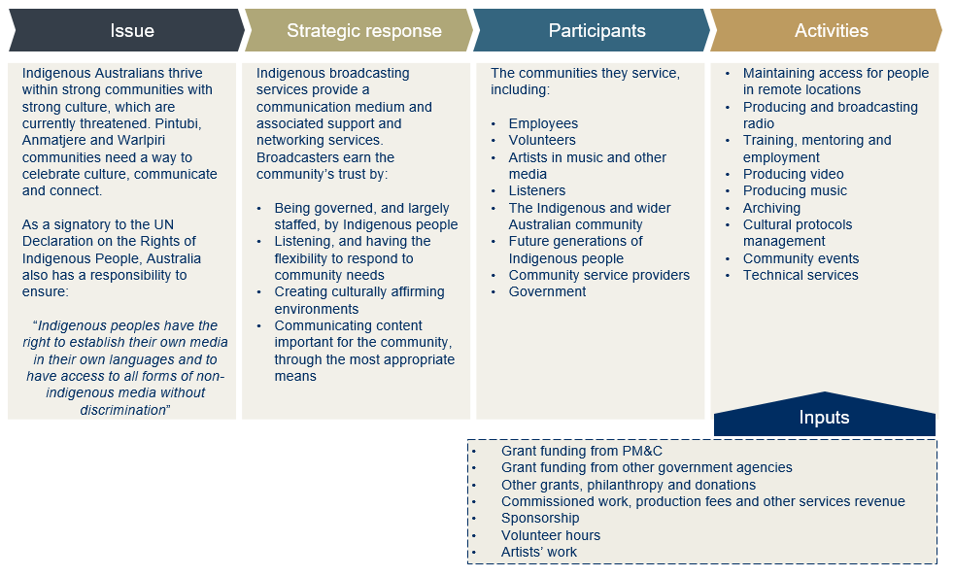
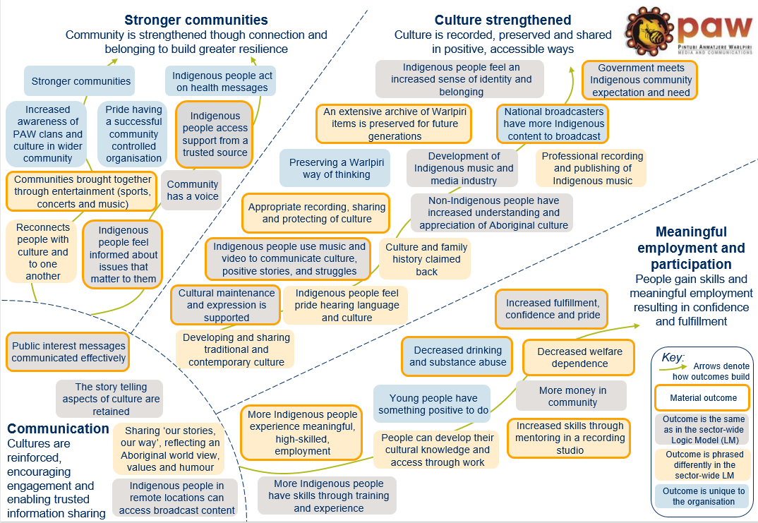

Appendix 2 – Umeewarra Logic Model
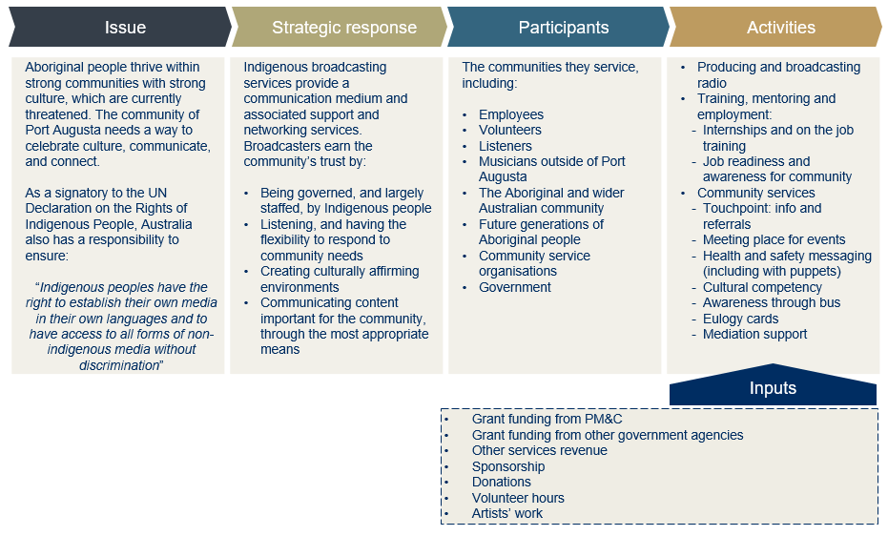
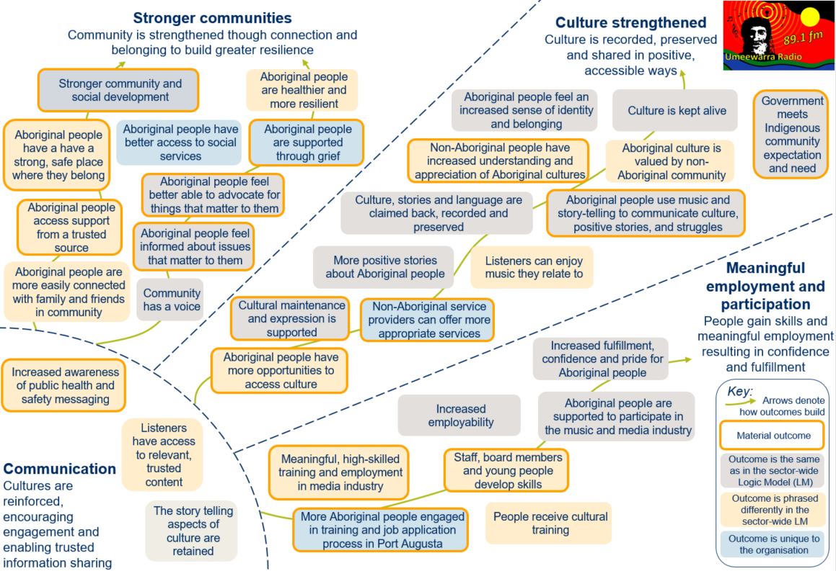

Appendix 3 – GIS Logic Model
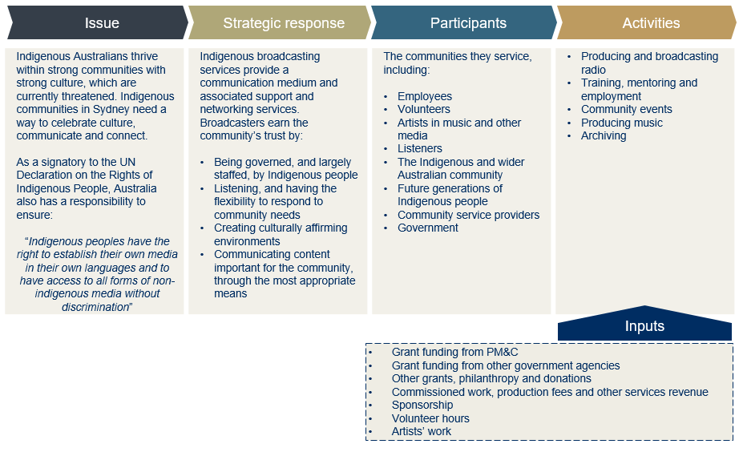
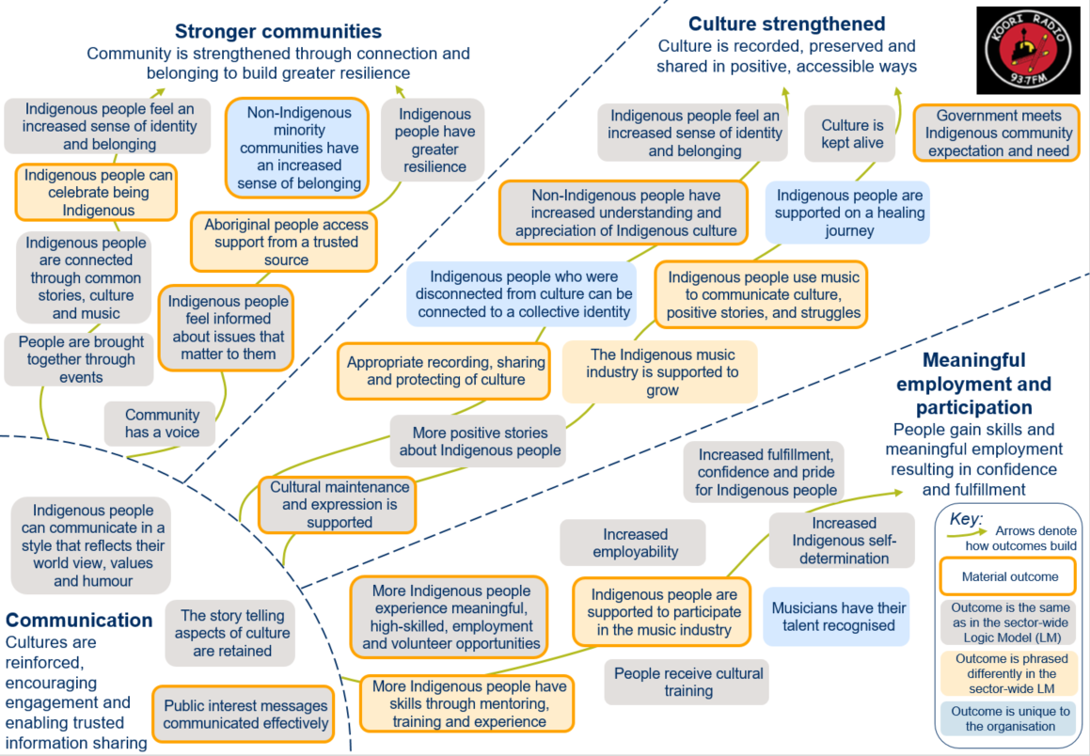

Appendix 4 – Alignment of IBSs outcomes with Government priorities
Alignment of IBSs’ outcomes with the Australian Government’s Broadcasting Priorities
2017-2020

The tables below map the outcomes being achieved by each of three organisations analysed against the Government’s media priorities.

Table A1.1: Alignment of PAW’s outcomes

Outcome | Alignment with Indigenous Broadcasting and Media priorities
PAW
Appropriate recording, sharing and protecting of culture | Contribution to cultural expression and maintenance
People use music and video to communicate culture, positive stories and struggles | Contribution to community social development
Communities brought together through entertainment (sports, concerts and music) | Contribution to community social development
People feel informed about issues that matter to them | Systematic monitoring and response to community communication needs
Aboriginal people access support from a trusted source | Contribution to community social development
More Indigenous people have skills through training and experience | Contribution to community economic development
More people experience meaningful, high-skilled, employment | Contribution to community economic development
Decreased drinking and substance abuse | Contribution to community social development
Decreased welfare dependence | Contribution to community economic development
Increased skills through mentoring in a professional studio | Contribution to community economic development
Increased fulfilment, confidence and pride | Contribution to community social development
An extensive archive of Warlpiri items is preserved for future generations | Contribution to cultural expression and maintenance
Public interest messages communicated effectively | Cooperative engagement on communication of community and government priorities
More people experience meaningful, high-skilled, employment | Contribution to community economic development
Cultural maintenance and expression is supported | Contribution to cultural expression and maintenance
National broadcasters have more Indigenous content to broadcast | Contribution to cultural expression and maintenance

Table A1.2: Alignment of Umeewarra Media’s outcomes
Outcome | Alignment with Indigenous Broadcasting and Media priorities
Umeewarra
Aboriginal people have a strong, safe place where they belong | Contribution to community social development
Aboriginal people access support from a trusted source | Contribution to community social development
People are supported through grief | Contribution to community social development
Aboriginal people feel informed about issues that matter to them | Systematic monitoring and response to community communication needs
People feel better able to advocate for things that matter to them | Systematic monitoring and response to community communication needs
Aboriginal people have more opportunities to access culture | Contribution to cultural expression and maintenance
People use music and story-telling to communicate culture, positive stories and the true story | Contribution to community social development
Non-Aboriginal people have increased understanding and appreciation of Aboriginal cultures | Contribution to community social development
Meaningful, high-skilled training and employment in media industry | Contribution to community economic development
More people engaged in training and job application process in Port Augusta | Contribution to community economic development
Staff, board members and young people develop skills | Contribution to community economic development
Increased awareness of public health and safety messaging | Cooperative engagement on communication of community and government priorities
Non-Aboriginal service providers can offer more appropriate services | Cooperative engagement on communication of community and government priorities
Stronger community and social development and cultural maintenance and expression | Cooperative engagement on communication of community and government priorities

Table A1.3: Alignment of GIS outcomes
Outcome | Alignment with Indigenous Broadcasting and Media priorities
GIS
Appropriate recording, sharing and protecting of culture | Contribution to cultural expression and maintenance
People use music to communicate culture, positive stories and struggles | Contribution to community social development
Indigenous people can come together to celebrate being Indigenous | Contribution to community social development
People feel informed about issues that matter to them | Systematic monitoring and response to community communication needs
The community has a voice | Systematic monitoring and response to community communication needs
Aboriginal people access support from a trusted source | Contribution to community social development
Non-Indigenous people have increased understanding and appreciation of Indigenous culture | Contribution to community social development
Other cultures are embraced by Indigenous people | Contribution to community social development
More Indigenous people experience meaningful, high-skilled, employment and volunteer opportunities | Contribution to community economic development
More Indigenous people experience meaningful, high-skilled, employment and volunteer opportunities | Contribution to community economic development
More Indigenous people have skills through mentoring, training and experience | Contribution to community economic development
Indigenous people are supported to participate in the music industry | Contribution to community economic development
Musicians have their talent recognised | Contribution to community economic development
Public interest messages communicated effectively | Cooperative engagement on communication of community and government priorities
More people experience meaningful, high-skilled, employment | Contribution to community economic development
Cultural maintenance and expression is supported | Contribution to cultural expression and maintenance
National broadcasters have more Indigenous content to broadcast | Contribution to cultural expression and maintenance

PM&C collects information about IBSs through contracted funding agreements. IBSs regularly report to PM&C throughout their funding agreement terms, including on Key Performance Indicators. PM&C has also funded an audience survey to understand the preferences of listeners, cited through this report as the McNair Ingenuity Research.
Including Adnyamathanha; Pitjantjatjara; Yankantjatjara; Arrente; Barngarla; Nukunu; Noongar; Dieri; Garundji; Arrabunna; Wilyakali; Luritja; Torres Strait Islander; Kookatha; Kaurna; Narrunga; Ngarrendjeri; Wangganguru; Ngadjuri; Kuyani; Antikarinya; Wirangu; Mirning; Yamatji; Yuin; Wirudjuri; Yandruwandha; Boandik; Wongaii; Malyangaba and Warlpiri.
Estimates informed by McNair Ingenuity Research survey data referenced throughout this report, and interviews with each provider.
Income is the total amount received from all sources, not just from Government.
Thirteen responses were received for this survey, of the 34 IBSs who were contacted. The details of the survey are outlined in the Methodological Attachment.
McNair Ingenuity Research, Australian Indigenous Communications and Media Survey, March 2017. ‘Regular listeners’ are taken to be Indigenous Australians who have listened to the radio at least once in the past week.
UNESCO, Community Radio and Sustainability, 2015
Sonya de Masi, When does information change lives? An evaluation of community radio development in South Sudan and the Three Areas, 2011; Edith Cowan University, Evaluation of a Community Radio station in Tulikup, Bali, Indonesia, 2008
Australian Government Department of Finance, Media Consumption and Communication Preferences of Aboriginal and Torres Strait Islander Audiences, 2014; Australian Government Department of Health and Ageing, Evaluation of the National Indigenous Ear Health Campaign, 2013
UNESCO, Community Radio and Sustainability, 2015
Reconciliation Australia, Australian Reconciliation Barometer 2010.
Neville Stevens. Review of Australian Government Investment in the Indigenous Broadcasting and Media Sector 2010. Office of the Arts, Department of Prime Minister and the Cabinet.
McNair Ingenuity Research, Australian Indigenous Communications and Media Survey, March 2017. * Photo credit: Getty’s images.
Information provided by PM&C in the context of this project in September 2017.
This includes long term (5 year) and short term (12 month) licensed services.
IRCA, Submission to Inquiry into Broadcasting, Online Content and Live Production to Rural and Regional Australia, 2016.
Data provided by the Department of the Prime Minister and Cabinet, Indigenous Affairs Group, Culture Branch, in the context of this project, in August 2017.
IRCA, Submission to Inquiry into Broadcasting, Online Content and Live Production to Rural and Regional Australia, 2016.
IRCA, Submission to Inquiry into Broadcasting, Online Content and Live Production to Rural and Regional Australia, 2016.
PAW coordinates radio broadcasting for 10 communities including Ali Curung, Kintore, Lajamanu, Laramba, Nturiya, Nyirripi, Pmara Jutunta, Willowra, Yuelamu and Yuendumu, and another four communities - Engawala, Imangara, Mt Liebig and Wilora – who do not have radio studios but receive PAW Radio.
Note the Aboriginal people of Port Augusta ask to be referred to as Aboriginal people, rather than as Indigenous or by other titles.
Umeewarra website: http://www.umeewarramedia.com/start.htm; accessed 21 August 2017
Umeewarra’s submission to the House of Representatives Standing Committee on Communications, Information and Technology and the Arts. Submission 98. 2006
Commissioner for Racism, Discrimination Against Aboriginals in South Australia Report, 1982, Len Owens Report into Racism and Discrimination in Port Augusta, 2010, cited in ABC Article, “Mayor says Port Augusta Racism worries ignored”, 17 December 2012, accessed 5 September 2017. http://www.abc.net.au/news/2010-12-17/mayor-says-pt-augusta-racism-worries-ignored/2377390.
Australian Government, ‘Find and Connect: History and information about Australian orphanages’ website, accessed 15 September 2017. https://www.findandconnect.gov.au/guide/sa/SE00351
The 1967 referendum was to amend the Australian Constitution so that Aboriginal and Torres Strait Islander people would be counted in the national census and be subject to Commonwealth, rather than just state, laws. * According to ABS State Suburb Code population statistics for Port Augusta – note some definitions suggest higher numbers.
The other is Pika Wiya Health Service Aboriginal Corporation.
Koori Radio website, http://www.kooriradio.com/history.html; accessed: 21 August 2017
ibid
Survey conducted for the purposes of this report. Thirteen IBSs responded to the question, including five RIMOs, two RIBS, and five who identified as an Indigenous Radio Service. The survey was conducted in July 2017, and details are included in the Methodological Attachment.
Australian Government, Review of Australian Government Investment in the Indigenous Broadcasting and Media Sector, 2010
Under the Broadcasting Services Act 1992. See: Australian Communications and Media Authority (ACMA), Community Broadcasting Sponsorship Guidelines, 2008.
Community Broadcasting Foundation, Annual Report, 2015-16.
Song Cycles Report, Australia Council, 2008
‘Total investment’ is distinct from revenue. Total investment, in this context, includes volunteer hours
This funding was through a one-off grant provided through the Aboriginal Benefit Account (ABA). Note the ABA can only be accessed by Indigenous organisations based in the Northern Territory.
In FY15, GIS received a grant of $1.7m from the Indigenous Land Corporation for the purchase of property. This investment has been excluded from this analysis as it is for an appreciating asset, and does not reflect their regular investments, nor expected investments, for GIS.
Voluntary hours were calculated using the Australian minimum wage of $18.29, assuming a total of 7850 volunteer hours were worked throughout FY15-FY17, by 145 volunteers.
Australian Bureau of Statistics, 2076.0 - Census of Population and Housing: Characteristics of Aboriginal and Torres Strait Islander Australians, 2011
Australian Government, Evaluation of the National Indigenous Ear Health Campaign Report, 2013.
Community Broadcasting Association of Australia, Community Broadcasting Sector Programming and Community Development Census, 2017
Survey of IBSs, conducted for the purposes of this report. Survey respondents selected ‘Strengthening language and culture’, followed by ‘Providing community with a voice, a way to communicate and share news’, Giving people an increased sense of pride and belonging’, then ‘Providing employment and training’.
McNair audience survey, Ibid.
Song Cycles Report, Australia Council, 2008
See PAW below.
* Data provided by the Department of the Prime Minister and Cabinet, Indigenous Affairs Group, Culture Branch, in the context of this project, in August 2017 McNair Ingenuity Research, The National Listener Survey, report prepared for GIS, July 2017.
IRCA, Submission to Inquiry into Broadcasting, Online Content and Live Production to Rural and Regional Australia, 2016.
Literature cited in The Department of the Prime Minister & Cabinet, Office for the Arts’ publication, Culture and Closing the Gap, 2013; and the Australian Institute of Health and Welfare’s Closing the Gap Clearing-house publication, Effective strategies to strengthen the mental health and wellbeing of Aboriginal and Torres Strait Islander people, 2014. This view is shared by Social Ventures Australia in its SVA Perspectives Paper: First Australians, 2016.
Ibid
ABS Census, QuickStats, 2016. Further, a recent survey of the population undertaken by McNair found as an estimated 28 percent of the population does not speak English at all. McNair Ingenuity Research, Remote Indigenous Communications and Media Survey; prepared for PAW Media, November 2016
Ibid.
Numbers ascertained through consultation with PAW and review of available data. *Image courtesy of PAW and reproduced with their permission.
Waters Consultancy Walpiri Media Archives Significance Assessment November 2009
* Images in this section have been provided by, and reproduced with the permission of, Umeewarra The rationale for valuing some outcomes over others is outlined in the Methodological Attachment.
Umeewarra and the Pika Wiya Health Service Aboriginal Corporation.
Over a sample of four months, organisations who booked the room included the NAIDOC committee, the Courts Authority, Woolworths Women’s meeting, community meetings on various issues, the Family Violence legal service, the Career Employment Group, SA Country Arts, Heathgate Resources, Drug and Alcohol group and Conservation Management.
This figure was validated both by Umeewarra and the local employment services provider in Port Augusta.
*Images in this section provided by, and reproduced with the permission of, GIS
Artist performance fees for music festivals are approximately $500-$5000 for newer artists and approximately $3000-$40,000 for fully established artists.
Sonya de Masi, When does information change lives? An evaluation of community radio development in South Sudan and the Three Areas, 2011; Edith Cowan University, Evaluation of a Community Radio station in Tulikup, Bali, Indonesia, 2008; UNESCO, Community Radio and Sustainability, 2015
Ibid.
Survey of IBSs, conducted for the purposes of this report.
UNESCO, Community Radio and Sustainability, 2015
McNair Australian Indigenous Communications and Media Survey, March 2017
The value associated with different outcomes and stakeholder groups for each provider is set out in section 6 of this report.
Australian Government Department of Health and Ageing, Evaluation of the National Indigenous Ear Health Campaign, 2013
Department of the Prime Minister and Cabinet, Corporate Plan, 2015-19, Improving the lives of Indigenous Australians
Note the priorities have been set for the sector in its entirety, including television stations and news distribution services.
Based on a survey of IBSs conducted for this report.
Across the broadcasters surveyed, an average of 6.5% of funding comes from the Community Broadcasting Foundation, funded through Government, and a further 3% from other government sources.
UNESCO, Community Radio and Sustainability, 2015

