Indigenous Procurement Policy (IPP) reform

Discussion Paper

December 2023

Indigenous Procurement Policy (IPP) reform

Discussion Paper

December 2023

Discussion Paper – IPP Reform
Contents

Discussion Paper – IPP Reform 2
Acknowledgment of Country 3
Foreword from the Minister for Indigenous Australians, the Hon Linda Burney MP 3
Purpose of the discussion paper 4
Overview of the IPP 4
The National Agreement on Closing the Gap 8
Buy Australian Plan 9
Key issues for consultation 10
Core IPP reform proposals 15
Other options to explore through consultation 19
Discussion questions on the future of the IPP 23
Next steps 25
Copyright notice 26
Privacy Collection Statement 26

Acknowledgment of Country
The National Indigenous Australians Agency (NIAA) acknowledges the Traditional Owners and Custodians of Country throughout Australia and acknowledges their continuing connection to land, waters and community. We pay our respects to people, cultures and Elders past and present.

Foreword from the Minister for Indigenous Australians, the Hon Linda Burney MP
I am pleased to present this public discussion paper on reforming the Commonwealth Government’s Indigenous Procurement Policy (IPP), for your consideration.
Central to this is transforming the way Government works. Through the ‘Buy Australian Plan’, the Government will leverage its significant purchasing power to grow and strengthen the local economy while creating more opportunities for First Nations business. I am also committed to tackling the issue of black cladding.
The IPP is the primary mechanism to drive Indigenous participation within the Commonwealth Procurement Framework. Since it was introduced in 2015, the policy has generated over $9 billion in contracts for Indigenous businesses. Indigenous businesses have showcased their capability as key delivery partners in major government projects and have demonstrated their capacity to deliver high quality work for Government and consequently the Australian people.
However, these positive outcomes have the potential to be undermined by the practice and perception of ‘black cladding’ – unfair arrangements where the economic benefits are not flowing to First Nations people as intended.
The Government has a zero tolerance of black cladding and I am committed to working with First Nations people, and those with a shared aspiration for a thriving Indigenous business sector, to increase the ambition, and strengthen the integrity of the IPP.
Just as growing a business is complex, the issues around IPP reform are complex, and before any changes are made, we must hear everyone’s views, to ensure the best outcome for First Nations businesses. We must ensure any changes we make, don’t disadvantage legitimate businesses run by First Nations people and risk making them uncompetitive.
I strongly encourage you to consider the key issues set out in this discussion paper and provide your views on how the IPP can create more opportunities for genuine First Nations business and meaningfully contribute to Closing the Gap outcomes. I look forward to hearing your perspectives on these issues.

The Hon Linda Burney MP
Minister for Indigenous Australians

Purpose of the discussion paper
The Commonwealth Government proposes reforms to the IPP. This discussion paper seeks views from First Nations business owners and other stakeholders on the proposed reforms.
The purposes of the reforms are:
- to create more opportunities for First Nations businesses through Commonwealth procurement processes
- to contribute more meaningfully to the outcomes set out in:
  - the National Agreement on Closing the Gap
  - the Government’s recently announced Buy Australian Plan.

Overview of the IPP
The IPP sets targets for the Commonwealth buying from First Nations businesses. This helps to raise the level of buying the Governments does with First Nations businesses. The targets are meant to:
- reflect the number of First Nations people in Australia
- make sure government spending equally includes First Nations people and businesses.
There is some help for agencies to reach the targets under the IPP.
People who buy goods and services on behalf of the Commonwealth must:
- give First Nations businesses the chance to quote first for certain contracts
- give First Nations people the chance to be part of delivering high-value contracts. The IPP does this by having rules about major suppliers’ First Nations supply chains and employment.
The targets intend to:
- grow the economy
- help develop businesses
- drive greater financial freedom
- empower First Nations people
- boost self-determination.
The IPP has 3 key parts:
- Yearly targets for the cost and amount of contracts to be awarded to First Nations businesses by
  - the Commonwealth
  - each Portfolio.
- A mandatory set aside (MSA), which means the Commonwealth buyer must give First Nations businesses a chance to show they can do the work and provide value for money before they reach out to the market. This is for:
  - all procurements in remote Australia (any value)
  - all other procurements valued between $80,000.00 and $200,000.00.
- Mandatory Minimum Indigenous Participation Requirements (MMR). MMRs are targets for engaging First Nations staff and businesses. These apply to contracts valued at $7.5 million or more across 19 industry sectors, where the whole contract is delivered in Australia.

IPP eligibility requirements
A First Nations business or enterprise must be at least 50% First Nations owned, or registered with the Office of the Registrar for Indigenous Corporations (ORIC) to:
- be able to access opportunities under the IPP
- count towards the Commonwealth targets.
The Government has heard from buyers, First Nations businesses and stakeholders from across the First Nations business sector that this is not strict enough to make sure First Nations people benefit from the IPP.

The IPP has driven a large increase in purchasing from First Nations business
Since the IPP began in 2015, more than 3,600 First Nations businesses have won more than $9.3 billion dollars of Commonwealth contracts.
The IPP has seen huge growth in contracts between the Commonwealth and First Nations businesses.
- In 2015–16, First Nations businesses won roughly $350 million in contracts.
- In 2022–23, First Nations businesses won more than $1.5 billion in contracts.
565 large contracts valued at $35.3 billion have MMR targets for Indigenous participation.
All Commonwealth Portfolios met their targets in 2022–23:
- 3% of the number of contracts awarded to First Nations businesses.
- 1.75% of addressable spend on First Nations businesses.
Information about the IPP is updated on the NIAA website annually.
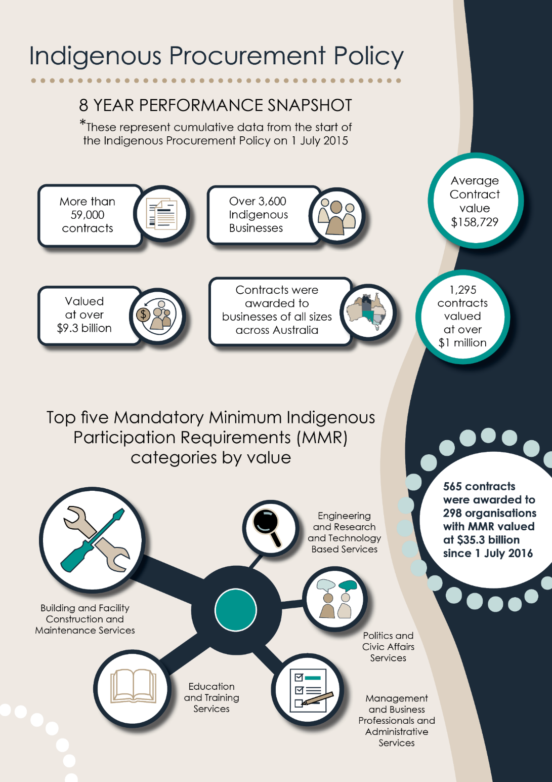

The Commonwealth funds Supply Nation to verify businesses are 50% First Nations owned in line with the IPP eligibility criteria
The Commonwealth funds Supply Nation to maintain a public list of First Nations businesses. Supply Nation uses a five step process to make sure businesses are at least 50% First Nations owned. Supply Nation conduct yearly and spot check audits to ensure the business still meets the criteria.
Joint ventures (JV) have stricter rules. To be eligible for the IPP, JVs must:
- be 50% First Nations owned and controlled
- have a plan to grow:
  - the First Nations business partner’s capability
  - it’s First Nations workforce.
Supply Nation reviews each JV’s progress against these plans every year.
Supply Nation’s work helps governments and the private sector to find First Nations businesses across Australia. They can then make partnerships with or buy from them.
It is free and voluntary to register with Supply Nation. Not all First Nations businesses do.
Supply Nation also asks for First Nations businesses owners to prove they:
- are of Aboriginal and/or Torres Strait Islander descent
- identify as an Aboriginal person and/or Torres Strait Islander
- are recognised as such by his or her community.
To do this, applicants must submit at least one of these:
- A confirmation letter from a recognised institution, like a land council.
- A statutory declaration supported by 2 referees. Roughly 8% of registered businesses used the statutory declaration.
The referees can be from:
- a recognised First Nations organisation
- an organisation Supply Nation says has public standing and credibility to attest to a person’s claim of Indigeneity.
The Australian Securities and Investments Commission (ASIC) tracks ownership information. Supply Nation gets updates about ownership changes in real time and looks into any changes. It reassesses businesses each year for eligibility.
There were 4,638 registered businesses as at 1 November 2023. In 2022–23, Supply Nation:
- did 4,390 audits
- evaluated 853 new registrations.

The National Agreement on Closing the Gap
The National Agreement on Closing the Gap commits the Government to working in partnership with First Nations communities. It is the first agreement to include First Nations Australians. The Coalition of Peaks represents the First Nations party.

Priority Reforms
The National Agreement has 4 Priority Reforms. These are aimed at transforming the way governments work with First Nations people.
- Partnership and shared decision making between Aboriginal and Torres Strait Islander people and governments.
- Building the Aboriginal and Torres Strait Islander community-controlled service sector in agreed outcome areas.
- Transforming mainstream government services to work better for Aboriginal and Torres Strait islander people.
- Building better data and sharing access to the right data to support Indigenous communities to make informed decisions with us.

Employment targets
The National Agreement also has 17 socio-economic targets. These track Australia’s progress in getting better outcomes for First Nations people.
- By 2031, increase the proportion of Aboriginal and Torres Strait Islander youth (15 to 24 years) who are in employment, education or training to 67% (Target 7)
- By 2031, increase the proportion of Aboriginal and Torres Strait Islander people aged 25 to 64 who are employed to 62% (Target 8).
Outcome 8 says to explore ways to track and report on First Nations businesses including:
- number (and as a proportion of all businesses)
- growth and revenue
- sectors and industries.

Outcomes for First Nations businesses
The National Agreement supports investing in First Nations business to get better long-term outcomes for First Nations people. It covers all levels of government in Australia. In line with the Closing the Gap targets and outcomes, the IPP supports:
- meaningful employment
- skills and economic development.
If done well, Commonwealth procurement can:
- grow the number of First Nations businesses
- help First Nations businesses to develop and earn more
- create diversity in the sectors and industries where First Nations businesses work.

Buy Australian Plan
The Commonwealth Government announced its Buy Australian Plan (the Plan) in the October 2022 Budget.
The Plan intends to use government buying power to increase opportunities for Australian businesses, including First Nations businesses.
There are 10 points to the Plan. IPP reform is key to delivering Point 5 – to ‘provide more opportunities for First Nations businesses with a view to maximise skills transfer so that we can get more First Nations workers into long-term skilled work.’
The Government is a major buyer of goods and services across the country. In the 2022–23 financial year, it entered into contracts valued at $74.8 billion in total. This is a big opportunity for all businesses, including:
- First Nations businesses
- small to medium enterprises (SME)
- regional and remote located businesses.
In applying for Government contracts, these businesses face more barriers than others, like:
- less resources
- less awareness of business opportunities.
The Plan will educate businesses to overcome these types of barriers. It will increase access to the market so they have fair and equal opportunity.

Key issues for consultation

The definition of a 50% owned First Nations business may no longer align with community expectations
A positive impact on the economy and society drives Government buyers to choose First Nations suppliers.
All buyers want to be sure that:
- a business is First Nations when it says it is
- First Nations people get direct benefits from business opportunities.
There are multiple perspectives on what a ‘genuine’ First Nations business is
A possible reform is to review what makes a First Nations business eligible under the IPP.
There are many views on how to define a First Nations business. For example, some believe:
- the business should be 100% First Nations owned
- businesses should have rules about First Nations employment or training
- the business should have First Nations values such as giving back to community.
The National Agreement on Closing the Gap defines an Aboriginal and Torres Strait Islander organisation as a business, charity, not for profit organisation, incorporated under Commonwealth, state or territory legislation that has:
- at least 51 per cent Aboriginal and /or Torres Strait Ownership and/or directorship;
- is operated for the benefit of Aboriginal and Torres Strait Islander communities.
In August 2021, the House of Representatives Standing Committee Inquiry tabled its Report on Indigenous Participation in Business and Employment. The report recommends:
- to review the definition of a First Nations business so winning IPP contracts benefits First Nations communities
- that instead of defining only by the percentage of ownership, define by, for example:
  - First Nations staff
  - skills transfer
  - the use of company profits.
Some corporate buyers only want to buy from businesses that meet a higher standard. Supply Nation has developed its own stricter ‘certified’ standard. To get ‘certified’, First Nations businesses must show through their application, business documents and interviews that they are at least 51%:
- owned
- managed
- controlled.
Others think having majority First Nations ownership should be the only definition. Commonwealth procurement is highly competitive. They say First Nations businesses should have an equal chance to compete against non-First Nations businesses.
In their view having staff targets and more reporting, or more rules on First Nations business, would:
- make their work more expensive compared to the businesses they compete against
- make it harder to win contracts and do the work
- make it harder to recruit qualified staff
- reduce the money they make for the work they do.

Managing ‘black cladding’
The Government is aware of community concerns about ‘black cladding’. This is when a business unfairly uses policies not intended for them, like the IPP, to access markets.
There is no agreed meaning for black cladding. People view it in different ways. It is hard to work out if black cladding is a problem with the system.
Some stakeholders, including First Nations businesses, suppliers and service providers, report seeing businesses created so non-First Nations businesses could access preferential procurement.
This is unfair. It disempowers the First Nations owner. It does not deliver meaningful economic benefit to the First Nations party. In some cases, it may be breaking the law.
The Government wants to make sure:
- the IPP eligibility criteria and verification process empowers First Nations business owners to have control over the business’s money and work
- no one is using First Nations businesses and people to access procurement policies or get contracts they would not otherwise be able to
- that corporate and government buyers can be sure that, when they buy from a First Nations business, they are empowering First Nations people and communities.
Since February 2018, Supply Nation has received and investigated 30 written complaints about black cladding. All 30 were unsubstantiated.
Each business met the IPP’s definition of a First Nations business. They were confirmed to be at least 50% First Nations owned.
Most concerns about black cladding are not just about the percentage of business ownership. There are some other key issues of concern:
- Figurehead ownership arrangements – where a First Nations person is used to promote a business but is not involved in its ongoing management and work.
- A business owner’s Indigeneity is questioned.
- First Nations owners are not actively involved or are not included in decision-making.
- First Nations owners got unequal or unfair financial returns from business involvement.
- Low or no First Nations involvement in the business’s work.
- Low rates of First Nations employment.
- Not being upfront about sub-contracting arrangements.
- Poor legal, governance, commercial and financial arrangements.

Employment targets and broader community benefits
Views differ on whether commercial First Nations businesses should have to achieve:
- First Nations employment outcomes
- broader community benefits.
Evidence shows First Nations businesses are more likely to:
- employ First Nations people than their non-First Nations competitors
- provide skills development and training opportunities.
The importance of understanding Indigenous employment in the Indigenous business says, ‘Indigenous owned businesses of all sizes, industries, locations and profit statuses consistently average higher proportional Indigenous employment rates than the Indigenous proportional population. Of all the people employed in Supply Nation listed businesses, over 35% are Indigenous.’
That compares with a 2.2% rate among 42 of Australia’s largest corporations surveyed in 2022.
Case study evidence also shows First Nations businesses can create an environment to foster young First Nations people into long-term career pathways. This gives them self-determination and the ability to build community values.
Some argue First Nations businesses are already doing more than their fair share. The rules meant to create more First Nations jobs should focus on non-First Nations businesses.
The Government heard views that First Nations businesses should operate within the norms and values of First Nations culture and community. They should:
- employ First Nations people where possible
- build skills
- deliver broader benefits for community.
One option is to be more open about First Nations employment. For example, require First Nations businesses to report its First Nations employment rates to the Commonwealth (or Supply Nation).
Another option is for First Nations businesses to have a target on percentage of First Nations staff. They would need to:
- collect information from staff
- prove their employment rates at certain times or on request.

Partnerships, joint ventures and sub-contracting
There are different views on whether partnerships with non-First Nations businesses should be allowed under the IPP.
Fair partnerships can help First Nations businesses access the resources to develop and scale business. JVs can support First Nations business owners to:
- access new opportunities
- achieve self-determination and economic empowerment.
But JVs can take power away when they are formed unfairly. They might have legal, governance and financial agreements that do not favour the First Nations business owner.
Using sub-contractors and services agreements can help a First Nations business access more services, such as:
- IT systems and support
- client management systems
- payroll processing.
This can also allow First Nations businesses to bid for contracts they could not do as an SME. These could have unequal terms which affect the First Nations business’s profits in a bad way.
It is important that the rules make sure that joint venture partnerships are fair.

Capability and capacity of the sector
Demand for First Nations business has grown under the IPP. It is expected to grow more as the businesses get bigger and more able to deliver on contracts of larger scale and value.
Since the IPP began in 2015 the First Nations business sector has grown rapidly. Roughly 17,900 First Nations people identified as business owners in the 2017 ABS Census. This grew from roughly 6,320 new business owners in 2016.
If the definition of Indigenous business changes, First Nations business owners may need to show that they control and manage their business. Some business owners may need support to develop their skills in managing and making decisions about the business.
Reforms may create more contracts of higher value for First Nations businesses. This consultation process will inform whether the First Nations business sector can handle the increase.
First Nations businesses are moving into new sectors and industries. In 2015, First Nations businesses won contracts in 36 industry categories. In 2021–22 this had grown to 51 Industry categories.
Some First Nations businesses have told the Government that they are over capacity. They cannot deliver more work nor respond to requests for quote.
Other First Nations businesses said they could not get contracts with the Commonwealth. They were not getting many requests for quote.

Comparing states, territories and overseas
Most governments in Australia have a policy to buy from businesses with at least 50% First Nations ownership.
The NT stands out. It has a policy to buy from businesses that are:
- At least 51 % First Nations owned
- Aboriginal and Torres Strait Islander people are involved in the daily operation
- Have effective control that is at least equal to the degree of ownership
- Registered with a certifying authority.
There are some state- or territory-focused:
- First Nations business registers
- Indigenous Chambers of Commerce.
Overseas, there’s a trend to 51% ownership by minority individuals to get certain benefits. The United States and South Africa use this rule.
In 2022, Canada’s National Indigenous Economic Development Board reviewed Canadian and international definitions. It proposed to define minority ownership based on 51%. This is in line with many similar Canadian registries.

First Nations business support and access to capital
The Government funds support for First Nations business owners, including:
- Indigenous Business Australia’s (IBA) and its Business Solutions Program (BSP)
- Indigenous Business and Employment Hubs in Sydney, Perth, Adelaide and Darwin.
The Government also funds the Australian Institute of Company Directors to give scholarships to First Nations leaders. This helps to build governance capability.
Indigenous Business Australia
IBA provides:
- business support and access to capital for First Nations businesses at all stages
- access to other experts for special support, like dealing with business risk.
Through its Business Support Program, businesses can get help with finance. The BSP focuses on:
- new entrepreneurs
- businesses that cannot access commercial finance.
IBA can:
- start and manage capital products
- build and develop the commercial ability of First Nations entrepreneurs
- support businesses to grow.
It depends on the business needs. IBA may deliver these services direct to the business or in partnership. Or it can contract with other business support providers (including other government agencies).

IBA has ways to help its clients through all stages of business development. This can include help to:
- seek advice on ways to return to profitability
- trade out of trouble
- exit a business as needed.
IBA has a program for First Nations women in business called ‘Strong Women. Strong Business.’ The network supports First Nations women entrepreneurs.
Indigenous Business and Employment hubs
The hubs help get businesses off the ground in lots of ways. They:
- connect First Nations businesses and suppliers doing major projects
- support businesses, like through giving advice to get the most out of partnerships with non‑First Nations businesses.
The hubs will provide more resources and training to help First Nations businesses get more from business partnerships.

Core IPP reform proposals
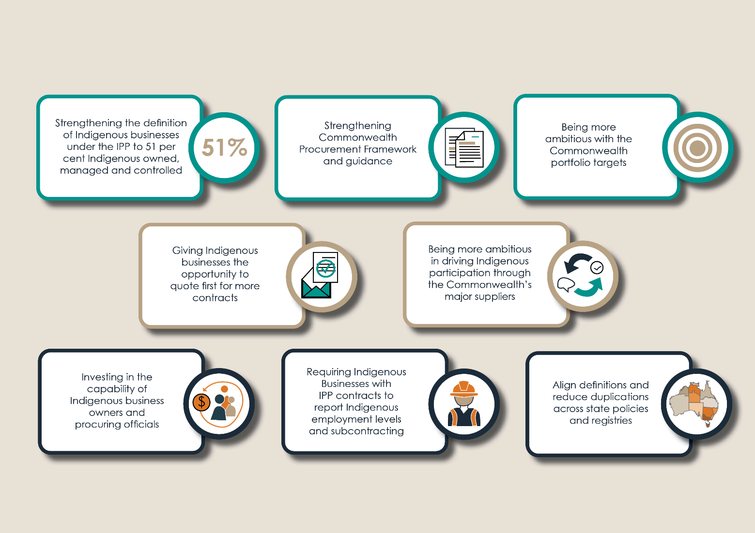

Strengthening the IPP definition of a First Nations business
A stronger definition of First Nations businesses is proposed. The current definition is 50% First Nations owned.
The proposal is to change the definition in the IPP so that a business must either be 51% First Nations owned, managed and controlled, or registered with ORIC.
The IPP intends for benefits to flow to First Nations people. Changing the definition is key to the IPP having stronger goals and impacts.
Requiring 51% ownership, management and control should support First Nations business owners to achieve self-determination. It should affect:
- how the business operates
- how profits and proceeds are distributed
Using this definition, First Nations business owners would have the power to decide whether, and how they want their business to give benefit to First Nations people and communities.
Some stakeholders have said publicly that they want this definition to be used, including:
- Supply Nation
- the National Indigenous Business Chambers Alliance.

Defining ownership, management and control
These are the proposed ways to define ownership, management and control.
Ownership – minimum 51% owned by First Nations people
Ownership would be determined from information in:
- application documents
- a site tour
- an interview
- a company ASIC search.
The information would show:
- 100% First Nations ownership if it is a sole proprietorship/trader
- 51% First Nations ownership if it is a partnership – each class of partnership interest must be First Nations owned and shown in the partnership agreement
- at least 51% of voting shares or other class of shares issued to First Nations people if it is a corporation or company
- majority beneficial First Nations owner(s) of securities or assets held in a trust
For corporations:
- with 5 or more members – at least 51% of the members are First Nations
- with 2 to 4 members – all but one member is First Nations
- with one member – that individual is First Nations.

Management – Managed by First Nations people
- There is evidence that First Nations interests have the demonstrated ability to, and actually exercise control over independent business decisions required to guide the future direction of the business, and the business’s operations, management, policies, and staffing.
Control – minimum 51% controlled by First Nations people
A First Nations person must hold the highest position in the business. That person must have authority to:
- influence the management, policies and strategic direction of the business
- make their own long-term business decisions to guide the direction and purpose of the business.
There are different terms of control depending on the type of business.
- Partnerships – one or more First Nations people must be general partners. They control all partnership decisions.
- Corporations – The Board of Directors must be under the control of Indigenous applicants upon whom eligibility is based. The board must operate within codified rules that ensure the Indigenous director(s) representing the Indigenous majority shareholder can exercise control over decision making.
- Trusts – the trustee must be First Nations or a majority First Nations owned and controlled commercial entity.

Stronger verification process
The verification process would change to make sure a business is 51% First Nations owned, managed and controlled. It would be like Supply Nation’s existing ‘Certified’ criteria.
The process would confirm First Nations people:
- own at least 51% – by checking the confirmation of Indigeneity documents against share structures on ASIC and/or other documentation, like partnership documents or trust deeds
- have most executive and board positions by checking the:
  - confirmation of Indigeneity documents
  - organisational charts
  - ASIC registration
  - partnership documents or trust deeds.
The process would also check that First Nations people manage and control the business. It would make sure First Nations parties could not be excluded from formal decision-making.
This could include:
- checking ASIC, ABNs, shareholding and directorship extract to confirm First Nations control of the board (for companies)
- checking a provided statutory declaration saying the First Nations party’s involvement in the business (for other businesses)
- making sure the business governance is equitable through looking into the:
  - company constitution
  - joint venture agreements
  - shareholders agreements
  - shared services or commercial agreements with non-First Nations partners.
- doing an annual interview or site visit to confirm the level of control and management from First Nations parties.
When there is a complaint or concerns, verification may ask for:
- financial information, such as financial statements
- evidence of payments between parties.
The business would need to produce these to show it is acting:
- in line with agreements
- with benefit to the First Nations party.
Extra rules for First Nations JVs may still apply.
Other options to have stronger verification include rules for:
- First Nations businesses to do a short training course during the registration process
- the business to prove the First Nations party got independent advice on legal and governance documents – this would be for JVs and business partnerships.

The Government thinks the sector is ready for this change. As at November 2023, more than 86% of Supply Nation businesses were already at least 51% First Nations owned. Many already show First Nations management and control through yearly interviews. Those who do not would have enough time – probably 12 months – to change.
Some businesses would not be eligible to access the IPP anymore. For example, JVs where the capability partner does not accept minority ownership.

Tackle black cladding
The Government proposes the following.
- Fund business and legal services to give some First Nations businesses advice on black cladding. This would be for businesses that are most vulnerable. There would be a means and merit test.
- Establish a black cladding taskforce to find ways to address black cladding through regulations. The taskforce would include:
  - key regulators
  - people from First Nations business
  - people from the legal sector.

Other options to explore through consultation

Strengthen Commonwealth Procurement Framework and Guidance
The Commonwealth Procurement Framework sets out the rules for managing procurement and contracts. There are resources online to help know the process for:
- government buyers
- businesses wanting to work with government.
The consultation will look at stronger guidance material about value for money to benefit the Australian economy. This may include guides for buyers about what to think about when assessing tender proposals.
It might look into preferring tenders that show economic impact, such as through:
- high levels of First Nations business ownership and involvement
- commitment to more First Nations employment
- qualifications or skills development
- commitment to using First Nations business in the supply chain
- commitment to partnering with First Nations organisations
- broader economic benefits to First Nations communities.
A new framework would:
- make sure suppliers and government buyers comply with their duties under the IPP
- strengthen the ability of Commonwealth contracts to audit and confirm First Nations participation, benefit and IPP eligibility.

Be more ambitious with the Commonwealth portfolio targets
Under the IPP, the Commonwealth commits to 3% of the number and value of contracts with First Nations businesses by 2027–28. The Commonwealth is already hitting these targets.
When working out the value target, some contracts are exempt. This includes for services for certain specialised goods or services which could not be awarded to First Nations businesses.
This halves the value of the target which agencies measure their success against.
The proposal is to change how Commonwealth Portfolio IPP targets are calculated. It would include more contracts in the total value which the Portfolio targets are measured against.
Some specialised contracts would still be exempt. The proposal would consider whether the First Nations business sector can do these types of services.
This would:
- make the targets more ambitious
- drive extra demand for First Nations businesses
- more closely align Portfolio contract value targets to the total value of contracts shown on AusTender – making reporting more transparent.
The NIAA looked at the 2020–21 financial year value targets including the exempt contracts. It expects most agencies could meet a new target made on this basis.
Agencies’ usual procurement would absorb the change. This should not create more contracts in the areas that are exempt.

Give First Nations businesses the chance to quote first for more contracts
Under the IPP’s MSA, First Nations businesses must have the chance to quote first for:
- contracts valued between $80,000 and $200,000
- procurements in remote areas.
The Government proposes to:
- change the contract value to $80,000 to $500,000
- promote engaging First Nations businesses for contracts valued at less than $80,000.
Data demonstrates a clear growth in the number of First Nations businesses contracted within the MSA range compared to outside the range. This shows the MSA has successfully driven First Nations business opportunities.

Address barriers created by procurement panels
First Nations businesses report that panels are a barrier for them. Panels are whole-of-government arrangements for procurement.
The Commonwealth is looking at how to address barriers from panels including through:
- activities to improve First Nations businesses’ ability to tender for government contracts
- ways to grow the number of First Nations business on panels
- new guidance about how often to refresh panels.

Be more bold in driving First Nations participation through major suppliers
The Commonwealth’s biggest suppliers have a role in First Nations economic empowerment. The First Nations participation targets reflect this.
Under the IPP’s MMRs, First Nations staff or businesses must be involved in delivering contracts valued above $7.5 million across 19 industries. The targets at a minimum are 3 or 4%. Targets are higher in remote areas based on First Nations population.
Suppliers can choose to set their target against:
- employment
- supply use
- a combination of both.
They report how they perform to the NIAA each quarter.
These targets have done well to get employment outcomes. The average First Nations employment rate for MMR contracts is 4.5%.
The Commonwealth is considering options like:
- applying the targets to contracts above $4 million
- applying the targets to a bigger list of industries
- a higher target of 5% by 2030
- major suppliers being more transparent about how they perform. For example public reporting of outcomes of major suppliers against First Nations employment and supplier use.

Invest in the capability of First Nations business owners and procuring officials
First Nations businesses have said Commonwealth procurement processes are complex and hard to use. In their view opportunities and outcomes are not clear. Some said they did not get much feedback on why they did not win a tender.
The Government is making new resources and policy guidance. It is developing training to make procurement processes more clear and open. This includes targeted support for First Nations businesses on procurement opportunities with:
- a refreshed ‘Selling to Government’ website
- learning events.
To build government buyers’ capability, they would have:
- best practice policy guidance
- procurement training.

Require First Nations businesses accessing contracts under the IPP to report First Nations employment levels
Registered First Nations businesses do not need to report on First Nations employment.
Access to high quality data on jobs created through First Nation’s businesses would support:
- evidence-based policy development
- understanding of the impact of the First Nations business sector on empowering First Nations people.
It is proposed that contracts require First Nations businesses to report on First Nations employment or supplier use. This would result in better data on how the IPP is driving First Nations employment outcomes.
This would mean First Nations businesses would need to keep good records of their First Nations employees. They may need to provide information of the number of First Nations staff in their reporting under Government contracts.

Increase visibility of subcontracting through reporting
Subcontracting is legal and used widely in Commonwealth procurement. Businesses often subcontract to gain specialist or technical skills to:
- deliver a project that includes work the business does not have the skills to do
- help deliver large-scale contracts or projects.
There have been concerns that First Nations businesses (mainly those in JV or partnership arrangements) subcontract most work to non-First Nations people or businesses. They may use uncommercial terms – that is, the First Nations business does not get much money for the work.
The proposed changes intend to avoid making it hard for First Nations businesses to grow and compete with other businesses. There could be rules for reporting subcontracting arrangements for better transparency.

Align definitions and reduce duplication across state policies and registries
The definition of a First Nations business could be better aligned across state, territory and federal governments.
At the moment First Nations businesses may register on multiple First Nations business registries. They might have to do this, or they may get benefits from it. This is especially true for businesses wanting to work in more than one jurisdiction.
In 2022 the Australasian Procurement and Construction Council surveyed 30 First Nations businesses. It found nearly 89% were at least registered with Supply Nation.
Of the 21 who were on multiple directories, most said this was to:
- access more ways to win work nationally
- get greater recognition and exposure.
Those who were registered on only one directory reported reasons like:
- not being aware of other directories
- cost
- limited time and resources.
This would need to be explored with each state and territory government.

Prioritise Aboriginal and Torres Strait Islander Community-Controlled Organisations
Priority Reform 2 of the National Agreement on Closing the Gap commits Government parties to building formal Aboriginal and Torres Strait Islander community-controlled sectors.
The IPP does not currently prioritise any specific type of First Nations business or organisation.
It is being considered whether Aboriginal and Torres Strait Islander community-controlled organisations should be prioritised over other First Nations businesses or organisations (where value for money is met) to support building the community-controlled sector.

Discussion questions on the future of the IPP
First Nations businesses
How would the proposed reforms impact on your business?
We are interested in understanding the impacts of the proposed changes on First Nations business:
- that are positive, such as:
  - giving buyers more confidence that they are buying from a First Nations business
  - creating more opportunities for First Nations business.
- that are negative, such as the business no longer being:
  - eligible to access IPP opportunities anymore
  - able to deliver services to the Commonwealth Government
  - viable or able to work.
- that related to financial, administrative and commercial activities, and how well you can absorb these costs, including:
  - changing your structure to meet stricter eligibility criteria
  - professional fees with updating governance and ownership documents like company constitutions or shareholders agreements
  - collecting and giving documents under registration and annual reporting rules to show First Nations management and control (for example, organisational structures showing First Nations board members/managers; taking part in interviews to confirm involvement).
- that relate to showing value-for-money when competing for Commonwealth contracts.
We also want to know if First Nations businesses want broader economic and social outcomes in the IPP eligibility criteria. First Nations businesses might have to reach and report on employment or training outcomes – which could raise costs.
Do you consider the proposed reforms will increase confidence in the First Nations business sector?
We are interested in whether the reforms will raise buyer confidence that buying from First Nations businesses helps First Nations people and communities.
Do you consider the proposed reforms will be effective in preventing black cladding?
We are interested in whether the proposed changes will:
- empower First Nations business owners
- meaningfully address black cladding
- balance building confidence in the First Nations business sector with the need to make the rules for Indigenous businesses stricter - which could make it harder for First Nations businesses to compete and make money.
How could IPP reforms be improved to deliver opportunities and outcomes for your business?
We are interested in how the proposed reforms can be:
- improved
- more impactful for First Nations businesses.
What suggestions do you have to ensure successful implementation of the changes?
We are interested in how the NIAA can transition well to a new definition, including timing with:
- talking about changes
- verification processes
- Commonwealth procurement processes.
We are interested in understanding what supports or training could help businesses to:
- meet stricter rules
- take part in Commonwealth procurement opportunities.
Other stakeholders
How would these reforms impact on your organisation?
We are interested in understanding:
- if the proposed changes are achievable for:
  - higher First Nations participation targets
  - reporting requirements.
- the good and bad impacts the changes would have on your organisation, including flow-on impacts to:
  - eligibility for services
  - administration
  - IT infrastructure, systems or business processes to support the changes
  - the way you collect, use and record data.
Do you consider the proposed reforms will increase confidence in the First Nations business sector?
We are interested in understanding if the proposed reforms will grow buyer confidence that a business is a genuine First Nations business.
What suggestions do you have to ensure successful implementation of the changes?
We are interested in views on:
- implementation
- timing
- transitional arrangements.
How could the proposed reforms be improved to deliver greater benefit to the First Nations business sector, or economy more broadly?
We are interested in hearing other options and new ideas for reform.
Do you have any other suggestions to ensure the IPP contributes to Closing the Gap economic participation outcomes?
We are interested in:
- finding ways to partner with the right stakeholders in the First Nations business sector
- how to best facilitate shared decision-making and local focus.

Next steps
Responses to this discussion paper will inform further engagement with stakeholders, such as:
- First Nations businesses
- government agencies
- service providers.
Responses will inform future consideration on possible IPP and Buy Australian Plan policy reforms.
For questions about this discussion paper or how to submit responses, email IPPreform@niaa.gov.au.
Submissions close 1 March 2024.
To make a submission:
- submit a detailed response to the discussion paper through the NIAA website - https://www.niaa.gov.au/indigenous-affairs/economic-development/indigenous-procurement-policy/submit-your-response-discussion-paper
- email IPPreform@niaa.gov.au

Copyright notice
Copyright in material sent to the National Indigenous Australians Agency (the Agency) resides with the authors(s). ‘Material’ includes anything submitted to the Agency in response to IPP Reform Discussion Paper 2023, including artistic works such as artwork, poems, songs, etc.
In providing submissions(s) you grant a permanent, irrevocable, royalty free licence to allow us to use, reproduce, publish adapt, perform or communicate to the public any of your material(s) on the website, including converting your material(s) to a different format for use in reporting or other communication channels.
Any submissions published or used by the Agency are done so under a Creative Commons Attribution License.
Do not send us material for which you are not the copyright owner. If you send us material for which you are not the copyright owner, you warrant that you have obtained all necessary licences and consents required for the use of those materials (including for us to use, reproduce, publish, perform or communicate to the public), and are liable for the payment of any royalties or other fees payable in respect of the use of such material. The Agency is not responsible or liable for any loss, damage or injury suffered or allegedly suffered as a result of the use of material provided to the Agency in response to the submission.
Please ensure that any material containing Indigenous knowledge of Indigenous Cultural and Intellectual Property does not include any sensitive information that you are not comfortable with being published or do not have permission to publish or share.

Privacy Collection Statement

The National Indigenous Australians Agency (NIAA) welcomes your participation in the consultation process to support reform of the Indigenous Procurement Policy (IPP). Your personal information is protected by law, including the Privacy Act 1988 (Cth) (Privacy Act) and the Australian Privacy Principles (APPs). This Privacy Notice describes how the NIAA collects your personal information pursuant to Australian Privacy Principle 5.
We collect your personal information where it is reasonably necessary for or directly related to the performance of NIAA’s functions or activities. Providing the requested information is voluntary. Anonymous responses or responses under a pseudonym will be accepted, however if you choose not to provide us with certain information we will be unable to invite you to future consultations on the IPP or provide further updates. NIAA is collecting your personal information so we can:
- record who participated in consultation processes and be able to contact respondents on matters related to the IPP consultation;
- be able to contact at a later stage those respondents who sought to be contacted about this consultation and the IPP reform more broadly;
- arrange face-to-face interview sessions with respondents who request this form of consultation;
- publish written submissions online;
- publish a consultation report on the NIAA website summarising key themes of consultation feedback. Personal information will not be included in this report without express consent.
- record and analyse survey responses to inform IPP reform and policy development;
- provide information and impact analysis to the Minister or other Commonwealth Minister’s and agencies to inform government consideration on IPP reform and implementation.
NIAA will only accept submissions from those aged 18 years and above. Please do not include personal information about other individuals in your submission.
NIAA will request each respondent’s name, email addresses, phone number, name of organisation(s), and submission or comments. Additional information relating to the business or organisation, industry sector, location and level of Indigenous ownership may also be requested to inform analysis of the impact of IPP reforms. NIAA will only accept submissions from those aged 18 years and above. The information collected will be retained by NIAA indefinitely to meet NIAA’s record keeping obligations under the Archives Act 1983 (Cth).
NIAA will also record respondents’ name, email addresses, phone number and name of organisation(s) in NIAA’s Customer Relationship Management (CRM) system. NIAA will collect this information to ensure we have an understanding of our stakeholders and who has participated in the consultation process. The content of your submission or comments will not be recorded in the CRM system.
NIAA will collect your personal information for the purposes of sending you updates and other communications related to IPP reforms to you. NIAA uses a third party provider, Campaign Monitor, to send you IPP reform updates when you subscribe. If you subscribe to receive our updates:
- Campaign Monitor will collect your personal information for the purposes of sending you updates and other related communications to you.
- Campaign Monitor records IP addresses and uses cookies, web beacons, local storage and session storage. They collect this information when you access our email communications. They use this information for the purpose of providing their subscription service, and to measure its performance.
- Campaign Monitor may transfer this information to its contractors or other third parties if they process information on Campaign Monitor’s behalf, or where otherwise required to do so by law.
- Campaign Monitor is a multinational entity. They will transmit and store information on servers located outside of Australia. The Privacy Act 1988 may not protect the information they collect. You may not be able to seek redress under it.
- You can find out more about how personal information held by Campaign Monitor is handled in accordance with Campaign Monitor's Privacy Notice and Terms of Use.
NIAA may provide collected personal information to other Commonwealth agencies who are supporting NIAA in the reform of the IPP. De-identified information may be disclosed to other Commonwealth agencies such as Department of Finance, Department of the Prime Minister and Cabinet, Department of Industry, Science and Resources, the Office of Impact Analysis, and relevant cross agency working groups and committees to inform and progress IPP reform. We may also provide this information to Commonwealth Ministers, and a third party contractor as part of public consultations on the reform of the IPP. NIAA will not provide the information collected from you to anyone else outside NIAA, other than to those outlined above, unless you have given consent for us to do this, or we are authorised or required to do so by law.
The privacy and security of your personal information is important to us, and is protected by law. NIAA’s Privacy Policy explains how NIAA handles and protects the information provided by you. NIAA’s Privacy Policy also explains how you can request access to or correct the personal information we hold about you, and who to contact if you have a privacy enquiry or complaint. To find out more about how we manage personal information you can contact: privacy@niaa.gov.au.

Indigenous Procurement Policy | National Indigenous Australians Agency (niaa.gov.au)
National Agreement on Closing the Gap | Closing The Gap
7B. Table B: Outcome 8
Buy Australian Plan | Department of Finance
House of Representatives Standing Committee on Indigenous Affairs, August 2021 Report – Parliament of Australia (aph.gov.au)
Hunter B 2015. Indigenous employment and businesses: Whose business is it to employ Indigenous workers? : Canberra, ACT: Centre for Aboriginal Economic Policy Research (CAEPR)
Eva C, Bodle K, Foley D, Harris J, Hunter, B 2023. The importance of understanding Indigenous Employment in the Indigenous business sector, Canberra ACT, Centre for Social Research Methods
Morrison M, Collins J, Krivokapic-Skoko B, Basu P 2017. Differences in the economic and social contributions of private and community-owned Australian indigenous businesses
Woort Koorliny – Australian Indigenous Employment Index
Fordham AE, Robinson GM & Blackwell BD 2017. Corporate social responsibility in resource companies–Opportunities for developing positive benefits and lasting legacies. Resources Policy 52:366-76.
PM&C 2018a. The Indigenous Business Sector Strategy
PM&C 2019a. Third Year Evaluation of the Indigenous Procurement Policy
NIAA analysis of Australian Bureau of Statistics (2022) 2021 Census of Population and Housing, [Census Table Builder], accessed 19 April 2023
Aboriginal procurement policy | NT.GOV.AU
Defining Indigenous Businesses in Canada (February 2021)
‘Are you registered in Multiple Directories?’ Survey by the Australasian Procurement and Construction Council, April – May 2022

