Indigenous Ranger Sector Strategy
2022–2028
Consultation Draft
April 2022
Indigenous Ranger Sector Strategy 2022–2028 – Consultation Draft
(April 2022)
© Commonwealth of Australia 2022
Copyright Notice
With the exception of the Commonwealth Coat of Arms, this work is licensed under a Creative Commons Attribution 4.0 International licence (CC BY 4.0)
( https://creativecommons.org/licenses/by/4.0/ ).
Third party copyright
Wherever a third party holds copyright in this material, the copyright remains with that party. Their permission may be required to use the material. Please contact them directly.
Attribution
This publication should be attributed as follows:
© Commonwealth of Australia, National Indigenous Australians Agency, Indigenous Ranger Sector Strategy 2022–2028 – Consultation Draft (April 2022)
Use of the Coat of Arms
The terms under which the Coat of Arms can be used are detailed on the following website:
https://pmc.gov.au/cca
Other uses
Enquiries regarding this document are welcome at:
www.niaa.gov.au/indigenous-ranger-sector-strategy

The National Indigenous Australians Agency acknowledges the traditional owners and custodians of Country throughout Australia and acknowledges their continuing connection to land, waters and community. We pay our respects to the people, the cultures and the elders past, present and emerging.
We want to hear from you
This Consultation Draft of the Indigenous Ranger Sector Strategy has been released for feedback and comment. Consultation is open until Tuesday 31 May 2022.
We invite you to have your say by:
- completing a survey;
- participating in an online workshop; and/or
- providing a written submission.
Go to www.niaa.gov.au/indigenous-ranger-sector-strategy for details.
A Conversation Guide and Information Sheets are also provided to assist you.
Contents
Part A: Introduction 4
What is the Indigenous Ranger Sector? 5
About this Strategy 7
Overview 7
How will a national approach work? 9
The Role of the NIAA 10
Part B: The Strategy 11
Description of the Sector 12
Challenges and Opportunities 15
What Indigenous ranger organisations told us 15
Opportunities 17
Key Directions 18
Strategic Intent 18
An integrated national approach 19
Implementation 21
Governance 23
Governance Bodies 23
Proposal for an Indigenous Ranger Industry Body 23
Monitoring, Evaluation and Reporting 24
Actions 25
1. Strong Country 25
2. Strong Economy (Skills) 27
3. Strong Economy (Jobs) 30
4. Strong Economy (Business) 32
5. Strong Culture 34

Part A:
Introduction

What is the Indigenous Ranger Sector?
Indigenous people in Australia have been managing land and waters sustainably for 60,000 years.
Australian governments, industry and communities acknowledge Indigenous peoples’ critical and continuing role in managing Australia’s unique natural and cultural heritage through Indigenous models of sustainable land and water management.
The Indigenous ranger sector is comprised of community-based organisations that operate ranger groups to carry out management of Country in their regions. They operate throughout Australia on a variety of land, water, coastal and marine areas. These may include Indigenous land and waters, native title areas, dedicated Indigenous Protected Areas, co-managed national parks, other conservation reserves and pastoral land. Predominantly, funding and resources for their activities are provided through grants from the Australian, state and territory governments, partnership arrangements, other independent sources and provision of commercial services.
Indigenous rangers are often the main or only land and water managers in vast remote and regional areas. For example, they operate in nearly 70% of Indigenous Protected Areas which comprise half of Australia’s National Reserve System. They are skilled, professional workforces that use traditional knowledge and western science (‘two-way’ knowledge) to protect and improve the integrity of landscapes, biodiversity and cultural heritage. Ranger activities include biodiversity risk mitigation, weed and feral animal control, environmental regeneration, drone operations, traditional burning, carbon abatement, biosecurity and fisheries compliance, water quality monitoring, area and infrastructure maintenance, visitor management and heritage protection.
Country, culture and community are intrinsically connected and imperative to Indigenous Australians’ overall wellbeing. In caring for Country Indigenous rangers make a vital contribution to their communities’ aspirations for connecting to Country and overall economic, cultural and social wellbeing.
Ranger operations support Traditional Owners and communities in their cultural obligations to care for Country. They assist many people to reconnect with and strengthen their bonds with Country. Through youth programs rangers assist traditional knowledge transfer between generations and development of pathways into employment for young people.
Indigenous ranger organisations offer meaningful jobs for Indigenous people, especially in remote and regional areas where there are limited employment opportunities. The work and associated skills development offers opportunities to build career and leadership pathways within ranger organisations, the wider land and water management sector, other industries and in commercial enterprises. Ranger employment also builds the human capital and financial resources within communities which supports community-led development.
Through delivering Indigenous ranger projects, organisations develop and strengthen culturally appropriate governance and decision-making frameworks that are also important for achieving communities’ aspirations for their futures.
Knowledge-sharing between ranger groups and other land and water managers has built bridges between cultures and contributes to broader reconciliation efforts.
Indigenous rangers are growing as a significant sector in land and water management.
The number of Indigenous ranger groups and their areas of operation have greatly expanded. Ranger groups now operate throughout Australia and are supported by several Australian, state and territory programs. Many Indigenous-led and private sector partnerships have also been developed to support ranger environmental activities, research and monitoring and extend their scope to ventures such as carbon abatement schemes.
Recognition of the particular skill sets of Indigenous land and water managers has led to increasing opportunities for ranger groups to apply their management knowledge and techniques to biodiversity conservation, fire management, carbon abatement and climate change resilience activities.

About this Strategy
The Indigenous Ranger Sector Strategy supports the successful growth and empowerment of Indigenous ranger operations throughout Australia.

Overview
The Strategy aims to support the aspirations of Indigenous Australians to care for Country and to amplify the environmental, cultural, economic and social outcomes possible where Indigenous ranger projects are operating.
Indigenous ranger activities are strengthening the overall wellbeing and social cohesion of their communities. The Strategy will build on this to achieve:
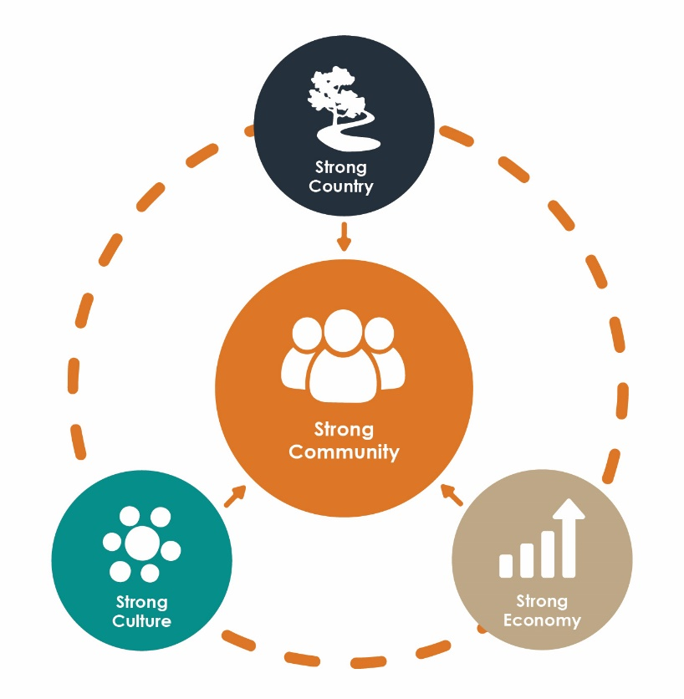
Strong Country – through enhancing Indigenous rangers’ effectiveness in caring for Country and engaging in land and water management, including climate change resilience. This will have positive outcomes for Indigenous communities, their regions and Australia as a whole;
Strong Economy – building human capital and greater resources through skills development, employment, career and youth pathways and business opportunities;
Strong Culture – protection and strengthening of culture and knowledge through connections with Country, inter-generational knowledge transfer, and building understanding and respect among partners.

There are emerging land and water management opportunities that can benefit the Indigenous ranger sector.
The Strategy aims to support Indigenous rangers in taking up opportunities to further participate in regional land and water management, provide services and develop businesses, should they wish to do so.
This is a critical time to plan for sector development and growth. Government agencies, industry, research institutions and the conservation sector are increasingly entering into partnership with ranger organisations and other Indigenous land and water managers to deliver environmental projects and services. The broader community is now recognising the benefits of harnessing Indigenous knowledge and experience to mitigate climate change impacts, protect environments and biodiversity and build greater resilience to bushfires, droughts and floods.
Indigenous ranger organisations face inter-linked challenges that need tailored, place-based solutions.
Indigenous ranger organisations and communities are seeking greater empowerment through Indigenous-led solutions that meet their particular needs and aspirations.
The Strategy seeks to respond to the varied Country management aspirations and capacity development needs among different Indigenous ranger organisations and communities.
The Strategy is proposed to be an integrated, national approach that will be relevant to all Indigenous ranger organisations, governments and private sector stakeholders.
It is proposed to cover all Indigenous ranger organisations including those funded by Australian, state and territory governments or independent sources.
The Strategy will be implemented in a collaborative, flexible manner across Australian, state and territory agencies, Indigenous organisations, and the private sector. It encourages cooperative regional approaches.
The Strategy is informed by and will contribute to broad strategies to work with and support Indigenous Australians to achieve improved life outcomes, including:
- The National Agreement on Closing the Gap, agreed between all governments and Indigenous representatives.
- The National Roadmap for Indigenous Skills, Jobs and Wealth Creation.

How will a national approach work?
The proposed integrated, national approach will be implemented collaboratively by stakeholders through:
- a Vision and agreed National Principles – proposed National Principles are on
page 22;
- lead actions – these are high level actions founded on key outcomes sought by Indigenous ranger organisations for Strong Country, Strong Economy (Skills, Jobs, Business) and Strong Culture (pages 28-39)
  - Some of these will involve stakeholders working together collaboratively to co-design solutions and investigate, facilitate or leverage opportunities, including across regions, jurisdictions and agencies.
  - Other actions will be implemented by jurisdictions and stakeholders, as relevant to their programs or context;
- implementation plans – detailed actions will be refined for delivery through organisational, agency, multi-stakeholder or regional implementation plans, depending on the circumstances. Where Indigenous ranger organisations and stakeholders agree, a regional approach to implementation to achieve place-based solutions is encouraged;
- a staged approach – the actions will be implemented in stages (short, medium and long term) over the six years of the Strategy (pages 23-24);
- governance arrangements – establishment of an Indigenous Ranger Reference Group is proposed to advise on implementation of the Strategy and evaluation of its success (page 25). A cross-jurisdictional working group is proposed to oversee coordination and collaboration between Australian, state and territory agencies;
- monitoring, evaluation and reporting as a basis for measuring success and adapting to change (page 27). An evaluation of the Strategy will be conducted at year five.

The Role of the NIAA
This strategy was developed by the Australian Government’s National Indigenous Australians Agency (NIAA) in consultation with Indigenous ranger organisations, Australian, state and territory government agencies and other stakeholders.
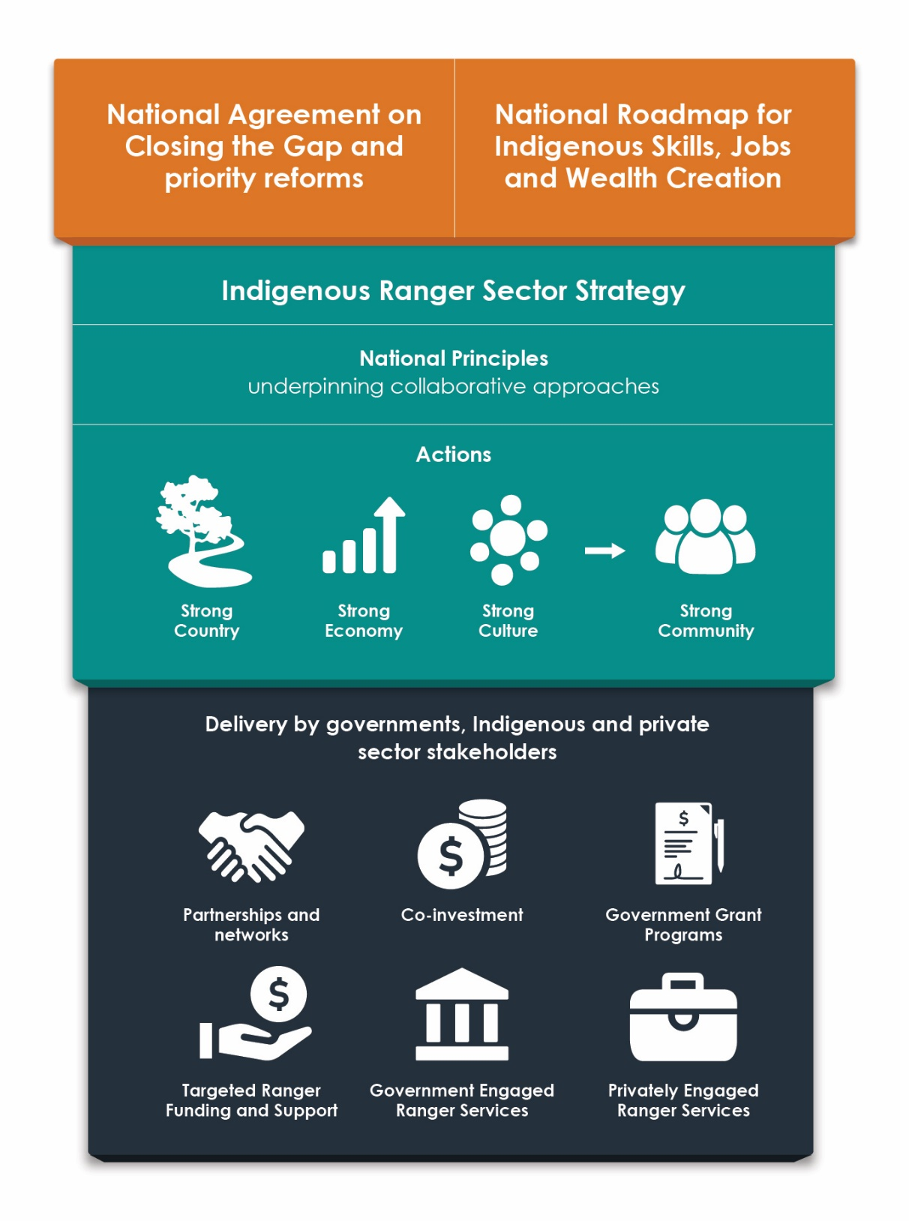
As described in Figure 1, this Strategy proposes an integrated, sector-wide approach. The NIAA will lead collaborative implementation of the Strategy by applying the National Principles and through consultative mechanisms with agencies and stakeholders at jurisdictional and regional levels.
Figure 1: An integrated national approach to the Indigenous Ranger Sector Strategy

Part B:
The Strategy

Description of the Sector
We are seeking information on Indigenous ranger groups’ location.
In the final Strategy a map will show the wide spread of government and independently funded ranger groups throughout Australia.
Please send the name of your ranger group and its location
(the community where it is based) to IndigenousRangersConsultation@niaa.gov.au.
Figure 2: Location of Indigenous ranger groups

Indigenous people in Australia have a 60,000 year history of sustainable land and water management. Over that time they have developed substantial knowledge of their Country that is embedded in their culture and traditions.
The establishment of Indigenous ranger organisations recognises Indigenous peoples’ knowledge and traditions and supports their continuing management of their Country.
Indigenous ranger organisations were first funded through the former Working on Country program operated by the Australian Government in 2007. Since then, the increasing number of Indigenous ranger groups has developed into a sector that provides land and water management throughout Australia. Indigenous ranger organisations operate on a variety of areas, including Indigenous land and waters, native title areas, dedicated Indigenous Protected Areas, co-managed national parks, other conservation reserves and pastoral land.
As at 2021, there were approximately 170 community-based Indigenous ranger groups funded under Australian, Queensland or Western Australian Indigenous ranger programs. The Northern Territory, South Australian and Victorian governments support Indigenous ranger operations under a variety of arrangements. In NSW many Local Aboriginal Land Councils operate Indigenous ranger groups. There are also a number of independently-funding Indigenous ranger groups throughout Australia.
Growth of the sector is continuing. In 2021 the Australian Government provided seven-year funding to groups under the Indigenous Ranger Program and formed a new Murray-Darling Basin River Rangers Program. Both the Queensland and Western Australian governments have announced expanded investment in new funding rounds of their Indigenous ranger programs.
Further growth of the sector is likely through opportunities now emerging in biosecurity management, climate change mitigation and adaptation, and ocean and reef protection.
In 2021, Indigenous rangers made a substantial contribution to the sustainable management and mitigation of biosecurity risks to Australia’s environment, including in remote lands and coastal waters. The Australian Government’s Indigenous Rangers Biosecurity Program supports existing ranger groups to help protect Australia against biosecurity threats in 64 areas, including for 10,000 kilometres of coastline across Northern Australia.
Indigenous rangers also manage large areas of Australia’s National Reserve System and contribute to meeting Australia’s obligations under international environment-related conventions. In remote and semi-remote areas, Indigenous rangers are often the only or major on-ground land and water managers.

The projects undertaken by Indigenous rangers are tailored to their particular Country and management goals. Examples of projects conducted by ranger groups are:
- Monitoring and managing wildlife (e.g. threatened animal habitat, turtle rescue and rehabilitation, crocodile management)
- Fire management (e.g. cultural burns, fire suppression, carbon abatement)
- Controlling weeds and revegetating land (e.g. native planting, mimosa control)
- Freshwater management (e.g. wetland fencing, waterhole maintenance)
- Controlling feral animals (e.g. feral pig control, cat hunting)
- Sea Country management (e.g. Traditional Use and Marine Resource Agreements (TUMRAs), ghost net removal, climate change research)
- Biosecurity and fisheries compliance (e.g. monitoring, recording, reporting unusual biosecurity activities)
- Managing and educating visitors (e.g. promoting walking trails, maintaining sites)
- Protecting and maintaining cultural sites.
Working closely with Traditional Owners and communities, Indigenous rangers facilitate ongoing connection with Country, transfer of knowledge between generations and strengthening of cultural identity. They support Country and cultural training for Indigenous young people through school programs.
Indigenous ranger positions are highly valued by individuals and their communities. Ranger work provides significant meaningful employment, training and career opportunities for Indigenous men and women, particularly in regional and remote areas. Ranger employment and training assists to build the community workforce and can lead to the development of business enterprises and greater community economic diversity.
Indigenous rangers and other Indigenous land and water managers have formed collaborative alliances to facilitate knowledge-sharing and Indigenous ranger sector development. They are part of Australian and international Indigenous land and water management and biodiversity conservation networks. These partnerships and networks have the potential to generate additional resources, employment and business opportunities for Indigenous ranger organisations and individual rangers.

Challenges and Opportunities

What Indigenous ranger organisations told us
Ranger groups and organisations face similar challenges throughout Australia, including access to education and skills development in remote and very remote regions, career development, and access to information and support to build organisational capability.
In 2020, the NIAA asked ranger organisations about ways to improve the Australian Government’s Indigenous Rangers Program and policies to inform the seven-year funding extension to the Program. An independent reference group of Indigenous land and water management oversaw that consultation process.
Organisations proposed design improvements to the program to support their organisational capability and business development and to streamline the administration of funding.
Most importantly, they sought a holistic set of outcomes (environmental, socio-economic, employment and cultural) that went beyond the delivery of the funding program.
The ranger organisations consulted seek:
- to build sustainable futures, grow their capabilities and expand their activities and resources;
- to enhance the value of ranger activities to their communities and amplify outcomes achievable where ranger projects are in place;
- support that is flexible, place-based and tailored to their specific needs. Different ranger organisations and individual rangers have varied organisational, skills and economic development needs and aspirations;
- empowerment to make their own Indigenous and community-led arrangements, partnerships and innovations that meet their particular aspirations, needs and circumstances, are culturally appropriate, and have community control and ownership. Many experienced ranger organisations with established partnerships see the role of government as a facilitator or broker that assists with policy measures, government and industry collaboration and access to resources; and
- pathways for young people to learn about Country and culture and develop the skills to engage in the land and water management sector.
The key aspirations and challenges identified by the Indigenous ranger organisations NIAA consulted are shown in Figure 3 under the themes of Strong Country, Strong Economy (Skills, Jobs, Business) and Strong Culture. These themes form the basis of the actions on pages 28 to 39.

Strong Country |  | - Caring for Country and achieving community and Traditional Owner aspirations for Country is core to Indigenous ranger activities.  - Indigenous ranger organisations seek to achieve sustainable Country management through Healthy Country planning, developing two-way traditional and western science techniques, building partnerships, achieving mutual understanding from local stakeholders and a voice in management of their local environment.
Strong Economy | Skills | - Training and capacity building are essential components for the continuation of skilled, professional ranger organisations and to opening up wider career opportunities for individual rangers.  - There are challenges in providing tailored, culturally-appropriate and accessible ranger training and education.  - There are also challenges in providing effective youth programs for transmitting cultural knowledge and encouraging young people into ranger roles.
 | Jobs | - Indigenous ranger jobs are highly regarded in communities as essential community service work.  - There are challenges in resourcing traineeships (to attract young people into Indigenous ranger work) and career development for leadership roles and succession planning within ranger organisations  - Ranger jobs provide a basis for career pathways into broader land and water management, where individuals hold these aspirations.
 | Business | - Many Indigenous ranger organisations and communities are diversifying their incomes and resources through commercial partnerships and fee-for-service activities (noting that not all ranger organisations aspire to commercial enterprises).  - Building business skills, management expertise, technical advice and business acumen are challenges faced by ranger organisations, especially in regional and remote areas.
Strong Culture |  | - Protection of culturally-sensitive data created through Indigenous ranger activities and partnerships is challenging. The right processes and protocols need to be applied in undertaking research and use of data.
Figure 3: Key aspirations and challenges raised by Indigenous ranger organisations

Opportunities
The Strategy aims to harness existing and emerging opportunities to amplify the benefits flowing from Indigenous ranger activities in the areas where they operate.
Currently Indigenous ranger organisations are funded or contracted by government land and water management agencies and independently, to deliver regulatory compliance, management and monitoring services in the areas of biosecurity, fisheries and conservation. Indigenous rangers are successfully partnering with government agencies, and research, conservation and private sector organisations to deliver services in threatened species protection activities and visitor management and tourism.
Increasingly, these partnerships also support the foundational training, technology and employment needs of rangers and ranger organisations.
Many additional opportunities exist for ranger organisations to partner in delivery of these services. In remote and regional locations they are uniquely positioned on the ground to provide land and water management services.
Climate change impacts are leading to further opportunities for Indigenous land and water managers to leverage their knowledge systems, Country management techniques and experience in new and emerging economic markets, such as carbon abatement and offsets. In northern Australia, Indigenous rangers and other organisations have established carbon abatement and fire management initiatives which are demonstrating multiple benefits for sustainable management of Country, cultural well-being, employment and community income generation. Demand for cultural burning services is also developing among local governments and land management agencies throughout Australia. Opportunities are also emerging in reef and ocean ecosystem protection.

Key Directions

Strategic Intent
The Indigenous Ranger Sector Strategy supports the long-term aspirations of Indigenous Australians to care for Country and achieve improved environmental, economic, cultural and social outcomes. It aims to support a growing sector and amplify the benefits possible for Indigenous communities where Indigenous ranger projects are operating.
The Strategy seeks to achieve:
- Strong Country – through enhancing Indigenous rangers’ effectiveness in caring for Country and engaging in land and water management. This will have positive outcomes for Indigenous communities, their regions and Australia as a whole;
- Strong Economy – the continuing development and diversification of professional Indigenous ranger organisations and land and water management workforce by
  - building human capital through skills development and youth pathways
  - building employment and career development pathways
  - facilitating opportunities to gain greater financial independence through service provision and enterprises;
- Strong Culture – protection and strengthening of culture and knowledge through connections with Country, inter-generational knowledge transfer, and building understanding and respect among partners.
As a result, the Strategy aims to contribute to building Strong Communities through positive flow-on effects to the health, social cohesion, safety and economic wellbeing of Indigenous communities and their members.
The Strategy supports the empowerment of Indigenous communities to achieve Indigenous-led solutions. It recognises that Indigenous ranger organisations and their communities are seeking Indigenous-led solutions that meet their particular needs and aspirations, which will vary.
Indigenous ranger organisations are organised and funded under a variety of government programs and other arrangements across Australia. The Strategy is designed to be relevant to all those organisations.
Harnessing existing and emerging opportunities for Indigenous ranger services in land and water management, in partnership and collaboration, is a significant way to increase the development of organisations and the growth of the sector.
A key strategic aim for the Strategy is to achieve more holistic and tailored, long term approaches to address the interlinked challenges faced by ranger organisations.

The Strategy will contribute to broad strategies to work with and support Indigenous Australians through the:
- the National Agreement on Closing the Gap, agreed between all governments and Indigenous representatives
- The National Roadmap for Indigenous Skills, Jobs and Wealth Creation.

An integrated national approach
An integrated, national approach is proposed for collaborative implementation of the Strategy by Indigenous ranger organisations, government agencies and the private sector.
The following Vision is proposed for the Indigenous Ranger Sector Strategy.
Vision
A vital Indigenous ranger sector empowered to manage Country sustainably, strengthen culture, provide economic and career opportunities for Indigenous people and communities, and have a recognised role and voice in land and water management

The following National Principles are proposed to underpin the collaborative approaches and specific actions in the Strategy. These proposed principles were informed by consultation with Indigenous ranger organisations and Australian, state and territory government agencies.

Proposed National Principles
Caring for Country and achieving sustainable Country management are core activities for Indigenous ranger organisations.
Ranger groups provide environmental and cultural services to the whole Australian community by conducting significant land and water management activities across Australia, including in substantial parts of the National Reserve System.
Ranger groups and communities set their own priorities and make their own decisions to pursue any new activities, partnerships and fee-for-service and commercial opportunities.
Multi-stakeholder collaboration, partnerships and co-investment will be used to harness resources and expertise and provide holistic approaches to Indigenous ranger projects and development.
Holistic, integrated solutions that can address common challenges and simplify funding administration are desirable, where possible.
Building human capital, economic opportunities and social and cultural well-being are important goals for Indigenous ranger activities.
Flexible, place-based approaches tailored to the local aspirations, needs and circumstances of Indigenous ranger groups and their communities are desirable.
Indigenous-led initiatives will be encouraged, facilitated and built upon.

Implementation
The Strategy will be implemented through actions to address each of the themes that respond to the aspirations and challenges identified by Indigenous ranger organisations for Strong Country, Strong Economy (Skills, Jobs, and Business) and Strong Culture.
The Strategy identifies high-level leading actions to be refined and implemented depending on the agencies, organisations, localities and stakeholder involved. Some actions will involve stakeholders working together collaboratively to co-design solutions and investigate, facilitate or leverage opportunities. Other actions will be implemented by jurisdictions and stakeholders as relevant to their programs or context.
The Strategy will be implemented in a flexible manner to account for the varying needs of the Indigenous ranger organisations.
Detailed actions will be refined for delivery through organisational, agency, multi-stakeholder or regional implementation plans, depending on the circumstances. Where Indigenous ranger organisations and stakeholders agree, a regional approach to implementation to achieve place-based solutions is encouraged.
The Strategy will be implemented over six years (as depicted in Figure 4). An adaptive management approach will be taken.
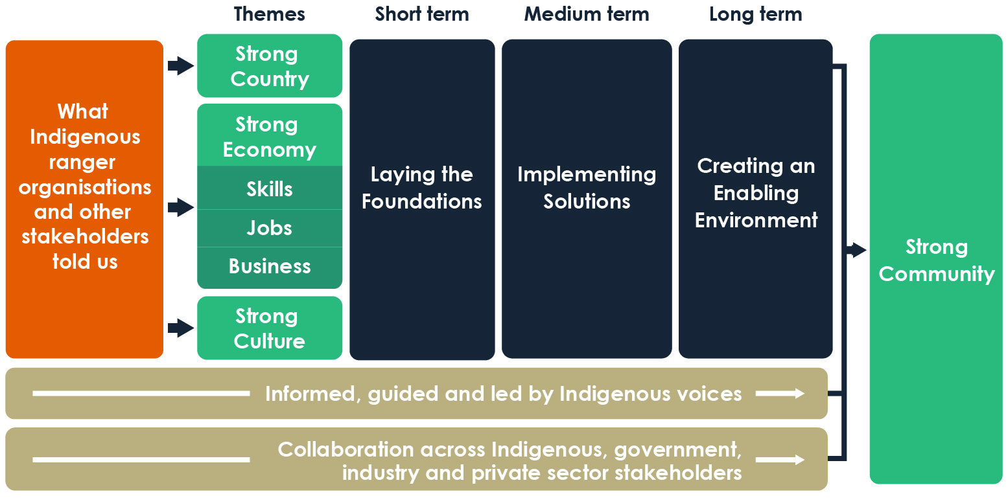
Figure 4: Strategy implementation

In the short term (the first two years) the emphasis will be on laying the foundations. Short term actions concentrate on:
- research, information and evidence gathering, analysis, and investigating opportunities and gaps related to caring for Country, skills, career and business development and access to cultural data;
- building awareness of Indigenous rangers’ skills and services, with a view to fostering increased demand for services;
- continuing capability building in Indigenous ranger organisations through access to support, strategic planning to identify priorities, long term goals and resource needs, and knowledge-sharing opportunities;
- building collaborative networks, especially at the regional level; and
- developing implementation plans
In the medium term (years three to four) the research, information and evidence gathering and analysis will be used to design and implement solutions, including:
- Indigenous rangers’ collaboration and participation in land and water and cultural management, including contribution to regional biodiversity and ecosystem management, climate change resilience and biosecurity protection; and provision of cultural protection services;
- building human capital through provision of culturally relevant and accessible skills development, training and education, and support for rangers to attend training;
- shoring up career pathways into and within ranger organisations, and in broader land and water management and other industries;
- tailored, accessible support for Indigenous ranger business development; and
- ways to enhance protection and maintenance of culture and knowledge when engaging in ranger activities and partnerships
In the long term (years five and six) solutions will become embedded and adapted as necessary, to support and enable a successful Indigenous ranger sector through:
- consolidating partnerships and other arrangements that support and advocate for the aspirations of a growing Indigenous ranger sector; and
- supporting the application of Indigenous management knowledge and specialist skills by rangers and ranger organisations across the broader land and water management sector in their regions.
Ongoing evaluation will occur to support adaptions to the implementation. A formal evaluation will occur in year five.

Governance

Governance Bodies
The following bodies will help oversee and direct implementation of the Indigenous Ranger Sector Strategy.

Indigenous Ranger Reference Group
Establishment of an Indigenous Ranger Reference Group is proposed to advise on implementation of the Strategy and evaluation of its success. The membership of this Reference Group will include Indigenous ranger organisations and other Indigenous ranger sector and land and water management experts. Terms of Reference will be developed in consultation with Indigenous ranger organisations, government agencies and other stakeholders. The NIAA will establish, and provide the Secretariat for, the Reference Group.

Cross-jurisdictional Working Group
A cross-jurisdictional working group is proposed to oversee coordination and collaboration between Australian, state and territory agencies. It will be convened by the NIAA.

Place-based and other collaborative working groups
There is scope under the Strategy to establish working groups of stakeholders to oversee the implementation of the Strategy within an area or region, or for a particular subject.

Proposal for an Indigenous Ranger Industry Body
The Indigenous ranger sector is growing and expanding its national footprint. The actions in this Strategy aim to support Indigenous rangers to improve their effectiveness and to leverage the increasing opportunities for rangers to contribute to broader land and water management across Australia.
An Indigenous Ranger Industry Body, that operates as a peak body for the sector, is one way to facilitate Indigenous leadership of the sector and development of integrated and collaborative partnerships.
It is proposed to consult with Indigenous ranger organisations and other Indigenous stakeholders on the development of an Indigenous-led Indigenous Ranger Industry Body.
If there is interest, the creation and structure of such a peak body would be developed by Indigenous stakeholders.
A peak industry body could provide functions such as information, support, advocacy, resources and services relevant across Indigenous rangers groups. A key role for an industry body could be to oversee the development of any accredited Indigenous land and water skills curriculum and training packages and associated employment award/s for Indigenous rangers (see Action 2.3).

Monitoring, Evaluation and Reporting
Achieving the objectives of the Strategy will be underpinned by monitoring and reporting to evaluate effectiveness and guide adaptation to new evidence and experience through the life of the Strategy.
Only outcomes that relate directly to critical pathways will be measured. We are seeking feedback on possible practical measures. Some ideas for measurements are provided at the end of each section of actions (see pages 30-39).
Monitoring and reporting will be tailored to each Strategy implementation stage.
- Short term – Measures of success will be decided and baselines established to enable future comparison. Monitoring will commence once this has occurred. Development of implementation plans and key foundational investigations and evidence gathering actions will also be monitored.
- Medium term – Monitoring will continue. Annual reporting will form the basis of any required adjustments.
- Long term – An evaluation of the Strategy’s effectiveness will be conducted after five years. The Indigenous Rangers Reference Group will advise on and evaluate the implementation of the Strategy.
Achieving the outcomes of the Strategy that support Indigenous rangers to expand and enhance their contribution to Strong Country, Strong Business and Strong Culture will have flow-on effects for achieving Strong Communities in the areas where Indigenous rangers operate.
The five-year evaluation will include consideration of the flow-on impacts of the Strategy in strengthening communities and benefiting individuals and organisations that do not participate directly in ranger projects. Measures of success for these impacts will be established early. Examples include opportunities for youth to connect to Country, local and regional employment, and financial benefits to communities flowing from Indigenous ranger commercial enterprises.

Actions
- Strong Country

Objectives
Core Objective: To increase Indigenous ranger organisations’ effectiveness in caring for Country and achieving sustainable land and water management that benefits their communities and all Australians.
The Strategy aims to amplify Indigenous rangers’ effectiveness in caring for Country and achieving sustainable land and water management that benefits their communities and all Australians. It aims to increase recognition of their expertise in application of two-way knowledge as a significant pathway into addressing the impacts of climate change, sustainable landscape and ecosystem management and biodiversity protection.
Indigenous rangers will have a greater voice in land and water management through engagement in management activities, research, planning and decision-making at regional, state and territory and national levels. This will create pathways to address climate change impacts and achieve sustainable landscape and ecosystem management and
biodiversity protection.
The Australian, state and territory governments, Indigenous organisations and the private sector will work together to contribute to Indigenous rangers’ management effectiveness and to facilitate opportunities for Indigenous rangers’ participation in delivering land and water management services.

Outcomes
- Indigenous ranger organisations have access to the technology (e.g. software and equipment), expertise and advice required for effective land and water management.
- Indigenous rangers have access to ongoing opportunities for knowledge-sharing and development of communities of practice among ranger groups.
- There is increased collaboration with, and integration of Indigenous rangers in land and water management in their regions.

Proposed Lead Actions
  - In consultation with Indigenous rangers, identify technical land and water management needs and ways to assist rangers’ access to technology, expertise and advice.
  - Encourage Indigenous ranger organisations to procure technology and expertise through grant, partnership and fee-for-service arrangements.
  - Investigate and implement ways to support Indigenous rangers’ knowledge-sharing events.
  - Publicise Indigenous rangers’ land and water management activities, successes and innovations.
  - Identify opportunities, gaps and barriers at regional levels for Indigenous ranger participation in land and water management including:
    - fire management
    - natural disaster resilience;
    - carbon abatement and other climate change initiatives;
    - biosecurity;
    - landscape and ecosystem regeneration;
    - ecosystem and species protection;
    - water management; and
    - cultural site protection and preservation.
  - Work with stakeholders to promote and implement identified land and water management opportunities for Indigenous rangers.
  - Address institutional, regulatory and other identified barriers to Indigenous rangers’ land and water management participation.

Measuring Success
The Strategy will contribute to Strong Country by supporting Indigenous rangers to contribute to the management of land and waters in their regions. With states and territories and Indigenous ranger organisations, we will identify practical measurements of success, such as:
- in the short term, improved information on opportunities for Indigenous rangers’ participation in land and water management in their regions;
- in the medium term, an increase in the engagement of Indigenous ranger organisations in the land and water sector broadly, including research;
- in the long term, an increase in Indigenous ranger organisations’ activities in their regions. Dependent on particular circumstances, this could include increases in the scope of services, partnerships or the area for which ranger services are provided.

- Strong Economy (Skills)

Objectives
Core Objectives: To facilitate Indigenous rangers’ access to relevant and culturally appropriate skills, training and education.
To improve on-Country programs delivered by Indigenous rangers and access to the programs for young Indigenous peoples.

Indigenous rangers’ access to the skills, training and education essential for their work underpins their effectiveness in caring for Country. Training in the right skills creates career pathways for individuals into and beyond ranger organisations into the broader land and water sector. This also builds human capital in communities and extends the cultural, social and economic benefits to individuals and communities that flow from employment in land and water management. On-Country training of young Indigenous people by rangers is proving to be a significant way to prepare them for entry into ranger or other employment.

Skills development initiatives are being taken by particular ranger organisations and partnerships but the availability of courses with the right content and the access to courses and trainers in remote and regional areas remains a challenge. The individual training needs of rangers and ranger organisations can vary considerably. For some, gaining the foundational literacy and numeracy skills is essential for certificate-level training. Others require training in specialised fields such as biosecurity monitoring and compliance activities and the use of data and mapping software.

The Strategy aims to improve Indigenous rangers’ access to accredited training and education that is tailored to their skills, cultural requirements and their locations in remote and regional areas. This includes the recognition of traditional knowledge and skills which are as important to rangers’ work as western land and water management training.

The Strategy also aims to improve on-Country programs delivered by Indigenous rangers and access to those programs for young Indigenous people.

Outcomes
- Education and training courses for Indigenous rangers are tailored to their needs and are accessible and culturally relevant.
- Indigenous rangers have improved access and support to undertake training and education courses.
- Young Indigenous people have improved access to on-Country learning and skills development that provide pathways into higher education or ranger and other vocational employment.
- Indigenous rangers have language, literacy and numeracy skills that provide a foundation for their ongoing education and training and career development.
- Indigenous rangers are able to access tailored training to support their current and future regulatory compliance activities.

Proposed Actions
  - Analyse the availability and suitability of training courses available to Indigenous ranger organisations and, where gaps are identified, develop accessible, tailored and culturally relevant courses for Indigenous rangers. (One possible approach could be development of an Indigenous land and water management curriculum and skills training package.)
  - Ensure that Indigenous rangers and Indigenous communities have information on current education and training support programs (e.g. away from base and higher education support). (The information should cover pre-vocational courses, traineeships, vocational and higher education courses.).
  - Investigate and implement ways to improve the availability and suitability of education and training support programs for Indigenous rangers.
  - Increase the availability of youth on-Country ranger programs, including through development of programs and curriculum materials.
  - Investigate and implement ways to address language, literacy and numeracy needs within Indigenous rangers’ training programs.
  - Investigate Indigenous ranger biosecurity and other compliance training needs and implement recommended training for relevant locations.

Measuring Success
The Strategy will contribute to a Strong Economy by supporting Indigenous rangers to have increased access to tailored, culturally appropriate skills training and education in land and water management that recognises their unique skills but is transferable beyond ranger programs.
With states and territories and Indigenous ranger organisations, we will identify practical measurements of success, which might include:
- an increase in the number of tailored courses in land and water management delivered to Indigenous rangers;
- an increase in the availability of youth on-Country ranger programs;
- an increase in the number of Indigenous rangers seeking other vocational land and water employment beyond ranger programs; and
- an increase in the higher level educational qualifications held by Indigenous rangers.

- Strong Economy (Jobs)

Objectives
Core Objective: To support and expand Indigenous rangers’ access to meaningful career pathways into and within ranger organisations, and more broadly in land and water management and other industries.
The Strategy aims to improve support for ranger employment as an important and meaningful employment and leadership pathway within communities and their regions.
The Strategy seeks to expand career pathways into and within ranger organisations, including through succession to senior and managerial roles within organisations and to employment outside of ranger organisations (where that is desired).
The Strategy recognises that flexible approaches tailored to the needs of individuals and communities have the most chance of success, especially in remote and regional areas.

Outcomes
- Indigenous people have access to programs in their communities and regions to assist them to prepare for Indigenous ranger employment and pursue career development pathways.
- There is increased awareness and knowledge of Indigenous ranger and related employment opportunities among communities, education and training providers and employers.
- There are expanded opportunities for Indigenous employment in land and water management and related sectors.
- Remuneration for Indigenous rangers’ work reflects their unique qualifications and experience.

Proposed Actions
  - Provide place-based employment and career development support tailored to the needs of Indigenous rangers.
  - Establish or extend staff exchanges, secondments and mentoring arrangements between Indigenous ranger organisations, land and water management agencies, and industry. (Staff exchanges and secondments should ideally provide for backfilling to ensure ranger organisations are able to maintain staff resources.)
  - Build awareness of, and promote, Indigenous rangers’ employment potential across government and industry.
  - Build awareness of youth pathways into and beyond Indigenous ranger employment among Indigenous people, schools, training providers and employers.
  - Ensure that Indigenous rangers operate under employment awards that link remuneration to qualifications.

Measuring Success
The Strategy will contribute to a Strong Economy by supporting more Indigenous rangers to advance their careers into, within and beyond ranger organisations.
With states and territories and Indigenous ranger organisations, we will identify practical measurements of success, which might include:
- an increase in the number of positions created for place-based exchanges/secondments/mentoring programs with land and water organisations and agencies; and
- an increase in the number of Indigenous ranger positions (in ranger organisations), number of senior managerial ranger positions, and number of Indigenous rangers employed in the broader land and water management sector.
- Strong Economy (Business)

Objectives
Core Objective: To empower Indigenous ranger organisations to undertake business services and enterprises that meet their aspirations and increase their access to resources.

The Strategy aims to further empower Indigenous rangers to develop commercial business ventures and fee-for-service partnerships that meet their aspirations. Business activities can increase organisations’ access to income diversity and people, technical and other resources.

It seeks to do this by encouraging demand for Indigenous ranger services and supporting ranger organisations to develop their business capabilities and acumen in order to offer quality, competitive products and services.

Many Indigenous ranger organisations have well-developed business and fee-for-service activities, including in the areas of carbon abatement, fire management, regulatory compliance and monitoring, tourism and drone operations. However, it is acknowledged that some ranger organisations and communities do not currently wish to develop businesses, and that business opportunities may be limited in remote areas.

Outcomes
- There is increased demand for Indigenous Ranger business services in the public and private sectors.
- Government Indigenous ranger programs facilitate ranger business and fee-for-service activities where ranger organisations wish to undertake them.
- Indigenous ranger organisations have access to business support and development services that address their needs.
- Indigenous rangers have a greater voice in development and management of the sector.

Proposed Actions
  - Facilitate procurement of Indigenous ranger services through government agencies, industry, research and other private sector stakeholders. This will include awareness raising, improvements to procurement arrangements and building agency and industry networks.
  - Provide accessible, place-based, tailored support to assist Indigenous ranger business development and operation.
  - Ensure that Indigenous ranger funding programs are designed to accommodate increasing organisational capability and business development by ranger organisations.
  - Support Indigenous-led initiatives for Indigenous ranger sector business development and advocacy.

Measuring Success
The Strategy will contribute to a Strong Economy by supporting Indigenous rangers to expand their enterprises, where desired, to increase their contribution to local employment and economy.
With states and territories and Indigenous ranger organisations, we will identify practical measurements of success, which might include:
- an increase in the dollar value of fee for service arrangements;
- an increase in the number of ranger positions created; and
- the number of ranger organisations (seeking fee-for-service opportunities) that have current Capability Statements and Strategic Plans in place.
- Strong Culture

Objectives
Core Objective: To empower Indigenous ranger organisations to continue to protect and maintain culture and traditional knowledge in conjunction with Traditional Owners and communities.

The Strategy aims to strengthen the empowerment of Indigenous ranger organisations, Traditional Owners and communities to protect, maintain and control access to their culture and traditional knowledge. It will do this by facilitating local control of traditional culture and knowledge and increasing awareness of, and respect for, cultural protocols among stakeholders.

Culturally appropriate access to cultural places and traditional knowledge is a significant consideration for Indigenous rangers, Traditional Owners and their communities. Ranger activities may involve culturally sensitive places and knowledge in many ways – for example, access to Country by researchers and partners, development of two-way science techniques, provision of mapping and monitoring data to researchers, performance reporting to grant programs.

The Strategy also aims to extend the opportunities for Indigenous rangers, guided by Traditional Owners and custodians, to provide services for protection and maintenance of cultural places that can facilitate compliance under environmental and cultural heritage legislation.

Outcomes
- Indigenous ranger organisations (with Traditional Owners) control access to and use of local cultural data and knowledge.
- Indigenous knowledge, cultural authority and protocols are recognised, valued and respected in accountable research and partnerships.
- Indigenous rangers have an increasing role in the provision of cultural protection and management services.

Proposed Lead Actions
  - Investigate and develop measures to ensure local control of access to cultural data generated for programs, research and other partnerships.
  - Provide information for government, industry and other potential Indigenous ranger partners on protocols for access to and use of Indigenous knowledge and cultural data.
  - Identify opportunities and work with stakeholders to promote and implement identified opportunities for Indigenous rangers to provide cultural protection and management services at the regional level.

Measuring Success
The Strategy will contribute to Strong Culture by supporting local control of cultural and Indigenous knowledge related to Indigenous ranger activities and an increased Indigenous ranger role in protection of cultural places.
With states and territories and Indigenous ranger organisations, we will identify practical, achievable data indicators to measure the achievement of outcomes. These might include:
- an increase in the arrangements for local cultural data control, in places where rangers operate;
- increased stakeholders and partner awareness and application of protocols for the access and use of Indigenous knowledge and cultural data (e.g. Our Knowledge Our Way guidelines); and
- increased direct engagement of Indigenous ranger organisations in cultural protection and maintenance services, compared with a baseline.

In its recommendations 18.1 and 18.2, the 2020 Royal Commission into National Natural Disaster Arrangements recommended that governments should engage further with Traditional Owners on Indigenous land and fire management insights and explore ways to leverage those insights in natural disaster resilience.

