Review into the Operation
of the Low Aromatic Fuel Act 2013

Table of Contents
Definitions 3
Terms of Reference 6
Government efforts to reduce petrol sniffing in Australia 6
Impact of low aromatic fuel on petrol sniffing 7
The Low Aromatic Fuel Act 2013 8
Special Measures 9
Low Aromatic Fuel Areas 9
Fuel Control Areas 10
Implementation of the Low Aromatic Fuel Act 2013 10
Public consultations 10
State and territory legislation 10
From reports of petrol sniffing through to using the Act 11
Designations under the Act 12
Compliance in the designated areas 12
Submissions 12
Common themes 13
Recommendations 20
Attachment A: The Review Process 21
Attachment B: Submissions 22
Attachment C: The Petrol Sniffing Strategy and “Eight Point Plan” 61
Attachment D: Further Reading 63

Definitions

Avgas An Aviation Gasoline intended primarily for use in aircraft spark ignition reciprocating engines. Avgas is generally used in small aircraft and is distinct from jet fuel and diesel used in some aircraft.
Low aromatic fuel Unleaded petrol that has a research octane number of less than 95, and that has aromatic compounds of less than 5% to help discourage fuel sniffing.
Minister Since September 2013 the Minister responsible for administering the Low Aromatic Fuel Act 2013 has been the Commonwealth Minister for Indigenous Affairs.
Opal fuel Since 2005, low aromatic fuel has been referred to as ‘Opal’, the brand name given to it by BP Australia, the company to first produce and supply low aromatic fuel. Viva Energy Australia began production and supply of low aromatic fuel in 2014; while using the term “Opal” to generically describe the fuel produced by both companies is incorrect, its colloquial use persists.
Petrol sniffing A form of substance misuse where the fumes from petrol are inhaled, leading to intoxication. The toxic chemicals in petrol are rapidly ingested by the body through the lungs and affect the brain and central nervous system.
Premium unleaded petrol Unleaded petrol that has a research octane number of 95
or more, including a research octane number of 98.
Regular unleaded petrol Unleaded petrol that has a research octane number of
less than 95 but does not include low aromatic fuel.
The Act The Low Aromatic Fuel Act 2013 (Cth).
The Department The Department of the Prime Minister and Cabinet Three pillars of harm minimisation Since 1985, Australia’s National Drug Strategy
(refreshed for 2017-2026) has been underpinned by an objective of minimising the harms associated with alcohol, tobacco, illicit drug and pharmaceutical drug use. The “three pillars” are:
Demand Reduction - Preventing the uptake and/ or delaying the onset of use of alcohol, tobacco and other drugs; reducing the misuse of alcohol, tobacco and other drugs in the community; and supporting people to recover from dependence through evidence-informed
treatment;

Supply Reduction - Preventing, stopping, disrupting or otherwise reducing the production and supply of illegal drugs; and controlling, managing and/or regulating the availability of legal drugs; and
Harm Reduction - Reducing the adverse health, social and economic consequences of the use of drugs, for the user, their families and the wider community.
Volatile substance abuse A behaviour whereby the fumes or vapours of volatile
substances are inhaled by a person to become intoxicated. Volatile substances include petrol, solvents, spray paints and aerosols that when inhaled can cause significant side effects, including brain damage and death.

Acronyms
AMSANT Aboriginal Medical Services Alliance Northern Territory
CAYLUS Central Australian Youth Link Up Service
DATSIP Department of Aboriginal and Torres Strait Islander Partnerships (Queensland)
IAS Indigenous Advancement Strategy
LAF Low Aromatic Fuel
NT Northern Territory
NT DoH Northern Territory Department of Health
NTRAI NP Northern Territory Remote Aboriginal Investment National Partnership
PSS Petrol Sniffing Strategy
PULP Premium Unleaded Petrol
RULP Regular Unleaded Petrol
VSA Volatile Substance Abuse

Terms of Reference
Section 18 of the Low Aromatic Fuel Act 2013 (the Act) requires that the Minister cause a review into its operations to commence as soon as possible after the Act’s fifth anniversary on 14 February 2018, and that further reviews be conducted every five years thereafter.
The Minister for Indigenous Affairs directed the Department of the Prime Minister and Cabinet to review the operations of the Act on 27 February 2018. The Terms of Reference agreed by the Minister were to review:
- The effectiveness of the Act in meeting its primary object: “to enable special measures to be taken to reduce potential harm to the health of people, including Aboriginal persons and Torres Strait Islanders, living in certain areas from sniffing fuel”.
- The effectiveness of the areas designated under the Act: Palm Island in Queensland, and the Tennant Creek, Daly and Katherine regions of the Northern Territory.
- The views of fuel manufacturers, outlets and fuel distributors operating in the designated areas as well as other stakeholders, including community representatives, Aboriginal and Torres Strait Islander people (or their representatives), persons with an interest in or knowledge of human health, and any other individuals who have an interest in the use of low aromatic fuel.
- The other provisions of the Act as they relate to achieving the object of the Act, such as the ability for the Minister to designate ‘Fuel Control Areas’ and the Act’s compliance measures in places where it has been used.
- Any other matter with a significant bearing on the operation of the Act that is identified during the process of the review.
Further information about the conduct of the review is at Attachment A. Copies of written submissions are at Attachment B.

Government efforts to reduce petrol sniffing in Australia
The history of the Commonwealth Government’s efforts to reduce the harms caused by petrol sniffing has been well documented elsewhere (see Attachment C and Attachment D) so will not be detailed here. The central elements of the Commonwealth’s current approach to reducing petrol sniffing in areas where it is a problem include the following:
- Subsidising the production, transport and storage of low aromatic fuel, allowing it to be sold in voluntarily converted and areas designated under the Act at a similar price to regular unleaded petrol;
- Consultation with communities and local service providers with the aim of working together;
- Working with fuel retailers and distributors to voluntarily convert from supplying regular unleaded petrol to low aromatic fuel; and
- Where voluntary approaches are unsuccessful, preventing the sale of regular unleaded petrol or controlling the use of other fuels using the powers of the Low Aromatic Fuel Act 2013, where legislated criteria are met.

While the states and territories have primary responsibility for addressing volatile substance abuse, the Commonwealth Government also provides funding for a range of initiatives and services for Aboriginal and Torres Strait Islander people including, but not limited to:
- $10.2 million in 2017-18 to support the rollout of low aromatic fuel and a further
$3.0 million to support other harm reduction measures;
- Around $70 million per year to support over 80 Indigenous alcohol and other drug treatment service providers across Australia;
- Around $31 million between 2015-16 to 2021-22 to the Northern Territory under the Northern Territory Remote Aboriginal Investment National Partnership to support a Remote Alcohol and Other Drug Workforce to provide alcohol and drug support and education, interventions, and referrals for community members; and
- Investment through the Indigenous Advancement Strategy in youth services and activities that ensure young people are engaged and able to participate in positive and constructive activities within their communities. As at 31 December 2018, this includes $156 million for 122 activities across Australia that use sport as a tool to engage young people and encourage participation, improve educational attendance and attainment, improve wellbeing and resilience and prevent involvement in potentially damaging behaviour such as volatile substance misuse including petrol sniffing.

Impact of low aromatic fuel on petrol sniffing
Since it was first rolled out in 2005, low aromatic fuel has played a key role in reducing petrol sniffing and its associated harms. Its impact has been studied in a series of independent but linked evaluations, which were released in 2007, 2008, 2013 and 2016. The research in each case was conducted by fieldworkers surveying community residents as well as a range of local stakeholders including health workers, police and school staff.
The survey published in 2016, conducted by the Menzies School of Health Research, found that petrol sniffing levels had reduced by 88 per cent since 2005-07 in communities where low aromatic fuel had been rolled out. In addition, the study found that people who continued to sniff petrol tended to do so less frequently, meaning that less harm was being caused overall. The study found that this outcome is “at least partially attributable to the fact that the replacement of regular unleaded petrol with low aromatic fuel makes the former more difficult to obtain.”1
The next stage of the survey into the prevalence of petrol sniffing is being finalised at the time of this report, and includes survey results from areas designated under the Act. Initial findings from the survey, conducted over the course of 2017 and 2018, suggest the overall rates of petrol sniffing have reduced further from the time those communities were surveyed in 2011-2014.
The final report on this survey is expected to be made publically available in the first half of 2019.

1 d’Abbs P and Shaw G 2016, Monitoring trends in prevalence of petrol sniffing in selected Aboriginal Communities: 2011 to 2014. Menzies School of Health, Darwin.

The Low Aromatic Fuel Act 2013
Since 2005, the replacement of regular unleaded petrol with low aromatic fuel has been highly effective in reducing rates of petrol sniffing. This has been largely achieved through the voluntary agreement of fuel outlets to switch fuels. Even today, the vast majority of fuel outlets selling low aromatic fuel do so on a voluntary basis. However, a small number of fuel outlets in regions where petrol sniffing was occurring chose not to stock low aromatic fuel, which created a potential supply pathway for regular unleaded petrol into vulnerable communities.
In response to this situation, the Low Aromatic Fuel Act 2013 (the Act) was enacted on 14 February 2013 to give the Minister powers to restrict the provision of fuels in order to reduce the potential harm to people living in certain areas from petrol sniffing.
The Act targets corporations, rather than individuals, with the purpose of enabling Government to prohibit service stations from stocking and selling regular unleaded petrol in places where corporations have been unwilling to do so voluntarily. Corporations who breach the Act can be fined up to 300 penalty units ($63,000 at the time of this review).
Under the Act, the Minister may designate an area as either a Low Aromatic Fuel Area or a Fuel Control Area if satisfied that:
- doing so is reasonably likely to assist in the reduction of petrol sniffing harms to people living in the area;
- there are adequate facilities or arrangements available to supply the area with low aromatic fuel; and
- the relevant states and territories do not have legislation that would duplicate the Act, and it is unlikely such legislation will be enacted within a reasonable period.
The Act specifies that in designating areas, the Minister must have regard to the wellbeing of people in the area, the health impact on people from petrol sniffing, the concerns of local people about sniffing fuel, and their views about the health and wellbeing benefits of designating the area.
Before designating an area, the Minister must consult with community representatives, Aboriginal and Torres Strait Islander people in the area, fuel manufacturers and suppliers, health services and any other appropriate people. Where the Act has been used, the outcomes of those public consultations have been made available on the Department’s website.
The geographic designations made to date under the Act cover a region or island, which include individual retail sites. A regional approach has several benefits: It ensures that restricted fuels are not easily accessible to people living within or nearby; any new fuel outlets in the region are automatically regulated in the same manner as existing outlets; and individual sites who had previously agreed to stock low aromatic fuel will not revert following a change in ownership or business decision.
The available evidence strongly supports taking a regional approach. The 2013 study from the Menzies School of Health Research that was funded by the Commonwealth, and cited in AMSANT’s submission to this review, noted that:
… the most significant factor contributing to the overall reduction in sniffing would appear to be the introduction of a regional approach to rolling out LAF. It found most

of the petrol sniffing that continues to occur takes place in areas where a regional rollout has not yet been implemented, and where sources of RULP are consequently relatively accessible.2

Special Measures
Certain provisions under the Act are deemed ‘special measures’ under the International Convention on the Elimination of All Forms of Racial Discrimination that is brought into effect through the Racial Discrimination Act 1975. The Convention specifies that:
Special measures taken for the sole purpose of securing adequate advancement of certain racial or ethnic groups or individuals requiring such protection as may be necessary in order to ensure such groups or individuals equal enjoyment or exercise of human rights and fundamental freedoms shall not be deemed racial discrimination, provided, however, that such measures do not, as a consequence, lead to the maintenance of separate rights for different racial groups and that they shall not be continued after the objectives for which they were taken have been achieved.
Provisions of the Act that are special measures are not deemed racially discriminatory despite the fact that the Act is likely to disproportionately impact Aboriginal and Torres Strait Islander people in certain areas.
In reviewing the operation of the Act, the Department has particularly considered the effectiveness and appropriateness of the areas designated to date under the Act, and whether the designations continue to be necessary to achieve the Act’s aim of reducing the potential harm to the health of people living in those areas. The Department’s assessment is that the four existing designations continue to be necessary to avoid the return of petrol sniffing issues, and so continue to meet the special measures test in the Convention. It is also important for the Act to continue to provide the ability to designate additional areas, if necessary, to reduce the potential harm to health of people living in those areas from petrol sniffing.

Low Aromatic Fuel Areas
Under the Act, the Minister may designate Low Aromatic Fuel Areas, in which it is prohibited for a corporation to possess, transport and supply regular unleaded petrol.
Designation of a Low Aromatic Fuel Area does not compel retailers to supply low aromatic fuel, and nor does it prohibit them from supplying fuels other than regular unleaded petrol (such as diesel and/or premium unleaded petrol). However, in practice, selling low aromatic fuel is the logical response when regular unleaded petrol cannot be sold, as purchasing premium is more expensive, and is unnecessary for motors designed to run on a 91 grade unleaded fuel. As a result, the majority of retailers in designated Low Aromatic Fuel Areas converted from regular unleaded petrol to low aromatic fuel. At the time of this review, all but one fuel retailer in the designated areas stocked low aromatic fuel.
The preference of the Commonwealth is to continue the rollout of low aromatic fuel in regional and remote areas of Australia primarily through the voluntary agreement of fuel retailers. The Act has only been used when fuel retail sites have refused to cease supplying regular unleaded petrol despite extensive negotiation and engagement, and there is evidence

2 d’Abbs P and Shaw G 2013, Monitoring trends in prevalence of petrol sniffing in selected Aboriginal communities: an interim report. Menzies School of Health, Darwin.

that the continued availability of regular unleaded petrol is leading to petrol sniffing. This is in keeping with the recommendations of the committee from the Inquiry into the
Low Aromatic Fuel Bill in 2012. Accordingly, the Act has been used as a ‘last resort’ strategy, with selected sections of its available powers applied only four times in five years.

Fuel Control Areas
The Act provides the Minister with the authority to prohibit or restrict access to other fuels in specified areas (including premium unleaded petrol and Avgas) and direct retailers to keep records in relation to their supply orders and sales, and provide these to the Commonwealth. The powers available under the Act to designate Fuel Control Areas have not been used to date.

Implementation of the Low Aromatic Fuel Act 2013
Ahead of each Low Aromatic Fuel Area designation, the Department undertook public consultations, reviewed other relevant legislation, and briefed the Minister on the outcomes.

Public consultations
The Department conducted a series of public consultations in 2015 for all four areas that were under consideration, seeking views on the likely impact of a Low Aromatic Fuel Area designation. Information about the Act was disseminated though a combination of letters to identified stakeholders across the regions (199 in total), local newspaper and radio advertisements, posters, information sheets and social media. The Department received views through 23 written submissions, 67 consultations, including public and targeted meetings, and individual discussions. The organisations and individuals who commented overwhelmingly supported the implementation of the Act in their communities.

State and territory legislation
As an area may only be designated if “the Minister considers that the appropriate States and Territories have not enacted legislation consistent with this Act to reduce the harm of petrol sniffing, and it is unlikely that they will enact such legislation within a reasonable period3”, the Department analysed other relevant legislation ahead of the Minister designating each area. Inhalant use is not a criminal offence in any Australian state or territory. However, it is an offence in some states and territories to knowingly sell or supply an inhalant to a person for the purpose of intentional inhalation. Some Australian states and territories have police powers to intervene in inhalant use in two main ways. In those jurisdictions, police have powers to seize inhalants and related equipment, and/or apprehend and transport a person under the influence of a volatile substance, and release them into the care of a responsible person, or a place of safety such as a hospital.
Of the two jurisdictions where the Act has been used to date, only the NT has legislation specifically relating to volatile substance abuse that can be applied to individuals as well as whole regions. Queensland has legislation that generally relates to individuals. These are detailed below.
In Western Australia and South Australia, there is no current legislation that specifically addresses volatile substance abuse on either an individual or regional basis.

3 Section 14(2)(c) of the Act

NT Government
The NT Volatile Substance Abuse Prevention Act 2004 (VSAP Act) aims to support individuals engaging in volatile substance abuse, including by penalising individuals who supply volatile substances where those individuals have reason to believe volatile substances will be abused. Under the VSAP Act, communities can develop Volatile Substance Abuse Management Plans to control access to identified volatile substances, and individuals can be placed into mandatory treatment interventions following the referral of a qualified person to make that assessment.
By contrast the Low Aromatic Fuel Act 2013 seeks to regulate the supply of regular unleaded petrol through the fuel industry. As a result, the Act complements the NT legislation and supports a cross-jurisdictional and regional approach to reducing the harm of petrol sniffing.
The NT submission to this review stated that the Low Aromatic Fuel Act 2013 and the VSAP Act together combine to underpin the:
…collaborative and coordinated effort between individuals, communities, treatment services and government agencies to minimise the harms arising from the misuse of volatile substances, including petrol.

Queensland Government
There is no Queensland Government legislation that exclusively addresses volatile substance abuse. However, there are two Acts which are relevant and complimentary:

- The Queensland Police Powers and Responsibilities Act 2000 provides police with powers to seize potentially harmful things, including inhalants, and to detain and transport an affected person to a place of safety including hospital; and
- The Summary Offences Act 2005, which makes it illegal to sell potentially harmful things including a product that can be intended to inhale or provide to another person to inhale.

From reports of petrol sniffing through to using the Act
Following verified reports of petrol sniffing in communities, the Department works with local stakeholders to ascertain whether low aromatic fuel is available and whether taking a regional response to restricting other fuels is likely to be appropriate and effective.
If low aromatic fuel is not available, the Department then works with local retailers with the aim of securing their voluntary agreement to convert to low aromatic fuel. The Department also works closely with state and territory governments to coordinate other timely demand and harm reduction approaches to support individuals and communities. The process generally includes consultation with the reporting organisation, community representatives, local health service providers and the police, as appropriate.
This approach has been successful to date. Most retailers in Australia that stock low aromatic fuel, do so voluntarily. Voluntary conversions continue, often following a substantial period of consultation. In recent months, two retailers on the Stuart Highway in South Australia voluntarily converted to low aromatic fuel following several years of engagement by the Department to help counter petrol sniffing harms which had arisen in nearby communities.

Similarly, from late 2017, all fuel retailers in Mt Isa voluntarily agreed to cease stocking regular unleaded petrol and convert to low aromatic fuel.
Where efforts to encourage voluntary conversion are not successful and petrol sniffing remains a problem, the Minister may consider using powers available under the Act to prohibit or otherwise regulate the possession, transport and supply of fuels in the region.

Designations under the Act
The Minister has used the powers of the Low Aromatic Fuel Act 2013 to designate the following areas as Low Aromatic Fuel Areas: Palm Island in Queensland, and the Tennant Creek, Daly and Katherine regions of the Northern Territory. It is now illegal to supply or sell regular unleaded petrol at all fuel outlets in these areas, and all distributors operating in those areas are subject to the Act.

Compliance in the designated areas
The Department maintains regular contact with distributors and fuel outlets operating in designated areas to ensure parties continue to be aware of their obligations under the Act. This includes an annual audit the Department conducts with fuel distributors and retailers operating in designated areas, primarily via phone and followed up with site visits by Departmental staff if required.
To date no compliance breaches have been prosecuted or penalties incurred by any corporation. The designation has the effect of encouraging self-policing within the fuel distribution chain. Should one corporation in the supply chain (fuel producer – fuel distributor – fuel retailer) intentionally or inadvertently attempt to supply a designated area with a prohibited fuel, other corporations in the same fuel supply chain face the same penalties under the legislation.

Submissions
The following ten organisations provided written submissions to this review:
- Aboriginal Medical Services Alliance Northern Territory (AMSANT)
- Anyinginyi Health Aboriginal Corporation (Anyinginyi)
- Army and Air Force Canteen Service (AAFCANS, who manage the fuel outlets at the RAAF Base at Tindal)
- Central Australian Youth Link Up Service (CAYLUS)
- Northern Territory Chief Minister, the Hon Michael Gunner MLA, on behalf of the Northern Territory Government
- Northern Territory Police
- Northern Territory Legal Aid Commission
- Queensland Deputy Premier, the Hon Jackie Trad MP, on behalf of the Queensland Government
- Viva Energy Australia
- A fuel industry stakeholder that did not wish to be identified
The Department also collected the views of fuel retailers and distributors impacted by the designations and who wished to comment, as part of its annual compliance check. The

majority of respondents expressed the view that the Act has been a valuable tool in reducing the harms being caused to the health of people from petrol sniffing in the areas where it has been used.

Common themes
A number of common themes emerged from the submissions and consultations.
- Restricting regular unleaded petrol reduces petrol sniffing, and existing designations under the Act should remain in place
Most respondents agree that the supply of low aromatic fuel and prohibition of regular unleaded petrol has been effective in reducing petrol sniffing, both in areas designated under the Act and where the fuel is stocked voluntarily by retailers. Government agencies and health providers individually monitor the rates of petrol sniffing in designated areas through their own methods. The agencies’ quantitative and qualitative information shows petrol sniffing rates in the four areas have decreased since the designations.
The NT Government submission provided data demonstrating a reduction of volatile substance abuse, including petrol sniffing, in the Katherine, Barkly and Central Australia regions since 2015. Further, the NT Government submission also referred to the need to maintain the designations:
It is the firm view of the VSA Clinical Teams that if low aromatic fuel mandating was removed from the Daly/Katherine region and the Barkly region, there would be a significant spike in petrol sniffing in Katherine, Tennant Creek and surrounding communities.
The CAYLUS submission noted:
CAYLUS has observed a clear reduction in levels of sniffing in Tennant Creek and the region since the LAF Area was declared there (which led to all outlets switching to LAF). We receive fewer reports in relation to sniffing in Tennant and surrounding communities and have observed a drop in the number of clients from the area that we are supporting to attend rehab.
This is partly because the Act provides:
… incentive to retailers to switch to LAF voluntarily, rather than face the red tape and potential loss of reputation incurred from being forced to switch.
And further:
… in locations like Alice Springs where all retailers use LAF voluntarily the existence of the legislation acts as a disincentive to retailers breaking from this.
Anyinginyi Health Aboriginal Corporation recommended retaining the Barkly region as a designated Low Aromatic Fuel Area under the Act due to the positive impact on reducing petrol sniffing, and further recommended expanding the designated area across the region to improve its effectiveness.
The submission from the Queensland Deputy Premier, the Hon Jackie Trad MP, stated:
I note that low aromatic fuel is currently available in a number of Queensland’s 19 discrete Aboriginal and Torres Strait Islander communities and in line with your

findings, I am informed that the introduction of low aromatic fuel in these communities has been an effective measure in reducing petrol sniffing and its associated harms.
The Queensland Government submission also commented on the improved community safety benefits of introducing low aromatic fuel regionally, noting that break-ins, vandalism and thefts have noticeably decreased as premises, cars and other equipment are no longer targeted as sources of regular unleaded petrol. In their submission, the Queensland Government noted the effectiveness of the Low Aromatic Fuel Act 2013 in meeting its objectives to reduce petrol sniffing harms, stating:
The provisions of the Act provide an effective mechanism to reduce petrol sniffing, and [the Deputy Premier of Queensland is] confident that as with Palm Island, considered steps will be taken by the Commonwealth Government in partnership with the Queensland government to reduce the impact of petrol sniffing in communities where it is shown to be a problem.
AMSANT reflected on the complexity of addressing the problem of petrol sniffing:
We acknowledge that LAF is just one part of the solution to addressing petrol sniffing in Aboriginal communities and we know that it is most effective when implemented along with other measures including adequately resourced early intervention services, youth and recreation programs and training and employment opportunities.
The Department acknowledges that the introduction of low aromatic fuel, which facilitates restricting the availability of regular unleaded petrol, has strongly contributed to a reduction in petrol sniffing and its associated harms. However, restricting the supply of regular is not a complete solution to the problem. Comprehensive approaches need to be developed in partnership with communities and local service providers to address the underlying causes.
- There has been growing acceptance of low aromatic fuel by retailers and customers
At the time the first designations were being considered, the Department was aware that some retailers were concerned that the conversion to low aromatic fuel would negatively impact their business. Their concerns ranged from the costs associated with technical maintenance required to fuel bowsers to transition between the two fuels (regular unleaded petrol and low aromatic fuel), through to fears that customers would not patronise their business if they were stocking low aromatic fuel in place of regular unleaded petrol.
Anyinginyi Health Aboriginal Corporation commented:
Initially there were concerns that LAF would damage motor vehicle engines however these concerns have been allayed and Service Station Proprietors have reported that there has not been any recent complaints about the LAF.
Local Service Station Proprietors have expressed their support for the sale of the LAF.
While no retailer provided a written submission, many made comments during the Department’s 2018 annual compliance audit. The majority of retailers advised the Department that customers’ acceptance of the product has grown, indicating that initial fears are dispelling over time. Comments such as the following were received:

People complained a fair bit at the start [when the area was designated], but I can’t say it’s a problem now at all …People have stopped asking questions about the fuel, possibly two people a week might ask a question about it now. It doesn’t impact on us at all. (Katherine region fuel retailer)
It’s just fuel as far as we’re concerned. (Barkly region fuel retailer)
In their submission, Viva Energy Australia made reference to the technical support they have provided to support community acceptance of the fuel:
Introduction of Low Aromatic Fuel (LAF) into communities has not been without its challenges. We have had some incidents in the past where we have had to have some difficult conversations with a limited number of independent service station owners that we supply fuel to, based on their resistance to accepting LAF. This resistance has primarily related to incorrect information and hearsay about the quality of the fuel and the perceived operability issues. This incorrect information has persisted since the initial introduction of Opal fuel – even though this information has not been based in fact. Viva Energy has invested considerable time and resources through the involvement of our Product Quality specialist, Dr Mark Tabone, in helping to educate communities, mechanics and service station operators and bust some of the myths about the fuel.
Low aromatic fuel supplied by BP Australia and Viva Energy Australia has undergone independent testing to ensure it complies with the Australian Fuel Standards. BP and Viva each stand by their products, and maintain processes to receive and investigate any customer complaints.
One factor promoting the general acceptance of low aromatic fuel by retailers has been that low aromatic fuel is the only 91 octane fuel available in the designated areas, and as a result, no retailer has had a real or perceived commercial advantage over another.
- Restriction of other fuels and the use of Fuel Control Areas power
Several respondents to the review discussed the risks involved in sniffing other fuels, such as premium unleaded petrol or Avgas, in connection with the as-yet-unused powers under the Act to control the supply of other fuels, such as premium unleaded petrol and Avgas.
Premium Unleaded Petrol
The submission from CAYLUS identified that the Act has not been used to control fuels other than regular unleaded petrol, in particular premium unleaded petrol. CAYLUS and Anyinginyi both made note of anecdotal reports of sniffing premium unleaded petrol, though CAYLUS acknowledged that they have not seen ‘conclusive evidence as to whether Premium is regularly being used for the purpose of become intoxicated.’
CAYLUS advised of a possible increase in fuel retailers choosing to stock premium unleaded petrol instead of low aromatic fuel. CAYLUS suggested the following process be followed to handle situations where fuel retailers refuse to convert to low aromatic fuel, and instead choose to stock premium unleaded petrol:
We suggest that in the case if sites that previously stocked Standard Unleaded fuel and which under pressure to switch from Standard Unleaded to LAF instead chose to switch to Premium the following should apply:

  - The outlet should be encouraged to switch the same tanks/bowers that were previously unleaded fuel to LAF voluntarily and be notified that doing this will help them avoid potentially burdensome future controls under the legislation. This will be the easiest path forward for everybody.
  - If they won’t do this and depending on the strategic importance of the site and the severity of issues identified in consultations, the following levels of control can be implemented:
    - (least imposing) - a register must be kept of all Premium sales, name of buyer, license plate of the vehicle, date, destination. The register would need to be provided to government reps (or perhaps even CAYLUS) at specified intervals
    - (more imposing) - photo id required and details recorded as a part of the register
    - (most imposing - attempting to deter retailers from opting for Premium) bowser would need to be locked, register as per option 2 kept and more requirements in terms of regular reporting
    - (banning) - the Minister uses his power to make it illegal to sell Premium within the zone
The NT Legal Aid Commission submission argued:
Sniffable fuels are still available in high octane and premium fuel products. It is understood that some individuals still access to these products and continue to sniff.
The measures [under the Act] will not be fully effective whilst high octane premium fuels are available.
The submission acknowledged that the community is unlikely to be receptive to the removal of high octane fuels from the market, and noted that some vehicles require premium unleaded petrol to operate. However, the submission recommended, firstly, additional powers under the Act to control supply of premium unleaded petrol and, secondly, investigation of a low aromatic premium unleaded petrol.
The AMSANT submission made similar points to those raised by CAYLUS, noting:
Premium fuel contains high levels of the volatile components that cause a ‘high' in RULP so it may be that in years to come that it will be necessary to restrict availability of Premium in some locations. …
This aspect of the legislation should be reviewed and strengthened so that if necessary it can be used to stop retailers or others from selling Premium in an LAF Area if this is likely to reduce potential harms caused by sniffing.
As described in the Explanatory Memorandum to the Low Aromatic Fuel Bill 2012, the Act broadly provides the Minister abilities to reduce petrol sniffing by:
- prohibiting the supply of regular unleaded petrol (RULP);
- promoting and monitoring the use of low aromatic fuel; and
- regulating the supply and storage of other fuel – in particular premium unleaded petrol (PULP).
The powers used to date under the Act have included prohibiting the supply of regular unleaded petrol through designation of Low Aromatic Fuel Areas, to allow its replacement with low aromatic fuel. While there are provisions to regulate the supply and storage of

premium unleaded petrol, there is currently no alternative low aromatic premium unleaded petrol available. While the Minister may be able to prohibit fuels other than regular unleaded petrol within a specified area, in practice were the Minister to do so there would be no alternate product available for engines which require premium unleaded fuel. In practice the powers available in relation to a fuel which cannot be otherwise replaced, are primarily to enforce security arrangements at fuel sites, and require ongoing reporting from the fuel retailers and distributors.
The Department notes that premium unleaded petrol has remained widely available in the areas designated under the Act (as well as areas that have voluntarily converted to stock low aromatic fuel). While there are reports of isolated incidents, there is little evidence to support concerns of a large scale transference from misusing regular unleaded petrol to premium unleaded petrol. In areas where low aromatic fuel is available in place of regular unleaded petrol, petrol sniffing has been proven to substantially reduce (by up to 88% in a number of communities that have been surveyed since 2005), meaning that people who sniff regular unleaded petrol are not regularly transferring their misuse of one petrol product to another.
This is particularly evident in Alice Springs, where prior to the town-wide conversion to low aromatic fuel, there were ‘over 400 active sniffers reported at any one time4’. While regular unleaded petrol was removed, premium unleaded petrol has remained widely available since 2005. Despite this, petrol sniffing cases have dramatically dropped and have not risen significantly since.
While CAYLUS and AMSANT express concern that retailers could stock premium unleaded petrol as a means to avoid stocking low aromatic fuel, the behaviours of retailers in the designated areas does not bear this out. Of the 27 retailers operating in designated areas, only one decided (before the designations took effect) to convert to premium unleaded petrol in place of regular unleaded petrol and refrain from stocking low aromatic fuel. The Department has not received any reports of petrol sniffing of fuel that have been traced back to this site since the designations.
The Department acknowledges the occasional reports of premium unleaded petrol sniffing and is monitoring occurrences, noting the Fuel Control Area powers remain an option for the Minister’s consideration if required.
A low aromatic version of premium unleaded petrol does not yet exist internationally or in Australia. The Department has informally discussed the option of producing a low aromatic premium unleaded petrol with a number of stakeholders. At this point, it is not clear that production of a low aromatic premium unleaded petrol would be feasible. If feasible, such a fuel would likely be more expensive to produce than a low aromatic unleaded 91 fuel. Formal investigation would be required to clarify feasibility.
Consumer choice and changing vehicle technologies are driving higher use of premium grade petrol5. For this reason, removing premium unleaded petrol completely from prescribed areas is unlikely to be a palatable option.

4 Senate Inquiry into the Low Aromatic Fuel Bill 2012 p18, clause 3.7 https://www.aph.gov.au/Parliamentary_Business/Committees/Senate/Community_Affairs/Completed_inquiries/ 2010-13/lowaromaticfuels/report/index
5 Australian Institute of Petroleum, 2017 Downstream Petroleum Report, p.6.

Avgas
The NT Police submission noted Avgas sniffing incidents in East Arnhem Land in 2017. In response to the incidents the Australian and the Northern Territory Governments worked jointly with the impacted communities to put in place a range of supply reduction, demand reduction and harm reduction strategies. Two effective approaches included firstly, engaging a night security guard at the airfield, and secondly, for young people engaging in the behaviours to be supported at a number of cultural camps with community elders. While the supply control measures available under the Low Aromatic Fuel Act 2013 could have been considered in response to this circumstance, the local responses to date have been sufficient to prevent further incidences.
The Department will continue to monitor issues of premium unleaded petrol and Avgas sniffing where they may occur, responding in the first instance with locally targeted solutions. Should the issues be unable to be reduced through other interventions, the Fuel Control Area powers of the Act remain an option for the Minister.
- Expanding Low Aromatic Fuel Areas
Several respondents asked that additional regions be designated under the Act.
Anyinginyi Health Aboriginal Corporation recommended that the Department maintain the current footprint of the Barkly Low Aromatic Fuel Area and undertake consultations about the benefits of extending it to the north, south and east of Tennant Creek6. The Department agrees there would be no benefit in reducing the footprint of the Barkly Low Aromatic Fuel Area, and is prepared to consult with stakeholders to investigate the likely impact of extending the area.
The NT Legal Aid Commission supported further consultation across the NT, and neighbouring states, with a view to increasing the number of Low Aromatic Fuel Areas. The Department’s approach to considering new Low Aromatic Fuel Areas has been referred to previously in this report. The Department would assess the circumstances of any new areas where there is evidence of petrol sniffing, including consideration of options for voluntary rollout of low aromatic fuel or options for the Minister under the Act.
The Queensland Government also recommended examining the possibility of stocking low aromatic fuel, voluntarily in the first instance, or through designating the area, in one community7. The Department and the Queensland Department of Aboriginal and Torres Strait Islander Partnerships have commenced exploring a range of options in consultation with the named Queensland community and relevant local stakeholders.
- Sufficiency of powers under the Act
The submissions from CAYLUS, AMSANT and the NT Legal Aid Commission raised general concerns about the adequacy of powers under the Act to restrict or regulate fuels other than regular unleaded petrol. CAYLUS recommended that Government clarify whether the Act has sufficient power to:

6 Note: In analysis under stakeholder recommendations four and five, the Department has avoided specifying the details of individual communities. It is the Department’s long standing practice, in accordance with communities’ preferences, not to name specific communities affected by petrol sniffing. If this is of concern to any stakeholder, the Department will work with stakeholders to provide additional appropriate detail.
7 Community names have been redacted from submissions and will not be individually named in this report, to protect the privacy of the community.

- declare a Fuel Control Area;
- place controls on the sale, transport and storage of other fuels such Avgas and Premium unleaded petrol in this area; and
- apply and enforce penalties where these controls are breached by individuals and retailers.
The Department considers that while as yet untested, the Act provides the Minister with sufficient powers to declare Fuel Control Areas, place controls on fuels such as premium unleaded petrol and Avgas in these areas, and apply and enforce penalties where these controls are breached by corporations.
- Recommended changes to the Act
Anyinginyi Health Aboriginal Corporation recommended strengthening the Act to include a consultation requirement before an exemption can be granted in a designated area. The Department advises that the provision at section 17 of the Act to allow for exemptions within designated areas is in part to enable the Minister to rapidly respond to isolated incidences of unexpected disruption to the production or supply of low aromatic fuel. This provision has never been used. To date, where disruptions have occurred, fuel companies have provided sufficient notice for alternative distribution arrangements to be made. In the unlikely event that a severe disruption were to occur, the Department would work closely with the relevant community and service providers to develop a local response.
Viva Energy Australia proposed some small amendments to the definition of regular unleaded petrol and the first portion of the definition of low aromatic fuel under the Act. Viva identified that the amendments would more appropriately reflect industry definitions.
Following clarification with Viva Energy (further to the submission at Attachment B), the proposed amendments are as follows:

 | Current | Proposed
Regular unleaded | unleaded petrol that has a | unleaded petrol that has a minimum
petrol means | research octane number | research octane number of 91.0 and
 | of less than 95, but does | meets the requirements of the Fuel
 | not include low aromatic | Quality Standards Act 2000, but does
 | fuel. | not include low aromatic fuel.
Low aromatic fuel means | (a) unleaded petrol that has a research octane number of less than 95, and that has aromatic compounds of less than 5% to help discourage fuel sniffing; or | (a) unleaded petrol that has a minimum research octane number of 91.0, meets the requirements of the Fuel Quality Standards Act 2000 and has a total aromatic content of less than 5% to help discourage volatile substance misuse in the form of fuel sniffing; or
 | … | …

While the Department acknowledges that definitions under the Act differ from industry terminology, no issues have become apparent under the existing definitions of regular unleaded fuel and low aromatic fuel since the passage of the Act and Ministerial designation of the four existing Low Aromatic Fuel Areas. The existing definitions distinguish between regular unleaded fuel and low aromatic fuel, which facilitates the operation of designated

Low Aromatic Fuel Areas. The existing definitions for regular unleaded petrol and low aromatic fuel also serve to distinguish between regular unleaded petrol (defined in the Act as having less than 95 octane) and premium unleaded petrol (which is not defined in the Act but has a minimum of 95 octane). This ensures that premium unleaded petrol can continue to be sold in Low Aromatic Fuel Areas without breaching section 8 of the Act.
Obligations under the Fuel Quality Standards Act 2000 will continue to apply to both regular unleaded petrol and low aromatic fuel regardless of whether or not this is included in the definition under the Act. Low aromatic fuel meets the standard for regular unleaded fuel.
While the existing definitions are enabling the operation of the Act without issues, the Department does not propose to pursue the proposed amendments but would review the definitions if a deficiency were to become apparent.

Recommendations
The Department makes the following recommendations following consideration of the terms of reference, submissions to this review, feedback from stakeholders, the preliminary findings of the 2017-18 study into the prevalence of petrol sniffing in selected communities, earlier inquiries and reports regarding low aromatic fuel, and its role in administering the Act.
  - No amendments to the Act are required for it to continue to be effective at this time, noting:
- Stakeholder submissions demonstrated that the Act is effectively meeting its primary object, “to enable special measures to be taken to reduce potential harm to the health of people, including Aboriginal persons and Torres Strait Islanders, living in certain areas from sniffing fuel” and these “special measures” under the Act continue to be necessary to avoid the return of petrol sniffing issues.
- The ability of the Minister to make use of the powers established by the Act, including designation of Fuel Control Areas, remains effective, subject to the requirements of the Act being met.
  - The four existing Low Aromatic Fuel Area designations should remain in place, as the designations have been effective in reducing petrol sniffing, and lifting the designations would risk a return of petrol sniffing.
  - Ongoing monitoring of petrol sniffing rates and the impact of low aromatic fuel in reducing these, will continue to be required by the Department in order to assess whether it is appropriate for current designations, and any made in the future, to remain in place.
  - That the Minister continue to pursue the rollout of low aromatic fuel where needed firstly through a voluntary approach, and using the powers under the Act as a ‘last resort’, following consultation with stakeholders, including communities and Aboriginal and Torres Strait Islander people and their representatives.

Attachment A: The Review Process
In February 2018, the Minister for Indigenous Affairs agreed that the Department should manage the review of the operation of the Act, with a targeted consultation process for organisations and individuals in areas designated as Low Aromatic Fuel Areas, and relevant State and Territory Ministers and Government agencies.
In March 2018, the Minister wrote to the Commonwealth Ministers for Health, Indigenous Health, Environment and Energy, federal parliamentarians whose electorates include designated area/s, the Queensland Deputy Premier and Minister for Health, and the
NT Chief Minister and Minster for Health, inviting them to participate in the review. The Department wrote to an additional 88 stakeholders inviting them to provide a submission to the review. This included Aboriginal and Torres Strait Islander people (through their representative bodies), health, education and youth organisations, police, and fuel retailers and distributors operating in the designated areas.
The Department followed up with individual phone calls to fuel retailers and distributors located in the designated areas. These phone calls were combined with the Department’s annual audit of retailer and distributor compliance in the areas.
The review was promoted on the Department’s website, as well on both the Indigenous.gov.au website and Facebook page.
A total of ten written submissions were received. These are provided in full at Attachment B.

Attachment B: Submissions

Aboriginal Medical Services Alliance NT
Low Aromatic Fuel Act Review
Health and Wellbeing Branch
Department of the Prime Minister and Cabinet PO Box 6500
Canberra ACT 2601

Via email to: lowaromaticfuel@pmc.gov.au

18 May 2018

Dear Minister

Re: AMSANT Response to the Review of Low Aromatic Fuel Act

AMSANT welcomes the opportunity to provide a submission to the Review of the Low Aromatic Fuel Act 2013. As the peak body for the community controlled Aboriginal primary health care sector in the Northern Territory AMSANT advocates for equity in health, focusing on supporting the provision of high quality comprehensive primary health care services for Aboriginal communities.

AMSANT has been supportive of the introduction and implementation of subsidised low aromatic fuel (LAF), including the designation of ‘low aromatic fuel areas’ and ‘fuel control areas’, under the Act since its introduction in 2012. This has been a positive step in ensuring the increased roll out of LAF which appears to have contributed to a reduction in volatile substance abuse (VSA) and related harms in locations where the roll out process was otherwise stalled.

A recent analysis of the impact of subsidised LAF on petrol sniffing found that among 15 communities which continually stocked LAF between 2005-06 and 2013-14 the median prevalence rate of petrol sniffers declined from 141.6 per 1000 population to 5.5. Similarly, a more recent study of 41 communities found that in 2013-14 those with LAF had lower rates of sniffing than those without, 5.6 per 1000 population compared with 11.0¹.
An interim report from the same study found that the most significant factor contributing to the overall reduction in sniffing would appear to be the introduction of a regional approach to rolling out LAF. It found most of the petrol sniffing that continues to occur takes place in areas where a regional rollout has not yet been implemented, and where sources of RULP are consequently relatively accessible². As such AMSANT supports the continuation of a regional approach to the supply of LAF through the implementation of LAF areas and fuel control areas.
1 d’Abbs P, Shaw G and Field E 2017, The impact of subsidized low aromatic fuel (LAF) on petrol (gasoline) sniffing in remote Australian Indigenous communities. Substance Abuse Treatment Prevent and Policy Vol 12, No 38.
2 d’Abbs P and Shaw G 2013, Monitoring trends in prevalence of petrol sniffing in selected Aboriginal communities: an
interim report. Menzies School of Health, Darwin.

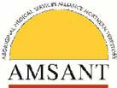
Aboriginal Medical Services Alliance NT

We acknowledge that LAF is just one part of the solution to addressing petrol sniffing in Aboriginal communities and we know that it is most effective when implemented along with other measures including adequately resourced early intervention services, youth and recreation programs and training and employment opportunities.

The existence of this legislation and the Government’s demonstrated willingness to implement it has provided incentives to retailers in other regions to voluntarily switch to LAF. Likewise the existence of the legislation acts a disincentive for retailers who are currently using LAF to switch back to regular unleaded petrol (RULP).

While it is clearly the intent of the legislation that it could be used to place controls on Premium fuel and impose penalties when these are breached, this aspect of the legislation we note that this has not been utilised or tested. Further there is some concern that this aspect of the legislation has been set up poorly and lacks capacity to place enforceable controls on Premium fuels.

Premium fuel contains high levels of the volatile components that cause a ‘high' in RULP so it may be that in years to come that it will be necessary to restrict availability of Premium in some locations. Also without enforceable controls on Premium it would be open to retailers to convert from RULP to Premium fuel as a way of getting around stocking LAF. This would not be a good outcome as there is some potential for Premium to be sniffed.

This aspect of the legislation should be reviewed and strengthened so that if necessary it can be used to stop retailers or others from selling Premium in an LAF Area if this is likely to reduce potential harms caused by sniffing.

Yours Sincerely

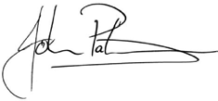

John Paterson Chief Executive

Low Aromatic Fuel Act Review Health and Wellbeing Branch
Department of the Prime Minister and Cabinet
PO Box 6500
Canberra ACT 2601

Sent by email: lowaromaticfuel@pmc.gov.au

May 18, 2018

Dear Sir or Madam,

Thank you for the opportunity to provide comments to the review of the Low Aromatic Fuel Act 2013. This submission is made on behalf of Viva Energy Australia Pty Ltd (“Viva Energy”).

About Viva Energy
Formed in 2014 following the purchase of Shell’s downstream business in Australia, Viva Energy’s operations include the Geelong refinery (Victoria), a 950 plus national service station network and bulk fuels, aviation, bitumen, marine, chemicals and lubricants businesses supported by more than 20 fuel import terminals across the country. Viva Energy is the exclusive licensee to the Shell brand in Australia.

As a business, Viva Energy is a proud supporter of the Governments program to reduce petrol sniffing, converting our first service station from Shell Unleaded 91 to Shell Unleaded 91 Low Aromatic in Alice Springs in 2007.

Viva Energy has manufactured Low Aromatic Fuel at our Geelong Refinery since 2014, and is the current contracted bulk supplier of Low Aromatic Fuel to industry terminals in the Northern Territory and Queensland.

Overview of the Low Aromatic Fuel Act 2013
Our overall view, both from our specific involvement and also from the research conducted by the University of Queensland and Menzies School of Health Research, is that the program is effective. The most recent report which surveyed 15 communities which have stocked low aromatic fuel since 2005, found that the median rates of petrol sniffing had declined by 96 per cent by 2014.

Introduction of Low Aromatic Fuel (LAF) into communities has not been without its challenges. We have had some incidents in the past where we have had to have some difficult conversations with a limited number of independent service station owners that we supply fuel to, based on their resistance to accepting LAF. This resistance has primarily related to incorrect information and hearsay about the quality of the fuel and the perceived operability issues. This incorrect information has persisted since the initial introduction of Opal fuel – even though this information has not been based in fact. Viva Energy has invested considerable time and resources through the involvement of our Product Quality specialist, Dr Mark Tabone, in helping to educate communities, mechanics and service station operators and bust some of the myths about the fuel. Having a legislative instrument to back up these conversations has, in our view, been beneficial even if it has not been used.
Viva Energy Australia Pty Ltd ABN 46 004 610 459

Level 16, 720 Bourke Street, Docklands, VIC 3008 T (03) 8823 4148 vivaenergy.com.au

Specifically in respect to the wording within the Act, Viva Energy proposes a number of small amendments to more appropriately reflect industry definitions of fuel products. Specifically we propose that the definition of regular unleaded petrol be updated to:

“regular unleaded petrol means unleaded petrol that has a minimum research octane number of 91.0 and meets the requirements of the Fuel Quality Standard Act (2000).”
Viva Energy also proposes that the definition of low aromatic petrol be updated to: “low aromatic fuel means:

(a) unleaded petrol that has a minimum research octane number of 91.0, meets the requirements of the Fuel Quality Standard Act (2000) and has a total aromatic content of no more than 5% to help discourage volatile substance misuse in the form of fuel sniffing.

Overall Viva Energy supports the operations of the Low Aromatic Fuel Act 2013 and is proud to be part of the program to help prevent petrol sniffing. The slight changes proposed to definitions of regular unleaded petrol and low aromatic fuel would help streamline the Act and make it consistent with industry definitions of fuel products and their basic specifications.

Should you have any questions or wish to discuss this brief submission the please do not hesitate to contact me on or .

Kind Regards,

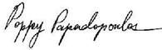

on behalf of
Edwina Pribyl
External Communications Manager

Viva Energy Australia Pty Ltd ABN 46 004 610 459
Level 16, 720 Bourke Street, Docklands, VIC 3008 T (03) 8823 4148 vivaenergy.com.au

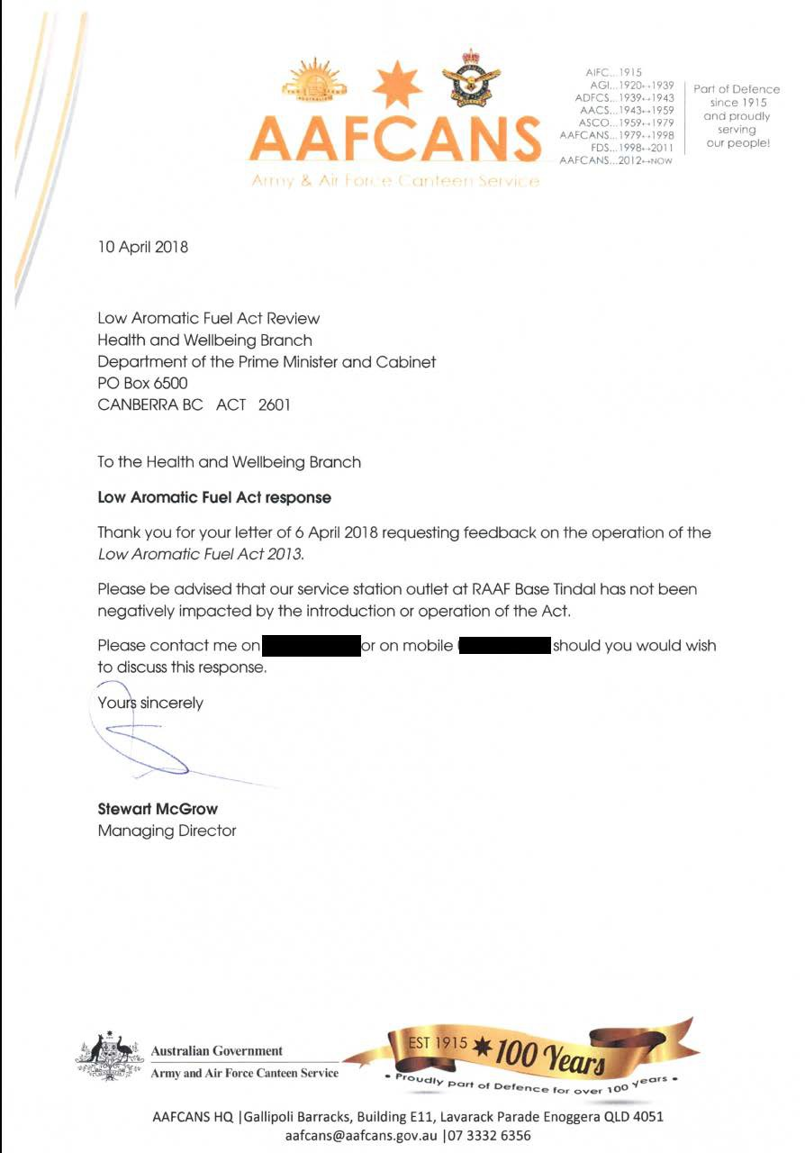

Alternate text format of Image above - AAFCANS
Logo of AAFCANS (Army and Air Force Canteen Service) Part of Defence since 1915 and proudly serving our people. Includes a number of different acronym’s that they have been known as.
10 April 2018

Low Aromatic Fuel Act review Health and Wellbeing Branch
Department of the prime Minister and Cabinet PO Box 6500
Canberra BC ACT 2601

To the Health and Wellbeing Branch Low Aromatic Fuel Act response
Thank you for your letter of 6 April 2018 requesting feedback on the operation of the Low Aromatic Fuel Act 2013.

Please be advised that our service station outlet at RAAF Base Tindal has not been negatively impacted by the introduction or operation of the Act.

Please contact me on [phone number redacted] or no mobile [mobile number redacted] should you would wish to discuss this response.

Yours sincerely s
[signature] Stewart McGrow Managing Director

Address details includes Australia’s Coat of Arms Letter head for Australian Government Army and Air Force Canteen Service. Then has a logo like a ribbon with Est 1915 * 100 years and underneath the ribbon Proudly part of defence for over 100 years. Then address AAFCANS HQ / Gallipoli Barracks, Building E11, Lavarack Parade Enoggera QLD 4051 email address aafcans@aafcans.gov.au / telephone number 07 3332 6356

Anyinginyi Health Aboriginal Corporation’s submission to the Low Aromatic Fuel Act 2013 Review

Tennant Creek and Three Ways Roadhouse were declared Low Aromatic Fuel Areas on the 17th of February 2016. The Three Ways Roadhouse is some
23 kilometres north of Tennant Creek.

This submission has been developed from information collected from consultations with a range of Tennant Creek local individuals, Programs and Services, Government and non-Government agencies, including Police and Service Stations. Conclusions from this information form the basis of Anyinginyi’s submission and they are:
- The declaration of Tennant Creek and the Three Ways Roadhouse as a Low Aromatic Fuel Area and the subsequent replacement of Regular Unleaded Fuel (RULF) with Low Aromatic Fuel (LAF) has had a positive impact on the reduction of petrol sniffing in Tennant Creek.
- Whilst there has been a significant reduction in the petrol sniffing, reports indicate that sniffing still occurs in much smaller numbers and less frequent. The local drug and alcohol abuse advisory service continues to have petrol sniffers referred and avail themselves of their rehabilitation services.
- Information has been received that attempts have been made to sniff premium fuel by heating it up and sniffing the fumes. Other information includes that sniffers are targeting vehicles from outside the Tennant Creek and Three Ways area to steal RULF, young people were reported sniffing leftover fuel in tanks of wrecked vehicles and RULF is being brought in from outlying communities for locals to sniff.
- Initially there were concerns that LAF would damage motor vehicle engines however these concerns have been allayed and Service Station Proprietors have reported that there has not been any recent complaints about the LAF.
- Local Service Station Proprietors have expressed their support for the sale of the LAF.

Recommendations to the Review:

Anyinginyi Health Aboriginal Corporation strongly recommends that Tennant Creek and Three Ways Roadhouse remained declared Low Aromatic Areas under the Act.

Department of Prime Minister and Cabinet undertake appropriate consultations to determine whether Communities, Towns and Roadhouse north to south to
and east to the from Tennant Creek are included as Low Aromatic Fuel Areas under the Act.

Recommendation for changes of the Low Aromatic Fuel Act 2013:

Part 4—Exemptions from requirements of this Act

17 Minister may exempt conduct in relation to low aromatic fuel areas and fuel control areas

To include:

The Minister must consult with such persons and bodies from the following in Low Aromatic Areas of intentions to exempt any conduct under the Act;
- Community representatives;
(aa) Aboriginal persons or Torres Strait Islanders (or representatives of Aboriginal persons or Torres Strait Islanders);
- Manufacturers and suppliers of fuel;
- Persons with an interest in or knowledge of human health; and,
- Any other person that the Minister considers appropriate.
- Without limiting subsection (1), the Minister must ensure that:
  - information setting out the following has been made available in the area:
- the proposal to exempt the conduct in the designated area;
- an explanation, in summary form, of the consequences of exempting the conduct in the area; and
  - people living in the area, and businesses and organisations operating in the area, have been given a reasonable opportunity to make submissions to the Minister about:
    - the proposal to exempt the conduct in the designated the area; and
    - the consequences of exempting the conduct in the designated area; and
    - their circumstances, concerns and views, so far as they relate to the exemption.

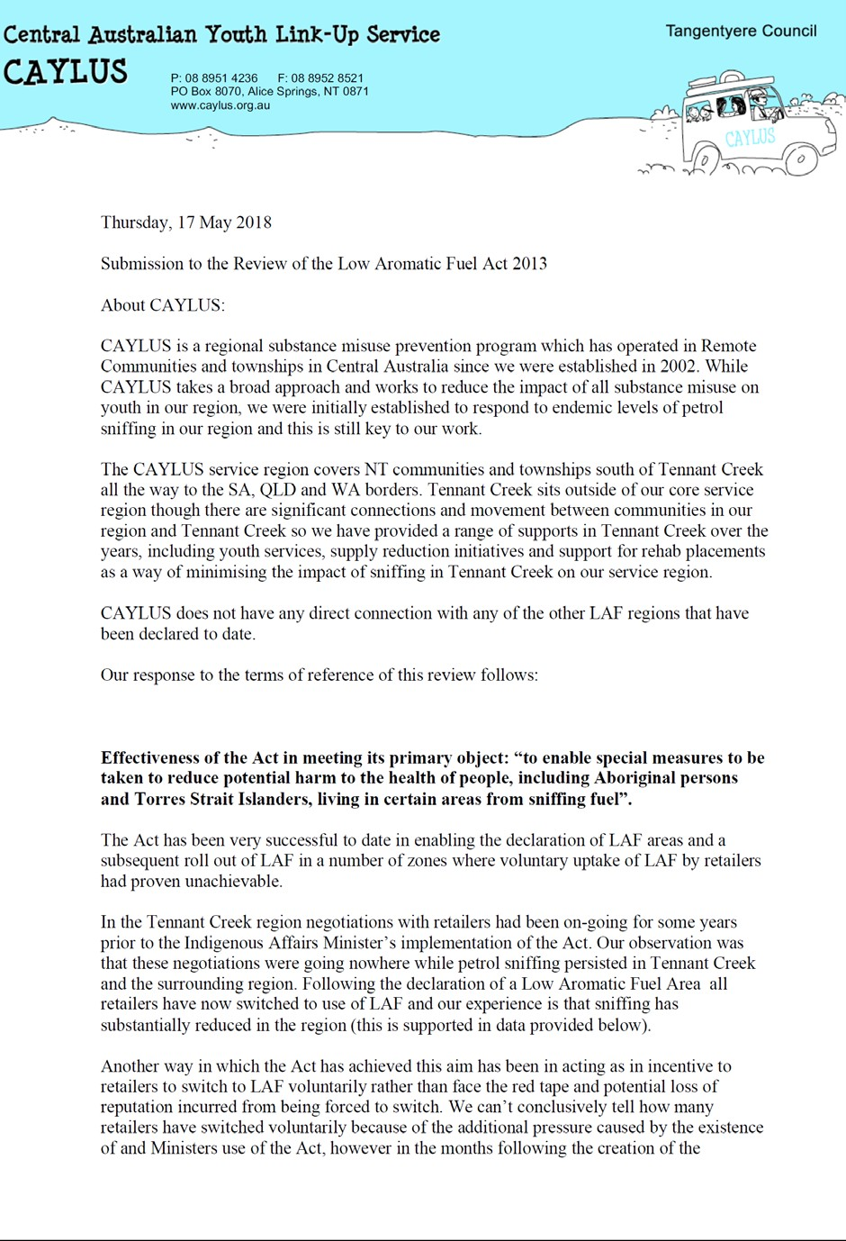

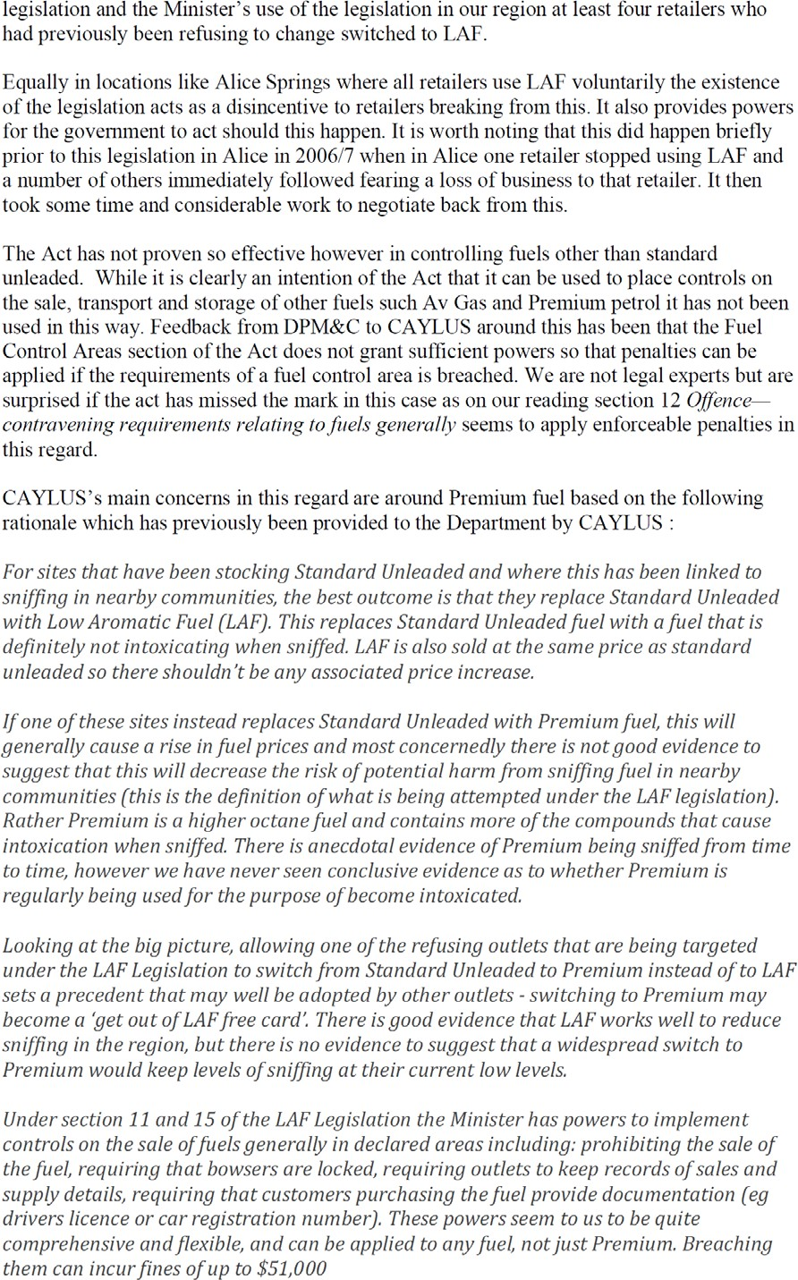

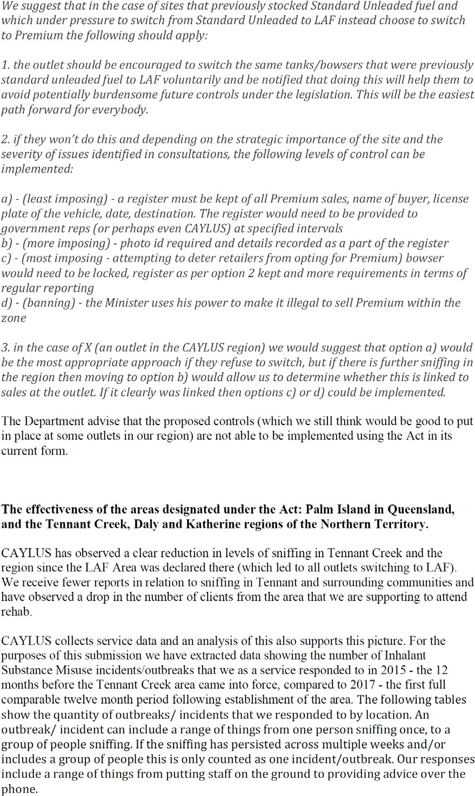

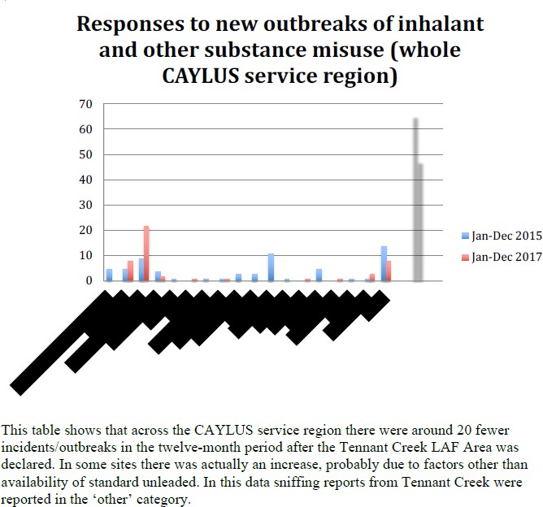

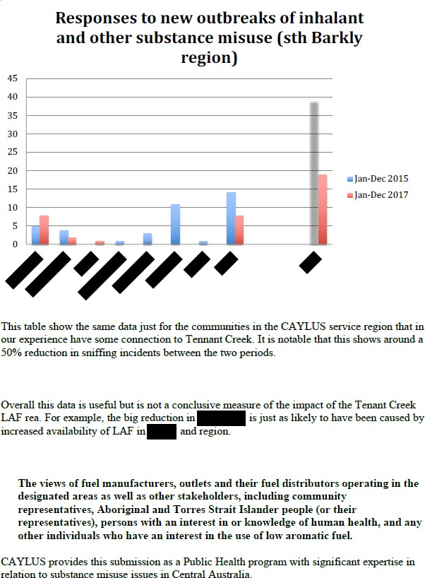

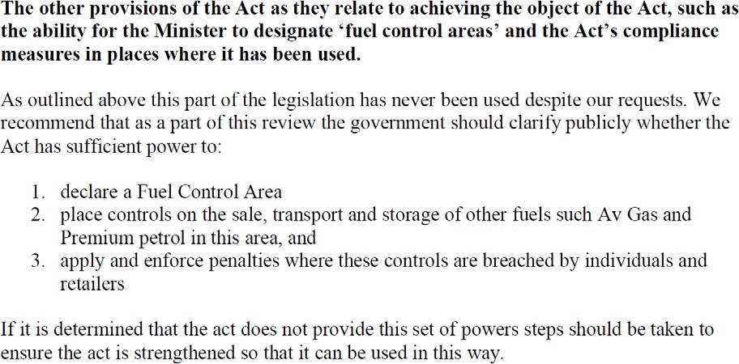

Alternate text format of Image above - CAYLUS

[HEADER]
Central Australian Youth Link Up Service Tangentyere Council CAYLUS
P: 08 8951 4236 F: 088952 8521
PO Box 8070, Alice Springs, NT 0871 www.caylus.org.au

Thursday, 17 May 2018

Submission to the Review of the Low Aromatic Fuel Act 2013 About CAYLUS:
CAYLUS is a regional substance misuse prevention program which has operated in Remote Communities and townships in Central Australia since we were established in 2002. While CAYLUS takes a broad approach and works to reduce the impact of all substance misuse on youth in our region, we were initially established to respond to endemic levels of petrol sniffing in our region and this is still key to our work.

The CAYLUS service region covers NT communities and townships south of Tennant Creek all the way to the SA, QLD, and WA borders. Tennant Creek sits outside of our core service region though there are significant connections and movement between communities in our region and Tennant Creek so we have provided a range of supports in Tennant Creek over the years, including youth services, supply reduction initiatives and support for rehab placements as a way of minimizing the impact of sniffing in Tennant Creek on our service region.

CAYLUS does not have any direct connection with any of the other LAF regions that have been declared to date.

Our response to the terms of reference of this review follows:

Effectiveness of the Act in meeting its primary object: “to enable special measures to be taken to reduce potential harm to the health of people, including Aboriginal persons and Torres Strait Islanders, living in certain areas from sniffing fuel”.

The Act has been very successful to date in enabling the declaration of LAF areas and a subsequent roll out of LAF in a number of zones where voluntary uptake of LAF by retailers had proven unachievable.

In the Tennant Creek region negotiations with retailers had been on-going for some years prior to the Indigenous Affairs Minister’s implementation of the Act. Our observation was that these negotiations were going nowhere while petrol sniffing persisted in Tennant Creek and the surrounding region. Following the declaration of a Low Aromatic Fuel Area all retailers have now switched to use of LAF and our experience is that sniffing has substantially reduced in the region (this is supported in data provided below).

Another way in which the Act has achieved this aim has been in acting as an incentive to retailers to switch to LAF voluntarily rather than face the red tape and potential loss of reputation incurred from being forced to switch. We can’t conclusively tell how many retailers have switched voluntarily because of the additional pressure caused by the existence of and Ministers use of the Act, however in the months following the creation of the legislation and the Minister’s use of the legislation in our region at least four retailers who had previously been refusing to change switched to LAF.

Equally in locations like Alice Springs where all retailers use LAF voluntarily the existence of the legislation acts as a disincentive to retailers breaking from this. It also provides powers for the government to act should this happen. It is worth noting that this did happen briefly prior to this legislation in Alice in 2006/7 when in Alice one retailer stopped using LAF and a number of others immediately followed fearing a loss of business to that retailer. It then took some time and considerable work to negotiate back from this.

The Act has not proven so effective however in controlling fuels other than standard unleaded. While it is clearly an intention of the Act that it can be used to place controls on the sale, transport and storage of other fuels such as Av Gas and Premium petrol it has not been used in this way. Feedback from PM&C to CAYLUS around this has been that the Fuel Control Areas section of the Act does not grant sufficient powers so that penalties can be applied if the requirements of a fuel control area is breached. We are not legal experts but are surprised if the act has missed the mark in this case as on our reading section 12 Offence – contravening requirements relating to fuels generally seems to apply enforceable penalties in this regard.

CAYLUS’s main concerns in this regard are around Premium fuel based on the following rationale which has previously been provided to the Department by CAYLUS:

For sites that have been stocking Standard Unleaded and where this has been linked to sniffing in nearby communities, the best outcome is that they replace Standard Unleaded with Low Aromatic Fuel (LAF). This replaces Standard Unleaded fuel with a fuel that is definitely not intoxicating when sniffed. LAF is also sold at the same price as standard unleaded so there shouldn’t be any associated price increase.

If one of these sites instead replaces Standard Unleaded with Premium fuel, this will generally cause a rise in fuel prices and most concernedly there is not good evidence to suggest that this will decrease the risk of potential harm from sniffing fuel in nearby communities (this is the definition of what is being attempted under the LAF legislation). Rather Premium is a higher octane fuel and contains more of the compounds that cause intoxication when sniffed. There is anecdotal evidence of Premium being sniffed from time to time, however we have never seen conclusive evidence as to whether Premium is regularly being used for the purpose of become intoxicated.

Looking at the big picture, allowing one of the refusing outlets that are being targeted under the LAF Legislation to switch from Standard Unleaded to Premium instead of to LAF sets a precedent that may well be adopted by other outlets – switching to Premium may become a ‘get out of LAF free card’. There is good evidence that LAF works well to reduce sniffing in

the region, but there is no evidence to suggest that a widespread switch to Premium would keep levels of sniffing at their current low levels.

Under section 11 and 15 of the LAF Legislation the Minister has powers to implement controls on the sale of fuels generally in declared areas including: prohibiting the sale of the fuel, requiring that bowsers are locked, requiring outlets to keep records of sales and supply details, requiring that customers purchasing the fuel provide documentation (eg drivers licence or car registration number). These powers seem to us to be quite comprehensive and flexible, and can be applied to any fuel, not just Premium. Breaching them can incur fines of up to $51,000

We suggest that in the case of sites that previously stocked Standard Unleaded fuel and which under pressure to switch from Standard Unleaded to LAF instead choose to switch to Premium the following should apply:

- the outlet should be encouraged to switch the same tanks/bowsers that were previously standard unleaded fuel to LAF voluntarily and be notified that doing this will help them to avoid potentially burdensome future controls under the legislation. This will be the easiest path forward for everybody.
- if they won’t do this and depending on the strategic importance of the site and the severity of the issues identified in consultations, the following levels of control can be implemented:
- – (least imposing) – a register must be kept of all Premium sales, name of buyer, license plate of the vehicle, date, destination. The register would need to be provided to government reps (or perhaps even CAYLUS) at specified intervals
- – (more imposing) – photo id required and details recorded as part of the register
- – (most imposing – attempting to deter retailers from opting for Premium) bowser would need to be locked, register as per option 2 kept and more requirements in terms of regular reporting
- – (banning) – the Minister uses his power to make it illegal to sell Premium within the zone
- in the case of X (an outlet in the CAYLUS region) we would suggest that option a) would be the most appropriate approach if they refuse to switch, but if there is further sniffing in the region then moving to option b) would allow us to determine whether this is linked to sales at the outlet. If it clearly was linked then options c) or d) could be implemented.

The Department advise that the proposed controls (which we still think would be good to put in place at some outlets in our region) are not able to be implemented using the Act in its current form.

The effectiveness of the areas designated under the Act: Palm Island in Queensland, and the Tennant Creek, Daly and Katherine regions of the Northern Territory.

CAYLUS has observed a clear reduction in levels of sniffing in Tennant Creek and the region since the LAF Area was declared there (which led to all outlets switching to LAF). We receive fewer reports in relation to sniffing in Tennant Creek and surrounding communities and have observed a drop in the number of clients from the area that we are supporting to attend rehab.

CAYLUS collects service data and an analysis of this also supports this picture. For the purposes of this submission we have extracted data showing the number of Inhalant Substance Misuse incidents/outbreaks that we as a service responded to in 2015 – the 12 months before the Tennant Creek area came into force, compared to 2017 – the first full comparable twelve month period following establishment of the area. The following tables show the quantity of outbreaks / incidents that we responded to by location. An outbreak / incident can include a range of things from one person sniffing once, to a group of people sniffing. If the sniffing has persisted across multiple weeks and/or includes a group of people this is only counted as one incident / outbreak. Our responses include a range of things from putting staff on the ground to providing advice over the phone.

[Graph: Responses to new outbreaks of inhalant and other substance misuse (whole CAYLUS service region)]

This table shows that across the CAYLUS service region there were around 20 fewer incidents / outbreaks in the twelve month period after the Tennant Creek LAF Area was declared. In some sites there was actually an increase, probably due to factors other than availability of standard unleaded. In this data sniffing reports from Tennant Creek were reported in the ‘other’ category.

[Graph: Responses to new outbreaks of inhalant and other substance misuse (sth Barkly region)]

This table show the same data just for the communities in the CAYLUS service region that in our experience have some connection to Tennant Creek. It is notable that this shows around a 50% reduction in sniffing incidents between the two periods.

Overall this data is useful but is not a conclusive measure of the impact of the Tennant Creek LAF rea. For example, the big reduction in [redacted] is just as likely to have been caused by increased availability of LAF in [redacted] and region.

The views of fuel manufacturers, outlets and their fuel distributors operating in the designated areas as well as other stakeholders, including community representatives, Aboriginal and Torres Strait Islander people (or their representatives), persons with an interest in or knowledge of human health, and any other individuals who have an interest in the use of low aromatic fuel.

CAYLUS provides this submission as a Public Health program with significant expertise in relation to substance misuse issues in Central Australia.

The other provisions of the Act as they relate to achieving the object of the Act, such as the ability for the Minister to designate ‘fuel control areas’ and the Act’s compliance measures in place where it has been used.

As outlined above this part of the legislation has never been used despite our requests. We recommend that as a part of this review the government should clarify publicly whether the Act has sufficient power to:

  - declare a Fuel Control Area
  - place controls on the sale of, transport and storage of other fuels such as Av Gas and Premium petrol in this area, and
  - apply and enforce penalties where these controls are breached by individuals and retailers

If it is determined that the act does not provide this set of powers steps should be taken to ensure the act is strengthened so that it can be used in this way.

Additional Industry Submission:

One additional fuel industry stakeholder that did not wish to be identified provided the following submission to the review:

- The stakeholder expressed that it had no concerns with low aromatic fuel as a product, or the operation of the Low Aromatic Fuel Act 2013. While the stakeholder was aware of some anecdotal consumer complaints relating to the impact of low aromatic fuel on engine performance, the stakeholder was not aware of any complaint being substantiated and believed that any residual concerns were based on customer misinformation.

- The stakeholder provided no comment on the impact of low aromatic fuel as a strategy to reduce petrol sniffing, or on the regions which the Minister for Indigenous Affairs designated as low aromatic fuel areas.

- The stakeholder noted that the supply of low aromatic fuel into bulk storage facilities for any given region comes from only one supplier, rather than through a multitude of different suppliers as would be the case for regular unleaded fuel. This affects the normal market dynamics between organisations in the fuel industry, and so dynamics around low aromatic fuel are different than those around regular unleaded fuel. This can have a small impact on the price of low aromatic fuel from bulk storage facilities for some distributors. The stakeholder did not provide a preferred approach that could better address this issue.

[The Department notes that the issue raised by the stakeholder in the third dot point is not specific to areas designated under the Low Aromatic Fuel Act, but applies for all regions stocking low aromatic fuel, whether they have converted to stock low aromatic fuel under a designation or voluntarily. The Department is aware of the limited affect of low aromatic fuel on market dynamics and takes steps to minimise this impact as far as possible without further inhibiting normal market operation.]

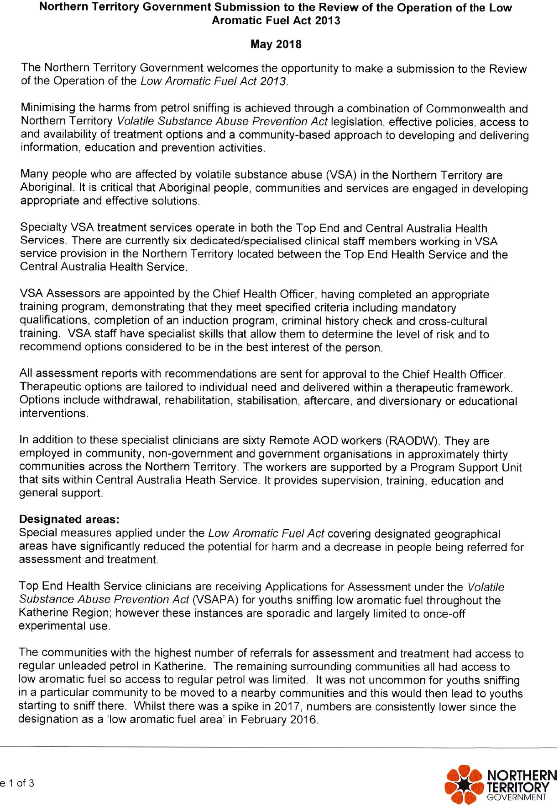

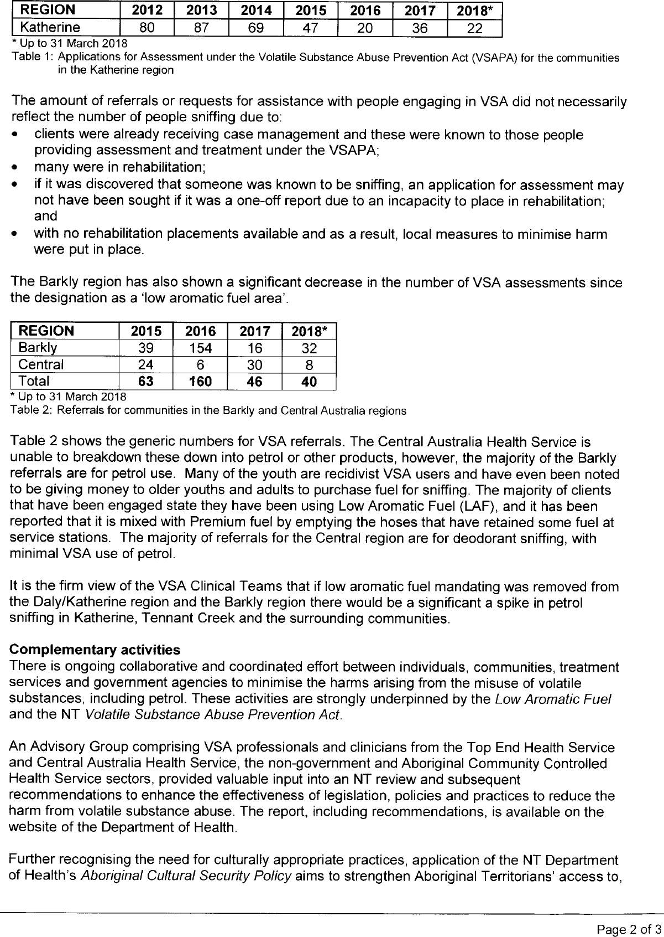

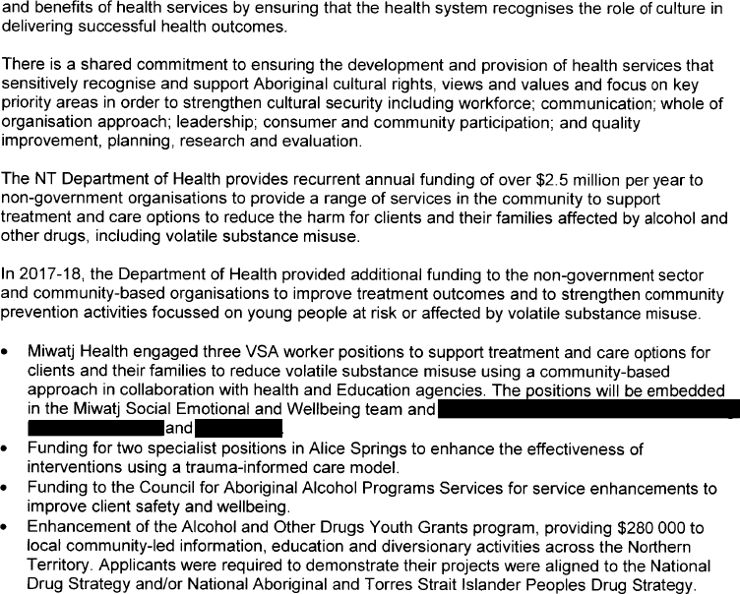

Alternate text format of Image above – NT Government
Northern Territory Government Submission to the review of the Operation of the Low Aromatic Fuel Act 2013
May 2018
The Northern Territory Government welcomes the opportunity to make a submission to the Review of the Operation of the Low Aromatic Fuel Act 2013.

Minimising the harms from petrol sniffing is achieved through a combination of Commonwealth and Northern Territory Volatile Substance Abuse Prevention Act legislation, effective polices, access to and availability of treatment options and a community-based approach to developing and delivering information, education and prevention activities.

Many people who are affected by volatile substance abuse (VSA) in the Northern territory are Aboriginal. It is critical that Aboriginal people, communities and services are engaged in developing appropriate and effective solutions.

Specialty VSA treatment services operate in both the Top End and Central Australia Health Services. There are currently six dedicated/specialised clinical staff members working in VSA service provision in the Northern Territory located between the Top End Health Service and the Central Australia Health Service.

VSA Assessors are appointed by the Chief Health Officer, having completed an appropriate training program, demonstrating that they meet specified criteria including mandatory qualifications, completion of an induction program, criminal history check and cross-cultural training. VSA staff have specialist skills that allow them to determine the level of risk and to recommend options considered to be in the best interest of the person.

All assessment reports with recommendations are sent for approval to the Chief Health Officer. Therapeutic options are tailored to individual need and delivered within a therapeutic framework. Options include withdrawal, rehabilitation, stabilisation, aftercare, and diversionary or educational interventions.

In addition to these specialist clinicians are sixty Remote AOD workers (RAODW). They are employed in community, non-government and government organisations in approximately thirty communities across the Northern Territory. The workers are supported by a Program Support Unit that sits within Central Australia Health Service. It provides supervision, training, education and general support.

Designated Areas:
Special measures applied under the Low Aromatic Fuel Act covering designated geographical areas have significantly reduced the potential for harm and a decrease in people being referred for assessment and treatment.

Top End Health Service clinicians are receiving Applications for Assessment under the Volatile Substance Abuse Prevention Act (VSAPA) for youths sniffing low aromatic fuel throughout the Katherine Region; however these instances are sporadic and largely limited to once-off experimental use.

The communities with the highest number of referrals for assessment and treatment had access to regular unleaded petrol in Katherine. The remaining surrounding communities all had access to low aromatic fuel so access to regular petrol was limited. It was not uncommon for youths sniffing in a particular community to be moved to a nearby communities and this would then lead to youths starting to sniff there. Whilst there was a spike in 2017, numbers are consistently lower since the designation as a ‘low aromatic fuel area’ in February 2016.

REGION | 2012 | 2013 | 2014 | 2015 | 2016 | 2017 | 2018*
Katherine | 80 | 87 | 69 | 47 | 20 | 36 | 22
- Up to 31 March 2018
Table 1: Applications for Assessments under the Volatile Substance Abuse Prevention Act (VSAPA) for the communities in the Katherine region

[Table 1 shows the number of applications for assessment received from 2012 to 2018 with a decline of 27 from 2015 to 2016 (47 to 20) and an increase of 16 from 2016 to 2017 (20 to
- and then a further decline of 14 from 2017 to 31 March 2018 (36 to 22).]

The amounts of referrals or requests for assistance with people engaging in VSA did not necessarily reflect the number of people sniffing due to:
  - clients were already receiving case management and these were known to those people providing assessment and treatment under the VSAPA;
  - many were in rehabilitation;
  - if it was discovered that someone was known to be sniffing, an application for assessment may not have been sought if it was a one-off report due to an incapacity to place in rehabilitation; and
  - with no rehabilitation placements available and as a result, local measures to minimise harm were in place.

The Barkly region has also shown a significant decrease in the number of VSA assessments since the designation as a ‘low aromatic fuel area’.

REGION | 2015 | 2016 | 2017 | 2018*
Barkly | 39 | 154 | 16 | 32
Central | 24 | 6 | 30 | 8
Total | 63 | 160 | 46 | 40
- Up to 31 March 2018
Table 2: Referrals for communities in the Barkly and Central Australia regions

[Table 2 shows the number of referrals from 2015 to 31 March 2018, with the total numbers climbing from 63 in 2015 to a peak of 160 in 2016 and then a decline to 46 in 2017 and then 40 to 31 March 2018.]

Table 2 shows the generic numbers for VSA referrals. The Central Australia Health Service is unable to breakdown these down into petrol or other products, however, the majority of the Barkly referrals are for petrol use. Many of the youth are recidivist VSA users and have even been noted to be giving money to older youths and adults to purchase fuel for sniffing. The majority of clients that have been engaged state they have been using Low Aromatic Fuel

(LAF), and it has been reported that it is mixed with Premium fuel by emptying the hoses that have retained some fuel at service stations. The majority of referrals for the Central region are for deodorant sniffing, with minimal VSA use of petrol.

It is the firm view of the VSA Clinical Teams that if low aromatic fuel mandating was removed from the Daly/Katherine region and the Barkly region there would be a significant a spike in petrol sniffing in Katherine, Tenant Creek and the surrounding communities.

Complementary activities
There is ongoing collaborative and coordinated effort between individuals, communities, treatment services and government agencies to minimise the harms arising from the misuse of volatile substances, including petrol. These activities are strongly underpinned by the Low Aromatic Fuel and the NT Volatile Substance Abuse Prevention Act.

An Advisory Group comprising VSA professionals and clinicians from the Top End Health Service and Central Australia Health Service, the non-government and Aboriginal Community Controlled Health Service sectors, provided valuable input into an NT review and subsequent recommendations to enhance the effectiveness of legislation, policies and practices to reduce the harm from volatile substance abuse. The report, including recommendations, is available on the website of the Department of Health.

Further recognising the need for culturally appropriate practices, application of the NT Department of Health’s Aboriginal Cultural Security Policy aims to strengthen Aboriginal Territorians’ access to, and benefits of health services by ensuring that the health system recognises the role of culture in delivering successful health outcomes.

There is a shared commitment to ensuring the development and provision of health services that sensitively recognise and support Aboriginal cultural rights, views and values and focus on key priority areas in order to strengthen cultural security including workforce; communication; whole of organisation approach; leadership; consumer and community participation; and quality improvement, planning, research and evaluation.

The NT Department of Health provides recurrent annual funding of over $2.5 million per year to non-government organisations to provide a range of services in the community to support treatment and care options to reduce the harm for clients and their families affected by alcohol and other drugs, including volatile substance misuse.

In 2017-18, the Department of Health provided additional funding to the non-government sector and community-based organisations to improve treatment outcomes and to strengthen community prevention activities focussed on young people at risk or affected by volatile substance misuse.

  - Miwatj Health engaged three VSA worker positions to support treatment and care options for clients and their families to reduce volatile substance misuse using a community-based approach in collaboration with health and Education agencies. The positions will be embedded in the Miwatj Social Emotional and Wellbeing team and based in affected communities including [redacted], [redacted] and [redacted].

  - Funding for two specialists positions in Alice Springs to enhance the effectiveness of interventions using a trauma-informed care model.
  - Funding to the Council for Aboriginal Alcohol Programs Services for service enhancements to improve client safety and wellbeing.
  - Enhancement of the Alcohol and Other Drugs Youth Grants program, providing
$280 000 to local community-led information, education and diversionary activities across the Northern Territory. Applicants were required to demonstrate their projects were aligned to the National Drug Strategy and/or National Aboriginal and Torres Strait Islander Peoples Drug Strategy.

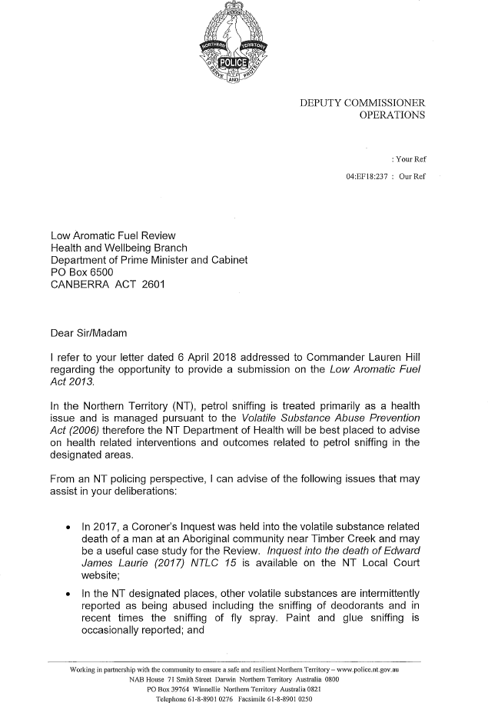

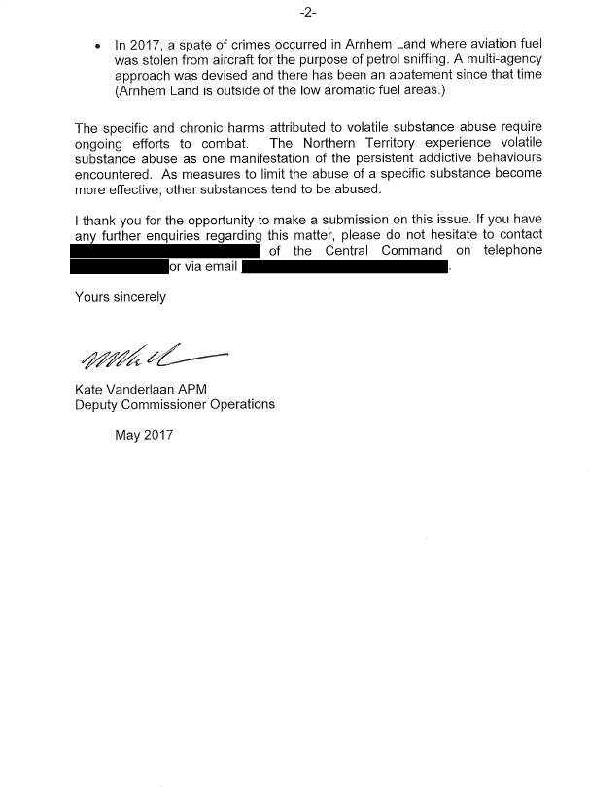

Alternate text format of Image above – NT Police
NORTHERN TERRITORY POLICE
DEPUTY COMMISSIONER
OPERATIONS

: Your Ref 04:EF18:237 : Our Ref

Low Aromatic Fuel Review Health and Wellbeing Branch
Department of the Prime Minister and Cabinet PO Box 6500
CANBERRA ACT 2601

Dear Sir/Madam
I refer to your letter dated 6 April 2018 addressed to Commander Lauren Hill regarding the opportunity to provide a submission on the Low Aromatic Fuel Act 2013.
In the Northern Territory (NT), petrol sniffing is treated primarily as a health issue and is managed pursuant to the Volatile Substance Abuse Prevention Act (2006) therefore the NT Department of Health will be best placed to advise on health related interventions and outcomes related to petrol sniffing in the designated areas.
From an NT policing perspective, I can advise of the following issues that may assist in your deliberations:
- In 2017 a Coroner’s Inquest was held into the volatile substance misuse related death of a man at an Aboriginal community near Timber Creek and may be a useful case study for the Review. Inquest into the death of Edward James Laurie (2017) NTCR 15 is available on the NT Local Court website;

- In the NT designated places, other volatile substances are intermittently reported as being abused including the sniffing of deodorants and in recent times the sniffing of fly spray. Paint and glue sniffing is occasionally reported; and
[DOCUMENT FOOTER]
Working in partnership to ensure a safe and resilient Northern Territory – www.police.nt.gov.au NAB House 71 Smith Street Darwin Northern Territory Australia 0800
PO Box 39764 Winnellie Northern Territory Australia 0821 Telephone 61-8-8901 0276 Facsimile 61-8-8901 0250

-2-
- In 2017, a spate of crimes occurred in Arnhem Land where aviation fuel was stolen from aircraft for the purpose of petrol sniffing. A multi-agency approach was devised and there has been an abatement since that time (Arnhem Land is outside of the low aromatic fuel areas.)
The specific and chronic harms attributed to volatile substance abuse require ongoing efforts to combat. The Northern Territory experience volatile substance abuse as one manifestation of the persistent addictive behaviours encountered. As measures to limit the abuse of a specific substance become more effective, other substances tend to be abused.
I thank you for the opportunity to make a submission on this issue. If you have any further enquiries regarding this matter, please do not hesitate to contact [redacted] of the Central Command on telephone [redacted] or via email [redacted].
Yours sincerely [signature]
Kate Vanderlaan APM
Deputy Commissioner Operations May 2017

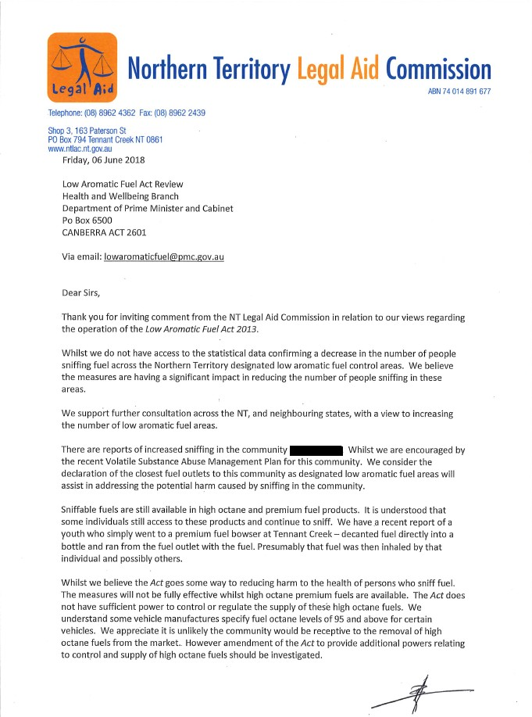

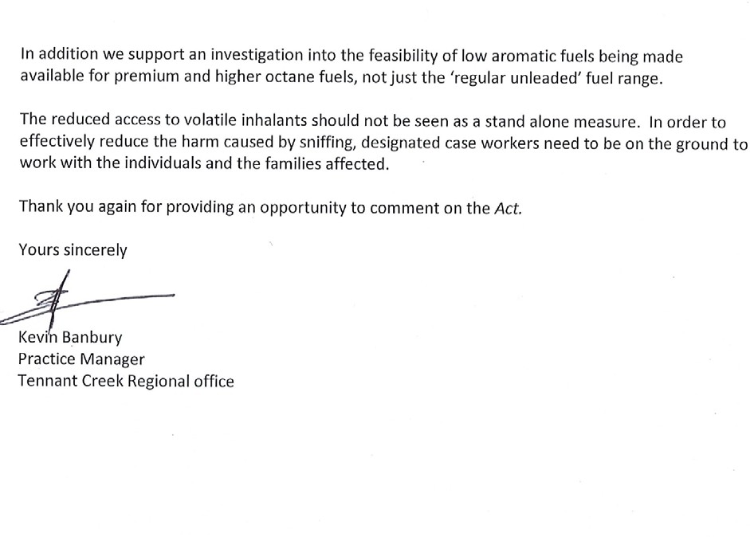

Alternate text format of Image above - NTLAC
[DOCUMENT HEADER]
Northern Territory Legal Aid Commission
ABN 74 014 891 677
Telephone: (08) 8962 4362 Fax (08) 8962 2439
Shop 3, 163 Paterson St
PO Box 794 Tennant Creek NT 0861 www.ntlac.gov.au
Friday 06 June 2018
Low Aromatic Fuel Review Health and Wellbeing Branch
Department of Prime Minister and Cabinet Po Box 6500
CANBERRA ACT 2601

Via email: lowaromaticfuel@pmc.gov.au

Dear Sirs,
Thank you for inviting comment from the NT Legal Aid Commission in relation to our views regarding the operation of the Low Aromatic Fuel Act 2013.
Whilst we do not have access to the statistical data confirming a decrease in the number of people sniffing fuel across the Northern Territory designated low aromatic fuel control areas. We believe the measures are having a significant impact in reducing the number of people sniffing in these areas.
We support further consultation across the NT, and neighbouring states, with a view to increasing the number of low aromatic fuel areas.
There are reports of increased sniffing in the community of [redacted]. Whilst we are encouraged by the recent Volatile Substance Abuse Management Plan for this community. We consider the declaration of the closest fuel outlets to this community as designated low aromatic fuel areas will assist in addressing the potential harm cause by sniffing in the community.
Sniffable fuels are still available in high octane and premium fuel products. It is understood that some individuals still access to these products and continue to sniff. We have a recent report of a youth who simply went to a premium fuel bowser at Tennant Creek – decanted fuel directly into a bottle and ran from the fuel outlet with the fuel. Presumably that fuel was then inhaled by that individual and possibly others.
Whilst we believe the Act goes some way to reducing harm to the health of persons who sniff fuel. The measures will not be fully effective whilst high octane premium fuels are available. The Act does not have sufficient power to control or regulate the supply of these high octane fuels. We understand some vehicle manufactures specify fuel octane levels of 95 and above for certain vehicles. We appreciate it is unlikely the community would be receptive to the removal of high octane fuels from the market. However amendment of the Act to provide additional powers relating to control and supply of high octane fuels should be investigated.
[initial]

In addition we support an investigation into the feasibility of low aromatic fuels being made available for premium and higher octane fuels, not just the ‘regular unleaded’ fuel range.
The reduced access to volatile inhalants should not be seen as a stand alone measure. In order to effectively reduce the harm caused by sniffing, designated case workers need to be on the ground to work with the individuals and the families affected.
Thank you again for providing an opportunity to comment on the Act.
Yours sincerely [signature] Kevin Banbury
Practice Manager
Tennant Creek Regional Office

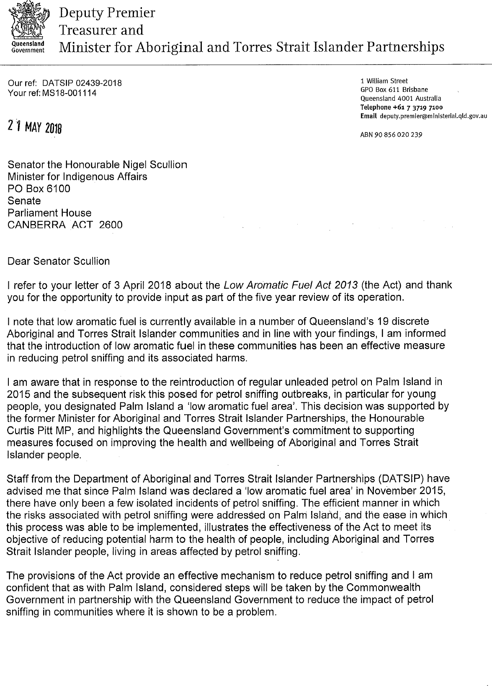

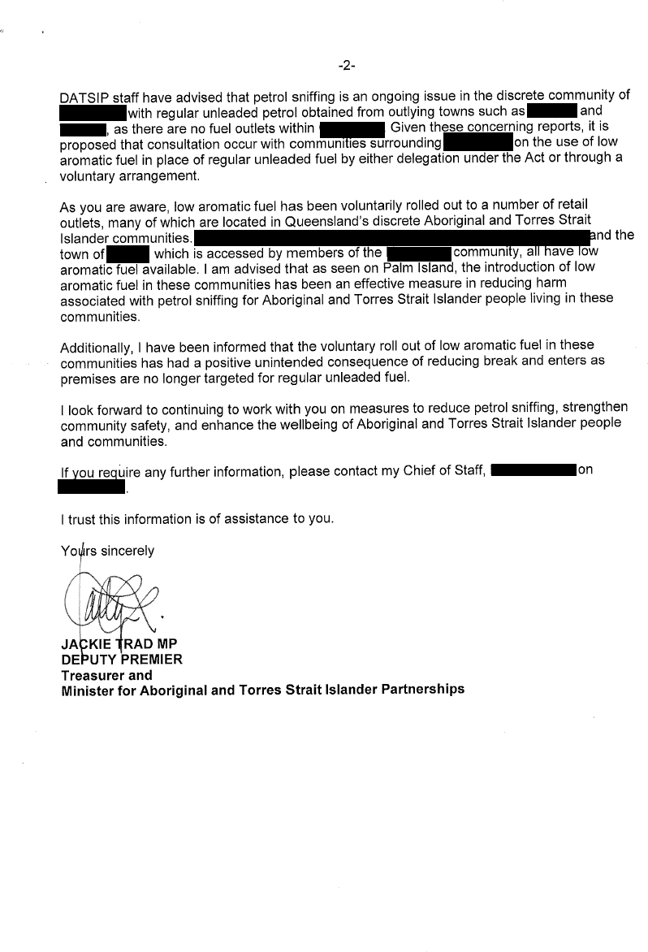

Alternate text format of Image above – QLD Government
[HEADER]
Deputy Premier Treasurer and Minister for Aboriginal and Torres Strait Islander Partnerships

Our ref: DATSIP 02439-2018
Your ref: MS18-001114

21 May 2018

Senator the Honourable Nigel Scullion Minister for Indigenous Affairs
PO Box 6100
Senate Parliament House
CANBERRA ACT 2600

Dear Senator Scullion

1 William Street GPO Box 611 Brisbane Queensland 4001 Australia
Telephone +61 7 3719 7100 Email deputy.premier@ministerial.qld.gov.au

ABN 90 856 020 239

I refer to your letter of 3 April 2018 about the Low Aromatic Fuel Act 2013 (the Act) and thank you for the opportunity to provide input as part of the five year review of its operation.

I note that low aromatic fuel is currently available in a number of Queensland’s 19 discrete Aboriginal and Torres Strait Islander communities and in line with your findings, I am informed that the introduction of low aromatic fuel in these communities has been an effective measure in reducing petrol sniffing and its associated harms.

I am aware that in response to the reintroduction of regular unleaded petrol on Palm Island in 2015 and the subsequent risk this posed for petrol sniffing outbreaks, in particular for young people, you designated Palm Island a ‘low aromatic fuel area’. This decision was supported by the former Minister for Aboriginal and Torres Strait Islander Partnerships, the Honourable Curtis Pitt MP, and highlights the Queensland Government’s commitment to supporting measures focused on improving the health and wellbeing of Aboriginal and Torres Strait Islander people.

Staff from the Department of Aboriginal and Torres Strait Islander Partnerships (DATSIP) have advised me that since Palm Island was declared a ‘low aromatic fuel area’ in November 2015, there have only been a few isolated incidents of petrol sniffing. The efficient manner in which the risks associated with petrol sniffing were addressed on Palm Island, and the ease in which this process was able to be implemented, illustrates the effectiveness of the Act to meet its objectives of reducing potential harm to the health of people, including Aboriginal and Torres Strait Islander people, living in areas affected by petrol sniffing.

The provisions of the Act provide an effective mechanism to reduce petrol sniffing and I am confident that as with Palm Island, considered steps will be taken by the Commonwealth Government in partnership with the Queensland Government to reduce the impact of petrol sniffing in communities where it is shown to be a problem.

DATSIP staff have advised that petrol sniffing is an ongoing issue in the discrete community of [redacted] with regular unleaded petrol obtained from outlying towns such as [redacted]

and [redacted] as there are no fuel outlets within [redacted]. Given these concerning reports, it is proposed that consultation occur with communities surrounding [redacted] on the use of low aromatic fuel in place of regular unleaded fuel by either delegation under the Act or through a voluntary arrangement.

As you are aware, low aromatic fuel has been voluntarily rolled out to a number of retail outlets, many of which are located in Queensland’s discrete Aboriginal and Torres Strait Islander communities. [Redacted] and the town of [redacted], which is accessed by members of the [redacted] community, all have low aromatic fuel available. I am advised that as seen on Palm Island, the introduction of low aromatic fuel in these communities has been an effective measure in reducing harm associated with petrol sniffing for Aboriginal and Torres Strait Islander people living in these communities.

Additionally, I have been informed that the voluntary roll out of low aromatic fuel in these communities has had a positive unintended consequence of reducing break and enters as premises are no longer targeted for regular unleaded fuel.

I look forward to continuing to work with you on measures to reduce petrol sniffing, strengthen community safety, and enhance the wellbeing of Aboriginal and Torres Strait Islander people and communities.

If you require any further information, please contact my Chief of Staff, [redacted] on [redacted].

I trust this information is of assistance to you.

Yours sincerely

[signature] JACKIE TRAD MP
DEPUTY PREMIER
Treasurer and
Minister for Aboriginal and Torres Strait Islander Partnerships

Attachment C: The Petrol Sniffing Strategy and “Eight Point Plan”
In the late 1990s, Indigenous communities concerned about petrol sniffing requested help from the Australian Government. In response, the Government introduced the
Comgas Scheme in 1998, which subsidised the provision of Avgas, then a low aromatic leaded aviation fuel, to participating communities. Avgas was unattractive to petrol sniffers but was not a viable long term option as Australia was phasing out leaded fuels generally due to health concerns. In 2005, a low aromatic unleaded fuel was developed by BP Australia as a substitute to regular unleaded petrol and the Government began supporting its distribution.
Building on the Comgas Scheme, the Petrol Sniffing Prevention Program (PSPP) was established in February 2005 to supply low aromatic fuel to participating communities. The PSPP was implemented by the former Department of Health and Ageing as part of the whole-of-government Petrol Sniffing Strategy (PSS). The PSS was developed in September 2005 as a collaborative approach between the Australian and the
Western Australian, South Australian and NT governments, to reduce petrol sniffing. Under the PSS, jurisdictions agreed to focus on developing: consistent legislation; appropriate levels of policing; further roll out of low aromatic fuel; alternative activities for young people; treatment and respite facilities; communication and education strategies; strengthening and supporting communities; and evaluation. These activities are collectively referred to as the Petrol Sniffing Strategy Eight Point Plan.
Between September 2005 and September 2013 the PSS was managed at the Commonwealth level across the Indigenous Affairs, Health, Education and Attorney-General’s portfolios.
Following the 2013 Federal election, new administrative arrangements for Indigenous policy, programmes and service delivery were announced and the PSS was consolidated in the Department of the Prime Minister and Cabinet.
In recent years more bulk storage locations have been established as the number of sites stocking low aromatic fuel has grown. Low aromatic fuel is now available from bulk storage facilities in Largs North (Adelaide), Kalgoorlie, Darwin, Townsville and Weipa. This has ensured that low aromatic fuel supply more seamlessly forms part of the fuel landscape in these areas, rather than having to be accessed from elsewhere through a special process.
Additional bulk storage facilities have also reduced the Department’s expenditure on distribution subsidies.
From 1 July 2014, funding to support petrol sniffing harm reduction activities has been drawn from the Safety and Wellbeing programme of the Indigenous Advancement Strategy (IAS).
This includes funds for the production, rollout and support of low aromatic fuel, along with targeted youth diversion activities in a number of communities.
In 2017-18 funding of $10.2 million was expended to support the rollout of low aromatic fuel and a further $3.0 million to support other harm reduction measures.
At the time of this review, approximately 175 fuel sites stock low aromatic fuel across Australia. The current suppliers of low aromatic fuel are BP Australia (to southern parts of Australia) and Viva Energy Australia (to northern parts of Australia), with contracts in place until 30 June 2020.
Research conducted by the Menzies School of Health published in 2016 has shown that:

- Low aromatic fuel is linked with a continuing decline in the numbers and frequency of young people sniffing petrol in remote communities
- Sniffing rates have been reduced by 88 per cent across communities surveyed since 2005-07, and
- A comprehensive regional approach works best to reduce petrol sniffing.

Attachment D: Further Reading
- Low aromatic fuel legislation and related instruments:
  - Low Aromatic Fuel Act 2013 - https://www.legislation.gov.au/Details/C2016C00163
  - Palm Island Designation - https://www.legislation.gov.au/Details/F2015L01844; and Explanatory Statement - https://www.legislation.gov.au/Details/F2015L01844/Explanatory%20Statement/ Text
  - Barkly Region Designation - https://www.legislation.gov.au/Details/F2016L0011; and Explanatory Statement - https://www.legislation.gov.au/Details/F2016L00111/Explanatory%20Statement/ Text
  - Daly Region Designation - https://www.legislation.gov.au/Details/F2016L00123; and Explanatory Statement - https://www.legislation.gov.au/Details/F2016L00123/Explanatory%20Statement/ Text
  - Katherine Region Designation - https://www.legislation.gov.au/Details/F2016L00122; and Explanatory Statement
-
https://www.legislation.gov.au/Details/F2016L00122/Explanatory%20Statement/ Text
- Delivery of the Petrol Sniffing Strategy in Remote Communities – Australian National Audit Office 2014-15: https://www.anao.gov.au/work/performance- audit/delivery-petrol-sniffing-strategy-remote-indigenous-communities
- 2005-2006 Senate Inquiry into Petrol Sniffing in remote Aboriginal communities Report: https://www.aph.gov.au/Parliamentary_Business/Committees/Senate/Community_Aff airs/Completed_inquiries/2004-07/petrol_sniffing/index
- 2009 Senate Inquiry into Petrol Sniffing and Substance Misuse Central Australia Report: https://www.aph.gov.au/Parliamentary_Business/Committees/Senate/Community_Aff airs/Completed_inquiries/2008-10/petrol_sniffing_substance_abuse08/index
- Combined Government Response to the 2006 and 2009 Senate Inquiries (available at the links above)
- Senate Inquiry into the Low Aromatic Fuel Bill 2012: https://www.aph.gov.au/Parliamentary_Business/Committees/Senate/Community_Aff airs/Completed_inquiries/2010-13/lowaromaticfuels/report/index
- Report from the Low Aromatic Fuel Bills 2012 Digest: https://www.aph.gov.au/Parliamentary_Business/Bills_Legislation/bd/bd1213a/13bd0 68

- Opal Cost Benefit Analysis – Report by Access Economics Pty Ltd 2006: https://www.npywc.org.au/wp-content/uploads/2011/09/OpalReport2006_02_23.pdf
- “Monitoring trends in the prevalence of petrol sniffing in selected Australian Aboriginal communities 2011-2014 – Final Report” by Menzies School of Health Research: https://www.pmc.gov.au/news-centre/indigenous-affairs/release-menzies- school-health-research-report

