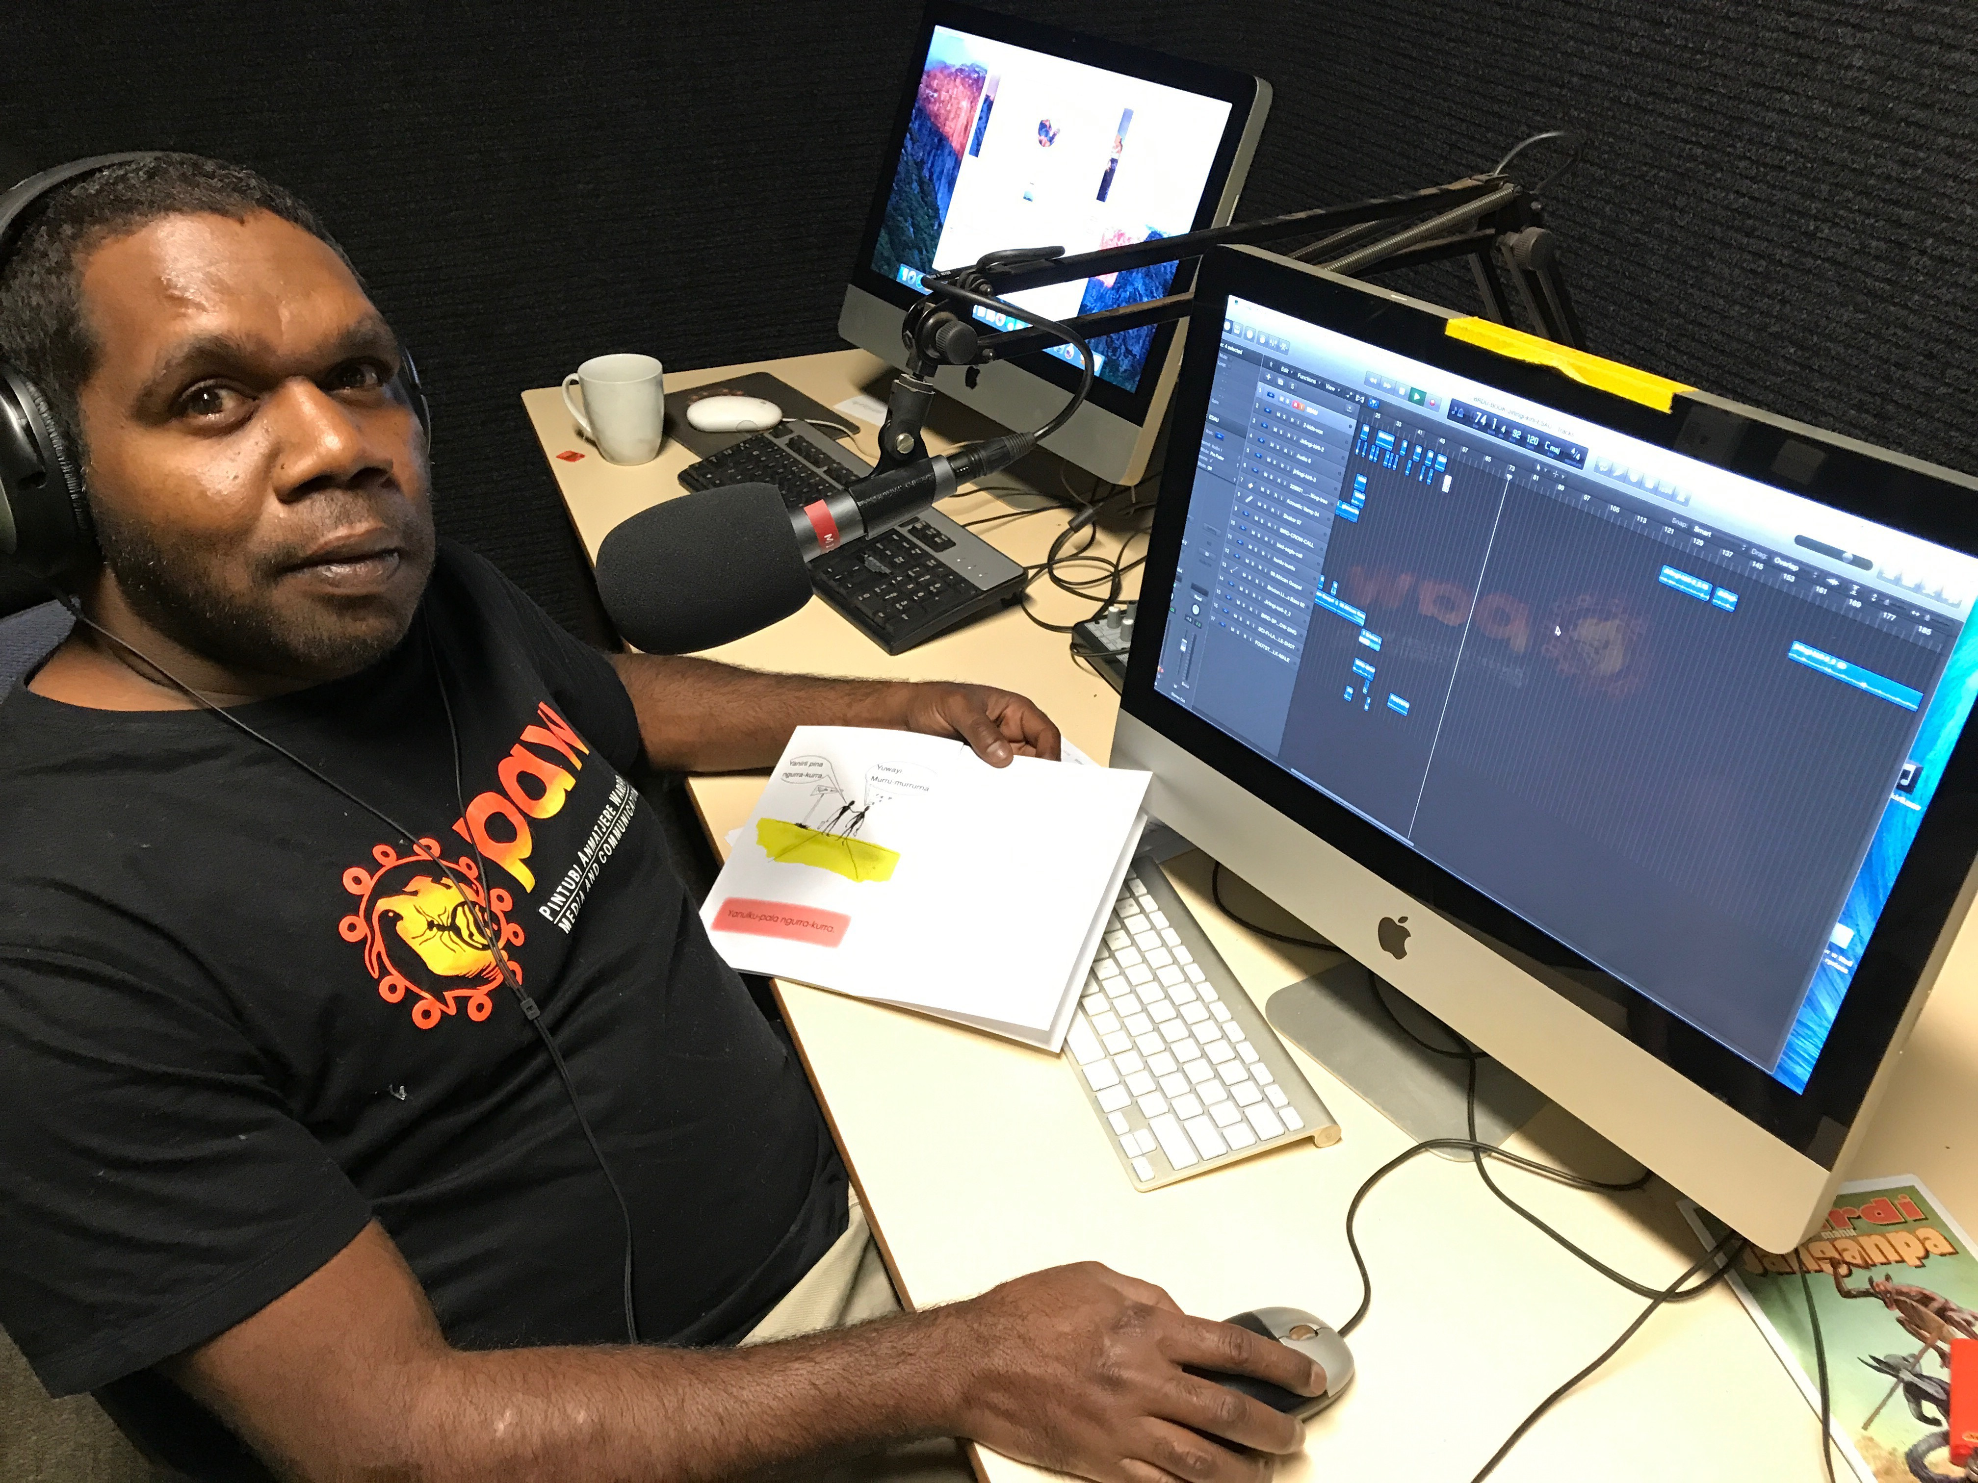

More than radio – a community asset
Social Return on Investment (SROI) analyses of Indigenous Broadcasting Services

Pintubi Anmatjere Warlpiri Media and Communications (PAW)

Insights
- PAW’s Indigenous broadcasting service and associated media activities are forecast to generate significant social, economic and cultural outcomes for a broad range of stakeholders including employees, community and Government.
- PAW provides an essential service that strengthens community. By operating a network of 14 remote broadcasters, and producing locally relevant content from 10 locations in English, Pintubi, Anmatjere and Warlpiri, PAW enables the remote communities of the Tanami region to stay informed and connected. Its activities not only serve community communication needs but also strengthen their connectivity and resilience.
- PAW provides opportunities to strengthen the proud Pintupi, Anmatjere and Warlpiri cultures and creates a culturally affirming environment. Through its work with local people, in accordance with local cultural protocols, PAW creates unique Indigenous media and records, shares and protects culture.
- Community trust is important to PAW’s operations, and has been established over more than 30 years of operation. That trust is enabled by PAW being an Indigenous owned and operated organisation and being an active member of, and responsive to, the needs of the community.
- PAW has leveraged Government funding to generate its own revenue and stimulate operations beyond broadcasting, which enables it to achieve greater impact in community.

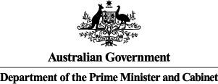
"It gives me goose bumps. It is so great to see these young people doing what they are good at, especially singing in language. It’s so important because it talks about feelings, it talks about country.

-Radio Listener, Yuendumu

About PAW

Yuendumu is an Indigenous community of 2100 people, 300 kilometres north west of Alice Springs on the edge of the Tanami desert. It’s on Warlpiri and Anmatjere lands and is also home to the Pintubi peoples.
The community maintains strong cultural practices and many of its residents speak English as a second or third language.
PAW Media at a glance
Broadcasting range: 450,000 km²
Total income (FY17): $1,081,000
IAS funding (FY17): $864,000
Estimated audience size: 6,000
Indigenous employees (FY17): 13

Established in 1983, PAW is based in Yuendumu, and is a core part of the community and the wider Tanami region. PAW works with local people according to local cultural protocols to create unique and modern Indigenous media productions. PAW produces radio, video and music, maintains the Warlpiri Media Archive of culturally significant photos and video and runs community events.

PAW operates a network of 14 Remote Indigenous Broadcasting Services which are spread across 450,000 square kilometres. It can produce radio from 10 of these locations, and broadcasts in English, Pintubi, Anmatjere and Warlpiri. It is famous for its nationally broadcast documentary – Bush Mechanics – a light-hearted Aboriginal take on fixing cars in the bush and for its claymation productions.

Impact of PAW
In the three year period covered by this SROI analysis, PAW is projected to generate substantial outcomes across four key areas: providing a communication means, strengthening communities, strengthening culture and providing meaningful employment and participation. These outcomes will be generated for listeners and community members, Indigenous employees, musicians and artists, other broadcasters, the community and Government.
The most significant outcomes for listeners and the community are that their community and cultures are strengthened through PAW’s activities. Community is strengthened by people in remote locations having access to content so they can be informed about issues that matter to them and by being brought together for events through entertainment. The community also experiences significant value through PAW’s appropriate recording, sharing and protecting of culture and their extensive archive of Warlpiri items.
For employees, musicians and artists, value is generated through PAW supporting people into meaningful employment by training, offering flexible working arrangements and creating work opportunities that are aligned with the interests of individuals. For some, this has led to decreased substance abuse and welfare dependence, but for all, it has led to increased fulfilment, confidence and pride.
Financial proxies have been used to approximate the value of these outcomes. The social, economic and cultural value associated with the outcomes is forecast to be $10.2m for FY18-20. During this period, $4.2m is forecast to be invested in PAW, with most (61 per cent) coming from the Department of the Prime Minister Cabinet (PM&C) through the Indigenous Advancement Strategy.
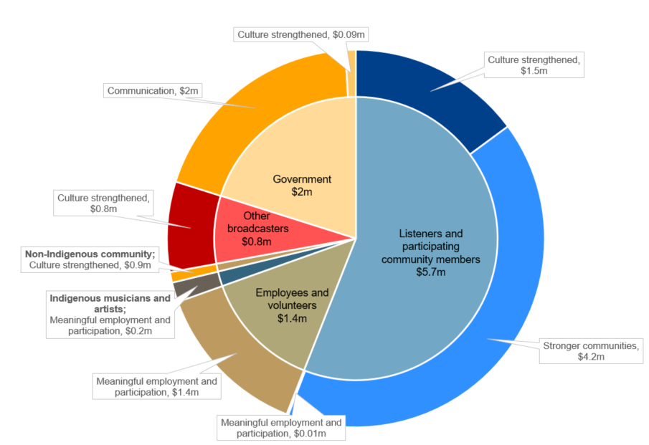
Forecast value of PAW outcomes generated by stakeholder group, FY18-20
PAW is forecast to deliver an SROI ratio of 2.44:1 from July 2017 to June 2020.
That is, for every $1 invested, approximately $2.44 of social, economic and cultural value will be created for stakeholders.

About this project

PM&C commissioned Social Ventures Australia Consulting to understand, estimate and value the changes expected to be achieved through the investment in PAW’s activities from FY18-20. This analysis is part of a broader project that considers three Indigenous Broadcasting Services across Australia including Umeewarra Media in South Australia and Gadigal Information Services (Koori Radio) in New South Wales. The SROI methodology was used to complete each of these analyses.
This analysis involved 38 consultations with stakeholders of PAW (this included employees, listeners and community members) and community service organisations, in both Yuendumu and Laramba. Interviews were conducted in May 2017. The analysis also drew from audience surveys conducted by McNair Ingenuity research in Yuendumu in 2016.
The broader project involved 79 stakeholder consultations and an Indigenous broadcasting sector survey. Further detail in relation to the methodology applied and the findings of the analysis are set out in the full report, More than radio – a community asset: Social Return on Investment analyses of Indigenous Broadcasting Services, and corresponding methodological attachment.

For more information about PAW, or for a copy of the full report, contact:

PAW Media and Communications

T: (08) 8956 4024

E: info@pawmedia.com.au

For more information on the Government’s funding of Indigenous Broadcasting Services, contact:

Culture and Capability Programme

T: 02 6271 6000 (request to speak with the Broadcasting, Interpreting and Telecommunications team)

E: CultureandCapabilityProgramme@pmc.gov.au

