PROTOCOL ON INDIGENOUS LANGUAGE INTERPRETING
For Commonwealth Government Agencies
Version 4, 17 November 2017

TABLE OF CONTENTS
1. Introduction 3
2. Legislative and Policy Framework 3
3. Indigenous Interpreting Need 4
4. When to use an Indigenous Interpreting Service 5
The Value of Bilingual Staff 5
5. Availability of Indigenous Interpreting and Translation Services 5
6. Principles to Guide the use of Indigenous Interpreters 6
Operational Principles for the Use of Indigenous Interpreters 7
7. Indigenous Interpreting Plans 7
Staff Training 7
Monitoring, Reporting and Evaluation 8
Attachment A 10
Indigenous Interpreting need in Australia 10
Attachment B 15
Operational Principles for the Use of Indigenous Interpreters 15
Attachment C 17
Example Indigenous Interpreting Plan 17

- INTRODUCTION
The Protocol on Indigenous Interpreters for Commonwealth Government agencies (the Protocol) provides guidance to all agencies and their contracted service providers on policies and processes that are needed to promote engagement of Indigenous interpreters in policy and program development, engagement, consultation and service delivery.
The original Protocol was developed in response to recommendations by the Commonwealth Ombudsman and the House of Representatives Standing Committee on Aboriginal and Torres Strait Islander Affairs report Our Land Our Languages. The Protocol complements the Commonwealth Multicultural Language Service Guidelines. The Protocol has been updated to include the Operational Principles recommended by the Commonwealth Ombudsman’s 2016 Report Accessibility of Indigenous Language Interpreters: talking in language follow-up investigation.
The Commonwealth Government recognises that language is essential to the wellbeing, culture and identity of Aboriginal and Torres Strait Islander Australians. Language plays an integral role in maintaining the strength of Indigenous communities.
The engagement of Indigenous language interpreting is critical to ensure Aboriginal and Torres Strait Islander Australians are effectively engaged with, and have equal access to, government services and opportunities.
Aboriginal and Torres Strait Islander Australians have a basic right to understand and be understood when communicating with government and service providers.
An interpreter is a certified practitioner or para-professional who enables communication between people who speak different languages.
The original Protocol focused on optimising the use of interpreters in the Northern Territory, Anangu Pitjantjatjara Yankunytjatjara in South Australia and Ngaanyatjarra Lands in Western Australia, as they were the locations where Indigenous interpreting services were available and/or developing. These updated Protocols apply across Australia. Continued implementation of the Protocol will further develop the sector, thereby improving outcomes, increasing Indigenous employment and will help to close the gap in Indigenous disadvantage.
To simplify the Protocol, fact sheets have been created to assist agencies to engage interpreters and translators.
There is separate guidance material available for interpreting and translation services for people who are from culturally or linguistically diverse backgrounds: (see Multicultural Language Services Guidelines for more information) or for people who are hearing impaired (see the Deaf Australia website).
- LEGISLATIVE AND POLICY FRAMEWORK
Legislative and policy frameworks establish obligations for the Australian Government to engage interpreters and other language services including: the Racial Discrimination Act, the Australian Public Service Act, principles of procedural fairness and their application under various administrative processes, Access and Equity obligations, and Australia’s Multicultural Policy and the Social Inclusion agenda (see Multicultural Language Services Guidelines for more information).
Australia is a party to a range of international human rights instruments that have implications for Indigenous interpreting and language services for Indigenous people, including the United Nations Declaration on the Rights of Indigenous Peoples, which stipulates that Indigenous peoples can understand and be understood in political, legal and administrative proceedings, where necessary through the provision of interpretation or by other appropriate means.
Agencies should research further when developing their own policies, guidelines, procedures or plans to identify any agency specific legislative requirements.
- INDIGENOUS INTERPRETING NEED
The 2011 Census estimates 60,000 Aboriginal and Torres Strait Islander people speak an Indigenous language at home – about 10 per cent of Australia’s First Nations people.
Estimates under the National Aboriginal and Torres Strait Islander Social Survey (NATSISS) are slightly higher, finding that in 2014-15, 16 per cent of Aboriginal and Torres Strait Islander Australians aged three years and over spoke an Indigenous language (with 10 per cent speaking it as their main language at home). Some of these Indigenous language speakers require an interpreter. The NATSISS found the proportions of people learning and speaking Indigenous languages remained relatively unchanged from 2008-09 to 2014-15.
The need for Indigenous interpreting occurs frequently in remote areas as well as urban centres as populations travel from remote and very remote locations to access services or engage with the justice system.
The figure below uses Census data to map where there are significant numbers of speakers of Indigenous languages. The red sections show areas where more than 50 per cent of Aboriginal and Torres Strait Islander people in that region speak an Indigenous language at home. The green highlights where between 10-50 per cent of Aboriginal and Torres Strait Islander people speak an Indigenous language at home.
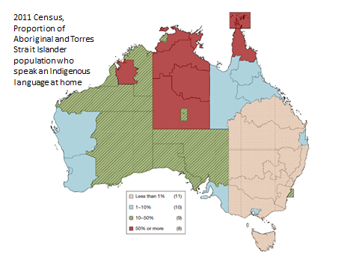

This is a good indicator for determining when an agency may need to use an interpreter, noting that from place to place, and even within communities, the language and communication needs will vary. A further breakdown by region and language can be found at Attachment A.

- WHEN TO USE AN INDIGENOUS INTERPRETING SERVICE
While not all Indigenous language speakers require the assistance of an interpreter, there are many circumstances where all parties will benefit from this assistance. This is particularly the case when:
- sensitive, complex and technical matters are being explained or discussed (for example income support, legal, health, accommodation, and employment assistance);
- the outcome of communication has a significant impact on the client, such as in the income support, health and justice systems;
- a major new initiative or programme is being rolled-out in remote areas and where engagement and consultation is being undertaken; or
- when requested by an Indigenous Australian.
When designing and developing policy and programs, it is important to consider how these will be implemented:
- policy makers should factor into the funding model the need for interpreters over the life of the program or policy. This includes how service providers will fund the purchase of interpreting services to deliver consultations with communities to establish new programs or evaluate the effective use of interpreters;
- funding agreements, deeds or other contractual arrangements should include the provision for service providers to provide interpreters for clients or customers where needed; and
- engaging translation services to transcribe key messages, develop brochures, recordings and other material in the relevant languages.

The Value of Bilingual Staff
Agencies could take additional measures to value the capability of their Indigenous language speaking staff and assist them to develop their skills as multilingual workers. However agencies should be mindful that bilingual staff are not independent when it comes to interpreting a conversation for their employer.
Developing multilingual workers can involve:
- recruiting Indigenous language speaking staff;
- creating opportunities for Indigenous language speaking staff to undertake interpreting training and certification as part of their development training;
- payment of a Community Language Allowance for staff who use their Indigenous language skills in the course of their employment; and
- implementing provisions in Certified Agreements for trained multilingual Indigenous staff to take leave to interpret, building on arrangements already in place which enable staff to undertake jury duty, volunteer with State Emergency Services or fulfil Australian Defence Force Reserve and Continuous Full-time Defence Service obligations.
- AVAILABILITY OF INDIGENOUS INTERPRETING AND TRANSLATION SERVICES
There are two Indigenous interpreting services that offer professional interpreting and translation services:
- The Northern Territory Aboriginal Interpreter Service (NT AIS), which is also currently delivering a cross-border service into the South Australian Anangu Pitjantjatjara Yankunytjatjara Lands and the Western Australian Ngaanyatjarra Lands; and
- The Kimberley Interpreting Service for Western Australia.
The National Accreditation Authority for Translators and Interpreters (NAATI) also provides a directory of independent certified Indigenous interpreters across Australia. The National Accreditation Authority for Translators and Interpreters (NAATI) sets and maintains national standards in translating and interpreting that enable the existence of a pool of translators and interpreters who are responsive to the changing needs and demography of the Australian community. NAATI is the only organisation which sets standards for translators and interpreters in Australia and issues certification against those standards.
Commonwealth agencies are encouraged to engage Indigenous interpreters from one of the interpreting services or contact NAATI. Certification is an acknowledgement that an individual has demonstrated the ability to meet the standards required by the translation and interpreting industry. Certification services are offered by NAATI.
Non-certified interpreters should only be used in an emergency where a certified interpreter from an interpreter service or is unavailable. The potential for misinterpretation, addition of personal opinions or advice and/or misreading of language or cultural nuances is increased by using family or community members or interpreters that are not registered or certified. Indigenous languages are unique to their community and it is important that the interpreter is registered and/or certified in the state or territory of the Indigenous community. Certified interpreters operate under a Code of Ethics, and they will identify where a conflict of interest exists. Interpreters engaged through an interpreting service are screened for each assignment, minimising potential conflict of interest as much as possible.
Children must not be used to interpret between their parents and a Commonwealth agency or service provider.
The demand for the use of Indigenous interpreters outstrips the supply available across Australia. There are a number of factors that impact upon the availability of Indigenous interpreters including:
- Local weather conditions and ability to travel;
- Language, gender and cultural considerations; and
- Technology availability and reliability.
As a result, planning is very important when considering the use of interpreters. Factors to take into consideration include:
- the number of clients/customers to be seen in the local region, leading to multiple bookings for an interpreter;
- liaison with other visiting services to coordinate arrangements and share an interpreter over a half or full day;
- allowing enough time between appointments for briefing to explain the context of the interaction to the interpreter, which allows them to ask questions and understand the nature of the interaction; and
- having awareness that the interpreter is possibly a member of the community or has family members residing in the community where a consultation or community engagement activity is occurring.
- PRINCIPLES TO GUIDE THE USE OF INDIGENOUS INTERPRETERS
The Commonwealth Ombudsman has released three reports examining the use of Indigenous interpreters by Australian Government agencies:
- Use of Interpreters, 2009 (also incorporate interpreters for people from culturally and linguistically diverse backgrounds);
- Talking in Language: Indigenous language interpreters and government communication, April 2011; and
- Accessibility of Indigenous Language Interpreters: talking in language follow-up investigation, December 2016.

The 2016 report states:
This report finds that a coordinated whole of government response is still required. While there has been some progress, ongoing barriers to accessing interpreters continue to undermine communication between government and Indigenous language speakers, even for those agencies who have gone to considerable lengths to try to improve accessibility.

Commonwealth Ombudsman Best Practice Principles
The recommendations from the Commonwealth Ombudsman’s 2009 report: Use of Interpreters became the Best Practice Principles, and agencies are encouraged to use them to help inform the use of Indigenous interpreters in all facets of Australian Government policy and program design and development, community engagement and consultation and service delivery.
The Commonwealth Ombudsman Best Practice Principles are:
- Develop a clear and comprehensive policy on the use of interpreters that covers all programs and services as well as contracted service providers.
- Provide a direct link to interpreter services and other information in languages other than English on websites.
- Endeavour to provide an interpreter whenever necessary.
- Specify who should and should not be used as an interpreter – the use of friends, family members and children should be avoided.
- Agency and contracted service provider staff should receive training on working with interpreters.
- Records of a client’s interpreter and language needs should be kept including dialect, any gender or other requirements, as well as details of occasions when an interpreter was used and when an interpreter was declined.
- Establish accessible complaint handling mechanisms that allow clients to complain about access to, use of, or quality of an interpreter’s services.
- Encourage the development of interpreters.

Operational Principles for the Use of Indigenous Interpreters
The Commonwealth Interdepartmental Committee considering the Commonwealth Ombudsman’s 2016 investigation report, Accessibility of Indigenous Language Interpreters, proposes Operational Principles for the Use of Indigenous Interpreters to provide further detail for agencies on how the Best Practice Principles can be actioned. Attachment B outlines the Operational Principles.
- INDIGENOUS INTERPRETING PLANS
Agencies are encouraged to develop Indigenous Interpreting Plans to reflect agency operational and business needs for the use of Indigenous language interpreting and translation services including: minimum obligations and best practice principles and specific requirements on interpreter use. The Best Practice Principles also provide a framework to underpin the development of Indigenous Interpreting Plans. Attachment C is an Indigenous Interpreting Plan template that agencies may use.
Smaller agencies that have minimal or ad-hoc need for the use of Indigenous interpreters or translators may seek to adopt the Commonwealth Protocols and include an addendum with agency specific requirements.

Staff Training
Agencies should raise awareness among staff and contracted service providers of the requirements to use Indigenous language interpreting and translation services, including through Reconciliation Action Plans, cultural awareness training programs, induction procedures and contractual requirements in funding agreements or deeds.
The NT AIS website offers information to support staff development and understanding about working with Indigenous interpreters and offers workshops in Darwin, Katherine and Alice Springs.
The Kimberley Interpreting Service also offers cross cultural communication and working with interpreter training in Western Australia.

Monitoring, Reporting and Evaluation
Commonwealth Government agencies are encouraged to have monitoring and reporting provisions in place for the use of Indigenous interpreting services. It is recognised that agency monitoring and reporting plans will vary based on the core business of the agency and the level of engagement with Aboriginal and Torres Strait Islander people. Noting that demand for Indigenous interpreting services outstrips supply, agencies are also encouraged to collect data on unmet demand, which will assist with future service planning.
Adequate reporting provides evidence of an agency’s efforts to meet its access and equity responsibilities in this area. It is a mechanism for agencies to record performance targets, track progress highlight lessons learned and facilitate improvement of government programs and activities.
Where relevant, an agency should put in place processes to systematically record a client’s interpreter and language needs, in order to assist with assessment of need and better planning. The Multicultural Language Guidelines outlines key consideration for agencies in developing a language monitoring and reporting provisions.
The following table outlines examples of data that could be collected by agencies to help support the development of future policy for Indigenous interpreter and translation service provision:
CLIENT / CUSTOMER DATA | PROGRAM DATA | AGENCY DATA
Interpreter required | Name of program | Consultations and community engagements
Language / dialect | Delivery location/s - spatial information (addresses, latitudes/longitudes or area identification) | Location
Location - spatial information (addresses, latitudes / longitudes or area identification) | Contractual requirement to engage interpreters by providers | Language / dialect
Number of hours of interpreting purchased | Translation of program materials (number of languages; documents; and expenditure) | Number of hours of interpreting purchased / expenditure
Name of Interpreting service used | Use of interpreters by service providers  - Number of clients / customers  - Location  - Language / dialect  - Number of hours  - Name of interpreting service  Expenditure | Name of Interpreting service used
Expenditure on interpreting services | Program consultations and/or community engagement  - Location/s  - Language / dialect  - Number of hours  - Name of interpreting service  Expenditure | Translation of information to support consultation and engagement

ATTACHMENT A

INDIGENOUS INTERPRETING NEED IN AUSTRALIA
The figure below provides a broad indication of expected need for interpreters across Australia. The map shows the distribution of Indigenous people that speak an Indigenous language at home. The darkest areas are those ABS Indigenous Areas where more than 70 per cent of Indigenous people speak an Indigenous language at home. It can be seen that the highest concentrations of Indigenous speakers are spread across most of the NT, parts of the Kimberley and the Anangu Pitjantjatjara Yankunytjatjara (APY) in South Australia in South Australia and the Ngaanyatjarra Lands in Western Australia, and parts of Far North Queensland. Comparing this to the Remoteness Area inset on the right, we can see that virtually all of these areas are very remote. This contrasts with the regional areas of Victoria, Tasmania and Southern Queensland, where only 0 to 5 per cent of Indigenous persons speak an Indigenous language at home in most areas. More detailed maps for Queensland, Western Australia and Queensland follow this one.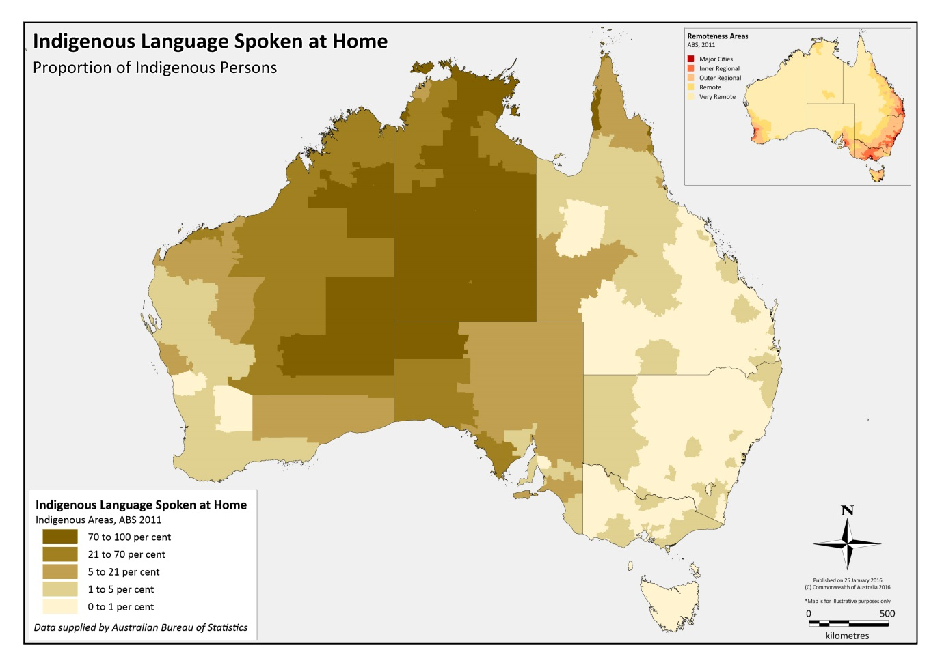
In recognition that most of the Northern Territory (NT) records 70 to 100 percent of Indigenous language being spoken at home, there is no separate map of the NT provided in Attachment A.

Indigenous interpreting demand in Far North Queensland
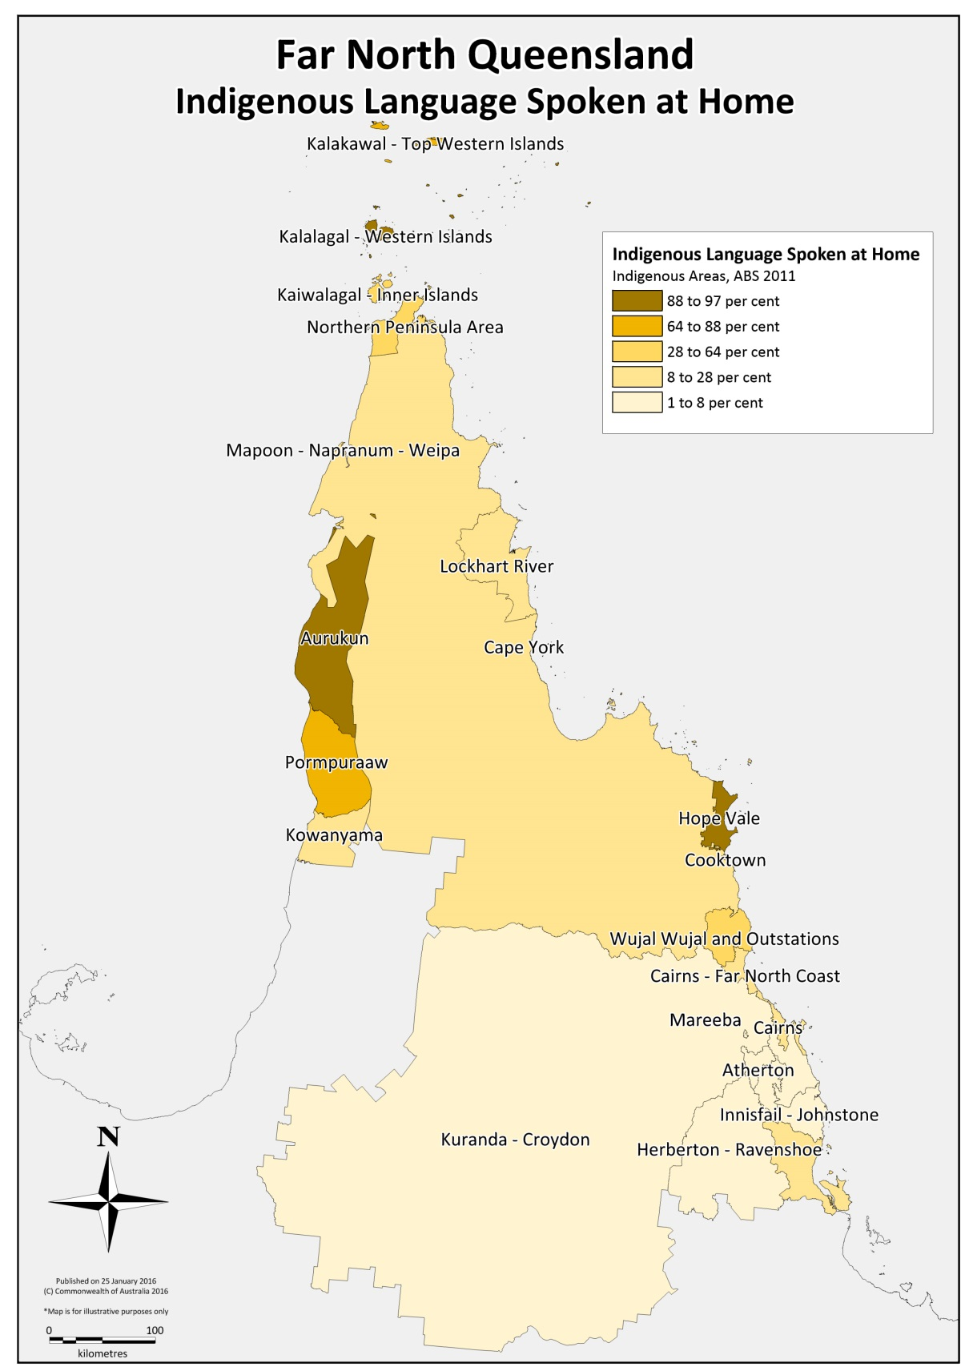

Indigenous interpreting demand in Western Australia
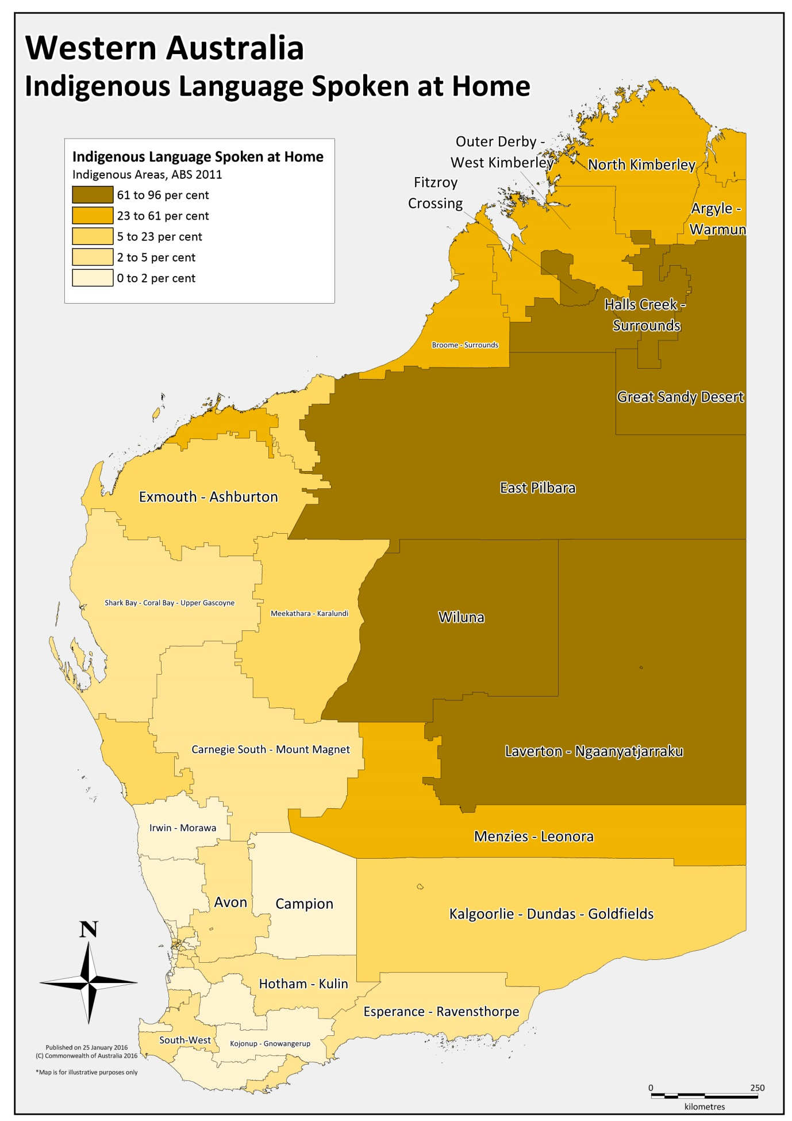

Indigenous Interpreting Demand in South Australia
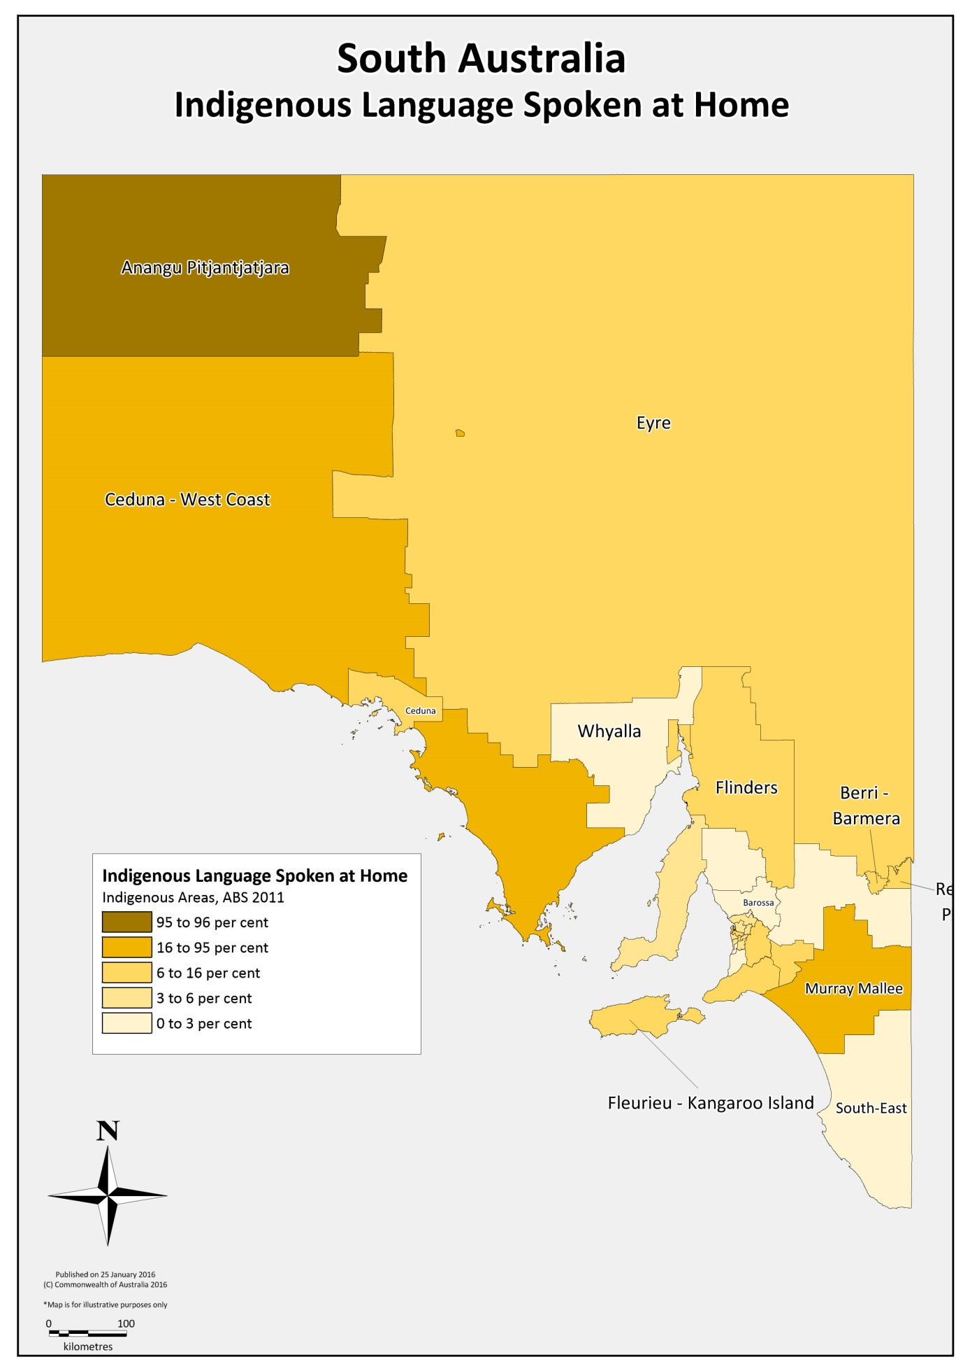

Below is the Australian Society for Indigenous Languages (AuSIL) map of the most widely spoken Indigenous languages. The map is a useful geographical summary of some of the most common languages that require interpreting.

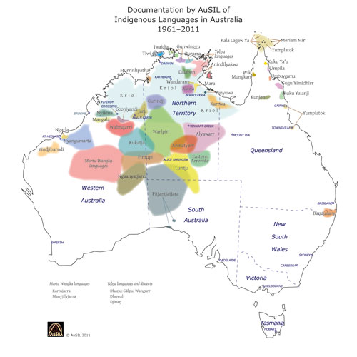

ATTACHMENT B

OPERATIONAL PRINCIPLES FOR THE USE OF INDIGENOUS INTERPRETERS
- Specific reference to Indigenous language interpreters should be incorporated into general interpreter policies, cultural awareness programs, relevant overarching policy frameworks and, where appropriate, Reconciliation Action Plans.
- Agencies should co-operate, where possible, with other agencies and non-government organisations to share resources and coordinate their use of and support for interpreter services.
- Agencies should ensure that training on the need for, and use of, interpreters is available and mandated for all staff and service providers involved in remote area servicing and such training is developed and delivered with the assistance of Indigenous language interpreter services.
- Agencies that engage interpreter services should ensure there is a dedicated contact person or area within their agency for interpreter services contact (i.e. a centralised contact point for handling questions and policy queries, managing relationships and supporting interpreter services).
- Agencies should be mindful that not all plain English words and phrases will be readily interpreted because many concepts do not have equivalents in Indigenous languages or may have different meanings.
- Agencies should provide briefings to interpreters in advance to enable them to become more familiar with the subject area and enable collaboration on terms and concepts which may need to be considered further.
- Agencies should develop simple plain English materials, in consultation with interpreter services, for the purposes of briefing interpreters in advance and where possible, for translation into language products. Where possible, subject matter dictionaries should be developed in consultation with Indigenous language interpreter services.
- Agencies should be mindful of the need to build in breaks and other measures to reduce interpreter burnout and fatigue.
- Agencies should ensure that individuals have access to Indigenous language interpreters for the purposes of communicating with their agency. Arrangements should be in place to ensure the costs of Indigenous language interpreters are not born by the non-English speaker.
- Agencies should monitor and review their accessibility to, and use of, Indigenous language interpreters on a regular basis.
- The use of Indigenous language interpreters should be considered during the consultation, design and implementation stages of new programs to remote areas, and incorporated into contracts and funding agreements where appropriate.
- Agencies should not assume interpreters will be available when needed and should consider implications for timeframes, contract compliance and the need for flexibility and contingency planning.

- For agencies whose use of Indigenous language interpreters may be contingent upon addressing broader barriers. The availability of Indigenous language interpreters should be incorporated into planning, messaging and in any measures designed to address those broader barriers.
- Where possible, agencies should recruit bilingual workers, pay community languages allowances, encourage and support further training and certification.
- Training and policy guidance on situations where it is more appropriate to use certified interpreters than bilingual workers should be provided to staff in agencies where bilingual staff are employed.
- Agencies should ensure they collect data and actively monitor use (and non-use) of Indigenous language interpreters, including under service provider contract.
- Agencies that provide services to remote communities through contracted service providers should:
- ensure use of Indigenous language interpreters is specifically required in service contracts where applicable and practical;
- collect data and actively monitor use (and non-use) of Indigenous language interpreters under service provider contracts where possible or practical;
- where possible, provide block funding to Indigenous language interpreter services to ensure staff and service providers have administratively easy access to interpreters, minimise financial disincentives to use interpreters and ensure free and regular access to 'working with interpreters' training; and
- if block funding is not possible, steps should be taken to remove financial and administrative disincentives to using interpreters, preferably by dedicated funding or at the very least, simple reimbursement procedures.

ATTACHMENT C

Example Indigenous Interpreting Plan
Agency Name:
Indigenous Champion:
Date of Creation:
Review Date:
Agency Contextual Statement:
- Type of work undertaken by the agency in remote Indigenous communities: policy and/or program design and development, community consultation and engagement, service delivery
- Agency’s commitment to using Indigenous language interpreting and translation services
- Complementary agency policies and procedures that support the implementation of the Indigenous Interpreting Plan
AREAS OF ACTION OR GUIDELINE | IMPLEMENTATION | KEYPERFORMANCE INDICATORS
Policy and procedures | Example text: XYZ Branch provides agency policies and procedures for staff to use when engaging with Indigenous communities. | Example text:  - Procedures to be updated by xyz date to include Commonwealth Ombudsman Operational Principles  Procedures reviewed every xyz months and updated as required.
Website links and information, including Intranet
Provision of an interpreter
Interpreter registered organisation
Staff and contracted service provider training
Record keeping and data collection
Complaints handling
Professional development
Communications Strategy (where, when how much and why?)

Map sourced from the Ausil website: http://ausil.org.au/

