OFFICIAL

Replacing the Community Development Program

Community consultations
Between February 2023 and June 2023, the National Indigenous Australians Agency (NIAA) conducted a ‘listen and learn’ consultations phase with remote communities on the Government’s commitment to replace the Community Development Program (CDP) with a program with real jobs, proper wages and decent conditions.
The ‘listen and learn’ phase was an opportunity for communities and stakeholders to speak to the NIAA directly about ways to design and deliver a program to replace CDP. We heard from over 2250 people in over 100 CDP communities. See Attachment A for a list of the communities we heard from.

Other Engagement
In most cases we visited communities face-to-face; where we couldn’t, virtual sessions were arranged. Additionally, an online form and survey provided the opportunity for a further 250 stakeholders to be involved.
Previous feedback on remote engagement, performance information, committee reports and evaluations also gave us valuable insights into how a new program could be developed and implemented.
Face-to-Face Virtual meetings Round tables Emails Web Form Survey

What we heard

The new program should be planned and led by communities
We heard that the new program needs to be developed and run by communities so that local priorities are addressed. Locals know other locals best and what jobs and services are truly required or available in their community. Community leaders want clearer control by having a local community organisation deliver the program. The program should return to a scheme more like the old Community Development Employment Projects (CDEP) that aimed to improve employment outcomes for locals with activities linked to local priorities that benefited the community.
Communities have their own priorities and cultural obligations that are led by community leaders which strengthens local governance. Community members are in the best position to make sure that jobs and activities are appropriate for each individual’s needs. Trauma informed and culturally appropriate staff are critical to the new program. Current CDP arrangements are not working. This could be improved if services were provided within the community. Some regionally based CDP providers could do more to help participants and their community, and also actively look for local job opportunities.

The new program needs to recognise roles carried out in the communities
There is a lot of existing critical work which supports communities that should be considered as jobs. This in turn will create more local jobs, particularly in very remote communities with thin labour markets.
There are cultural jobs that could be created that are not currently being done, or are being done as unpaid work. This includes meeting cultural obligations such as caring for country, caring for community, leadership, teaching, mentoring, mediation, traditional artwork, hunting and bush medicine.
There are many other important roles not being done or being done as unpaid work including: security, bus driving, road, land and building maintenance which are important for creating a strong and proud community. Community needs to be involved in creating jobs like these that address genuine needs.
A new program should provide jobs to locals, with proper wages and decent conditions, to address the employment gap.
Caring roles are often performed as full-time unpaid work in remote communities, where some carers are managing their own health conditions along with those of other family members’ health conditions. Caring responsibilities range from looking after little ones to caring for elders—all of which are valuable contributions to the community. Other valuable unpaid roles include informal mentoring, organising entertainment and recreational activities to build community engagement. There are many local volunteers in communities teaching language in school and leading other important cultural and community activities that are crucial in maintaining and teaching culture to the next generations. There are opportunities to create tourism positions as well as selling artwork to keep money within the community.
CDEP was seen as being part of the fabric of many communities, and the jobs which were created by it were viewed as real employment. There is consistent support for participants to receive top-ups to income support for undertaking additional activities in newly approved roles.

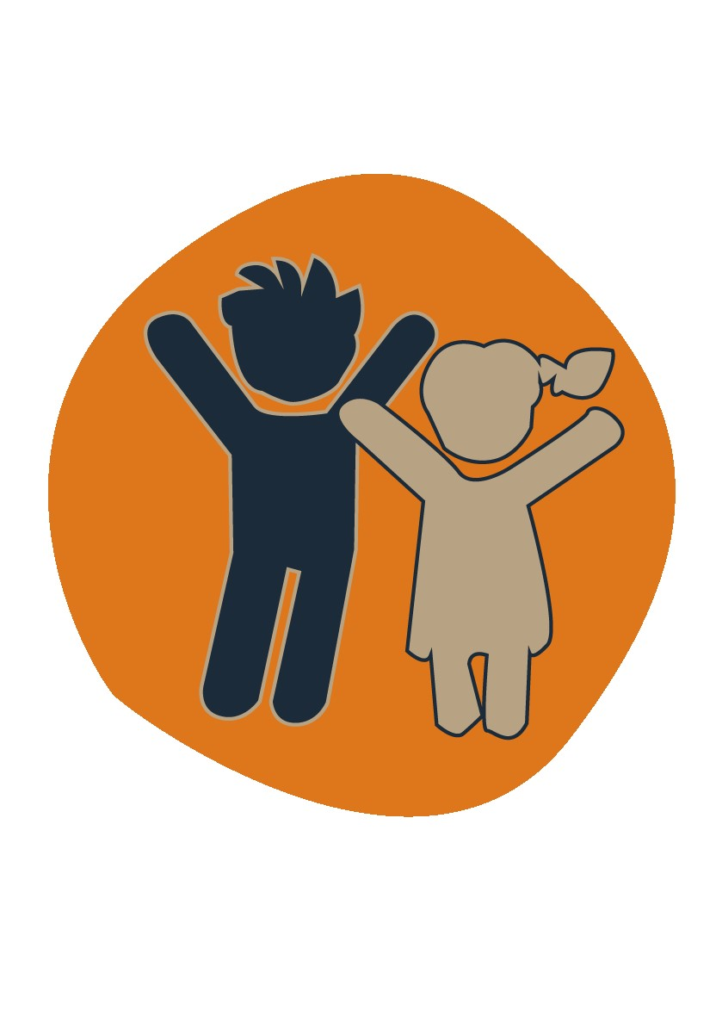
A new approach for youth
A new approach for youth should be at the forefront of the new program with clear outcomes and opportunities for youth living in remote communities. The new program should include job pathways with job training that is fit for purpose—with a very strong focus on keeping school leavers engaged by having a positive direction for their future to break the unemployment cycle. There is a need for more opportunities and career pathways through school-based traineeships and apprenticeships as well as opportunities for youth to gain formal qualifications.
School programs help school leavers with access to the documents needed to be job-ready such as a tax file number, driver’s licence, OH&S card, working with vulnerable people card, Medicare card and bank accounts etc. One of the biggest barriers in remote communities is the difficulty of accessing these documents.
First Nations youth face the complexity of living and working in two separate worlds; for this reason culturally safe mentoring is important to help youth become job-ready. The ability to look up to a role model or trusted person in the community helps to grow confidence and boost engagement. Having someone in the community responsible for mentoring the youth would also create a local job.
Having available support for youth after commencing a job and enabling proactive engagement with employers is considered best practice into promoting longer-term employment outcomes. Approaches that help employers to understand cultural issues and accommodate them in work design would be valuable.
Communities that have youth development programs in place have positive employment outcomes linked to these programs. For example, the Indigenous Rangers program has been an important advantage in motivating youth to get the skills to become job-ready. There is clear interest in extending programs like this in all communities.

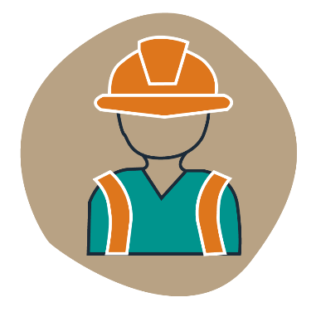
There should be more local jobs for local people
Many participants want a job in their community however too many jobs are filled by people from outside of the community. These jobs could be done by locals with the right training and support, although it is very difficult to get the right training into communities.
Transport is a major barrier in remote communities and is linked to other barriers, such as travelling to source documents, housing, training and work. Many participants do not have a driver’s license or access to a vehicle. Participants that do have transport cannot always afford the cost of fuel to travel long distances for employment. In some communities a bus only comes once a week, while some do not have a local bus service at all.
Being trained in community is important and having community people approved to deliver training to others would be more culturally appropriate. A greater focus on culture would encourage buy-in from participants.
It is important that meaningfully structured jobs, with interlinked work experience or training are created in the community. It is also important to have on-the-job training. Some people are currently doing activities with no clear job objective or value to community. The Trailing Pathways to Real Jobs initiative was motivating because people experienced employment with real incomes.
The current CDP focus on full-time 13 and 26-week employment outcomes does not work in remote communities. The new program needs to be flexible to support part-time, seasonal and casual work. Except for a small number of people, mostly in service-based jobs, full-time work is not a norm in many very remote communities. Agriculture and pastoral work, for example, is seasonal while road, infrastructure and construction is usually time-limited. In addition, any retail and extra service work is often part-time. In these circumstances, employers tend to enter into casual employment contracts which do not offer long-term job security.
The new program should invest in more time to build participants’ skills and knowledge to ensure they have the right skills and are job-ready.
Some communities need extra assistance to ensure local employers and services meet employment targets set out in Reconciliation Action Plans or in government procurement requirements.

It is fair to do something meaningful for the community or for your job prospects in return for income support
There are benefits to reintroducing some requirement to attend activities in return for income support. The new program should look more like CDEP because it kept people engaged with the community. Activities provided work readiness and life skills and created a sense of pride when contributing to community. Activities should focus on preparing people for work and be positive to participate in.
When mutual obligations were removed it had a negative effect on people’s wellbeing and communities. It also removed any incentive for job seekers to show up for activities or training.
There is a need for fair and consistent rules across the country and the new program should have flexibility to allow for cultural obligations and personal circumstances that suit remote conditions. There are people in the community who have poor health issues that prevent them contributing to the same extent as others to meet their obligations, and those personal circumstances need to be taken into account.
No-show penalties are generally supported to motivate people into work.

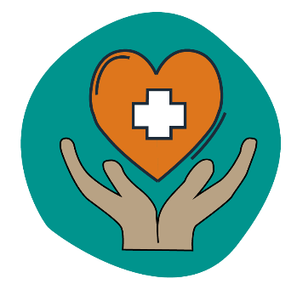
There needs to be support for people who cannot work right now
Current CDP arrangements fail to appropriately identify the individual needs of participants.
Too many people are streamed into the current Work for the Dole category but, in fact, needed additional training and assistance or are unable to work within the medium-term.
Broader work-ready, life skills and mental health support is important for many participants. The current program often relied on referral to services that were delivered from a distance, through periodic visits or that were stretched to meet current demands.
An approach focusing on improving foundation skills, including literacy and numeracy, would assist in building participants’ work readiness. A replacement program also needs to consider enhancing peoples’ life skills to assist them to integrate or reintegrate into the community with wrap-around services available to deliver broader work-ready, life skills, and mental health support (especially for those who have been long term unemployed).
Providing long-term support by a mentor to help participants secure and keep a job will help. Many participants reported facing multiple non-skills related barriers to work, including racism, language barriers and cultural obligations. Participants need to be offered more comprehensive support, including culturally appropriate mentoring as a wrap-around service to deliver a strong person-centred approach.
For the new program to achieve long term outcomes it needs to include training for mentors and have the ability to attract more mentors. More tailored mentorship is needed for psychological support, coaching and navigating participants through complex work arrangements, including working in a different language.

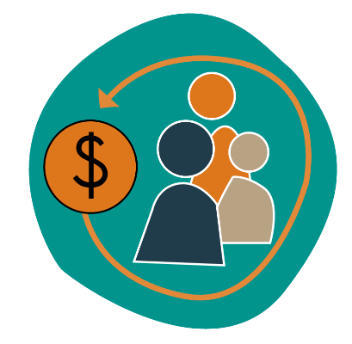
The new program needs flexibility to invest
in local priorities
The new program needs to be flexible enough to respond to local priorities and conditions and to the needs of participants. Flexibility is needed to access loans or purchase equipment to support work in community or establish a business.
There has been a decline in job opportunities and capital for infrastructure. Many communities used to have equipment under CDEP that was needed for the community to be self-reliant. Communities have lost their leadership and power to prioritise and make decisions regarding their own community needs. Communities want to have the capability to deliver services that address their community needs.
Greater use of social enterprises to build participant work skills and take advantage of small segments of economic activity present in remote communities should be included. Many communities have ideas for the development of small enterprises. For example, parents could get paid to work at a crèche or family day care supporting CDP participants going to work. The absence of child care is a barrier for new parents to return to work in many communities.
Many individuals are interested in developing their own small business and/or be self-employed. Opportunities like this would provide mentoring opportunities and employ locals in the community with jobs. The new program needs to include training and mentoring opportunities tailored to individual skills and abilities with a focus on culture.

For more information
You can keep up-to-date on the progress of replacing CDP with a new jobs program, including additional opportunities to provide feedback by, registering your interest to receive email updates.
Let us know what you think by completing the Replacing CDP survey or Have Your Say webform. Or email us at: ret@niaa.gov.au.
Contact your local NIAA Regional Office on: 1800 079 098. Visit: niaa.gov.au/remote-jobs

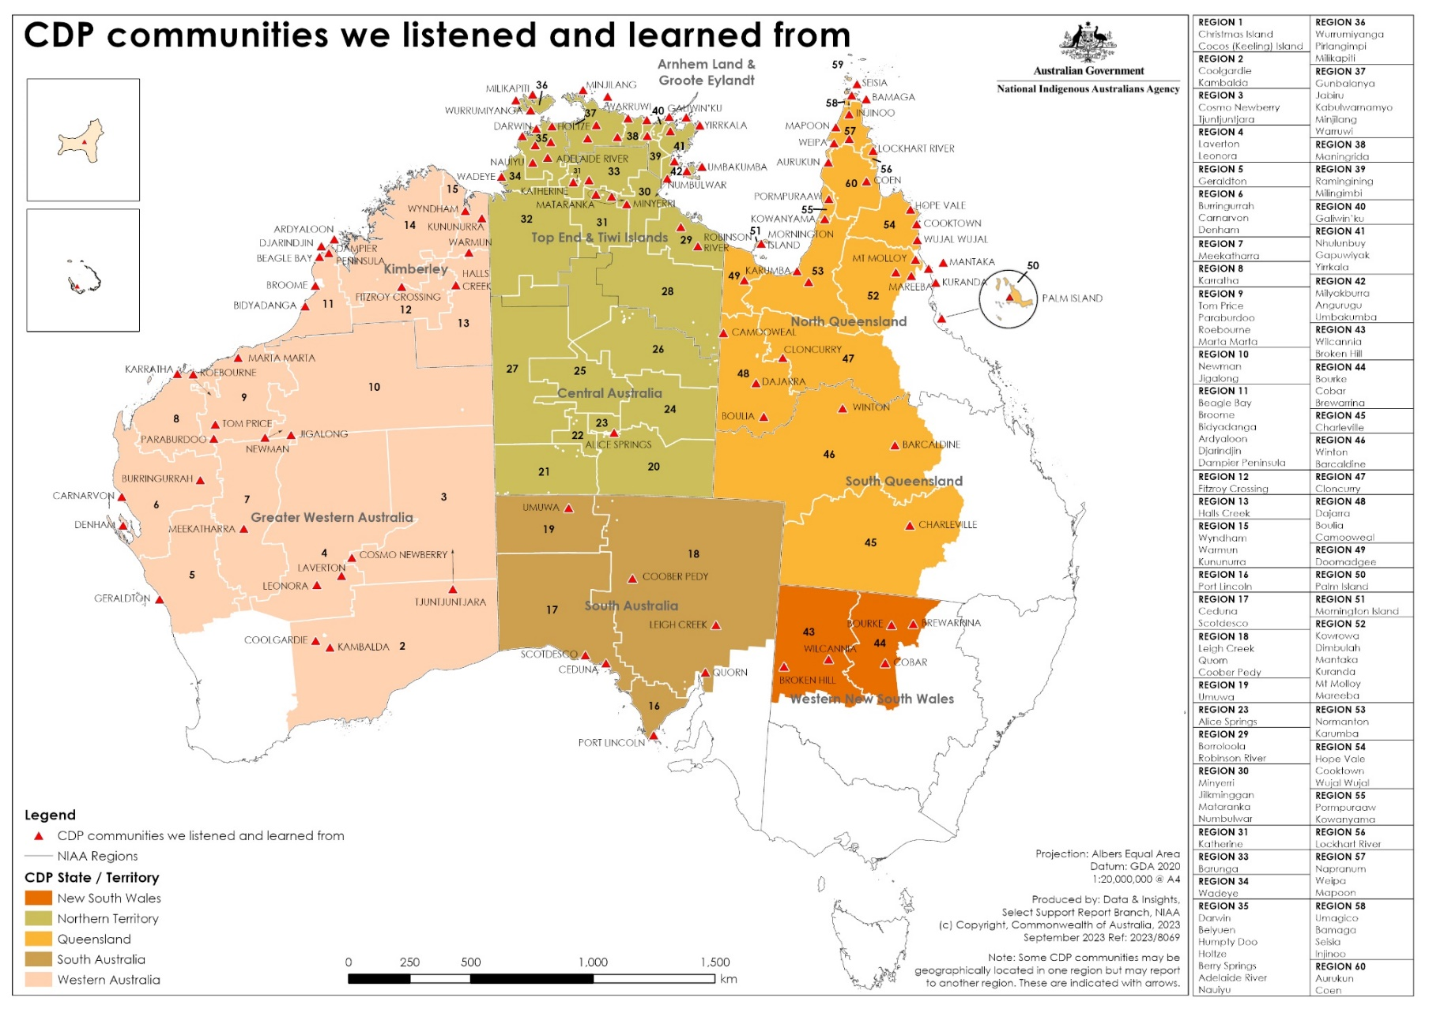
Attachment A – Community Development Program map of communities

