# Study Away Review

**Review of Support for Aboriginal and Torres Strait Islander Secondary Students Studying   
Away From Home**

## Copyright Statement

________________________________________________________________________________________

**Study Away Review: Review of Support for Aboriginal and Torres Strait Islander Secondary Students Studying Away From Home**

© Commonwealth of Australia 2017

ISBN 978-1-925363-08-1 *Study Away Review: Review of Support for Aboriginal and Torres Strait Islander Secondary Students Studying Away From Home* (PDF)

ISBN 978-1-925363-09-8 *Study Away Review: Review of Support for Aboriginal and Torres Strait Islander Secondary Students Studying Away From Home* (DOCX)

**Copyright Notice**

With the exception of the Commonwealth Coat of Arms, this work is licensed under a Creative Commons Attribution 4.0 International licence (CC BY 4.0) ( <https://creativecommons.org/licenses/by/4.0/>).

[ccby](http://library.pmc.gov.au/wp-content/uploads/ccby.png)

**Third party copyright**Wherever a third party holds copyright in this material, the copyright remains with that party. Their permission may be required to use the material. Please contact them directly.

**Attribution**This publication should be attributed as follows:

© Commonwealth of Australia, Department of the Prime Minister and Cabinet, *Study Away Review: Review of Support for Aboriginal and Torres Strait Islander Secondary Students Studying Away From Home*

**Use of the Coat of Arms**The terms under which the Coat of Arms can be used are detailed on the following website: [http://www.pmc.gov.au/government/its-honour](http://www.dpmc.gov.au/government/its-honour).

**Other uses**Enquiries regarding this licence and any other use of this document are welcome at:

The Department of the Prime Minister and Cabinet

PO Box 6500

CANBERRA ACT 2600

### **Table of Contents**

Copyright Statement 2

Table of Contents 3

MINISTER’S FOREWORD 5

EXECUTIVE SUMMARY 6

The Pillars of Support 7

1. INTRODUCTION 10

1.1 About the Review 10

1.2 Scope of this Report 10

1.3 The Pillars of Support 10

1.4 Methodology 11

2. WHY, WHERE AND HOW MANY? 12

2.1 Availability of Secondary Schools 12

2.2 Which States and Territories are These Students Coming from? 12

2.3 Type of Boarding Residence and School 13

2.4 Growth in Demand 15

3. COMMONWEALTH ASSISTANCE 16

3.1 Current Assistance 16

4. PILLARS OF SUPPORT 20

4.1 Pillar One – Preparation 20

a) Preparation: Key Issues 20

b) Preparation: What Works 21

c) Preparation: Existing Arrangements 23

Preparation: Summary of Service and Support Gaps 24

4.2. Pillar Two – Travel 25

a) Travel: Key Issues 25

b) Travel: What Works 27

c) Travel: Existing Arrangements 27

Travel: Summary of Service and Support Gaps 28

4.3 Pillar Three – In‑School and Accommodation Support 29

a) In‑School and Accommodation Support: Key Issues 30

b) In‑School and Accommodation Support: What Works 36

c) In‑School and Accommodation Support: Existing Arrangements 37

In-School and Accommodation Support: Summary of Service and Support Gaps 39

4.4. Pillar Four – Family and Community Engagement 40

a) Family and Community Engagement: Key Issues 40

b) Family and Community Engagement: What Works 43

c) Family and Community Engagement: Existing Arrangements 44

Family and Community Engagement: Summary of Service and Support Gaps 45

5. SUMMARY AND RESPONSE 45

5.1 Summary of Findings 45

5.2 Work Delivered 46

5.3 Broader Initiatives 46

Appendix A: ABSTUDY Benefits under Schooling B Award 47

Appendix B: ABSTUDY Claim Processing Times Halved – Media Release 48

BIBLIOGRAPHY 49

## MINISTER’S FOREWORD



The world over, education is the catalyst for transforming lives. My vision for Aboriginal and Torres Strait Islander children is a life of hope, possibility and opportunity. That is why I champion children attending school every day and ensuring they have access to the very best educational opportunities. Many Aboriginal and Torres Strait Islander children living in remote and very remote communities do not have access to a full secondary education and their transitions between home and boarding can be challenging.

Advice from communities and boarding providers is that, at the moment, many Aboriginal and Torres Strait Islander students are not well prepared and supported for boarding. We must get this support right.

So I am very pleased to release this *Study Away Review,* which my Department, in collaboration with the Departments of Human Services, Social Services and Education and Training, has undertaken to identify the current issues in boarding for Aboriginal and Torres Strait Islander students.

The level of investment in Indigenous education is at record levels. It is important we all utilise and manage this investment to maximise the benefits for Indigenous students. This report outlines a number of areas where we need greater cooperation between governments, services and schools to support these students. This includes sharing data, better use of existing resources, collaboration between education and health services, and improved communication with, and support of, students and families.

Families and communities need to be empowered to make the right choices for their children and to support them while they are away studying and back home in community. I hope this report will help to start a conversation about the next steps we can take to give Aboriginal and Torres Strait Islander students better boarding experiences.

In the spirit of collaboration, I will be working with the Ministers for Social Services, Human Services, Education and Training, and Indigenous Health to respond to the issues identified in this report. Recognising the important role of state and territory governments in the education of these young people, we will also be seeking to work with relevant education Ministers and departments across Australia to ensure more coordinated support for these students.

Our Departments look forward to working in partnership with Aboriginal and Torres Strait Islander communities, boarding students, boarding providers and schools, and health organisations to develop sustainable, meaningful and beneficial solutions for these young people.

Senator the Hon Nigel Scullion

Minister for Indigenous Affairs

## EXECUTIVE SUMMARY

The Study Away Review (the Review) examines the issues facing Aboriginal and Torres Strait Islander students who study away from home. The Review looks at the role of Commonwealth support for students and where there are gaps in support and service delivery. The development of this report included the examination of available data and existing literature, and limited consultation with some key representative bodies. This report is the conclusion of Phase 1 of the Review.

Phase 2 of the Review includes the Department of the Prime Minister and Cabinet (PM&C) leading work in collaboration with the Departments of Human Services (DHS), Social Services (DSS), Education and Training (DET), and Health (DoH), to identify and implement solutions to the issues outlined in this report.

In the 2015 calendar year, there were more than 5,700 Aboriginal and Torres Strait Islander secondary boarders who received ABSTUDY payments to assist with the costs of study, boarding expenses and travel. Approximately 5,200 of these students had their ABSTUDY benefits paid directly to a boarding school or residence (eg. student hostel) on their behalf, and 77 per cent of the 5,700 were attending non-government schools within their home state. More than three-quarters had a home address classified as ‘very remote’ or ‘remote’. Less than 10 per cent had a home address classified as ‘inner regional’ or ‘major city’.

The majority of Aboriginal and Torres Strait Islander students study away from home because of limited access to secondary schools in community. A smaller number of these students receive scholarships to study away (1,250 of the 5,700 in 2015).

The transition from home to studying away is difficult for many of these students. The Review found that:

* many are sent to boarding with little preparation
* ABSTUDY administration is experienced as being overly complex
* travel support varies from student to student and for many students it is inadequate
* many families and communities are unsure of how to prepare and support their children in boarding school
* there are a lack of alternative education options for students not suited to mainstream boarding, and
* there are gaps in funding and policy responsibility in a range of areas such as health management, family and community engagement, travel support and staff development (e.g. in cultural awareness and trauma informed practices).

This report frames the issues facing these students around four pillars of support. These are:

* preparation
* travel
* in-school and accommodation support, and
* family and community engagement.

The last pillar is relevant and critical to the success of the other pillars, but is considered on its own due to its importance for the wellbeing of the student through building identity, belonging and cultural connectedness.

### The Pillars of Support

#### Preparation

Many students and their families are not adequately prepared for the transition to secondary school away from home. Some students and their families have no preparation support at all, while others receive support only three or four months prior to departure. In contrast, the literature and stakeholders advocate for student preparation to begin no later than Year 5—more than a year in advance.

Many remote Aboriginal and Torres Strait Islander students arrive at their boarding school/residence with untreated health issues, undiagnosed disabilities, higher than average emotional and behavioural difficulties, and lower than average levels of mainstream educational attainment. Some boarding schools/residences reported spending the first week or two assessing and treating health and developmental requirements. This delays the child starting school and increases the cost of supporting these students.

A key activity, late in the preparation phase for many students, is applying for ABSTUDY. Consultations have revealed that stakeholders believe many ABSTUDY claimants find the application process long, complex and confusing, resulting in some families not submitting claims until well into the school year, and/or submitting incomplete claims. Stakeholders reported many parents submit incomplete applications believing they are complete. Late and incomplete claims can cause delays in ABSTUDY approvals, which can result in delayed travel arrangements and students starting school late.

From 28 November 2016, DHS replaced the requirement for a paper based signed declaration form for ABSTUDY with a verbal declaration taken over the phone. This streamlined process nearly halved claim processing times, with many claims now able to be completed over the phone.

This was supported by a targeted communication campaign encouraging families to submit their ABSTUDY claims early to ensure support is in place for the beginning of the year. These measures are further detailed in **Section 5.2 – Work Delivered**.

#### Travel

Arranging travel for students to and from community is a complex task. There are high incidences of missed travel and risks regarding the safety of students travelling unaccompanied.

High numbers of students travel unaccompanied and currently there is no system to manage the associated risks. The Commonwealth and other parties currently filling this gap carry significant risk by providing or acting as volunteer supervisors for young unaccompanied students who experience a disruption to their travel. Students may require same day or overnight supervision by these volunteers if no other suitable option is available.

Missed travel occurs for a number of reasons, including absence of support in community to reach departure points, students becoming anxious and not wanting to catch the plane or bus, or the late receipt of travel itineraries.

#### In-School and Accommodation Support

Stakeholders are concerned that funding for in-school and boarding costs for Aboriginal and Torres Strait Islander secondary students fails to cover costs associated with the additional needs of these students, who are often from remote and very remote locations. This includes meeting many of the students’ complex and ongoing physical and mental health needs, behaviour management, extra tutoring, mentoring, travel support, and cultural activities. This is particularly pertinent for schools where the majority of students are of Aboriginal and Torres Strait Islander descent and where there is an absence of private sources of funding (school fees and philanthropic support) to help cover the costs associated with supporting these additional needs.

In some instances the inability to support the students means a school or boarding residence may choose not to offer them enrolment or will manage difficult behaviour through expulsions or long term suspensions.

ABSTUDY data demonstrates the rate of expulsions for which schools have sought ABSTUDY assistance to return students home has increased steadily since 2011. Boarding schools with a majority of Aboriginal and Torres Strait Islander students feature significantly in this data. Some of these schools have expressed that they do not have the resources to:

* manage the complex needs, trauma and behaviour of some students
* access health services to address ongoing and significant health needs
* build authentic engagement with communities and families, or
* train staff to better support the emotional needs of students or to be more culturally sensitive or aware.

Students who are expelled, return to community and run the risk of complete disengagement from education.

There is a significant gap in alternative education opportunities for those young people who did not do well at boarding school. Few alternative education models, such as those offered through ‘special assistance schools,’ offer residential support. Some exceptions are the Clontarf Academy in Western Australia, Melbourne Indigenous Transition School and Worawa Aboriginal College in Victoria, and the Cape York Girls Academy in Queensland.

#### Family and Community Engagement

Engaging families and communities successfully in their children’s education and boarding experience is an effective way to improve the child’s level of engagement and attainment in schooling. Evidence indicates that, in most cases, insufficient engagement and collaboration are taking place between boarding schools/residences and the families and communities of the children in their care. Many parents and communities may also lack the skills and knowledge to effectively engage in their child(ren)’s education and with the boarding school/residence when their children are studying away from home.

## 1. INTRODUCTION

### 1.1 About the Review

Many Aboriginal and Torres Strait Islander students and their families find the transition from home to studying away very difficult and face a multitude of challenges along the way. These include insufficient preparation, administrative challenges and the need to overcome significant social and cultural gaps between boarding and home.

The Study Away Review (‘the Review’) looks at the issues facing Aboriginal and Torres Strait Islander students who have to leave home to access secondary school, considers the role of Commonwealth support and identifies where there are gaps in support and service delivery.

This report is the conclusion of Phase 1 of the Review. Phase 2 of the Review will involve the Department of the Prime Minister and Cabinet (PM&C) leading work in collaboration with the Departments of Human Services (DHS), Social Services (DSS), Education and Training (DET), and Health (DoH), to identify and implement possible solutions to the issues and gaps outlined in this report.

### 1.2 Scope of this Report

This report focuses on the circumstances of secondary school students who study away and does not consider whether it is better to educate Aboriginal and Torres Strait Islander secondary students in their own communities or away from home at schools in regional or metropolitan Australia. While it is recognised that this is an important issue, this report focuses on identifying the effectiveness of and issues with Commonwealth support for Aboriginal and Torres Strait Islander students who study away from home. Phase 2 of the Review will seek to identify ways of addressing these issues.

For the purposes of this report, an [**Aboriginal and Torres Strait Islander student**](https://aeaguide.education.gov.au/content/f2-glossary#glossary-aboriginal-and-torres-strait-islander-student-881) is a student of Aboriginal and/or Torres Strait Islander descent who identifies as a person of that descent, and is accepted by the community in which he or she lives as being of that descent.

### 1.3 The Pillars of Support

To help navigate this complex landscape, Phase 1 of the Review considered the support available to students who study away through the lens of four main pillars.

1. **Preparation—**psychological and practical preparation for boarding school for both families and the student, as well as the experience of applying for financial support (e.g. ABSTUDY and scholarships) prior to the school year.
2. **Travel—**students travelling from community to school and back to community.
3. **In School and Accommodation Support—**activity both within the school gate and outside school hours through boarding residences. This includes pastoral care, health services, mentoring and extra-curricular activities.
4. **Family and Community Engagement—**activities to enhance collaboration and communication between home and the boarding school/residence as well as family and community engagement in students’ education and boarding experiences.

### 1.4 Methodology

The methodology used to develop this report involved:

* a literature review on needs of students studying away and what works to support them
* analysis of available statistical data
* analysis of submissions made in 2015 to the *Inquiry into educational opportunities for Aboriginal and Torres Strait Islander students* conducted by the House of Representatives Standing Committee on Indigenous Affairs (HoRSCIA), and
* consultations with stakeholders from 9 June 2016 through to mid-September 2016, including a total of 27 meetings using semi-structured interview format, mostly via teleconference. Stakeholders consulted include boarding schools/providers, community groups, scholarship providers, boarding associations and education authorities.

Wider consultations were limited by available resources. These constraints influenced the decision for initial consultations to occur mostly with peak bodies and a small sample of boarding schools or residences with high numbers of Aboriginal and Torres Strait Islander student enrolments.

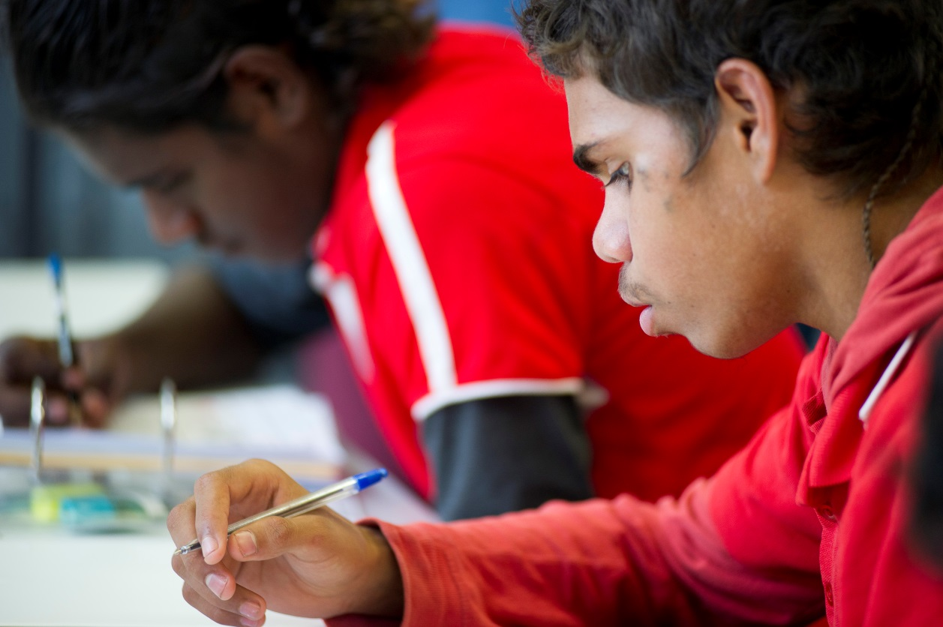

## 2. WHY, WHERE AND HOW MANY?

### 2.1 Availability of Secondary Schools

Many remote students do not have access to a local secondary school that offers a full secondary program. Data from the *Community, Housing and Infrastructure Needs Survey 2006* showed that in the Northern Territory, Queensland, Western Australia and South Australia over 60 per cent of Aboriginal and Torres Strait Islander communities were more than 100 km from a secondary school that has a full program on offer.

**Table 1** shows almost half the 5700 students granted ABSTUDY Away From Home benefits in 2015 did not have reasonable access to a full secondary school program because there was no secondary school within a reasonable distance or the local secondary school could not support the student to Year 12 or enable tertiary entry.

**Table 1: Breakdown of reason for the provision of ABSTUDY Away From Home payment (for the approximately 5700 recipients in 2015)**

| Per cent | Reason for provision of Away From Home payment |
| --- | --- |
| 24 % | local school has a limited program (bypass school) |
| 23 % | unreasonable travelling time / distance / isolation |
| 22 % | received a recognised scholarship |
| 18 % | home conditions prevent / disrupt / impede educational progress |
| 7 % | undertaking a special course that is not available locally |
| 4 % | in state care |
| 2 % | other reasons |

### 2.2 Which States and Territories are These Students Coming from?

In the 2015 calendar year, more than 5,700 secondary level students received ABSTUDY Away from Home benefits at some point in the year. This figure includes a small proportion of students (less than 150) who were living away from home to undertake secondary level courses at non‑school institutions (e.g. bridging or general education courses offered at a university, TAFE, or Registered Training Organisation).

Around 75 per cent of secondary students who were paid ABSTUDY Away from Home benefits in 2015 came from Queensland, Northern Territory or Western Australia—see **Diagram 1** for a jurisdictional breakdown.

16%

21%

38%

6%

13%

6%

**Diagram 1: Distribution of ABSTUDY Away from Home Benefits by State/Territory in 2015 (based on student’s home address)**

More than three‑quarters of ABSTUDY Away From Home secondary school students had a home address classified as ‘very remote’ or ‘remote’, and less than 10 per cent had a home address classified as ‘inner regional’ or ‘major city.’ Around 1,000 secondary school students in receipt of ABSTUDY were boarding outside their home state, with almost 600 of these students coming from the Northern Territory. The higher rate for Northern Territory students is partly the effect of living close to state borders and the cost‑effectiveness of travelling interstate versus intrastate.

### 2.3 Type of Boarding Residence and School

Around 5,200 (of the 5,700) students had their ABSTUDY benefits paid directly to a boarding school or residence on their behalf. Based on this data, it is estimated that around 350 secondary school students receiving ABSTUDY Away from Home benefits were in private accommodation arrangements.

The majority (77 per cent) of the ABSTUDY Away From Home students were attending   
non‑government schools within their home state.

**Non-Government School**

**Government School**

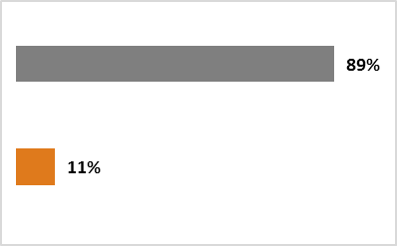

**Total recipients = 313**

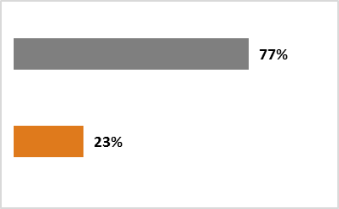

**Total recipients = 904**

**Victoria**

**Western Australia**

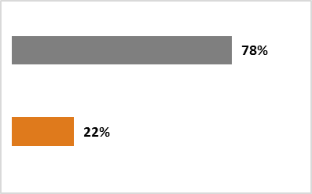

**Total recipients = 2126**

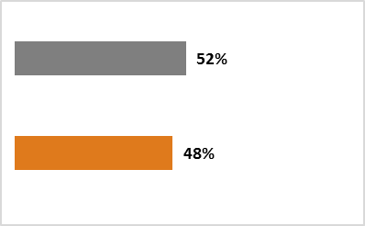

**Total recipients = 307**

**Queensland**

**South Australia**

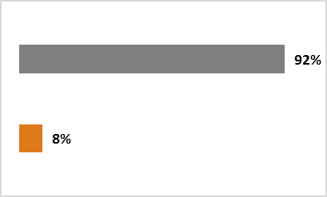

**Total recipients = 1209**

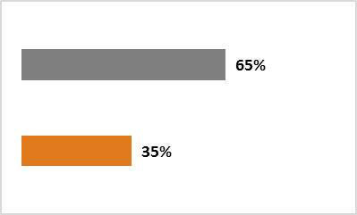

**Total recipients = 687**

**Northern Territory**

**New South Wales**

**Diagram 2: Percentage of ABSTUDY Away From Home students in each state and territory attending government and non‑government schools (2015)**

### 2.4 Growth in Demand

Australian Boarding Schools Association (ABSA) Census data—drawn from a membership which represents 95 per cent of Australian Boarding Schools—reports that demand for Aboriginal and Torres Strait Islander boarding places increased by 40.5 per cent between 2012 and 2016 (from 2,398 places to 3,369 places). This is three times the increase in overall boarding school enrolments for these same schools, with a 13 per cent increase in all enrolments between 2012 and 2016, from 18,703 places to 21,167 places. This data also indicates Aboriginal and Torres Strait Islander boarders represent 16 per cent of overall enrolments in Australian Boarding Schools in 2016.

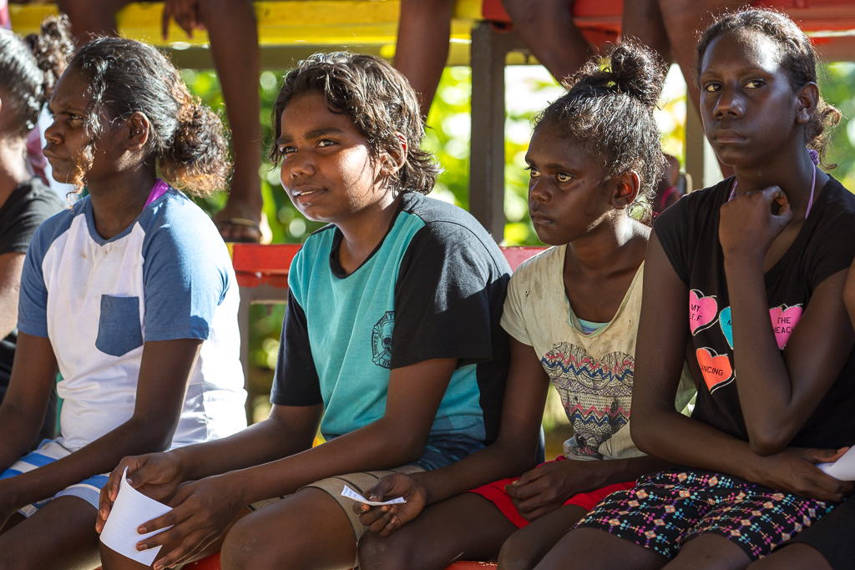The ABSA Census findings on the growth in the numbers of Aboriginal and Torres Strait Islander boarders is supported by ABSTUDY administrative data showing that recipients of ABSTUDY student entitlements paid to boarding schools/residences has steadily increased since 2008. The number of students whose ABSTUDY entitlement was paid directly to their boarding school or residence increased from around 3,100 in 2008 to just over 5,200 in 2015, an increase of around 68 per cent.

## 3. COMMONWEALTH ASSISTANCE

### 3.1 Current Assistance

Assistance available to Aboriginal and Torres Strait Islander students undertaking secondary education[1] away from home is provided by the Commonwealth government, state and territory governments, schools and the non‑profit sector.

The majority (77 per cent) of ABSTUDY Away from Home students are attending non-government schools and the Commonwealth government is the main public funder for this sector, providing 75 per cent of total government recurrent funding for independent schools. State and territory governments contribute the remaining 25 per cent.

The Commonwealth/State split on government funding for boarding is not available on a national basis. The 2016 KPMG report on funding for non-government Indigenous boarding schools in the Northern Territory (commissioned by the Northern Territory Government) reports that the Commonwealth contributes 74 per cent of funding for boarding service delivery in NT Indigenous boarding schools and the Northern Territory Government contributes 26 per cent. [2]

The main sources of Commonwealth Government support for Aboriginal and Torres Strait Islander boarding students are:

* Recurrent School Funding—not Indigenous specific nor boarding specific, although includes a loading to support Aboriginal and Torres Strait Islander students
* ABSTUDY—for travel, school fees and boarding costs
* Indigenous Advancement Strategy (IAS)—Children and Schooling program (scholarship and education support).

State and territory governments also have various schemes to assist with students’ travel, boarding and education costs. Many non‑government education providers offer scholarships, discounted fees, and other assistance for Aboriginal and Torres Strait Islander families and their children.

The Queensland and Northern Territory governments also have transition support units to help Aboriginal and Torres Strait Islander students with the transition to secondary schooling away from home.

#### Recurrent School Funding

Recurrent School Funding is the main mechanism for the Commonwealth Government to contribute to in‑school educational costs. This funding supplements funding provided by state and territory governments and, in the majority of cases, funding from other sources, such as fees and other contributions from school communities.

Over the 2014–2017 funding period, Commonwealth recurrent funding for schools under the *Australian Education Act 2013 (the Act)* totalled $62.4 billion. Following passage of the *Australian Education Amendment Bill 2017*, the Government is moving towards consistent Commonwealth shares of the Schooling Resource Standard (SRS) for government and non-government schools. The majority of schools currently attract less than the new Commonwealth funding shares (80 per cent for non-government schools and 20 per cent for government schools)—these schools will transition in six years and schools currently funded above the new Commonwealth shares will transition over 10 years. Under the SRS, funding is calculated with reference to a base per student amount plus additional loadings for school size, location, socio-economic background, students with disability, Aboriginal and Torres Strait Islander students and students with low English proficiency.

#### ABSTUDY

ABSTUDY is the primary assistance the Commonwealth Government offers Aboriginal and Torres Strait Islander families and individuals to support study at both secondary and tertiary levels, including support for secondary students living away from home for study. ABSTUDY expenditure is driven by the number of eligible recipients, with estimates of annual expenditure for secondary students ranging from $144 million for 2015–16 and currently projected to be $159 million for 2019–20.[3] Students in receipt of ABSTUDY are not eligible for a range of other payments, including Family Tax Benefit (FTB) if the student is over 16.

As indicated in **Table 2** (on the following page), the maximum possible annual amount of ABSTUDY payments for students studying away from home in 2017 is $25,926.89 – this includes up to $15,509.89 a year to help cover boarding fees (Living Allowance, Rent Assistance and Remote Area Allowance) and up to $10,417 to cover schools fees (School Fees Allowance). This figure excludes Fares Allowance as this is generally paid directly to the travel vendor.

**Table 2**: **Maximum Annual ABSTUDY Payments to Boarding Schools**

|  |  |
| --- | --- |
| **ABSTUDY payments to boarding schools** | **2017\*** |
| Maximum annual amount of ABSTUDY for an eligible secondary school student approved to live away from home to attend school (incl. Energy Supplement). | 25,926.89 |
| **Includes the following payments:** |  |
| Living Allowance** (means-tested) | |
| Maximum for students 16-21 y/o | 11,588.75 |
| Maximum for students under 16 y/o | 6,345.79 |
| *and* Under 16 Boarding Supplement (school entitlement for ABSTUDY eligible boarding students under 16 y/o) | 5,162.20 |
| School Fees Allowance (boarding rate) | 10,417.00 |
| Non-means-tested component | 8,095.00 |
| Means tested component | 2,322.00 |
| Rent Assistance | 3446.64 |
| Remote Area Allowance | 474.50 |
| Fares (arranged by DHS – Centrelink) | *Actual costs, paid to travel provider* |
| *\* 2017 rates as at 20 March 2017 (includes Energy Supplement).*  *\*\*Living Allowance eligibility and payment rates are subject to income and assets tests. Some students may have no entitlement or receive less than the maximum amounts due to parental income or not meeting the one of the approved away from home provisions.* | |

While allowances available under the ABSTUDY scheme are organised under seven awards, this report focuses on Schooling B Award as this supports almost all secondary school students studying away from home. **Appendix A** outlines payments available under Schooling B Award.

#### IAS Children and Schooling Program

The Commonwealth’s IAS Children and Schooling program funds a range of programs to support school access, attendance and achievement for Aboriginal and Torres Strait Islander students. The Children and Schooling Program provides funding for projects supporting these students from early childhood through to university, including mentoring, youth programs, pre- and post‑school transitions, and family and community engagement. While many of the projects are reaching students who are likely to undertake their secondary education away from home, only a small number of projects specifically target this group with the most direct support being through scholarships.

In 2015, the Commonwealth provided $15.2 million to support 778 secondary scholarship holders across 70 schools. Scholarship funding under the IAS was provided to ten scholarship administrators to provide scholarships to Aboriginal and Torres Strait Islander secondary students. Many of these are for students to attend high performing, high fee boarding schools.

Scholarship funds can be used for tutoring, leadership activities, sporting opportunities, and a personal allowance. Students generally still rely on ABSTUDY payments to cover the bulk of their school‑based expenses. Schools use scholarship money in varying ways, from targeted support for scholarship holders to support for the cost of general student services, but the bulk of scholarship money is used to help cover school fees not entirely covered by the ABSTUDY School Fees Allowance.

Of the scholarship recipients in 2016, 49.7% (705) were from remote and very remote communities and a further 30.4% (431) were from regional areas of Australia. The majority of recipients (61.4%) were completing Year 10, 11 or 12.

On 24 May 2017, the Minister for Indigenous Affairs, the Hon Nigel Scullion announced an additional $138 million Education Package to increase opportunities and improve outcomes for Aboriginal and Torres Strait Islander students.

A key component of the Package is $60 million for mentoring and support services for secondary students and $32 million for secondary scholarships.

## 4. PILLARS OF SUPPORT

Phase 1 of the Review is framed around four *Pillars of Support*—preparation, travel, in‑school and accommodation support, and family and community engagement.

## 4.1 Pillar One – Preparation

### a) Preparation: Key Issues

Many students and their families are not adequately prepared for the transition to secondary school away from home. Preparation includes being informed about:

* available schooling options
* what boarding life means, including the social and emotional challenges
* what practical things need to be done prior to boarding
* the types of things the student needs to take with them to boarding, and
* the importance of ensuring their child is health ready and there is continuity of health care between home and boarding where required.

The consultations revealed that some students have no preparation at all, while others are being prepared only three to four months prior to departure. Reports from schools during consultations cited many examples of students arriving with very little in the way of clothing or books, with untreated health issues, undiagnosed disabilities and emotional and behavioural issues.

In contrast, the literature and stakeholders advocate for preparation to begin no later than Year 5. Those consulted argued preparation to study away requires early engagement from local primary schools and secondary boarding residences/schools, and greater support for families and communities so that they can better contribute to the preparation of their children.

|  |
| --- |
| *The reason kids are dropping out and returning to community is that we aren’t preparing them early enough. There needs to be at least six to 12 months preparation time and this includes being in contact with the parents and the secondary school. The kids need time to adjust and get to know the new environment.*  *Personal interview with educator, 11 July 2016* |

A key activity later in the preparation phase to study away from home is applying for ABSTUDY support. Consultations revealed stakeholders believe many ABSTUDY claimants find the application process long, complex and confusing, resulting in some families not submitting claims until well into the school year and/or submitting incomplete claims.

Stakeholders reported many parents submit applications believing they are complete, only to find out later that more needs to be done. In some cases this is simply the signing of a customer declaration form at the end of a “staff assisted claim” that occurs over the phone. Incomplete claims cause delays in ABSTUDY approvals, which can also result in students starting school late.

|  |
| --- |
| *Many of our parents have English as their second or third language and lack the literacy required to fill out the ABSTUDY application form. There is many a time that the parents fill out the application form and send it off and then don’t hear anything from DHS and then they find much later that there was another step for them to do and then another step. How many forms are there? And how long do we have to wait for a response? The forms can take forever and parents wait and wait. Parents are waiting too long and kids are missing out on school time. We have to queue for ABSTUDY and have to wait 2 to 3 weeks before we hear anything. Parents get really frustrated and angry. They think they are done and then find out they have to do more. There really is a need to simplify the process.*  *­Personal interview with Indigenous community group, 1 September 2016* |

Work undertaken by DHS to simplify the ABSTUDY claim process is detailed in **Section 5.2 – Work Delivered**.

### b) Preparation: What Works

Successful strategies profiled by the literature[4] that help deal with the transition experience for students studying away from home include:

* early connections between family and school
* parental support and engagement, including help with applications
* community engagement with the schools, and
* pre‑enrolment information and orientation strategies, and screening of students to ensure an understanding of the students’ needs and best school and student match.

Early transition support was raised as a recommended way forward in the 2014 Wilson Review of the Northern Territory education system, with most respondents supporting the idea of an extensive transition process with Year 5 and 6 primary students being contacted by potential feeder schools and residential facilities.[5]

A community group that consulted for this review recommended boarding providers send a ‘Getting Ready’ (what to bring) list to parents prior to Aboriginal and Torres Strait Islander students traveling.[6] A scholarship administrator that gives this type of support to their students and families via their parent handbook report positive outcomes from this approach.

One of the boarding schools consulted reported that they begin student engagement via contact with the community and family at least six months prior to the student commencing at the college. This includes home visits, providing support to parents and building parental capacity to provide the right supports for their child. They also establish community contacts, help with ABSTUDY applications and conduct aptitude tests so that the right support is available when the student commences at the college.[7]

|  |
| --- |
| **Case Study 1: Ready, Set Crow Program**  The Ready Set Crow program is an IAS funded project that targets students in years 5, 6 and 7 in the APY Lands and Far West Coast of South Australia who have been identified by school principals as suitable for placement in the Wiltja Residential Programme, located in Adelaide.  The program works closely with over 110 students from 11 Remote School Attendance Strategy communities, providing information, individualised support and advice to increase students’ access to alternative school and training pathways. In 2016, 43 of these students received intensive case management support, after participating in short term visits to the Wiltja residential facility as part of the ‘Taste of Wiltja’ program.  During the visits, two Ready Set Crow Project Officers based at Wiltja become mentors to the students and provide one on one support in and out of the classroom. Students also take part in a day of activities at the Crows’ home base, the Adelaide Football Club, located at West Lakes. The visits give the students a taste of life in Adelaide and an understanding of expectations should they take up the opportunity to board at the Wiltja residence.  Following the short-term stays in Adelaide, the Ready Set Crow team visits the home communities of the students to re-engage and meet the families and teachers of the students. During the home visits, the team encourages students (and their families) to consider attending the residence in Wiltja.  In November 2016, the Ready Set Crow team attended the Wiltja Graduation Ceremony where seven students graduated with their South Australian Certificate of Education (Year 12 completion). In 2017, all of the graduates who have taken part in the program have either found employment or been accepted into higher education. |

### c) Preparation: Existing Arrangements

#### ABSTUDY

Currently DHS offers a comprehensive support network for families and students applying for financial assistance:

* ABSTUDY Smart Centres provide a dedicated ABSTUDY phone line (1800 132 317) and a staff assisted claiming option that removes the need for a paper form or a signed customer declaration.
* A network of Indigenous Service Officers deliver support to Aboriginal and Torres Strait Islander customers, communities and stakeholders. This includes raising awareness of the ABSTUDY program and supporting ABSTUDY customers.
* DHS Remote Servicing Teams work collaboratively with internal stakeholders, including Smart Centres, specialist and professional services such as social work and assessment services, to assist families in remote locations.
* Agents and Access Points, located in regional, rural and remote Australia, provide access to an internet‑enabled computer so customers can utilise DHS and other government related online services. Services also include the provision of information products and forms, and access to the dedicated ABSTUDY phone line to claim or get information.
* DHS undertakes a comprehensive communication campaign each year to raise awareness of the ABSTUDY program and promote the importance of claiming early.
* The DHS website provides information on ABSTUDY, including eligibility, payment rates and advising how to claim a payment.
* Students and families can also access ABSTUDY Fares Allowance each school term and for a number of other reasons, such as school enrolment interviews or orientation visits to the school or boarding residence.

#### IAS Children and Schooling Program

The IAS funds some activities to support the transition to boarding such as the *Ready Set Crow Program* (see **Case Study 1**) and support to help IAS Scholarship administrators support students and their families’ transition to boarding. There is, however, no specific focus on transition support under the IAS Children and Schooling Program.

#### State and Territory Transition Support Services

In the Northern Territory, the *National Partnership on Northern Territory Remote Aboriginal Investment* includes Australian Government funding of $24.7 million towards activities to ensure Aboriginal students complete schooling well equipped to take up employment, training or higher education. These activities include the operation of a transition support unit to help remote secondary students negotiate secondary pathways, including boarding school.

The Queensland government also provides transition support services to help students and families in Cape York and Palm Island with accessing secondary education away from home, including support with school enrolments, travel and ABSTUDY claims and reengagement with education when students have dropped out or been expelled.

#### Schools/Boarding Residences

Some schools and boarding residences begin their contact with students and families at least six months prior to the beginning of secondary school and provide a range of orientation opportunities and information to support student preparation for boarding (see **Case Study 1**, which refers to ‘Taste of Wiltja’ program).

|  |
| --- |
| Preparation: Summary of Service and Support Gaps  * There is limited to no activity occurring in community at the primary school level to help prepare students and their families for boarding, including ensuring their children are mentally and physically ready. * There is limited access to appropriate resources for families and communities to help build their understanding of the boarding options, of the boarding experience for their children and of the important role of the family and community in supporting these students and what they need to do to help them get ready. * ABSTUDY claim forms are experienced as complex and at times there have been delays in getting approvals. |

## 4.2. Pillar Two – Travel

### a) Travel: Key Issues

Remote Aboriginal and Torres Strait Islander students face challenges when travelling from community to boarding and back, including:

* long periods waiting for travel connections
* disrupted travel (where a travel connection is missed or cancelled)
* a lack of contingency planning for disrupted travel
* being assisted by travel supervisors with no experience, and/or
* travelling unaccompanied and trying to navigate travel schedules and airports with no or limited travel experience.

In the event a student is disrupted in transit, DHS can book accommodation when the student has a travel supervisor. However, high numbers of students travel unaccompanied and currently there is no systemised risk management plan for when these students are in transit. For students who experience disrupted travel and are traveling unaccompanied, DHS look at all avenues in the area, such as family, boarding residences, hostels and other services to support and, where necessary, accommodate the student. If all avenues are exhausted, DHS staff have at times voluntarily supervised disrupted student travellers as a last resort.

Currently DHS carries significant risk by providing volunteer employee supervisors (when no other suitable option is available) for unaccompanied young students who experience a disruption to their travel and who require same day or overnight supervision. This is also true for those providing the same type of support from other services such as scholarship providers, and Queensland and Northern Territory transition support staff. While there are people stepping in to address this gap, the current approach is ad hoc and there is confusion about who has duty of care for the student while they are transit.

|  |
| --- |
| *A key concern is travel of young students unaccompanied, especially when flights are cancelled and the student ends up at the airport with no adult supervision or support. Sometimes boarding staff accompany students but this is not across the board. The Transition Support Service used to camp out at the Cairns airport and help students from their regions to change flights and check in or make sure they are on the correct buses. It was common to see students from Torres Strait or the Gulf there on their own unsupported.*  *—Personal interview with education organisation, 14 June 2016* |

In addition to unaccompanied travel, Aboriginal and Torres Strait Islander students also have high incidences of missed travel (1,291 in the first half of 2016). Interestingly the bulk of these incidents occurred after a school vacation, rather than at the commencement of boarding.

Stakeholders identified many reasons for why students may miss travel, including:

* not having support in community to return to school or reach their departure point
* becoming anxious and not wanting to catch the plane or bus, and
* receiving travel itineraries late, therefore having insufficient time to prepare or to find a suitable travel companion.

Stakeholders also expressed concerns about the inflexibility of ABSTUDY Fares Allowance policy. This includes frustration around rules restricting unaccompanied young students from travelling on weekends and after hours, or limiting approved travel to direct trips between the home address and boarding address when the family is not in community or the student is not at boarding (see **Case Study 2**).

|  |
| --- |
| **Case Study 2: ABSTUDY Travel Rules – example provided by a school in Western Australia**  An example that caused significant frustration was the travel for some of our students at the end of term 2. Since 1995 (our) students have been participating in the Country Week Sports carnival in Perth. This event is in the last week of term 2 so that interruption to schooling is minimised and schools have plenty of lead time to prepare for such a significant event. Historically, (our) students who have participated in this event have been able to travel home on ABSTUDY booked and funded flights directly out of Perth. This has always been the most logical step as students would otherwise have to return to (location of school—700km from Perth) only to then return to Perth as they make their way home for school holidays.  This year we were advised that this process would not be possible as it failed to meet the ABSTUDY travel guidelines. We were advised that the only option to avoid students having to return to (school) was for the school to book and fund the student return travel home and then claim for reimbursement from ABSTUDY. This places significant strain on schools like ours as this is a time of year when cash reserves are low as we wait for the next lot of Commonwealth and state per capita funding.  Not being given any other alternatives and wanting the students to be given the opportunity to participate, we did book and fund the travel for participating students to return to their families with the understanding that we would be reimbursed. This obviously created an increased administrative burden for the school and while we received reimbursements for most students, we were advised that one lot of travel would not be reimbursed. The reason for this was because we had arranged for the student to travel to Kalgoorlie where she was met by her family. Because she wasn’t booked all the way back to her community, it was considered to be outside the travel policy and not eligible for reimbursement. |

### b) Travel: What Works

No research or evaluation exists on the travel experience of Aboriginal and Torres Strait Islander secondary students studying away from home. Anecdotal evidence from consultations for this report outlines approaches that are working effectively.

One of the scholarship administrators consulted for this Review reported that the approach they take with their students is working well. They begin travel plans well in advance and work closely with family and community to establish an agreed set of rules. They also work with the school to obtain travel details for each student and ensure each student is escorted on and off flights:

|  |
| --- |
| *Travel is something we are well used to and we have a well-oiled system. We plan so far in advance and have the support well in place. In fact DHS have asked us what we are doing because all our students catch their flights and return to school. It works because we work with parents and community and parents have ‘skin in the game’ by having to contribute to the costs of the education. We are also there to greet them at the airport and to send them on their next flight and then there is someone there to meet them at the other end. The schools give us the travel details and we have worked with communities and established an agreed set of rules on what students will return home for. We have also worked with families to develop a parent handbook. This was developed with lots of consultation with families where we clarified roles and responsibilities. Everyone knows the rules.*  *Personal interview with scholarship administrator, 2 August 2016* |

It is evident from the above example that incidents of missed travel can be reduced through early planning, family and community engagement, and establishing an agreed set of expectations between the school and the parents (and sometimes a third party such as a scholarship provider or Transition Support Service).

### c) Travel: Existing Arrangements

#### ABSTUDY Fares Allowance

ABSTUDY Fares Allowance is the main Commonwealth support measure for travel bookings and costs for Aboriginal and Torres Strait Islander students studying away from home. ABSTUDY Fares Allowance policy includes provisions designed to address student safety, such as meeting travel costs for a supervisor to travel with students, and allowing flexibility of travel via reimbursement options. Nonetheless, supervised travel is not compulsory under ABSTUDY and stakeholders advise that when flexibility is required for travel arrangements, paying for travel upfront and getting reimbursed is not always financially viable for the school/provider/family who would need to book and pay for the travel upfront.

#### IAS Children and Schooling Program

The IAS Guidelines state that the Children and Schooling Program will not pay for elements of measures funded through ABSTUDY, including travel. Nonetheless some scholarship providers funded under the IAS program assist students with travel to ensure their safety.

#### State and Territory Governments

Transition support services in Queensland and Northern Territory assist with students’ travel, including being present at major transit hubs to help students transfer to their connecting flights. Often this support is being provided due to gaps in service delivery, rather than being a key part of the transition support services role. It should also be noted at the time of writing this report the Queensland transition support services were limited to students from Cape York and Palm Island.

Some state and territory governments also offer travel concessions to assist with travel for these students but play no role in the risk management of the student when they are in transit between boarding and home.

|  |
| --- |
| Travel: Summary of Service and Support Gaps  * There is a lack of clarity around roles and responsibilities for care of the student when the student is in transit and during travel disruptions. * There is no requirement for a risk assessment or management plan for students travelling unaccompanied or on the suitability of the travel supervisor. * ABSTUDY Fares Allowance rules lack flexibility to cover all travel scenarios. |

## 4.3 Pillar Three – In‑School and Accommodation Support

Aboriginal and Torres Strait Islander students studying away from home access different types of boarding residences and schools, including:

* + low fee boarding residences and schools, many of which do not charge beyond the students’ ABSTUDY entitlements. These are boarding providers with high numbers and/or percentages of Aboriginal and Torres Strait Islander boarders. This category includes:
    - boarding schools run by the independent sector that have high numbers of Aboriginal and Torres Strait Islander students
    - community led schools where boarding is offered through family group home arrangements
    - community led boarding schools that are owned and managed by the community, such as Tiwi College
    - special assistance schools targeted at remote Aboriginal and Torres Strait Islander boarders with small numbers of students (e.g. Worawa Aboriginal College, the Melbourne Indigenous Transition School and Clontarf Aboriginal College)
  + mainstream boarding schools – schools with low numbers and/or percentages of Aboriginal and Torres Strait Islander students
  + mainstream day schools (government and non-government) with low percentages of Aboriginal and Torres Strait Islander students, where the student is staying in a hostel, residential college[8] or private arrangements
  + vocationally oriented boarding schools for senior secondary students, such as Wongutha CAPS, La Salle College and TEC NQ, and
  + non‑school institutions offering secondary level courses, such as TAFEs and Registered Training Organisations where the student is staying in a hostel, residential college or private arrangements.

Due to the array of boarding and schooling options and the overlap in support that these services are required to provide to students (such as trauma informed practices, culturally respectful environments, health and wellbeing, tutoring, mentoring and family and community engagement) these two environments have been considered under the same pillar in this report (*In-School and Accommodation Support*). However, our research and feedback from stakeholders suggests that the boarding space is where the greater cost pressures are experienced. Cost pressures are particularly problematic for boarding residences with high numbers of Aboriginal and Torres Strait Islander students from remote communities.

### a) In‑School and Accommodation Support: Key Issues

#### Funding concerns

The costs associated with providing boarding accommodation and schooling for Aboriginal and Torres Strait Islander school students has been the topic of extensive discussion between affected boarding residences/schools and governments for more than a decade.

|  |
| --- |
| *It is common practice for schools to subsidise the cost of educating Aboriginal students. The extent of the burden to the school communities varies but it remains a significant issue. It is acknowledged that the Australian Government has already committed important funds to boarding school education. However, in the long term, the costs of supporting the increasing numbers of Aboriginal students in boarding schools could, without appropriate measures being in place, prove unsustainable.*  *Catholic Education Commission NSW, 2008, p 9* |

During the consultations for Phase 1 of this review stakeholders expressed concerns about the lack of recognition (under current funding arrangements) of the additional support needs for remote Aboriginal and Torres Strait Islander students.

For many Aboriginal young people, undertaking their secondary education away from home coincides with important cultural transitions and psychological needs during early adolescence such as developing a sense of identity and self-worth. This exacerbates the challenges of the transition to boarding. In addition research has found that Aboriginal boarding school students experience higher levels of ‘emotional difficulties and greater levels of depression, anxiety and stress than non-boarders’.[9]

The stakeholders consulted reported that many remote Aboriginal and Torres Strait Islander students arrive at boarding school with untreated health issues, undiagnosed disabilities, emotional and behavioural difficulties, increased trauma, and lower levels of mainstream educational attainment, all of which need to be assessed.

Other factors reported by stakeholders and the research that contribute to the additional support needs of remote Aboriginal and Torres Strait Islander students include limited access to internet at home,[10] high degrees of family mobility, and parents’ uneasiness about engaging with government and school bureaucracies.[11]

Both the consultations and the research report that majority Aboriginal and Torres Strait Islander boarding schools[12] incur significant costs in:

* addressing and managing remote Aboriginal and Torres Strait Islander students’ ongoing physical and mental health needs
* training staff in trauma informed practices and cultural awareness
* employing extra staff to manage ABSTUDY administration
* employing staff to undertake community outreach activities, and
* providing additional student mentoring and one on one tutoring.

When schools and boarding residences are catering for a large number of Aboriginal and Torres Strait Islander students from remote and very remote communities, it becomes increasingly challenging to meet the additional costs associated with these services.

Mainstream boarding schools with relatively small numbers of remote Aboriginal and Torres Strait Islander boarders attract students on scholarships, have a wealthier customer base and more easily attract private sources of funding, including parental contributions through school fees. These schools are more able to absorb the additional costs that come with supporting the relatively small number of remote Aboriginal and Torres Strait Islander students in their boarding residences. In contrast, for boarding schools/residences with a high percentage of remote Aboriginal and Torres Strait Islander boarders the additional costs are significant and most of these schools do not have students on scholarships nor do they charge private school fees beyond the student’s ABSTUDY entitlements. The combination of the high number of remote Aboriginal and Torres Strait Islander students and limited funding sources creates financial strain for these institutions.

#### Private School Fees

For mainstream boarding schools, funding for boarding is met primarily through parental contributions. The Independent Schools Council of Australia reports that the ratio of private funding (mostly parental contributions and fund raising) to government funding is generally 58 per cent to 42 per cent.[13] However, majority Aboriginal and Torres Islander boarding residences/schools are almost entirely reliant on government funding to operate, including students’ ABSTUDY entitlements. These schools have few to no recipients of scholarships to provide additional funding.

#### Recurrent School Funding

Schools receive additional Commonwealth funding (loadings under Recurrent School Funding) for the number of Aboriginal and Torres Strait Islander students enrolled. Remote loadings are based on the location of the school, rather than the home address of the student. Some stakeholders argued for recognition of the remoteness of the home address of the student to recognise their additional needs. Recurrent School Funding only covers in-school costs and does not provide funding for boarding costs.

#### ABSTUDY

ABSTUDY is the main source of government funding to cover boarding costs. It covers the day to day living costs of Aboriginal and Torres Strait Islander boarding students (including bed, board and travel), but is not designed to cover costs for the additional services required by many students coming from remote and very remote communities (including health, trauma and additional academic services), which do not fall under its remit.

ABSTUDY’s complex administration process is also a primary concern for majority Aboriginal and Torres Strait Islander boarding schools. The 2016 KPMG report expressed that the current ABSTUDY funding arrangements can make it difficult for boarding schools to receive their students’ full entitlements and places a high regulatory burden on schools with significant numbers of Aboriginal and Torres Strait Islander students. The same report also found that where there was investment by the boarding school in employing a staff member to manage ABSTUDY entitlements, there was a better outcome in the rate of ABSTUDY payments.

#### IAS Children and Schooling Program

IAS scholarships are often targeted at higher performing students. Most of the schools taking students with higher support needs do not get additional funding through scholarship recipients. Some stakeholders felt that greater support was needed for students at the other end of the scale who are at risk of disengaging from school.

|  |
| --- |
| *There are a whole group of students who need extra support. We need to reconsider where the money is being spent and redirect it to where it is needed most and stop wastage of money. This doesn’t mean stopping support for those students who are identified as future leaders and having academic potential. These scholarships are a wonderful thing and we need to continue to support these students.*  *Personal interview with principal of a boarding school, 11 August 2016* |

A further issue raised by stakeholders in relationship to IAS scholarship funding was its ‘drip feed’ funding approach which limits funding agreements to a maximum of three years. This approach means providers cannot guarantee scholarship support for the entirety of a student’s secondary schooling. Some scholarship providers are managing by only offering scholarships to students in Years 11 and 12, while others are running on a model of uncertainty.

|  |
| --- |
| *All our students currently on scholarships we can fund until the end of their schooling, but this is not the case for our new students. We have to say to schools that we don’t know how many students we can support for next year and we can’t tell schools how to plan. It is difficult to run a program with this lack of certainty as we are trying to support six years or more of these students’ lives. It would be great to have greater certainty and a link between outcomes and funding.*  *Personal interview with IAS scholarship provider, 29 September 2016* |

#### Health and Wellbeing

In addition to funding issues, the KPMG report and consultations indicated that majority Aboriginal and Torres Strait Islander boarding schools reported difficulties in accessing health services to address the ongoing and significant health needs of their students. Stakeholders identified that there is currently a lack of coordination between support services, a duplication of services and a lack of access to high quality and affordable pastoral care. It was also noted that funding for health and wellbeing services is often provided to government schools by state and territory governments, while the non-government school sector, the main secondary school option for remote students studying away, do not receive this additional funding.

|  |
| --- |
| *When a new student arrives, and when a student returns following an extended absence, we spend the first 2 weeks profiling them, doing hearing and dental checks, general health checks, blood tests, academic testing etc. Sometimes if we are fore warned, psychiatric testing is also organised.  Parents are kept informed and appropriate consent organised. Our clinic also does catch up vaccinations for our Indigenous students. Recently 200 injections were given over a couple of days, starting from our senior students first, as we want them all vaccinated prior to leaving school. Eighteen of our students have rheumatic heart disease which requires an injection every 28 days (exactly) which must continue over a period of 10 years. A number of our Indigenous students have diabetes and sometimes the students turn up to school with broken bones or bad infections. Attending to their health first thing on arrival is critical because we can’t teach them until these are addressed.*  *Personal interview with principal of a boarding school, 8 September 2016* |

Access to quality, coordinated health services for students in both their community and at school, is of great importance in improving their health and wellbeing so that they can engage effectively in education and achieve positive results. A lack of adequate access to affordable health and wellbeing services was a key area of concern in both the literature and consultations with stakeholders.

#### Growth in the Number of Expulsions and Lack of Alternative Options

With some boarding schools struggling to meet the additional costs associated with properly supporting remote Aboriginal and Torres Strait Islander students, behavioural problems can exacerbate this issue. This can result in growing numbers of expulsions or long-term suspensions (“time out”) from these boarding schools. ABSTUDY data shows a steady increase, since 2011, in the number of students accessing Fares Allowance to travel home following expulsion.

The consultations also revealed practices where expulsions or long-term suspensions occurred without any re‑engagement plan or communication with families:

|  |
| --- |
| *For students at risk of dropping out of school there needs to be good communication with the child so there is a good understanding of what is happening for them. You need to work alongside the student and make a plan that will work for them. We as community leaders need to work with parents and teach the parents as well. We are already there as a core person in the area and they already ask us for advice. The schools also need to be clear about why the student has been suspended. Often the student will come back to community with no letter explaining what they did and why they have returned.*  *Personal interview with Indigenous community group, 1 September 2016* |

Students that are expelled run the risk of complete disengagement from education and employment (see **Case Study 3**) and there is a significant gap in alternative education options for these students either in community or as a boarding option.

Some jurisdictions fund Independent ‘special assistance schools’ which are specifically set up for students who are non‑traditional learners and disengaged from mainstream education. These schools do not charge tuition fees and are almost entirely dependent on government funding to operate. In recognition of the special services the special assistance schools provide to the State’s most vulnerable students, special assistance schools receive a guaranteed minimum rate of State recurrent funding which is higher than most other non‑state schools. These schools are, however, difficult to access for students from remote areas given only a small number of special assistance schools offer residential facilities. A key finding from a recent study of Queensland’s alternative education sector was that “[d]ifficulties with accessing alternative educational services for young people who are excluded from/leave the system increase with geographical distance from major centres in Queensland. This is exacerbated by attendant issues in respect of transport and communication resources.”[14]

|  |
| --- |
| **Case Study 3: 2015 Submission from an Aboriginal Corporation**  In 2015, an estimated eight out of 12 enrolled students from a remote community in Queensland were either suspended/expelled or had absconded within the first term from local and interstate boarding schools. The Aboriginal Corporation reported the following consequences: increased anti-social behaviour, breached youth diversion agreements, disruption to schooling, and lack of alternative options to support learning and engagement. At the time the corporation reported that these students have now missed approximately four months of schooling making their school engagement increasingly challenging. The predominant age group affected by suspensions has been 13–16 years old. This age group is particularly vulnerable as there is a lack of suitable alternatives for them in community. For instance they are not eligible for the Community Development Program, cannot enrol in any courses and are unable to access secondary schooling in community. |

#### Culture

There is strong consensus across the literature on the important role of the school and boarding environments in generating a sense of belonging for Aboriginal and Torres Strait Islander students studying away from home. Research suggests that the culture of the school can play a more important role in improving attendance and engagement of Aboriginal and Torres Strait Islander students than family background.[15]

In addition to wanting to succeed academically and being able to adapt to a new school environment when studying away from home, Aboriginal and Torres Strait Islander students have reported wanting to maintain a link with their family, culture and community.[16] Recent research based on data from the *Longitudinal Study of Indigenous Children (LSIC)* reports that Aboriginal and Torres Strait Islander children from remote Australia have stronger connections to land and culture and where the links to culture are encouraged by the parent, the child shows better cognitive development and physical health and wellbeing.[17]

Despite best intentions and the known link between culture and wellbeing, the research reports that boarding residences/schools rarely create a space within their culture or classrooms to enable Aboriginal and Torres Strait Islander students to explore their identity in conjunction with their education.[18]

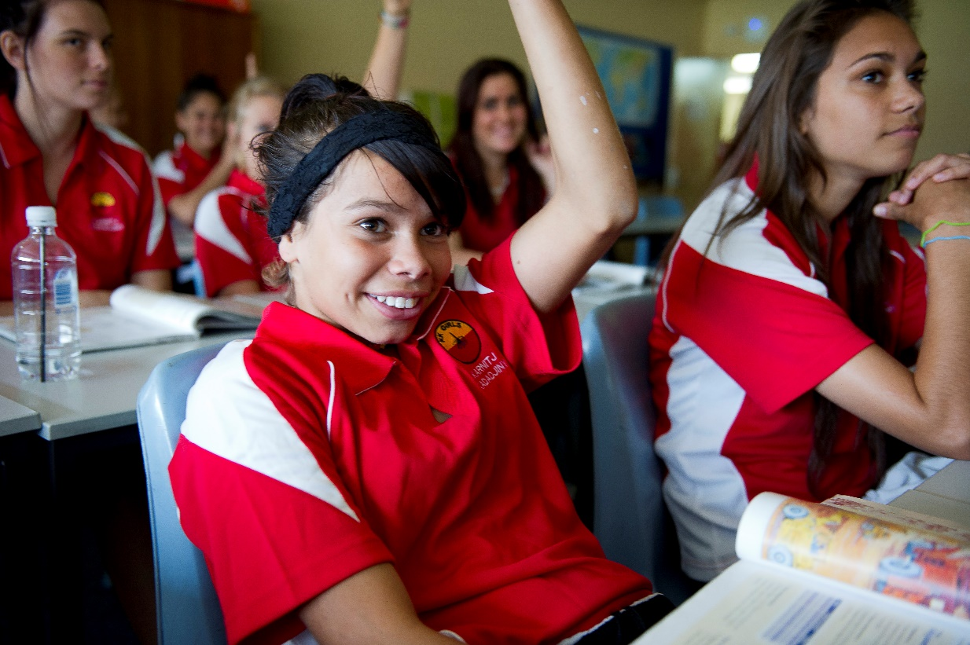

### b) In‑School and Accommodation Support: What Works

#### Health and Wellbeing

Leadership staff (principal, school board, senior teachers) and the staff in general play an important role in creating a sense of belonging and opportunities for connection to culture in both the school and accommodation settings.[19] Several studies report on the positive impact of the transition experience that results when teaching staff allocate time to build rapport and foster a relationship with Aboriginal and Torres Strait Islander students.[20]

A key finding of Mander’s 2012 study was that students valued teachers who primarily demonstrated a personal interest in them as individuals, as well as learning about where they were from, their respective culture, family, and community.

The Berry Street Education Model (BSEM) based on trauma‑informed teaching and learning endorses the critical role of the teacher in working with vulnerable students affected by trauma. BSEM aims to expand the possibilities of teaching and learning through integrating clinical, educational and welfare approaches and perspectives. The design of the model draws on the premise that the child’s biological and developmental responses to trauma need to be addressed before he/she is ‘ready’ to build relationships and engage with learning content.[21]

Evidence suggests that mentoring is a successful strategy for building and maintaining student engagement.[22] McCalman et al (2016) reports that a growing body of research demonstrates the powerful and lasting positive effects of mentoring in improving the behavioural, academic and vocational outcomes for at‑risk youth. Further, the most effective mentoring models are culturally‑tailored, long‑term, formal, one‑on‑one models that account for mentor competence and are integrated into broader support services and programs. Mentoring has been linked to a range of developmental benefits, including higher self‑esteem, greater engagement and performance in school, and better mental health.[23] During the consultations for this report, a senior secondary college reported marked improvements in the level of student engagement and commitment to school since the appointment of an Aboriginal and Torres Strait Islander mentor.

The consultations also revealed various strategies for dealing with suspensions. Most of these involved working with family and community, staying in contact with the student, and setting up a return‑to‑school plan. In some cases, suspensions were ‘in‑school’ suspensions.

Intensive case management that integrates mentoring outside of school hours with broader support services and program is recommended to effectively support Aboriginal and Torres Strait Islander boarding students.[24]

|  |
| --- |
| *Our students are well covered for support but the majority of students have no one looking after them and many of them are falling through the system. Ours have a case manager and mentoring and other support and all students should be getting this type of support, not just those on a scholarship. All remote students should have case management support.*  *Personal interview with IAS scholarship administrator, 2 August 2016* |

All the boarding residences and schools consulted for Phase 1 of the Review, as well as those included in the former Department of Education, Science and Training’s *What Works* manual on boarding, had systems in place to provide ongoing treatment of student health issues. One school had set up a Wellbeing Unit staffed by two social workers and a full‑time nurse. Another had a Student Services team accessible 24 hours a day.

#### Academic Support

Academic support is profiled in the literature as an important support measure, particularly for those from remote and very remote communities who often have significant learning gaps.[25] Depending on the needs of the student, effective academic support includes bridging programs, intensive classroom support, on‑site tutoring by teachers or volunteers, withdrawal lessons, English as an Additional/Second Language support, and homework supervision.[26] Academic support needs to be delivered in both the school and boarding environments.

### **c) In‑School and Accommodation** Support: Existing Arrangements

#### Recurrent School Funding

Recurrent School Funding is the main mechanism for the Commonwealth Government’s contribution to in‑school educational costs.

The SRS base amount for most non-government schools is reduced by the anticipated capacity of their school community to financially contribute towards the school’s operating costs. The reduction is based on the socio-economic status (SES) score of the school or the approved system authority which determines a school’s capacity to contribute. Along with special schools, special assistance schools, and sole provider schools, majority Aboriginal and Torres Strait Islander schools are anticipated to have a capacity to contribute of zero and therefore the base amount of Commonwealth funding for students at these schools is not reduced based on the schools’ SES scores.

The Aboriginal and Torres Strait Islander loading provides extra funding on top of the base amount for each Indigenous student. The amount of extra funding for each student depends on the proportion of Indigenous students in the school. If there is a single Indigenous student in the school, the loading is 20 per cent of the base amount. If 100 per cent of the students in the school are Indigenous students, the loading is 120 per cent of the base amount. There is no capacity to contribute discount applied to the loadings.

Commonwealth funding provided through the loading will increase from $962.6 million over   
2014–17 to approximately $1.4 billion over 2018–21, an increase of 48.5 per cent.

In 2018, this additional funding is expected to benefit around 213,504 students who identify as Aboriginal or as a Torres Strait Islander.

#### ABSTUDY

ABSTUDY covers the cost of school fees up to $10,417 in 2017. ABSTUDY School Fees Allowance can be used to cover fees levied by schools where:

* there is no suitable government school available locally
* the student is unable to undertake secondary schooling while living at home, or
* the student is approved to bypass the local school for other reasons (such as receiving a scholarship to attend another school).

This assistance is available to both day students and boarders. The first $8,095 of this allowance is not means tested, the rest ($2,322) is means tested. Payments are made directly to the school or as a reimbursement.

In 2017, ABSTUDY helps cover boarding fees through:

* ABSTUDY away from home living allowance ($11,588 per year)
* Rent Assistance ($3,446 per year), and
* Remote Area Allowance for students whose home is in a remote area ($474 per year).

These payments are means tested, total $15,508 a year and are generally made direct to the school or hostel, four times a year on a term‑in‑advance basis.

In cases where the annual school fee charged is less than the student’s maximum ABSTUDY entitlement for school fees and the annual boarding fee charged by the school or hostel is above that covered by the ABSTUDY allowances for boarding, the unused School Fees Allowance can be used to contribute to the boarding fee.

#### IAS Children and Schooling Program

The major investment under the IAS Children and Schooling Program for Aboriginal and Torres Strait Islander secondary students studying away from home is funding for scholarships. Schools and scholarship providers use scholarship money in varying ways, from targeted support for scholarship holders to support for the cost of general student services. The bulk of scholarship money is used to help cover the fees not entirely covered by ABSTUDY benefits.

|  |
| --- |
| In-School and Accommodation Support: Summary of Service and Support Gaps  * There is a lack of clarity on the funding and policy responsibility for Indigenous boarding. * Funding is not designed to recognise the additional support needs of many remote Aboriginal and Torres Strait Islander students. * There are gaps in alternative education boarding models for remote youth who do not have access to secondary schooling in community and who are not doing well in boarding. * There is a lack of coordination between support services, particularly in relation to health services. * There is a need for the development of more culturally safe boarding residences/schools. |

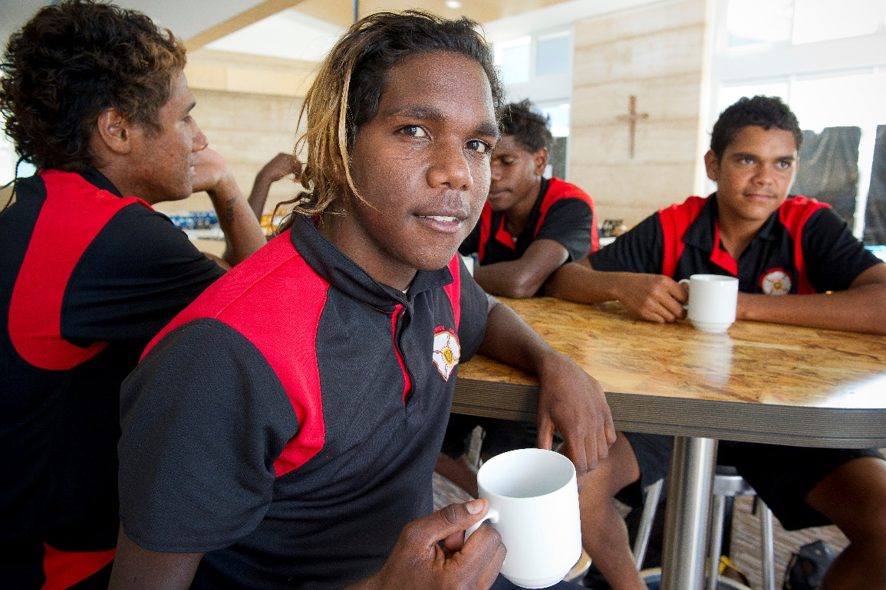

## 4.4. Pillar Four – Family and Community Engagement

This pillar of support also sits across the other three pillars (preparation, travel, in‑school and accommodation), however it is also treated here as a pillar in its own right because of the importance of its role in connection with culture and the students’ overall wellbeing and self-worth.[27] This pillar relates not only to efforts at the boarding residence/school end to engage with family and community but also to the importance of building family and community skills in engaging with the education of their children who are studying away from home, including engaging actively with the boarding residence and school.

### a) Family and Community Engagement: Key Issues

Successfully engaging families and communities in their children’s education is an effective way to improve both the child’s level of engagement and attainment in schooling.[28] Unfortunately research indicates that efforts by schools to engage with families and communities are not always resulting in authentic engagement.[29] Many parents want to interact meaningfully with schools and participate in their child’s educational journey,[30] but report feeling uncertain of how best to support their children while they are at boarding.[31]

#### Boarding Residence/School Efforts

During consultations the term ‘in loco parentis” was used by some stakeholders when describing the role of boarding staff. This view runs the risk of diminishing the important role the family and community continue to play in supporting the wellbeing and boarding experience of the student and of being in communication with the school and the teachers.

Authentic engagement with family and community is particularly pertinent for remote Aboriginal and Torres Strait Islander families who have no choice but to send their child away from home for their secondary schooling. The research reports on the anxiety experienced by parents about their child’s potential loss of connection to family and culture[32] when their child goes to boarding school. Parents interviewed by Mander said that the opportunity to interact meaningfully with school staff and participate in decision‑making processes about their child’s educational journey reassured them that the school prioritised the care and wellbeing of their child.[33]

The 2016 KPMG report on funding arrangements for Aboriginal and Torres Strait Islander boarding schools in the Northern Territory found lower degrees of compliance with the *Australian National Boarding Standards* when it came to family and community engagement:

|  |
| --- |
| *Engagement with parents and communities was an area of strong focus across all the schools with schools citing that it was not only boarding house managers and staff that attended communities, but the school principals, administration staff and teaching staff (sometimes on a voluntary basis during school holidays) also regularly attended communities to engage with parents and the wider community. It is likely, however, that the focus of these community visits is not so much on engagement for the purposes of information sharing, obtaining feedback and developing partnerships, as much as it is on the administration task to ensure that ABSTUDY forms are adequately completed and signed by families to secure funding to the school for academic and boarding service delivery.*  *KMPG, 2016, p 18* |

It is difficult to perceive what effective engagement with family and community looks like for a boarding residence/school that is servicing over 20 different remote communities, let alone trying to do this with limited funding for such activity. There appears to be no research or data that has considered this issue.

The literature, however, does identify a communication gap between home and school that leaves Aboriginal parents feeling further marginalised and ostracised from their children’s educational journey.[34] Some studies report that schools often do not understand the need to fully involve Aboriginal and Torres Strait Islander parents and communities in the education process; nor do they understand why differentiated approaches are needed for Aboriginal and Torres Strait Islander students.[35] This, however, is unlikely to be the case for majority Aboriginal and Torres Strait Islander boarding residences/schools. The schools consulted all expressed the importance of investing in this activity, but did comment on limited resourcing to do so.

The consultations for this report revealed strong support for family and community engagement activity, including from those in community:

|  |
| --- |
| *Engagement with family and community is really important. Schools have parent teacher interviews at the school but there would be huge value if the schools ran these interviews in community.  The staff could come out and see where their students live and get a better understanding of their community and home life. Boarding providers need to more readily engage with parents and to make the effort to come to community and engage with the parents. It is about building trust and respect and connection so that if something goes wrong the family, the community and the school can work together to fix it.*  *Personal interview with community group, 1 September 2016* |

Efforts to engage family and community for the duration of secondary schooling were also strongly endorsed by those who made submissions to the 2016 HoRSCIA *Inquiry into educational opportunities for Aboriginal and Torres Strait Islander students*, with a number of stakeholders calling for funding to support school activities to engage family and community:

|  |
| --- |
| *Targeted funding for school community partnerships is required to encourage attendance and retention of Indigenous Boarding students.*  *Independent Schools Queensland, Submission No 19, HoRSCIA, p 4* |

Some stakeholders recommended funding to support the specific job roles such as community liaison officers and Aboriginal and Torres Strait Islander education workers whose role is to build connections between the school, families and community.

|  |
| --- |
| *Contact with parents/guardians is always difficult particularly in remote communities. Access to community liaison staff who are able to facilitate communication with schools would assist both in the settling in period and also throughout the students schooling.*  *Catholic Agricultural College, Submission No 5, HoRSCIA, p 1* |

Many boarding residences already employ Community Liaison Officers, an activity identified as an additional cost pressure.[36] Some of the literature argues that such roles run the risk of being driven by the school needs[37] and of school staff relying on this person to be a “cultural translator” rather than staff and the school as a whole developing the cultural competence necessary to support their Aboriginal and Torres Strait Islander students and families.

#### Family and Community Engagement with the Student’s Education

Just as remote Aboriginal and Torres Strait Islander students studying away from home need holistic support measures while they are in boarding, so too this support is needed when they are in community. One of the great stresses identified for these students is that of having to move between the “two worlds” and the experience of “lateral violence” when the student returns home for holidays or cultural business.[38]

As mentioned under the pillar of preparation, community and family support needs to start early for prospective boarders. This support needs to continue while at boarding and when the students return to community during school breaks or for cultural business. It includes travel support, in community mentoring, maintaining connection with culture, and encouragement to return to school after school breaks[39]. It also includes building parental skills and confidence in engaging and communicating with the schools and understanding and appreciation of the critical role parents and family play in the wellbeing of their child.

Efforts at the community end may help to alleviate some of the cost pressures experienced by boarding residences/schools. Currently most of the attention around family and community engagement has been from the school end and there is lack of consideration of what needs to be happening in community and of how families and communities can be empowered and supported to engage.

### b) Family and Community Engagement: What Works

|  |
| --- |
| **Case Study 4: Tiwi College**  Tiwi College is a weekly boarding residence employing a relationship-based and restorative practice for managing student behaviour. Since introducing this practice, Tiwi has seen a 53 per cent decrease in longer term suspensions from 2011–2012 and a 23 per cent decrease from 2012–2013. Tiwi works and functions around relationships. It has partnerships with organisations to assist with the delivery of key programs and focuses its finances on primary operational objectives. The College employs a Tiwi liaison manager to help build relationships with parents and a college counsellor who visits family and community. The College ran a two-day professional development session for the whole community on restorative justice — an approach where behaviours are managed in terms of the effect on others in the community. This approach was used to resolve most issues in the community. |

As in the Tiwi College example, there are some excellent models of family engagement and capacity building taking place in remote and very remote Aboriginal and Torres Strait Islander communities, which could be used to inform best practice moving forward.

There is little research on how Aboriginal and Torres Strait Islander families can effectively support their children while they are in boarding, but the research highlights some successful approaches that schools have implemented for engaging with families and communities more generally.[40] These include:

* leadership on community engagement from the principal
* use of technology and social media platforms
* focused partnerships with a small number of communities
* dedicated staff resources
* staff visits to community and support for family visits to the boarding residence/school
* parent orientation programs, and
* community outreach and partnership approaches that encompass both community and family.

|  |
| --- |
| *It is important to acknowledge that disconnection between home and school can leave Indigenous parents feeling marginalised and ostracised from their child’s educational journey (…).  Without exception, all participants recognised the importance of being involved with their children’s educational journey. Moreover, they were highly aware of the risks to their children’s success at boarding school if they became disconnected.*  *Mander, 2015, p 4* |

### c) Family and Community Engagement: Existing Arrangements

#### IAS Children and Schooling Program

The IAS Children and Schooling Program supports activities that work towards improving family and community engagement and parenting support, but the level of investment in this area is limited and there is no focused investment on family and community engagement in the boarding context.

One of the projects funded under the IAS to support family and community engagement with boarding schools is the establishment of the Remote Indigenous Parents’ Association (RIPA). The purpose of RIPA is to promote parental involvement in the life of their child while their child is in boarding for school education. RIPA works in collaboration with Boarding Australia. This project began in June 2015 and has not been evaluated to date.

#### ABSTUDY Fares Allowance

Family and community engagement with boarding schools and hostels is supported through ABSTUDY Fares Allowance payments for enrolment interviews or orientation visits before school starts. This allows the student and one family member to travel to and from the school for the purpose of enrolment or orientation activities. ABSTUDY Fares Allowance is also available for school staff to travel to a community for enrolment interviews or if they are supervising a student’s travel. However, the allowance does not generally extend to support staff to stay in community to engage with families and community members.

#### State and Territory Transition Support Services

One of the key roles of the transition support services in Queensland and the Northern Territory is to facilitate engagement between schools and families. Transition support staff work with parents/carers and families to support their child/ren to live away from home, to engage with secondary schooling and to manage transition related challenges.

|  |
| --- |
| Family and Community Engagement: Summary of Service and Support Gaps  * There are no specific funding arrangements to support efforts in family and community engagement activities from either the school end or in building parents skills and knowledge on how to engage with their child/ren’s education and boarding residence. * Community Liaison Officer positions run the risk of having limited influence on the culture of the boarding and school environments and staff. * There are no examples of best practice regarding authentic engagement with remote Aboriginal and Torres Strait Islander families and communities when a boarding school/provider is servicing a significant number of different communities. * There is no research on how existing community engagement activities through boarding residences, scholarship providers, transition support services are working to empower communities to ensure their needs are met in the boarding and school environments. |

## 

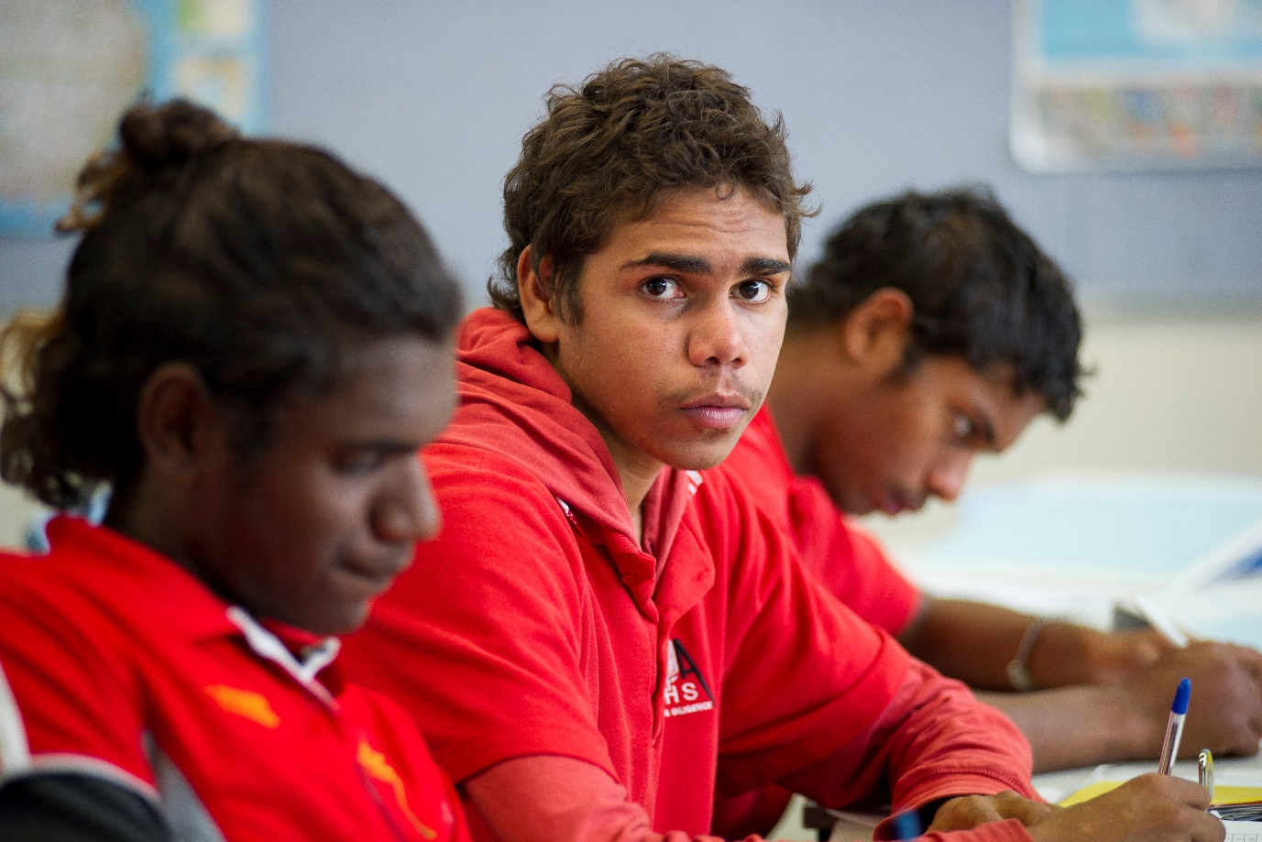

## 5. SUMMARY AND RESPONSE

### 5.1 Summary of Findings

Phase 1 of the Review has uncovered a number of gaps and areas that need addressing and that will be further considered during Phase 2 of the Review. It is clear that there is need for:

* better preparation for students and families, including preparation beginning earlier
* reducing the complexity of ABSTUDY administration
* ensuring the safety of students when travelling to and from school, including developing greater clarity on who is responsible for the care of the student when s/he is in transit
* recognition of the additional costs required both in school and in boarding to effectively support Aboriginal and Torres Strait Islander boarders from remote and very remote regions of Australia and articulation of where funding and policy responsibility for this lies
* better understanding of the effectiveness and cost of different boarding/school arrangements
* improved clarity around who should be playing what role in relation to engagement between family and community and boarding residences and schools, and
* development of family and community capacity in understanding and engaging in their children’s education and with boarding residences and schools.

### 5.2 Work Delivered

Following concerns raised during Phase 1 of the Review, DHS undertook immediate work to simplify the ABSTUDY claim process, including a verbal declaration and ‘claim early’ communication campaign.

Around 80 per cent of ABSTUDY claims are taken over the phone by DHS through a staff assisted claim process. Previously, an ABSTUDY claimant was required to return a signed customer declaration form to confirm that the information they provided over the phone is true and correct. Non-return of the declaration form by the claimant was one of the main reasons for claims not being completed.

From 28 November 2016, DHS replaced the requirement for a paper based signed declaration form with a verbal declaration taken over the phone. This streamlined process nearly halved claim processing times, with many claims now able to be completed over the phone.

The streamlined claim process was supported by a targeted communication campaign encouraging families to submit their ABSTUDY claims early to ensure support is in place for the beginning of the year. Information encouraging students to lodge their ABSTUDY claim as early as possible was provided on the DHS website, social media channels, through third parties such as schools and targeted radio advertising. The communication campaign resulted in more claims being made before the end of December, allowing more time for travel arrangements for students studying away from home and supporting students to start school on time.

DHS continues to offer the verbal declaration option and will continue its targeted communication campaign prior to the start of each school year.

A Media Release from 16 November 2017 published on the website of the Hon Alan Tudge MP, Minister for Human Services and relating to ABSTUDY claim processing and the verbal declaration process is at **Appendix B**.

### 5.3 Broader Initiatives

In addition to this PM&C is leading joint work across several agencies, and in consultation with a range of stakeholders, to identify strategies for addressing a number of the issues raised by Phase 1 of this Review, including:

* building the evidence and data on Aboriginal and Torres Strait Islander students in boarding
* improving the preparation of students and families for boarding
* identifying ways to simplify ABSTUDY administration for both schools and families
* better ensuring the safe travel of students, and
* improving the way support is accessed and used by families, communities and schools, so they can better assist students to get to school, have a positive boarding experience and stay engaged.

## Appendix A: ABSTUDY Benefits under Schooling B Award

A student approved for a Schooling B Award may be entitled to one or more of the following benefits:

* *Living Allowance* or *Pensioner Education Supplement (PES)*.
* *Rent Assistance* to assist in meeting the board and lodging expenses of eligible students and Australian apprentices.
* *Remote Area Allowance* to assist eligible students in meeting additional costs associated with residence in a remote area.
* *Pharmaceutical Allowance* to assist eligible ABSTUDY recipients who are temporarily incapacitated for study with the purchase of prescription medicines listed on the Pharmaceutical Benefit Scheme (PBS).
* *School Fees Allowance (Group 2)* to assist Aboriginal and Torres Strait Islander families to meet the costs of school fees levied by the approved education institution for the student. *School Fees Allowance* is paid directly to the education institution or as a reimbursement.
* *Away‑from‑Base* *assistance* for distance education/correspondence students to attend residential schools and for boarding students to attend school field trips. Assistance for approved *Away‑from‑Base* activities may include:
  + *Fares Allowance*;
  + *Meals Allowance*; and
  + *Accommodation Allowance*.
* *Fares Allowance* to cover the cost of specified travel for students (and their nominated travel supervisor) who need to live away from home to attend study.
* *Meals Allowance* and *Accommodation Allowance* to cover the cost of meals and accommodation associated with specified travel for students (and their nominated travel supervisor) who need to live away from home to attend study.
* *Incidentals Allowance* (where the student is 18 years or over at 1 January in the year of study), to assist students and Australian Apprentices to meet expenses associated with commencement of study in an approved course.
* *Under 16 Boarding Supplement* paid directly to eligible boarding schools with a significant number of Aboriginal and Torres Strait Islander enrolments, and to eligible student hostels. The supplement makes up for the shortfall in assistance for students under 16 years of age who receive a lower rate of ABSTUDY Living Allowance than those aged between 16 and 21 years.
* *Additional Assistance* to provide, in exceptional circumstances, financial benefit over and above ABSTUDY entitlements for students and Australian Apprentices who experience severe financial difficulties meeting associated education and training costs. *Additional Assistance* is intended to provide a safety net to reduce the risk of students or Australian Apprentices withdrawing from education or training.

## Appendix B: ABSTUDY Claim Processing Times Halved – Media Release

Media Release, 16 November 2017

**The Hon Alan Tudge MP – Minister for Human Services**

Indigenous students starting or continuing study or an apprenticeship in 2018 should lodge their ABSTUDY claim now for the new school year.

It is faster and easier than ever before to claim ABSTUDY. Results from our trial to streamline the ABSTUDY claim process this year saw around 14,000 students provide a verbal declaration over the phone instead of posting a signed declaration form.

This verbal declaration speeds up claims, especially for students living in remote areas. During the first two months of the trial, ABSTUDY claims finalised with the verbal declaration were processed nearly 50 percent faster than usual.

Previously, applicants who claimed over the phone still needed to sign and return a Customer Declaration Form to confirm the information they provided is true and correct before their ABSTUDY claim could be processed.

Due to the success of this trial and the very high take-up rate we have implemented this option permanently.

ABSTUDY payments help Indigenous students with the costs of studying or doing an Australian apprenticeship.

Claiming early is also important to ensure students have their claims finalised sooner which helps them plan for the school year by organising travel and school books.

Having payments in place before school starts is particularly important for students from remote areas who need to travel away from home to study.

Minister for Human Services Alan Tudge said the recent changes have simplified the ABSTUDY claim process, making it easier for students to claim.

“The Government is committed to supporting young Indigenous people, particularly those from remote communities, achieve better educational outcomes,” Minister Tudge said.

“We’ve streamlined processes and are working smarter to grant claims faster, so students are ready to travel and start school on time.

“The earlier students claim, the sooner applications can be processed and eligible students can have payments in place before the start of the school year.”

To claim ABSTUDY, students can call the department on FreecallTM**1800 132 317**. If students can’t claim over the phone, they can fill in a paper claim form.

## BIBLIOGRAPHY

Adermann J and Campbell MA, 2010. ‘Anxiety and Aboriginal and Torres Strait Islander young people’, in Purdie et al. (eds), *Working together: Aboriginal and Torres Strait Islander mental health and wellbeing.*[*http://aboriginal.telethonkids.org.au/media/54847/working_together_full_book.pdf*](http://aboriginal.telethonkids.org.au/media/54847/working_together_full_book.pdf)

AIEF, 2015. *AIEF Compendium of best practice for achieving successful outcomes with Indigenous students in Australian boarding schools.*

Appleyard, S, 2002. ‘Education issues facing Aboriginal families in rural Australia: A case study,’ *The Australian Journal of Indigenous Education, 30*(1), pp.25-41.

<http://search.informit.com.au/fullText;dn=226596545084991;res=IELIND>

Australian Government, 2012. *Cape York Welfare Reform Evaluation*. <https://www.dss.gov.au/sites/default/files/documents/03_2013/cywr_evaluation_report_v1.2_0.pdf>

Baills, L, & Rossi, T, 2001. ‘The transition from isolated, rural contexts to boarding school: can school physical education and sport play a role?’ *Journal of Physical Education New Zealand, 34(1)*, pp.40-52. Retrieved from <http://library.ecu.edu.au>.

Benveniste, T 2014*. Deciphering Distance: Exploring how Indigenous boarding schools facilitate and maintain relationships with remote families and communities.*

*Benveniste, T, Guenther J, Dawson, D, Rainbird, S, 2014. Out of Sight, Out of Mind? Bringing Indigenous Parent- Boarding School Communication to Light*, AARE-NZARE Conference, Brisbane, 2014

Benveniste, T, Disbray, S and Guenther, J, 2014. *A brief review of literature on boarding school education for Indigenous students and recent Australian media coverage of the issue.*

Beresford, Q, & Partington, G. (Ed.), 2003. *Reform and resistance in Aboriginal education: The Australian experience*. Crawley, WA: UWA Press.

Biddle, N, & Rogers, J, 2016. ‘*Stuck in the Middle: The effect of boarding schools for Aboriginal and Torres Strait Islander students*,’ *Submission 14 to HoRSCIA Inquiry into Educational Opportunities for Aboriginal and Torres Strait Islander Students*, [*http://www.aph.gov.au/Parliamentary_Business/Committees/House/Indigenous_Affairs/Educational_Opportunities/Submissions*](http://www.aph.gov.au/Parliamentary_Business/Committees/House/Indigenous_Affairs/Educational_Opportunities/Submissions)*.*

Bosch, C, 2015. *Parent and Family Engagement In Boarding School Contexts*, Australian Parents Council. <http://austparents.edu.au/2015/wp-content/uploads/APC_FINAL-REPORT_Parent-and-Family-Engagement-in-Boarding-Contexts_JUNE-2015.pdf>

Bramston, P, & Patrick, J, 2007. ‘Rural adolescents experiencing an urban transition,’ *Australian Journal of Rural Health, 15*(4), pp.247-251.

Broadbent, R & Papadopoulos, T, 2009. ‘Community education and youth mentoring: how to build good practice’, *Australian Journal of Adult Learning, vol. 49, no. 2*, pp.318-351.

Carrigg, J, 1994. ‘Bringing renewal to the boarding house: The Aquinas experience,’ *Independence,*

*19*(1), pp.11-14. Retrieved from <http://library.ecu.edu.au>

Catholic Education Commission, NSW, 2008. *Supporting Aboriginal Students being Schooled away from Home*,<http://www.cecnsw.catholic.edu.au/db_uploads/CEC_Submission_Supporting_Aboriginal_Students_living_away_from_home_Discussion_Paper_Updated.pdf>

Commonwealth of Australia, 2000. *Katu Kalpa - Report on the inquiry into the effectiveness of education and training programs for Indigenous Australians*. <http://www.aph.gov.au/Parliamentary_Business/Committees/Senate/Education_Employment_and_Workplace_Relations/Completed_inquiries/1999-02/indiged/index>

De Campo, J, 2010. *Across Two Worlds: Aboriginal and Torres Strait Islander students in Victorian Secondary Boarding Schools.* [*http://independence.realviewdigital.com/?iid=62625#folio=30*](http://independence.realviewdigital.com/?iid=62625#folio=30)

Deloitte Access Economics, 2012. *Youth transitions evidence base: 2012 update*. Australian

Government Department of Education, Employment and Workplace Relations.

Deloitte Access Economics, 2013. *Project Vale: Review Funding of Selected Indigenous Boarding Schools. (unpublished)*

Department of Education, Science and Training, 2007. *What Works. The Work Program: Core Issues 6: Boarding* <http://www.whatworks.edu.au/upload/1250832097332_file_6Boarding.pdf>

Dockery, 2017. *Culture, housing, remoteness and Aboriginal and Torres Strait Islander child development: Evidence from the Longitudinal Study of Indigenous Children* <http://apo.org.au/system/files/73490/apo-nid73490-40301.pdf>

Doecke, M, 2008a. ‘More than just teaching: Educating Indigenous young people from remote communities,’ *Teacher, 188*, pp.48-51. Retrieved from <http://library.ecu.edu.au>

Downs, J, 2001. *Coping with change: Adolescents’ experiences of transition to secondary and boarding school.* (Doctoral dissertation). <http://trove.nla.gov.au/work/35503242>

Doyle, L, & Hill, R, 2008. *Our children, our future - achieving improved primary and secondary*

*education outcomes for Indigenous students: An overview of investment opportunities and approaches.* The AMP Foundation, Effective Philanthropy, and Social Ventures Australia.<http://www.socialventures.com.au/wpcontent/uploads/2010/09/Our_Children_Our_Future.pdf>

Drew, N, Adams, Y, & Walker, R, 2010. ‘Issues in mental health assessment with Indigenous Australians’, Chapter 8 in *Working Together: Aboriginal and Torres Strait Islander Mental Health and Wellbeing Support, ed by Purdie, N, Dungeon, P and Roz Walker.* <http://aboriginal.telethonkids.org.au/media/54847/working_together_full_book.pdf>

Duncan, B J, 1990. ‘The integration of Aboriginal and Torres Strait Islander primary and secondary students within non-government boarding schools in Queensland,’ *Ngulaig* *Monograph, 2*, pp.1-17.

Gollan, S, & Malin, M, 2012. ‘Teachers and families working together to build stronger futures for

our children in school,’ in Beresford, Partington, & Gower (Eds.), *Reform and resistance in Aboriginal education: Fully revised edition* (pp.149-173). Crawley, WA: UWA Press.

Guenther, J, Milgate, G, Perrett, B, Benveniste, T, Osbourne, S, Disbray, S, 2016, Boarding Schools for Remote Aboriginal Learners in the Northern Territory. Smooth Transition or Rough Ride. AARE Conference, 2016

Hamilton, M, 2015. *Walking Together to Make a Difference, A case study of Worawa Aboriginal College*. <http://www.worawa.vic.edu.au/walking-together-to-make-a-difference/>

[Hatchell, H](http://researchrepository.murdoch.edu.au/view/author/Hatchell,%20Helen.html), 2003. Masculinities and whiteness: the shaping of adolescent male students' subjectivities in an Australian boys' school. PhD thesis, Murdoch University. <http://researchrepository.murdoch.edu.au/69/>

Higgins, D, & Morley, S, 2014. *Engaging Indigenous parents in their children’s education*, Resource

sheet no. 32 produced by the Closing the Gap Clearinghouse. Canberra: Australian Government. <http://www.aihw.gov.au/WorkArea/DownloadAsset.aspx?id=60129548210>

Hodges, J, Sheffield, J, & Ralph, A, 2013. ‘Home away from home? Boarding in Australian schools,’ *Australian Journal of Education, 57(1)*, p.32.

HoRSCIA, 2016. *Inquiry into the Educational Opportunities for Aboriginal and Torres Strait Islander Students,*<http://www.aph.gov.au/Parliamentary_Business/Committees/House/Indigenous_Affairs/Educational_Opportunities>

The Human Rights and Equal Opportunity Commission (HREOC), 1999. *The National Inquiry into Rural and Remote Education*. <https://www.humanrights.gov.au/our-work/rights-and-freedoms/projects/rural-and-remote-education-inquiry>

Independent Schools Council of Australia website, <http://isca.edu.au/about-independent-schools/the-school-funding-partnership/>

Isolated Children’s Parents’ Association, 2016. *Boarding School Survey Results, April 2016,* [*http://www.icpa.com.au/documents/download/1021/federal-icpa-portfolios/federal-boarding-portfolio/boarding-school-survey-results-april-2016.pdf*](http://www.icpa.com.au/documents/download/1021/federal-icpa-portfolios/federal-boarding-portfolio/boarding-school-survey-results-april-2016.pdf)

Jensen, B, 2014. *Turning Around Schools: It Can Be Don*e, <http://grattan.edu.au/wp-content/uploads/2014/04/805-turning-around-schools.pdf>

Long, M, Frigo T & Batten, M, 1998. *The School to Work Transition of Indigenous Australians, A Review of the Literature and Statistical Analysis.* <http://research.acer.edu.au/cgi/viewcontent.cgi?article=1012&context=indigenous_education>

Lonsdale, M et al 2011. *Evaluation of the Sporting Chance Program for Department of Education, Employment and Workplace Relations*, Australian Council for Educational Research, Camberwell, Victoria.

McCalman, J et al, 2016. *Psycho-social resilience, vulnerability and suicide prevention: impact evaluation of a mentoring approach to modify suicide risk for remote Indigenous Australian students at boarding school, BMC Public Health*, Volume: 16, Issue: 2016, pp.1-12. <https://www.ncbi.nlm.nih.gov/pmc/articles/PMC4736696/>

Mander, D, 2012. *The Transition Experience to Boarding School for Male Aboriginal Secondary School Students from Regional and Remote Communities across Western Australia*, Edith Cowan University, Western Australia. <http://ro.ecu.edu.au/cgi/viewcontent.cgi?article=1522&context=theses>

Mander, D. J., Lester, L & Cross, D 2015. "The social and emotional well-being and mental health implications for adolescents transitioning to secondary boarding school." International Journal of Child and Adolescent Health, 8(2): 131.

Mander, D. J. 2015. Enabling Voice: Aboriginal Parents, Experiences and Perceptions of Sending a Child to Boarding School in Western Australia. The Australian Journal of Indigenous Education, 44 (Special Issue 02), 173-183.

MCEETYA Taskforce on Indigenous Education, 2001. *Exploring multiple pathways for Indigenous Australian students*, Discussion paper, Melbourne. <http://www.scseec.edu.au/site/DefaultSite/filesystem/documents/Reports%20and%20publications/Publications/Cultural%20inclusion%20and%20ATSI/Exploring%20multiple%20pathways%20for%20Indigenous%20Students-Discussion%20paper.pdf>

Mellor, S, & Corrigan, M, 2004. *The case for change: A review of contemporary research on Indigenous education outcomes*. Camberwell, Victoria: Australian Council for EducationalResearch Press. <http://research.acer.edu.au/aer/7>

Mills, M, & McGregor, G, 2016. *Engaging students in engaging schools: Lessons from*

*Queensland’s alternative education sector*. Brisbane: YANQ. <http://www.yanq.org.au/uploads/1/4/1/7/14174316/engaging_students_in_engaging_schools.pdf>

Muller, D, 2012. *Parents as Partners in Indigenous Children’s Learning*. Family-School and Community Partnerships Bureau: Canberra.

O’Bryan, M, December 2016. *Shaping futures, shaping lives: an investigation into the lived experience of Aboriginal and Torres Strait Islander students in Australian boarding schools*, PhD Thesis, Melbourne Graduate School of Education, University of Melbourne, [*https://minerva-access.unimelb.edu.au/handle/11343/190477?show=full*](https://minerva-access.unimelb.edu.au/handle/11343/190477?show=full)

Ockenden, L, 2014. *Positive learning environments for Indigenous children and young people*, Resource sheet no. 33 produced by the Closing the Gap Clearinghouse July 2014.

Otero, G, 2012. *Rural Communities Education for the 21st Century*. Flinders University, Adelaide: Sidney Myer Rural Lecture.

Queensland Indigenous Education Consultative Body, 2004. *Position Paper - Boarding Schools*. <http://qiecc.eq.edu.au/files/3014/1297/4201/QIECB_Position_Paper_-_Boarding_Schools.pdf>

Stewart, R, 2015. ‘Transition from Remote Indigenous Community to Boarding School: The Lockhart River Experience,’ *UNESCO Observatory Multi-Disciplinary Journal in the Arts, 4(1)*, pp.1-18.

Stokes, H. & Turnbull, M, 2016. Evaluation of the Berry Street Education Model: Trauma informed positive education enacted in mainstream schools. Melbourne, VIC: University of Melbourne Graduate School of Education, Youth Research Centre, <http://education.unimelb.edu.au/__data/assets/pdf_file/0007/1962718/User_croftsj_Stokes_26_Turnbull_Final_Web_18-5-16.pdf>

Taylor, J, 2010. *Demography as Destiny: Schooling, Work and Aboriginal Population Change at Wadeye*. <http://caepr.anu.edu.au/sites/default/files/Publications/WP/CAEPRWP64.pdf>

Wilson, B, 2014. *A Share in the Future: Review of Indigenous Education in the Northern Territory* <https://www.humanrights.gov.au/sites/default/files/57.3%20%20Review%20of%20Indigenous%20Education%20in%20the%20Northern%20Territory.pdf>

1. Secondary education refers to Years 7 to 12 in the [Australian Capital T](https://aeaguide.education.gov.au/content/f2-glossary#glossary-act-889)erritory, New South Wales, Northern Territory, Queensland, Tasmania, Victoria and Western Australia, and Years 8 to 12 in South Australia.
2. KPMG, 2016, p.7.
3. Department of Social Services Portfolio Budget Statement 2016–17.
4. AIEF, 2010; DEST, 2008; DET 2008; Mander, 2012; MCEETYA, 2001; Queensland Education Consultative Body, 2004; and Wilson, 2014.
5. Wilson, 2014, p.148.
6. Personal interview with Indigenous community group, 1 September 2016.
7. Personal interview with boarding school/provider, 31 August 2016.
8. Some hostels and residential colleges are Aboriginal and Torres Strait Islander focused such as AFL Cape York House and NRL Cowboys House.
9. Mander, Lester and Cross, 2015, p.131
10. The large majority of non-Indigenous households have internet connections while less than half (41%) of all Indigenous households and only 18% of very remote Indigenous households are connected – Wilson, 2014, p.44.
11. Mander, 2012.
12. A school that offers residential support for 50 or more Aboriginal and Torres Strait Islander students from remote Australia or whose composition of boarding students consists of 50 per cent or more of Aboriginal and Torres Strait Islander students from remote Australia.
13. Independent Schools Council of Australia, <http://isca.edu.au/about-independent-schools/the-school-funding-partnership/>
14. Mills and McGregor, 2016, p.4.
15. Adermann and Campbell, 2010; AIEF, 2016; Mander, 2012; Ockenden, 2014; and Zubrick et al., 2006.
16. Mander, 2012; and MCEETYA, 2001.
17. A M Docker, 2017.
18. Hatchell, 2003; and Mander 2012.
19. AIEF, 2015; Beresford, Partington, & Gower, 2012; Byrne & Munns, 2012; Mander, 2012; Nelson & Hay, 2010; and Ockenden, 2014.
20. Appleyard, 2002; Beresford, Partington, & Gower, 2012; Mander, 2012; and Prout, 2008.
21. Stokes & Turnbull, 2016.
22. McCalman et al, 2016; and Catholic Education Commission, 2008.
23. Broadbent & Papadopoulos, 2009; and McCalman et al, 2016.
24. McCalman et al, 2016; and Forrest Review, 2015.
25. AIEF, 2016; Catholic Education Commission, 2008; Queensland Indigenous Education Consultative Body (QIECB), 2004; and DEST, 2007.
26. DEST, 2007; and AIEF, 2016.
27. Benveniste, 2014; Beresford, Partington, & Gower, 2012.
28. Higgins & Morley, 2014, p.1.
29. KPMG, 2016.
30. Mander, 2015.
31. HREOC, 2000, Mander, 2015.
32. Mander, 2012.
33. Mander, 2012, p.196.
34. Beresford, Partington, & Gower, 2012; Duncan, 1990; and Wilson, 2014.
35. Beresford & Partington, 2003; and Gray & Beresford, 2001.
36. KPMG, 2016; Deloitte, 2013.
37. Benveniste, 2014.
38. O’Bryan, 2017.
39. The highest incidences of missed ABSTUDY supported travel occur after a school vacation.
40. AIEF, 2015; Bosch, 2015; DEST, 2007; Muller, 2012; and Stewart, 2015.