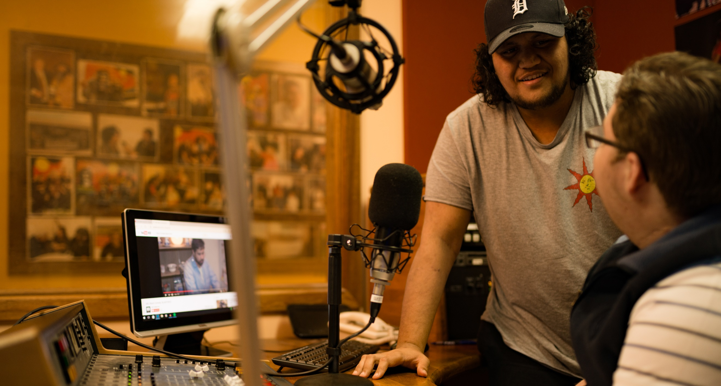

More than radio – a community asset
Social Return on Investment (SROI) analyses of Indigenous Broadcasting Services

Umeewarra Media (Umeewarra)

Insights
- Umeewarra’s Indigenous Broadcasting Service and associated media activities are forecast to generate significant social, economic and cultural outcomes for a broad range of stakeholders including employees, community, and Government.
- Umeewarra provides an essential service that strengthens community. By providing a trusted communication platform, Umeewarra keeps the Aboriginal community of Port Augusta and surrounding towns connected and informed about issues that matter to them. Its activities not only serve community communication needs but also strengthens their connectivity and resilience and are highly valued by stakeholders.
- Umeewarra cultivates a culturally safe space, both on air and at their studios, where the Aboriginal community feel they belong. This enables them to support the community to connect to one another, to those they’ve lost touch with and to social services, as well as to support them through grief and into employment.
- Umeewarra has built the community’s trust through more than 30 years of operation, which allows it to have the impact it does for the community. That trust is enabled by Umeewarra being an Aboriginal owned and operated organisation, and being an active member of, and responsive to, the needs of the community.

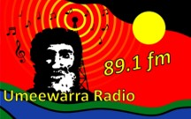
“It (Umeewarra radio) validates your own stories… It makes you know you’re not alone and that makes you feel empowered.”
-Traditional Owner and radio listener, Port Augusta

About Umeewarra

Port Augusta is a community of 6,500 people, 19% of whom identify as Aboriginal.
Traditionally a meeting place for Aboriginal people, Port Augusta is still home to over 35 language groups, including a great number from the Anangu Pitjantjatjara Yankunytjatjara lands.
Umeewarra Media at a glance
Broadcasting range: 150 km²
Total income (FY17): $382,000
IAS funding (FY17): $323,000
Estimated audience size: 15,000
Employees (FY17): 3 employees, _ and 25 volunteers

Umeewarra Aboriginal Media Association, or Umeewarra Radio
89.1 FM, is based in Port Augusta and was set up in 1987. Umeewarra broadcasts to the community of Port Augusta as well as to the Aboriginal communities in Davenport, Whyalla and Port Pirie.
The Aboriginal and non-Aboriginal people of Port Augusta have endured a fractious relationship over the years, so Umeewarra plays an important role in bringing people together. Umeewarra is now one of only two Aboriginal community controlled organisations in Port Augusta, down from at least 10 in the 1980s. Umeewarra produces radio and community education campaigns and provide a range of community services.

Impact of Umeewarra
In the three year period covered by this SROI analysis, Umeewarra is projected to generate substantial outcomes across four key areas: providing a communication medium, strengthening community, strengthening culture and facilitating meaningful employment and participation. These outcomes will be generated for listeners and community members, employees and volunteers, Aboriginal people employed by other organisations in Port Augusta and the Government.
The most significant outcomes for listeners and the community are that their community and cultures are strengthened through Umeewarra’s activities. Umeewarra does this in part by providing a strong, safe place where Aboriginal people feel they belong. Community is also strengthened through being informed about issues that matter to them and by being able to tune in and hear positive stories and music about Aboriginal people. Non-Aboriginal community members also experience value in being brought together for events, including during NAIDOC week, through which Umeewarra plays an important role in the reconciliation of a fractured community. Government benefits from the resultant strengthened community cohesion, and from the community having an increased awareness of public health and safety messages through Umeewarra’s effective communication of these messages.
For employees and volunteers, Umeewarra creates employment and volunteer opportunities which are aligned with their interests and supports people in those roles with training. Umeewarra also helps connect Aboriginal people to employment with other organisations through their Job Watch radio segment.
Financial proxies have been used to approximate the value of these outcomes. The social, economic and cultural value associated with the outcomes is forecast to be $5m for FY18-20. During this period, $1.2m is forecast to be invested in Umeewarra, with most (78 per cent) coming from the Department of the Prime Minister Cabinet (PM&C) through the Indigenous Advancement Strategy.
Forecast value of Umeewarra outcomes generated by stakeholder group, FY18-20
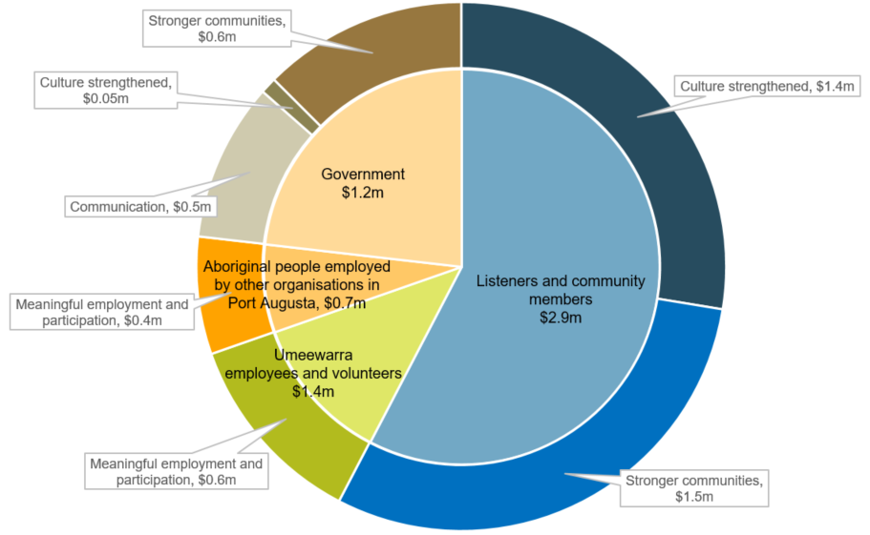
Umeewarra is forecast to deliver an SROI ratio of 4.3:1 from July 2017 to June 2020.
That is, for every $1 invested, approximately $4.30 of social, economic and cultural value will be created for stakeholders.

About this project

PM&C commissioned Social Ventures Australia Consulting to understand, estimate and value the changes expected to be achieved through the investment in Umeewarra’s activities from FY18-20. This analysis is part of a broader project that considers three Indigenous Broadcasting Services across Australia including PAW in the Northern Territory and Gadigal Information Services (Koori Radio) in New South Wales. The SROI methodology was used to complete each of these analyses.
This analysis involved 21 consultations with stakeholders of Umeewarra (this included employees and volunteers, listeners and community members) and community service organisations. Interviews were conducted in May 2017.
The broader project involved 79 stakeholder consultations and an Indigenous broadcasting sector survey. Further detail in relation to the methodology applied and the findings of the analysis are set out in the full report, More than radio – a community asset: Social Return on Investment analyses of Indigenous Broadcasting Services, and corresponding methodological attachment.

For more information about Umeewarra, or for a copy of the full report, contact:

Vincent Coulthard, CEO

Umeewarra Aboriginal Media Association

E: vince@umeewarramedia.com

For more information on the Government’s funding of Indigenous Broadcasting Services, contact:

Culture and Capability Programme

T: 02 6271 6000 (request to speak with the Broadcasting, Interpreting and Telecommunications team)

E: CultureandCapabilityProgramme@pmc.gov.au

