Indigenous job-ready staff available!
Employment
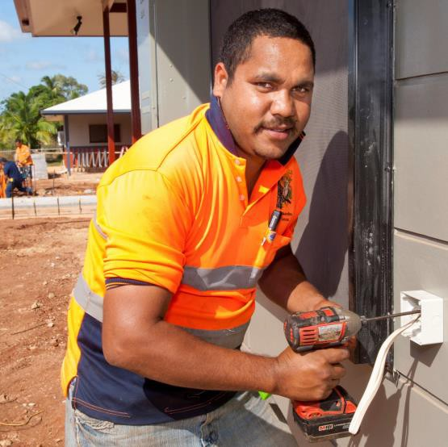
Are you an employer looking for Indigenous staff?
Vocational Training and Employment Centres (VTECs) will help find the right person for you.
VTECs identify committed Indigenous job seekers to be trained for a specific job guaranteed by you for 26 weeks.
A VTEC will support you and your new employee
throughout the process.
VTEC’s access to committed Indigenous job seekers and
job-specific training offers employers an effective recruitment alternative:
- you select the employee
- you determine the training needed
- no VTEC fees – value for money.
Job training for a guaranteed job, with great support.

How does it work?
The VTEC will work closely with you to deliver training and support for the employee that is specific to the job. You guarantee a job for at least 26 weeks upon the job seeker’s successful completion of their training.
VTECs support the job seeker with any difficulties they have and work with employers to make the placement a success. Job seeker support could include:
- machinery/drivers licences or tickets
- reading and writing
- work experience and mentorship
- certificate or diploma courses.

Get in touch!
There is a local VTEC near you. Get in touch today to find Indigenous job-ready staff. Visit www.niaa.gov.au/vtec.

