Guaranteed jobs available!
Employment

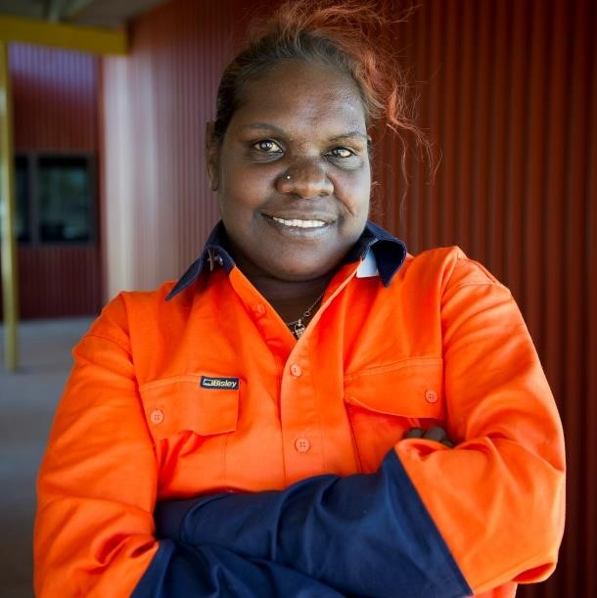
Are you a committed job seeker?
Vocational Training and Employment Centres (VTEC) have a job for you.
You can get support before you start a guaranteed job, so you can be confident to start and succeed in your new job.
If you are an Indigenous job seeker or school leaver then you can get help with:
- a guaranteed job for 26 weeks
- support to prepare you for a job and long-term employment
- mentoring and support once you are in the job.
VTECs will help you find a job, prepare you for work, and support you to stay in that job!

How does it work?
A VTEC will work with you to identify what you need to start a new job. They will help you with any difficulties you may have and support you into the job when you’re ready.
Once you’re in the job, the VTEC will work with you and your employer for the first 26 weeks of your new job to make sure you get the best possible start.
You get a guaranteed job in return for successfully preparing for that job. You could receive support to:
- get a driver’s licence, or some other licence or ticket
- improve your reading and writing
- gain work experience
- study for a certificate or diploma
- get other practical support.

Get in touch!
There is a local VTEC near you. Get in touch today and get help to prepare for your new job. Visit www.niaa.gov.au/vtec.

