Indigenous Procurement Policy Reporting Solution (IPPRS)

Welcome pack for Commonwealth agencies

IAG Systems Capability Branch & Economic Policy Branch

IAG Business Transformation Office & Community and Economic Development Division

table of Contents

[table of Contents 2](#_Toc505166960)

[Overview 3](#_Toc505166961)

[Purpose 3](#_Toc505166962)

[Background 3](#_Toc505166963)

[System requirements 3](#_Toc505166964)

[Getting Started 4](#_Toc505166965)

[Setting up a User ID and Password 4](#_Toc505166966)

[What you need to login 5](#_Toc505166967)

[Logging In 6](#_Toc505166968)

[Basic Navigation 9](#_Toc505166969)

[The Landing Page/Dashboard 9](#_Toc505166970)

[Contract Information Screen 10](#_Toc505166971)

[The Command Bar 11](#_Toc505166972)

[The Header 11](#_Toc505166973)

[Process 11](#_Toc505166974)

[Body 11](#_Toc505166975)

[Footer 12](#_Toc505166976)

[Support 12](#_Toc505166977)

[APPENDIX A Example MMR Reporting obligations email 13](#_Toc505166978)

# Overview

## Purpose

The purpose of this pack is to help you get started with the Indigenous Procurement Policy Reporting Solution (IPPRS)

This document gives you an overview of:

* system requirements
* how to get started
* how to login
* basic navigation
* where to get support
* useful Links.

## Background

The IPPRS gives Commonwealth agencies and industry contractors the ability to more efficiently and accurately manage and report their obligations, as mandated by the Indigenous Procurement Policy ([IPP](https://www.pmc.gov.au/resource-centre/government/commonwealth-indigenous-procurement-policy)).

# System requirements

The Indigenous Procurement Policy Reporting Solution (IPPRS) is a Microsoft Dynamics 365 web application and is accessible via a web browser. However, the preferred browser to use is Google Chrome. The application is supported by a recommended set of desktop operating system / web browser combinations. The following table describes the Windows and Internet Explorer or Microsoft Edge versions supported for use with the Microsoft Dynamics 365 web application:

| Windows Version | Internet Explorer 10 | Internet Explorer 11 | Microsoft Edge |
| --- | --- | --- | --- |
| Windows 10 | Not supported | Supported | Supported |
| Windows 8.1 | Not supported | Supported | Not supported |
| Windows 8 | Supported | Not Supported | Not Supported |
| Windows 7 | Supported | Supported | Not Supported |

Table 1: Windows and Internet Explorer or Microsoft Edge supported versions

In addition to the above, Microsoft Dynamics 365 web applications can also operate in any of the following web browsers running on the specified operating systems:

* Mozilla Firefox (latest publicly released version) running on Windows 10, Windows 8.1, Windows 8, or Windows 7
* Google Chrome (latest publicly released version) running on Windows 10, Windows 8.1, Windows 8, Windows 7, or [AndroID](https://technet.microsoft.com/en-us/library/dn531131.aspx" \l "BKMK_Nexus) 10 tablet
* Apple Safari (latest publicly released version) running on Mac OS X 10.8 (Mountain Lion), 10.9 (Mavericks), 10.10 (Yosemite), or [Apple iPad](https://technet.microsoft.com/en-us/library/dn531131.aspx#BKMK_iPad)

Ensure that your desktop Standard Operating Environment (SOE) operating system / web browser combination meets the above requirements.

# Getting Started

## Setting up a User ID and Password

The PM&C IPP Business Administrator sets up all nominated users in Office 365. These are the key contacts sent to the PM&C IPP Team by each agency. Once a user is set up, they are automatically sent an email with their user ID and asked to set up a password:

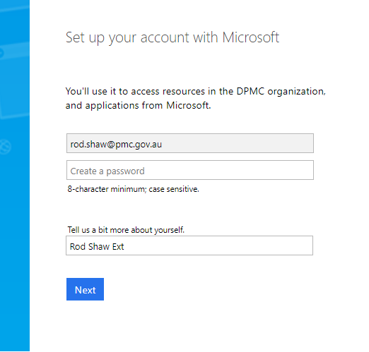

Figure 1: Example Email from Office 365

Follow the prompts to set your account.

When the account is set up with a password, the IPPRS system will generate a Welcome email:

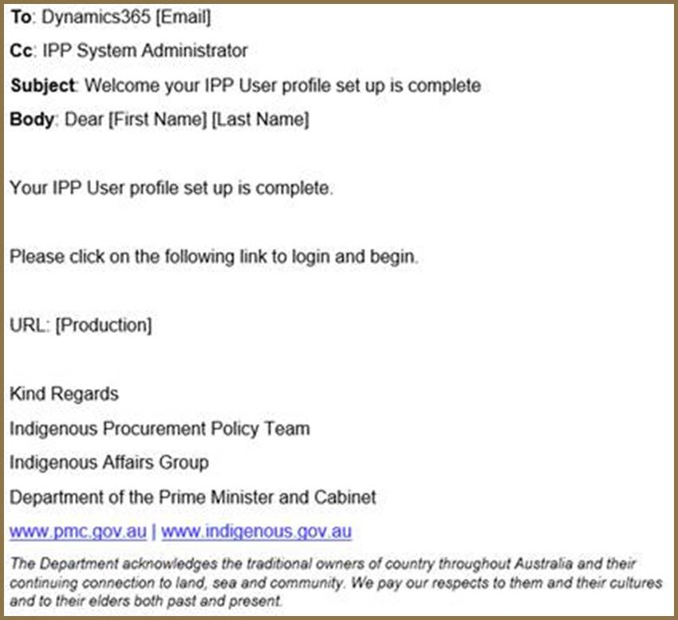

Figure 2: Example Welcome Email from IPPRS

## What you need to login

There are three different roles set up for Commonwealth agency users:

* IPP Portfolio Manager
* IPP Agency Manager
* IPP Contractor Manager
* a new role for Defence

***NOTE:*** The landing page, presented on login will vary slightly depending on the user role. The IPP Portfolio Manager is used as an example in this document.

To get started you need to have:

* The URL to take you to the portal  
  This is included in the welcome email sent by IPPRS.
* User ID   
  This will be an email from Office 365.
* Password  
  This is the password setup by the user as prompted by Office 365 to set up their account.

## Logging In

When logging in for the first time, please follow these instructions.

| **Step No.** | **Action** |
| --- | --- |
| 1 | Enter the URL shown in the Welcome email, into your Web browser. The Microsoft Sign In window is displayed:    This screenshot displays the Microsoft sign in screen.  Figure 3: Microsoft Sign in window  Enter your email address (user ID) and click NEXT. |
| 2 | The Microsoft window is displayed, prompting for your password:  This screen shot displays the Microsoft screen requesting a user enter their password.  Figure 4: Microsoft Enter password window  Enter your password and click Sign in. The password is the password you entered when you were prompted by the “Set up your account with Microsoft”. |
| 3 | The Microsoft Stay signed in window is displayed:  This screen shot displays a dialog box asking if the user would like to stay signed in to prevent having to login each time.  Figure 5: Microsoft Stay signed in window  Click YES. This will prevent you from being timed out during the day. |
| 4 | The Office 365 screen is displayed, showing the applications you have access to:  This screen shot displays the dashboard of Office 365.  Figure 6: Office 365 Hello Screen  Click on Dynamics 365. |
| 5 | The IPPRS Landing page is displayed:  This screen shot displays the IPP Reporting Solution dashboard.  Figure 7: IPPRS Landing Page  You have now logged in. |

# Basic Navigation

On successful login to IPPRS the landing page or dashboard is displayed:

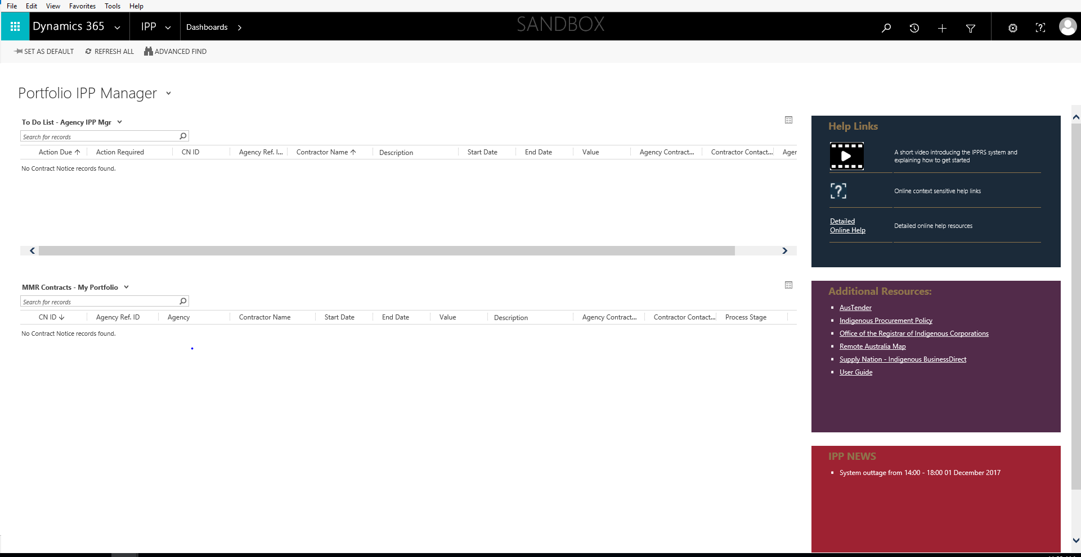

Figure 8: IPPRS Landing Page

## The Landing Page/Dashboard

The Landing Page or Dashboard, consists of the following components:

|  |  |
| --- | --- |
| **Navigation Bar** | |
| This is a screen shot of the IPP Reporting Solution navigation bar. | |
| This section of the Navigation Bar provides several icons: In Order: Search Recently Viewed Items The plus sign is not used Advanced Search Settings Online Help • User Profile | This section of the Navigation Bar provides several icons:  In Order:   * Search * Recently Viewed Items * + - Not Used * Advanced Search * Settings * Online Help * User Profile |
| **To Do List** | |
| This screen shot shows the users To Do List. | This list shows you all the items you need to action. |
| **MMR Contracts** | |
| This screen shot shows the MMR Contract list assigned to the user. | This list displays all the MMR contracts that belong to your agency. |
| **Resource Panes** | |
| This screen shot shows the resources availiable to a user in the side panel. | This pane displays the help links available.  This is where you can access the online help! |
| This screen shot shows the additional resources availiable to a user in the side panel. | This pane has several links to useful information. |
| This screen shot displays any IPP news items such as system outages. | Any news that you should be aware of is displayed here. |

## Contract Information Screen

From the Landing Page, double click on a contract to have the Contract Information screen displayed:

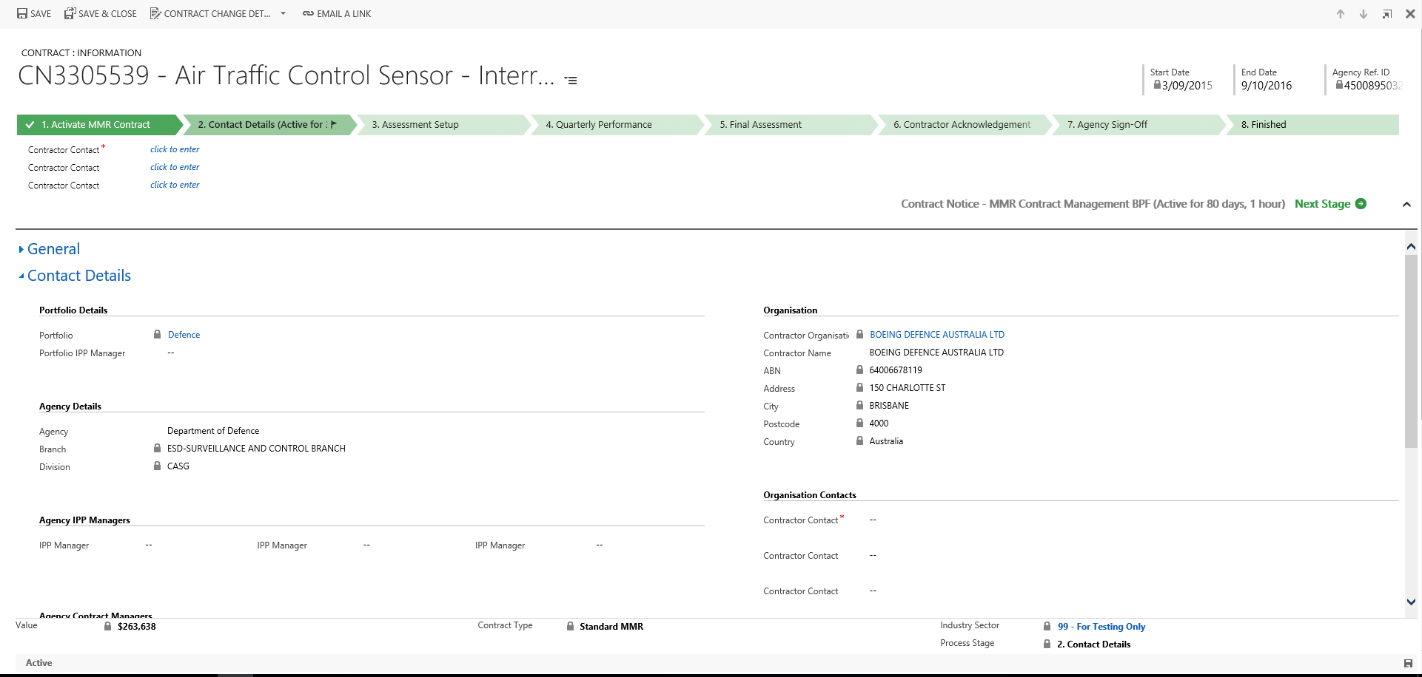

Figure 9: Contract Information

The Contract Information screen consists of five sections:

* The Command Bar
* The Header
* Process
* Body
* Footer.

### The Command Bar

The Command Bar allows you to Save and ‘Save and Close’ the contract. You can also change the Contract Change Details and email a link to the contract using Outlook:



Figure 10: The Command Bar

### The Header

The Header displays the Contract No, who the contract is with, the Start and End Date and the Agency Reference no. as shown below:



Figure 11: Contract Header

### Process

The Process section displays where the contract is in the workflow, shown in Chevrons.



Figure 12: Process Flow

Important to note in this section is the An screen shot displaying what the next stage icon looks like.button. Use this to move through the workflow.

### Body

The Body section gives you access to several parts of the contract:

* General Information
* Contract Details
* Assessment Setup
* Quarterly Performance Reports
* Final Assessment
* IPP Documents and Emails
* Variations.
* Administration

These sections can be expanded and collapsed by clicking the arrows beside the headings as shown below:

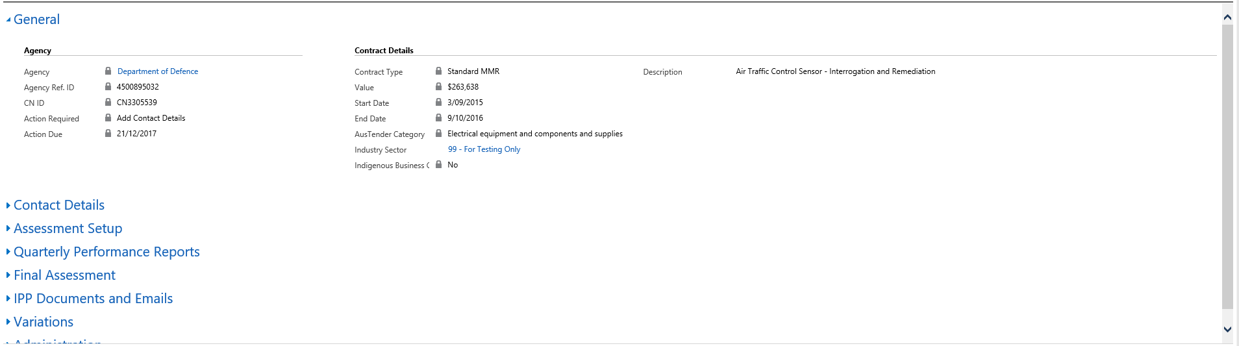

Figure 13: Contract Body

### Footer

The footer displays the value of the contract, the contract type, the industry sector of the contract and the process stage the contract is, as shown below:

The Process section shows where the contract is in the workflow.

This screen shot shows an example of a footer within a contract.

Figure 14: Contract Footer

# Support

The IPPRS contains extensive online help which includes FAQ’s.

In addition, support is available through:

Email: [IPPRS@pmc.gov.au](mailto:IPPRS@pmc.gov.au)

Email requests received prior to noon (12pm) each working day will be answered that working day.

Email requests received after 12pm each day will be answered by 12pm the following working day.

Telephone: 02 6152 3522

8am to 5pm Monday to Friday AEDT

# APPENDIX A Example MMR Reporting obligations email

The following is an example email that is automatically generated by IPPRS when an Agency IPP Manager allocates a Contract Manager.

|  |
| --- |
| Dear Agency Contract Manager  You have been assigned as the Agency Contract Manager for the following contract with Mandatory Minimum Requirements for Indigenous participation (MMR) -   Contract ID:   CN3407587  Agency Ref ID: 4500122916  Contractor:    Jones Lang LaSalle VIC Pty Ltd  Description:   Property Lease  Duration:      1/03/2017 - 1/03/2022  Value:         $18,556,773  Under the MMR, the Contractor is required to report quarterly on information about the Indigenous workforce and/or supply chain outcomes for this contract or for the contractor organisation.  Please use the link below to log in to the IPP Portal. The portal will allow you to enter contract assessment information and nominate the contact within the contractor organisation responsible for providing quarterly performance reporting on the contractor’s Indigenous employment and/or supply chain outcomes.   <https://ipptest.crm6.dynamics.com:443/main.aspx?etc=10085&id=8576eb16-2a89-e711-8154-e0071b662bb1&histKey=593598117&newWindow=true&pagetype=entityrecord>  Please contact your Agency IPP Managers if you have any queries regarding MMR reporting -  Fiona Shaw  [fiona.shaw@pmc.gov.au](mailto:fiona.shaw@pmc.gov.au) |

Figure 15: Example Contract Manager Email