Closing the Gap
Prime Minister’s Report 2017
As a nation we will walk side by side with Aboriginal and Torres Strait Islander people on the journey of recognition and reconciliation, to build a promising future for all.

Closing the Gap Prime Minister’s Report 2017
© Commonwealth of Australia 2017
978-1-925238-13-8 (Hardcopy)
978-1-925238-14-5 (PDF)
978-1-925238-15-2 (HTML)
978-1-925238-16-9 (DOCX)
Copyright Notice
With the exception of the Commonwealth Coat of Arms, this work is licensed under a Creative
Commons Attribution 3.0 Australia licence (CC BY 3.0)
(http://creativecommons.org/licenses/by/3.0/au/deed.en).
Attribution
This publication should be attributed as follows: Commonwealth of Australia, Department of the Prime Minister and Cabinet, Closing the Gap Prime Minister’s Report 2017.
Third party copyright
Wherever a third party holds copyright in this material, the copyright remains with that party.
Their permission may be required to use the material. Please contact them directly.
Use of the Coat of Arms
The terms under which the Coat of Arms can be used are detailed on the following website: http://www.dpmc.gov.au/government/its-honour
Please be aware that this report may contain images of Aboriginal and Torres Strait Islander people who have passed away.

PRIME MINISTER'S INTRODUCTION
Working with Aboriginal and Torres Strait Islander people for a better Australia.
“It is clear that Closing the Gap is a national responsibility that belongs with every Australian. Ending the disparity is complex and challenging. This will not lessen our resolve or diminish our efforts, even when some problems seem intractable and targets elusive.”
– The Hon Malcolm Turnbull MP, Prime Minister of Australia
This year we mark important milestones in the relationship between Aboriginal and Torres Strait Islander people and the Australian Government.
It is 50 years since the 1967 Referendum which saw Australians overwhelmingly agree the Commonwealth had a duty to make laws to benefit our First Australians.
The past year saw the 50th anniversary of the Wave Hill Walk Off, in which Gurindji people petitioned the Governor-General for the return of some of their traditional land, and the 40th anniversary of the passage of Aboriginal land rights legislation for the Northern Territory.
In June last year I was honoured to hand the title deeds for some 52,000 hectares of land on the Cox Peninsula near Darwin to the Larrakia people as part of the Kenbi land claim settlement. Theirs is a story that epitomises the survival and resilience of our First Australians, and of the Larrakia people.
This ninth Closing the Gap report showcases real successes being achieved across the country— by individuals, communities, organisations and government.
For example, in response to the Prison to Work Report, we are collaborating nationally to explore ways to support reintegration of Indigenous prisoners into communities, address the barriers to employment and improve the coordination of services across and within all jurisdictions.
We have taken great strides in progressing financial independence for Indigenous Australians through the Commonwealth’s Indigenous Procurement Policy. In its first year, 493 Indigenous businesses were awarded $284.2 million in Commonwealth contracts. State and territory governments have agreed to explore similar policies in their own jurisdictions and the Indigenous business sector will continue to grow.
While we celebrate the successes we cannot shy away from the stark reality that we are not seeing sufficient national progress on the Closing the Gap targets. While many successes are being achieved locally, as a nation, we are only on track to meet one of the seven Closing the Gap targets this year. Although we are not on track to meet the ambitious targets we have set, we must stay the course.
We will continue to focus on key priorities – from preconception and the early years through school, providing a positive start to life, which of course opens opportunities for further study and employment.
The high rates of suicide and disproportionately high rates of incarceration among our First Australians are issues that all governments, in partnership with community, need to work tirelessly to resolve.
We have listened to calls from the community. We will not shy away from our goal of supporting equal opportunity for First Australians. This is our national responsibility. Our commitment to the end goal will not waiver, but we must do things differently. We must build on what is working, and change what isn’t working.
Twelve months ago, when I tabled my first Closing the Gap report in Parliament, I made a commitment that my Government would do things with Aboriginal and Torres Strait Islander people, not do things to them and I am pleased to say we have made some real gains in that regard.
We are building a new way of working together with Indigenous leaders and their communities to create local solutions—putting Aboriginal and Torres Strait Islander people at the centre of decision-making in their regions.
As I have said before, our greatest strides in Closing the Gap will come when we work together—all levels of government, business and the community.
The Empowered Communities model is now in eight regions across the country, in addition to other local decision-making models such as the Murdi Paaki Regional Assembly in western New South Wales. Over the coming year we will continue to build the capacity and capability of communities and government to truly engage with each other and to jointly make informed decisions.
As part of the Government’s commitment to enable Indigenous leaders to develop local solutions, we have a responsibility to measure the success or otherwise of our policies and programs, and adjust where needed. And sharing this knowledge and evidence with communities enables local decision-making. We need to be patient and acknowledge that these things take time – but we are determined to get it right.
We must also recognise culture as paramount to finding solutions that respect, acknowledge and support identity.
We are on a path of an ambitious reform agenda for Indigenous affairs. Changing the way in which Governments work together, and with communities to deliver better outcomes.
I am heartened that we have bipartisan support to improve the wellbeing of our First Australians, and that the Council of Australian Governments (COAG) has recently agreed to work together, and with Indigenous Australians, to refresh the Closing the Gap agenda, emphasising collaboration and acknowledging that one size does not fit all.
With the tenth anniversary of Closing the Gap approaching in 2018, it is timely to look at what we have learned. What has worked and where we need to focus efforts to drive greater change. Over the decade there has been greater collaboration and national focus on Indigenous outcomes than ever before. This will continue, this must continue.
Last year, as part of my commitment to bring Indigenous Affairs to the forefront of government, I established the Indigenous Policy Committee of Cabinet. The Committee will support better engagement with Cabinet Ministers, their portfolios and Aboriginal and Torres Strait Islander people, including through collaboration with the Indigenous Advisory Council.
With the term of the inaugural Prime Minister’s Indigenous Advisory Council having recently ended, I take this opportunity to thank all Council members for their hard work and dedication to improving the lives of Australia’s First Peoples. I look forward to building on that legacy with the new members for the Council’s second term.
As Aboriginal and Torres Strait leaders have said for a long time, it is not all about what you seek to achieve, it is equally about how you achieve it. The ends we seek from our efforts are non-negotiable; the means by which we achieve them can differ but must always be in concert with the wishes of Indigenous people.
The Hon Malcolm Turnbull MP
Prime Minister of Australia

EXECUTIVE SUMMARY
This ninth Closing the Gap report showcases real successes being achieved at a local level across the country— by individuals, communities, organisations and government.
However, at a national level, progress needs to accelerate. Over the long term there are improvements across a number of the targets, however these improvements are not enough to meet the majority of the outcomes set by the Council of Australian Governments (COAG).
This is a report card on how we, as a nation, are meeting our responsibilities in improving outcomes for our First Australians. This report recognises changes are underway and successes are being achieved, however, progress overall nationally, is too slow.
The Closing the Gap targets address the areas of health, education and employment, and provide an important snapshot of where progress is being made and where further efforts are needed. We know we will not make the necessary gains across any of these areas if we don’t work in partnership with Aboriginal and Torres Strait Islander people. It is only once we establish effective mechanisms for working together, for supporting decision-making at the community level, that we are likely to see the gains needed to meet the targets.
The importance of culture cannot be underestimated in working to close the gap. The connection to land, family and culture is fundamental to the wellbeing of Aboriginal and Torres Strait Islander people. Aboriginal and Torres Strait Islander cultures are the world’s oldest continuous cultures – they have stood the test of time. We must continue to preserve and respect Indigenous cultures for this generation and the future and we must acknowledge the impact of past policies on our First Australians, and work to heal the wounds of the past.
We need to look at what the evidence tells us will work and, where needed, invest in better understanding the most effective solutions. Our ambitious reform agenda, with COAG and Indigenous leaders, will consider learnings over the last decade under Closing the Gap and where we need to change course to deliver sustainable change.

THE POPULATION
Aboriginal and Torres Strait Islander people make up three per cent of Australia’s population with almost 80 per cent living in regional and metropolitan areas. While only 14 per cent of Indigenous Australians live in very remote areas, they make up 45 per cent of Australians living in these areas.
The Aboriginal and Torres Strait Islander population is quite young compared to the general population. In 2011, 36 per cent of Indigenous Australians were aged 0-14 years compared to 18 per cent of non-Indigenous Australians. However, the Indigenous population is getting older and by 2026 the proportion of the Indigenous population aged over 65 is projected to almost double from the proportion in 2011 (from 3.4 per cent in 2011 to 6.4 per cent in 2026).

PROGRESS AGAINST THE TARGETS
The target to halve the gap in child mortality by 2018 is not on track this year. The 2015 Indigenous child mortality rate is just outside the range for the target. Over the longer-term (1998 to 2015), the Indigenous child mortality rate declined by 33 per cent. The child mortality gap narrowed (by 31 per cent) over the same period. Continued improvements in key factors which influence the health of Indigenous children, such as access to antenatal care and rates of smoking during pregnancy, have the potential to support the achievement of this target by 2018.
The target to close the gap in life expectancy by 2031 is not on track based on data since the 2006 baseline. Over the longer term, the total Indigenous mortality rate declined by 15 per cent between 1998 and 2015, with the largest decline from circulatory disease (the leading cause of Indigenous deaths). However, the Indigenous mortality rate from cancer (the second leading cause of death) is rising and the gap is widening. The recent declines in smoking rates will contribute to improvements in health outcomes into the future. There has been a 9 percentage point decline in Indigenous smoking rates for those aged 15 years and over between 2002 and 2014-15.
In December 2015, COAG renewed the early childhood education target, aiming for 95 per cent of all Indigenous four-year-olds enrolled in early childhood education by 2025. The baseline data for this new target is for 2015. The data shows that in 2015, 87 per cent of all Indigenous children were enrolled in early childhood education in the year before full-time school, compared with 98 per cent of their non-Indigenous counterparts. South Australia, Western Australia and the Australian Capital Territory are showing 100 per cent enrolment rates for both Indigenous and non-Indigenous children.
In May 2014, COAG agreed to a new target to close the gap in school attendance by the end of 2018. The attendance rate for Aboriginal and Torres Strait Islander students in 2016 was 83.4 per cent, similar to 2014 (83.5 per cent). The attendance rate for non-Indigenous students remained steady at 93.1 per cent. Progress will need to accelerate for this target to be met.
The target to halve the gap in reading and numeracy for Indigenous students by 2018 is not on track. The latest data show of the eight areas measured (reading and numeracy for Years 3, 5, 7 and 9), only one (Year 9 numeracy) is on track. That being said, half of the eight areas showed statistically significant improvements in the proportion of Aboriginal and Torres Strait Islander students at or above the national minimum standard between 2008 and 2016. The four areas with significant improvement were Years 3 and 5 reading, and Years 5 and 9 numeracy.
Nationally the proportion of Indigenous 20-24 year-olds who had achieved Year 12 or equivalent increased from 45.4 per cent in 2008 to 61.5 per cent in 2014-15. Over the same period, the rates for non-Indigenous attainment did not change significantly. This means the target to halve the gap in Year 12 attainment by 2020 is on track.
The target to halve the gap in employment by 2018 is not on track. While there has been an increase in the Indigenous employment rate since 1994, there has been a decline since 2008. However, the rate of non-CDEP employment has remained steady since 2008. In 2014-15, the Indigenous employment rate was 48.4 per cent, compared with 72.6 per cent for non-Indigenous Australians. Geography is an important factor in Indigenous employment – in 2014-15, only 35.1 per cent of Indigenous people of working age in very remote areas were employed, compared with 57.5 per cent of those living in major cities.

HOW ARE WE RESPONDING?
COAG has reaffirmed that improving the lives of Indigenous Australians is a priority of its strategic forward agenda and agreed that the Closing the Gap framework has played a significant role in driving unprecedented national effort to improve Indigenous outcomes. With the framework approaching its 10-year anniversary and some targets due to expire in 2018, governments have agreed to work together with Indigenous leaders and communities, establishing opportunities for collaboration and partnerships. Together, we will reflect on what needs to change and replicate areas that have shown success.
We will continue to focus on the long-term priorities of education, employment, health and wellbeing and safety. These priorities need the wrap-around services that support Aboriginal and Torres Strait Islander people throughout life, from pre-conception through to old age.
We have continued to grow the number of Indigenous-specific mothers and babies services, delivering antenatal and postnatal care to families, providing children with a positive start to life. Early childhood is an important time in a person’s development – by the age of three a child’s brain has reached 90 per cent of its adult size and many neural pathways have developed. Our investment in the early years is providing better access to the right services, by improving integration across the spectrum of health, child care and school. In addition, we are targeting intensive support for those in the community who need it most or are at risk of falling behind.
Aboriginal and Torres Strait Islander people have higher rates of chronic disease than non-Indigenous Australians, and the continued focus on prevention and management of chronic disease is crucial to close the gap in life expectancy. The Aboriginal community controlled health sector is a critical provider of primary health care to Indigenous Australians.
Success in education, from early childhood, through schooling and into higher education remains critical. Education sets the foundation for success and opens doors to opportunities later in life. We know that regular school attendance leads to better educational outcomes and are continuing to encourage all children to regularly attend school, particularly in remote areas where attendance is lowest. All governments have committed to individualised learnings strategies, for students at risk of not achieving their full potential. And we have implemented strategies to support Indigenous students to succeed in pursuit of higher education.
Employment programs continue to link Indigenous Australians with jobs and help build the skills required for sustainable employment. The Commonwealth has implemented Indigenous employment targets across the public sector and into a number of our large infrastructure contracts, and state and territory governments are looking to do the same.
In economic development the Indigenous Procurement Policy has shown great success, with $284.2 million in contracts awarded to 493 Indigenous businesses in the first year. We are also working on how to better support communities to leverage their land for mainstream economic development. And we have established a new fund for Indigenous entrepreneurs in regional and remote areas who are starting or growing a business, which is providing targeted financial and business assistance.
Community safety remains a priority for all governments – reducing substance abuse and harm, preventing crime, reducing violence and supporting victims, particularly women and children – an acknowledgement that the rates of family and domestic violence for Indigenous women far outweigh that of their non-Indigenous counterparts.

A NEW WAY OF WORKING TOGETHER
Governments and Indigenous Australians making decisions together
“We have to hope, not despair – we have the solutions.”
– June Oscar AO, West Kimberley Aboriginal leader
While governments have a critical role in setting policies and implementing programs, true gains are made when Aboriginal and Torres Strait Islander people are able to work with governments to set the agendas that impact on their wellbeing. This aligns with the Prime Minister’s commitment to ‘work with Aboriginal and Torres Strait Islander people’.
When governments listen, collaboration puts Indigenous Australians at the centre of decision-making, builds capacity of individuals, organisations and communities, and enables people to make decisions to support their wellbeing. Given the diversity of Aboriginal and Torres Strait Islander cultures and circumstances, a ‘one size fits all’ approach does not achieve desired outcomes.
We are shifting to a new way of engaging – we are working with Indigenous leaders and communities to support Indigenous ownership and enable true partnerships with government. We are using different approaches in different regions across the country.
One example of this new approach is the Indigenous-designed and led Empowered Communities initiative – it brings together Indigenous communities and governments to set priorities, improve services and apply funding effectively at a regional level. At its core, Empowered Communities is about governments backing Indigenous leaders to work with their communities to introduce positive change. It aims to empower Indigenous people to build positive futures for themselves and their families and build trust between communities and governments.
Empowered Communities puts Indigenous culture and participation front and centre in the decisions of government. It is moving us from an application driven, transactional approach to one of partnership, transparency and shared accountability.
We are sharing government data and funding backbone organisations to help Indigenous leaders in Empowered Communities regions drive implementation across their communities. We are moving to jointly making decisions about discretionary investment, and a ‘learn and adapt as you go’ approach ensures implementation is informed by what works and what does not. Next steps include progressing long term regional development plans and addressing first priorities to secure early wins and strengthen collaboration between governments and communities.
We thank the National Congress of Australia’s First Peoples for their leadership in bringing together the Redfern Statement alliance. The government will work with a diversity of representatives to ensure a broad range of views are heard on key issue such as health, justice, education and employment.

OUTSTANDING LOCAL SOLUTIONS DELIVERING EXCITING OUTCOMES

Murdi Paaki Regional Assembly
The Murdi Paaki Regional Assembly is a self-formed regional governance body representing Aboriginal and Torres Strait Islander people in 16 communities across Western New South Wales. The Assembly has evolved in the Murdi Paaki region over 20 years and is now a representative regional voice participating in decision-making and assisting in implementing government policy. The Commonwealth works with the Assembly as a key point of engagement on service delivery in the region and has provided funding to support ongoing governance.
The Assembly has navigated government policy, and continues to identify and articulate issues faced by the region’s communities, as well as local solutions to address them.
“The biggest issue for the Assembly has been to maintain its relevance by keeping its governance strong. If the Assembly was not strong, it would not be relevant to its communities or to government.”
– Alistair Ferguson Acting Chairperson Murdi Paaki Regional Assembly
As part of the Local Decision Making model, the Assembly has signed an Accord with the New South Wales Government. This will provide a platform for decision-making power, authority and control of government services in the Murdi Paaki region to be devolved to the Assembly over time.

Prioritising children in West Kimberley
West Kimberley Aboriginal people involved in Empowered Communities identified children in out-of-home care as a first priority for their region. Rates of out-of-home care in the Kimberley are significantly higher for Aboriginal children than their non-Aboriginal peers.
Aboriginal leaders established the Kimberley Aboriginal Children in Care Committee, which worked with Aarnja, an Empowered Communities backbone organisation to address this important priority. The Committee provided a report identifying key issues and gaps in the child protection system, as well as next steps to address the gaps. The report identified the need to consult with Aboriginal organisations and communities; an absence of prevention and early intervention services; supporting parents of children at risk or in placement; supporting Aboriginal carers to become foster parents; assistance with developing and implementing care plans; and assessment of children with Fetal Alcohol Spectrum Disorder.
The report has been strongly backed by the Western Australian Government which has agreed to establish a new regional body that government agencies can engage with on case management of a child in care; to set up a trial site to implement family empowerment and preventative measures in Beagle Bay; and to ensure changes to legislation and policies support and encourage Aboriginal engagement and the protection of Aboriginal culture, and a child’s connection to culture.

CHAPTER 1: APPRECIATING OUR NATIONAL CULTURE
Celebrating the world’s oldest living cultures.
“In Australia we’re fortunate to have the oldest continuous cultures in the world. The strong connections between culture, language and identity and the strong correlation between language status and educational, employment, training, and physical and mental health outcomes in communities requires a social and cultural determinant focus by all arms of government.”
– Professor Tom Calma AO

INTRODUCTION
For more than 50,000 years Aboriginal and Torres Strait Islander people have been caretakers of this land. While the diversity of culture, languages and customs within Aboriginal and Torres Strait Islander populations is as broad as the country we live in, the connection to family and the connection to country are at the heart of all Aboriginal and Torres Strait Islander culture.
Aboriginal and Torres Strait Islander culture is a key part of Australia’s national identity and as a nation we must be vigilant in preserving the knowledge and wisdom of the world’s oldest continuous culture. It is with great pride that we showcase to the world the art, languages and traditional practices of our First Peoples.
In our schools, children throughout their schooling now have the opportunity to develop a broader understanding, respect and recognition of Aboriginal and Torres Strait Islander heritage through Australia’s national Foundation to Year 10 Australian Curriculum.
Our national commitment to revitalising and preserving culture will strengthen and nurture existing cultural identity. It will help to increase capability and cohesion within Aboriginal and Torres Strait Islander communities and build a greater understanding of our First Peoples by the broader community, both here and abroad.
Culturally-based activities such as land and sea management, heritage protection, traditional food and medicine production, cultural tourism and arts and craft production can form a significant part of the economic backbone in remote communities. The benefits of such activities are many – they increase employment and economic participation, support the preservation and maintenance of Indigenous cultures and enrich the fabric of Australian society.

PRESERVING AND CELEBRATING ABORIGINAL AND TORRES STRAIT ISLANDER CULTURE
Each year we celebrate Aboriginal and Torres Strait achievement and culture through the National NAIDOC Awards Ceremony. Government supports communities throughout Australia to hold NAIDOC Week celebrations with a NAIDOC local grant round. In 2015 and 2016, over $3 million in grants supported over 1,000 local and regional NAIDOC week events. In 2017, local and national celebrations will also centre around the 50th anniversary of the successful 1967 Referendum.
Through the Indigenous Advancement Strategy, Culture and Capability Program, around $21 million is provided every year to the Indigenous broadcasting and media sector. Over 50 organisations and 120 licenced broadcasting services are supported, including remote, regional and urban radio stations, and Indigenous Community Television in remote Australia. The sector strengthens opportunities for First Australians to share their cultures and languages and access culturally relevant information and entertainment, including traditional and contemporary Indigenous music.
Government also celebrates and preserves culture by funding cultural festivals, cultural exchange camps and programs, culture centres and hubs, heritage trails and the preservation and archiving of community collections through the Indigenous Advancement Strategy.
The Australian Heritage Strategy 2015 identifies the defining role of Aboriginal and Torres Strait Islander culture in Australia’s heritage, underpinned by national leadership, strong partnerships and engaged communities. As part of the strategy, we will add more Aboriginal and Torres Strait Islander heritage sites to the United Nations Educational, Scientific and Cultural Organization’s (UNESCO) Memory of the World register.
Along with preserving culture within Australia, we are supporting Aboriginal and Torres Strait Islander people to facilitate the return of ancestral remains from overseas collections, and the return of ancestral remains and secret sacred objects held in major Australian museums to their communities of origin. The Indigenous Repatriation Program identifies this as fundamental to promote respect and understanding of Indigenous cultures and keep culture, families and communities strong. Since 1990, the program has facilitated the safe return of over 1,300 Indigenous ancestral remains from overseas collections.

Sharing culture and stories through art and language
Languages are at the heart of any culture – delivering a definitive link to the past and encompassing knowledge of the land and sea. They form a large part of cultural identity for Aboriginal and Torres Strait Islander peoples. For First Australians, history and culture have been passed down for thousands of years through language.
There were 250 distinct Indigenous language groups in Australia at the time of European settlement. Now, only around 120 of those languages are still spoken and many are on the endangered languages list and are at risk of being lost. We have an obligation to protect, preserve and celebrate Aboriginal and Torres Strait languages as part of the living story of Australia’s shared history and culture. The 2017 NAIDOC theme Our Languages Matter focuses on the importance, resilience and richness of Aboriginal and Torres Strait Islander languages.
The Australian Government has shown ongoing commitment to protecting and preserving Indigenous languages through new funding. In February 2016, the Prime Minister announced $20 million over two years for the Australian Institute of Aboriginal and Torres Strait Islander Studies to digitise and preserve its collection to ensure the traditions, languages and stories of the past and present are protected for future generations. Additionally, the Government announced a further $10 million to increase recognition of Aboriginal and Torres Strait languages by the wider Australian community and ensure Indigenous languages can be taught to future generations. This funding will focus on community-driven projects that use digital technology in an innovative and culturally sensitive way.
The Government also supports language use by funding the Indigenous Interpreting sector to provide, train and accredit Indigenous interpreters. This service is critical for effective engagement between government and Indigenous people whose traditional language is not English.
Momentum is building around the importance of Aboriginal and Torres Strait Islander students being supported through their school education to live in both worlds. The Framework for Aboriginal Languages and Torres Strait Islander Languages is designed to support schools at the local level across Australia, offering guidance in developing curriculum to teach an Aboriginal and/or Torres Strait Islander language. The Framework is designed to develop the cultural awareness of all students, while strengthening cultural identity for Indigenous students.
In 2016, the New South Wales Government announced its intention to legislate to protect and revive the Aboriginal languages of New South Wales. This move should not only see Aboriginal languages protected but it should instil stronger cultural values in young people.
The Indigenous Languages and Arts Program provides around $20 million each year for community-based activities, including a range of language programs and a network of over 50 Indigenous language centres and community organisations, which promote the revival and maintenance of Indigenous languages throughout Australia.
Through the program, internationally renowned curator, Djon Mundine OAM curated an exhibition showcasing eight emerging Indigenous artists. The Old Land, New Marks exhibition explored the premise that we live not in the past, nor the future, but in the present. The exhibition included works across a number of mediums, with Indigenous artists combining traditional techniques such as weaving with etching and printmaking and telling stories through film, dance, theatre and song.
Over 300 Aboriginal and Torres Strait Islander arts workers are employed while remaining on country through the Indigenous Visual Arts Industry Support Program, with around $20 million annually. The program provides operational funding to around 80 Indigenous owned art centres, mostly in remote communities, as well as service organisations, art fairs and regional hubs. Together, these organisations provide economic opportunities for around 8,000 artists. The program has also funded the development of vocational training courses for Aboriginal and Torres Strait Islander arts workers.
Indigenous-owned art centres are often at the heart of community life and can be central to the social and economic well-being of communities. While their primary purpose is the production and marketing of visual art, they also play an important role in passing on stories and culture in a contemporary setting. Art centres often subsidise other initiatives in their communities such as nutrition, education and youth programs.
Mainstream programs are also supporting Indigenous artists – almost half of the projects funded through Catalyst – Australian Arts and Culture Fund include Indigenous artists and personnel, while 90 of the 220 arts sector trainees participating in the ArtsReady program in July 2016 were young Indigenous Australians.

The importance of land and waters
Connection to land and waters is very important to Indigenous Australians and is at the core of Indigenous culture. This connection is the basis of relationships, identities, and cultural practices. The recognition of Indigenous rights in land and waters by the Australian legal, political and economic systems is a key foundation to the process of reconciliation.
The legal processes of recognising Indigenous Australians’ connection to land and waters have been underway for over 40 years. The passing of the Aboriginal Land Rights (Northern Territory) Act 1976 (Cth), the High Court’s decision in Mabo v Queensland, and subsequent enactment of the Native Title Act 1993 (the Native Title Act) are historic moments for Australia. The Mabo case established that Aboriginal and Torres Strait Islander rights in land existed then and may continue to exist.
The Native Title Act establishes a framework for the protection and recognition of native title. Native title claimants must prove they have an uninterrupted connection to the area being claimed, and they have continued to practice their traditional laws and customs.
Native title has delivered recognition for Indigenous Australians and has ensured that the connection they have to country is respected and protected. The Australian Government believes the fundamentals of native title should not only be protected because of its cultural and spiritual significance, but also because it can be an economic asset for Aboriginal and Torres Strait Islander people.

Embedding Aboriginal and Torres Strait Islander culture in public administration
Australian Government agencies have a range of initiatives in place to maintain focus on Aboriginal and Torres Strait Islander culture and the unique role it plays in our national identity. Across the public service, employees are offered training in cultural awareness and cultural competence, to build an understanding of Aboriginal and Torres Strait Islander cultures. Reconciliation Action Plans increase focus on Aboriginal and Torres Strait Islander cultures and provide opportunities for developing respectful relationships.
The professional and lived experience of Aboriginal and Torres Strait Islander staff across the public sector adds to the diversity and quality of policy and program design, and service delivery. The Australian Government has set targets for Indigenous employment across all agencies and supports Aboriginal and Torres Strait Islander staff networks.
Many agencies also participate in the Jawun Indigenous Community – Australian Public Sector Secondment Programme for executive level staff. The program is a two-way learning opportunity designed to facilitate on the ground experience in Aboriginal and Torres Strait Islander organisations and communities. In 2016, over 80 Australian Public Service staff participated in the program.

HEALING OUR PAST

Aboriginal and Torres Strait Islander service men and women
For more than 100 years, Aboriginal and Torres Strait Islander people have served side by side with other Australians in the armed forces to protect our nation and many continue to serve today. The First World War saw around 1,000 Indigenous Australians fighting for their country, and in the Second World War, while many Indigenous Australians served overseas, around 50 Yolngu men were the first line of defence on the northern coastline they patrolled.
While there are many stories of exemplary service by Indigenous Australians, many are only now being told. These are stories of men who served their country, despite not having the right to vote and were treated poorly upon their return. These stories must continue to be told, and preserved, as part of our Anzac and Indigenous history.

Lovett family serving our country
Alfred John Henry Lovett, a Gunditjmara man from Victoria’s Western districts, was the eldest of 12 children. While Australia was in the midst of the Gallipoli campaign, 35-year-old Alfred joined the rush of young men eager to enlist in the Australian Imperial Force. Four of his brothers followed in his footsteps.
In October 1915, Alfred farewelled his wife and two sons and embarked aboard HMAT Ulysses for the Western Front. Soon after he arrived, Alfred was involved in the battle of Pozières. While on active service Alfred suffered from mumps, influenza and bronchitis, and after nearly two years he was declared medically unfit and returned to Australia.
Alfred was the first of 20 Lovett family members to serve Australia in war and peacekeeping operations, from the First World War to East Timor. All of the Lovetts survived the various wars. Lovett Tower in Canberra was named in honour of the family’s generations of service.

Recognising First Australians in our founding document
The 2008 National Apology to the Stolen Generations was an important milestone in the healing of our nation. It was a long overdue acknowledgement of grief, suffering and loss experienced by generations of Aboriginal and Torres Strait Islander people.
The recognition of Aboriginal and Torres Strait Islander people in Australia’s Constitution is another step in the journey of healing. It speaks to the nation we are today and the nation we want to become in the future.
It also complements the work all Australian states have done in recognising our First Peoples in their constitutions.
Throughout 2016, the bipartisan-appointed Referendum Council began a series of Indigenous-designed and led consultations, placing Aboriginal and Torres Strait Islander peoples at the centre of discussions about a referendum proposal. This process will continue in early 2017. Concurrently, the Referendum Council released a public Discussion Paper, and will reach out through its website, to facilitate discussion throughout the broader Australian community on this matter of national significance. The Council will conclude the process with a National Indigenous Constitutional Convention in Uluru and will report to the Prime Minister and the Leader of the Opposition by 30 June 2017 on a range of matters, including advice on timing and the question to be taken to a referendum.

Reconciling with Aboriginal and Torres Strait Islander people
Reconciliation is an ongoing process of acknowledgement of the past and commitment to move forward together. The Government supports Reconciliation Australia to raise awareness of Aboriginal and Torres Strait Islander histories, cultures, identities and successes and to build relationships, respect and trust between the wider Australian community and our First Australians.
Its flagship Reconciliation Action Plan program builds commitment to reconciliation in workplaces across the country, strengthening respect and understanding between Aboriginal and Torres Strait Islander Australians and other Australians.
In 2015, Reconciliation Australia also launched Narragunnawali: Reconciliation in Schools and Early Learning to foster pride in Aboriginal and Torres Strait Islander histories and cultures in the more than 21,000 early learning services, primary and secondary schools in Australia. Narragunnawali guides the development of Reconciliation Action Plans for schools and early learning services and provides access to curriculum resources to support meaningful reconciliation in the classroom.

Reconciliation through national icons
As part of their Reconciliation Action Plan, the Sydney Opera House has developed Aboriginal perspectives of Bennelong Point: Guwanyi Walama. Anywhere in Australia, students in Years 3 to 6 can take a free virtual tour from their classrooms through the history of Bennelong Point and the Gadigal lands of Sydney Cove before 1788. Guwanyi Walama enables students outside of Sydney to explore the Opera House and connect with stories of the First Peoples.

Rebuilding family connections for the Stolen Generations
This year marks the 20th anniversary since the Bringing Them Home report highlighted the tragedy of the Stolen Generations and brought the need for change to the attention of all Australian people, leading to the National Apology in 2008. Eight Link-Up services across Australia continue to trace family connections for members of the Stolen Generations and where possible arrange for reunions to be held with family on traditional lands. Link-Up coordinated family reunions are often seen as a seminal aspect of the healing journey to improved wellbeing and resilience.
The Healing Foundation was established in 2009, following the Apology, to help Aboriginal and Torres Strait Islander peoples heal from historical traumas. Since 2009, the Foundation has engaged over 20,000 Indigenous Australians in community-based healing projects across 90 communities and distributed grants in over 70 communities nationally.
The centrality of culture as a tool for healing is consistently and strongly noted as a critical success factor in health programs. Rather than being incidental or an added extra, connection to culture and spirituality are the key components through which healing takes place. Through involvement in collective healing activities, participants develop skills to help manage trauma and grief.
The Australian Institute of Aboriginal and Torres Strait Islander Studies (AIATSIS) Family History Unit provides Link-Up services with research expertise for complex cases and works to build capacity to handle these matters. The Unit also provides family history research services to Indigenous people through guided self-help and research assistance. AIATSIS has developed online research tools which support guided self-help family tracing for all Indigenous people. As well as this day-to-day work, the Unit has designed, in collaboration with Link-Up services, a Certificate IV in Stolen Generations Family Research and Case Management. This was first piloted in two locations (New South Wales and South Australia) from February to June 2016.

OUTSTANDING LOCAL SOLUTIONS DELIVERING EXCITING OUTCOMES
“Indigenous leaders and participants, both young and old, were clearly proud to share a part of their country and culture with interested visitors.”
– Melissa Bentivoglio, Thamarrurr Rangers
“I am very passionate about culture and I hope to inspire other Aboriginal young people.”
– Alkira Blair-Bain

Cultural walks in Wadeye
The Thamarrurr Rangers and Wadeye Health Clinic have led the “Walk on Country” two years running.
The walk supports people’s fundamental connection and access to Country, and promotes cultural heritage and intergenerational transfer of knowledge, as well as healthy lifestyle choices. Participants included Traditional Owners, rangers, youth group and health professionals.
“For some of the Elders, the Walk brought back memories of the old days where they were fit and healthy from walking right through their countries for bush-tucker and ceremony.”
– Melissa Bentivoglio, Thamarrurr Rangers

Literacy success at Spinifex in WA
Ten kids from five communities with four language groups recently came together with Australian authors and illustrators for the three-day Indigenous Literacy Foundation Spinifex Writers’ Camp in Tjuntjuntjara, the remotest community in the Great Western Desert. There in the sights and sounds of Spinifex Country, they nurtured and developed the kids’ love of writing and illustrating.
Indigenous Literacy Foundation Program Manager, Tina Raye said “it’s about bringing together groups of interested and talented young storytellers and artists to create stories with the guidance and support of authors and illustrators.”
Most of the kids didn’t know each other at the start of the camp, but by the end of the week, the bonds between them were strong and also with the Tjuntjuntjara Remote Community School.
“It’s about allowing the country to be the inspiration for the writing.”
– Tina Raye, Indigenous Literacy Foundation Programme Manager

Young Alkira takes out NSW leadership award
Alkira Blair-Bain, a young Gamilaroi student in Year 9 at Glen Innes High School won the inaugural Aboriginal Student of the Year Award for her demonstration of leadership within her school and local community.
“I haven’t made up my mind on what I would like to do when I leave school, although I am interested in becoming either a teacher or a musician.”
“The support and encouragement that I have received from my family and teachers has been a great help, and knowing that they are proud of me and my achievements gives me the motivation to continue forward.”

Culture through music in Central Australia, NT
Sand Tracks partners high profile Aboriginal acts with emerging Central Australian Aboriginal bands for tours through the central desert region. The tours provide opportunities for local bands to gain industry experience, and remote communities have access to performances and music and culture workshops. Sand Tracks is funded under the Regional Arts Fund.

Nurturing family connections in SA
Reunion to Self is a community-initiated project in South Australia for people who are not able to reunite or re-establish an ongoing connection with family, community or country. With the support of local leaders from the Kaurna, Ngarrindjeri and Peramangk language groups, the program connects members of the Stolen Generations with Aboriginal people in their local area.
“Elders give permission for clients to connect with the local stories, history and cultures and provide opportunities to visit sites of significance, with a high emphasis on acknowledging local cultural protocols and cultural safety for all involved. People say they feel really safe and humbled to be accepted by the local mob.”
– Lou Turner, Link-Up SA Team Manager

CHAPTER 2: INFANCY AND EARLY CHILDHOOD
A healthy start to life sets the foundations throughout the early years, giving children the best chance of succeeding at school and going on to follow their dreams throughout life. Evidence shows investment in the early years is one of the best ways to improve disadvantage over the longer term.

Cultural Learning at Kalwun, QLD
The Kalwun Early Learning Program delivers cultural connections within an early childhood learning environment. It aims to develop ‘strong’ children, through building both strong communities and a culturally strong education program.
The program prepares Aboriginal and Torres Strait Islander children for their first year of formal schooling and builds a sense of cultural pride, incorporating local Indigenous language in daily activities.
“There is quite a significant gap in the access to childhood sercices that Aboriginal and Torres Strait Islander kids have… we’re trying to close that gap.”
– Kalwun Programme Manager Kirby Talyor
“There are many ways of knowing and learning. I am keen to help encourage Indigenous children to find their voice through the power of music whilst strengthening an understanding about Indigenous ways of knowledge transfer.”
– Deborah Cheetham AO

CHILD MORTALITY
Target: Halve the gap in mortality rates for Indigenous children under five within a decade (by 2018).

KEY POINTS
- The target to halve the gap in child mortality by 2018 is not on track this year.
- However, over the longer term, Indigenous child mortality rates have declined and the gap has narrowed (between 1998 and 2015).
- There have been improvements in recent years in the proportion of Aboriginal and Torres Strait Islander mothers not smoking during pregnancy and a lower proportion of babies born with low birthweight.
- Better integration of services across health, child care, early childhood education and school will result in better access to the right services.
- Intensive support for the children and families who need it most will ensure children have a good start to life.

WHAT THE DATA TELLS US
For the most part, the child mortality target has been on track in previous years. However, Figure 1 (over page) shows that the 2015 Indigenous child mortality rate was slightly outside the range required for this target to be on track this year. In part, the Indigenous child mortality trend has changed for this reporting period due to an improvement in the quality of Indigenous identification.¹
Any death of an infant or child is a tragedy. The relatively small numbers involved result in fluctuations in the Indigenous child mortality rate each year. The 2015 result highlights this volatility which was only slightly outside of the range for the target.² That said, an increase in the number of deaths is always of concern and reminds us that there is no room for complacency about this target. The small numbers involved means this target is within our reach with continued focus.
Over the long-term (1998 to 2015), the Indigenous child mortality rate declined significantly (by 33 per cent). There was also a significant narrowing (31 per cent) of the child mortality gap. In the short-term, the decline in Indigenous child mortality rates between 2008 and 2015 was not statistically significant.
Figure 1: Child mortality rates by Indigenous status: NSW, Qld, WA, SA and the NT combined, 1998 to 2018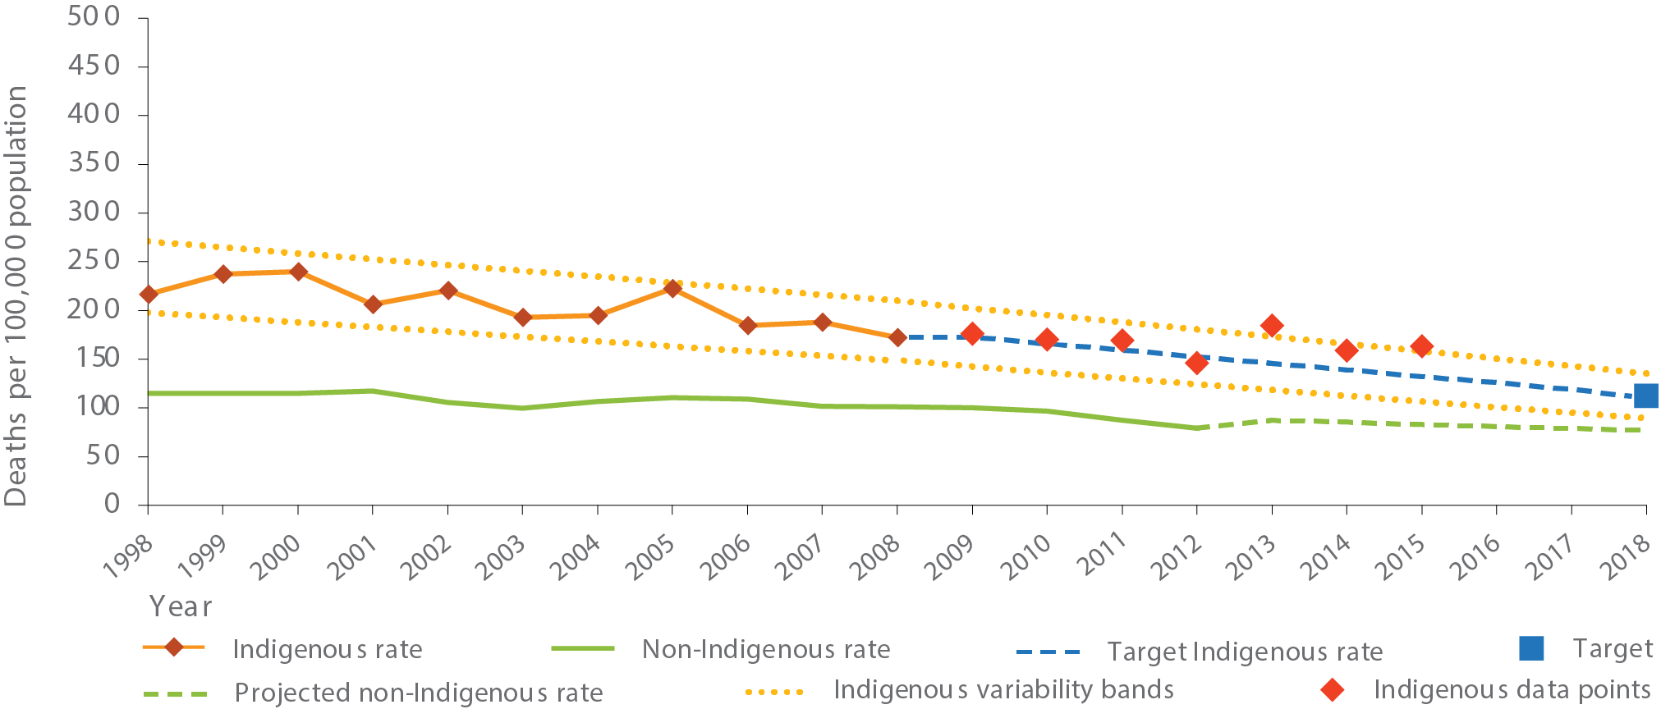
Source: ABS and AIHW analysis of National Mortality Database
View the text alternative for Figure 1.
The child mortality target is only reported for the five jurisdictions for which Indigenous status data are of sufficient quality to publish (New South Wales, Queensland, Western Australia, South Australia and the Northern Territory). Figure 2 shows state and territory child mortality rates by Indigenous status for the period 2011 to 2015. This illustrates that there is some variation by geography. New South Wales had the smallest Indigenous child mortality rate (111 per 100,000 population) and the smallest gap with non-Indigenous children. The Northern Territory had the highest Indigenous child mortality rate (333 per 100,000) and the largest gap.
In the period 2011 to 2015, there were 610 Indigenous child deaths (0-4 years), of which 500 (or 82 per cent) were infant deaths (less than one year). The Indigenous infant mortality rate has more than halved from 13.5 per 1,000 live births in 1998 to 6.3 per 1,000 in 2015, and the gap has narrowed significantly (by 84 per cent) over this period. While much of the long term gain in child mortality has been made due to progress in preventing infant deaths, there has also been a non-significant decline in death rates for those aged 1-4 years (by 13 per cent from 1998 to 2015). Further gains will be achieved by addressing the leading causes of Indigenous child death including conditions originating in the perinatal period (42 per cent of Indigenous child deaths) such as birth trauma, foetal growth disorders, complications of pregnancy, and respiratory and cardiovascular disorders; sudden and ill-defined deaths such as Sudden Infant Death Syndrome (18 per cent) and injury (13 per cent of 0-4 year-old deaths and 54 per cent of deaths for those aged 1-4 years).
There are signs of improvement in key factors which influence the health of Aboriginal and Torres Strait Islander children including access to antenatal care, rates of smoking during pregnancy and child immunisation.
The majority of Indigenous mothers (54 per cent in 2014) attended antenatal care in the first trimester of pregnancy and 86 per cent of Indigenous mothers attended five or more times during their pregnancy.³ From 2011 to 2014, the proportion of Indigenous mothers who attended antenatal care in the first trimester of pregnancy increased by 13 per cent.⁴ However in 2014, the age standardised proportion of Indigenous mothers who attended antenatal care in the first trimester was still lower than for non-Indigenous mothers (by 7 percentage points).⁵ For Indigenous mothers the rate was highest in outer regional areas (60 per cent) and lowest in major cities (47 per cent).
There was a 13 per cent decline in the rate of low birthweight babies born to Indigenous mothers between 2000 and 2014. However, in 2014 the low birthweight rate among babies born to Indigenous mothers was still more than twice that of babies with non-Indigenous mothers (10.5 per cent compared with 4.7 per cent). Smoking during pregnancy continues to be a major factor contributing to the high rates of low birthweight among babies born to Indigenous mothers (AIHW, 2016).
Figure 2: Child mortality rates (0-4 years) by Indigenous status: NSW, Qld, WA, SA and the NT, 2011-2015
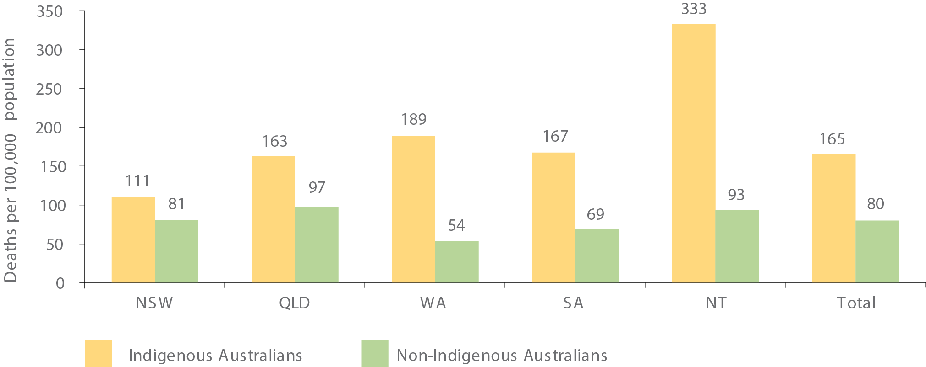
Source: ABS and AIHW analysis of National Mortality Database
View the text alternative for Figure 2.
A multivariate analysis of 2009 to 2011 data showed that 51 per cent of low birthweight births to Indigenous mothers were attributable to smoking during pregnancy, compared with 19 per cent for other mothers (AHMAC, 2015). While the proportion of Indigenous mothers who smoked during pregnancy declined from 54 to 46 per cent between 2006 and 2014,⁶ in 2014 the Indigenous rate was 3.6 times the non-Indigenous rate.⁷

NATIONAL POLICY TO DRIVE IMPROVEMENT IN CHILD MORTALITY OUTCOMES
Our investment in the early years is twofold: improving integration of services across health, child care, early childhood education and school resulting in better access to the right services; and intensive support for the children and families who need it most.
In 2016, all governments collaborated on the National Framework for Health Services for Aboriginal and Torres Strait Islander Children and Families, which will guide development, implementation and evaluation of maternal, child and family health services. It focuses on pre-conception and maternity care services through to early childhood services for children up to eight years of age.

TRANSLATING POLICY INTO ACTION

Delivering services where they are needed
By bringing together health, education and early childhood services we can engage families from conception through to preschool, monitor developmental progress and implement early intervention and case management strategies where required.
Ensuring Indigenous children start school with the same skills and development as their non-Indigenous peers is the key aim of Connected Beginnings, a new program under the Jobs for Families Child Care Package. The program is informed by the ‘Challis model’ of integrated service delivery, an early learning and parenting centre co-located within the Challis Community Primary School in Armadale, Western Australia, which brings together existing services at the school, providing easy access for families.
In addition, there are currently 110 New Directions: Mothers and Babies Services nationally providing access to antenatal and postnatal care, standard information about baby care, practical advice and assistance with breastfeeding, nutrition and parenting, monitoring of development milestones, immunisation status and health checks before starting school. This will expand to an additional 26 sites by 2018.

Targeted intensive support for families who need it most
Some families need extra support to ensure their children meet health and developmental milestones, giving them the best chance to thrive in the early years and through to school. Programs providing intensive support include:
- The Australian Nurse-Family Partnership Program which offers nurse-led home visits to families, from birth through to the child turning two. Early outcomes from program participants include lower rates of alcohol and tobacco consumption during pregnancy. Babies born to program participants were also of a higher than average birthweight and immunisations rates for infants in the program exceeded the national average for Indigenous children at 24 months. Currently operating in five sites, it will expand to an additional eight sites by 2018.
- Trauma Assessment Referral and Recovery Outreach Teams which are helping families manage health, wellbeing and behavioural issues of their children. The teams use cultural care plans and a child-centred approach to coordinate allied health and specialist case management. The pilot program will be implemented in six sites.
- The National Fetal Alcohol Spectrum Disorder Action Plan which is underpinned by $9.2 million to reduce the incidence of Fetal Alcohol Spectrum Disorder, including prevention and health promotion resources, of which $4 million is for support for Aboriginal and Torres Strait Islander people. A further $10.5 million to address Fetal Alcohol Spectrum Disorder was announced in the 2016 Budget.

EARLY CHILDHOOD EDUCATION
Target: 95 per cent of all Indigenous four year-olds enrolled in early childhood education (by 2025).

KEY POINTS
- There are strong links between participation in early childhood education and academic success.
- In 2015, 87 per cent of Aboriginal and Torres Strait Islander children in Australia were enrolled in early childhood education in the year before full-time school.
- Early childhood education programs for all children in the year before full-time school are a priority for all governments.
The original target to ensure access for all Indigenous four-year-olds in remote communities to early childhood education expired unmet in 2013. Australian governments remain committed to closing the gap in the developmental outcomes of Aboriginal and Torres Strait Islander children by increasing their participation in quality early childhood education. In December 2015 a revised Closing the Gap target was agreed between Australian governments. The new target focuses on increasing Aboriginal and Torres Strait Islander children’s participation in quality education programmes nationally, extending beyond the original focus on remote communities.⁸
The renewed target also aligns with the objectives and outcomes of the National Partnership Agreement on Universal Access to Early Childhood Education, which includes a focus on lifting the preschool participation rates of all Aboriginal and Torres Strait Islander children and vulnerable and disadvantaged children, regardless of setting.
Early childhood education prepares a child for school and provides a solid foundation for learning and achieving at school and beyond. This can be delivered through a pre-school or child care setting – the important factors are a quality program and regular participation.
Since 2009, the Commonwealth has funded the Australian Early Development Census (AEDC) to measure the development of children in Australia in their first year of full-time school.
The AEDC highlights what is working well and what needs to be improved or developed to support children and their families and in 2015, it collected data on 17,351 Indigenous children.
In 2015, Indigenous children were almost twice as likely as non-Indigenous children to be developmentally vulnerable in health and wellbeing, social competence, communication and emotional maturity. This increases to nearly four times more likely to be developmentally vulnerable in language and cognitive skills. The gap in this domain has decreased from 20.7 percentage points in 2009 to 14.5 percentage points in 2015. Findings from the AEDC inform early childhood national policy.
Evidence shows that participation in preschool has a significant positive impact on vocabulary for Indigenous students in the following two years (Arcos Holzinger & Biddle, 2015). Three to five years after preschool enrolment, positive impacts included developmental outcomes as well as reading and maths achievements.
Importantly, evidence shows 15-year-old students who had attended at least a year of preschool outperformed students who had not, even after accounting for socioeconomic background (OECD, 2014).
Figure 3: Enrolment in early childhood education in the year before full-time school, by Indigenous status and state/territory, 2015 (per cent)⁹
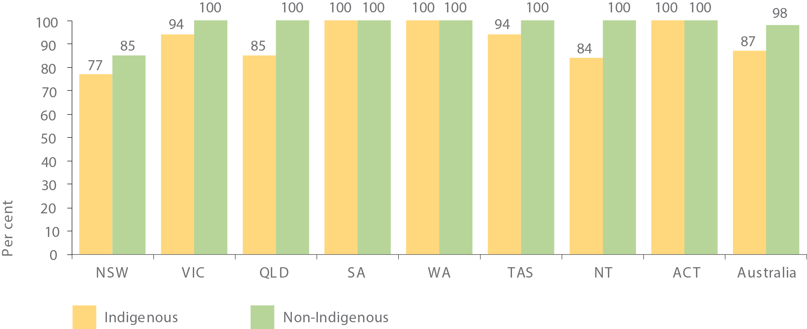
Source: ABS unpublished, Preschool Education, Australia 215; Australian Demographic Statistics, June 2015; Births, Australia, 2015; Estimates and Projections, Aboriginal and Torres Strait Islander Australians, 2001 to 2026; Schools, Australia 2015.
View the text alternative for Figure 3.

WHAT THE DATA TELLS US
The baseline for this target is 2015. In 2015, 87 per cent of Indigenous children were enrolled in early childhood education in the year before full-time school, compared to the target benchmark of 95 per cent (Figure 3). Data to measure progress against this target will be available for next year’s report.
In 2015, the information available suggests that all Indigenous and non-Indigenous children were enrolled in early childhood education in the year before full-time school in Western Australia, South Australia and the Australian Capital Territory (Figure 3). Early childhood education enrolment rates for Indigenous children in the other states and territories were below the required benchmark of 95 per cent, although Victoria and Tasmania were very close.
Of Indigenous children enrolled in early childhood education in the year before full-time school in 2015, 92 per cent had attended¹⁰ early childhood education in 2015 (Figure 4), with the highest attendance rates in Tasmania (98 per cent) and South Australia (97 per cent).
In 2015, almost all Indigenous children enrolled in early childhood education the year before full-time school in major cities and regional Australia actually attended¹¹ (both 95 per cent) (Figure 5). In remote Australia the attendance rate for Indigenous children was lower, at 82 per cent.
Figure 4: Proportion of children enrolled in early childhood education in the year before full-time schooling who had attended by Indigenous status and state/territory, 2015 (per cent)
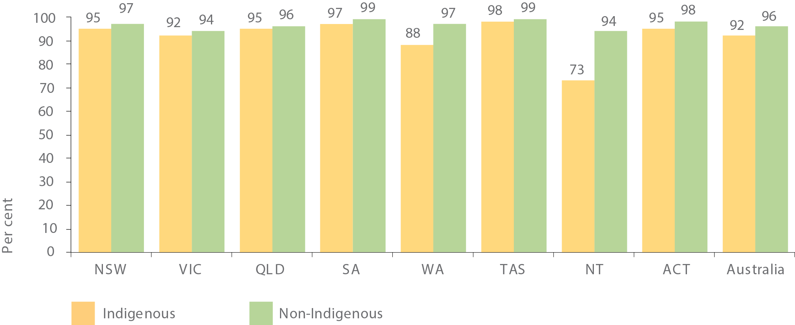
Source: ABS unpublished, Preschool Education, Australia 2015.
View the text alternative for Figure 4.
Figure 5: Proportion of children enrolled in early childhood education in the year before full-time schooling who had attended by Indigenous status and remoteness, 2015 (per cent)
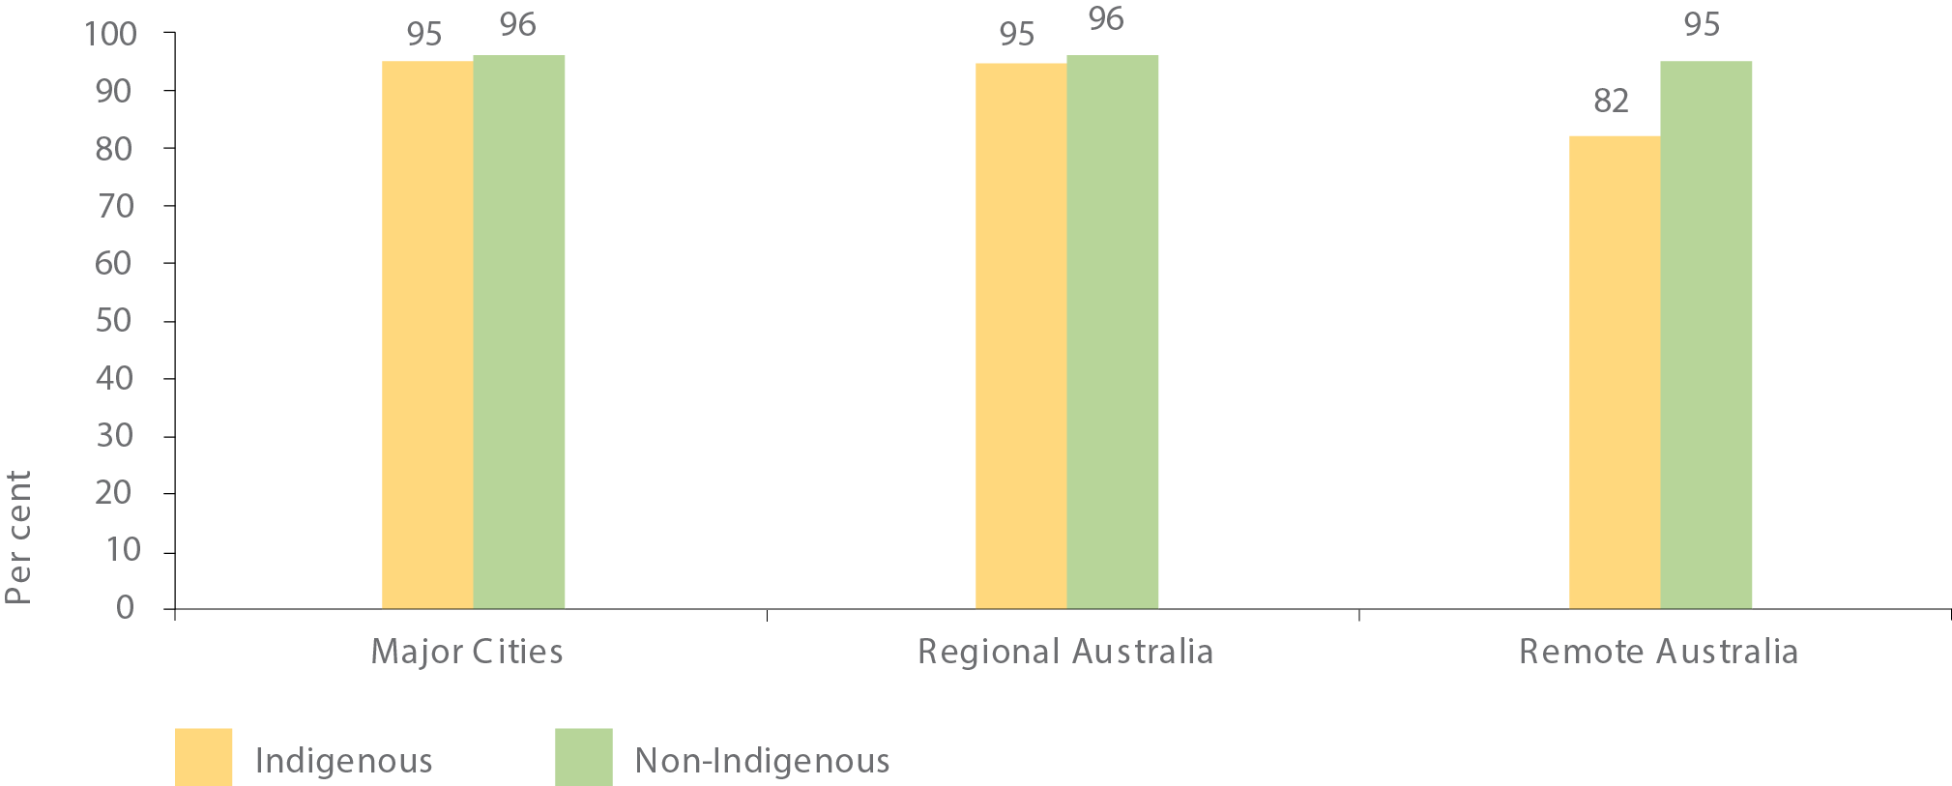
Source: ABS unpublished, Preschool Education, Australia 2015.
View the text alternative for Figure 5.

NATIONAL POLICY TO DRIVE IMPROVEMENT IN EARLY CHILDHOOD EDUCATION OUTCOMES
Early childhood education is a collaborative effort across all governments. Under the National Partnership Agreement (NPA) on Universal Access to Early Childhood Education, the Commonwealth is providing over $840 million over 2016 and 2017 to states and territories to ensure every Australian child has access to quality early childhood education programs for 15 hours per week in the year before formal school, regardless of the setting. The agreement has a strong focus on participation by Aboriginal and Torres Strait Islander children.
Better integration of services has been identified as an effective way to improve support for vulnerable children and families. From 2016-17, the Government is investing $10 million annually through the Community Child Care Fund to integrate early childhood, maternal and child health and family support services with schools in a number of disadvantaged Indigenous communities. The focus is on supporting Aboriginal and Torres Strait Islander families so their children make a positive transition to school.

TRANSLATING POLICY INTO ACTION

Preparing children for school
In some areas, particularly remote communities, additional support is required. In addition to the Commonwealth’s contribution for child care subsidies and preschool funding, the Indigenous Advancement Strategy supports almost 400 early childhood activities for children, families and communities in preschools and early childhood education, where the need is greatest.
Additional programs preparing Indigenous children for school include:
- The Home Interaction Program for Parents and Youngsters which works with families in the home to create a positive learning environment for four and five year-olds in preparation for school.
- The Stronger Communities for Children program which delivers community-led service design in ten remote communities in the Northern Territory. Local people have a real say in what services they need and how they are delivered.
- Families as First Teachers which delivers quality early childhood engagement using the Australian Abecedarian Approach to empower parents as the first and primary educators of their children.

BUILDING THE EVIDENCE
For nearly ten years, a major longitudinal research study, Footprints in Time has followed the lives of around 1,700 Indigenous families. This study by the National Centre for Longitudinal Data, within the Department of Social Services, collects information on health, development, education, family relationships, culture, community as well as many other issues. The study employs Aboriginal and Torres Strait Islander staff to conduct face-to-face interviews.
Among many other findings, the study has recently provided robust evidence of the importance of early childhood education and care programs in boosting cognitive and developmental outcomes among Indigenous children.
Early childhood programs currently being evaluated include the Australian Nurse-Family Partnership Program, Stronger Communities for Children and the Abecedarian Approach Australia (3a) being used in some Supported Playgroups. Findings from these evaluations will strengthen our understanding of early childhood development and inform future policy and programs.

OUTSTANDING LOCAL SOLUTIONS DELIVERING EXCITING OUTCOMES
“Our parents and the community acknowledge the importance of early childhood education and fully support the 3a programme.”
– Gumala Coordinator Julie Christine

Supporting mothers and babies in Armidale
Armidale Aboriginal Mothers and Babies program has been helping women through pregnancy and birth for over 10 years. Nearly 500 women have received antenatal care, including one mother who used the service for all of her 10 children.
The program is funded by the New South Wales Government in recognition of the number of Indigenous families who for varied reasons were not regularly accessing mainstream maternal or infant services. The program has been improving breast feeding rates, reducing smoking during pregnancy and improving immunisation rates for Aboriginal children.

Wiradjuri learning in Tumut, NSW
The small town of Tumut on Wiradjuri country has over five per cent Indigenous population. The Tumut Preschool project, funded through the Indigenous Advancement Strategy, employs two Indigenous educators to increase cultural knowledge and learning in the local community.
Children and parents participate in activities such as learning the local Wiradjuri language, writing lyrics, playing music and creating artwork that is displayed in the community.

Gumala supporting early childhood learning in Pilbara, WA
The Pilbara region of Northern Western Australia may be remote, but that’s not stopping local children from getting the best possible early childhood education.
Gumala Aboriginal Corporation runs five early childhood learning centres in the region and is working to build the next generation of community leaders.
“The program we run at our centres has been specifically created for zero to four-year-old children,” Coordinator Julie Christine said.
“We have over 200 learning games for the children that are simple to play but help develop vital learning skills the children will need when they transition to school. We also educate parents about the importance of teaching their children. Good learning begins at home.”

- For 2015 data, the Queensland Registry of Births, Deaths and Marriages included Medical Certificate of Cause of Death information for the first time to contribute to the Indigenous status data item. This was associated with a decrease in the number of deaths for which the Indigenous status was 'not stated' and an increase in the number of deaths identified as Indigenous in Queensland. Although the Indigenous child mortality rate was higher in Queensland in 2015, for New South Wales, Western Australia and South Australia the rates were lower in 2015 than in 2014. This change in method means that time series data are not directly comparable and caution should be used in interpreting the trend.
- In 2015, there were 124 Indigenous child deaths. This was four deaths outside the range of the target and an increase of six deaths since 2014.
- Aboriginal and Torres Strait Islander women who gave birth at 32 weeks or more gestation, NSW, Queensland, SA, WA, Tasmania, NT and ACT. These data are not generalizable to Australia.
- Age standardised data. This time series excludes data from NSW due to a change in data collection practices from 2011.
- Comparisons between Indigenous and non-Indigenous mothers are age standardised to account for the different age profiles of the two populations.
- Trends exclude Victoria as data were not available for Victoria before 2009.
- Comparisons between Indigenous and non-Indigenous mothers are age standardised to account for the different age profiles of the two populations.
- A revised method was developed to address numerator and denominator misalignment for age and location, removing children already in school from the denominator, and adjusting for Indigenous status not stated. It is considered a significant improvement, but there are some further potential sources of difference between the early childhood education numerators and the population denominators that may impact on the accuracy of the estimates.
- Proportions are over 100 per cent but displayed as 100 per cent for the following: Indigenous children in WA (105 per cent); SA (112 per cent); and ACT (124 per cent). Non-Indigenous children in Vic. (103 per cent); QLD (108 per cent); WA (101 per cent); SA (103 per cent); Tas. (102 per cent); ACT (109 per cent); and NT (106 per cent).
- Present for at least one hour during the reference period. The census date for the 2015 Collection is Friday 7 August 2015, with the one- week reference period spanning 3 of August to 9 August 2015. Some jurisdictions may adopt a two-week reference period, which means the permissible period spans 27 July to 16 August 2015 inclusive.
- Present for at least one hour during the reference period.

CHAPTER 3: EDUCATION
There is no doubt that a good education unlocks opportunities later in life. Children ready to learn when they first walk through the school gates are more likely to thrive throughout their school years. Education is fundamental to unlocking the potential of future generations – whether through higher education, employment or starting a business.

Literacy for Life in Brewarrina, Western NSW
Now that Brewarrina resident Neranellis Coffey, 41, has improved her reading and writing, she can’t wait to help others. “I want to read to my family, especially to the children,” Neranellis said.
Neranellis is one of more than 100 graduates who have taken part in the Literacy for Life Foundation’s project, funded through the Indigenous Advancement Strategy, to reduce low literacy among Indigenous adults.
“If people need help reading a book, filling out forms or help with the computer, I can help them with the skills I have learnt with the Literacy for Life Foundation.”
Neranellis says the way the entire community is engaged and supports the campaign is the reason it works. Everyone shares the success and gains inspiration from each other.
“I want to step up and have confidence and be empowered. With these new skills, I can.”
– Literacy for Life participant Neranellis Coffey
“There is no place in any education jurisdiction for educators with stifled perceptions of who Indigenous students are, or what they can achieve.”
– Dr Chris Sarra

NATIONAL POLICY TO DRIVE IMPROVEMENT IN EDUCATION OUTCOMES
While the responsibility for schooling sits with state and territory governments, the Australian Government has an overarching role in national education policy and programs. We work with key stakeholders, supporting early intervention and engaging with parents to encourage school attendance; promoting evidence-based school teaching methods; supporting high quality teachers and leaders in school; and increasing education completion rates, in high school and beyond.
Well trained, skilled and knowledgeable teachers provide the foundation for a high quality education system and quality teaching is essential to lifting student outcomes.
The National Aboriginal and Torres Strait Islander Education Strategy and the Framework for Aboriginal Languages and Torres Islander Languages commit and support all governments to ensure teachers, schools and communities build a culturally inclusive school environment for Aboriginal and Torres Strait Islander students.
Across the education continuum, young people are also supported to complete secondary school. Year 12 attainment or the equivalent provides a pathway into further education and employment, opening up economic and social opportunities.

SCHOOL ATTENDANCE
In May 2014, a new target to close the gap between Indigenous and non-Indigenous school attendance by the end of 2018 was agreed, in acknowledgement of the strong link between school attendance and student performance. Around 20 per cent of the gap in school performance between Indigenous and non-Indigenous 15 year-olds is explained by poorer school attendance of Indigenous students (Biddle N., 2014). A recent study by the Productivity Commission (2016) found that lower average school attendance rates were associated with poorer Indigenous literacy and numeracy results in primary schools (Productivity Commission, 2016).
School attendance is affected by a range of underlying issues such as housing, health care, mental health issues, family violence and intergenerational unemployment (Mission Australia, 2016).
Longer term trends demonstrate that significant progress is being made to boost the participation of Aboriginal and Torres Strait Islander people in school. In 1976 over half of all Indigenous men aged 20-64 had either never attended school or left school at 14 or younger. By 2011, only 14 per cent of all Indigenous men had either never attended school or left school at Year 8 or below.¹²
Target: Close the gap between Indigenous and non-Indigenous school attendance within five years (by 2018).

KEY POINTS
- Recognising the critical importance of school attendance, both government and non-government education authorities will continue to work with communities and families to encourage and support children going to school regularly.
- In 2016, the overall attendance rate for Indigenous students nationally was 83.4 per cent, compared with 93.1 per cent for non-Indigenous students.
- There has been no meaningful change in the national Indigenous school attendance rate from 2014 (83.5 per cent) to 2016 (83.4 per cent). Progress will need to accelerate across most jurisdictions for this target to be met.
- School attendance for Indigenous students decreases with remoteness. In 2016, Indigenous attendance rates ranged from 86.9 per cent in inner regional areas to 66.4 per cent in very remote areas.
- Schools selected for the Remote School Attendance Strategy (RSAS) generally had a history of low and declining attendance rates over a number of years. RSAS is addressing these declining rates of school attendance and the majority of RSAS schools had a higher attendance rate in Semester 1 2016 compared to Semester 1 2013.
Figure 6: Indigenous student attendance rates (per cent) Year 1 to 10 combined, by state/territory, Semester 1, 2014 and 2016
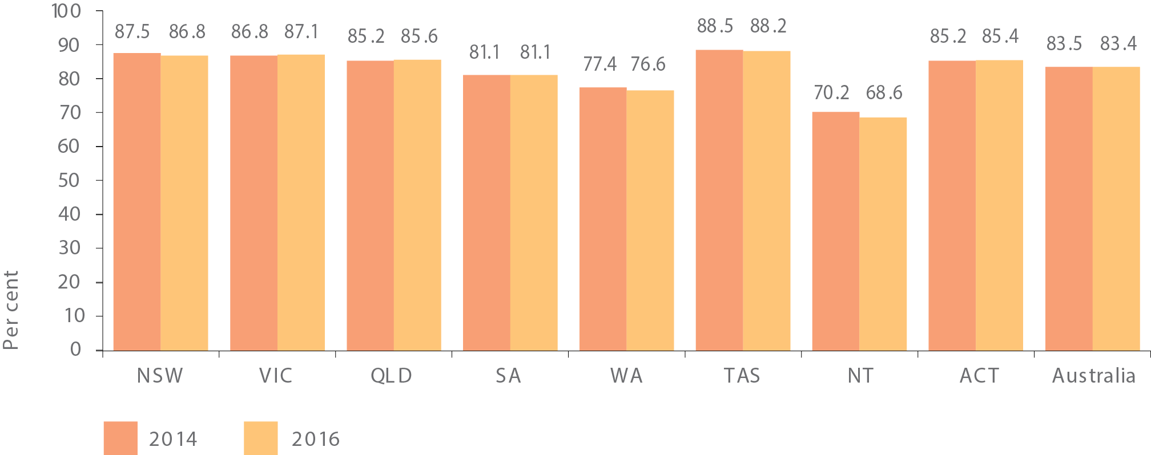
Source: Australian Curriculum, Assessment and Reporting Authority
View the text alternative for Figure 6.

WHAT THE DATA TELLS US
In Semester 1 2016, the national school attendance rate (Year 1 to 10) was 92.5 per cent; however, there is a sizable gap between Indigenous and non-Indigenous students. In 2016, the attendance rate for Indigenous students was 83.4 per cent, almost 10 percentage points lower than the comparable rate for non-Indigenous students (93.1 per cent). While this is a sizeable gap, the data tell us that on a given school day the majority of Aboriginal and Torres Strait Islander students are attending school.
There has been negligible change in the rate of school attendance for Aboriginal and Torres Strait Islander children from 2014 (83.5 per cent) to 2016 (83.4 per cent).
There was also little change in the rate of attendance for Aboriginal and Torres Strait Islander students from 2014 to 2016 by state and territory. All of the changes were less than one percentage point, apart from the Northern Territory (1.6 percentage point fall). No jurisdictions were on track for this target in 2016 (see Figure 6).¹³
Indigenous attendance rates decrease with remoteness. In 2016 the attendance rate for Indigenous students fell from 86.9 per cent in inner regional areas to 66.4 per cent in very remote areas. As this relationship is less pronounced for non-Indigenous students, the gap in attendance rates increases with remoteness (illustrated in Figure 7). In very remote areas, the gap between Indigenous and non-Indigenous attendance rates was 24.7 percentage points in 2016.
Aboriginal and Torres Strait Islander student attendance rates for 2016 were lower than for non-Indigenous students for all year levels. Indigenous and non-Indigenous attendance rates both fall in secondary grades, declining with increasing year level. As with remoteness, the decline for Indigenous students is more rapid, and so the attendance gap increases throughout secondary school.
In addition to attendance rates, another new measure is the attendance level – the proportion of students who attended school 90 per cent or more of the time. These are available for Year 1 to 10 students in Semester 1, from 2015.¹⁴ In Semester 1 2016, 49.0 per cent of Indigenous students attended school 90 per cent or more of the time, compared to 79.3 per cent of non-Indigenous students. While the gap between Indigenous and non-Indigenous attendance levels is around 30 percentage points, consistent attendance is not just an issue for Aboriginal and Torres Strait Islander students. These proportions in 2016 were almost unchanged from 2015.
Figure 7: Student attendance rates (per cent) Year 1 to 10 combined, by Indigenous status and remoteness, Semester 1, 2016
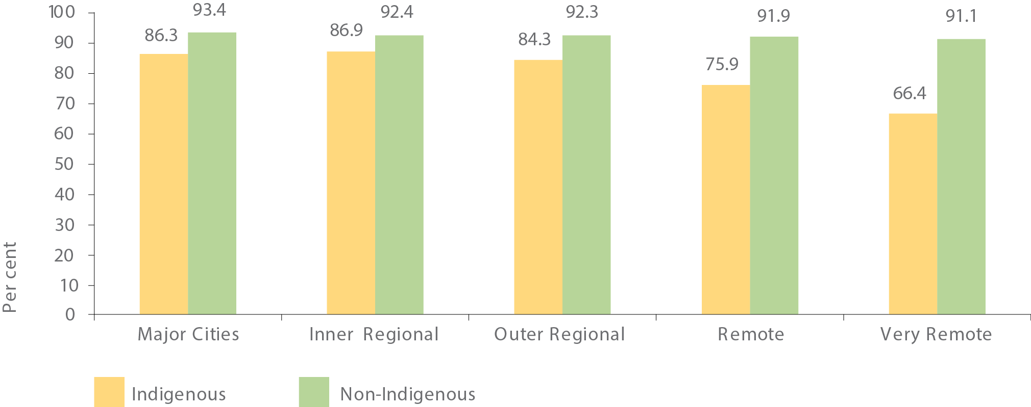
Source: Australian Curriculum, Assessment and Reporting Authority
View the text alternative for Figure 7.
Figure 8: Proportion of students attending school 90 per cent or more of the time (per cent), Year 1 to 10 combined, by Indigenous status and remoteness, Semester 1, 2016
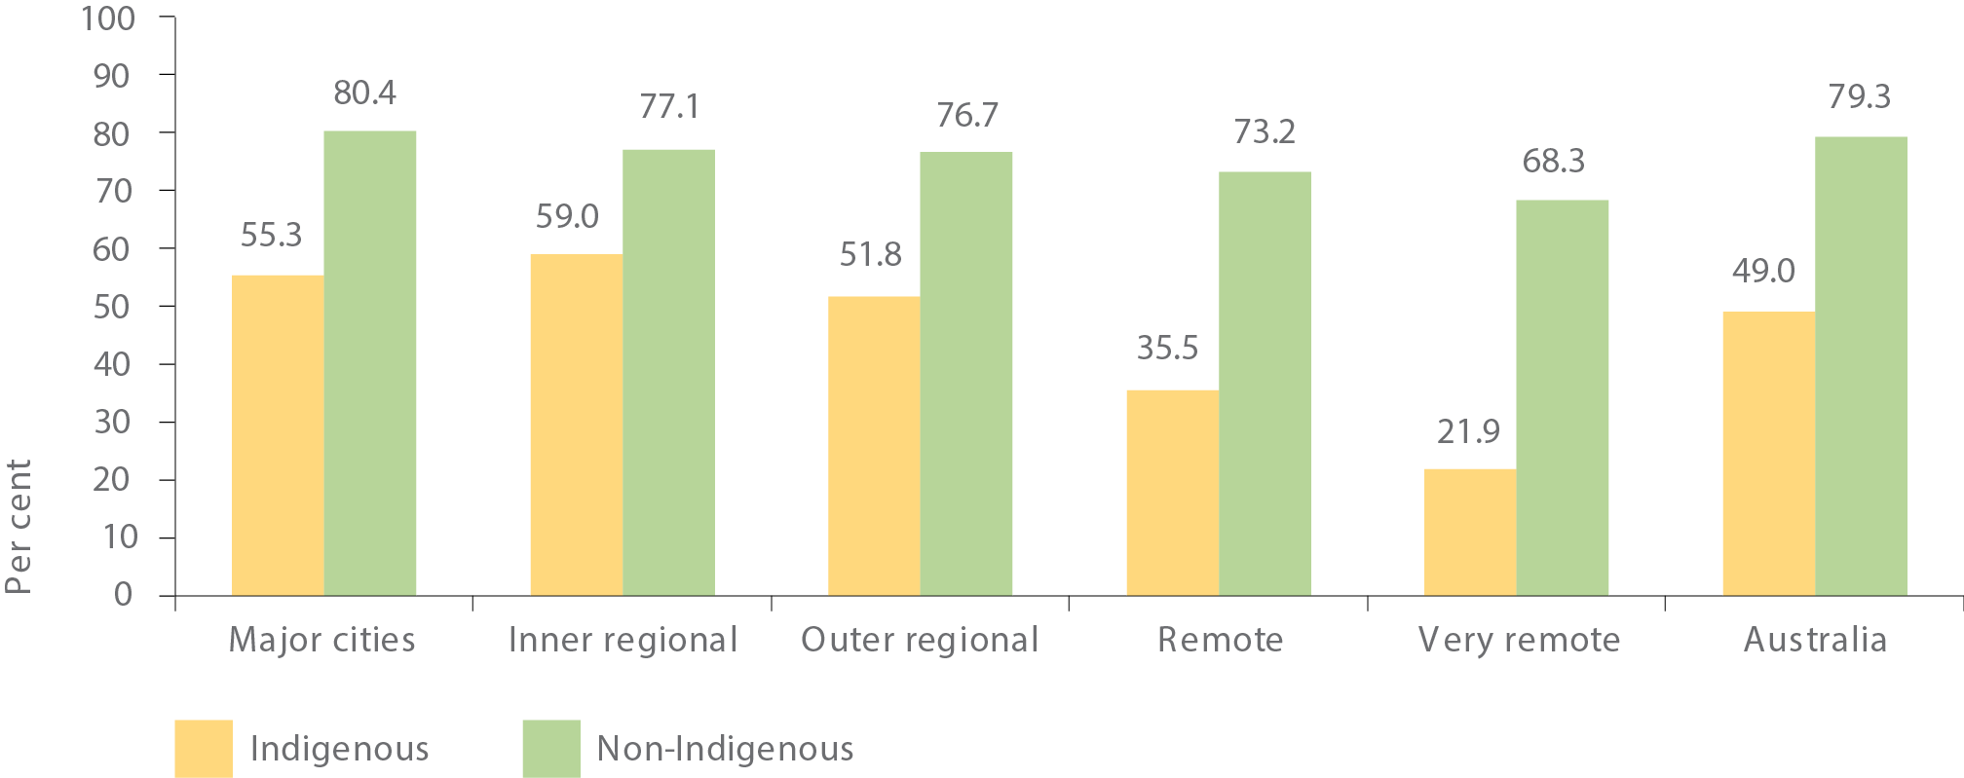
Note: Excludes NSW government schools
Source: Australian Curriculum, Assessment and Reporting Authority
View the text alternative for Figure 8.
The attendance level has the same pattern by remoteness as the attendance rate. The highest Indigenous attendance level is in inner regional areas (59.0 per cent attending 90 per cent or more of the time) and it falls off sharply with remoteness (to 21.9 per cent in very remote areas). Again, this relationship is weaker for non-Indigenous attendance levels, and so the gap is widest in remote areas (see Figure 8).
Research has shown that Indigenous boys have a lower level of school attendance than Indigenous girls, and this difference between boys and girls is larger for Indigenous students than for non-Indigenous students (Biddle & Meehl, 2016).

TRANSLATING POLICY INTO ACTION
Regular school attendance contributes to better educational outcomes, so it is important to foster a positive school environment for Aboriginal and Torres Strait Islander children. We continue to collaborate with government and non-government education authorities to provide an enabling school environment for all Aboriginal and Torres Strait Islander children.

Encouraging children to go to school
The Remote School Attendance Strategy (RSAS) employs around 450 local Indigenous community members to develop culturally appropriate strategies supporting families in ensuring children go to school. It currently supports approximately 14,000 students in 77 schools across remote Northern Territory, New South Wales, Queensland, South Australia and Western Australia. Around 60 per cent of RSAS schools had higher attendance rates in Semester 1 2016 compared with Semester 1 2013 (Australian Curriculum, Assessment and Reporting Authority, 2016).
In urban and regional areas, the Children and Parenting Support program delivers early intervention services such as playgroups, parenting courses, home visiting, school readiness and peer support groups.
The Communities for Children Facilitating Partners program operates in 52 disadvantaged communities across Australia. A facilitator works with the community to tailor programs to enhance early childhood development and wellbeing, which are then delivered by community partners. In 2016, almost 20 per cent of clients identified as Aboriginal and/or Torres Strait Islander.

LITERACY AND NUMERACY
Literacy and numeracy skills are vital for students to succeed at school and move into employment.
Target: Halve the gap for Indigenous children in reading, writing and numeracy within a decade (by 2018).

KEY POINTS
- Across the eight areas (reading and numeracy for Years 3, 5, 7 and 9), the proportion of Indigenous students achieving national minimum standards in NAPLAN¹⁵ is on track in only one area (Year 9 numeracy).
- NAPLAN results for Indigenous students are worse in more remote areas.
- Indigenous 15 year-olds are on average about two-and-a-third years behind non-Indigenous
- 15 year-olds in reading literacy and mathematical literacy and Indigenous boys are trailing their female peers in performance at school.
- Although the literacy and numeracy gap remains, the numbers required to halve the gap are within reach: in 2016, if an additional 440 Indigenous Year 3 children throughout Australia had achieved national minimum standards in reading, that target would have been met.

WHAT THE DATA TELLS US
Progress against this target is assessed using data on the proportion of students at or above the National Minimum Standards (NMS) as measured through NAPLAN. Progress is tracked each year for eight areas – reading and numeracy for Years 3, 5, 7 and 9 against agreed trajectory points. ¹⁶ ¹⁷
In 2016, the result in only one of the eight areas (Year 9 numeracy) was consistent with the required trajectory point at the national level. In the other seven areas, 2016 results were below the required trajectory points, meaning that progress will need to accelerate for this target to be met. This year’s results are less positive than the results for 2015, where four of the eight areas were on track. However, caution is required in interpreting these results, as they vary a lot from one year to the next.
Another way to assess progress is to see whether the latest results for Aboriginal and Torres Strait Islander students have improved. This year at the national level, half of the eight areas showed statistically significant improvements in the proportion of Aboriginal and Torres Strait Islander students at or above the NMS from 2008 to 2016. The four areas with significant improvement were Years 3 and 5 reading, and Years 5 and 9 numeracy. There was no significant change from 2008 to 2016 for Years 7 and 9 reading and Years 3 and Year 7 numeracy.
Although the literacy and numeracy gap remains, the good news is that in terms of actual student numbers the gap is not large. If an additional 440 Indigenous Year 3 students achieved the NMS in reading and 800 in numeracy, the target would have been met for Year 3 in 2016.¹⁸

Remoteness
NAPLAN results for Aboriginal and Torres Strait Islander students vary sharply by remoteness area. For example, in 2016, 84 per cent of all Indigenous students in major city areas met or exceeded the NMS for Year 5 numeracy, double the 42 per cent of students in very remote areas. As results for non-Indigenous students show less variation by remoteness area, the gap is much wider in very remote areas than it is in metropolitan areas (Figure 9 illustrates this for Year 5 numeracy).

State and Territory
Results also vary by state and territory. The Northern Territory had the lowest proportion of Indigenous students at or above the NMS for each area measured. This result partly reflects the pattern by remoteness area, as the Northern Territory has a much higher proportion of Indigenous students in remote or very remote areas than any other jurisdiction.
Queensland has shown the largest improvements, with significant Indigenous improvement in six of the eight measures from 2008 to 2016 (the two exceptions are Year 9 reading and Year 7 numeracy). Figure 10 illustrates this using Year 3 reading results, where Queensland had the largest gain for Indigenous students. Overall there has been significant improvement in Indigenous results for 14 of the 64 state-level measures (numeracy and reading across four year levels in eight jurisdictions).²⁰
Figure 9: Proportion of students reaching National Minimum Standards for Year 5 numeracy by Indigenous status and remoteness, 2016
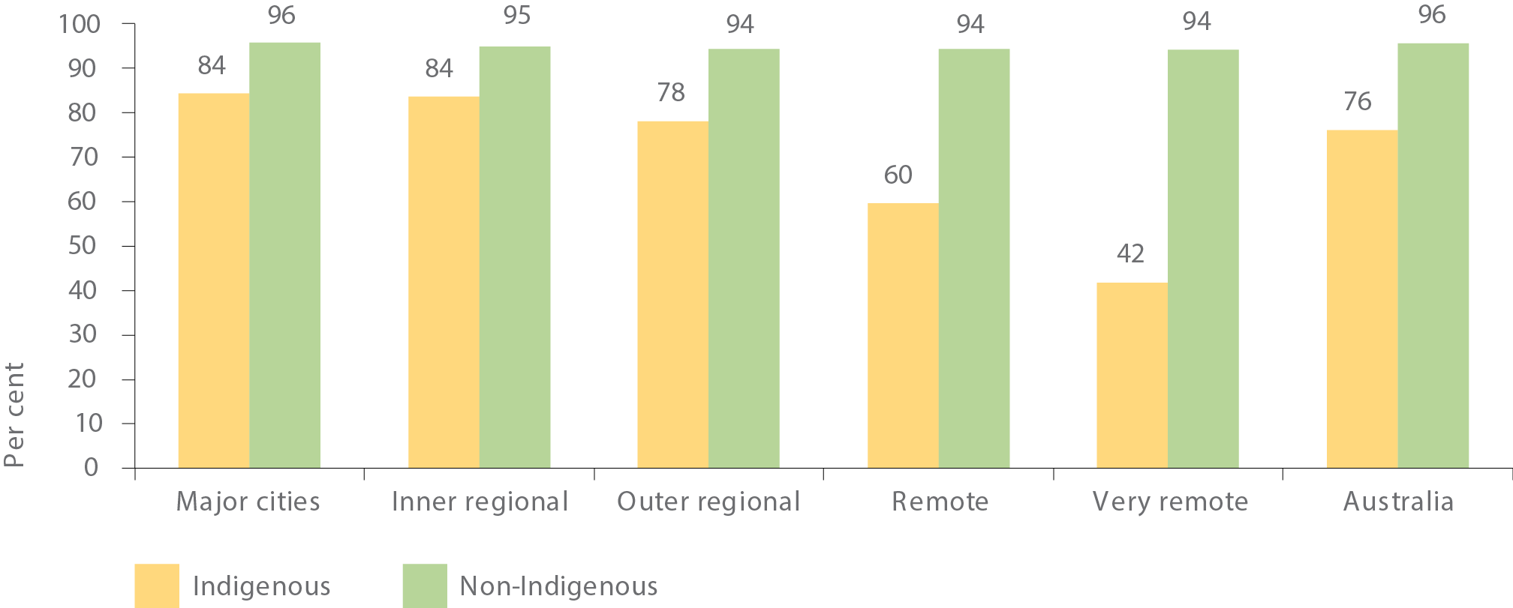
Source: Australian Curriculum, Assessment and Reporting Authority
View the text alternative for Figure 9.
Figure 10: Proportion of Indigenous students reaching National Minimum Standards for Year 3 reading state/territory, 2008 and 2016
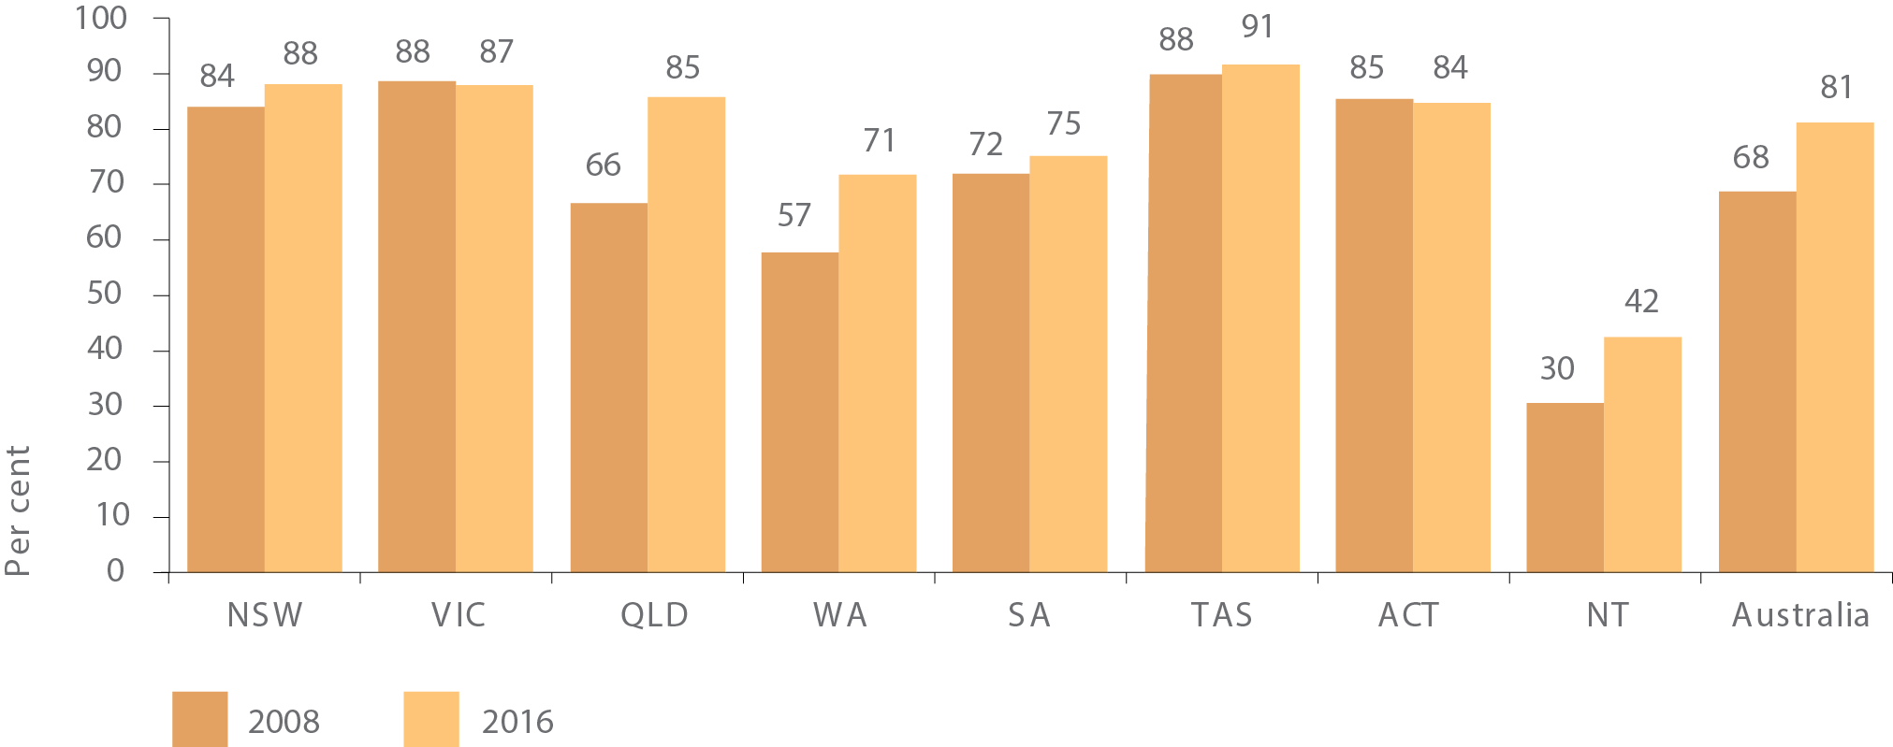
Source: Australian Curriculum, Assessment and Reporting Authority
View the text alternative for Figure 10.

State and Territory progress against trajectories
Across the eight jurisdictions and the eight result areas, 29 of the 64 measures were on track (i.e. consistent with or above, the required trajectory points) in 2016 (see Table 1). The Northern Territory was not on track for all eight areas, while the Australian Capital Territory was on track for all eight.²¹ Note that most of the trajectories for each jurisdiction are not straight lines from the 2008 baseline to the 2018 target year, but reflect assumptions about the lag in improvement over time as policies and programs take effect.

Programme for International Student Assessment
According to results from the Programme for International Student Assessment (PISA), there has been a significant decline in mean scores for scientific and mathematical literacy achieved by Australian 15 year-olds between 2012 and 2015. Internationally, Australia’s relative performance has declined against all domains since 2012. In 2015, Indigenous 15 year-olds were on average about two-and-a-third years behind non-Indigenous 15 year-olds in reading literacy and mathematical literacy. They also had a lower share of high performers and a larger share of low performers (Thomson, Bortoli, & Underwood, 2016).
The 2012 PISA identified a significant gap in performance at school between Indigenous boys and girls. For reading literacy, on average 15 year-old Indigenous males are performing about one-and-a-third years of schooling below their Indigenous female peers (Thomson, De Bortoli, & Buckley, 2013). A recent study shows that for both the Indigenous and non-Indigenous population, females outperform their male counterparts when maths, reading and science test scores are averaged (Biddle & Meehl, 2016). The gap between females and males is considerably larger for the Indigenous population.²²

Regional findings
We can also analyse the NAPLAN data for small areas to support targeting of efforts. Regional data are available for 2015. The map shows the proportion of Indigenous Year 3 students who met the NMS for reading across Indigenous areas (IAREs). In 2015, 35 IAREs had less than half of Indigenous students achieving NMS for Year 3 reading (shown in red) and 57 had 90 per cent or more achieving NMS (shown in dark green). There were also 76 IAREs where the numbers were too small to report (shown in grey).²³ Of note, most of the areas with low rates of achievement were remote.
Table 1: NAPLAN measures (on track/not on track), by state/territory, 2016
 | NSW | VIC | QLD | WA | SA | TAS | ACT | NT | AUST
Reading
Year 3
Year 5
Year 7
Year 9
Numeracy
Year 3
Year 5
Year 7
Year 9
Source: Analysis of data from the Australian Curriculum, Assessment and Reporting Authority
Note: Tick indicates measure is on track with the target. Remaining measures are not on track with the target.
View the text alternative for Table 1.
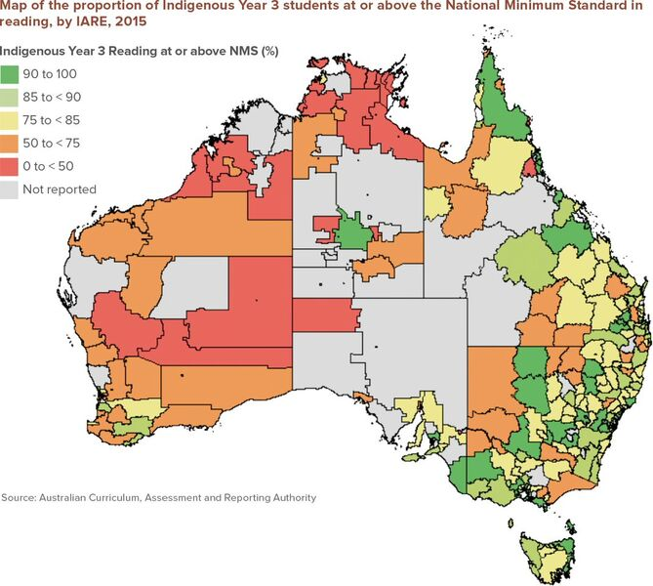
View the text alternative for Map.

TRANSLATING POLICY INTO ACTION
The disparities in NAPLAN achievement between Indigenous and non-Indigenous students are widespread. Analysis by the Productivity Commission (2016) found that after controlling for socioeconomic status and language background, Indigenous primary school students had lower scores than non-Indigenous students across all remoteness areas. In 2014, 80 per cent of Indigenous primary students lived in non-remote areas. Indigenous students in non-remote areas accounted for 55 per cent of the national gap in reading achievement between Indigenous and non-Indigenous Year 5 students. Indigenous students make up only five per cent of all primary school students and the vast majority of schools have at least one Indigenous student. One quarter of Indigenous primary school students attend schools with an Indigenous enrolment of less than 20 students. Therefore, a ‘one size fits all’ approach is unlikely to be effective (Productivity Commission, 2016).
All governments have committed to individualised learning strategies for students at risk of not achieving their full potential. Consistent with the analysis of what works in Indigenous Primary School Achievement (Productivity Commission, 2016) these strategies will use data to track student progress and adapt teaching to support individual needs. In December 2016, COAG leaders reiterated the importance of individualised learning strategies for students at risk of not achieving their full potential as a way to accelerate progress toward the critical Year 3 Closing the Gap reading target.

YEAR 12 ATTAINMENT
Having literacy and numeracy skills opens doors in life and is an essential precursor to success in school, university and employment. Indigenous and non-Indigenous children with the same level of academic achievement at the age of 15 go on to complete Year 12 and higher education at the same rates. (Mahuteau, Karmel, Mayromaras, & Zhu, 2015).
Target: Halve the gap for Indigenous Australians aged 20-24 in Year 12 attainment or equivalent²⁴ attainment rates (by 2020).

KEY POINTS
- The target to halve the gap in Year 12 attainment by 2020 is on track.
- Nationally the proportion of Indigenous 20-24 year-olds who had achieved Year 12 or equivalent increased from 45.4 per cent in 2008 to 61.5 per cent in 2014-15. Over the same period, the rates for non-Indigenous attainment did not change significantly.
- The greatest increases occurred in Outer Regional areas (43.2 per cent to 66.3 per cent) and Very Remote areas (24.1 per cent to 41.7 per cent).
Figure 11: Proportion of Indigenous 20-24 year olds with Year 12 or equivalent attainment, by state/territory, 2008 and 2014-15
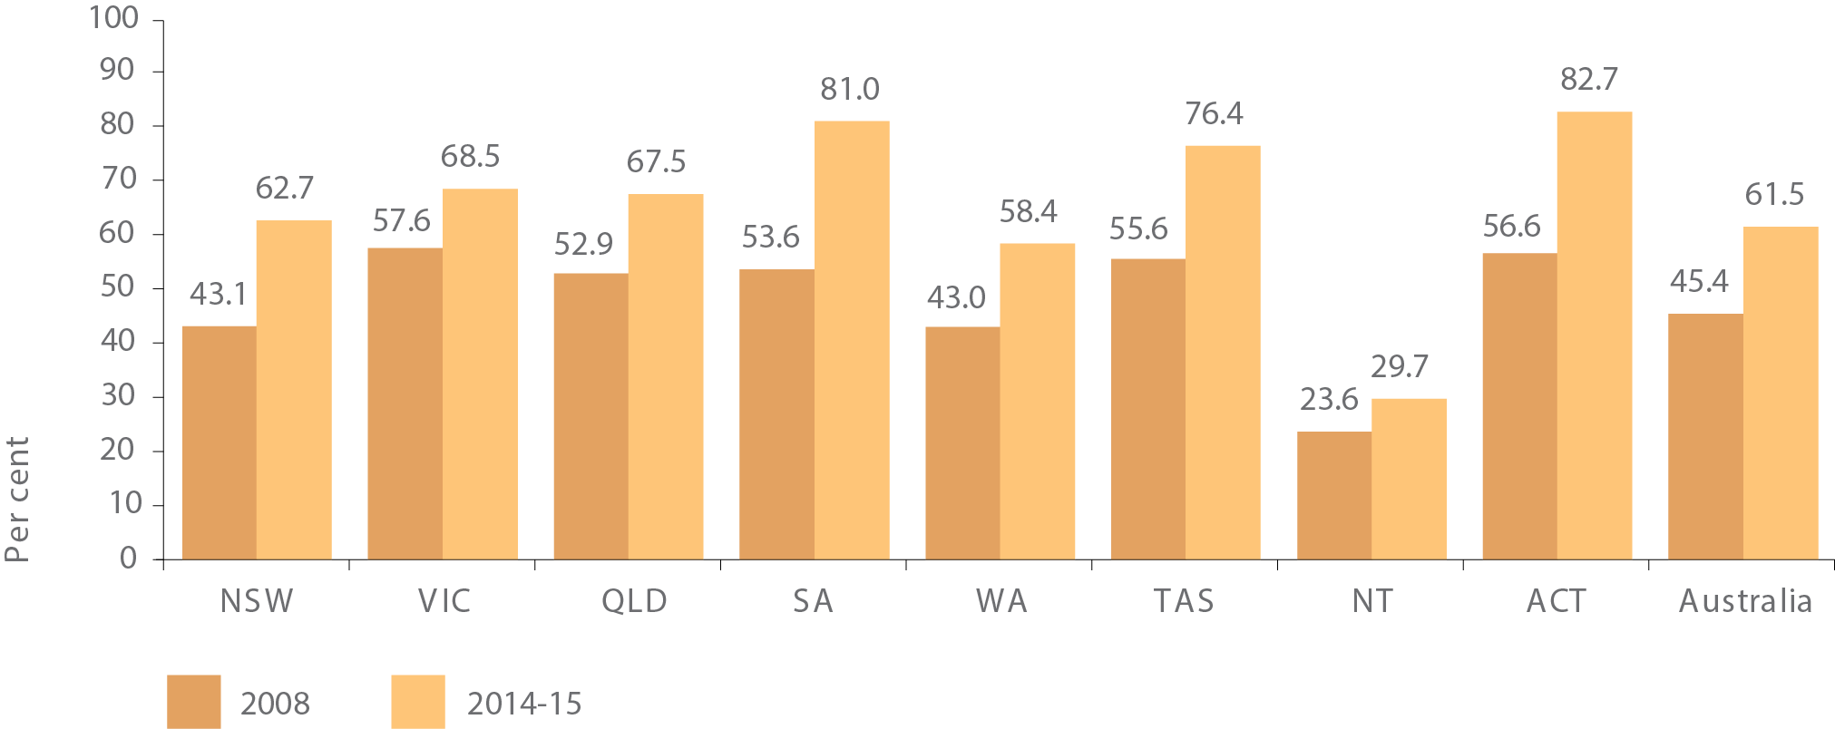
Source: ABS National Aboriginal and Torres Strait Islander Social Survey, 2008 and 2014-15
View the text alternative for Figure 11.

WHAT THE DATA TELLS US
The main data source used to assess progress against this target is the ABS Census. New data will be available from the 2016 Census in October 2017. Data from the 2011 Census showed that this target is on track, with 53.9 per cent of Indigenous Australians aged between 20 and 24 having attained a Year 12 or equivalent qualification, up from 47.4 per cent in 2006.
While not directly comparable with Census data, the ABS National Aboriginal and Torres Strait Islander Social Survey (NATSISS) provides a secondary source of data for this target. New data for 2014-15 was released in April 2016.
According to the NATSISS, between 2008 and 2014-15 rates of Year 12 or equivalent attainment for Indigenous 20 to 24 year-olds increased from 45.4 per cent to 61.5 per cent, while rates for non-Indigenous Australians²⁵ of the same age did not change significantly (from 85.0 per cent to 86.4 per cent). This has resulted in the gap in Year 12 or equivalent attainment rates narrowing by 14.7 percentage points (from 39.6 percentage points to 24.9 percentage points) over this period.
All states and territories have had increases in Indigenous Year 12 or equivalent attainment. The Census data show that between 2006 and 2011 Indigenous results for Western Australia, South Australia, the Australian Capital Territory and the Northern Territory were on track for this target. The more recent survey data also show statistically significant increases for Indigenous Year 12 attainment in the Australian Capital Territory, South Australia, New South Wales and Tasmania between 2008 and 2014-15 (Figure 11).²⁶
Year 12 attainment among Aboriginal and Torres Strait Islander young people aged 20 to 24 years varied considerably by remoteness area in 2014-15, ranging from 69.4 per cent in inner regional areas to 41.7 per cent in remote and very remote areas (see Figure 12). Between 2008 and 2014-15 rates of Year 12 attainment rose across all remoteness areas, but the only statistically significant increases occurred in outer regional areas and very remote areas.²⁷
Another source of data informing on longer term trends is the apparent retention rate, which is an estimate of the proportion of Year 7/8 students who have stayed at school until Year 12. In 2015, the apparent retention rate data suggested that almost 60 per cent of Indigenous students stayed at school until Year 12.²⁸ This is a vast improvement on the late 1990s when only one in three stayed until Year 12. For the most part this rate has been steadily increasing and the gap with non-Indigenous young people has narrowed. The apparent retention rate also reveals higher rates for Indigenous females than for Indigenous males in 2015 (64.1 per cent compared with 54.9 per cent).
There is a close association between low levels of education and incarceration for Indigenous Australians. In 2014-15, Indigenous men aged 25 years and over who had ever been incarcerated were over twice as likely to have an educational attainment level below Year 10 (43.7 per cent) as those who had never been incarcerated (20.6 per cent). The equivalent proportions for Indigenous women in the same age group were 43.5 per cent and 23.5 per cent respectively.
Figure 12: Proportion of Indigenous 20-24 year-olds with Year 12 or equivalent attainment, by remoteness, 2008 and 2014-15
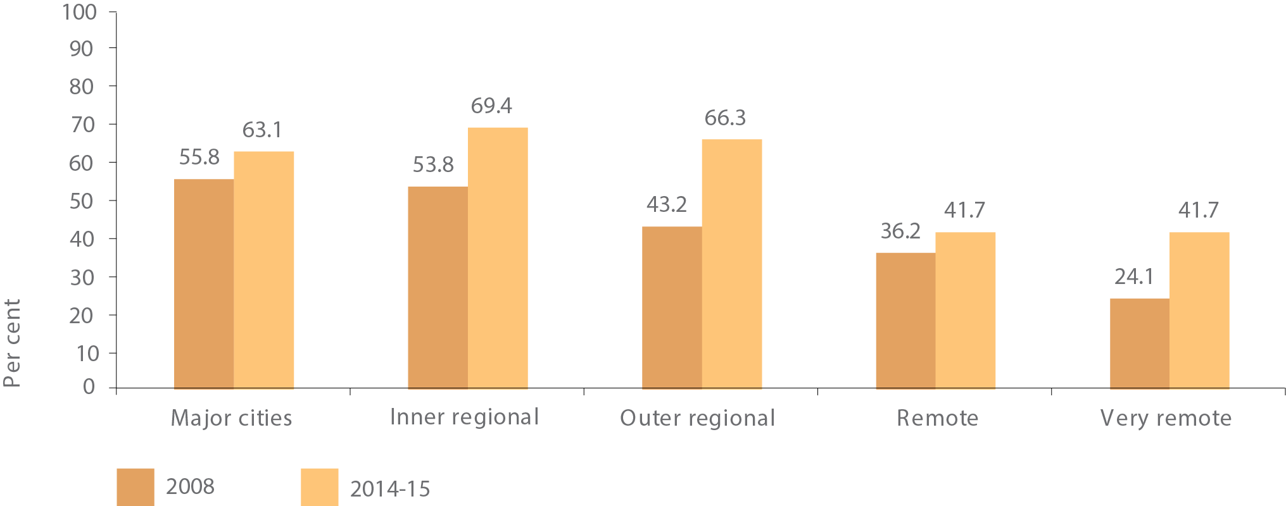
Source: ABS National Aboriginal and Torres Strait Islander Social Survey, 2008 and 2014-15
View the text alternative for Figure 12.

TRANSLATING POLICY INTO ACTION

Studying at home or away from home
Achieving Year 12 or equivalent qualifications sets a solid foundation for moving on to university or starting a career. For many students, particularly from regional and remote areas, finishing school can be challenging and the financial burden difficult to meet.
ABSTUDY addresses the financial burden by providing a living allowance and other supplementary benefits to Indigenous students in school and higher education. During 2015-16, an average of 20,526 school students and an average of 10,316 higher education students received ABSTUDY assistance.
ABSTUDY includes special measures to address the specific circumstances of Indigenous students and their families, particularly those from regional and remote areas. Around 5,700 Indigenous secondary students received ABSTUDY Away from Home benefits at some point during 2015. Most of these students were in boarding schools, or staying in hostels, with a small number in private accommodation arrangements and more than three-quarters had a home address classified as ‘very remote’ or ‘remote’.
The majority of remote Indigenous students live long distances from the nearest secondary school. Many leave communities to complete their secondary education. Throughout 2016, we have undertaken consultations with education authorities, representative bodies and other key stakeholders to clearly identify the issues encountered by Indigenous students, families and schools when accessing and providing support for studying away from home. As a result, we are implementing additional strategies to ensure claims are lodged as early as possible and families are better supported to successfully complete claims.
Around 80 per cent of all ABSTUDY claims are already submitted through a staff assisted telephone service. At the end of 2016, the Department of Human Services began a trial of verbal customer declarations, which removes the need for signed declaration forms to be submitted following a phone call. This is expected to speed up processing of ABSTUDY claims, especially for families in remote areas. The trial will continue until the end of March 2017 and will be assessed. In addition, improved communications materials and strategies are promoting early claiming of ABSTUDY and the importance of starting school on time.

Scholarships and mentoring to support young people
Mentoring, engagement and scholarship programs will support young people to move from school to further education, training and work. Engagement and mentoring activities, such as those delivered by the Clontarf Foundation, Role Models and Leaders Australia and the Australian Indigenous Mentoring Experience (AIME), are critical to engaging young Aboriginal and Torres Strait Islander people with their education in a meaningful way. Providing young people with inspiration and encouragement to attend school through these programs can greatly improve Year 12 completion outcomes.
Scholarships to support disadvantaged Aboriginal and Torres Strait Islander students, mostly from remote locations, to attend high performing secondary schools also means that young people who may not otherwise have the opportunity to attend educational facilities and complete Year 12 are afforded the opportunity to do so.

Vocational education and training delivered to secondary students
Both Indigenous and non-Indigenous secondary students can develop workplace skills through nationally recognised training or an accredited course while studying for their senior secondary certificate. Students who would have once left school early to go to an apprenticeship, or disengaged entirely from education are provided with an alternative pathway to remain at school, undertake Vocational Education and Training (VET) and attain a Year 12 certificate. Studies have found that offering students VET in the senior school years tends to increase school attendance and completion and improve the labour market outcomes of school completers (Bishop & Mane, 2004) (Lamb, 2008).
In 2015, approximately 14,577 (NCVER, 2016) 15 to 19 year old Aboriginal and Torres Strait Islander secondary students participated in a VET course. Of these, 12 per cent (1,742) were undertaking a school-based apprenticeship or traineeship.

HIGHER EDUCATION

WHAT THE DATA TELLS US
We know Indigenous university graduates find work more quickly than their non-Indigenous counterparts and have, on average, higher commencing salaries. Indigenous graduates have very high levels of employment. In 2016 over 74 per cent of Aboriginal and Torres Strait Islander graduates were in full-time employment compared with 70.9 per cent of non-Indigenous graduates (Quality Indicators for Learning and Teaching, 2016).
From 2005 to 2015 there was a 93 per cent increase (from 8,330 in 2005 to 16,062 in 2015) in the number of Aboriginal and Torres Strait Islander students in higher education award courses compared with 47 per cent growth for all domestic students.
Indigenous enrolments in an award course continue to grow more quickly than enrolment rates for all domestic award course students: in 2015 Indigenous students represented 1.5 per cent of domestic students in higher education, up from 1.4 per cent in 2013 and 1.2 per cent in 2005. Females make up 66 per cent of the Indigenous cohort (compared with 56 per cent of all female higher education award course students) (Department of Education and Training, 2016).
Data from the 2011 census shows that Indigenous Australians with bachelor or higher qualifications have very high levels of employment (similar to non-Indigenous graduates), compared to those with Certificate II and below qualifications and those who have no post-school qualifications.

TRANSLATING POLICY INTO ACTION

Supporting Indigenous success at university
While there has been a significant improvement in the enrolment of Aboriginal and Torres Strait Islander students in university over the past 10 years, these students are more than twice as likely to drop out of university in their first year compared to other domestic students. Amongst Indigenous students who had seriously considered leaving university, financial difficulty was the most commonly reported reason (44 per cent). This differs from the broader cohort whose most commonly reported reasons for leaving were health or stress (32 per cent), workload difficulties (30 per cent), study/life balance (30 per cent) and financial difficulties (29 per cent) (Edwards & McMillan, 2015).
The new Indigenous Student Success Programme is providing universities with greater flexibility to address the needs of Indigenous university students to improve enrolment, progression and graduation rates.
The Aurora Education Foundation has been transforming the lives of Aboriginal and Torres Strait Islander Australians through education, growing the numbers of Indigenous leaders, mentors and academic role models. It provides education programs to challenge low expectations, build aspirations and academic potential. Programs include international study tours and scholarships.
The New Colombo Plan supports Australian undergraduates to study and undertake internships in the Indo Pacific region. Between 2014 and 2016, the New Colombo Plan supported a number of Indigenous undergraduate students to study in the Indo-Pacific region. The plan has also recently established the inaugural Indigenous Fellowship, commencing in 2017.
The Indigenous Youth Mobility Pathways Project, funded through the Indigenous Advancement Strategy, offers young Indigenous people from regional and remote communities the opportunity to move to a host location to participate in further education or training. It is an innovative project designed to inspire, excite, educate and encourage the young people’s passion to achieve and attain their long term career goals.

BUILDING THE EVIDENCE
The largest gap in the national evidence base on education is in the evaluation of policies, programs and teaching practices to identify what works best, for whom, and in what circumstances (Productivity Commission, 2016b). A recent literature review of effective teaching practices for Aboriginal and Torres Strait Islander students found that much of the published literature is predominantly in the ‘good ideas’ category rather than rigorous quantitative studies (Lloyd, Lewthwaite, Osbourne, & Boon, 2015).

Accelerating Indigenous Higher Education
The National Aboriginal and Torres Strait Islander Higher Education Consortium, through the University of South Australia, is engaging experts and leaders in university and industry to determine the most effective reform strategies in three priority areas: Indigenous student participation and outcomes in Science, Technology, Engineering and Mathematics (STEM); the number and capacity of the Indigenous academic workforce; and whole-of-university approaches to improving Indigenous higher education outcomes.
Much work has already been done to outline and examine the issues regarding Indigenous higher education. These three areas were identified as priorities based on the Aboriginal and Torres Strait Islander Higher Education Advisory Council’s final advice of 2015. This project will help to translate existing research into clear strategies which can be implemented by government, universities and other higher education providers, and industry in collaboration and with the support of Indigenous leaders and communities.

Strengthening Indigenous identity through education
The Learning on Country Programme was designed to increase school attendance, completion and retention rates, established in four sites in Arnhem Land: Maningrida, Yirrkala, Laynhapuy Homelands, and Galiwin’ku (Elcho Island). An evaluation of the program has found there is strong support from local Elders and senior rangers, as well as the schools which have increased their capacity to address and meet the needs of the Indigenous communities.
Although it was too early in the life of the program to see a statistically significant relationship between the program and school attendance rates – teachers, principals and community members reported a positive influence on school attendance. The program has reported a small number of employment outcomes so far, but has the potential to provide a wide range of employment pathways. The evaluation also found that the program is supporting young people to keep and maintain a strong sense of their Indigenous identity.

Remote School Attendance Strategy
Two major evaluations were undertaken during the first two years of the Remote School Attendance Strategy (RSAS). The interim progress report found that RSAS is having an independently statistically significant impact on school attendance in Queensland and the Northern Territory RSAS schools relative to comparable schools. However, it was hard to determine any obvious impact of RSAS in South Australian, Western Australian and New South Wales RSAS schools. The report also found that the most frequently cited factors for low school attendance across all schools in the study were funerals/cultural activities, poor student behaviour, community unrest and family travel for non-cultural reasons.
The second evaluation, which involved case study research in six communities where RSAS was perceived as successful, found that the ability to adapt RSAS to local conditions is the critical success factor. Four additional high level success factors common to all six sites included an effective and stable RSAS team, a skilled RSAS coordinator, creating relationships with the community and the RSAS team and the school working together.

OUTSTANDING LOCAL SOLUTIONS DELIVERING EXCITING OUTCOMES
“The Horizons Camp has helped with my dreams, culture, being brave, having a good education and being proud of myself.”
– Horizons participant
“I now want to begin my studies at Flinders University and study a bachelor of social work to become a social worker.”
– Kell Gunter IYMP Participant

Supporting principals with cultural understanding
The Remote Principals Project is building the cultural competency of over 140 principals, school leaders and teachers in remote communities. The project works in schools with high numbers of Aboriginal and Torres Strait Islander students in Queensland, Western Australia, Northern Territory, South Australia and New South Wales.
The Commonwealth-funded project is an initiative of the Stronger Smarter Institute, founded by Dr Chris Sarra, a Goreng Goreng man and former school principal.

Community drives school attendance in Fregon, SA
In Fregon, a remote community in the Anangu Pitjantjatjara Yankunytjatjara (APY) Lands of South Australia, positive school habits are being formed early, and families are now getting involved in their children’s education.
The Remote School Attendance Strategy has allowed the community to be innovative in order to achieve better school attendance, with many activities centring around the Fregon Early Learning Centre, enhancing parental engagement.
The Centre is now becoming a ‘community owned’ space, with Child and Family Health Service nurses and visiting specialists using it as the liaison point to undertake health checks, and to provide other vital services to families in community.

Cathy Freeman Foundation, Horizons project
The Cathy Freeman Foundation Horizons Project, is a personal development program providing school students with the tools to finish Year 12 and achieve their goals.
The highest achieving students from the Foundation’s four remote partner communities of Palm Island, Galiwin’ku, Woorabinda and Wurrumiyanga are rewarded for their school attendance and commitment to learning with a week in Melbourne, Sydney or Canberra. The week focuses on a mix of education and cultural activities, including mentoring sessions with Indigenous role models and developing public speaking skills.
The project is supported through the Indigenous Advancement Strategy.
“The biggest impact on the students is gaining confidence in themselves, dreaming big about their goals in the future and keeping their culture strong and alive,” said Clifford Beetham, a teacher’s aide who attended a Melbourne Horizons camp.

Developing tomorrow's Indigenous marine leaders
The Aboriginals and Torres Strait Islanders in Marine Science (ATSIMS) Program combines Indigenous ecological knowledge and cutting edge marine and environmental science through field-based, hands-on curriculum activities for Indigenous students in North Queensland.
High school students can experience life as an Indigenous ranger through learning from the Girringun and Gudjuda rangers. This links with further opportunities for students to get involved in local junior ranger programs to help learn about and protect country.
Education programs like ATSIMS will produce the future leaders in marine science that will advance existing research and marine management techniques and inspire new and innovative research based upon the best that traditional knowledge and modern science has to offer.
“I think this program is important to Aboriginal and Torres Strait Islanders as we can bring two different knowledges and sciences together to accomplish more, and to make sure that we are doing everything we can to protect the ocean,” said Mary Dingley-Paiwan from Pimlico State High School.
Now in its fourth year, the program founded by marine biologist, Dr Joseph Pollock has engaged more than 150 Indigenous secondary students from schools along the Great Barrier Reef coast.

Kurongkurl Katijin, Dreamtime Project
Edith Cowan University’s Kurongkurl Katijin Support Unit is helping achieve increases in Indigenous women enrolling and graduating from the university through innovative initiatives like the Dreamtime Project. The project has seen an increase of 32 per cent in the number of Indigenous women enrolling at the university between 2014 and 2015, with 70 women enrolled in Semester 2 2015. The unit provides cultural support to students and coordinates a wide range of services such as dedicated study areas, academic tutoring, pastoral care and mentoring as well as course and careers advice. In 2017, Kurongkurl Katijin will benefit from the new flexibilities being introduced under the Indigenous Student Success Programme.

Supporting youth pathways
Nineteen-year-old Kell Gunter from Ceduna on South Australia’s west coast is being helped by the Indigenous Youth Mobility Pathways project to support her dream to become a social worker. The project supports Indigenous young people aged 16 to 24 who choose to move away from home to gain qualifications.
Moving to Adelaide to study proved challenging for Kelli, but thanks to the Indigenous Youth Mobility Pathways, Kelli is studying a Certificate 3 in Business Administration and working as an administrative trainee, gaining essential work experience in the process. Her next goal is to start university.

- Current Year 8 figures are the closest approximation available for comparison to the 1976 data for 14 year olds.
- The Indigenous attendance rate was counted as being on track if the attendance rate (rounded to a whole number) was equal or greater than the agreed trajectory point.
- This measure is not yet available for New South Wales Government schools.
- National Assessment Program – Literacy and Numeracy (NAPLAN).
- These trajectory points allow us to assess whether progress is occurring at a sufficient rate to halve the gap by 2018.
- Writing results from 2011 onwards cannot be directly compared to the writing results from previous years, and so have been excluded.
- This only counts students who participated in the test in 2016, excluding those who were absent or withdrawn. Since these numbers are not projected to the target year (2018), they do not have to be adjusted for population growth or potential changes in non-Indigenous rates.
- From 2016, the ABS Australian Statistical Geography Standard (ASGS) Remoteness Structure replaces the previous geolocation classification categories. As a result, the geolocation results obtained from the 2016 NAPLAN are not comparable to those of previous years.
- There was only one significant decline – Victoria in Year 3 numeracy.
- Note that as the smallest jurisdiction, the ACT has the most uncertainty around its results. In 2016, the results for all eight areas were under the trajectory points, but were still consistent with the trajectories due to large confidence intervals around those results.
- This analysis is based on the Longitudinal Survey of Australian Youth which includes results from the Programme for International Student Assessment survey.
- Those with no usual address or with a migratory, offshore or shipping address are excluded, as they cannot be shown on a map.
- Those whose level of highest non-school qualification is at Australian Qualifications Framework Certificate level II or above.
- Comparisons with non-Indigenous Australians for this target are sourced from the ABS Survey of Education and Work 2008 and 2014.
- Due to the small numbers of 20-24 year olds in the survey samples, it is difficult to detect change over time at the jurisdictional level.
- Due to the small numbers of 20-24 year olds in the survey samples, it is difficult to detect change over time by remoteness.
- The apparent retention rate estimates all students who progress to Year 12, not just those who complete Year 12.

CHAPTER 4: EMPLOYMENT
Along with building skills and financial independence, being employed contributes to overall wellbeing. Having a job opens up other opportunities and contributes to improving living standards. It also has a positive flow-on effect for family members and the community more broadly.

Indigenous Defence Force Careers
Since 2010, the Navy led Indigenous Development Program has been helping Indigenous people to benefit from a rewarding career in the Defence Force.
Lieutenant Commander Luke Weston said "the success of these recruits is a shining example of what can be achieved through embracing culture and diversity. With a one hundred per cent completion rate over four programs so far, it is a great initiative for not only Navy and Defence, but also the broader Australian community."
Part of the Navy’s Indigenous Employment Strategy, the program is closely aligned to the Defence Reconciliation Action Plan and the Australian Government’s agreement to increase Indigenous representation in the workforce.
One of the six female participants and recruit of the intake, Kelly Curry, was positive about the experience. "The program has given me the opportunity to learn new skills, to absorb the knowledge of Navy life and the ability to share my Indigenous culture," Kelly said.
“I am very proud of the people we have become and the new outlook we have on life.”
–Participant Kelly Curry
“Through one life-changing job placement at a time, every minute of every day, we will continue to chip away at the disabling issue of intergenerational welfare dependency. Change is occurring. Creating expectation, delivering quality education and providing opportunities through employment will continue to be the change agents that will empower our people and communities. The AES has achieved 20,000 job placements in 20 years. We will not walk away from the wicked challenges in our communities. Together we will face them, and together we will succeed.”
– Kristy Masella, CEO, Aboriginal Employment Strategy
Target: Halve the gap in employment outcomes between Indigenous and non-Indigenous Australians within a decade (by 2018).

KEY POINTS
- This target is not on track. However, Indigenous employment rates are considerably higher now than they were in the early 1990s. Over the years, softening of the labour market has impacted adversely on employment prospects.
- In 2014-15, the Indigenous employment rate was 48.4 per cent, down from 53.8 per cent in 2008. However, the non-CDEP Indigenous employment rate was flat (48.4 per cent in 2014-15 compared to 48.2 per cent in 2008).
- There is a strong link between education and employment – at high levels of education, there is virtually no employment gap between Indigenous and non-Indigenous Australians.
- Governments are setting targets for Indigenous procurement and employment and corporate Australia has been putting in a concerted effort to provide employment opportunities for Indigenous Australians.

WHAT THE DATA TELLS US
Progress against this target is measured using data on the proportion of Aboriginal and Torres Strait Islander people of workforce age (15-64 years) who are employed (the employment rate). New 2014-15 data from the ABS National Aboriginal and Torres Strait Islander Social Survey (NATSISS) was released in April 2016.²⁹
This target is not on track. The Indigenous employment rate fell from 53.8 per cent in 2008 to 48.4 per cent in 2014-15. The non-Indigenous employment rate also declined from 75.0 per cent in 2008 to 72.6 per cent in 2014-15.³⁰ The gap has not changed significantly (21.2 percentage points in 2008 and 24.2 percentage points in 2014-15).
This occurred in the context of a general softening in the labour market over this period. The overall employment rate for all Australians fell from 73.4 per cent in June 2008 to 72.1 per cent in June 2015, with sharper falls evident for men with relatively low levels of education. The employment rate for men with a Year 10 or below level of education fell from 67.4 per cent in 2008 to 60.6 per cent in 2015.³¹ It is therefore not surprising the employment rate for Indigenous men fell sharply from 2008 to 2014-15 as nearly half of all Indigenous men of workforce age have a Year 10 or below level of education.³²
In its independent report on progress against the employment target, the Productivity Commission acknowledged “Aboriginal and Torres Strait Islander Australians have almost certainly been more adversely affected by recent cyclical softness in the labour market” (Productivity Commission, 2015).
Another important factor in the fall in the Indigenous employment rate is the gradual cessation of Community Development Employment Projects (CDEP), in June 2015. During the life of the program, the ABS classified CDEP participants as being employed.³³ Job seekers previously eligible for CDEP are now supported into work-like activities through jobactive and Disability Employment Services (in urban and regional areas) and the Community Development Programme (in remote areas), however are no longer classified as being employed.
To get a more accurate sense of the employment gap, it is better to focus on the non-CDEP employment rate and how this has changed over time. This rate remained flat from 48.2 per cent in 2008 to 48.4 per cent in 2014-15.
It is also worth noting while there has been no progress against this target there have been some longer-term improvements. The Indigenous employment rate was considerably higher in 2014-15 (48.4 per cent) than 1994 (37.6 per cent) (see Figure 13).
Figure 13: Indigenous working age (15-64) employment rates, 1994 to 2014-15 (per cent)
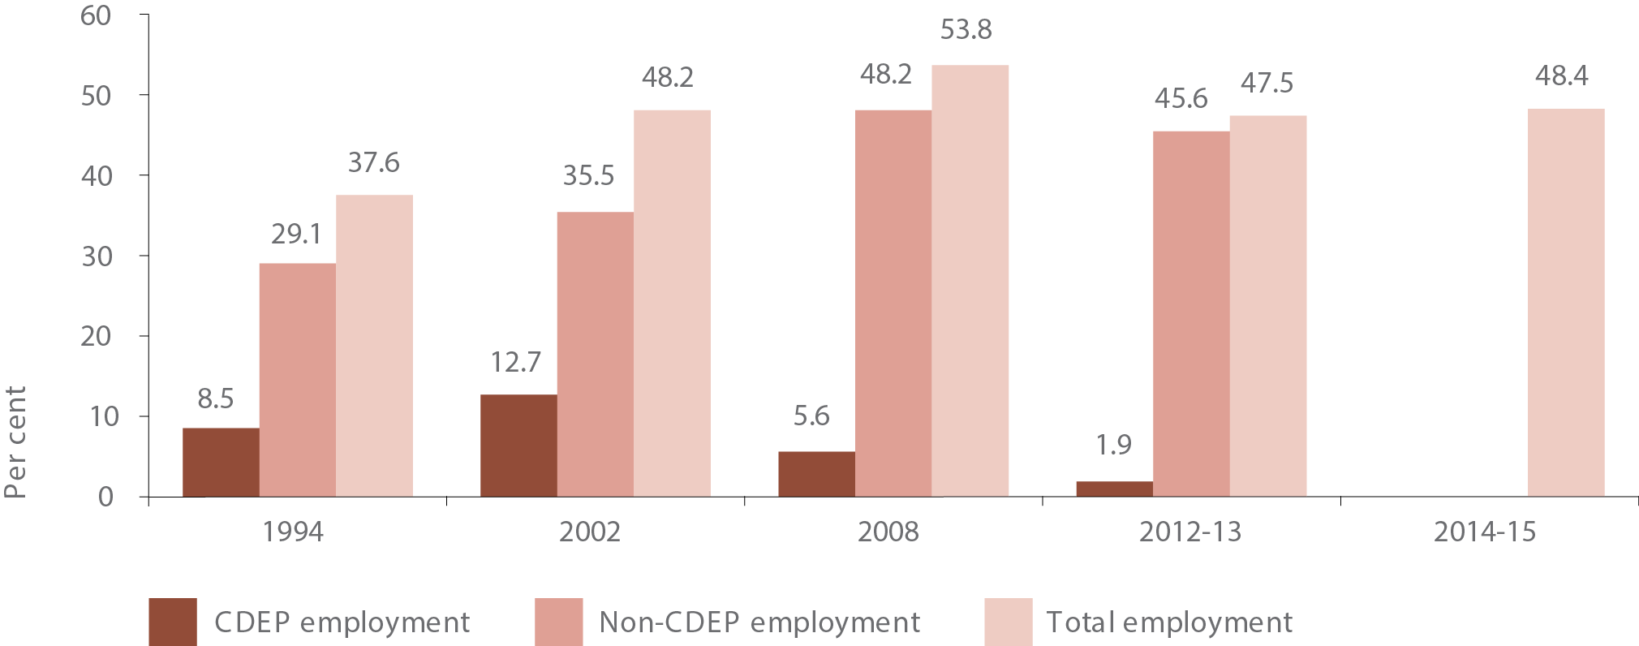
Source: ABS National Aboriginal and Torres Strait Islander Survey 1994, National Aboriginal and Torres Strait Islander Social Survey 2002, 2008 & 2014-15, Australian Aboriginal and Torres Strait Islander Health Survey (core component) 2012-13
View the text alternative for Figure 13.

Remoteness
Indigenous employment rates vary sharply by geography. In 2014-15, only 35.1 per cent of all Indigenous people of workforce age (15-64 years) in very remote areas were employed compared with 57.5 per cent of those living in the major cities. Most Indigenous men of workforce age in the major cities (66.0 per cent), inner regional areas (51.0 per cent) and outer regional areas (51.5 per cent) were employed in 2014-15.

State and Territory
New South Wales was the only jurisdiction that saw an improvement (albeit not significantly) in Indigenous working age (15-64) employment rates between 2008 (47.3 per cent) and 2014-15 (53.1 per cent) (see Figure 14). Between 2008 and 2014-15, changes in employment rates in Victoria, South Australia, Tasmania and the Australian Capital Territory were not statistically significant.
In Queensland, Western Australia and the Northern Territory, employment rates decreased significantly between 2008 and 2014-15. However, interpretation of trends in Indigenous employment in these jurisdictions is affected by the decline in CDEP participants between 2008 and 2014-15. Between 2008 and 2014-15, there was no statistically significant change in the non-CDEP employment rate for these jurisdictions.
In 2014-15, the gap between Indigenous and non-Indigenous total employment rates had decreased since 2008 in New South Wales. The gap for New South Wales is smaller than the gap required to meet the trajectory point for the target in 2014-15, and is therefore, on track. In all other jurisdictions the gap in employment rates significantly increased during this time, apart from Victoria where the increase was not statistically significant.

Gender
The longer-term data tells an important story by gender. Aboriginal and Torres Strait Islander women have made substantial progress in employment over the longer term. The employment rate for working aged women in 2014-15 (43.3 per cent) is higher than the mid 1990’s (28.9 per cent) (Figure 15). Also while Indigenous female employment rates are considerably lower than Indigenous male employment rates, the gap has narrowed considerably since 1994.³⁴
Figure 14: Indigenous working age (15-64) employment rates, by state/territory, 2008 and 2014-15 (per cent)
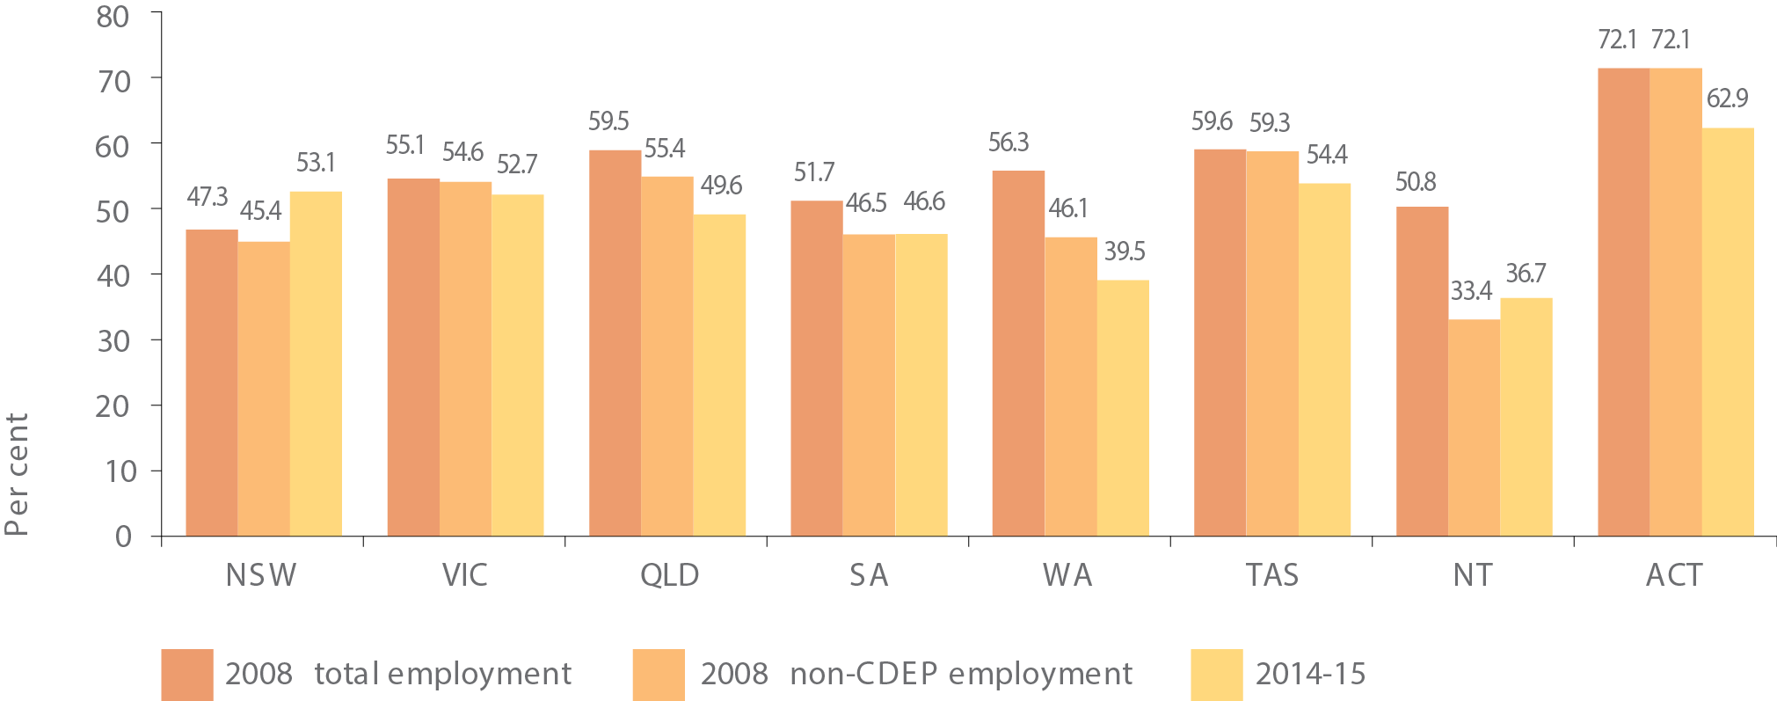
Source: ABS National Aboriginal and Torres Strait Islander Social Survey 2008 & 2014-15
View the text alternative for Figure 14.
Figure 15: Indigenous working age (15-64) employment rates, by sex, 1994 to 2014-15 (per cent)
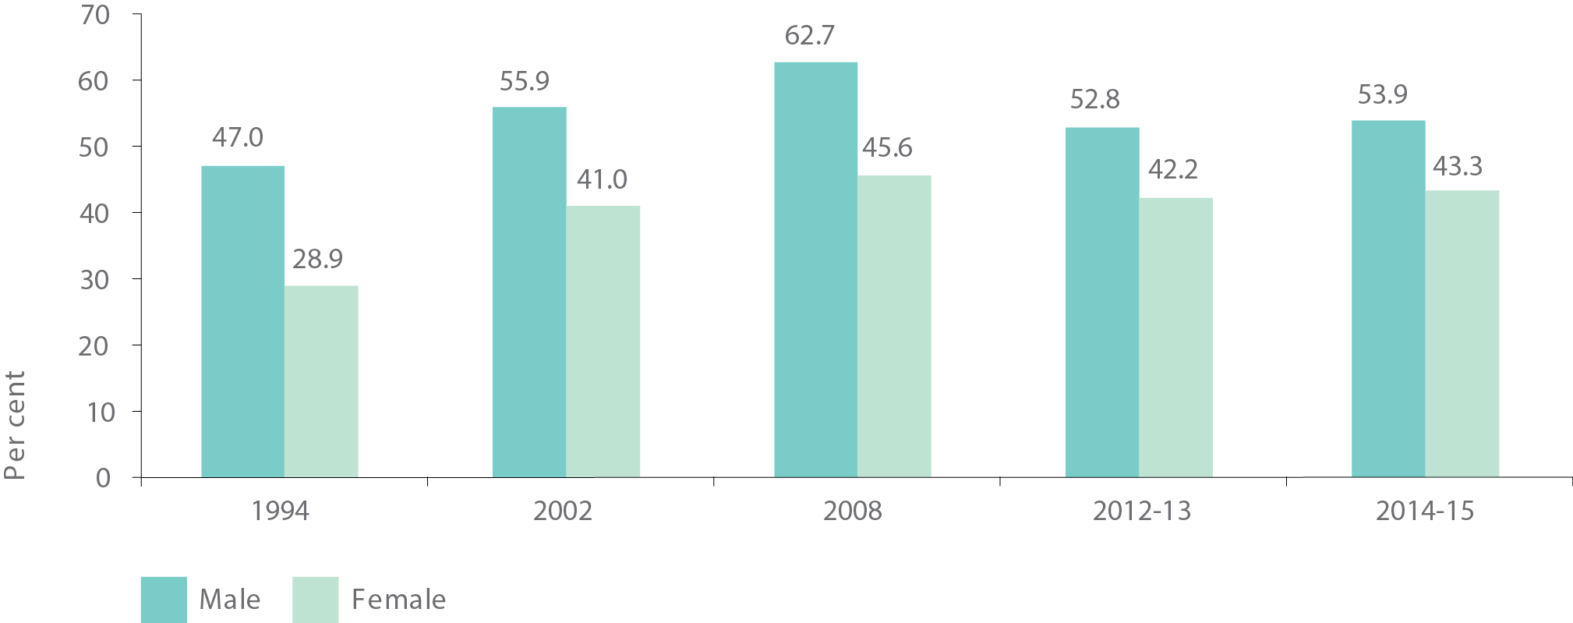
Source: ABS National Aboriginal and Torres Strait Islander Survey 1994, National Aboriginal and Torres Strait Islander Social Survey 2002, 2008 & 2014-15, Australian Aboriginal and Torres Strait Islander Health Survey (Core Component) 2012-13
View the text alternative for Figure 15.

Education and Employment
There is a strong link between education and employment. The employment gap between Indigenous and non-Indigenous people declines as the level of education increases, highlighting just how important education is for closing the employment gap (see Figure 16).
While Aboriginal and Torres Strait Islander people are still considerably less likely to have a Certificate III or higher levels of qualification there have been some longer-term improvements. For example, in 1971 only 4.9 per cent of all Indigenous men aged 20-64 had a post school qualification – by 2011 this proportion had risen to 31 per cent.
While closing the employment gap is very challenging we know improving education levels can make an important difference. In each year cohort the number of Indigenous people is not large. It is critical to start early in making gains in educational attainment. For example, in 2016 there were 16,500 Indigenous 9 year-olds. If we focus on improving educational outcomes for each cohort of school age children, this will in turn have a positive impact on the employment gap in years to come.

Incarceration and Employment
In 2014-15, 21.8 per cent of Indigenous men aged 35 years and over reported having been incarcerated at some time in their life. This proportion is even higher in remote (31.0 per cent) and very remote areas (27.2 per cent).³⁵ This is having a large impact on the employment prospects for Indigenous men. Only 28.4 per cent of Indigenous males aged 35-64 years who had been incarcerated were employed in 2014-15. In stark contrast 65.6 per cent of Indigenous men who have never been to jail were employed. In 2015, Indigenous prison entrants were also 1.4 times as likely to have been unemployed in the month prior to imprisonment compared with non-Indigenous prison entrants (AIHW, 2015).
Figure 16: Employment rate for persons aged 20 to 64 years, by level of highest educational attainment and Indigenous status, 2011
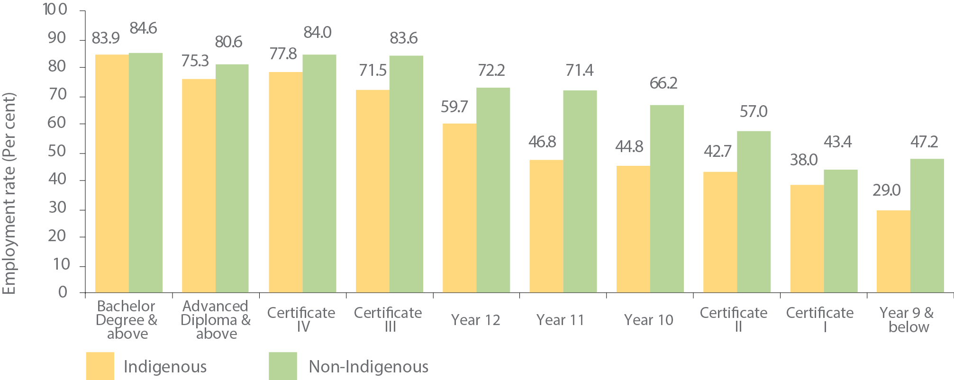
Source: ABS Census of Population and Housing 2011
View the text alternative for Figure 16.

Health and Employment
There is a strong relationship between major chronic diseases, poor/fair health status, carer responsibilities and labour force participation (Belachew & Kumar, 2014) (Hunter, Gray, & Crawford, 2016).

Unemployment
In 2014-15, the unemployment rate³⁶ for Indigenous people of working age (15-64 years) was 20.8 per cent, 3.6 times the non-Indigenous unemployment rate (5.8 per cent) (see Figure 17). Unemployment rates for Indigenous people in very remote areas were almost double the unemployment rates for Indigenous people in the major cities. Nationally unemployment rates for Indigenous males and females were similar (21.0 per cent compared with 20.7 per cent).

Labour force participation
For the Indigenous population it is also important to consider the labour force participation rate, particularly in remote areas, as people may have given up looking for work (due to there being no jobs in their local area, for example) and dropped out of the labour force. In 2014-15, labour force participation rates for Indigenous people of working age (15-64 years) were lower in remote areas compared with non-remote areas. Under half (49.1 per cent) of Indigenous people of working age in very remote areas were participating in the labour force, compared with 67.1 per cent of Indigenous people in the major cities (see Figure 18). Nationally and by remoteness area, Indigenous females aged 15-64 had lower labour force participation rates than Indigenous males in this age group (although the difference in very remote areas was not statistically significant). This difference was greatest in outer regional areas, where 49.8 per cent of Indigenous females aged 15- 64 were participating in the labour force, compared with 68.6 per cent of Indigenous males. This difference in participation rates was also pronounced in the major cities (59.8 per cent for Indigenous females compared with 75.5 per cent for Indigenous males).
Figure 17: Working age (15-64) unemployment rates, by Indigenous status and remoteness, 2014-15 (per cent)
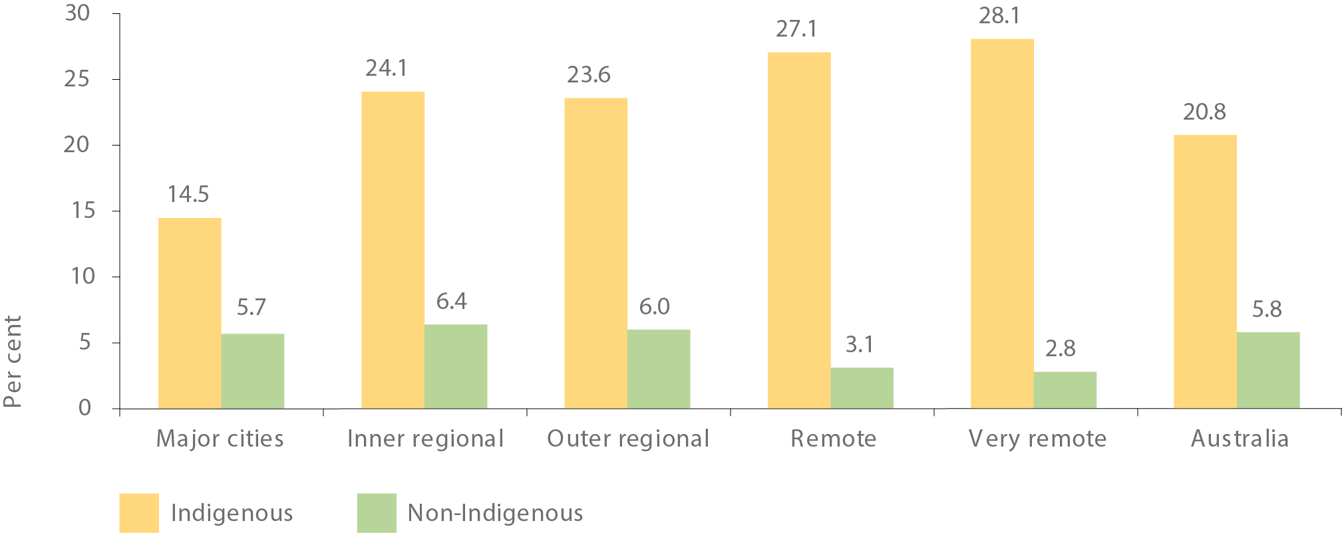
Note: In Remote areas, the unemployment rate for non-Indigenous people has a relative standard error of 25 per cent to 50 per cent and should be used with caution. In Very remote areas, the unemployment rate for non-Indigenous people has a relative standard error greater than 50 per cent and is considered too unreliable for general use.
Source: ABS National Aboriginal and Torres Strait Islander Social Survey 2014-15 and ABS Survey of Education and Work 2014
View the text alternative for Figure 17.
Figure 18: Indigenous working age (15-64) labour force participation rates, by sex and remoteness, 2014-15 (per cent)
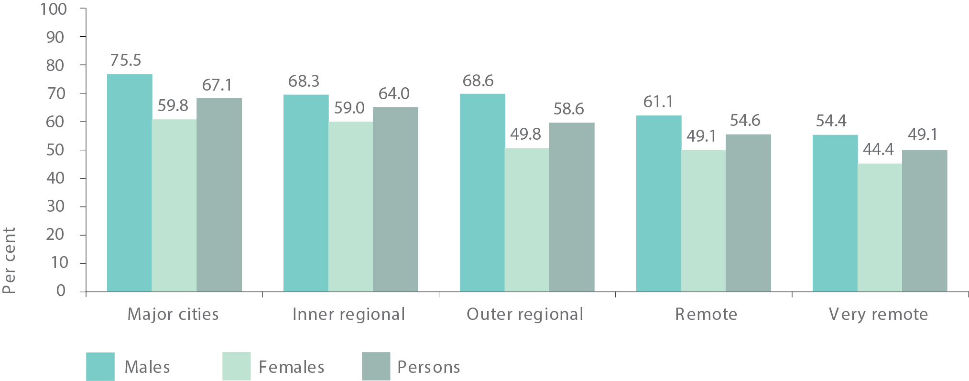
Source: ABS National Aboriginal and Torres Strait Islander Social Survey 2014-15
View the text alternative for Figure 18.
Overall in 2014-15, the Indigenous working age (15-64 years) labour force participation rate was 61.1 per cent, resulting in a gap of 16.0 percentage points when compared to the non-Indigenous participation rate of 77.1 per cent (see Figure 19). The gap for Indigenous females compared to non-Indigenous females was slightly higher (17.0 percentage points) than the participation rate gap between Indigenous and non-Indigenous males (14.3 percentage points).
Figure 19: Indigenous working age (15-64) labour force participation rates, by sex and Indigenous status, 2014-15 (per cent)
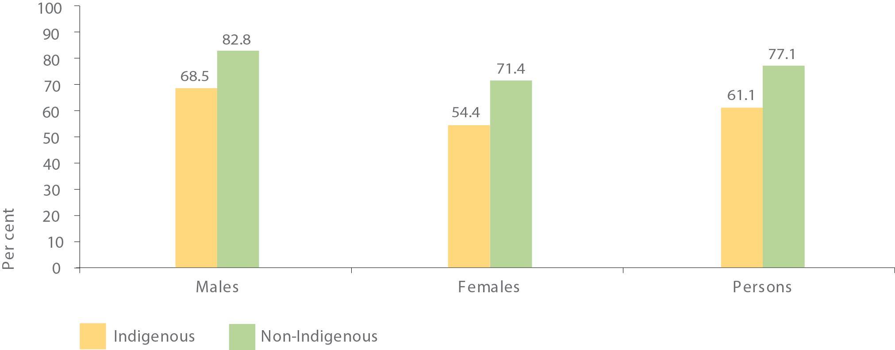
Source: ABS National Aboriginal and Torres Strait Islander Social Survey 2014-15 and ABS Survey of Education and Work 2014
View the text alternative for Figure 19.

NATIONAL POLICY TO DRIVE IMPROVEMENT IN EMPLOYMENT OUTCOMES
While gains in employment outcomes for Indigenous Australians have been hard won, we have seen a concerted effort across government and big business to bring more Aboriginal and Torres Strait Islander people into the workforce. We also know that Indigenous students who graduate from university are more likely to gain employment.
Our Indigenous Procurement Policy (addressed in further detail in Chapter 5) has seen a significant increase in the number of Commonwealth contracts being awarded to Indigenous businesses, which has a flow-on effect for Indigenous employment. We are introducing Indigenous employment and supplier targets in our big infrastructure projects and encouraging big business and state and territory governments to do the same.
All governments have agreed to consider establishing state-specific whole-of-government Indigenous procurement policies and Indigenous employment and Indigenous business targets. Many of the programs that deliver services to the community, such as the National Disability Insurance Scheme, provide an excellent pathway for Indigenous employment.
In addition, utilising Indigenous culture and knowledge, particularly in land and sea management, establishes two-way learning practices while providing career opportunities, often in rural and remote areas.

TRANSLATING POLICY INTO ACTION

Building skills and linking people with jobs
jobactive is the Commonwealth employment service for urban and regional centres connecting jobseekers with employers and is delivered by a network of jobactive providers. Around two-thirds of Indigenous job seekers receiving Commonwealth employment assistance are supported through jobactive, with around 45,500 job placements for Indigenous Australians since the program commenced, as at December 2016. As at 31 December 2016, approximately 75,000 (10 per cent) jobactive participants identified as Aboriginal and/or Torres Strait Islander.
In many remote communities where there are fewer job opportunities, the Government’s Community Development Programme (CDP) offers job seekers a pathway to build their skills, experience and work-readiness through training, individualised support, attending work-like activities and placements in real work settings. Activities are broad, flexible and are designed to contribute to community goals, such as by establishing community gardens, helping in schools or aged care facilities and preserving culture and language. Since July 2015, the Programme has supported remote job seekers into over 12,000 jobs (including nearly 9,000 jobs for Indigenous Australians). In the same period, CDP supported job seekers to stay in over 4,000 jobs for at least six months (including over 2,800 jobs for Indigenous Australians). The Programme is also increasing engagement in skills-building, community-led activities.
Key initiatives like the National Disability Insurance Scheme provide employment opportunities, particularly in remote communities. The Commonwealth and state and territory governments are working closely with service providers to leverage the significant employment opportunities arising.
Through the National Disability Insurance Scheme Sector Development Fund (SDF), one project is trialling the development and implementation of an accredited training package to develop support worker skills for the disability sector in remote communities. The program is being trialled in Barkly region in the Northern Territory, and may be a model for employers and/or governments to consider. The Northern Territory Government is also funded through SDF to grow the remote workforce capacity in the Northern Territory.
Other targeted programs providing Indigenous Australians with important pathways into employment include:
- Vocational Training and Employment Centres – twenty-four Centres are working with jobactive and the Community Development Programme to align job seekers with jobs. They provide training so employers can recruit Indigenous job seekers with the right skills and encourage sustainable, long-term employment. In October 2016, the Prime Minister and Minister for Indigenous Affairs joined in to celebrate the milestone of 5,000 job placements.
- Tailored Assistance Employment Grants – connect people with jobs and help the transition from school to employment. This includes tailored assistance to support employees and employers to address barriers to employment.
- Indigenous Cadetships – provide an important pathway through university and into employment. Employers are funded to support Indigenous university students through their first undergraduate degree and into ongoing employment.
- ParentsNext - helps parents identify education and employment goals and develop a pathway to achieve them once their children are at school.
Specific programs to assist young people with pathways to into the workforce include:
- Transition to Work – offers pre-employment support to 15-21 year-olds, by helping them to understand what is expected in the workplace and to develop the skills and behaviours needed to be a successful employee. To date, over 3,600 Indigenous jobseekers have commenced in the program, which is around 17 per cent of total participants.
- Empowering YOUth Initiatives – funds not-for-profit and non-government organisations to trial innovative approaches to support 15-24 year-olds onto a pathway to sustainable employment. The majority of projects funded to date are focused on delivering services specifically to, or including, young Indigenous people.
- Defence Indigenous Development Program – supports young Indigenous adults wanting to join the defence forces but may encounter barriers in reading, writing or fitness. In 2016, 38 Indigenous people graduated from the program.

Encouraging employers to play their part

Big business playing a role
Building capacity of key employers is vital to ensure that Aboriginal and Torres Strait Islander people have the same opportunities as non-Indigenous people. The Employment Parity Initiative calls on large Australian companies to demonstrate their commitment to workplace diversity and build their Indigenous workforce. The initiative aims for an additional 20,000 Indigenous employees by 2020.
To date, eleven big businesses have proudly created an additional 7,265 new jobs for Indigenous Australians. Participating companies use their networks to encourage other large employers to follow suit and increase Indigenous employment.

Building an Indigenous workforce in the public sector
The Commonwealth has set a target of three per cent Indigenous representation across the public sector by 2018, with individual agency targets based on current Indigenous representation and regional footprint. In June 2016, 2.4 per cent (8,154) of the Commonwealth public sector identified as Indigenous. A breakdown of agencies and progress against their targets is at Appendix A.
We also support pathways into the public sector with Indigenous-specific entry-level programs, including the Australian Public Service Indigenous Graduate Program, the Indigenous Australian Government Development Programme, the Indigenous Apprenticeship Programme and the Australian Public Service Indigenous Traineeship Program.
The Commonwealth Aboriginal and Torres Strait Islander Employment Strategy supports cultural awareness, increasing Indigenous representation in senior roles and investing in capability of Indigenous employees. A dedicated Commonwealth employment portal has also been established (www.indigenouscareers.gov.au).

Removing the barriers to employment

Helping prisoners find work
Indigenous Australians are staggeringly overrepresented in our prison system. In 2016, 27 per cent of the incarcerated population identified as Aboriginal and/or Torres Strait Islander. While there are a range of factors influencing Aboriginal and Torres Strait Islander incarceration rates, access to meaningful and stable employment can play an important role as a circuit-breaker for Indigenous re-offending.
Figure 20: School attainment of Indigenous adults (18 years and over), by disability status, 2014-15 (per cent)
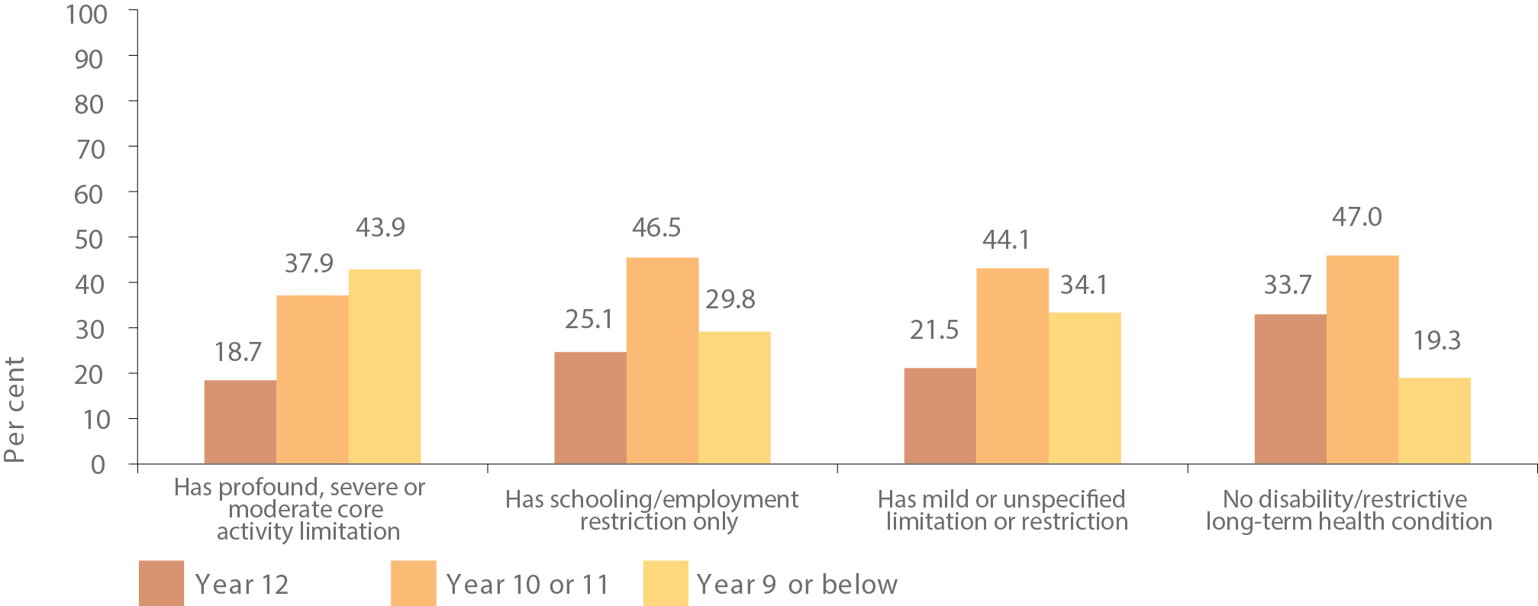
Source: ABS National Aboriginal and Torres Strait Islander Social Survey 2014-15
View the text alternative for Figure 20.
In December 2016 COAG released the Prison to Work Report, which recognises the alarming rate of Indigenous incarceration and recidivism and explores ways to support Aboriginal and/or Torres Strait Islander prisoners to transition from incarceration to employment. All governments have committed to better coordinating government services, including in-prison training and rehabilitation programs, and employment, health and income support services. The Commonwealth is working bilaterally with states and territories to develop action plans to support re-integration into communities and reduce recidivism. This includes addressing barriers to employment and improving the coordination of services across and within all jurisdictions.
The collaborative spirit of the Report is a reflection of the collective commitment of all governments to creating positive pathways to employment from prison for all adult Aboriginal and Torres Strait Islander offenders. This consultation-led approach reflects the importance all governments place on working with communities to identify problems and tailor solutions.

Supporting people with disability into employment
There is a clear relationship between education, employment and disability for Aboriginal and Torres Strait Islander adults. Indigenous adults with a disability are less likely to have completed Year 12 than those without a disability (18.7 per cent compared with 33.7 per cent) (Figure 20).
Disability has a large impact on Indigenous employment. The majority of Aboriginal and Torres Strait Islander people of workforce age without a disability were employed in 2014-15 (54.9 per cent). In contrast only 39.7 per cent of Aboriginal and Torres Strait Islander people with a disability were employed (Figure 21).
Disability Employment Services is a specialised employment support program for people whose disability is their main barrier to gaining employment. Around 10,000 Indigenous jobseekers are supported. Other programs, such as the School Leaver Employment Supports, the JobAccess gateway and the Employment Assistance Fund, provide services to people with disabilities and their potential employers to support pathways to employment.
Complementary support to address non-vocational barriers to employment for people severely affected by mental illness is provided through Personal Helpers and Mentors services. To date, six Aboriginal-controlled organisations are funded to provide services. The Government actively seeks to fund Indigenous-controlled organisations to deliver community-based mental health support services in communities where the population is predominantly Indigenous.

Supporting Indigenous Australians to get drivers licences
Not having a drivers licence, or losing a licence can be a significant barrier to employment. Austroads, has recently released a report with recommendations to support Indigenous Australians to get and keep their drivers licence. The report recommends states and territories work together to develop common national policy principles for Indigenous driver license service delivery.
Figure 21: Indigenous working age (15-64) employment rates, by disability status, 2014-15, (per cent)
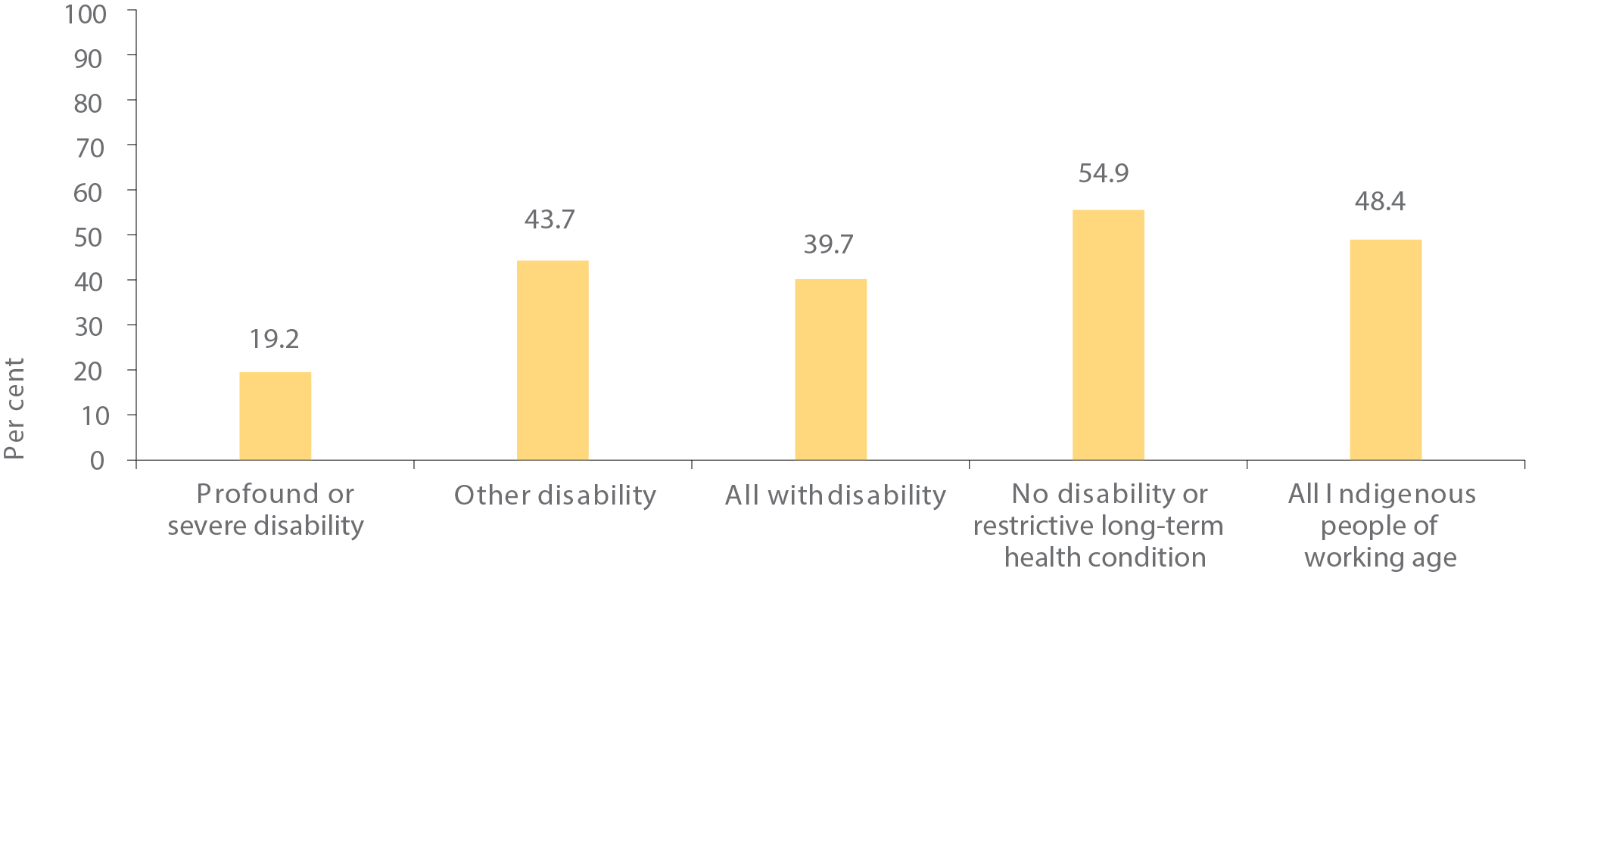
Source: ABS National Aboriginal and Torres Strait Islander Social Survey 2014-15
View the text alternative for Figure 21.

Boosting employment opportunities while caring for country
The benefits of having Aboriginal and Torres Strait Islander people involved in land and sea management are two-fold – the significant knowledge of land and sea country, having successfully managed and protected it for many generations, provides a unique perspective and brings a diversity of skills to environmental management. Additionally, working on country helps preserve the strong cultural connection between Indigenous Australians and their land, reaping a wide range of social and economic benefits for local Indigenous communities.
More than 2,600 Aboriginal and Torres Strait Islander people are employed as Indigenous rangers through the Indigenous Rangers and the Indigenous Protected Areas programs:
- Indigenous Rangers – funds 777 full-time equivalent Indigenous ranger positions, providing approximately 2,000 people with employment in full-time, part-time and casual ranger jobs. Junior ranger programs are also encouraging school attendance while passing down cultural and ecological knowledge.
- Specialised Indigenous Rangers – provides formal qualification and recognition of the technical role rangers play in protecting our ecosystem. It also enables rangers to stop people doing the wrong thing on land and sea.
- Indigenous Protected Areas Program – employs over 600 Aboriginal and Torres Strait Islander people work in full-time, part-time and casual positions. It encourages Indigenous communities to voluntarily dedicate their land or sea country as part of the national reserve system, many of which are cared for by Indigenous rangers.
Parks Australia and Traditional Owners have joint responsibility for the ongoing management of three national parks (Kakadu, Uluru-Kata Tjuta and Booderee). Traditional land management skills and Indigenous knowledge are used in park management and Indigenous employment is a key priority. Overall, Indigenous employment across Parks Australia has increased in recent years. In 2015-16, 23.5 per cent of all employees identified as Indigenous (up from 16 per cent in 2013-14). Staff voluntarily identify as Indigenous in Parks Australia.
Traditional Owners also work in partnership with the Commonwealth and Queensland Governments to manage traditional use activities of the Great Barrier Reef. Traditional Owners share knowledge of sea country management and are supported by five coordinators to effectively co-manage the park.
One of the real success stories and achievements of the Great Barrier Reef Marine Park Authority is its ability to attract and maintain the employment of Aboriginal and Torres Strait Islander staff. Around six per cent of the staff are Aboriginal and/or Torres Strait Islander, with around half of them having worked for the Authority for over 15 years.

BUILDING THE EVIDENCE
An evaluation of the Community Development Programme (CDP) is currently underway. It will include analysis of administrative data and field research (including surveys and interviews) with CDP participants, former participants, and other community members in a selection of eight remote communities. This will provide information on the broader impact of the programme and help explain variation in programme outcomes. The evaluation is due to be completed by April 2018.
The Department of Employment, with its established expertise in evaluating labour market programs, is evaluating how its programs help Indigenous people find and keep employment, improve skills, and become job ready. Initiatives to be evaluated include jobactive, Transition to Work, ParentsNext, Empowering YOUth Initiatives, Youth Jobs PaTH, Relocation Assistance to Take Up a Job, the National Work Experience Program and the Enhancing Entrepreneurship measures.

OUTSTANDING LOCAL SOLUTIONS DELIVERING EXCITING OUTCOMES
“Stick to it, it’s worth it and will start your pathway to bigger and better things.”
– Montana AhWon, NIADOC 2016 Apprentice of the Year
“My long-term aspiration is to become an Aboriginal Education Officer and guide other Aboriginal and Torres Strait Islander youth in the right direction to achieve their goals with a little hard work.”
– Ashlen Foster-Britton, Indigenous Apprenticeships Programme Graduate
“The best part of the job is getting to know our clients and becoming a part of their lives and I get a lot of satisfaction when I hear what changes I have made to the lives of people I drive around.”
– Jacob Keed

Community development programme delivering in construction jobs at Ironbark, NT
With the construction boom in Northern Australia, there are unique employment opportunities for remote residents.
A collaboration between Community Development Programme provider Ironbark Aboriginal Corporation and Charles Darwin University has delivered the Certificate III in Civil Construction (Plant) at Ironbark’s Adelaide River site, one hundred kilometres south of Darwin.
Fifteen Community Development Programme participants from regional towns attended the training where they learnt to operate machinery in a safe environment.
Post-training, Ironbark linked participants with recruitment agencies in the construction industry, with twelve of the participants securing employment with construction projects.

Kunurra young apprentice of the year, WA
Montana AhWon is an 18-year-old Miriwoong Gajeroong woman from Kununurra in East Kimberley and winner of the 2016 NAIDOC Apprentice of the Year.
After leaving school early, Montana realised she needed some training to open up opportunities for her future. Montana started with a hospitality pre-employment course offered by Kimberley Group Training, a Vocational Training and Employment Centre provider, and after excelling in that, she completed a Certificate II in Hospitality.
Montana is now working for Wunan House Bed and Breakfast, where she has a well-deserved reputation for dedication and professionalism. Passionate about her career, Montana is keen to soak up as much experience in the hospitality industry as she can. She also has her sights firmly set on continuing her studies and gaining business qualifications in the future.

Jobactive delivers for young Daniel
Indigenous youth Daniel McKechnie made the most of jobactive opportunities when he joined the Sawtell Golf Club under the Work for the Dole initiative. The initiative places job seekers in activities where they can gain skills and experience that give back to the community and can help them find a job.
According to Alvin Kan, the General Manager at the Sawtell Golf Club, Daniel had been with the club for just over three weeks when they offered him a permanent role.
“We could see that Daniel really enjoyed the work and was enthusiastic. A position became available and so we decided to take him on as an apprentice greenkeeper,” Mr Kan said.
Daniel said he came into work early each day and worked hard to prove himself to the club.
“This was the type of work that I really wanted to do. I love working outdoors and with nature. It’s good to be out in the fresh air and to work with good people,” Daniel said.
“This is my first full-time job and it’s great to have the reliable work and income. It helps with my life situation at the moment and it’s great that I get a qualification at the end as well.”
“My friends and family are all proud of me.”
“Now I’m lucky to have one of the most multi-skilled apprenticeships out there – learning about machinery, chemicals, plumbing and horticulture.”

Cadetships deliver for twins
Twins Barbie-Lee and John Kirby have been supported by CareerTrackers to undertake their undergraduate degrees. Barbie-Lee secured a cadetship with Qantas and upon graduation from university in 2015, earned a position in the Qantas graduate program. John’s cadetship is with CPB Contractors and he expects to graduate from university in 2017.
The cadetships have allowed the twins to focus their efforts on their studies without having to worry about how to pay the bills.

Thursday Island Boat Club upgrade
The Thursday Island Boat Club upgrade was a year-long project that commenced in December 2015 and provided Community Development Programme (CDP) participants an opportunity to gain new skills and provide a pathway from training to employment. The Boat Club was a much used centre for youth sports, recreation and community events and had long needed revitalising to give the whole community a refreshed venue for community gatherings.
“The renovation of the club facilities has been an aspiration of the Association for a long time and the Association is very happy that a large proportion of the work will be completed by unemployed youth under the direction of skilled builders,” said Alan Filewood, President of the Torres Strait Youth Recreational Sports Association. CDP provider My Pathway mentor, Gavin Bin Juda said ‘Working with ‘Bob’ [John Brown, site Foreman] was good. We got a heap of boys employed which was my goal. Watching and learning about the little things was amazing. I always wondered, how do you do that? And now I know!’.
By using this project as a launching platform, 19 CDP participants have gained full-time paid employment and successfully exited the program with a range of new skills, experience and qualifications.
The Commonwealth Government’s Community Development Programme is creating better opportunities for job seekers in remote Australia and strengthening remote economies.

Spotless supporting Indigenous jobs in Melbourne, VIC
As an Employment Parity Initiative employer, Spotless engaged Damien Seden in March 2016 to work with the catering team across the three National Australia Bank buildings in Melbourne. Damien’s self-esteem and confidence has grown considerably since he started work and he is regarded as one of the best caterers on the team. Damien’s manager has said “He’s a great role model and I think he’s a great candidate for a supervisor role in the near future”.

Jobs through national tourism
An initiative of the National Museum of Australia in 2016-17 was the inaugural Encounters Indigenous Cultural Workers Scholarships program. This three-month long program enabled six Indigenous participants to work at the Museum and in their communities on a culturally focused project. It also provided an opportunity to participate in programs both at the Museum and at The Prince’s School of Traditional Arts in London.

Ashlen’s success after Indigenous Apprenticeships Programme
A Wiradjuri woman from regional Queanbeyan in NSW, Ashlen Foster-Britton is an inspirational young leader determined to empower other young people to achieve success.
Looking to the future, Ashlen joined the Indigenous Apprenticeships Programme, which provides a pathway of employment and structured learning for Indigenous Australians to start their career in the Australian Public Service.
“I have a passion for Indigenous Affairs and wanted to be in a position where I could contribute and make a difference in Indigenous lives” Ashlen said.
Juggling full-time employment with her studies, Ashlen has now successfully completed a Diploma in Government.

Flexible employment at Green Glass in Alice Springs, NT
Green Glass Consulting employs a pool of appropriately skilled Aboriginal and Torres Strait Islander workers to meet the labour requirements in the Alice Springs region. Flexibility in their employment model enables employees to have time away from work to attend to family or cultural commitments.
Green Glass participates in the Northern Territory Government’s Sentenced to a Job program, supporting employees when they are released from prison. This includes finding accommodation, negotiating the repayment of any outstanding debts and providing transport to and from work. Green Glass works to link employees with appropriate support services where possible.
Green Glass has provided support to female participants in the Sentenced to a Job program to work at an Alice Springs hotel for the past 18 months. One woman has continued to work in the hotel since her release, while the second woman is preparing for release. Additionally, Green Glass has recently negotiated employment for a prisoner in the Sentenced to a Job program on a mine site.

Top of the Town in Tennant Creek, NT
Tony and Heather Watson operate the Top of the Town Café in Tennant Creek and employ prisoners through the Northern Territory Government’s Sentenced to a Job program. The program provides Tony and Heather with access to a reliable local workforce in a region where the retention of staff is an ongoing challenge. Tony and Heather support their employees in many different ways after they are released from prison, including helping them to find housing in Tennant Creek and reintegrate back into the community.

Driving success in the ACT
Jacob Keed is helping the most vulnerable of his mob remain connected to the community, while busy studying so he can continue to help in the future.
Jacob, a Wiradjuri and Kamiloroi man living in Canberra, works for the Aboriginal and Torres Strait Islander community bus service, transporting local Indigenous people to everything from appointments to cultural activities.
“I really enjoy the work as it is much more than being a bus driver,” said Jacob.
“One unemployed single mother who didn’t have transport felt cut off from the world. Because of our relationship with other community groups, we were able to link her to the services she needed and now she has a job and is getting out in the community and has a completely new life.”

Cape York Biosecurity officers protecting QLD coast
Eric Cottis is a proud Gudang man from the Northern Peninsular Area of Cape York, with family connections in Badu, Mabuiag and Saibai Islands in the Torres Strait.
He is one of the many dedicated biosecurity officers working to keep northern Australia safe from exotic pests and diseases, working as a Community Liaison Officer and Ambassador for the Department of Agriculture and Water Resources in the Torres Strait.
“I'm the senior staff member in our department's office in Bamaga on the tip of Cape York. I also work out of our main Torres Strait office on Thursday Island as a Community Liaison Officer.” Eric said.
Eric and his team are responsible for helping safeguard the Australian mainland from biosecurity risk material being transported by boats, yachts and people through the Torres Strait.
“I really enjoy what I do, not only do I work on different projects but I also get to experience other Indigenous cultures which is very important to me.”
“I think one of the strengths I bring to my role is being of mixed race, both Aboriginal and Torres Strait lineage.”

Solar energy options in NT
The Northern Territory Solar Energy Transformation Program is integrating solar power into existing diesel power stations in around 30 Indigenous communities in the Northern Territory. The program includes a requirement for Indigenous employment on all projects, including for site preparation and installation.

Ngarrindjeri knowledge in SA
Over the last five years, the Ngarrindjeri people have been closely involved in the natural and cultural resource management of their wetlands as part of the Coorong Lower Lakes and Murray Mouth Recovery Project. This two-way learning project has built Ngarrindjeri knowledge and understanding of planning, legislation and non-Indigenous natural resource management practices, while sharing Indigenous cultural knowledge in caring for country. The Ngarrindjeri Elders play an important role in transferring skills and knowledge to the next generation. The project has created real employment for Ngarrindjeri people and has strengthened the relationship between the South Australian Government and the local community.

Truwana rangers caring for country in Tasmania
Around Australia, Indigenous Rangers are working hard caring for their country – they are looking after endangered native animals and ecosystems, stopping feral animals from damaging waterholes and performing controlled burnings.
In Tasmania, the locals are quietly but effectively looking after Truwana, which is the local Aboriginal language word for Cape Barren Island.
When Truwana was returned to Aboriginal ownership in 2005, locals were determined to take the lead caring for their country. With funding through the Indigenous Advancement Strategy, there’s now a team of five Truwana On Country Rangers working to protect the island's cultural and natural assets.
The Rangers are working closely with Elders to include traditional cultural and environmental management and make certain traditional spirituality is taken into account in all their work.
It’s clear that the Rangers have proven their worth to Truwana in not only ensuring protection of the Island they call home, but also their continuing cultural practices and self-reliance.

- Labour force data for Indigenous Australians will also be available in 2017 from the 2016 Census.
- Comparisons with non-Indigenous Australians for this target are sourced from the ABS Survey of Education and Work 2008 and 2014.
- Unpublished data from the ABS Survey of Education and Work.
- Unpublished data from the 2011 Census for Indigenous men aged 20-64. There was no statistically significant change in the Indigenous female employment rate from 2008 (45.6 per cent) to 2014-15 (43.3 per cent).
- CDEP was a Commonwealth employment program in which participants were paid CDEP wages (derived from income support) to participate in activity or training. As CDEP was wound down and participation declined, many of these individuals transferred across to other employment services such as Remote Jobs and Communities Program, where they received income support and were then counted as unemployed. For 2014- 15 the ABS did not collect information on CDEP participation as the number of CDEP participants was negligible.
- Indigenous male employment had been impacted by the decline in the number of CDEP participants. The Indigenous male non-CDEP employment rate rose from 34.9 per cent in 1994 to 55.3 per cent in 2008 before falling to 50.1 per cent in 2012-13. The equivalent figures for Indigenous women are 23.7 per cent, 41.6 per cent and 41.2 per cent.
- These statistics, stark as they are, understate the situation, as current prisoners are excluded from the NATSISS. If we add Indigenous men aged 35 and over who were in jail in 2015, then 24.4 per cent of all Indigenous men aged 35 and over (rather than 21.8 per cent) have already been in jail at least once in their life.
- The number of unemployed people as a proportion of the number of people in the labour force.

CHAPTER 5: ECONOMIC DEVELOPMENT
Indigenous economic development is at the heart of the national agenda. We are working with Aboriginal and Torres Strait Islander people to recognise the tremendous potential of the Indigenous business sector and create more opportunities for growth.

Gunyangara township lease to boost economic development, NT
In 2016, the first township lease on the mainland Northern Territory was approved by the Northern Land Council for the Arnhem Land community of Gunyangara. Driven by the community, the 99 year lease will provide local control over long-term tenure and support the economic and social development work underway by the Gumatj people, the Traditional Owners of Gunyangara.
Gumatj Corporation runs a range of businesses in Gunyangara and the Gove Peninsula area to support local employment, including a saw mill and timber works, concrete batching plan, construction joint venture, a cattle farm and butcher, shop, café and nursery and the first Indigenous-owned and operated mine in the Northern Territory.
The township lease will provide long-term, tradeable tenure to support the ongoing development of these businesses and the creation of new business and rental returns which will be reinvested in the community. It also provides suitable tenure to enable investment under the Remote Housing Strategy, with $5 million being provided to build employee houses in Gunyangara. This will provide Gumatj Corporation with further private housing to reward long-term employees. The housing will be built by Gumatj Corporation, using materials from their saw mill and concrete batching plant.
“Foster economic development in Northern Australia, where 43 per cent of land is held under native title, must not be a wasted opportunity.”
– Bruce Martin
“We work closely with our local remote Indigenous communities to understand the aspirations of the community and collaboratively identify ways to bring them to reality.”
– Alastair King, ALPA CEO
“Tiwi people are for the first time in a position to own their own home, realising the ‘great Australian dream’ that the rest of Australia takes for granted.”
– Mr Kerinaiua Senior, Mantiyupwi Traditional Owner

KEY POINTS
- All governments are prioritising Indigenous economic participation – driving demand for Indigenous businesses while also helping to build supply and capacity.
- The Australian Government’s new Indigenous Procurement Policy has seen Government contracts valued in total at $284.2 million awarded, a 45-fold increase on previous years.
- Indigenous businesses are active across all sectors of the economy
- Land is a significant asset base for Aboriginal and Torres Strait Islander people. Governments are working on how they can better support communities to leverage their land assets for economic development, as part of the mainstream economy.

NATIONAL POLICY TO DRIVE IMPROVEMENT IN ECONOMIC DEVELOPMENT
Governments are collaborating with Indigenous leaders and communities to provide better opportunities for Indigenous Australians to engage in the economy and increase employment prospects.
This follows a collaborative effort from governments to improve Indigenous land administration, enabling Traditional Owners to attract private sector investment and finance to develop their own land with new industries and businesses.
In addition, the Commonwealth is looking at ways to apply Indigenous Procurement Policy principles to other forms of Government spending, including grants and is developing an Indigenous Business Sector Strategy to build economic empowerment and independence.
Indigenous businesses around Australia are doing fantastic things from mining and construction to renewable battery storage and fibre optics. However, there is a clear gap in the rates of self employment of Indigenous people compared to non-Indigenous people – Aboriginal and Torres Strait Islander people are around three times less likely to be self-employed than non-Indigenous Australians.

TRANSLATING POLICY INTO ACTION

Harnessing purchasing power and driving demand
The Indigenous Procurement Policy, introduced in July 2015, is harnessing the purchasing power of the Australian Government to drive demand for goods and services delivered by Indigenous owned businesses. Supply Nation’s Indigenous Business Direct is the first reference point for government buyers when fulfilling targets under the Indigenous Procurement Policy. Indigenous Business Direct is equally valuable as a resource for any procurement professional or buyer.
Just one year of the policy has seen substantial increases in the number of Commonwealth contracts awarded to Indigenous-owned businesses. In the first year, 493 Indigenous businesses were awarded 1,509 contracts, totalling $284.2 million (up from $6.2 million in 2012-13).³⁷ In July 2016, minimum requirements for employing Indigenous Australians and using Indigenous businesses in an Australian Government contractor’s supply chain came into effect. The mandatory minimum requirements apply to contracts valued at or above $7.5 million in eight industry sectors. The requirements ensure that Indigenous Australians gain skills and economic benefit from some of the larger pieces of work that the Commonwealth outsources, including in remote areas.
In addition, more corporate businesses are adopting Indigenous supply chains and providing opportunities for Indigenous businesses in their purchasing power, including Employment Parity Initiative employers, such as Woolworths, Telstra and Crown Resorts.
The Government has agreed, building on the success of the Indigenous Procurement Policy, to develop an Indigenous Grants Policy which would apply to Commonwealth grants that are intended to benefit Indigenous Australians and their communities. The purpose of the Policy is to ensure Indigenous Australians have strong involvement in relation to Commonwealth grant activities that have a direct benefit for Indigenous Australians.

Developing Indigenous businesses, entrepreneurs and innovators
We’ve increased demand for Indigenous businesses, goods and services. It is important we continue to support Indigenous sector growth. Given that Indigenous-owned businesses are significantly more likely to employ Indigenous people than non-Indigenous businesses, the development of the Indigenous business sector will not only empower Indigenous Australians, build wealth and independence, it will also create significant employment opportunities for more Indigenous Australians over time.
In consultation with Indigenous business owners, business support providers and other key stakeholders, the Australian Government is developing an Indigenous Business Sector Strategy. The Strategy will provide Indigenous entrepreneurs with a clear roadmap to take advantage of the increasing opportunities available to Indigenous businesses.
Indigenous Business Australia’s Business Development and Assistance Programme supports Indigenous entrepreneurs to start and grow their own businesses. The programme offers concessional loans, workshops, and business advice to Indigenous businesses, including advice about how to identify and access supply chain opportunities, such as those created through the Indigenous Procurement Policy.
Indigenous Business Australia’s Equity and Investments Programme co-invests with Indigenous businesses in commercial ventures, facilitating sound financial returns while building commercial capability and generating employment. In June 2016, the investment portfolio was valued at $407.9 million, of which just over a quarter was held by Indigenous partners.
The $90 million Indigenous Entrepreneurs Fund is ensuring Aboriginal and Torres Strait Islander people in regional and remote Australia have the ability to secure their own future by being self-employed, starting or growing a small business and running enterprises that employ people. The fund includes a business advisory service to provide targeted assistance to Indigenous start-ups and existing enterprises and one-off grants for capacity-enhancing infrastructure complemented by commercial finance options.

Microfinance helping Indigenous business
Many Rivers Microfinance is a not-for-profit organisation, providing small investments to reap big returns. It offers business support, mentoring and access to finance to around 250 Indigenous businesses over three years. Many Rivers supported 99 Indigenous businesses to achieve first income in 2015-16

Stimulating economic growth through infrastructure
It is important that Aboriginal and Torres Strait Islander people have the opportunity to benefit from the investment made by governments and the private sector into infrastructure. To this end, we are embedding Indigenous economic objectives within cornerstone nation-building projects; this started with ensuring that the road projects funded under the White Paper on Developing Northern Australia include Indigenous employment and supplier-use targets that reflect the available local Indigenous working-age population.
Key infrastructure initiatives that provide Indigenous people with business and employment opportunities include:
- The $600 million Northern Australia Roads Programme and the $100 million Northern Australian Beef Roads Programme – will include Indigenous employment and procurement targets.
- The Northern Australia Infrastructure Facility – encourages private sector investment funding.
Indigenous economic development is also dependent upon improved access to land and infrastructure. In recognition of this, governments across Australia are also committing funds towards infrastructure upgrades and development.
Key initiatives include:
- Building Better Regions Fund – supports infrastructure projects and community investment in regional and remote Australia.
- Remote Air Services Scheme – supports flights to around 260 remote communities while also indirectly servicing a further 106 remote communities.
- Queensland’s Aboriginal and Torres Strait Islander Transport Infrastructure Development Scheme – significantly improved access to Indigenous communities across the state.

Boosting Indigenous industry and employment Cape York package
The $260 million Cape York Region Package provides a unique opportunity to engage Indigenous trainees, employees and businesses in some of Queensland's most remote communities. The Peninsula Development Road includes targets for Indigenous training, employment and economic development and local industry participation. These targets were significantly exceeded in 2015 and have been adjusted for 2016 projects. These skills and expertise will stay in the communities long after the project is finished.
State, territory and local governments have also shown strong leadership with Indigenous employment and supplier-use targets on many major projects, such as the Forrestfield Airport Link in Western Australia, the Pacific Highway and the Lismore Hospital in New South Wales, and several key Northern Territory projects.

Economic growth on country

Indigenous carbon projects
Indigenous communities are contributing towards reducing Australia’s greenhouse gas emissions through carbon projects which apply traditional knowledge in looking after country. Carbon credits earned through carbon projects contracted under the Emissions Reduction Fund create jobs and economic development opportunities in remote and rural communities. Commercial opportunities through the sale of Australian carbon credits provide a platform for Indigenous business to grow.
There are over 25 projects with Indigenous involvement under the Emissions Reduction Fund, including savanna fire management projects, reforestation projects and reducing emissions from farming beef cattle. The Government purchases emission reductions delivered under these projects.
There are currently 18 savanna fire management projects using traditional Indigenous burning practices to reduce the occurrence of late dry season fires, thereby reducing emissions. Based on average auction prices, these projects are estimated to generate revenue of around $45 million over the next decade.

Land for economic development
Land is a significant asset base for many Aboriginal and Torres Strait Islander people and is providing ever increasing levels of economic development. We are working with local communities to create an economically independent future, in recognition that native title and other Indigenous land holding groups must be able to use their land in line with their cultural, spiritual or economic aspirations.
In the last 12 months, more than 2,100 square kilometres has been granted as Aboriginal land in the Northern Territory, including approximately 520 square kilometres of land related to the iconic Kenbi land claim in the vicinity of Darwin. The Government is committed to finalising the remaining unresolved Aboriginal land claims in the Northern Territory during the current term.
All jurisdictions are working on ways to improve the frameworks underpinning Indigenous land administration and use across Australia to better enable Traditional Owners to use their land assets for economic development.
Township leases are a proven model for achieving long-term tradeable tenure on Aboriginal land in the Northern Territory, by simplifying land use and access to subleases across communities. The Executive Director of Township Leasing, an independent government statutory authority, has continued working with communities with township leases already in place, including Wurrumiyanga, Milikapati, Ranku,
Groote Eylandt and Bickerton Island to deliver home ownership and economic development outcomes.
The Department of the Prime Minister and Cabinet has also continued work with Traditional Owners on the community entity township lease model in the Northern Territory in 2016. This new model of township leasing will see Traditional Owners and communities in the driver’s seat for development on their land, with these township leases being held and administered by a community corporation rather than a government statutory authority. Community entity township lease and sublease arrangements for the Gunyangara and Mutitjulu communities are now close to finalisation.
The Our North, Our Future, White Paper on Developing Northern Australia package focuses on land, water, business, trade and investment, infrastructure, workforce and government. Initiatives under the package are creating new opportunities for Aboriginal and Torres Strait Islander people to share in economic development, while protecting the Indigenous cultural and natural assets of northern Australia. Projects include land tenure pilots, home ownership pathways, tenure reform, capacity building for native title holders and exclusive native title rights for commercial purposes. The Government is committed to building long term capacity of native title holders with the aim of enabling them to manage their native title and take advantage of economic opportunities on their own terms.

BUILDING THE EVIDENCE

Evaluating water and agricultural development in Northern Australia
The Northern Australia Water Resource Assessment will provide a comprehensive evaluation of the feasibility, economic viability and sustainability of water and agricultural development in three priority regions of northern Australia – Mitchell River Basin in Queensland, Darwin River Basins in the Northern Territory and the Fitzroy River Basin in Western Australia.
The project aims to ensure that Indigenous businesses and communities have the information required to explore and enact land and water-based economic development opportunities. It includes cultural heritage assessment and consultation with Indigenous stakeholders to explore development options on their land.

OUTSTANDING LOCAL SOLUTIONS DELIVERING EXCITING OUTCOMES
“It’s opportunities like this that inspires other small business owners to compete for big business and grow their market share.”
– Herb Smith, DreamTime Tuka founder
“By encouraging Indigenous business, we are helping to create Indigenous employment and sustainable economic development opportunities, which allow money to stay within Indigenous communities.”
– Troy Casey, Indigenous Startup organiser

DreamTime Tuka takes bush foods to the world
Founded by Wiradjuri man Herb Smith from Wellington in NSW, DreamTime Tuka is 100 per cent Indigenous owned and operated. The Indigenous entrepreneur wanted to raise the profile of gourmet native foods across the world.
“Native foods are not only delicious but are in an important part of Indigenous culture. This is the heart of DreamTime Tuka, sharing the benefits of an ancient culture with modern cuisine.”
In 2016 DreamTime Tuka signed a deal to provide inflight snacks to Qantas and in doing so become the first 100 per cent stand-alone Indigenous company to become a supplier of food and beverages to Qantas.
“I am thrilled that Qantas is helping us share this on a larger scale,” Herb said. “The long-term goal for DreamTime Tuka is business expansion which will create an industry where I am able to employ local Indigenous people.”

Indigenous governance delivering for communities
Reconciliation Australia in partnership with BHP Billiton, held the eleventh Indigenous Governance Awards in Sydney in November 2016. The awards celebrate Aboriginal and Torres Strait Islander organisations with outstanding governance levels and showcase their leadership in delivering positive outcomes for their communities.
The Western Desert Nganampa Walytja Palyantjaku Tjutaku Aboriginal Corporation won the Incorporated Organisation Award. The community-controlled, not-for-profit organisation provides dialysis treatment and support services to Indigenous patients from remote communities in Northern and Western Australia.
Murdi Paaki Regional Assembly took out the honour for non-incorporated projects. The Assembly is the peak governance body for 16 Indigenous communities in Western New South Wales.

Indigenous startup weekend in Brisbane, QLD
Australia’s first ever Indigenous Startup Weekend was held in Brisbane in August 2016. The weekend was organised by entrepreneurs Dean Foley and Troy Casey, both proud Aboriginal men from Kamilaroi country in North-West New South Wales.
Troy said they wanted the Startup Weekend to be a powerful movement for everyone involved, to help create a better world for their community.
“In the true spirit of reconciliation, the Startup Weekend was about Indigenous people empowering themselves but also coming together to work with non-Indigenous Australians on ideas and solutions,” Troy said.
Dean has since launched Barayamal, an Indigenous Accelerator program for Aboriginal and Torres Strait Islander entrepreneurs in Brisbane. He has also been busy planning the next Indigenous Startup Weekend which will be held in Cairns in the new year.

Ayers Rock Resort boosting Indigenous employment, NT
The Ayers Rock Resort in Yulara is managed by Voyages Indigenous Tourism Australia, a subsidiary of the Indigenous Land Corporation. It plays a critical role in creating employment and economic development opportunities for the local Anangu people and other Indigenous Australians – over one third of its current workforce is Indigenous. In 2015-16, the Australian Government provided support for the commencement of 112 traineeships which includes the delivery of accredited training and 157 employment places.

Social enterprise in Arnhem Land, NT
Supporting the local community is a core part of the Arnhem Land Progress Aboriginal Corporation (ALPA) ethos. The organisation has grown over 44 years from a co-operative of remote community stores in Arnhem Land into Australia’s largest Indigenous corporation of 1,185 people with 85 per cent Indigenous employment.
Owned by its five member communities of Galiwin’ku, Gapuwiyak, Ramingining, Milingimbi and Minjilang, ALPA looks for innovative ways to support community sustainability across their projects.
ALPA has a unique cross-cultural approach to Indigenous workforce development – building and operating successful social enterprises and delivering multi-sector job creation programs that underpin growth in remote regions.
ALPA’s investment in 26 remote communities across the Top End has earned ALPA a 2016 Australian Charity Award for Outstanding Achievement, Keep Australia Beautiful Environmental Innovation Award 2015 and 2016 and Large Employer of the Year in 2015 and 2016 at the Northern Territory Training Awards.

Indigenous innovation through Flint programme
The Indigenous Digital Excellence Flint Program is sparking the interest, ideas and talent of young Aboriginal and Torres Strait Islanders through digital technology.
The non-government partnership between the Telstra Foundation and the Redfern-based National Centre of Indigenous Excellence (NCIE) provides in-kind support for regional Indigenous communities through hands on workshops for young people, skills development for local facilitators as well as equipment and educational resources.
“Technology is being embraced in our communities in all kinds of ways. We know that smart phones for example, are in heavy use in our communities but when you move into coding, robotics or 3D printing you’re really talking about quite new technologies,” said Kirstie Parker, CEO of the National Centre of Indigenous Excellence.
The Flint Program encourages excitement and a thirst for knowledge in remote communities where both young people and Elders can participate. As part of the program, local facilitators receive technical training to deliver digital workshops and communities receive a range of world class equipment to foster hands on learning.
“We wanted to establish programs and support infrastructure that strengthens Indigenous participation, practice and entrepreneurship in the digital economy.”
– Kirstie Parker, CEO NCIE.

Fish River combining local knowledge to care for country
Fish River is a property in the Northern Territory that was purchased in 2010 through a collaborative partnership between the Australian Government’s Caring for Our Country Program, the Indigenous Land Corporation (ILC) and conservation organisations, including The Nature Conservancy, Greening Australia and the Pew Environment Group. It is currently owned and managed by the ILC and will be transferred to Traditional Owners in the future.
By combining traditional burning knowledge with fire management practices grounded in the latest science, the ILC earns carbon credits for the emissions they avoid.
Fish River is home to a savanna fire management project, under the Emissions Reduction Fund. The project has seen the introduction of traditional early dry-season burning practices, which has reduced the late dry-season fires significantly, thereby reducing carbon emissions. The project is also improving biodiversity at Fish River – feral animals are being more effectively controlled and threatened species conservation measures are being applied.
Through this project, the ILC earns carbon credits for the emissions they avoid. Income earned is reinvested to support the implementation of better fire management practices, improved protection of cultural and environmental values, and access to the property—allowing traditional land owners to reconnect with cultural values and actively manage important cultural sites.
“All we’re doing now is using the old and incorporating it with the new and now we’ve derived a dollar value from what we used to do in the past.”
– John Daly, Indigenous Ranger/Mentor, Fish River Station
The ILC reinvests the income from the project to support the implementation of better fire management practices, improved protection of cultural and environmental values, and access to the property – allowing traditional land owners to reconnect with cultural values and actively manage important cultural sites.

Wik Timber innovative local solution
Communities across Cape York have a long-standing history of harvesting local timber, used to help build communities such as Aurukun, Napranum and Mapoon. Products from sawmills operated by community members were used for community infrastructure including houses and churches. Beautiful examples of this craftsmanship can still be seen today.
Continuing this proud tradition, a unique business partnership is developing between Wik Timber Holdings, Traditional Owners, the Ngan Aak-Kunch Aboriginal Corporation and Rio Tinto to provide ‘on country’ job opportunities and training for Indigenous people from the Cape York region.
The partnership supports sustainable community forestry and is committed to the protection of cultural heritage and the environment as well as using forest resources constructively rather than see them go to waste.
Wik Timber is negotiating access to an estimated 4 million tonnes of salvageable timber at the Amrun Bauxite development south of Weipa. Before mine clearing in an area of the Amrun Bauxite development the Wik Timber team will collect the seeds of trees in the area to propagate in the nursery. These seedlings will be used to rehabilitate the area once mining has ceased.
In 2017, up to 30 Indigenous people from Western Cape York will start forestry operations training.

- Indigenous Business Australia unpublished analysis of data extracted from AusTender 2012-13 matched with known First Australian business lists, including Supply Nation, the ICN gateway and Digedi directories. The figure is likely to be an underestimate due to difficulty in identifying First Australian businesses.

CHAPTER 6: HEALTHY LIVES
Health and wellbeing are important from pre-conception through to old age. The Aboriginal and Torres Strait Islander definition of health is much more than physical – it’s social, emotional, cultural and spiritual wellbeing of the individual and the community. The connection to country and family lies at the heart of Indigenous wellbeing.

Community led responses to suicide prevention
Norma Ashwin from Leonora in the Goldfields-Esperance region of WA lost her 17 year old son to suicide in 2014 and her 14 year old son attempted suicide on the night following his brother's funeral. She knows first-hand the impact of suicide can have on families and tight-knit communities.
“You blame yourself that somehow you should have known. There wasn't a day I didn't think like this and it made me worry for all my children. It hurts and you don't know what to do,” Norma said.
Late last year at Parliament House in Canberra, the Prime Minister met with two families from Western Australian affected by suicide who shared their personal story of how suicide affected their families and communities.
“The trip to Canberra, the love shown to us by so many, meeting the Prime Minister, his words to my children, the experience of being heard, it meant much, made such a difference to my children, it was good for them.” said Norma Ashwin.
Lena Andrews is another West Australian parent who lost a child to suicide in 2014.
“My daughter always smiled, was always cheering up everyone. We needed help when we lost our child but there was none except for the Critical Response Project who has been there for us all this time. To lose a child puts a hole in your heart,” said Lena from Fitzroy Crossing.
“It’s time to move away from the deficit model that is implicit in much discussion about the social determinants of health, and instead take a strengths- based cultural determinants approach to improving the health of Aboriginal and Torres Strait Islander people.”
– Professor Ngiare Brown
“When I finish school I want to go to university to study nursing, I want to be able to encourage and show other Indigenous children that gaining a good education is important and will make life better.”
– Shadeene Evans
Target: Close the gap in life expectancy between Indigenous and non-Indigenous Australians within a generation (by 2031)

KEY POINTS
- We are not on track to close the gap in life expectancy by 2031.
- Over the longer term, Indigenous mortality rates have declined significantly by 15 per cent since 1998.
- There have been significant improvements in the Indigenous mortality rate from chronic diseases, particularly from circulatory diseases (the leading cause of death) since 1998. However, Indigenous mortality rates from cancer (second leading cause of death) are rising and the gap is widening.
- There have been improvements in health care access and reductions in smoking which should contribute to long-term improvements in the health of Aboriginal and Torres Strait Islander peoples.
- Working collaboratively across governments, the health sector and with Aboriginal and Torres Strait Islander communities on local and regional responses is central to the Government’s approach to improve life expectancy.

WHAT THE DATA TELLS US
The health of Aboriginal and Torres Strait Islander people is slowly improving but the current rate of progress will have to gather pace if the life expectancy target is to be met by 2031. Meeting this target remains challenging because, among other things, non-Indigenous life expectancy is expected to rise over the coming years. In order to meet the target over the period 2006 to 2031, Indigenous life expectancy would need to increase by 16 years and 21 years for females and males respectively, with average annual life expectancy gains for Indigenous Australians of between 0.6 and 0.8 years required.
The most recent Indigenous life expectancy figures were published in late 2013 and showed a gap of 10.6 years for males and 9.5 years for females. In 2010-12, life expectancy at birth was estimated to be 69.1 years for Indigenous males (compared with 79.7 years for non-Indigenous males) and 73.7 years for females (compared with 83.1 years for their non-Indigenous counterparts). Between 2005-07 and 2010-12, there was a small reduction in the gap of 0.8 years for males and 0.1 years for females (ABS, 2013).
It is important to recognise that these estimates are for life expectancy at birth. That is, it is an estimate of the average number of years a group of newborns (in the period 2010-12) could live if current death rates remain unchanged. It is an average and therefore many Aboriginal and Torres Strait Islander people and non-Indigenous Australians will live beyond average life expectancy. Furthermore, as these estimates are for newborns they do not reflect estimates of life expectancy for any other age group and therefore do not apply to other age groups. However, the ABS has published estimates for other age groups for 2010-12. For example, the Indigenous life expectancy for those aged 65 years during 2010-12 is another 13.9 years for males and 15.8 years for females with a gap compared to non-Indigenous Australians of 4.7 years for males and 4.8 years for females (ABS, 2013).
While official Indigenous life expectancy estimates are only available every five years, we track progress for this target annually using mortality rates.³⁸
Between 1998 to 2015, the overall Indigenous mortality rate declined significantly, by 15 per cent.
Despite these long-term improvements, there has been no significant change in the Indigenous mortality rate between the 2006 baseline and 2015, nor in the gap since 1998.³⁹ Figure 22 shows that the current Indigenous mortality rate is not on track to meet the target. It also shows that mortality rates are continuing to decline for both populations, which explains why the gap has not narrowed.
Over the period 1998 to 2015, Indigenous mortality rates did not change significantly in New South Wales or South Australia. The Indigenous mortality rate declined by 30 per cent in Western Australia, 20 per cent in Queensland and 14 per cent in the Northern Territory over this period. Only Western Australia had a significant decline in the gap over the long term (by 37 per cent) and since the 2006 baseline for the target (by 31 per cent).
In the period 2011 to 2015, the Northern Territory had the highest Indigenous mortality rate (1,520 per 100,000 population) as well as the largest gap with non-Indigenous Australians, followed by Western Australia (1,215 per 100,000) as shown in Figure 23. For the five jurisdictions combined, the Indigenous mortality rate was 1.7 times the non-Indigenous rate.
Health outcomes at a population level generally do not improve within short or medium timeframes. There is a time lag between interventions and improvements in outcomes. While it is undeniable that progress needs to be faster, there have been long-term, gradual improvements in health outcomes, particularly in chronic diseases.
Figure 22: Overall mortality rates by Indigenous status: NSW, Qld, WA, SA and the NT combined 1998 to 2031 (age standardised)
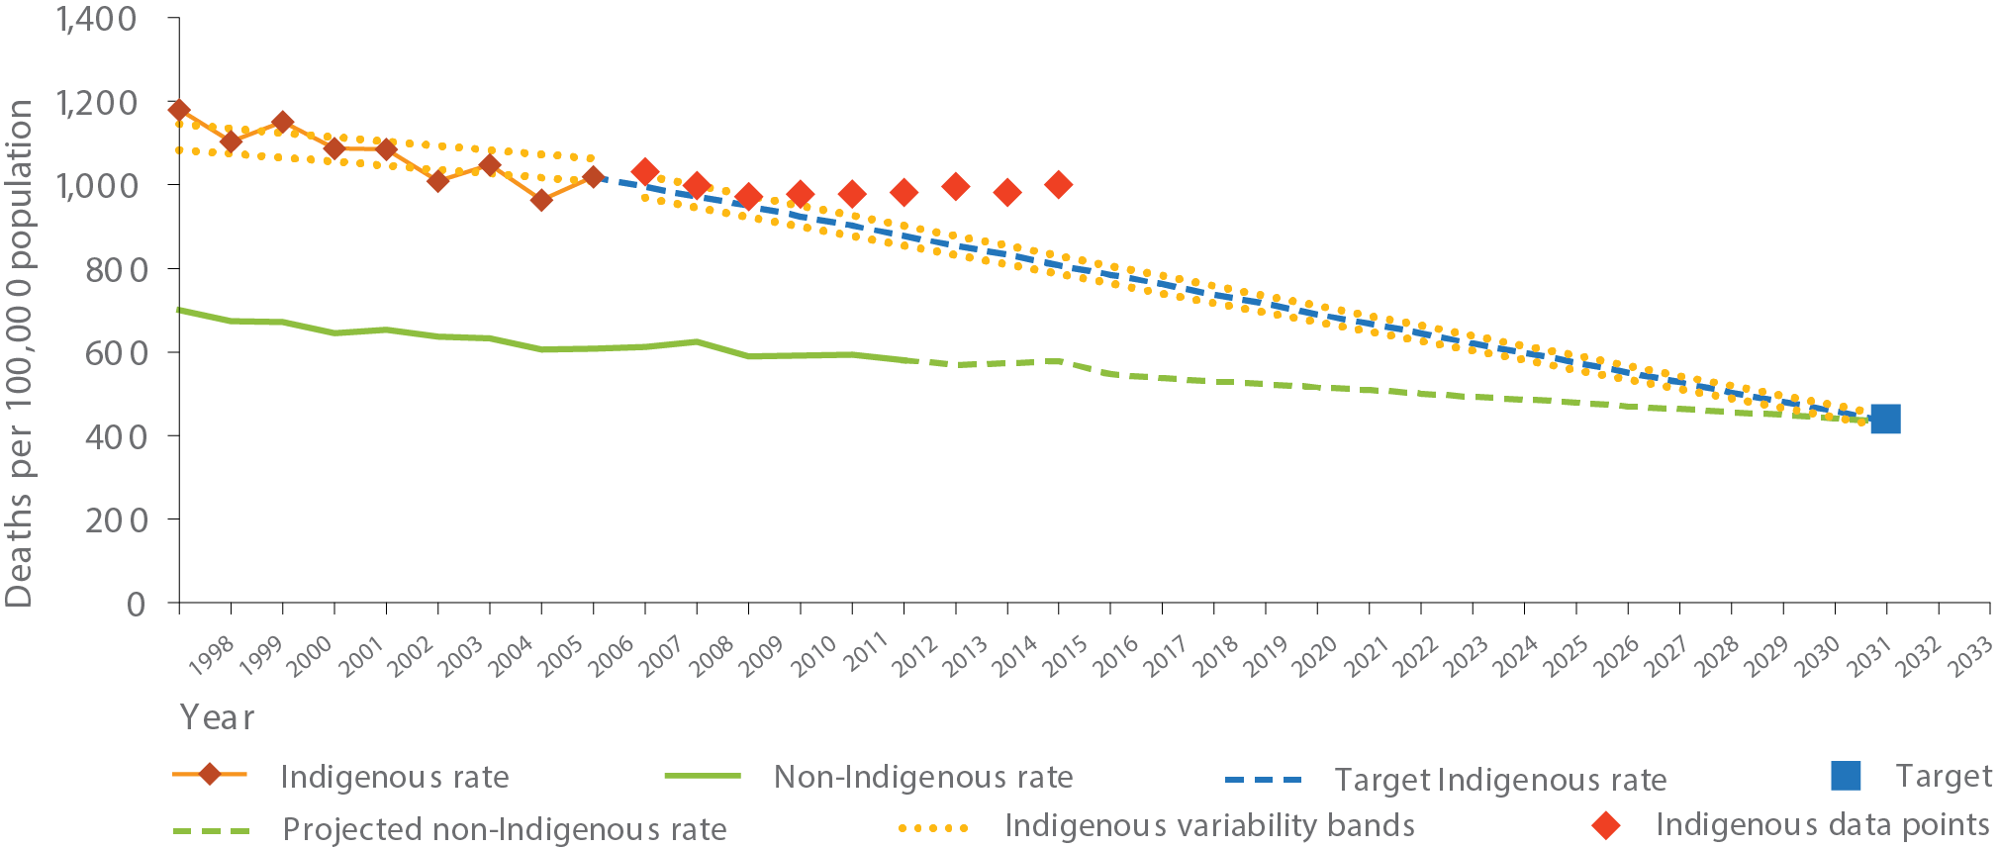
Source: ABS and AIHW analysis of National Mortality Database
View the text alternative for Figure 22.
Chronic disease, such as circulatory disease, cancer, diabetes and respiratory disease, accounts for around 70 per cent of Indigenous deaths and three quarters of the gap in mortality rates between Indigenous and non-Indigenous Australians. Between 1998 and 2015, the Indigenous mortality rate from chronic disease declined significantly by 19 per cent, and in the short term since 2006 there was a significant decline of 6 percent. However, rates for non-Indigenous Australians are also declining and so there has been no significant change in the gap. The decline in the Indigenous mortality rate from circulatory disease was even stronger (by 43 per cent) and the gap narrowed (by 42 per cent) over the period 1998 to 2015. Over the same period there was also a significant decline in the Indigenous mortality rate from respiratory disease (by 24 per cent). Between 2006 and 2015 there was a significant decline in the Indigenous kidney disease mortality rate (by 47 per cent).
However, cancer mortality rates are rising and the gap between Indigenous and non-Indigenous Australians dying from cancer is widening. Between 1998 and 2015, there was a 21 per cent increase in the cancer mortality rate for Indigenous Australians and a 13 per cent decline for non-Indigenous Australians.
Over the long-term, improvements in the social determinants of health such as the Year 12 target, health system performance and reductions in risk factors such as smoking are expected to have a positive impact. Analysis by the Australian Institute of Health and Welfare of the 2011-13 Australian Health Survey has found that selected social determinants such as education, employment status, overcrowding and household income accounted for 34 per cent of the gap in health outcomes between Indigenous and non-Indigenous Australians; selected risk factors such as smoking, obesity, alcohol, and diet accounted for 19 per cent of the gap; there was also overlap between social determinants and risk factors (11 per cent of the gap). The relationships are complex and mediated by interactions with other factors.
From 2002 to 2014-15, there has been a 9 percentage point decline in current smoking rates for Aboriginal and Torres Strait Islander people aged 15 years and over (from 51 per cent to 42 per cent). Current smoking includes 39 per cent who smoked daily and 3 per cent less than daily. Despite these improvements, the current Indigenous smoking rate was 2.7 times the non-Indigenous rate. Indigenous Australians who lived in very remote areas were more likely to be current smokers in 2014-15 (53 per cent) than those living in major cities (36 per cent). This reflects the declines in smoking rates in non-remote areas (from 50 per cent in 2002 to 39 per cent in 2014-15); while in remote areas, rates have not changed significantly (55 per cent in 2002 and 52 per cent in 2014-15). In 2014-15, Indigenous smoking rates ranged from 49 per cent in the Northern Territory to 38 per cent in Tasmania.
Primary health care plays an essential role in identifying and managing care for people with chronic disease. One way to illustrate how the health system is improving care for Indigenous Australians is through Medicare health assessments. Measures to increase uptake of health assessments by Indigenous Australians were introduced in 2009-10. Between July 2009 and June 2016, Indigenous health assessment rates for 0 to 14 years olds increased by 278 per cent; 15 to 54 year-olds increased by 256 per cent; 55 years and over by 195 per cent (see Figure 24). In the same period, Indigenous Australians roughly doubled their rate of claims for management of chronic disease through Medicare GP management plans and team care arrangements. Indigenous Australians are now making claims for Medicare GP management plans at a higher rate than non-Indigenous Australians (129 and 86 per 1,000 respectively). This is also the case for team care arrangements (112 and 72 per 1,000 respectively).
Figure 23: Overall mortality rates by Indigenous status: NSW, Qld, WA, SA, and the NT, 2011-2015 (age standardised)
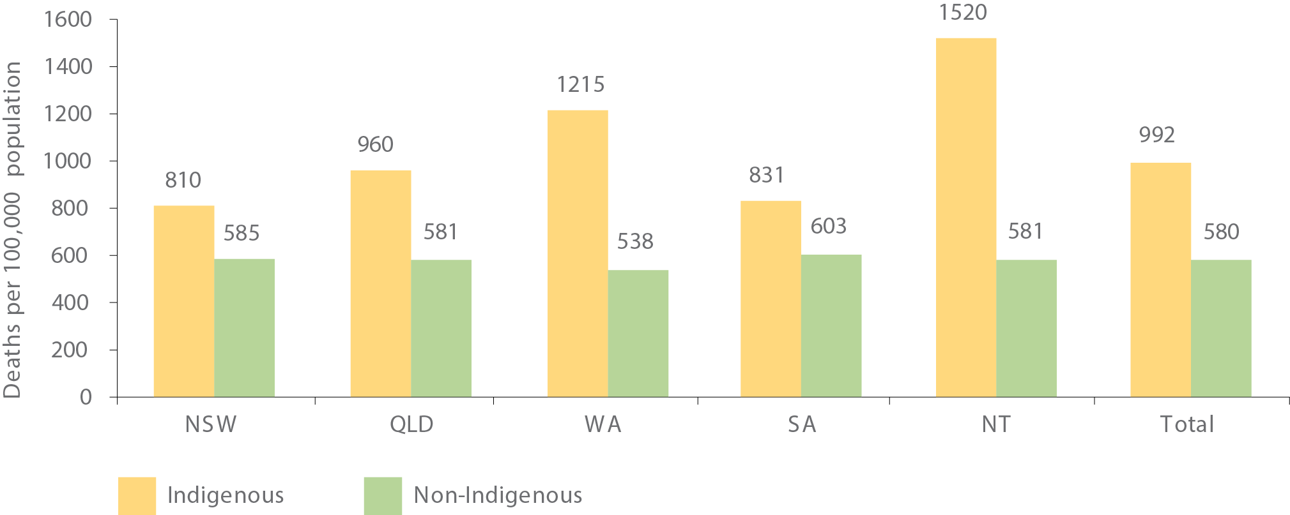
Source: ABS and AIHW analysis of National Mortality Database.
View the text alternative for Figure 23.

National policy to drive improvement in health outcomes
Australia’s health system is complex, with services provided by state and territory governments, community controlled health services and private practitioners. While the Australian Government has a limited role in the delivery of health services, we have an important part to play in ensuring the health system as a whole works for Australians and supports patients in their journey through the system. Commonwealth funded policies and programs such as the Medicare Benefits Schedule, the Pharmaceutical Benefits Scheme and Practice Incentives Programs play a significant role in the health system.

A collaborative approach to Aboriginal and Torres Strait Islander health
The Implementation Plan for the National Aboriginal and Torres Strait Islander Health Plan 2013-2023 identifies actions to address challenges in the current system and improve the patient journey of Aboriginal and Torres Strait Islander people.
Figure 24: Rate per 1,000 persons receiving Medicare Benefits Schedule health assessments, by age group, Indigenous Australians, 2006-07 to 201-16
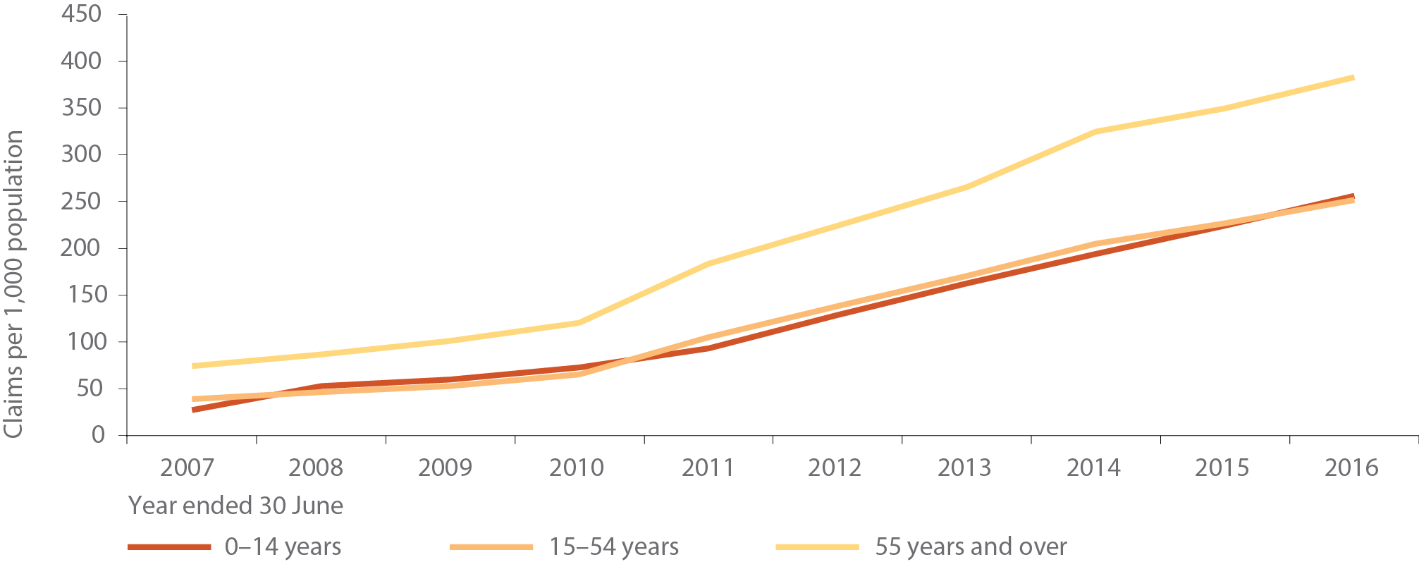
Source: AIHW analysis of Medicare Australia data.
View the text alternative for Figure 24.
Some recent achievements include:
- exceeding the 88 per cent immunisation rate target set for Indigenous one-year-olds, as well as five-year-olds having the highest immunisation rates of any group nationally;
- the launch of a Cultural Respect Framework to give guidance to mainstream health system providers on providing culturally competent health service delivery;
- continuation of the National Health and Medical Research Council’s commitment to allocate more than five per cent of funding to Aboriginal and Torres Strait Islander health; and
- the establishment of a Centre of Research Excellence to build Indigenous research capacity.
Development of the second iteration of the implementation plan is underway and will focus on addressing the social and cultural determinants of health, cultural competence in mainstream health services and identify new evidence, opportunities and priorities.
Governments are working together with the Aboriginal community controlled sector in each state and territory through Aboriginal and Torres Strait Islander Partnership Forums. The forums provide a platform to work together on planning, data and information sharing to ensure Indigenous health needs are met in the delivery of services.
The members of the partnership forums recently recommitted to the Aboriginal and Torres Strait Islander Health and Wellbeing Framework Agreements in each jurisdiction, which demonstrate a shared commitment to Closing the Gap.

Primary health care
Primary health care services play a key role in health and wellbeing of Aboriginal and Torres Strait Islander Australians. Increasing access to primary health care and specialist services, particularly for people living in regional, rural and remote locations is vital to prevention and management of chronic disease.
The Indigenous Australians’ Health Programme provides Aboriginal and Torres Strait Islander people with access to culturally safe primary health care services in urban, regional, rural and remote locations, delivered through a network of Aboriginal community controlled health services where possible. In addition, the programme aims to improve the capacity of mainstream services to deliver culturally safe services.
Primary Health Networks (PHNs) support Aboriginal community controlled and mainstream health services to improve coordination of care for patients, particularly for those at risk of poor health outcomes. Aboriginal and Torres Strait Islander health is one of the six priority areas identified for targeted activities and the PHNs work with Indigenous stakeholders in considering the health needs of their region.
Through the PHNs, Integrated Team Care provides an integrated, team-based approach for the provision of coordinated, multidisciplinary care for Indigenous people with chronic disease. The program consolidates the Care Coordination and Supplementary Services and Improving Indigenous Access to Mainstream Primary Care programmes previously managed through PHNs. PHNs also support Indigenous-specific mental health and drug and alcohol treatment services.

Improving cancer outcomes for Aboriginal and Torres Strait Islander people
Prevalence of cancer contributes to the gap in life expectancy between Indigenous and non-Indigenous Australians.
The 2015 National Aboriginal and Torres Strait Islander Cancer Framework, launched by Cancer Australia, identifies seven national evidence-based priorities to improve cancer outcomes experienced by Aboriginal and Torres Strait Islander peoples.
Cancer Australia undertakes a range of initiatives to address disparities and improve outcomes for Indigenous Australians with cancer. For example, in 2015-16, Cancer Australia supported the Aboriginal Health Council of South Australia to develop resources to support Indigenous Australians with lung cancer and deliver up to 60 community workshops to raise awareness of the risks of lung, breast and gynaecological cancer and the importance of early detection.

Health and wellbeing of Aboriginal and Torres Strait Islander people with a disability
The National Disability Strategy 2010-2020 provides a policy framework for all levels of government to improve the lives of people with disability. As part of the strategy’s second implementation plan, the Australian Government plan to improve outcomes for Aboriginal and Torres Strait Islander people with disability is being developed. The vision for the plan is an environment where Aboriginal and Torres Strait Islander people with disability achieve improved life outcomes and overall social, emotional and cultural wellbeing. This is the first time such a plan has been developed. It is forward-looking and supports community-driven approaches for better access to culturally responsive support and service systems.
The Aboriginal and Torres Strait Islander Engagement Strategy under the National Disability Insurance Scheme focuses on building relationships between service providers and communities on a community-by-community basis, supporting providers to build culturally appropriate skills and engage in a culturally responsive manner.

Social and emotional wellbeing
Social and emotional wellbeing is a holistic concept which recognises the importance of connection to land, culture, spirituality, ancestry, family and community, and how these affect the individual. A person’s wellbeing can be affected by the social determinants of health including homelessness, education and unemployment and a broader range of problems resulting from grief and loss, trauma, violence, removal from family, cultural dislocation, racism and social disadvantage.
Governments are working together to develop the Fifth National Mental Health Plan to improve the wellbeing of all Australians and prioritise Aboriginal and Torres Strait Islander mental health and suicide prevention.
Aboriginal community controlled health services provide frontline counselling, case management and healing services. The PHNs work with the Aboriginal community controlled health sector to provide greater access to culturally appropriate and integrated mental health services for Aboriginal and Torres Strait Islander people.

Suicide prevention
Indigenous suicide rates are double that of non-Indigenous Australians. During 2011 to 2015, among Indigenous Australians, 71 per cent of suicides were male. The Aboriginal and Torres Strait Islander Suicide Prevention Evaluation Project Report was commissioned by the Commonwealth to identify what is working to address this national crisis and provide a blueprint to improve culturally appropriate services in Aboriginal and Torres Strait Islander communities.
The report was built by working with families who have been personally impacted by the tragedy of suicide, including through the first ever Aboriginal and Torres Strait Islander suicide prevention conference held in Alice Springs in May 2016. The report recommendations focus on the need for approaches to Indigenous suicide prevention that are culturally-embedded, community-led, and include specialist trauma training for regional workers.
As part of a broad suicide prevention initiative, four PHNs in Perth, Brisbane, Melbourne and North Coast New South Wales are trialling new collaborative approaches to community-based suicide prevention. In addition, eight regional sites including in Townsville and the Kimberley, will trial new suicide prevention and follow-up care models and build partnerships with local service providers and communities. The trial site in the Kimberley will include a focus on the development of a model that can support the unique and culturally sensitive requirements of remote Indigenous communities.

Health and aged care workforce
It is important to have a strong Indigenous health and aged care workforce to provide culturally appropriate services to the Aboriginal and Torres Strait Islander community, and for the mainstream health care system to employ Indigenous health professionals.
The Australian Government funds four Indigenous-specific health professional organisations to assist in growing the Aboriginal and Torres Strait Islander health workforce and support culturally appropriate health services for Aboriginal and Torres Strait Islander peoples. Activities provided by these organisations range from mentoring programs, professional development opportunities, leadership programs and networking opportunities for Aboriginal and Torres Strait Islander health professionals and students. These organisations also provide cultural safety programs for health professionals working in mainstream services and the Aboriginal community controlled health sector.
In the aged care workforce, we support training for Aboriginal and Torres Strait Islander health and aged care workers in rural and remote locations in Western Australia, South Australia, Queensland and the Northern Territory. Some of the around 750 Aboriginal and Torres Strait Islander people in permanent full-time and part-time positions created since 2007 through aged care Indigenous employment initiatives are supported through this training.
In addition, the Indigenous Remote Service Delivery Traineeship program aims to build business and management capacity of Indigenous aged care and primary health care services, specifically in remote areas. Traineeship positions receive accredited training in business and management. The program has seen a high success rate – since its inception, more than 80 per cent of participants have completed their training.

Supporting ageing in the community
The National Aboriginal and Torres Strait Islander Flexible Aged Care Program is part of the strategy to improve access to high quality, culturally appropriate aged care services for older Aboriginal and Torres Strait Islander people. There are currently 32 flexible aged care services operating in rural and remote locations. Services include a mix of residential, respite and home-care services based on the needs of the communities, and are designed to be able to adapt as the care needs of communities change.
The Remote and Indigenous Aged Care Service Development Assistance Panel supports aged care providers to build capacity and improve the quality of aged care services. The Panel provides expert advice on quality care, governance and financial matters. It also assists aged care providers to develop culturally appropriate local solutions to delivering services in the remote and very remote areas of Australia.

Supporting healthy lifestyles and choices

School nutrition
School nutrition projects provide meals to around 5,800 school children in 63 Northern Territory communities every school day. As well as providing children with nutritious meals, projects contribute to school attendance and provide employment opportunities for Aboriginal and Torres Strait Islander people, often enhancing parental engagement in the school community.

Encouraging sport and active lifestyles
The Australian Sports Commission (ASC) provides funding and support to national sporting organisations for participation and high performance outcomes, including providing opportunities for Indigenous Australians to participate in sport. A number of national sporting organisations hold Indigenous sporting carnivals. Indigenous school students also participate in the ASC’s Sporting Schools program.
The Elite Indigenous Travel and Accommodation Assistance Program provides funding for athletes coaches, team managers and umpires attending national championships or participating as part of Australian teams. The ASC is currently developing a sustainable model of remote sport delivery that aims to embed an Indigenous coach pathway in remote community secondary schools.
In addition, the Indigenous Advancement Strategy committed over $13 million in 2015-16 for 82 initiatives to increase participation of Indigenous Australians in sport and active recreation. Structured sport, such as football, cricket and basketball, promotes positive activities and supports school attendance.

Reducing substance misuse and harm
The National Aboriginal and Torres Strait Islander Peoples’ Drug Strategy 2014-2019 provides a framework for action to minimise the harms to individuals, families and communities from alcohol, tobacco and other drugs. The Strategy guides governments, communities, service providers and individuals to identify key issues and priority areas for action.
As part of the Indigenous Advancement Strategy’s Safety and Wellbeing Programme, the Australian Government funds over 80 organisations across the country to deliver Indigenous-specific alcohol and other drug treatment services. Providers aim to reduce substance misuse by providing a range of services which can include early intervention, treatment and prevention, residential rehabilitation, transitional aftercare and outreach support. Elements can include access to sobering up shelters, advocacy and referral, counselling, mediation, case management, youth specific support, education and health promotion, cultural and capacity building, and life skills support.
Overall funding for alcohol and other drug treatment services under the Indigenous Advancement Strategy in 2016-17 is around $69 million. This is in addition to alcohol and other drug services, including Indigenous-specific services, funded through the health portfolio.
In recognition of the acute need in the Northern Territory, the Commonwealth is investing around $91 million over 7 years to tackle alcohol misuse through the National Partnership on Northern Territory Remote Aboriginal Investment (NP NTRAI). This includes around $13 million for Alcohol Action Initiatives (AAI), which are community-developed activities to tackle alcohol misuse and harm. An additional $14 million is provided under NP NTRAI for an AAI workforce to engage directly with communities to ensure activities are evidence based and to strengthen community capacity and governance to help communities proactively manage alcohol concerns. In addition, around $31 million has been provided under NP NTRAI to support a Remote Alcohol and Other Drug Workforce to provide alcohol and drug support and education, interventions, and referrals for community members.
The National Indigenous Alcohol and Other Drug Centre is an online resource that provides practical support to the workforce and communities involved in efforts to reduce the impact of substance misuse.

Reducing smoking
The National Tobacco Strategy 2012-2018 sets out the national framework to reduce tobacco-related harm in Australia and provides a framework for building the evidence base for tobacco control and monitoring progress. A key priority of the Strategy is to reduce smoking rates among Aboriginal and Torres Strait Islander people.
Tobacco use is one of the leading causes of preventable disease and premature death in Australia. While smoking rates have continued to decline in Australia, the smoking rates of Indigenous Australians aged 15 and over are significantly higher than the broader population.
The Tackling Indigenous Smoking program funds 37 regional grants to deliver best practice tobacco control approaches. Local community activities promote the benefits of not smoking, improve access to support and build capacity of individuals and organisations. National supports include funding to enhance Quitline services for Aboriginal and Torres Strait Islander callers, training in brief interventions and a National Best Practice Unit.
The program also funds seven innovation grants, targeting critical smoking behaviours within Aboriginal and Torres Strait Islander communities, particularly pregnant women and young people in remote communities. These grants deliver intensive smoking prevention and cessation activities, coupled with research and evaluation.
Tackling Ice
Under the National Ice Action Strategy, we have committed almost $300 million over four years from July 2016 towards a number of measures to reduce the impacts associated with drug and alcohol misuse to individuals, families and communities. This funding will strengthen education, prevention, treatment, support and community engagement. Of this total investment, $78.6 million over four years is being provided for PHNs to commission Indigenous-specific drug and alcohol treatment services.

Reducing petrol sniffing
In some remote communities, petrol sniffing was having a significant impact on the health and wellbeing of individuals, families and communities. This led to communities and governments working together to develop a solution. Low aromatic fuel (known as Opal at the time) was first made available in communities in Central Australia and Western Australia in 2005 and has been highly successful in reducing rates of petrol sniffing. The availability of the fuel has grown and it is now available in more than 170 fuel outlets in regional and remote parts of Australia. The tenth anniversary of low aromatic fuel being available in fuel outlets in Alice Springs was celebrated in October 2016.
Research released in 2016 from the Menzies School of Health Research found that, in communities surveyed since 2005-07, petrol sniffing has reduced by up to 88 per cent since the introduction of low aromatic fuel (d'Abbs & Shaw, 2016). This research also found a 90 per cent reduction in the number of people sniffing at least once week and who are most at risk of potentially irreversible physical harm.

BUILDING THE EVIDENCE

Tackling Indigenous Smoking program
The Tackling Indigenous Smoking program is a targeted investment to reduce smoking rates in the Indigenous population. Innovation grants funded under the program will build evidence on reducing smoking in hard to reach groups, with a focus on intensive interventions for pregnant women, for remote communities, and for youth in remote areas. The program also includes a National Best Practice Unit that facilitates implementation of best practice Indigenous tobacco control by regional grant recipients and promotes research, monitoring and evaluation of evidence-based models for tobacco control, including through the Tackling Indigenous Smoking portal on the Australian Indigenous Alcohol and Other Drugs Centre website. A full program evaluation is underway and is due for completion in mid-2018.

School nutrition projects
The Menzies School of Health Research is reviewing school nutrition projects to determine their nutritional contribution, measure the extent to which school nutrition projects comply with relevant dietary guidelines and explore the importance of the school nutrition projects in providing for children’s nutrition needs. This review is expected to be completed in June 2017.

National Disability Research and Development Agenda
The National Disability Research and Development Agenda includes projects with a specific focus on Aboriginal and Torres Strait Islander people with disability. These research projects, which are currently underway, aim to support Indigenous people to live and stay on country, undertake Indigenous-led disability research, improve education and employment outcomes through digital enterprise, and address legal barriers for Indigenous Australians with a disability.

Suicide Prevention Centre of Best Practice
A National Centre of Best Practice in Aboriginal and Torres Strait Islander Suicide Prevention will be established to provide best practice information and advice, building the capacities of Primary Health Networks and Indigenous communities to take action in response to suicide and self-harm in their immediate region.

OUTSTANDING LOCAL SOLUTIONS DELIVERING EXCITING OUTCOMES

Tackling trachoma in Lajamanu, NT
Trachoma is an infectious eye disease that can lead to blindness. It is entirely preventable and continues to be a significant public health problem in many remote Aboriginal and Torres Strait Islander communities.
After a number of reported cases of trachoma in the remote Northern Territory community of Lajamanu, the local health clinic decided to take action and screened the entire community of 1,000 people.
Screening resulted in early detection for five community members at risk of suffering long term consequences of trachoma. The Lajamanu Health Clinic now undertakes trachoma screening annually as part of the national push to eliminate the disease.

Healthy lifestyles in Pormpuraaw, QLD
Apunipima Healthy Lifestyles and Diabetes teams and Pormpur Paanthu held a Women’s Group Gathering in Pormpuraaw to educate women on how they can be part of the prevention and management of diabetes.
Apunipima’s Diabetes Nurse Educator Cath Dowey said the Women’s Health and Wellbeing Awareness evening focused on social wellbeing activities with the key message about diabetes.
The women with diabetes yarned about helpful ways of managing the disease, and appreciated the one-on-one interaction and being able to talk to other women in the group.
“We spoke about healthy lifestyle choices including how to provide healthy choices for kids with simple lunch box and snack ideas and how women can encourage their children to have water instead of sugary drinks,” Cath said.

Holistic approach to health care in Bundaberg
The Indigenous Wellbeing Centre (IWC) is an Aboriginal-community controlled charitable and non-government organisation delivering health and wellbeing services that empower Indigenous, vulnerable, at-risk and disadvantaged peoples.
Established in 2006, it has more than 12,500 clients and delivers 91,000 episodes of care a year, with around 93 per cent of Indigenous Australians in Wide Bay/Burnett, Queensland using its services.
Cheri Yavu-Kama-Harathunian is an IWC Director and Aboriginal Elder.
“IWC developed, in consultation with Traditional Owners / Elders, a unique, holistic model of care, with every service culturally responsive, taking a whole-of-person approach,” she said.
“We listened to the Cultural Philosophical Ethos of our people, and that underpins how we operate.”

Mental health first aid training supports over 60 remote communities
Improving the mental health and wellbeing of all Australians requires a better understanding and awareness of mental health.
Working across more than 60 remote Indigenous communities, Mental Health First Aid training is being delivered to more than 1,500 frontline staff to help combat mental health issues. The first aid training is focused on frontline staff from the Remote School Attendance Strategy (RSAS), Community Development Programme and Community Night Patrols in locations where communities are participating in RSAS. The training teaches participants to recognise the early warning signs of mental health issues and to intervene early as a preventative measure. Participants are putting their new skills to use to assist other community members in need of help.
“A strength was highlighting the mental health issues in community and how we need to work together to get the right assistance for people with mental health,” a participant said.
Collaboration is a key feature of the initiative, with local health services providing advice on what services are available. Participants learn where and how to get help from others, including professional mental health services and other support networks, such as family and friends.

Flexible ageing in Nhulunbuy, NT
A new flexible aged care service will be established in Nhulunbuy, Northern Territory. The service model will be co-designed with aged care, health and disability providers as well as the East Arnhem community, ensuring a service that meets community needs and expectations. The community will be encouraged to participate in all aspects of service provision, from planning through to the operation of the service. The co-design model was successfully used to establish a flexible aged care service at Mutitjulu, Northern Territory.

Dementia support in Victoria
The Yarn Up About Dementia project was a collaboration between Alzheimer’s Australia Victoria and the Gunditjmara communities of Heywood, Portland and Hamilton. The project created an educational music and dance performance to educate young Aboriginal people about dementia both to reduce their risk and improve their attitudes toward community members with dementia. The resource is used by Aboriginal and Torres Strait Islander Health Workers to encourage risk-reduction behaviours.

La Perouse aged care alliance in NSW
Members of the La Perouse Aboriginal Alliance, established as part of Empowered Communities, identified an Aboriginal-operated residential aged care facility as a priority for their region. There are no Aboriginal run aged care facilities in inner Sydney meaning that older people either stay at home and are cared for by their families or they travel off country and away from their families to Kempsey or Nowra.
“We have been talking for many years about being able to take care of our Elders on our own country. The opportunity is here now and we are all working together to make it happen” said Karen Cooley, General Manager of Guriwal Aboriginal Corporation.
The proposed aged care facility will offer community-based and culturally appropriate residential aged care services for the Indigenous community as well as training for Indigenous care workers.
The Guriwal Aboriginal Corporation will work together with other Indigenous organisations to establish the community-based facility, with land identified by the La Perouse Local Aboriginal Land Council and support offered from Wyanga Aboriginal Aged Care in Redfern and Kurranualla Aboriginal Corporation in Sutherland.

Collaborative approach to school nutrition in Lajamanu, NT
In Lajamanu, a school nutrition project ensures children have access to regular, healthy meals. The project is a result of community members prioritising what is important in their community. While the Northern Territory Government funds staff and kitchen equipment, the community has agreed to use mining royalties to pay for the food. It is an example of what can be achieved if people have a say in the programs, priorities and activities that will improve their lives.

Kicking goals in Borroloola, NT
Young Marra woman from Borroloola, Shadeene Evans, is kicking goals.
At the age of nine, Shadeene first started playing football and by age 12 was representing the Northern Territory. Shadeene has been supported by the John Moriarty Football Nangala Project, funded through the Indigenous Advancement Strategy.
And now, Shadeene has made her way into the New South Wales Institute of Sport Girls Football Program, a pathway to Young Matildas representation. Shadeene says her love of the game is her motivation to get a good education and excel in her field.
“Moving from Borroloola to Sydney was very different and so much busier than what I was used to but I have fit in well and enjoy school and the soccer program. I love school and my education is very important to me – as important as football,” said Shadeene.

Amata healthy fun run in SA
Students from the remote community of Amata in South Australia have been running for their health and for fun.
The Indigenous Marathon Foundation hosted the Deadly Fun Run as part of a series of events in remote communities to encourage healthy lifestyles and physical activity.
“The Foundation is using running to drive social change, celebrate Indigenous resilience and achievement, and address the high incidence of chronic disease and obesity in Indigenous communities across the country.” said Kellie O’Sullivan from the Indigenous Marathon Foundation.
Thirty-four students, competing in junior and senior events, completed the three kilometre race from the Amata oval to the Amata school pool. Elders from the community supported the Deadly Fun Run by marking out the race track and serving the food at the end of the race.

Deadly choices in Queensland schools
The Institute of Urban Indigenous Health delivers the Deadly Choices program in South East Queensland schools. The seven-week program primarily targets young people aged 15 to 18 years and encourages participants to lead a healthy lifestyle and be positive role models and mentors for their family and community. It comprises eight modules in: leadership; chronic disease; physical activity; nutrition; smoking cessation; sexual health; and importance of accessing local primary health care service.

Community led solution to reduce petrol sniffing
“We had big struggles all over Central desert with this big mess of petrol sniffing and everyone found it really hard. When non-sniffable fuel arrived in Papunya, it made a lot of change. It made us really move forward. Bringing Opal into Central Australia is a wonderful achievement.”
– Lance McDonald, Luritja Elder, Papunya

- Indigenous mortality rates are presented for the five jurisdictions with sufficient quality Indigenous identification in mortality data to publish (NSW, Qld, WA, SA and the NT).
- For 2015 data, the Queensland Registry of Births, Deaths and Marriages included Medical Certificate of Cause of Death information for the first time to contribute to the Indigenous status data item. This data improvement was associated with a decrease in the number of deaths for which the Indigenous status was 'not stated' and an increase in the number of deaths identified as Indigenous in Queensland. Although the Indigenous mortality rate was higher in Queensland in 2015, for the other jurisdictions the rates were lower in 2015 than in 2014. This change in method means that time series data are not directly comparable and caution should be used in interpreting the trend.

CHAPTER 7: SAFE AND STRONG COMMUNITIES
Every man, woman and child should feel safe in their homes and their communities.

Communities unite against domestic and family violence
The NO MORE campaign is a grassroots movement founded in 2006 by Charlie King OAM. The campaign places the responsibility for reducing family violence on men, recognising that they have the power to respect women and look after their families. The campaign has links with over 100 sporting teams nationally. In Arnhem Land, they have reduced domestic and family violence by 27.9 per cent in one year.
In November 2016, the NO MORE campaign brought the Rirratjingu dancers from North East Arnhem Land to Parliament House in Canberra to perform a Djan'kawu ceremony. Parliamentarians from the major parties linked arms in solidarity with the cause to reduce family violence.
“What do we stand for in this community? Do we want to live in peace and harmony or are we happy to have chaos that destroys and makes families dysfunctional?”
– Charlie King AO
“To be the great nation we can be, we have to accept and acknowledge the horrific tragedies of the past but not let the pain of the past define our future. Because I can see these stories of great change and great hope, I don’t think you can allow yourself to be broken by the negativity. This is about our resilience as a nation and our ability to build a life together.”
– Jeremy Donovan
“It is essential Aboriginal and Torres Strait Islander voices are at the centre of developing future housing reform”
– Rachelle Towart, Co-Chair, Remote Housing Review
“We aim to engage with the clients as close to six months pre-release as possible, and continue with them for a period of time. It’s really client- driven, and its emphasis is on client empowerment and individual responsibility.”
– Samantha Taylor-Hunt, Prisoner Throughcare Program Coordinator

NATIONAL POLICY TO BUILD SAFE COMMUNITIES
There are many layers to building safe and resilient communities, including adequate infrastructure and access to services. This is a significant challenge in remote communities, where families are often living in overcrowded houses which can lead to health and social problems.
Addressing substance misuse, violence and incarceration are immediate priorities to ensure safe and functioning communities. While government has a crucial role to play in ensuring adequate infrastructure and services are in place, it is essential that we work closely with Aboriginal and Torres Strait Islander people to implement the local solutions.
Keeping Aboriginal and Torres Strait Islander children and families safe is a priority for all governments. The National Framework for Protecting Australia’s Children 2009-2020 reflects the long-term commitment of all governments and the non-government sector to ensure the safety and wellbeing of Australia’s children. One of its priorities is to reduce the over-representation of Aboriginal and Torres Strait Islander children and young people needing child protection services.
The Third Action Plan of the National Framework will help reduce the likelihood of children entering the child protection system. Each strategy and action will be consistent with the five principles of the Aboriginal and Torres Strait Islander Child Placement Principle (prevention, partnership, placement, participation and connection).

TRANSLATING POLICY INTO ACTION

Making communities safer

Reducing violence
During the two years to June 2015, Indigenous Australians were hospitalised for assault at 14 times the rate of non-Indigenous Australians. Indigenous females were 30 times as likely to have been hospitalised for assault as non-Indigenous females, and Indigenous males were 9 times as likely as non-Indigenous males. This contrast is particularly stark in remote areas. The Indigenous female rate was 53 times the non-Indigenous female rate in remote areas (and 38 times in very remote areas).
Indigenous children are much more likely to experience child abuse and neglect. In 2014-15, Indigenous children aged 0-17 years were 6.7 times as likely to be the subject of substantiated child protection notifications as non-Indigenous children. These problems are complex and intergenerational.
Factors such as poor education and low employment contribute to Aboriginal and Torres Strait Islander people being over-represented in the criminal justice system – as at 30 June 2016 there were 10,596 prisoners who identified as Indigenous, representing 27 per cent of total prisoners (ABS, 2016). The Indigenous imprisonment rate is 13 times the rate for non-Indigenous Australians and has increased by 42 per cent since 2006. Rates of re-offending are high and in 2016 the majority (63 per cent) of Indigenous Australians were in prison for violent related offences and offences that cause harm.
In 2014-15, Aboriginal and Torres Strait Islander women were 32 times more likely to be hospitalised due to family violence related assaults than other women (SCRGSP, 2016). One-third of Aboriginal and Torres Strait Islander women have experienced physical violence from a partner, this is twice the level recorded among non-Indigenous women (Department of Social Services, 2016).
Addressing violence against Aboriginal and Torres Strait Islander women and their children is a national priority. The Third Action Plan of the National Plan to Reduce Violence against Women and their Children 2010-2022 specifically targets early intervention and addresses violence in Indigenous communities. Culturally-centred policy, programs and primary prevention activities will be delivered in partnership with communities, including wraparound, case-managed support for families.
In addition, the $100 million Women’s Safety Package, includes $21 million over four years to improve Indigenous women’s safety.
Frontline community workers are being supported through new Indigenous-specific domestic violence alert training and eleven projects under the Building Safe Communities for Women grants in Indigenous communities.
In 2016-17, thirteen of the fourteen Family Violence Prevention Legal Services funded under the Indigenous Advancement Strategy are Indigenous organisations. These organisations provide legal and counselling services for victims of family violence.

Support for policing in remote communities
Safety in remote Indigenous communities continues to be a focus, through enhancing policing presence, and establishing new infrastructure and specialist units.
Community Engagement Police Officers are experienced police officers who work across the community to support crime prevention, help out in the community and build trust with the police. The Commonwealth and Northern Territory Governments have made a joint investment to continue the Community Engagement Police Officers initiative.
Work is underway on a new and expanded police station in Wadeye. Policing on Groote Eylandt will also be enhanced through upgrades to police facilities in Alyangula and Angurugu, with support for operations including establishing a Dog Operations Unit.
Policing in Queensland is also being enhanced, through upgrades to airstrips on five islands in the Torres Strait.

Community members making communities safer
Community Night Patrols help keep communities safer by employing local people to serve their local communities through crisis and non-crisis support. Community Night Patrol operate in 81 communities in the Northern Territory, nine communities in South Australia and one in Western Australia. The Commonwealth funds 20 service providers through the Indigenous Advancement Strategy with total funding of $28.3 million being provided in 2015-16. Last year alone Night Patrollers provided more than 240,000 assists to their local communities.
Patrollers also ensure that children are at home or in another safe location at night with a parent or carer, so they are able to go to school every day.
As well as making communities safer Community Night Patrols create jobs. In 2015-16, 98 per cent of the 350 patrollers and team leaders delivering services on the ground identified as Aboriginal.

Housing and home ownership
Housing is fundamental to the well-being of all Australians – it supports employment, education and health and has a significant impact on workforce participation. In 2014-15, Indigenous households were about half as likely as non-Indigenous Australian households to own their home and more than three times as likely to live in overcrowded dwellings.
The condition of housing is also of concern. In 2014-15:
- 18 per cent of Indigenous households were living in houses of an unacceptable standard (more than two major structural problems and less than four working facilities for washing people, clothes/bedding, storing/preparing food, and sewerage). There has been an increase in the proportion of Indigenous households living in houses of an acceptable standard, from 78 per cent in 2012-13 to 82 per cent in 2014-15.
- Around 26 per cent of Indigenous households were living in dwellings with major structural problems (including problems such as sinking/ moving foundations, sagging floors, wood rot/termite damage and roof defects). This was a reduction from 2012-13 (34 per cent).
- In very remote areas 37 per cent of Indigenous households were living in dwellings with major structural problems.
The Commonwealth has implemented a range of strategies to address housing affordability and homelessness for all Australians, including:
- National Affordable Housing Agreement which aims to ensure Australians have access to affordable, safe and sustainable housing and includes Indigenous-specific outcomes.
- National Partnership Agreement on Homelessness which recognises the increased risk of homelessness for Indigenous Australians and commits funding to frontline homelessness services, including Indigenous-specific services.
- Commonwealth Rent Assistance which provides assistance to individuals and families renting in the private market to reduce rental stress.
- National Rental Affordability Scheme – provides rental housing at least 20 per cent below market value rent, by offering financial incentives for the construction and rental of dwellings for low and moderate income households.
Home ownership allows families to take control of their living space and use a substantial asset to develop personal and an inter-generational wealth. There remains a sizeable gap in outcomes for First Australians, with 68 per cent of non-Indigenous Australians owning their home in 2014-15, compared with 30 per cent of Indigenous households.
Indigenous Business Australia is working hard to increase the number of Indigenous homeowners. The Remote Indigenous Home Loan Programme tailors lending in remote communities and the Indigenous Home Ownership Programme provides loans to urban and regional Indigenous Australians who cannot obtain mainstream finance. In 2016, Indigenous Business Australia renewed its focus on providing loans to low income earners and in September 2016 had 4,521 active home loans.
Efforts are also being made to address the challenges of land tenure and market failure in remote communities, which currently impact levels of home ownership.

Overcoming overcrowding in remote communities
The shortage and condition of housing in remote communities means that Aboriginal and Torres Strait Islander people living in these communities are more likely to be homeless or living in an overcrowded house. A Indigenous-led, independent review into remote housing will explore practical and innovative solutions to address the inadequate conditions faced in many communities and is a priority for 2017.
The Remote Housing Strategy focuses on addressing critical housing need for Aboriginal and Torres Strait Islander people in remote communities, improving service delivery, leveraging employment and business opportunities and creating more sustainable housing systems. The Commonwealth’s investment of $774 million over two years (from 2016-17) will deliver more than 785 new houses and refurbish 207 houses bringing the total investment over ten years to $5.5 billion.
In recognition of the additional housing pressures in the Northern Territory, we have committed $141.6 million over three years (2015 - 2018) to improve the amenity and durability of houses in remote communities, through the National Partnership on NT Remote Aboriginal Investment.

Building stronger communities

Improving remote infrastructure in the Northern Territory
Community stores have been constructed or upgraded in 16 Northern Territory communities through a $55.8 million investment from the Aboriginals Benefit Account. An additional two stores are scheduled for completion this year. The project will improve food security and the availability of healthy food choices in these 18 communities by allowing for the storage and sale of a range of healthy food lines. Promoting Aboriginal employment has also been a major focus of the project. Builders contracted under the project were required to maximise the use of local, Aboriginal employees. To date, 143 local employees have been engaged in construction and refurbishment of stores and store manager housing. The project will be completed before the end of 2017.

Better food in remote communities
Outback Stores is a Commonwealth entity improving access to affordable healthy food in 36 Indigenous communities across the Northern Territory, Western Australia, South Australia and Queensland. Outback Stores has a nutrition policy to encourage people to eat more fruits and vegetables and drink water. This has seen a modest increase in water sales and corresponding decrease in sales of full sugar soft drinks.
Outback Stores is a major employer in remote communities, with almost 300 local Indigenous staff employed in 2016. Additionally, almost 80 per cent of permanent Indigenous employees were enrolled in accredited training in 2016.

Infrastructure projects
This year celebrates the 20th anniversary of the Army Aboriginal Community Assistance Programme (AACAP). AACAP projects deliver a mix of infrastructure projects to remote Indigenous communities, including housing, road construction and upgrades, sewerage treatment plants, airfield construction or upgrades, health clinics, telecommunications infrastructure, school upgrades, potable water supply infrastructure, and housing sub divisions.
In 2017, the Army will deploy to the remote Toomelah community in New South Wales followed by Yalata in 2018, through a partnership with the South Australian Government.
We support access to phone and internet services for residents of some of Australia’s smallest and most remote Indigenous communities including 245 community payphone and 301 WiFi Telephone services – the WiFi phones provide up to 20 gigabytes of free data each month. The Remote Indigenous Internet Training activity ($6.7 million over three years from 2015-16) will provide internet access, training and essential internet infrastructure in remote Indigenous communities to address barriers to access.
A new project to invest $40 million from the Aboriginals Benefit Account will commence in 2017. This will be dedicated to improving infrastructure in Aboriginal homelands across the Northern Territory.
Other infrastructure projects include:
- Sky Muster Satellite Service – providing affordable and fast internet connectivity in regional and remote Australia, including in many remote Indigenous communities.
- Mobile Black Spot Program – investing in telecommunications infrastructure to improve mobile coverage and competition in small communities, along major regional transport routes and in locations prone to natural disasters.
- Regional Aviation Access Programme – supports aerodrome infrastructure and air services to remote areas where they are not commercially viable.

Strengthening families and communities

Communities making positive steps to reduce social harm
The Cashless Debit Card trial reduces the supply of cash in a community in an effort to reduce social harm caused by gambling and excessive alcohol and drug use. Following a call from Indigenous leaders for welfare reform, the trial commenced in Ceduna in South Australia in March 2016 and Kununurra and Wyndham in the East Kimberley region in April 2016 and is running for 12 months. While the trial is not an Indigenous-specific measure, it does operate in regions with high Indigenous populations.
Eighty per cent of a recipient’s welfare payment is provided to the debit card account and can be used anywhere, except to gamble, purchase alcohol or withdraw as cash. The remaining 20 per cent is available to be withdrawn in cash. The card differs from income management as it operates like an ordinary debit card.
Perhaps the most important feature of the trial is the collaboration between governments and community leaders in co-designing the parameters of the trial, including the amount of the welfare payment quarantined. Indigenous leaders have also been integral in identifying gaps in support services in their communities and in designing culturally appropriate education and communication materials.
In both trial regions, community panels have been established, independent from Government, to assess applications to reduce the restricted portion of a participant’s welfare payment.

Supporting strong families
The Intensive Family Support Service provides intensive support in the home and community, aimed at building parental capacity in vulnerable families, reducing neglect and improving children’s health, safety and wellbeing. It operates in 24 sites in the Northern Territory and Anangu Pitjantjatjara Yankunytjatjara (APY) Lands of South Australia and in 2016 over 85 per cent of clients identified as Aboriginal and/or Torres Strait Islander.
Reconnect is a community-based early intervention program for young people aged 12 to 18 years who are homeless or at risk of homelessness, and their families. Reconnect provides practical support, such as counselling and mediation, to assist young people to improve their living situation and engage with work, education, family and their community.

Indigenous-specific legal services
Eight Indigenous legal assistance organisations are funded under the Indigenous Legal Assistance Program to provide access to services, manage legal issues and exercise legal rights. The organisations provide services at permanent sites, court circuits and outreach locations in urban, rural and remote areas. In 2015-16, providers delivered 15,848 services nationally to Indigenous clients.
The National Partnership Agreement on Legal Assistance Services 2015-2020 identifies Indigenous Australians as a priority client group for legal aid commissions and community legal centres. In 2015-16, legal aid commissions provided 2,470 grants of legal aid to Indigenous Australians, while community legal centres delivered 1,401 casework services to Indigenous Australians.

BUILDING THE EVIDENCE

Cashless Debit Card
The Cashless Debit Card trial runs for an initial period of 12 months (to April 2017) and will include a full, independent evaluation, which will supplement ongoing monitoring and data collection from government agencies, support services and community organisations.

Prisoner Through-care Randomised Control Trials
The Department of the Prime Minister and Cabinet is conducting randomised controlled trials (RCTs) to evaluate a number of community safety activities funded under the Indigenous Advancement Strategy. There are currently seven RCTs in the process of design and implementation, four of which are looking at how effective prisoner through-care services are in reducing reoffending. RCTs are internationally recognised as the ‘gold standard’ in evaluation and provide the most reliable measure of the impact of specific activities on the ground. These RCTs will enable Government to make better, more informed funding decisions, create a strong evidence base to inform future policy direction, and ensure our investments are working to improve community safety for Aboriginal and Torres Strait Islander Australians.

Prisoner Through-care program supports community
North Australian Aboriginal Justice Agency’s (NAAJA) Prisoner Throughcare program supports Indigenous prisoners and juvenile detainees at the Darwin Correctional Centre and Don Dale Juvenile Detention Centre. It begins with their initial contact with correctional services and continues until the offender has successfully reintegrated with the community.

OUTSTANDING LOCAL SOLUTIONS DELIVERING EXCITING OUTCOMES
“It’s these sorts of actions that really build long-term relationships between those involved in the military and the local community. It was a job very well done.”
– Member for Leichhardt, the Hon, Warren Entsch MP

Community engagement officers supporting safety in NT
First Class Constable Shane Blanchard has been working throughout the Northern Territory since 2014, building relationships with communities. Shane says that Community Engagement Officers are different from other police officers as they spend more time based in communities and build close relationships with locals.
“It allows you to better discuss issues with community members and resolve them before they arise, as well as being an intermediary between other police and the community.”
“Communities are more willing to come to police for help or talk to us about reporting issues and the kids absolutely love having us around.”
Shane works closely with local Community Safety Committees to ensure the Community Safety Action Plans they develop are followed and community concerns are addressed.
He now wants to see the relationships that have been built between community members and police grow stronger.

Community construction rebuilds Galiwin'ku houses
In 2015, Galiwin'ku, a community on Elcho Island in the Northern Territory, was left devastated by Cyclone Lam and Cyclone Nathan in consecutive months. Homes were destroyed and roads and infrastructure were washed away, and as a result many people were forced to live in tents and other temporary accommodation.
The local community has been heavily involved in the rebuild of Galiwin'ku, providing residents with the opportunity to take up real jobs and training as well as business enterprise opportunities. During the construction phase Indigenous employment participation was estimated to be as high as 50 per cent.
Funding was provided to rebuild 47 public houses that were destroyed. As of October 2016, 40 houses had been built and a further 4 houses were under construction.During the rebuild, Arnhem Land Progress Association (ALPA) established a concrete batching business in Galiwin’ku and Gumatj Corporation set up a concrete block business and a truss assembly facility in Nhulunbuy. These enterprises provided much needed employment and training opportunities for the local Yolngu people.

Sunrise Health helping families in NSW
One of Sunrise Health Service’s Intensive Family Support Service success stories is a young mother who was referred to the service due to concerns of child neglect. The support team discovered that she was struggling financially, she seldom left the house, her children rarely attended school and her rent was in arrears.
The team also realised the mother had been overcharged child care fees for a prolonged period of time. With the help of the support team, the child care provider was advised of the overpayment and the money refunded to the mother.
The mother, who had previously walked around the community with her head down avoiding contact with people, is now more confident and engaged and her children have since returned to school.

Communities trialling cashless debit card in SA, WA
Mick Haynes, CEO of the Ceduna Aboriginal Corporation and part of the Ceduna leadership group said “collectively we as Leaders agree that across our region we have lost far too many of our people due to the low life expectancy rates for Indigenous people and we want to build a future for our younger generation to aspire to and believe we cannot do this if our families and youth are caught up in the destructive cycle of alcohol or drugs that not only destroys our culture, but our lands and the communities we live in.
Since the trial began almost 10 months ago we as Community Leaders have witnessed positive change throughout our respective communities and we now have an opportunity to make positive change in the lives of our people.
In the past many things have been tried but they’ve failed and this card is seen as a potential circuit-breaker in addressing the complexity of social issues our communities have endured over many years.”
In the East Kimberley, the Empowered Communities leadership group identified welfare reform as being critical to drive change in the region. “We believe the restricted debit card could be the catalyst we need to break the devastating cycle of poverty, hopelessness and despair among Aboriginal people in the East Kimberley.” said Ian Trust, Executive Chairman of Wunan Foundation. Mr Trust said that the trial has been a success in the East Kimberley because it has been led by Indigenous people.
Every step of the design and implementation of the cashless debit card trials has been done in conjunction with members of the community and the leadership groups in the two trial sites. Regular consultations included families and individuals, directors of the Aboriginal corporations, service providers, pensioners, merchants and job seekers.

Community development in Laura, QLD
In 2016, residents of Laura welcomed a 170 strong contingent of Army personnel including a team of engineers, tradesmen and plant operators who delivered a new wastewater disposal system, a multi-purpose facility, a roof over the basketball court, a kilometre of footpaths and a community picnic ground.
Indigenous capacity-building organisation, Many Rivers, provided business and administration training specifically tailored to the needs of the local Aboriginal corporation, Ang-Gnarra. Training was focused on employment opportunities and healthy lifestyles.
Laura residents also received health and dental treatments throughout the project, with a dental team setting up at the town’s Quinkan Cultural Centre.

APPENDIX A

Indigenous representation in the Commonwealth public sector by agency at 30 June 2016
Agency | Indigenous representation target % | Indigenous representation 30 June 2016 %
Agriculture and Water Resources
Department of Agriculture and Water Resources | 2.5 | 2.0
Australian Fisheries Management Authority | 2.5 | 1.1
Australian Grape and Wine Authority | 2.5 | 0.0
Australian Pesticides and Veterinary Medicines Authority | 2.5 | 0.0
Cotton Research and Development Corporationª | 2.5 | -
Fisheries Research and Development Corporationª | 2.5 | -
Grains Research and Development Corporation | 2.5 | 0.0
Murray Darling Basin Authority | 3.0 | 1.6
Rural Industries Research and Development Corporationª | 2.5 | -
Attorney-General’s
Attorney-General's Department | 2.5 | 1.1
Administrative Appeals Tribunal | 2.5 | 1.5
Australian Commission for Law Enforcement Integrity | 2.5 | 0.0
Australian Crime Commissionª | 2.5 | 1.9
Australian Federal Police | 2.5 | 1.6
Australian Financial Security Authority | 2.5 | 2.4
Australian Human Rights Commission | 3.5 | 3.4
Australian Law Reform Commissionª | 2.5 | -
Australian Transaction Reports and Analysis Centre | 2.5 | 0.3
CrimTrac Agency | 2.5 | 0.4
Family Court and Federal Circuit Court | 2.5 | 1.0
Federal Court of Australia | 2.5 | 2.1
National Archives of Australia | 2.5 | 1.1
Office of Parliamentary Counsel | 2.5 | 1.0
Office of the Australian Information Commissioner | 2.5 | 1.4
Office of the Commonwealth Director of Public Prosecutions | 2.5 | 0.5
Communications and the Arts
Department of Communications and the Arts | 4.5 | 3.8
Australia Council | 6.8 | 5.7
Australian Broadcasting Corporation^{b} | 3.0 | 2.1
Australian Communications and Media Authority | 2.5 | 0.9
Australian Film Television and Radio School | 2.5 | 0.8
Australian National Maritime Museum | 2.5 | 1.7
Australian Postal Corporation | 2.5 | 2.1
National Film and Sound Archive | 3.0 | 2.0
National Gallery of Australia | 2.5 | 1.6
National Library of Australia | 2.5 | 2.4
National Museum of Australia | 5.0 | 4.3

Agency | Indigenous representation target % | Indigenous representation 30 June 2016 %
National Portrait Gallery | 2.5 | 1.6
Old Parliament House | 2.5 | 1.0
Screen Australia | 4.0 | 5.0
Special Broadcasting Service Corporation | 4.0 | 2.9
Defence
Department of Defence | 2.5 | 1.8
Army and Air Force Canteen Service (Frontline Defence Services | 2.5 | 1.2
Australian Defence Force - excludes active reservists | 2.7 | 1.8
- Active reservists | 2.5 | 1.7
Defence Housing Australia | 2.5 | 1.4
Education and Training
Department of Education and Training | 4.5 | 3.7
Australian Curriculum, Assessment and Reporting Authority | 0.0 | 0.0
Australian Institute of Aboriginal and Torres Strait Islander Studies | 35.0 | 21.8
Australian National University(c) | 2.5 | 0.0
Australian Research Council | 2.5 | 0.0
Australian Skills Quality Authority | 2.5 | 0.5
Tertiary Education Quality and Standards Agency | 2.5 | 0.0
Employment
Department of Employment | 3.0 | 2.7
Asbestos Safety and Eradication Agencyª | 2.5 | ..
Comcare | 2.5 | 0.6
Fair Work Commission | 2.5 | 0.0
Office of the Fair Work Building Industry Inspectorate | 2.5 | 0.7
(trading as Fair Work Building and Construction)
Office of the Fair Work Ombudsman | 2.5 | 1.1
Safe Work Australia | 2.5 | 0.0
Workplace Gender Equality Agencyª | 2.5 | ..
Environment
Department of the Environment (including National Parks) | 4.5 | 6.4
Bureau of Meteorology | 2.5 | 1.0
Clean Energy Regulator | 2.5 | 1.6
Climate Change Authority(a) | 2.5 | ..
Great Barrier Reef Marine Park Authority | 6.0 | 5.4
Sydney Harbour Federation Trust | 2.5 | 1.2
Finance
Department of Finance | 2.5 | 1.4
Australian Electoral Commission^{d} | 2.5 | 1.7
Commonwealth Superannuation Corporation^{c} | 2.5 | 0.0
Future Fund Management Agency | 2.5 | 0.0
Clean Energy Finance Corporation | 2.5 | 0.0
Foreign Affairs and Trade
Department of Foreign Affairs and Trade | 2.5 | 1.9
Australian Centre for International Agricultural Research | 2.5 | 0.0

Agency | Indigenous representation target % | Indigenous representation 30 June 2016 %
Australian Trade Commission | 2.5 | 0.7
Export Finance and Insurance Corporation | 2.5 | 0.0
Tourism Australia | 5.0 | 4.3
Health
Department of Health | 2.5 | 2.4
Australian Aged Care Quality Agency | 2.5 | 0.4
Australian Commission on Safety and Quality in Health Care | 2.5 | 0.0
Australian Institute of Health and Welfare | 2.5 | 0.6
Australian Organ and Tissue Donation and Transplantation Authority | 2.5 | ..
Australian Radiation Protection and Nuclear Safety Agency | 2.5 | 0.0
Australian Sports Anti-Doping Authority | 2.5 | 0.0
Australian Sports Commission (Australian Institute of Sport) | 2.5 | 0.4
Cancer Australia | 2.5 | 0.0
Food Standards Australia New Zealand | 2.5 | 2.0
Independent Hospital Pricing Authority | 5.0 | 3.6
National Blood Authority | 2.5 | 0.0
National Health and Medical Research Council | 2.5 | 0.9
National Health Funding Bodyª | 11.8 | 11.8
National Health Performance Authorityª | 2.5 | ..
National Mental Health Commissionª | 7.1 | 7.1
Professional Services Reviewª | 2.5 | ..
Human Services
Department of Human Services | 5.0 | 4.4
Australian Hearing Services | 2.7 | 2.
Immigration and Border Protection
Department of Immigration and Border Protection | 2.5 | 1.8
Industry and Science
Department of Industry and Science | 2.5 | 1.3
Australian Institute of Marine Science | 2.5 | 0.5
Australian Nuclear Science and Technology Organisation | 2.5 | 0.6
Commonwealth Scientific and Industrial Research Organisation | 2.5 | 1.8
Geoscience Australia | 2.5 | 0.5
IP AUSTRALIA | 2.5 | 0.5
National Offshore Petroleum Safety and Environmental Management Authority | 2.5 | 0.0
Infrastructure and Regional Development
Department of Infrastructure and Regional Development | 2.5 | 2.1
Airservices Australia | 2.5 | 1.2
Australian Maritime Safety Authority | 2.5 | 0.8
Australian Transport Safety Bureau | 2.5 | 0.0
Civil Aviation Safety Authority | 2.5 | 0.6
Infrastructure Australiaª | 2.5 | 4.0
National Capital Authority | 2.5 | 6.5
National Transport Commissionª | 2.5 | ..
Parliamentary Departments
Department of Parliamentary Services | 2.5 | 1.3

Agency | Indigenous representation target % | Indigenous representation 30 June 2016 %
Department of the House of Representatives | 2.5 | 0.7
Department of the Senate | 2.5 | 0.0
Parliamentary Budget Office | 2.5 | 2.1
Prime Minister and Cabinet
Department of the Prime Minister and Cabinet | 17.0 | 16.1
Aboriginal Hostels Ltd. | 70.0 | 65.2
Anindilyakwa Land Council | 47.1 | 47.1
Australian National Audit Office | 2.5 | 0.9
Central Land Council (CLC) | 47.1 | 47.1
Australian Public Service Commission | 6.0 | 4.6
Commonwealth Ombudsman | 2.5 | 2.4
Digital Transformation Office | 2.5 | 1.4
Indigenous Business Australia | 35.0 | 21.9
Indigenous Land Corporation | 29.1 | 29.1
Northern Land Council | 61.5 | 61.7
Office of National Assessments | 2.5 | 0.0
Office of the Inspector General of Intelligence and Security(a) | 2.5 | ..
Office of the Official Secretary to the Governor-General | 3.0 | 3.3
Tiwi Land Council(a) | 16.7 | 16.7
Torres Strait Regional Authority | 70.0 | 62.2
Wreck Bay Aboriginal Community Council | 89.5 | 89.5
Social Services
Department of Social Services | 5.0 | 4.5
Australian Institute of Family Studies | 2.5 | 0.0
National Disability Insurance Agency | 2.5 | 2.1
Treasury
Department of the Treasury | 2.5 | 0.2
Auditing and Assurance Standards Boardª | 2.5 | ..
Australian Bureau of Statistics | 2.5 | 0.6
Australian Competition and Consumer Commission | 3.0 | 1.3
Australian Office of Financial Management | 2.5 | 0.0
Australian Prudential Regulation Authority | 2.5 | 0.2
Australian Reinsurance Pool Corporationª | 2.5 | ..
Australian Securities and Investments Commission | 2.5 | 0.7
Australian Taxation Office | 2.5 | 1.6
Commonwealth Grants Commissionª | 2.5 | ..
Office of the Australian Accounting Standards Boardª | 2.5 | ..
Office of the Inspector-General of Taxationª | 2.5 | ..
Productivity Commission | 2.5 | 0.6
Reserve Bank of Australia | 2.5 | 0.4
Royal Australian Mint | 2.5 | 0.8
Veterans' Affairs
Department of Veterans' Affairs | 2.5 | 1.6
Australian War Memorial | 2.5 | 1.3
Total Commonwealth | 3.0 | 2.4

Notes
- Data confidentialised for agencies with less than 40 employees.
- The Australian Broadcasting Commission does not routinely ask casual staff to disclose their Indigenous status. This data represents the best available information.
- Agencies that did not provide data for 30 June 2016 - data from the previous year was used in providing an estimate of the total Commonwealth public sector employment.
- Data for the Australian Electoral Commission includes over 37,000 temporary employees for the 2 July 2016 election.
- This figure excludes Census Field employees who identify as Aboriginal and/or Torres Strait Islander, as this data was unavailable at the time of publication.
- This figure includes 3039 Census Field employees.
Source: https://www.dpmc.gov.au/indigenous-affairs/employment/indigenous-representation-commonwealth-public-sector

REFERENCES

ABS. (2013). Life Tables for Aboriginal and Torres Strait Islander Australians ABS Cat.
No. 3302.0.55.003. Canberra: Australian Bureau of Statistics.

ABS. (2016). Schools, Australia, 2015 cat. no. 4221.0. ABS.

ABS. (2016). Prisoners in Australia, 2016. Cat. No. 4517.0. Canberra: Australian Bureau of Statistics. Retrieved January 4 , 2016, from http://www.abs.gov.au/ausstats/abs@.nsf/Lookup/by%20Subject/4517.0~2015~Main%20 Features~Aboriginal%20and%20Torres%20Strait%20Islander%20prisoner%20characteristics~7

AHMAC. (2015). Aboriginal and Torres Strait Islander Health Performance Framework 2014 Report. Canberra: Australian Health Ministers' Advisory Council.

AIHW. (2015). The health of Australia's prisoners 2015. Cat.No. PHE 207. . Canberra: AIHW. AIHW. (2016). Australia's mothers and babies 2014-in brief. Perinatal statistics series no.

32. Cat no. PER 87. Canberra: Australian Institute of Health and Welfare.

Arcos Holzinger, L., & Biddle, N. (2015). The relationship between early childhood education and care and the outcomes of Indigenous children: evidence from the Longitudinal Study of Indigenous Children. Canberra: Centre for Aboriginal Economic Policy Research. Retrieved January 4, 2016, from http:// caepr.anu.edu.au/sites/default/files/Publications/WP/Working%20Paper%20103-15.pdf

Australian Curriculum, Assessment and Reporting Authority. (2016). My School Website. Australian Curriculum, Assessment and Reporting Authority.

Belachew, T., & Kumar, A. (2014). Examining association between self-assessed health status and labour force participation using pooled NHS data. Canberra: ABS Research Paper.

Biddle, N. (2014). Developing a behavioural model of school attendance: policy implications for Indigenous children and youth. . Canberra: Centre for Aboriginal Economic Policy Research, Australian National University.

Biddle, N., & Meehl, A. (2016). The gendered nature of Indigenous education participation and attainment. Canberra: Centre for Aboriginal Economic Policy Research.

Bishop, J., & Mane, F. (2004). The impacts of career-technical education on high school labor market success. Economics of Education Review 23:381-402.

d'Abbs, P., & Shaw, G. (2016). Monitoring trends in the prevalence of petrol sniffing in selected Australian Aboriginal communities 2011-2014: Final Report. Menzies School of Health Research.

Department of Education and Training. (2016). Higher Education Statistics 2015. Canberra: Commonwealth of Australia. Department of Social Services. (2016). Third Action Plan 2016–2019 of the National Plan to Reduce Violence against Women and their Children 2010–2022. Canberra: Commonwealth of Australia.

Edwards, D., & McMillan, J. (2015). Completing university in a growing sector: Is equity an issue? Australian Council for Educational Research.

Hunter, B., Gray, M., & Crawford, H. (2016). Who cares and does it matter for the labour market? A longitudinal analysis of the Indigenous and non-Indigenous carers. Centre for Aboriginal Economic Policy Research, Working Paper No. 105/2016, .

Lamb, S. (2008). Alternative pathways to high school graduation: an international comparison report for the California Dropout Research Project report no. 7. . Santa Barbara: University of California.

Lloyd, N., Lewthwaite, B., Osbourne, B., & Boon, H. (2015). Lloyd Effective Teaching Practices for Aboriginal and Torres Strait Islander Students: A Review of the Literature. Australian Journal of Teacher Education, 40(11).

Mahuteau, S., Karmel, T., Mayromaras, K., & Zhu, R. (2015). Educational Outcomes of Young Indigenous Australians. Report submitted to the National Centre for Student Equity in Higher Education (NCSEHE). Adelaide: National Institute of Labour Studies, Flinders University.

Mission Australia. (2016). National Aboriginal and Torres Strait Islander Youth Report 2016.

NCVER. (2016). Australian vocational education and training statistics: VET in Schools 2015 – pivot tables. Adelaide: NCVER . OECD. (2014). PISA 2012 Results: What 15-year-olds know and can do. Organisation for Economic Co-operation and Development. doi:10.1787/9789264208780-en

Productivity Commission. (2015). National Indigenous Reform Agreement. Performance Assessment 2013-14. Canberra. Productivity Commission. (2016). Indigenous Primary School Achievement. Canberra: Commonwealth of Australia.

Productivity Commission. (2016b). National Education Evidence Base Draft Report. Canberra: Productivity Commission.

Quality Indicators for Learning and Teaching. (2016). 2016 Graduate Outcomes Survey National Report. Quality Indicators for Learning and Teaching.

SCRGSP. (2014). Report on Government Service Provision 2014. Canberra: Productivity Commission.

SCRGSP. (2016). Overcoming Indigenous Disadvantage: Key Indicators 2016. Canberra: Productivity Commission.

Thomson, Bortoli, D., & Underwood. (2016). PISA 2015: A first look at Australia's results. Programme for International Student Assessment (PISA).

Thomson, S., De Bortoli, L., & Buckley, S. (2013). PISA 2012: How Australia measures up. Victoria: Australian Council for Educational Research. Retrieved from https://www.acer.edu.au/ozpisa/reports

EXTENDED TEXT DESCRIPTIONS FOR IMAGES AND TABLE

Figures

Figure 1: Child mortality rates by Indigenous status: NSW, Qld, WA, SA and the NT combined, 1998 to 2018
A line graph from 1998 to 2018 that shows Indigenous and non-Indigenous mortality rates over time. It plots Indigenous mortality rates against the target rate that is required to meet the target in 2018
It shows a declining trend for child mortality for both groups from 1998 and that Indigenous child mortality rates are higher than non-Indigenous child mortality rates. Variability bands provide a range within which Indigenous rates are considered on track. 2013 and 2015 data for Indigenous child mortality are outside the Indigenous variability bands.
Return to Chapter 2.

Figure 2: Child mortality rates (0-4 years) by Indigenous status: NSW, Qld, WA, SA and the NT, 2011-2015
A bar graph that compares child mortality rates (0-4 years) by Indigenous status for 2011 to 2015.
It shows higher child mortality rates for Indigenous Australians than for non-Indigenous Australians nationally and in the states and territories plotted for which data are published.
From 2011 to 2015 there were 165 child deaths per 100,000 people for Indigenous Australians and 80 for non-Indigenous Australians.
In NSW, child deaths per 100,000 population for Indigenous Australians was 111 and for non-Indigenous Australians was 81.
In Queensland, child deaths per 100,000 population for Indigenous Australians was 163 and for non-Indigenous Australians was 97.
In Western Australia, child deaths per 100,000 population for Indigenous Australians was 189 and for non-Indigenous Australians was 54.
In South Australia, child deaths per 100,000 population for Indigenous Australians was 167 and for non-Indigenous Australians was 69.
In the Northern Territory, child deaths per 100,000 population for Indigenous Australians was the highest for all states and territories at 333 and for non-Indigenous Australians was 93.
Return to Chapter 2.

Figure 3: Enrolment in early childhood education in the year before full-time school, by Indigenous status and state/territory, 2015 (per cent)
A bar graph compares the percentage of enrolment in early childhood education in the year before school for Indigenous and non-Indigenous children, for each state and territory in 2015.
It shows that nationally, 87 per cent of Indigenous children are enrolled in early childhood education in the year before full-time school compared to 98 per cent of non-Indigenous children.
For NSW, 77 per cent of Indigenous children are enrolled and 85 per cent of non-Indigenous children are enrolled
For Victoria, 94 per cent of Indigenous children are enrolled and 100 per cent of non-Indigenous children are enrolled.
For Queensland, 85 per cent of Indigenous children are enrolled and 100 per cent of non-Indigenous children are enrolled.
In South Australia, Western Australia and the ACT 100 per cent of Indigenous children are enrolled and 100 per cent of non-Indigenous children are enrolled.
In Tasmania, 94 per cent of Indigenous children are enrolled and 100 per cent of non-Indigenous children are enrolled.
In the Northern Territory, 84 per cent of Indigenous children are enrolled and 100 per cent of non-Indigenous children are enrolled.
Return to Chapter 2.

Figure 4: Proportion of children enrolled in early childhood education in the year before full-time schooling who had attended by Indigenous status and state/territory, 2015 (per cent)
A bar graph compares the percentage of Indigenous and non-Indigenous children enrolled in early childhood education who had attended, for each state and territory in 2015.
It shows that nationally, 92 per cent of Indigenous children enrolled had attended in the year before full-time school compared to 96 per cent of non-Indigenous children.
For NSW, 95 per cent of enrolled Indigenous children attended and 97 per cent of enrolled non-Indigenous children attended.
For Victoria, 92 per cent of enrolled Indigenous children attended and 94 per cent of enrolled non-Indigenous children attended.
For Queensland, 95 per cent of enrolled Indigenous children attended and 96 per cent of enrolled non-Indigenous children attended.
In South Australia, 97 per cent of enrolled Indigenous children attended and 99 per cent of enrolled non-Indigenous children attended.
In Western Australia, 88 per cent of enrolled Indigenous children attended and 97 per cent of enrolled non-Indigenous children attended.
In Tasmania, 98 per cent of enrolled Indigenous children attended and 99 per cent of non-Indigenous children attended.
In the Northern Territory, 73 per cent of enrolled Indigenous children attended and 94 per cent of non-Indigenous children attended.
In the ACT, 95 per cent of enrolled Indigenous children attended and 98 per cent on non-Indigenous children attended.
Return to Chapter 2.

Figure 5: Proportion of children enrolled in early childhood education in the year before full-time schooling who had attended, by Indigenous status and remoteness, 2015 (per cent)
A bar graph compares the percentage of Indigenous and non-Indigenous children enrolled in early childhood education who had attended for major cities and regional and remote locations in 2015.
It shows that the difference is greatest in remote Australia, where 82 per cent of enrolled Indigenous children attended compared to 95 per cent of non-Indigenous children.
In major cities and regional Australia the difference is the same: 95 per cent of enrolled Indigenous children attended compared to 96 per cent of non-Indigenous children.
Return to Chapter 2.

Figure 6: Indigenous student attendance rates (per cent) Year 1 to 10 combined, by state/territory, Semester 1, 2014 and 2016
A bar graph compares the Indigenous student attendance rates in Semester 1 2014 to Semester 1 2016, by state and territory.
It shows very small differences between 2014 and 2016 for every state and territory.
Nationally, in 2014 the attendance rate was 83.5 per cent and in 2016 was 83.4 per cent.
For NSW, in 2014 the attendance rate was 87.5 per cent and in 2016 was 86.8 per cent.
For Victoria, in 2014 the attendance rate was 86.8 per cent and in 2016 was 87.1 per cent.
For Queensland, in 2014 the attendance rate was 85.2 per cent and in 2016 was 85.6 per cent.
In South Australia, in 2014 the attendance rate was 81.1 per cent and remained the same in 2016.
In Western Australia, in 2014 the attendance rate was 77.4 per cent and in 2016 was 76.6 per cent.
In Tasmania, in 2014 the attendance rate was 88.5 per cent and in 2016 was 88.2 per cent.
In the Northern Territory, in 2014 the attendance rate was 70.2 per cent and in 2016 was 68.6 per cent.
In the ACT in 2014 the attendance rate was 85.2 per cent and in 2016 was 85.4 per cent.
Return to Chapter 3.

Figure 7: Student attendance rates (per cent) Year 1 to 10 combined, by Indigenous status and remoteness, Semester 1, 2016
A bar graph compares attendance rates of Indigenous and non-Indigenous students for major cities, inner regional, outer regional, remote and very remote locations, in Semester 1 2016.
It shows that attendance is higher for non-Indigenous students in all locations. The difference is greatest in very remote locations, where attendance is 91.1 per cent for non-Indigenous students compared to 66.4 per cent of Indigenous students.
In remote locations, attendance is 91.9 per cent for non-Indigenous students compared to 75.9 per cent of Indigenous students.
In outer regional locations, attendance is 92.3 per cent for non-Indigenous students compared to 84.3 per cent of Indigenous students.
In inner regional locations, attendance is 92.4 per cent for non-Indigenous students compared to 86.9 per cent of Indigenous students.
In major cities, attendance is 93.4 per cent for non-Indigenous students compared to 86.3 per cent of Indigenous students.
Return to Chapter 3.

Figure 8: Proportion of students attending school 90 per cent or more of the time (per cent), Year 1 to 10 combined, by Indigenous status and remoteness, Semester 1, 2016
A bar graph compares proportion of Indigenous and non-Indigenous students attending school 90 per cent or more of the time, for major cities, inner regional, outer regional, remote and very remote locations, in Semester 1 2016.
It shows a distinct gap between Indigenous and non-Indigenous Australians in all locations.
Nationally, attendance is 79.3 per cent for non-Indigenous students compared to 49 per cent of Indigenous students.
In very remote locations, attendance is 68.3 per cent for non-Indigenous students compared to 21.9 per cent of Indigenous students.
In remote locations, attendance is 73.2 per cent for non-Indigenous students compared to 35.5 per cent of Indigenous students.
In outer regional locations, attendance is 76.7 per cent for non-Indigenous students compared to 51.8 per cent of Indigenous students.
In inner regional locations, attendance is 77.1 per cent for non-Indigenous students compared to 59 per cent of Indigenous students.
In major cities, attendance is 80.4 per cent for non-Indigenous students compared to 55.3 per cent of Indigenous students.
Return to Chapter 3.

Figure 9: Proportion of students reaching National Minimum Standards for Year 5 numeracy by Indigenous status and remoteness, 2016
A bar graph compares the proportion of Indigenous and non-Indigenous students reaching National Minimum Standards (NMS) for Year 5 numeracy, for major cities, inner regional, outer regional, remote and very remote locations, in Semester 1 2016.
It shows the gap between Indigenous and non-Indigenous Australians in all locations and it is larger for more remote locations.
Nationally, 96 per cent of non-Indigenous students reached NMS compared to 76 per cent of Indigenous students.
In very remote locations, 94 per cent for non-Indigenous students reached NMS compared to 42 per cent of Indigenous students.
In remote locations, 94 per cent for non-Indigenous students reached NMS compared to 60 per cent of Indigenous students.
In outer regional locations, 94 per cent for non-Indigenous students reached NMS compared to 78 per cent of Indigenous students.
For inner regional locations, 95 per cent for non-Indigenous students reached NMS compared to 84 per cent of Indigenous students.
In major cities, 96 per cent for non-Indigenous students reached NMS compared to 84 per cent of Indigenous students.
Return to Chapter 3.

Figure 10: Proportion of Indigenous students reaching National Minimum Standards for Year 3 reading state/territory, 2008 and 2016
A bar graph compares the proportion of Indigenous students reaching National Minimum Standards (NMS) for Year 3 reading in 2008 and 2016, for each state and territory.
In 2016, nationally, 81 per cent of Indigenous students reached NMS for Yr 3 reading compared to 68 per cent in 2008.
For NSW, 88 per cent of Indigenous students reached NMS for Yr 3 reading in 2016 compared to 84 per cent in 2008.
For Victoria, 87 per cent of Indigenous students reached NMS for Yr 3 reading in 2016 compared to 88 per cent in 2008.
For Queensland, 85 per cent of Indigenous students reached NMS for Yr 3 reading in 2016 compared to 66 per cent in 2008.
In South Australia, 75 per cent of Indigenous students reached NMS for Yr 3 reading in 2016 compared to 72 per cent in 2008.
In Western Australia, 71 per cent of Indigenous students reached NMS for Yr 3 reading in 2016 compared to 57 per cent in 2008.
In Tasmania, 91 per cent of Indigenous students reached NMS for Yr 3 reading in 2016 compared to 88 per cent in 2008.
In the ACT, 84 per cent of Indigenous students reached NMS for Yr 3 reading in 2016 compared to 85 per cent in 2008.
In the Northern Territory, 42 per cent of Indigenous students reached NMS for Yr 3 reading in 2016 compared to 30 per cent in 2008.
Return to Chapter 3.

Figure 11: Proportion of Indigenous 20-24 year olds with Year 12 or equivalent attainment, by state/territory, 2008 and 2014-15
A bar graph compares the proportion of Indigenous 20-24 year olds with Year 12 or equivalent attainment in 2008 and 2014-5, for each state and territory.
Nationally, 61.5 per cent of Indigenous 20-24 year olds attained Year 12 or equivalent in 2014-15 compared to 45.4 per cent in 2008.
For NSW, 62.7 per cent of Indigenous 20-24 year olds had attained Year 12 or equivalent in 2014-15 compared to 43.1 per cent in 2008.
For Victoria, 68.5 per cent of Indigenous 20-24 year olds had attained Year 12 or equivalent in 2014-15 compared to 57.6 per cent in 2008.
For Queensland, 67.5 per cent of Indigenous 20-24 year olds had attained Year 12 or equivalent in 2014-15 compared to 52.9 per cent in 2008.
In South Australia, 81 per cent of Indigenous 20-24 year olds had attained Year 12 or equivalent in 2014-15 compared to 53.6 per cent in 2008.
In Western Australia, 58.4 per cent of Indigenous 20-24 year olds had attained Year 12 or equivalent in 2014-15 compared to 43 per cent in 2008.
In Tasmania, 76.4 per cent of Indigenous 20-24 year olds had attained Year 12 or equivalent in 2014-15 compared to 55.6 per cent in 2008.
In the ACT, 82.7 per cent of Indigenous 20-24 year olds had attained Year 12 or equivalent in 2014-15 compared to 56.6 per cent in 2008.
In the Northern Territory, 29.7 per cent of Indigenous 20-24 year olds had attained Year 12 or equivalent in 2014-15 compared to 23.6 per cent in 2008.
Return to Chapter 3.

Figure 12: Proportion of Indigenous 20-24 year-olds with Year 12 or equivalent attainment, by remoteness, 2008 and 2014-15
A bar graph compares the proportion of Indigenous 20-24 year olds with Year 12 or equivalent attainment in 2008 and 2014-5, for major cities, inner regional, outer regional, remote and very remote locations.
It shows greater attainment across all locations between 2008 and 2014-15.
In very remote locations, 41.7 per cent of Indigenous 20-24 year-olds attained Year 12 or equivalent in 2014-15, compared to 24.1 per cent in 2008.
In remote locations, 41.7 per cent of Indigenous 20-24 year-olds attained Year 12 or equivalent in 2014-15, compared to 36.2 per cent in 2008.
In outer regional locations, 66.3 per cent of Indigenous 20-24 year-olds attained Year 12 or equivalent in 2014-15, compared to 43.2 per cent in 2008.
For inner regional locations, 69.4 per cent of Indigenous 20-24 year-olds attained Year 12 or equivalent in 2014-15, compared to 53.8 per cent in 2008.
In major cities, 63.1 per cent of Indigenous 20-24 year-olds attained Year 12 or equivalent in 2014-15, compared to 55.8 per cent in 2008.
Return to Chapter 3.

Figure 13: Indigenous working age (15-64) employment rates, 1994 to 2014-15 (per cent)
Bar graph shows employment rates for Indigenous people aged between 15 and 64, from 1994 to 2014-15 and compares total employment with CDEP employment and non-CDEP employment.
It shows declining CDEP employment from its peak in 2002 (12.7 per cent).
In 1994, total employment for Indigenous people aged 15 to 64 was 37.6 per cent. The non-CDEP employment rate was 29.1 per cent and the CDEP employment rate was 8.5 per cent.
In 2002, total employment for Indigenous people aged 15 to 64 was 48.2 per cent. The non-CDEP employment rate was 35.5 per cent and the CDEP employment rate was 12.7 per cent.
In 2008, total employment for Indigenous people aged 15 to 64 was 53.8 per cent. The non-CDEP employment rate was 48.2 per cent and the CDEP employment rate was 5.6 per cent.
In 2012-13, total employment for Indigenous people aged 15 to 64 was 47.5 per cent. The non-CDEP employment rate was 45.6 per cent and the CDEP employment rate was 1.9 per cent.
In 2014-15, total employment for Indigenous people aged 15 to 64 was 48.4 per cent and there is no comparison with CDEP as the number of CDEP participants by this time was negligible and data not collected.
Return to Chapter 4.

Figure 14: Indigenous working age (15-64) employment rates, by state/territory, 2008 and 2014-15 (per cent)
Bar graph shows employment rates for Indigenous people aged between 15 and 64 for each state and territory, and compares 2008 total and non-CDEP employment with total employment rate in 2014-15.
Broadly, it shows declining employment between 2008 and 2014-15 in Victoria, Queensland, Western Australia, Tasmania and the ACT.
For NSW, in 2014-15 total employment was 53.1 per cent. In 2008 total employment was 47.3 per cent and non-CDEP employment was 45.4 percent.
For Victoria, in 2014-15 total employment was 52.7 per cent. In 2008 total employment was 55.1 per cent and non-CDEP employment was 54.6 percent.
For Queensland, in 2014-15 total employment was 49.6 per cent. In 2008 total employment was 59.5 per cent and non-CDEP employment was 55.4 percent.
For South Australia, in 2014-15 total employment was 46.6 per cent. In 2008 total employment was 51.7 per cent and non-CDEP employment was 46.5 percent.
For Western Australia, in 2014-15 total employment was 39.5 per cent. In 2008 total employment was 56.3 per cent and non-CDEP employment was 46.1 percent.
For Tasmania, in 2014-15 total employment was 54.4 per cent. In 2008 total employment was 59.6 per cent and non-CDEP employment was 59.3 percent.
For the Northern Territory, in 2014-15 total employment was 36.7 per cent. In 2008 total employment was 50.8 per cent and non-CDEP employment was 33.4 percent.
For the ACT, in 2014-15 total employment was 62.9 per cent. In 2008 total employment was 72.1 per cent and non-CDEP employment was 72.1 percent.
Return to Chapter 4.

Figure 15: Indigenous working age (15-64) employment rates, by sex, 1994 to 2014-15 (per cent)
Bar graph shows a comparison by gender of employment rates for Indigenous people aged 15 to 64, from 1994 to 2014-15. It shows that female employment rates are lower than male rates but that the gender gap has narrowed over time.
In 2014-15, the Indigenous female employment rate was 43.3 per cent and the Indigenous male employment rate was 53.9 per cent.
In 2012-13, the Indigenous female employment rate was 42.2 per cent and the Indigenous male employment rate was 52.8 per cent.
In 2008, the Indigenous female employment rate was 45.6 per cent and the Indigenous male employment rate was 62.7 per cent.
In 2002, the Indigenous female employment rate was 41 per cent and the Indigenous male employment rate was 55.9 per cent.
In 1994, the Indigenous female employment rate was 28.9 per cent and the Indigenous male employment rate was 47 per cent.
Return to Chapter 4.

Figure 16: Employment rate for persons aged 20 to 64 years, by level of highest educational attainment and Indigenous status, 2011
A bar graph showing the employment rate according to highest educational attainment, comparing Indigenous with non-Indigenous Australians.
The employment gap between Indigenous and non-Indigenous people declines as the level of education increases.
The non-Indigenous employment rate is higher across all levels of educational attainment however the difference between Indigenous and non-Indigenous employment rates for those with a bachelor degree and higher is negligible.
Return to Chapter 4.

Figure 17: Working age (15-64) unemployment rates, by Indigenous status and remoteness, 2014-15 (per cent)
A bar graph comparing unemployment rates in 2014-15 for Indigenous and non-Indigenous people aged 15 to 64 in major cities, inner regional, outer regional, remote and very remote locations. It shows that Indigenous people have significantly higher unemployment rates than non-Indigenous people across all locations and the gap is largest in very remote locations.
Nationally, the unemployment rate for Indigenous people in 2014-15 was 20.8 per cent and for non-Indigenous people was 5.8 per cent.
In major cities, the unemployment rate for Indigenous people in 2014-15 was 14.5 per cent and for non-Indigenous people was 5.7 per cent.
In inner regional areas, the unemployment rate for Indigenous people in 2014-15 was 24.1 per cent and for non-Indigenous people was 6.4 per cent.
In outer regional areas, the unemployment rate for Indigenous people in 2014-15 was 23.6 per cent and for non-Indigenous people was 6 per cent.
In remote areas, the unemployment rate for Indigenous people in 2014-15 was 27.1 per cent and for non-Indigenous people was 3.1 per cent.
In very remote areas, the unemployment rate for Indigenous people in 2014-15 was 28.1 per cent and for non-Indigenous people was 2.8 per cent.
Return to Chapter 4.

Figure 18: Indigenous working age (15-64) labour force participation rates, by sex and remoteness, 2014-15 (per cent)
A bar graph comparing labour force participation in 2014-15 for Indigenous people aged 15 to 64 by sex, in major cities, inner regional, outer regional, remote and very remote locations. It shows higher participation rates for men across all locations and lower labour force participation for both genders in remote areas compared with non-remote areas.
In major cities, Indigenous female labour force participation in 2014-15 was 59.8 per cent and for males was 75.5 per cent. Total labour force was 67.1 per cent.
In inner regional areas, Indigenous female labour force participation in 2014-15 was 59 per cent and for males was 68.3 per cent. Total labour force was 64 per cent.
In outer regional areas, Indigenous female labour force participation in 2014-15 was 49.8 per cent and for males was 68.6 per cent. Total labour force was 58.6 per cent.
In remote areas, Indigenous female labour force participation in 2014-15 was 49.1 per cent and for males was 61.1 per cent. Total labour force was 54.6 per cent.
In very remote areas, Indigenous female labour force participation in 2014-15 was 44.4 per cent and for males was 54.4 per cent. Total labour force was 49.1 per cent.
Return to Chapter 4.

Figure 19: Indigenous working age (15-64) labour force participation rates, by sex and Indigenous status, 2014-15 (per cent)
Bar graph compares Indigenous and non-indigenous labour force participation rates in 2014-15 by sex.
It shows that Indigenous labour force participation is lower than for non-Indigneous for males and females.
Among males, Indigenous labour force participation in 2014-15 was 68.5 per cent compared to 82.8 per cent and for non-indigenous males.
Among females, Indigenous labour force participation in 2014-15 was 54.4 per cent compared to 71.4 per cent and for non-indigenous females.
Return to Chapter 4.

Figure 20: School attainment of Indigenous adults (18 years and over), by disability status, 2014-15 (per cent)
Bar graph showing the level of high school attachment for Indigenous adults with a disability in 2014-15.
Indigenous adults with a disability are less likely to have completed Year 12 than those without a disability (18.7 per cent compared with 33.7 per cent).
Return to Chapter 4.

Figure 21: Indigenous working age (15-64) employment rates, by disability status, 2014-15, (per cent)
Bar graph showing employment rates by disability status for Indigenous people aged 15 to 64. It shows that the majority (54.9 per cent) of Indigenous people of workforce age without a disability or restrictive long term health condition were employed in 2014-15 and 39.7 percent of those with a disability were employed.
Of those with a profound or severe disability, 19.2 per cent were employed and 43.7 per cent of those with other disability were employed. In total the employment rate for all Indigenous people of working age in 2014-15 was 48.4 per cent.
Return to Chapter 4.

Figure 22: Overall mortality rates by Indigenous status: NSW, Qld, WA, SA and the NT combined 1998 to 2031 (age standardised)
A line graph from 1998 to 2031 that shows Indigenous and non-Indigenous mortality rates over time. It plots Indigenous mortality rates against the target rate that is required to meet the Closing the Gap target in 2031.
It shows that the Indigenous mortality rate has declined since 1998 but there is no significant change between 2006 and 2015. The Indigenous rate is not within the range required to meet the target. It shows the non-Indigenous mortality rate over the long-term has declined.
Return to Chapter 6.

Figure 23: Overall mortality rates by Indigenous status: NSW, Qld, WA, SA, and the NT, 2011-2015 (age standardised)
A bar graph that compares Indigenous and non-Indigenous mortality rates for NSW, Queensland, Western Australia, South Australia and the Northern Territory for 2011 - 2015.
It shows that the Indigenous mortality rate is higher than non-Indigenous for all states and territories included in the graph and the gap is widest in the Northern Territory.
Nationally the Indigenous mortality rate is 992 deaths per 100,000 population and the non-Indigenous rate is 580 deaths per 100,000.
In New South Wales, the Indigenous mortality rate is 810 deaths per 100,000 population and the non-indigenous rate is 585 deaths per 100,000.
In Queensland, the Indigenous mortality rate is 960 deaths per 100,000 population and the non-indigenous rate is 581 deaths per 100,000.
In Western Australia, the Indigenous mortality rate is 1215 deaths per 100,000 population and the non-indigenous rate is 538 deaths per 100,000.
In South Australia, the Indigenous mortality rate is 831 deaths per 100,000 population and the non-indigenous rate is 603 deaths per 100,000.
In the Northern Territory, the Indigenous mortality rate is 1520 deaths per 100,000 population and the non-indigenous rate is 581 deaths per 100,000.
Return to Chapter 6.

Figure 24: Rate per 1,000 persons receiving Medicare Benefits Schedule health assessments, by age group, Indigenous Australians, 2006-07 to 201-16
A line graph that tracks Medicare claims by Indigenous Australians per 1,000 population for three age groups: 0-14 years; 15-54 years and 55 years and over.
It shows that from 2007 to 2016, claims have increased for all age groups, and the 55 years and over age group has made more claims than the other groups.
Return to Chapter 6.

Table

Table 1: NAPLAN measures (on tack/not on track), by state/territory, 2016
Table showing that NAPLAN measures in 2016 for reading are on track for Year 3 in New South Wales, Western Australia, South Australia, Tasmania and the ACT; for Year 5 in Victoria, South Australia and the ACT; for Year 7 in South Australia and the ACT; and for Year 9 in Victoria, Queensland, Western Australia, South Australia and the ACT. It also shows that NAPLAN measures in 2016 for numeracy are on track for Year 3 in Tasmania and the ACT; for Year 5 in Victoria, Tasmania and the ACT; for Year 7 in South Australia and the ACT; and for Year 9 in all states and territories except the Northern Territory. Nationally, Year 9 numeracy is on track.
Return to Chapter 3.

Map

Map of the proportion of Indigenous Year 3 students at or above the National Minimum Standard in reading, by IARE, 2015
Map of Australia coloured to reflect ranges of percentage rates of Indigenous Year 3 reading at or above NMS. Generally, it shows higher reading levels on Australia’s eastern states and lower in the west and northern regions. It also shows large areas where data has not been reported – predominantly in the centre of Australia, South Australia and western Queensland.
Return to Chapter 3.

